|  |  |
| --- | --- |
| **Exposure Java** | **Lab 04b** |
| **The AWT Graphics Program** | **60, 70, 80, 90, 100 & 110 Point Versions** |
| **Assignment Purpose:**  The purpose of this program is to demonstrate knowledge of calling methods, using correct parameter passing with some of the common methods found in the **Graphics** class of the **java.awt** package. | |

Write a program, which displays geometric designs using the **Graphics** class. You will be provided with a skeleton program. Your job is to use the proper methods along with the correct parameter values to match the output shown on this assignment. The syntax of the **Graphics** methods, necessary for this assignment is shown below.

**Methods of the Graphics class used for Lab04b**

|  |
| --- |
| **drawLine Method Class: Graphics** |
| **g.drawLine(100,200,300,400);**  Draws a line segment connecting the starting coordinate point (100,200) with the ending point (300,400). |
| **drawRect and fillRect Methods Class: Graphics** |
| **g.drawRect(300,400,100,200);**  Draws a open rectangle with top-left corner at coordinate (300,400).  The rectangle will be 100 pixels wide and 200 pixels tall.    **fillRect** uses identical parameters, but fills in the rectangle. |
| **drawOval and fillOval Methods Class: Graphics** |
| **g.drawOval(300,400,100,200);**  Draws an oval that is circumscribed by the rectangle with top-left corner at coordinate (300,400). The oval will be 100 pixels wide and 200 pixels tall.    **fillOval** uses identical parameters, but fills in the oval. |
| **drawArc and fillArc Methods Class: Graphics** |
| **g.drawArc(300,400,100,200,90,180);**  An arc is a piece of an oval. The first 4 parameters if **drawArc** are identical to **drawOval**. The arc begins 90 degrees counter-clockwise from the 3 o’clock position and will end 180 degrees counter-clockwise from where it started.    **fillArc** uses identical parameters, but makes the arc solid. |

|  |  |
| --- | --- |
| **Lab04bvst Student Version** | **Do not copy this file, which is provided.** |
| // Lab04bvst.java  // The AWT Graphics Program  // This is the student, starting version of Lab04b.  import java.awt.*;  import java.applet.*;  public class Lab04bvst extends Applet  {  public void paint(Graphics g)  {  // DRAW CUBE  // DRAW SPHERE  // DRAW INSCRIBED/CIRCUMSCRIBED TRIANGLE  // DRAW APCS  // DRAW PACMEN FLOWER  }  } | |

**60, 70, 80, 90 and 100 Point Versions**

The 60-point version displays any 1 of the 5 pictures below.

The 70-point version displays any 2 of the 5 pictures below

The 80-point version displays any 3 of the 5 pictures below

The 90-point version displays any 4 of the 5 pictures below

The 100-point version displays ALL 5 pictures below

**NOTE**

The pictures do not need to look exactly as they appear below. They should be very similar.

They also should not overlap with any other picture.

For the *inscribed/circumscribed triangle*, the triangle can be in any orientation, but it must be tangent to the outer circle in exactly 3 points and also tangent to the inner circle in exactly 3 points.

**HINT**

You will find that trial & error will work much faster than if you mathematically try to figure out where everything should go.

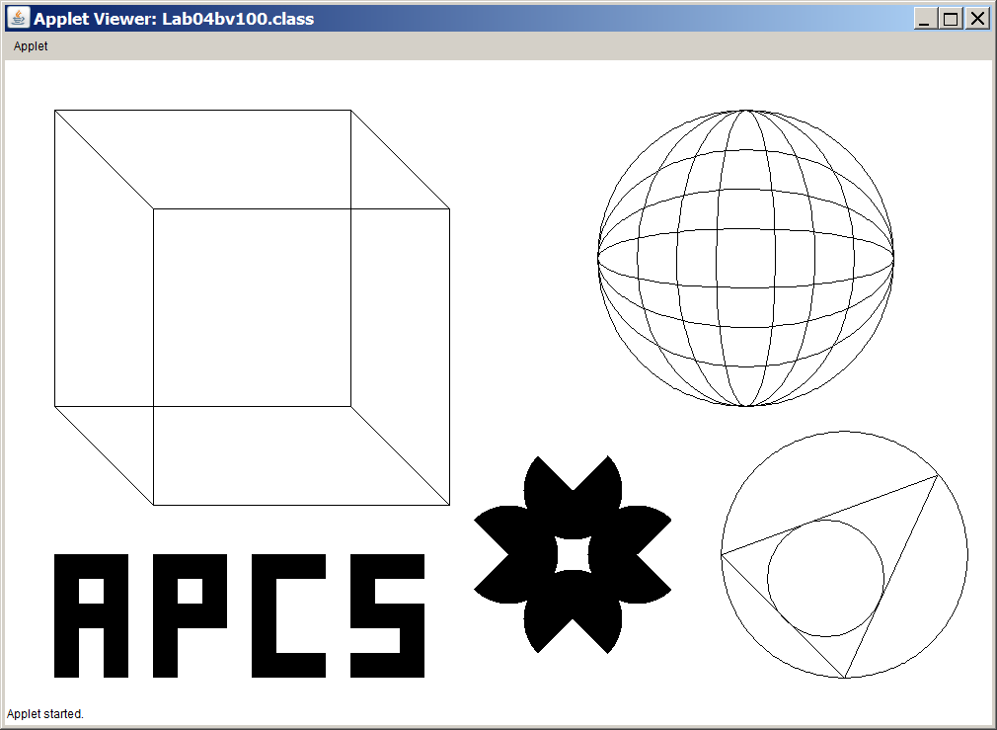

**110 Point Version**

For the 110 point version, you need to move the sphere and place it inside the cube. It is not good enough that the sphere be inside the cube, the sphere must fit perfectly. It should appear tangent in exactly 6 points, one for each side of the cube.

