|  |  |
| --- | --- |
| **Exposure Java** | **Lab 07** |
| **Open-Ended Lab Assignment** | **80, 90, 100 & 110 Point Versions** |
| **Assignment Purpose:**  The purpose of this program is to demonstrate knowledge of modular programming and placing program statement in appropriate methods. | |

Chapter VII introduced creating methods and modular programming with the philosophy of *one task, one module* or method. Methods with a common purpose are placed in a class. The picture below was shown in your chapter and created with three the **Background**, **House** and **Tree** classes. Each class has multiple methods.

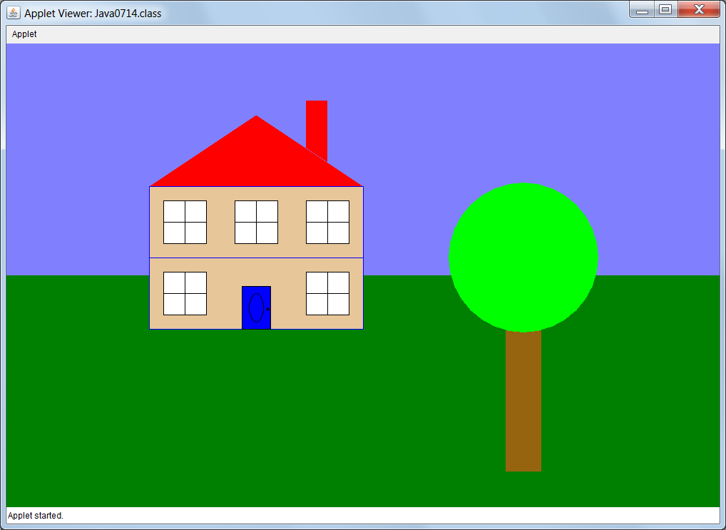

This is your first *open-ended* lab assignment. This means that you are not shown a specific picture or program computation output that is required when you execute your lab assignment. You need to create a graphics display. This display requires one or more classes and each class requires multiple methods. You will work with a partner on this program.

**80 Point Version**

Your program has one class with four or more methods.

**90 Point Version**

Your program has one class with four or more methods.

It has a second class with three or more methods.

**100 Point Version**

Your program has one class with four or more methods.

It has a second class with three or more methods.

It has a third class with two or more methods.

**110 Point Version**

This has the same classes as the 100 point version, but each class is now in its own file.

**Remember…**

The program will not receive credit if you place program statements, except for method calls, inside the **paint** method.

All the methods you create must be placed inside a class, which is outside the **GraphicsLab04st** class.

Make sure to use self-documenting identifiers.