|  |  |
| --- | --- |
| **AP Computer Science** | **Lab14b Assignment** |
| **The Proper OOP Choo-Choo Train** | **80 & 100 Point Versions** |
| **Assignment Purpose:**  The purpose of this program to rewrite the existing Choo-Choo Train with proper Object Oriented Programming Features. | |

The **Lab14bvst.java** starting program displays a complete Choo-Choo train, shown below. The object of this lab assignment is not to display some type of different train, but the exact same train you saw in Chapter XIV. You are expected to take the existing classes and rewrite both classes and methods to develop a program that meets proper Object Oriented Programming standards.

The next chapter with be a summary of Object Oriented Program design, but you have slowly and steadily learned many features already. This program gives you come good practice. The fact that the program output is the same train does not mean that this is a simple program with a little tweak here and a little tweak there. This assignment is quite challenging. So get ready.

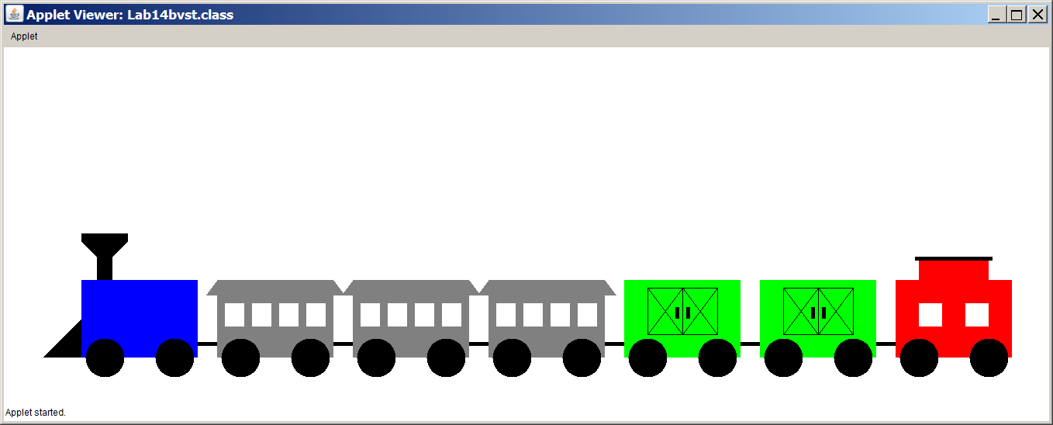

You are provided with the **Lab14bv80.java** and **Lab14bv100.java** files. These are testing files for the 80-point and 100-Point versions of the lab assignment. Make no changes in these files.

The current starting program does a good job illustrating polymorphism, but this is done with poor program design. It is your job - with a lab partner - to alter the existing files (except the testing files) into proper Object Oriented Design.

Let's start by taking a sequential inventory how the train program was developed up to this point.

* Class **RailCar** was created first to create a fundamental car with wheels.
* Classes **FreightCar**, **Locomotive**, **PassengerCar**, and **Caboose** were written as subclasses of the **RailCar** superclass.
* Every one of the subclasses used a **drawCar** method that first used **super.drawCar(g)** to draw the **RailCar** object that is part of every subclass of **RailCar**.
* Then all of these classes were tested, thrown in an array, and displayed. This demonstrated how polymorphism can select the correct method for each object.

The essence of this assignment is to create a **Train** class that neatly encapsulates all the necessary classes in one container. Sometimes student underestimate the challenge of an assignment. This may even cause concentration on other academic subjects that seem more pressing. This assignment is challenging. The 80-point version is relatively easy, but for the 100-point version you need to overcome some interesting obstacles that will test if you truly understand inheritance. It is an ideal team project for two or three people to work on together and solve the problems.

80-Point Version Specifics

The 80-Point version requires that all methods connected with the train program are contained in a **Train** class or that they are contained in a class that has its object as attribute in the **Train** class.

|  |
| --- |
| **Lab14bv80.java Provided Student File** |
| public class Lab14bv80 extends Applet  {  public void paint(Graphics g)  {  Train train = new Train(100,300);  train.addCar("Locomotive",Color.blue);  train.addCar("PassengerCar",Color.gray);  train.addCar("PassengerCar",Color.gray);  train.addCar("FreightCar",Color.green);  train.addCar("PassengerCar",Color.gray);  train.addCar("FreightCar",Color.green);  train.addCar("Caboose",Color.red);  train.addCar("FreightCar",Color.green);  train.showCars(g);  }  } |

The provided testing file shows that the program starts by creating a **Train** object. Well there is no **Train** class right now. The parameters information of **(100,300)** is the top-left coordinate position of the train.

The testing program continues and then adds eight cars to the train. Notice that the only thing specified for each new car is the color. For the 80-Point version each new car is added to the end of the train. In the starting program method **add** created a new car objects with a specified color and a specified location. This has changed. Every car has a location in the whole train that is relative to the front of the train.

The **Train** class requires an **addCar** method that adds a new **RailCar** object to a **railCars** dynamic array. The 80-Point version has only one **addCar** method and it places each new **RailCar** object at the rear of the train.

The **Train** class also needs a **showCars** method, which displays the car in the sequence that the cars were added. The very first car added to the **Train** object is displayed at the (x,y) coordinate that was provided with the instantiation of the new **Train** object.

80-Point Version Output

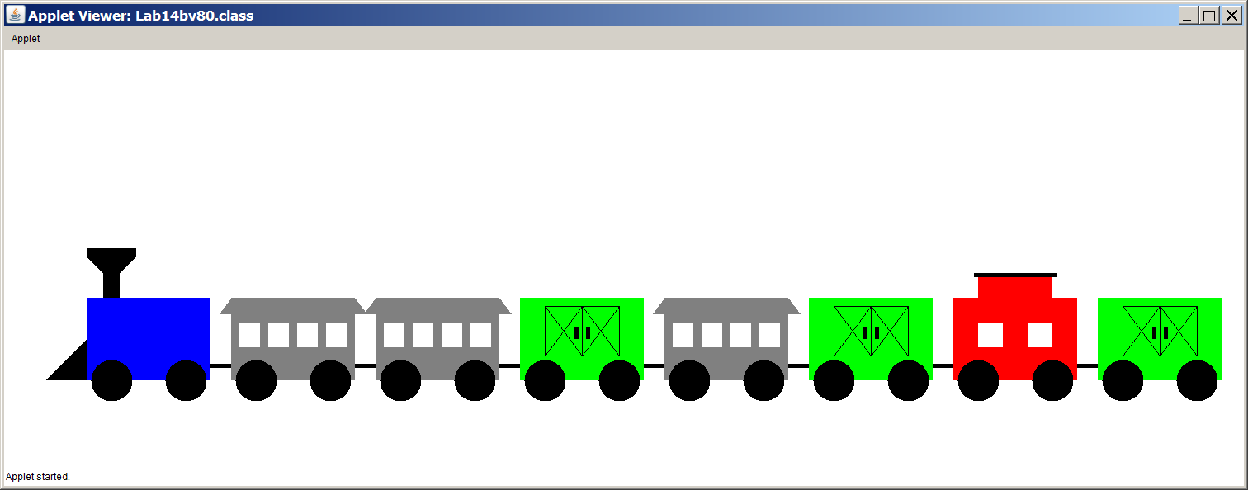

100-Point Version Specifics

First look at the provided test program, **Lab14bv100.java** and compare it to the 80-Point version. At a quick, first glance the two files may appear identical. Both versions start by creating a **Train** object and both versions place it at the same location. Both versions add eight **RailCar** objects.

The main difference is that in the 100-Point version, two of the cars use a second, overloaded **addCar** method that inserts a new **RailCar** object at a specified location. This is the 100-point challenge. How do you put a new car between two existing cars and keep every else in sequence?

|  |
| --- |
| **Lab14bv100.java Provided Student File** |
| public class Lab14bv100 extends Applet  {  public void paint(Graphics g)  {  Train train = new Train(100,300);  train.addCar("Locomotive",Color.blue);  train.addCar("PassengerCar",Color.gray);  train.addCar("PassengerCar",Color.gray);  train.addCar("FreightCar",Color.green);  train.addCar(3,"PassengerCar",Color.gray);  train.addCar("FreightCar",Color.green);  train.addCar("Caboose",Color.red);  train.addCar(6,"FreightCar",Color.green);  train.showCars(g);  }  } |

The **Train** class requires an **addCar** method that adds a new **RailCar** object to a **railCars** dynamic array and places it at the end of the train. The 100-Point version also has a second **addCar** method, which places a new **RailCar** object at a sequence number in the train. The first position, occupied by the locomotive is position 0.

The **Train** class also needs a **showCars** method, which displays the car in the sequence that the cars were added. The very first car added to the **Train** object is displayed at the (x,y) coordinate that was provided with the instantiation of the new **Train** object.

100-Point Version Output

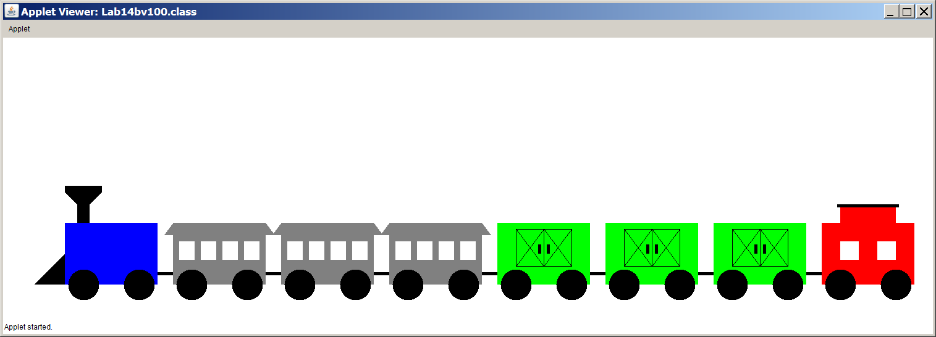

It was stated earlier that there are some inheritance issues that can cause a problem. Your teacher will decide if and when to you give you appropriate hints to solve this problem. You may not get any help at all. The only hint given in the lab assignment is to watch out for this 100-Point version output. This output shows some very confused **RailCar** objects. It is the result of not handling inheritance concerns properly. That is the only hint you get here. Anything else, your teacher will decide.

