

QUIET, PLEASE!


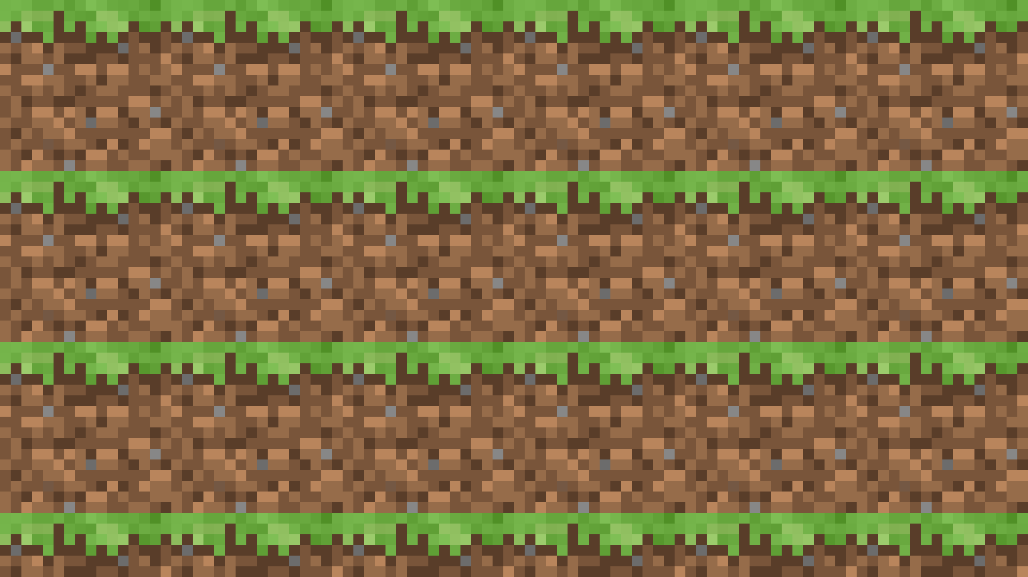

EXPERIMENT IN PROGRESS

