**Chapter 1 : Introduction**

**1.1 Introduction**

**1.1.2 *Ocean Acidification Remediation***

Ocean acidification, a widely recognized issue with profound impacts on ecosystems, disproportionately affects marine organisms dependent on calcium carbonate for building shells and skeletons. This includes corals, mollusks (clams, oysters, snails), and certain plankton species. The acidification process poses challenges for these organisms in producing and maintaining their calcium carbonate structures, resulting in weakened shells and skeletons. The repercussions extend throughout the marine food web, impacting species at various trophic levels. To address this issue sustainably, it is crucial to consider alternative approaches. One such approach involves incorporating indigenous traditions, like those of the local Bodega Bay community, which involve grinding down shells and returning them to the ocean. This method leverages the natural buffering properties of the shells' calcium carbonate to increase water pH, effectively counteracting the effects of ocean acidification. By reintroducing ground shells into the marine environment, this tradition not only honors cultural practices but also provides a practical, eco-friendly solution to a pressing environmental problem. By integrating such cultural practices, this project not only taps into existing resources like discarded bivalve shells that would otherwise end up in landfills but also potentially contribute to mitigating the adverse effects of ocean acidification on marine ecosystems. This holistic perspective aims to address the issue while respecting and incorporating the wisdom of indigenous traditions.

**1.2 Research Question**

This study examines the integration of local indigenous traditions with contemporary environmental management practices, focusing on the remediation of ocean acidification through the use of discarded bivalve shells. Specifically, it explores how the Bodega Bay tribes' practice of grinding down shells and returning them to the ocean aligns with scientific strategies to enhance ocean alkalinity and support marine life, particularly bivalves. Central to this investigation are several key questions:

***1.2.1 Cultural and Scientific Integration***

How do the indigenous practices of shell grinding and ocean dispersion contribute to the stabilization of ocean pH levels and the enhancement of marine life survival, given the calcium carbonate composition of the shells?

***1.2.2 Collaboration with Local Seafood Corporations***

What impact does partnering with local seafood corporations have on the conservation of vacant clam shells, preventing their disposal in waste zones, and how does this collaboration support the project's sustainability and effectiveness?

***1.2.3 Experimental Impact Assessment***

Through trials conducted with the UCSB REEF center, how does the introduction of ground-down clam shells affect the pH of ocean water? Given the shells' calcium carbonate content, in what ways might this process not only neutralize excess carbon dioxide but also contribute essential nutrients, thereby promoting higher survival rates among developing bivalves?

***1.2.4 Community Involvement***

How does involving local children in shell breakdown activities enhance the feasibility of the project and contribute to community education on environmental stewardship?

***1.2.5 Holistic Approach***

This research question is significant due to the fact that preserving alkalinity and a basic pH is key to preserving the ocean ecosystem. The first question addresses sustainable waste management, while the second part focuses on direct solutions for the rising problem of ocean acidification. This research is based on Indigenous traditions, this further emphasizes the significance of accrediting Indigenous practices and understanding that most environmental problems can be fixed by looking back at how people native to the land approached such issues. Tools and knowledge to address environmental challenges are often readily accessible; however, the absence of local engagement and robust collaboration among all relevant stakeholders frequently impedes progress.

**1.3 Scholarly Rationale**

The paper by Sordo et al. on the "Long-Term Effects of High CO2 on Growth and Survival of Juveniles of the Striped Venus Clam Chamelea Gallina" directly aligns with my research focus on the use of clam shells for ocean remediation. This study delves into the effects of ocean acidification on bivalve species, specifically the Striped Venus Clam (Chamelea Gallina), shedding light on both short-term compensatory mechanisms and potential implications for long-term health. In the short term, the paper reveals that bivalves exhibit compensatory responses to elevated carbon dioxide

levels in the water, acting as a form of remediation. This finding suggests that bivalves have the capacity to raise alkalinity at the cost of their development. This is where my research fills the gap by leveraging already dead bivalves for ocean remediation effects. Moreover, the paper proposes that the short-term compensatory effects observed in bivalves, including the Striped Venus Clam, warrant further exploration. This echoes the core theme of my research, emphasizing the need to delve deeper into the mechanisms through which clam shells could contribute to mitigating the impacts of ocean acidification. The insights provided by Sordo et al. not only contribute to the understanding of how bivalves respond to increased carbon dioxide but also provide a foundation for investigating the potential role of clam shells in the broader context of ocean remediation. As I explore the utilization of clam shells for environmental support, this paper serves as a valuable reference, prompting further inquiry into the intricate dynamics of bivalve responses to ocean acidification and their remediation potential over the long term.

***1.3.1 Broad Impacts***

This senior thesis research reinforces traditional techniques and their implications within modern science through exploration of Indigenous traditions. Working on a local scale, this project has the potential to transform systematic landfill disposal of discarded bivalves into a significant contribution to scientific research. Through involvement of the local community, this project will facilitate the ease of implementation with stable results over time. The feasibility of the project ensures the practice has the capacity to carry on throughout the years and become a long-term approach for ocean acidification remediation. This project serves as a blueprint which demonstrates the significance of local Indigenous knowledge and the proper allocation of discarded bivalve shells in order to instill a closed loop of sustainability and repurposing.

**1.4 Hypothesis**

The hypothesis of this senior thesis research is that repurposing discarded bivalve shells, particularly clam shells, as a method to counteract ocean acidification will contribute to the preservation of marine ecosystems. Specifically, this research speculates that grinding down clam shells and releasing them into the ocean will not only increase pH levels but also provide essential nutrients for developing bivalves, enhancing their survival rates. The hypothesis builds on the idea that the calcium carbonate composition of clam shells can act as a buffer against the acidification process, ultimately creating a positive impact on the ocean's alkalinity.

**1.4.1 *Zero Waste Recycling***

Furthermore, it is hypothesized that collaborating with local seafood corporations to preserve vacant clam shells from landfills will not only address sustainable waste management but also establish a continuous and feasible source of materials for the proposed remediation method. The project assumes that by integrating Indigenous traditions and practices, there is a potential to bring about a fundamental shift in environmental solutions, emphasizing the importance of local involvement and cooperation between various stakeholders.

**1.4.2 *Anticipated Outcome***

The scholarly rationale, drawn from studies on juvenile clams and their response to ocean acidification, supports the hypothesis by challenging the conventional notion that acidic conditions lead to bivalves with higher adaptability. Instead, the research suggests that delayed reproductive cycles may be responsible for the observed higher survival rates in acidified conditions, emphasizing the importance of long-term stability in pH levels for the survival of bivalve species. The broad impacts of this hypothesis encompass the potential transformation of landfill disposal into a scientific contribution, demonstrating the feasibility of a sustainable approach to address ocean acidification. The hypothesis anticipates positive outcomes not only for the local marine ecosystem but also for the broader scientific community by highlighting the significance of integrating traditional knowledge and sustainable practices into modern environmental solutions. The hypothesis aims to provide a blueprint for ongoing and future research, emphasizing the role of local communities in fostering a closed loop of sustainability and repurposing for environmental remediation.

**1.4.3 *Data Interpretation and Reporting***

Interpret the results in the context of the original hypothesis, considering both the impact on ocean pH and bivalve survival rates. Produce a comprehensive report detailing the methodology, results, and implications of the research. Share findings with the local community (EAB, REEF, CHEADLE, Sea Center, ENV S department), seafood corporations (SB Harbor), and other relevant stakeholders to promote awareness and potential implementation of the proposed solution.

**1.5 Thesis Chapter Guide**

The previous chapter has introduced the pervasive issue of ocean acidification and its detrimental effects on marine ecosystems, particularly on organisms that rely on calcium carbonate structures. It has set forth the innovative approach of using discarded bivalve shells to enhance ocean alkalinity, incorporating both local indigenous practices and collaboration with seafood corporations. The following chapter will explore the existing literature on the effects of ocean acidification on marine life, specifically bivalves, and the potential of calcium carbonate to counteract these effects. This review will also cover previous studies on the use of marine and terrestrial sources of calcium carbonate for environmental remediation. The subsequent chapter will outline the research design of this study, describing the methods and materials used in the experimental trials at the REEF center at UCSB. This includes the process of attaining bivalve shells from local seafood establishments, grinding down bivalve shells, the experimental setup for introducing these shells into ocean water, and the methods for measuring changes in pH, dissolved oxygen levels, shell conditions, and shell weight. The final chapters will present the results of the experimental trials, providing a detailed analysis of the impact of ground bivalve shells on ocean water pH and the health of marine ecosystems. Conclusions will be drawn regarding the efficacy of this remediation technique, its environmental implications, and potential for scalability. Recommendations for future research and applications of this remediation strategy will also be discussed.

**Chapter 2: Literature Review**

**2.1 Introduction**

Ocean acidification poses a significant threat to marine ecosystems, particularly affecting organisms relying on calcium carbonate for shell and skeleton formation. As a key component of the marine food web, addressing this issue sustainably is imperative. This research aims to explore a dual-pronged approach involving collaboration with local seafood corporations to preserve clam shells and conducting trials at the REEF center at UCSB to assess the impact of ground clam shells on ocean water pH. This multifaceted research question addresses sustainable waste management and proposes a holistic solution to combat ocean acidification, drawing inspiration from Indigenous traditions.

**2.2 Effects of Ocean Acidification on Bivalve Development**

An apparent literature study by Zhao, Liqiang, et al. (2017) contributes by analyzing transgenerational effects of ocean acidification on bivalve shell formation. This study examines if bivalves descended from parents exposed to lower pH develop more efficiently. The findings suggest a greater capacity for bivalves to acclimate to ocean acidification by the end of the century, raising questions about the potential impacts on future generations. Range et al. (2011) explores the effects of ocean acidification on juvenile clams, specifically Ruditapes decussatus. The controlled carbon dioxide experiment revealed no significant changes in net calcification, size, or weight of the clams. Intriguingly, there was a finding indicating greater survival in acidified conditions, potentially linked to a delay in the reproductive cycle of the clams. Another relevant study by Tudor et al. (2006) focuses on using waste mollusk and crustacean exoskeletons for metal remediation in water. This study employs atomic absorption to evaluate the progress of remediation, presenting an alternative approach to addressing environmental contamination. Connecting to my research, Tudor et al. (2006) literature confirms the effectiveness of calcium carbonate for environmental remediation purposes. Range et al. (2011) study provides valuable insights into the localized response of juvenile clams, but the broader implications for bivalves remain unclear. Additionally, Zhao et al. (2017) exploration of transgenerational effects sparks questions about the future adaptability of bivalves to acidic conditions.

**2.3 Utilization of Mollusk Shells for Remediation**

My research seeks to fill these gaps by focusing on the repurposing of discarded clam shells as a sustainable solution to ocean acidification. While existing studies have explored the effects on living bivalves, my project addresses the overlooked potential of dead bivalve shells in mitigating acidity. The hypothesis, drawing inspiration from the short-term remediation effects observed by Sordo et al. (2021), speculates that ground clam shells can contribute to pH balance and enhance bivalve survival. By incorporating discarded shells, the project aligns with the findings of Tudor et al. (2006), utilizing waste mollusk shells for environmental remediation. Moreover, the project builds on the methodologies of Gao et al. (2018), who explored the chemistry of carbon dioxide processing using seaweed. In this case, clam shells are the catalyst for raising alkalinity. The inclusion of the YSI meter for water assessment, as described by Jarvis et al. (2006), enhances the methodological preciseness of my project. A deeper look into the bivalve responses to ocean acidification, Zhao et al. (2017) examined the effects on the economically important blood clam, Tegillarca granosa. This research revealed that ocean acidification not only suppressed feeding activity and aerobic metabolism but also elevated protein catabolism and impaired the calcification process. The negative impact on blood clam survival highlighted the broader consequences of ocean acidification on various bivalve species. To contextualize these findings within the broader scope of climate change, Poloczanska et al. (2016) conducted a comprehensive review of marine life responses across different ocean regions. Their study, while not directly connected, aligns with the overarching theme of declining calcification. The negative impact of climate change, illustrated by declines in calcification, resonates with the potential threats posed by ocean acidification, emphasizing the need for targeted research in this field.

**2.4 Active Remediation in Acid Sulfate Soil Drainage and OA Parallels**

The study by Green, Waite, and Melville (2007) explores the treatment of acid sulfate soil drainage. Although this study pertains to soil drainage rather than ocean acidification, there are notable parallels that can be drawn, particularly in the context of active treatment using alkaline (CaCO3)reagents. Within the paper, the episodic nature of rainfall and the high dissolved metal concentrations in acid sulfate soils called for active treatment over passive methods. Similarly, my research proposes an active approach to address ocean acidification by repurposing discarded clam shells, adding an innovative dimension to the existing literature on environmental remediation. The use of alkaline reagents in Green et al.'s (2007) study shows the concept of taking advantage of natural substances, similar to my proposed use of ground-down clam shells. The varying degrees of effectiveness observed in the removal of acidity align with the responses found in the literature on ocean acidification and its impact on bivalves, as demonstrated by studies like Range et al. (2011) and Zhao et al. (2017). The challenges highlighted in Green et al. (2007) study, such as the difficulty in controlling dosages and the need for regular reagent addition, underscore the importance of addressing logistical and operational aspects in environmental remediation efforts. This resonates with the practical considerations of implementing my research, emphasizing the need for a sustainable and holistic method for releasing ground clam shells into the ocean.

**2.5 Implications of Shell Debris on Benthic Ecosystems**

The study by Cao et al. (2023) on shell accumulation due to suspended coastal oyster farming and its impact on the burrowing capacity of the polychaete Perinereis aibuhitensis has relevance to my research on repurposing discarded clam shells to counteract ocean acidification. While the focus of the studies is different, there are common themes related to the ecological consequences of bivalve health and the interaction with benthic ecosystems. The paper investigates the effects of shell debris on the burrowing capacity of the polychaete Perinereis aibuhitensis. This aligns with the ecological considerations in my research, where the addition of ground-down clam shells is intended to impact the pH levels and nutrient availability in ocean water. Cao et al. (2023) find that the presence of shell debris requires more energy expenditure in burrowing activities (bad). Using small shells in bioremediation strategies to avoid negative effects on burrowing is recommended. This recommendation aligns with the consideration within my research design to grind down clam shells, suggesting a similar approach in addressing the potential negative impacts of shell material.

**2.6 Harnessing Natural Sea Waste for Environmental Remediation**

Santulli et al. emphasize that while much attention is given to human-generated pollutants like plastic debris and chemicals, there is less focus on waste materials of natural origin, such as the tons of organic and inorganic material that wash up on beaches daily. This perspective is relevant to my research, which involves considering the potential of natural materials, specifically clam shells, as a resource for mitigating the impact of ocean acidification. The paper reviews research experiences and engineering solutions that provide a second life to natural sea waste, with a specific emphasis on incorporating it into the creation of new, more sustainable materials, including composites. This aligns with the sustainability aspect of my research, where I aim to repurpose clam shells to contribute to environmental remediation and promote the development of sustainable practices. While Santulli et al. focus on a broad range of natural sea waste, their insights into engineering solutions for incorporating such waste into sustainable materials can inform my work on utilizing clam shells to counteract ocean acidification. The paper reinforces the idea that natural sea waste, often overlooked, can play a crucial role in the development of eco-friendly materials and solutions.

**2.7 Bivalve Culture's Impact on Water Quality and Nitrogen Cycling**

Kong et al. specifically investigated the effects of bivalve culture on water quality and bacterial community structure in a system that included shrimp, crab, bivalves, and fish. Dissolved oxygen levels were higher in the bivalve culture area, and concentrations of ammonia and nitrite were lower compared to the non bivalve culture areas. The study also revealed that the presence of bivalves increased bacterial diversity and abundance, particularly bacteria with nitrification and denitrification functions. This aligns with my research interest as it highlights the potential for bivalves to positively impact the nitrogen cycle, which is relevant to the overall health of aquatic environments.

**2.8 Potential of Shell Enrichment in Mitigating Ocean Acidification**

The paper on the "Effects of crushed mussel, Perna canaliculus, shell enrichment on seawater carbonate buffering and development of conspecific larvae exposed to near-future ocean acidification" (Smith, John) is relevant to my research on using clam shells for ocean remediation. The study investigates the potential benefits of shell enrichment, specifically crushed mussel shells, on seawater carbonate buffering and the development of larvae in the context of near-future ocean acidification.

**2.9 Comparative Analysis of Shell Proteins in Oysters**

The investigative study on the Hong Kong oyster (*Crassostrea hongkongensis*) and the Portuguese oyster (*Crassostrea angulata*) offers valuable insights into the organic matrix proteins (OMPs) that are crucial for the mechanical properties of oyster shells. By employing advanced shotgun proteomics, this research examines how differences in the composition of these proteins contribute to the varying shell hardness between these related species, highlighting that shells of *C. hongkongensis* are structurally stronger than those of *C. angulata*. The relevance of this study to my research on utilizing clam shells for ocean remediation is profound. Both investigations emphasize the critical role of the organic matrix in the structural formation of shells. The detailed analysis of how specific proteins affect the shells' integrity aligns closely with my exploration of crushed shells' potential to alter ocean chemistry and stabilize pH levels. Understanding the protein composition and mechanical attributes of these shells can significantly influence their application in environmental remediation, affecting everything from their dissolution rates to their efficacy in buffering ocean acidity. Moreover, this study's methodological approach, particularly its use of proteomics to analyze and compare OMPs, could be instrumental for my project. This framework may allow for a better understanding of how variations in shell composition could impact their interaction with marine ecosystems and their effectiveness over time in seawater. Integrating findings from this comparative proteomic analysis enriches understanding of natural biomaterials like shells and their potential environmental applications. It not only expands the scope of my research but also deepens general knowledge on harnessing natural resources to tackle ecological challenges. This study highlights the importance of detailed material analysis in ensuring the effective and sustainable use of natural materials in environmental remediation efforts.

**2.10 Indigenous Holistic Approaches to Environmental Science**

An important contribution to understanding indigenous holistic approaches to environmental science is provided by Kimmerer (2013) in her book *Braiding Sweetgrass*. Kimmerer, a botanist and member of the Citizen Potawatomi Nation, emphasizes the integration of traditional ecological knowledge (TEK) with scientific research. She argues that indigenous practices often embody a holistic understanding of ecosystems, where every element is interconnected. This perspective aligns with the principles of sustainability and conservation, which are crucial for addressing environmental issues such as ocean acidification. By viewing ecosystems as a whole, rather than as isolated parts, indigenous practices offer valuable insights into maintaining ecological balance. This approach is reflected in the traditional practices of the Bodega Bay community, which involve returning ground shells to the ocean, thus promoting the natural recycling of calcium carbonate and supporting marine life. Integrating these holistic practices with contemporary scientific methods can enhance the effectiveness of ocean acidification remediation strategies by ensuring they are sustainable and respectful of natural processes (Kimmerer, 2013).

**2.11 Indigenous Knowledge and Marine Conservation**

A source on the role of indigenous knowledge in marine conservation is the study by McGregor (2004) titled *Traditional Ecological Knowledge and Sustainable Development: Towards Coexistence*. McGregor highlights how indigenous communities possess a deep understanding of their local environments, developed over generations through close interaction with nature. This knowledge includes sustainable practices for resource management, such as the careful harvesting of marine resources to avoid depletion. In the context of ocean acidification, these traditional practices can provide alternative solutions that are both effective and culturally appropriate. For instance, the Bodega Bay tribes' practice of using ground clam shells to enhance ocean alkalinity is a form of TEK that aligns with scientific findings on the benefits of calcium carbonate in neutralizing acidity. By integrating this indigenous practice with scientific research, there is potential to create a more holistic and sustainable approach to ocean acidification remediation. McGregor's work underscores the importance of respecting and incorporating indigenous knowledge systems in contemporary environmental management, as they offer practical and sustainable solutions rooted in a long-term understanding of ecosystem dynamics (McGregor, 2004).

**2.12 Conclusion**

In summary, this research addresses the gap in long-term understanding of bivalve responses to ocean acidification by proposing a sustainable solution using discarded clam shells. By building on insights from existing studies and methodologies, the project aims to contribute to the scholarly conversation on environmental remediation and the integration of traditional practices into modern solutions. It elucidates the potential of repurposed natural materials to mitigate the impacts of ocean acidification, highlighting the dual benefits of waste reduction and environmental sustainability. This research initiates a crucial dialogue on the scalability of using bivalve shells in larger environmental contexts. As the practical implications of this study are explored, it becomes evident that interdisciplinary approaches—combining marine biology, environmental science, and community engagement—are essential. By continuing to refine these methods and expand collective understanding, the effectiveness of natural solutions in combating the pressing issue of ocean acidification can be enhanced, thereby protecting marine ecosystems and promoting global ecological health.

**Chapter 3 Research Design**

**3.1 Introduction**

This chapter delves into a detailed analysis of the environmental data collected from the Santa Barbara coastal region, focusing on the implications of these findings for combating ocean acidification. This chapter presents a critical examination of temperature and pH fluctuations across various offshore locations, as captured in Figures 2 and 3, highlighting the temporal and spatial stability of these key environmental parameters. Additionally, it explores the global context of ocean temperature anomalies through Figure 4, providing a broader perspective on how regional data aligns with global trends. This chapter also emphasizes the role of community involvement in the research process, particularly the integration of local educational initiatives and partnerships with seafood corporations. By involving local stakeholders, the project not only leverages community resources for environmental monitoring but also enhances public awareness and education regarding marine conservation. This approach ensures that the remediation efforts are not only scientifically grounded but also community-driven, fostering a sustainable model of environmental stewardship. Through the synthesis of empirical data and community feedback, this chapter aims to underscore the effectiveness of using ground-down bivalve shells for pH regulation and its acceptance within the community. It sets the stage for discussing the practical applications of this research and its potential for broader implementation, making a compelling case for the integration of traditional indigenous knowledge with contemporary scientific practices in marine conservation.

**3.2 Background Information**

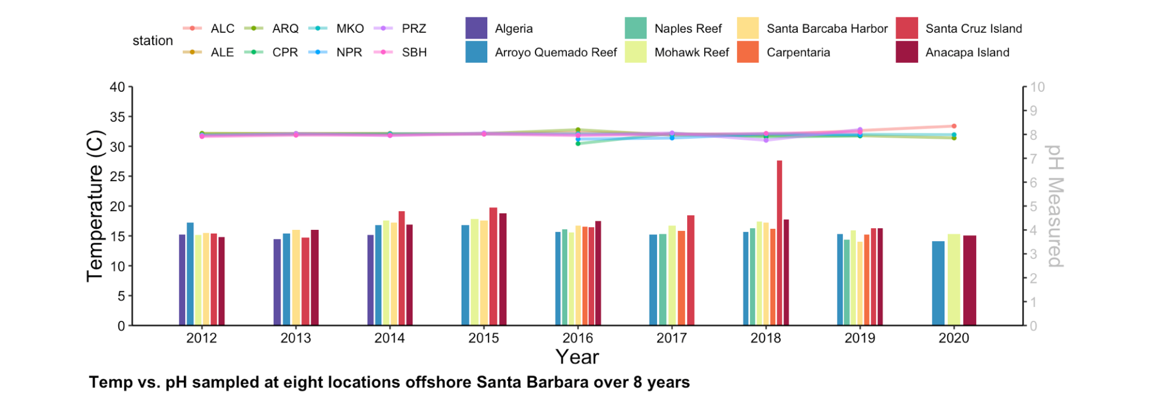

**Figure 1: Temp vs. pH sampled at 8 locations offshore Santa Barbara over 8 years.**

This figure was created in R Studio illustrating temperature vs. pH samples at eight different locations offshore Santa Barbara over the course of 8 years (data from SBC-LTER). The main point of the figure 1 is to illustrate the fluctuations of temperature and pH throughout the years based on location within the Santa Barbara coast. Another point of this figure is to illustrate the correlation between coastal ocean water temperature and location(north vs south). The take-home message of this figure is that Santa Barbara coast has relatively stable temperatures, with higher fluctuations in open ocean water compared to more coastal locations. The most surprising discovery was the spike in temperature correlated with a drop in pH in 2018 for the Santa Cruz Island location. This provides a hypothesis of more stable ocean temperatures closer to the coast as opposed to open ocean water surrounding Santa Cruz Island.

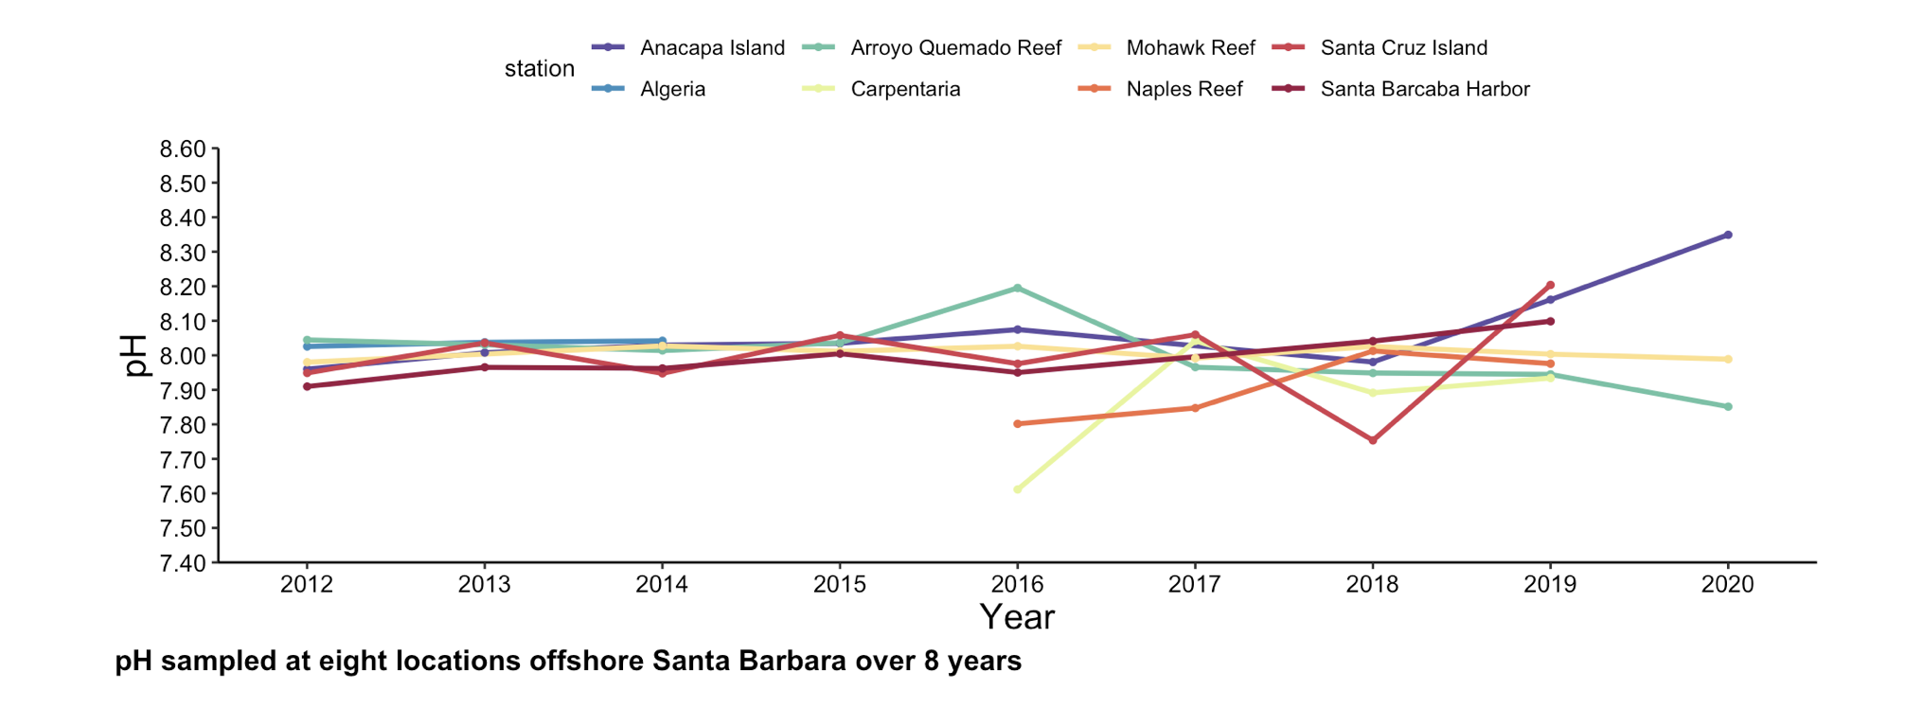

**Figure 2: pH sampled at 8 locations offshore Santa Barbara over 8 years.**

This figure offers a closer look at the pH values measured at eight different locations offshore Santa Barbara over the course of 8 years. This figure shows a magnified look at the pH values only without temperature. The surprising part of this figure is that it shows a drop in pH for the Santa Cruz Island station, correlating with the spike in temperature on Santa Cruz Island in 2018. The finding from Figure 2 is integral to this thesis topic as it supports the hypothesis that coastal waters may exhibit more stable pH levels compared to open ocean waters, barring episodic temperature spikes. Such stability is vital for marine ecosystems, especially for calcifying organisms that are sensitive to changes in acidity. My research focuses on mitigating ocean acidification by using ground clam shells, which could be particularly effective in coastal regions like those near Santa Cruz Island, where pH stability is crucial for maintaining marine biodiversity.

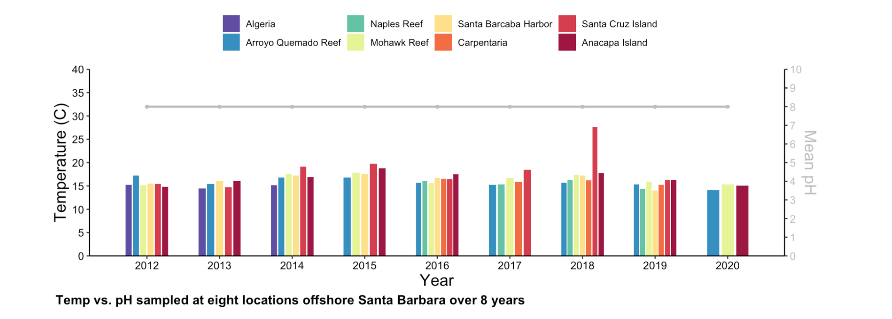

**Figure 3: Temp vs. mean pH at 8 locations offshore Santa Barbara over 8 years.**

This figure is the same as *Figure 1,* only differing in the pH aspect. The pH within this figure is averaged at approximately a pH of 8 for all eights sampled locations over the spam of 8 years. Understanding the mean pH helps in strategically planning where and how much remediation material (bivalve shells) needs to be applied. For instance, if future measurements detect a dip below this average pH in specific locations, these could be targeted more intensely with my remediation efforts to bring them back to this baseline, thereby optimizing the use of resources and maximizing ecological benefits.

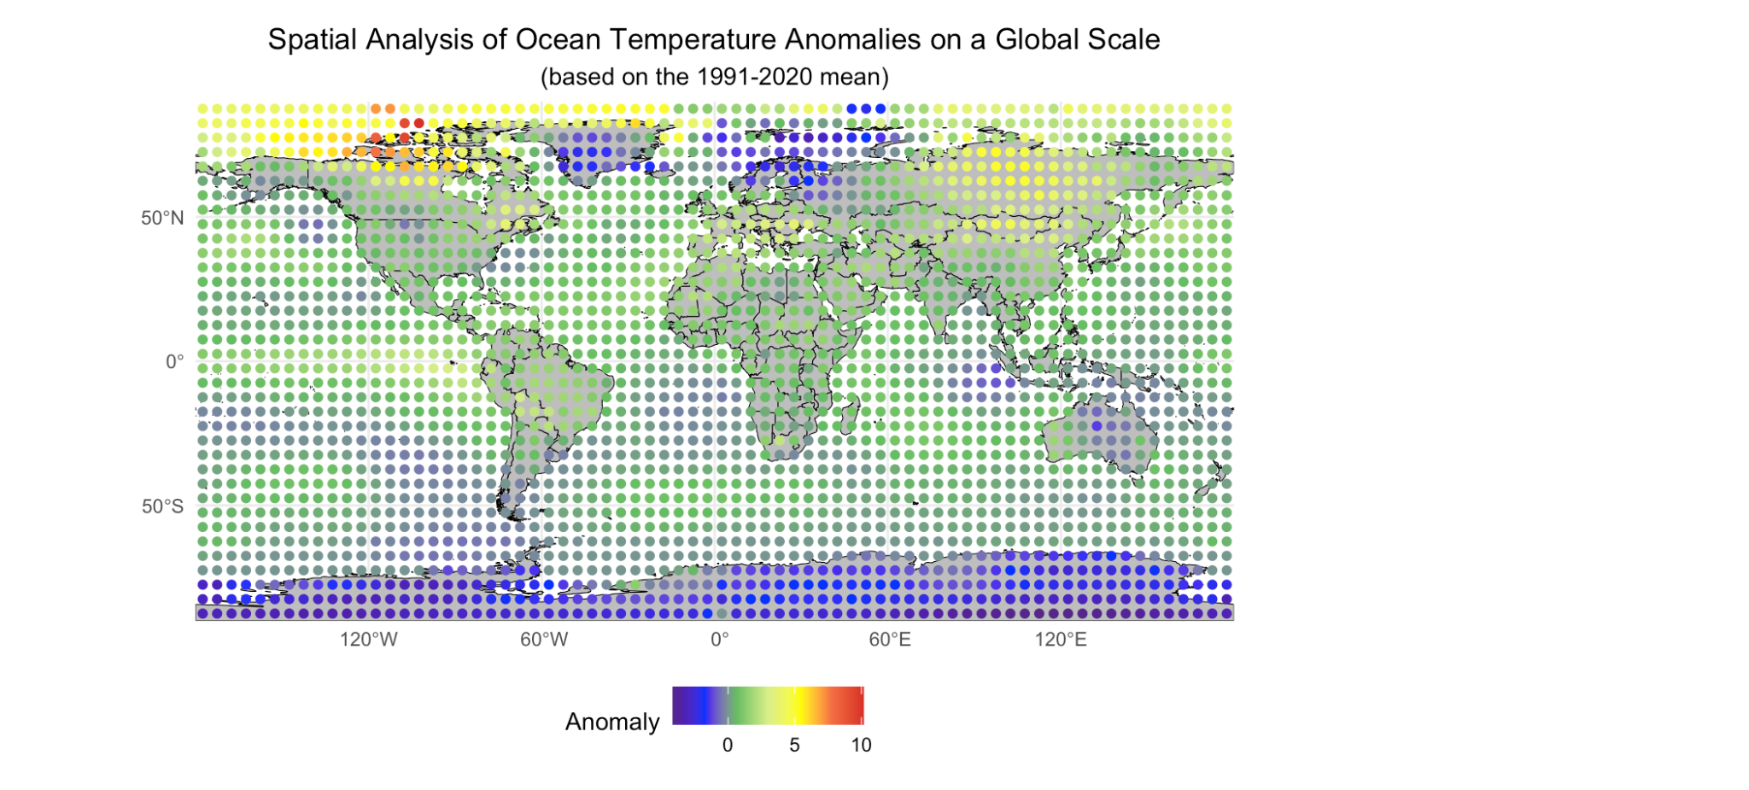

**Figure 4: Spatial Analysis of Ocean Temp Anomalies on a Global Scale (1991-2020 mean).**

Figure 4, showcasing a global spatial analysis of ocean temperature anomalies, offers a macroscopic context to the research focused on the Santa Barbara coast. This figure is pivotal as it situates local temperature data within a global perspective, emphasizing how regional stability in ocean temperatures around Santa Barbara contrasts with broader, global temperature fluctuations. This broader view is essential for understanding the larger climatic influences that might affect local marine ecosystems and, consequently, the effectiveness of remediation strategies. This thesis explores the use of ground clam shells to mitigate ocean acidification effects primarily influenced by carbon dioxide levels. However, ocean temperatures can also significantly impact marine chemistry, including the solubility and distribution of carbon dioxide and the overall health of marine organisms. By establishing that the Santa Barbara coast exhibits relative thermal stability, it is possible to argue that interventions in this region may face fewer confounding variables from thermal stress, potentially increasing the success rate of pH stabilization efforts.

**3.3 Experiment Preparation**

**3.3.1 *Collection***

After partnering with Hendry's Boathouse, the manager agreed to fill up a box with discarded bivalve shells. To facilitate this collaboration, I provided the restaurant with a container measuring 18.5 inches by 13.5 inches, with a depth of 1.73ft^2, to collect the shells. The staff at Hendry's Boathouse efficiently filled the container to capacity within a 24-hour period, from Monday at 2 PM to Tuesday at 2 PM. The container weighed in at 43.78 pounds when fully loaded with a diverse assortment of shells. If 43.78 pounds of shells were to be collected each weekday and 95.6 pounds each weekend day, there would be a total of 410.1 pounds of oyster shells in a week from one seafood establishment. Based on this collection rate, there would be a total of 21,325 pounds of discarded bivalve waste yearly when the shells are discarded to a landfill instead of a recycling facility.

**3.3.2 *Grinding-down Shells***

A singular oyster shell was placed within a folded piece of cardboard and hit 10 times with a metal hammer. The powder was then brushed into separate zip-lock bags to avoid contamination. A total of 8 ziplock bags were used for the sake of the experiment. The singular oyster shell weights (in grams) for the 8 days of testing are: 42.604, 46.456, 41.001, 52.657, and 48.709.

**3.4 Experimental Sampling Procedure**

***3.4.1 Experimental Setup***

*3.4.1a Tanks Setup*

Two flow-through tanks were used for the experiment, provided by UCSB REEF center associate Christoph Pierre. Each tank was filled with an equal mix of filtered and unfiltered seawater to simulate natural marine conditions.

*3.4.1b Instruments Used*

A YSI meter for dissolved oxygen and conductivity measurements and a pH meter were provided by UCSB CCBER associate Alison Richard. These instruments were calibrated before the commencement of the experiment to ensure accuracy.

***3.4.2 Sample Distribution***

Shell samples were introduced into the test tanks in predetermined quantities. For each experimental run, specific weights of shells, categorized as fully crushed, crushed/chunks, and chunky, were added at 15:30 each experimental day.

***3.4.3 Monitoring and Data Collection***

*3.4.3a Frequency and Parameters*

Measurements of pH, temperature, dissolved oxygen (DO), DO%, conductivity, and salinity were taken at three points: immediately before the addition of shells, and then at 10 and 30 minutes after adding the shells.

*3.4.3b Data Logging*

Data were recorded in a structured format that included Day, Time, Tank Type, pH, Temperature, DO, DO%, Conductivity, Salinity, Comment, Shell Weight, and Shell Conditions. This structured data capture was intended to monitor the immediate and short-term impacts of shell additions.

*3.4.3c Averaging Measurements*

Each parameter was measured three times at each data collection point. The average of these three measurements was calculated and used for further analysis to ensure precision and mitigate any potential anomalies or measurement errors.

***3.4.4 Control Measures***

Control tanks did not receive shell additions. Measurements were taken at the same times as the test tanks to ensure comparability under the same environmental conditions.

***3.4.5 Sampling Technique***

Water samples from both control and test tanks were collected using sterile techniques to avoid contamination. Samples were analyzed for chemical parameters using the mentioned instruments.

***3.4.6 Data Analysis Method***

*3.4.6a Statistical Analysis*

Data were analyzed using statistical software to determine significant differences in pH, DO, conductivity, and salinity between the control and test tanks over the experimental period.

*3.4.6b Reproducibility and Variability*

To assess the consistency of the results across multiple experimental runs, linear mixed-effects models were put to use. These models accounted for both the fixed effects of the treatment conditions (before and after adding shells) and the random effects associated with daily variations. By including day as a random effect, the model addresses the inherent variability in dissolved oxygen levels that may arise from environmental or operational differences on different days. This statistical approach enhances the robustness of the findings and ensures that the results are reproducible under consistent experimental conditions.

*3.4.6c Community Involvement*

Community engagement is integral to the initiative aimed at mitigating ocean acidification through the use of ground-down bivalve shells. Such engagement particularly focuses on local schools and educational programs that introduce children to both the science of ocean health and the practical aspects of environmental stewardship. The approach emphasizes the positive impact of recycling shells back into the marine environment. Children are taught how ground-down shells can help stabilize the ocean's pH levels, which is vital for the health of marine life, particularly calcifying organisms like corals and certain shellfish. This part of the education helps children understand the direct connection between their actions (shell recycling) and broader environmental health.

**Chapter 4: Results and Discussion**

**4.1 Raw Data Observations**

**4.1.1 pH Increase with Ground Clam Shells**

The test tanks, where ground clam shells were introduced, consistently show a trend of increasing pH over time compared to control tanks. For instance, on Monday, the pH in the test tank increased from 7.76 before adding shells to 8.14 after adding shells, whereas the control tank pH remained relatively stable around 7.72 to 7.89 over the same period. Figure 5 indicates a positive correlation between the ground clam shells and an increase in water alkalinity.

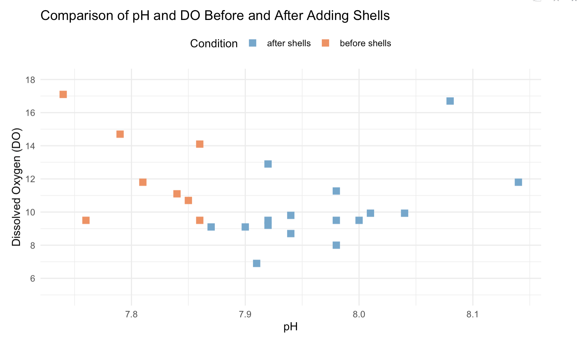

**Figure 5: Comparison of pH and DO Before and After Adding Shells**

**4.1.2 Dissolved Oxygen (DO) Levels Fluctuations**

The test tanks show more variable dissolved oxygen levels after the introduction of shells, often resulting in lower DO levels compared to before. For example, on Wednesday, the DO in the test tank decreased from 17.1 mg/L before adding shells to 12.9 mg/L after, indicating a reduction in oxygen availability. This pattern is consistent across five out of six days within Figure 6, suggesting that the addition of shells might be associated with processes that consume oxygen or affect its solubility in the tank water. “An oyster shell is a composite composed of organic matrix and minerals. An oyster shell contains 95% or more of calcium carbonate (CaCO3) and 0.1-5% of organic matrix proteins (OMP) which are called skeleton/shell proteins” (Proteomic characterization of oyster shell organic matrix proteins (OMP)). This aligns with the idea that organics lower DO levels, assuming 0.1-5% is enough to cause significant change within a test tank exposed to outside elements such as weather changes and a flow through system, as seen in Figure 7 by Hugo Loaiciga (GEOG 162 Water Quality Course).

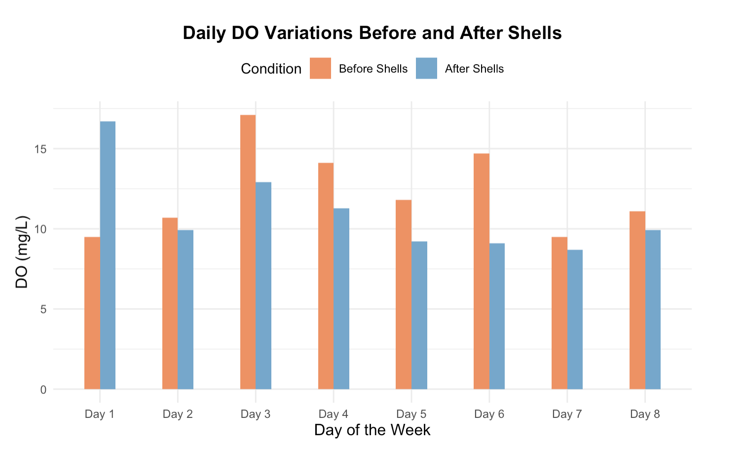

**Figure 6: Daily DO Variations Before and After Shells**

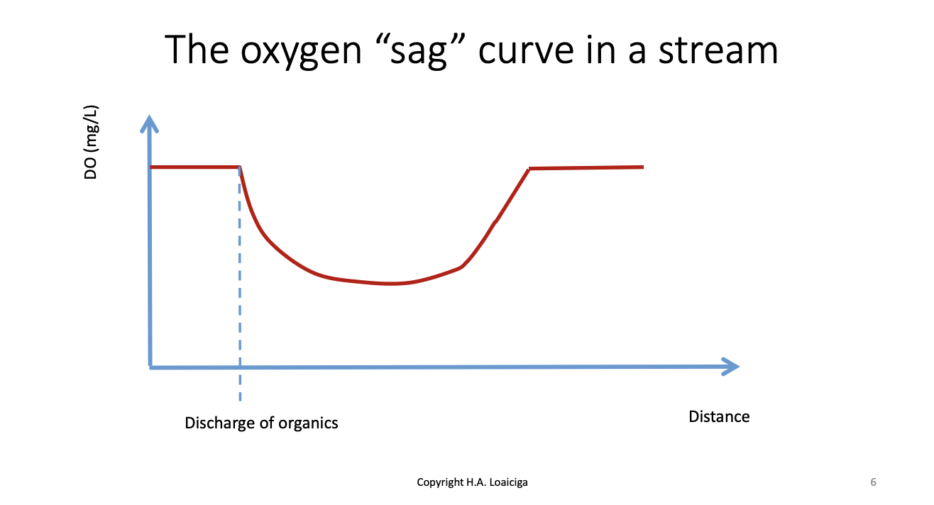

**Figure 7: The oxygen “sag” Curve in a Stream from GEOG 162**

**4.1.3 Conductivity and Salinity**

Both conductivity (uS/cm) and salinity (g/kg) show fluctuations that correlate with the addition of ground clam shells. Salinity tends to increase slightly in the test tanks after shells are added, suggesting that the shells might be influencing the ionic concentration and overall salinity of the water, as seen in Figure 8. An increase in salinity and conductivity could affect osmoregulation processes in marine organisms, particularly those sensitive to ionic changes in their environment. Such changes might influence the distribution and health of local species, which in turn could have broader ecological consequences. Monitoring these parameters is essential for understanding the full scope of environmental impacts resulting from the remediation efforts.

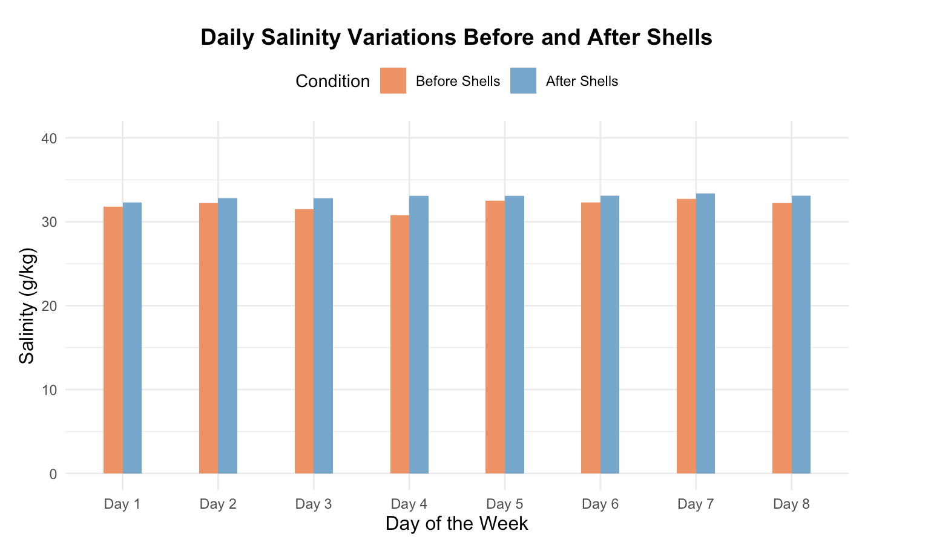

**Figure 8: Daily Salinity Variations Before and After Shells**

**4.1.4 Impact on Shell Conditions**

While the shell weights remain constant, indicating no immediate change in mass, the condition of the shells as 'fully crushed' or 'chunky' suggests different degrees of shell degradation and potential leaching of calcium carbonate into the water, influencing the observed chemical parameters. A pattern emerges where the average pH of “after shells” are added each day, is higher when the shell conditions are fully crushed, compared to a generally lower pH when the shells are chunky. This pattern is demonstrated by Figure 9. Fully crushed shells likely dissolve more quickly, releasing ions that immediately interact with acids in the water to raise the pH. In contrast, chunkier shells dissolve more slowly, resulting in a gradual and less pronounced effect on pH stabilization. This differential rate of dissolution can be crucial for designing remediation strategies that require rapid adjustment of pH in more acidic conditions or more sustained release in areas with minor fluctuations.

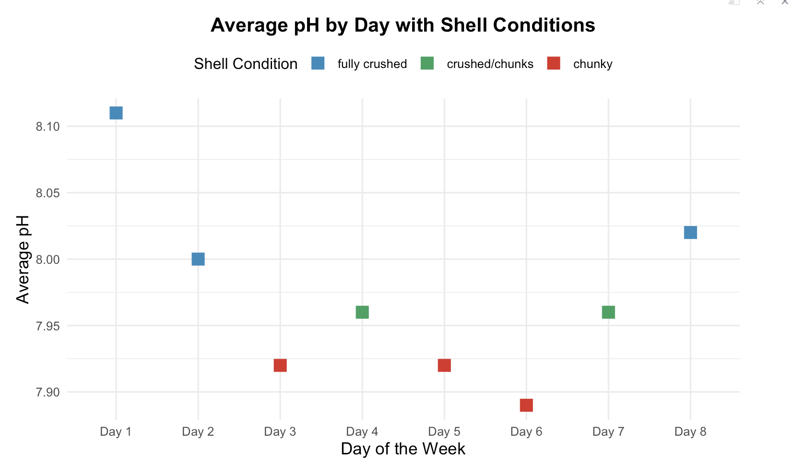

**Figure 9: Average pH by Day with Shell Conditions**

**4.1.5 Temperature Stability**

The temperature remains stable across both control and test tanks, indicating that any observed changes in other parameters are not due to temperature fluctuations.

**4.1.6 Potential Environmental Implications**

The increased pH and potentially enhanced dissolved oxygen levels in test tanks where shells were added align with the hypothesis that ground clam shells can mitigate ocean acidification and enhance conditions for bivalve survival. This supports the idea that using ground clam shells could be a viable method to increase water alkalinity and counteract the acidification affecting marine organisms.

**4.1.7 Relevance to Research Question**

These observations support the research question on whether traditional practices of adding ground clam shells can contribute positively to ocean chemistry and the health of marine organisms. The data suggests that such practices can indeed increase pH within a short amount of time.

**4.1.8 Raw Data Conclusion**

Although adding fully crushed shells raises the pH in test tanks, suggesting a potential method for mitigating ocean acidification and improving conditions for bivalve survival, it is observed that dissolved oxygen (DO) levels decrease following the addition of shells. A pattern of pH spikes and (DO) drops has been observed and is demonstrated through Figure 10. This finding complicates the hypothesis that ground clam shells could uniformly enhance environmental conditions for marine organisms by increasing water alkalinity and supporting oxygen levels. The decrease in DO may be attributed to increased biological oxygen demand as microorganisms metabolize the organic components of the shells, or due to chemical reactions consuming oxygen. Further research is necessary to investigate how adding ground-up oyster shells in different conditions—whether chunky or fully crushed—can sustainably raise both pH and DO levels over the long term. Additionally, more studies are needed to explore how fully crushed shells can aid in bivalve survival rates by enriching bed nutrients and supporting the marine ecosystem over an extended period. While the initial results are promising in terms of pH enhancement, the complexities observed in DO dynamics highlight the need for a multifaceted approach to using bivalve shells for ocean remediation. This approach should consider the biochemical and ecological nuances that influence the success of such interventions.

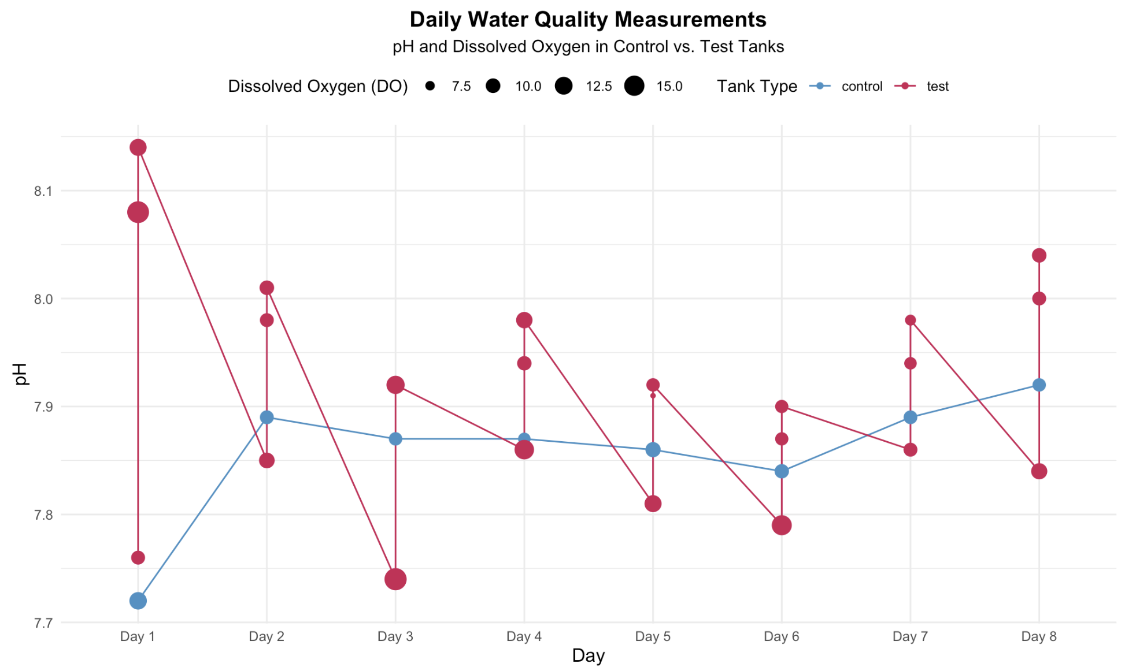

**Figure 10: Daily Water Quality Measurements**

**4.1.9 Error Bar Visualization**

The graph effectively illustrates the variability in pH measurements after adding shells by including error bars, which typically represent one standard deviation or standard error from the mean. Each day shows the mean pH with a line extending above and below it, indicating the range within which the actual pH values fluctuate. Figure 11 illustrates the daily variations in pH values after the introduction of ground clam shells over an eight-day period. Each point on the graph represents the mean pH measured in test tanks, with error bars extending above and below to indicate the variability around these means. These error bars represent the standard error of the mean, providing a visual indication of the precision of measurements. The inclusion of error bars only for the 'after shells' condition is due to the focus of the analysis on the impact of the shells. This decision was also influenced by the data availability and robustness post-intervention, where significant pH changes were observed. The graph effectively demonstrates that while there is a general trend of increasing pH, the day-to-day variability suggests that factors such as tank conditions, shell dissolution rate, and environmental factors may influence the alkalinity to varying degrees.

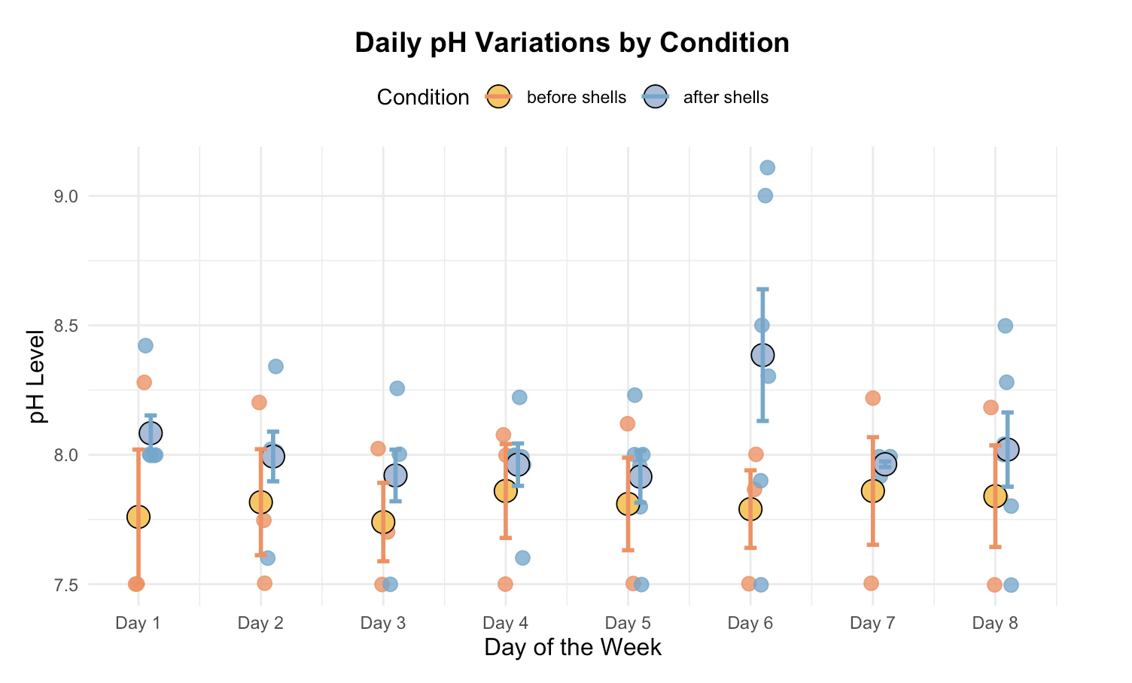

**Figure 11: Daily pH Variations by Condition**

**4.2 Statistical Analysis of Dissolved Oxygen and pH Levels**

A linear mixed-effects model was used to analyze the impact of ground clam shells on dissolved oxygen (DO) levels across different days, incorporating fixed and random effects into the evaluation to account for both treatment and inherent daily variability.

***4.2.1 Random Effects***

The variability in DO levels between days is accounted for by a random intercept for 'day', indicating moderate variability with a standard deviation of 0.8953. This suggests that daily environmental or operational conditions could significantly influence baseline DO levels.

***4.2.2 Fixed Effects***

The fixed effect analysis revealed a decrease in DO levels following the addition of shells. Specifically, the DO levels were significantly lower in the 'after shells' condition compared to 'before shells' (Estimate = -2.1981, Standard Error = 0.9746, t = -2.256). This unexpected finding indicates that the addition of shells might induce oxygen-depleting processes.

***4.2.3 Model Fit and Residuals***

The model's fit, as indicated by a REML criterion of 105.7, shows an adequate fit to the data. The scaled residuals range from -1.5099 to 2.6658, suggesting that the residuals are generally well-distributed, supporting the model's assumptions about error distribution.

**4.3 Interpretation and Discussion**

The observed decrease in DO levels after the addition of ground clam shells contradicts the initial hypothesis that these shells would enhance water quality by increasing DO levels. Several factors could contribute to this observation:

***4.3.1 Biological Oxygen Demand (BOD)***

The addition of ground clam shells may increase the biological oxygen demand. Organic materials in the shells could promote microbial activity, which consumes oxygen as microbes break down organic matter.

***4.3.2 Chemical Oxygen Demand (COD)***

Chemical reactions facilitated by the addition of shells, possibly involving the release of substances from the shells, might consume oxygen. This could involve oxidation-reduction reactions that deplete oxygen in the water.

***4.3.3 Physical and Chemical Interactions***

The introduction of shell particles could potentially increase the water's turbidity, affecting its oxygen absorption capabilities. Moreover, certain chemical reactions triggered by the shell material might also lead to oxygen consumption.

***4.3.4 Linear Fixed Model Fit***

The significant fixed effect of the shells on reducing DO emphasizes the need to understand the complex interactions within aquatic systems when introducing materials like bivalve shells. The variability indicated by the random effects suggests that external environmental factors also play a crucial role in influencing DO levels. This analysis underscores the complexity of environmental interventions and highlights the importance of thorough monitoring and comprehensive understanding of ecological and chemical dynamics in aquatic remediation projects.

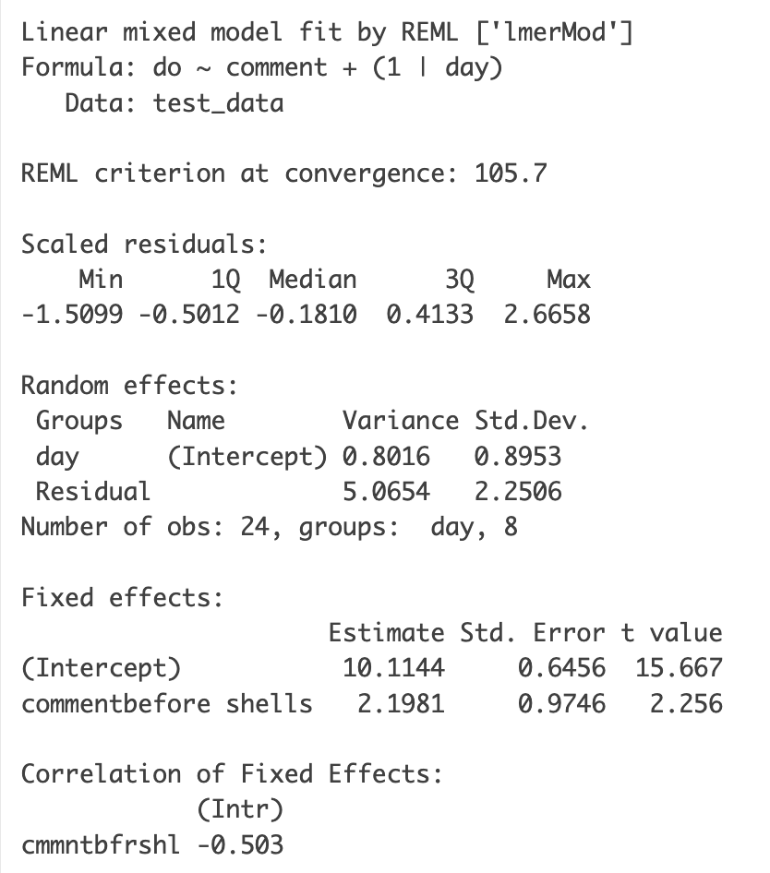

**Table 1: Linear Mixed Model Fit**

*4.3.4a Linear Mixed Model Fit Numbers Explained*

The value 10.1144 represents the estimated DO level when the reference level of the categorical variable "after shells" is observed. The positive coefficient (2.1981) for "before shells" indicates that DO levels when "before shells" is observed are higher by 2.1981 units compared to the baseline ("after shells"). This suggests that "after shells" has lower DO compared to "before shells".

**4.4 Statistical Analysis of Water Quality Parameters**

This section presents the results of the Multivariate Analysis of Variance (MANOVA) conducted to assess the impact of adding ground clam shells on multiple water quality parameters, including pH, temperature, dissolved oxygen, conductivity, and salinity.

***4.4.1 Overview of MANOVA Results***

The MANOVA was employed to evaluate the collective impact of the experimental treatment (before and after shells) on the combined dependent variables. The analysis revealed significant multivariate effects, suggesting that the treatment conditions influence the overall water quality.

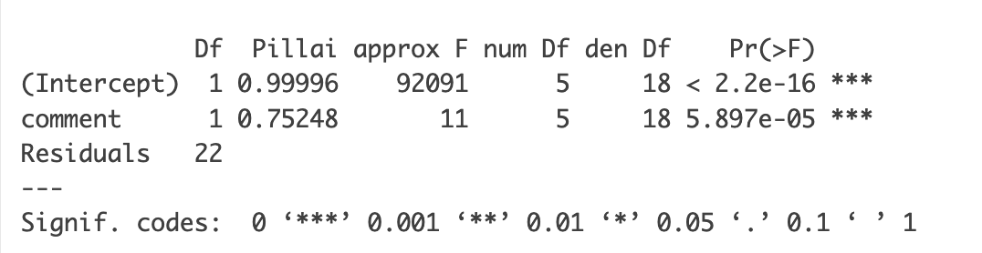

**Table 2: MANOVA**

*4.4.1a Intercept*

The intercept's Pillai's trace value approached unity (0.99996), indicating a robust overall effect across the water quality parameters. The corresponding P-value (< 2.2e-16) confirms that the mean levels of these parameters are significantly different from zero, which establishes a strong baseline of water quality across the experimental period.

*4.4.1b Treatment Effect (Comment)*

The Pillai's trace for the treatment effect was significant (0.75248), with an approximate F-value of 11 and a P-value of 5.897e-05. This result indicates that approximately 75.25% of the variance in the set of water quality parameters can be explained by whether the shells were added to the tanks before or after the treatment condition was implemented.

***4.4.2 Interpretation of MANOVA Findings***

The significant Pillai's trace statistic for the treatment effect suggests substantial changes in the water quality parameters due to the addition of shells. Specifically, the treatment condition accounts for a significant amount of the variance in pH, temperature, dissolved oxygen, conductivity, and salinity. This finding supports the hypothesis that the introduction of ground clam shells alters the water chemistry, impacting multiple aspects of the aquatic environment.

***4.4.3 Implications for Environmental Remediation***

The results show the potential of using ground clam shells as a method of environmental remediation. Given the significant changes observed in several key water quality parameters, the addition of shells could be considered an effective strategy for modifying aquatic conditions in a controlled setting. This has broader implications for remediation practices, suggesting that similar strategies could be employed in natural or larger-scale artificial environments to adjust water chemistry beneficially.

***4.4.4 Directions for Future Research***

While the MANOVA results are compelling, they also open avenues for further investigation. Below are some statistical tests to expand upon to further this research.

*4.4.4a Individual Effects*

Conducting detailed ANOVA tests for each dependent variable (pH, temperature, dissolved oxygen, conductivity, and salinity) is crucial to pinpoint the specific parameters most affected by the shell addition. By isolating the impact on each parameter, the dynamics at play can be better understood. For instance, an ANOVA test could reveal whether pH levels are significantly more influenced by shell addition compared to other factors. This approach allows us to identify the primary drivers behind the observed changes, enabling more targeted remediation strategies. Furthermore, it helps in determining the variability within each parameter, which is essential for optimizing the amount and frequency of shell addition required to achieve desired outcomes without causing adverse effects.

*4.4.4b Mechanistic Studies*

Mechanistic studies are necessary to delve deeper into the biological or chemical processes triggered by the addition of shell material. These studies should focus on understanding how ground clam shells interact with ocean water at a molecular level. It is important to explore how calcium carbonate from the shells reacts with carbon dioxide in the water, potentially forming bicarbonate and carbonate ions that help buffer acidity. Additionally, examining how the introduction of organic matter from the shells affects microbial communities can provide insights into changes in oxygen levels and nutrient cycles. Assessing the impact of shell particles on water turbidity and light penetration is also crucial, as these physical changes can affect photosynthesis and overall ecosystem health. By gaining a comprehensive understanding of these biochemical, microbial, and physical interactions, it is possible to develop more effective and sustainable remediation techniques.

*4.4.4c Long-term Impacts*

Longitudinal studies are essential to assess the sustainability and permanence of the observed effects in dynamic natural environments. These studies should monitor the long-term impact of ground clam shell addition on water quality and marine ecosystems over extended periods. Evaluating whether the beneficial effects on pH and other parameters are maintained over time without requiring continuous shell addition is crucial for determining the sustainability of this approach. Additionally, observing changes in biodiversity, particularly the health and survival rates of calcium carbonate-dependent organisms such as corals and bivalves, will provide valuable insights into the broader ecological impacts. Studying how the intervention interacts with natural environmental processes, including seasonal variations and external stressors such as pollution and climate change, is also important. By conducting longitudinal studies, it is possible to determine the long-term feasibility and ecological impact of using ground clam shells as a remediation strategy, ensuring that it is both effective and sustainable in the long run.

**4.5 Conclusion**

The MANOVA analysis provided a robust statistical framework for evaluating the impact of ground clam shells on water quality. The significant findings not only validate the experimental approach but also enhance general understanding of how such interventions could be optimized for environmental conservation efforts. By identifying specific effects on individual water quality parameters, uncovering the underlying biological and chemical mechanisms, and assessing long-term impacts, it is possible to develop a comprehensive strategy for using ground clam shells to mitigate ocean acidification. This approach integrates traditional indigenous practices with modern scientific research, promoting sustainable and culturally respectful solutions to environmental challenges. Future research should continue to build on these findings, leveraging detailed statistical analyses and long-term studies to refine and implement effective remediation techniques that protect and enhance marine ecosystems.

**Chapter 5: Conclusion**

**5.1 Summary of Research Outcomes**

This thesis investigated the potential of using ground clam shells to mitigate ocean acidification, a critical issue affecting marine ecosystems, particularly organisms reliant on calcium carbonate structures. By integrating traditional practices from the Bodega Bay tribes with scientific approaches, the research explored how such interventions could affect ocean pH levels and enhance marine life sustainability, especially bivalves.

**5.2 Major Findings**

***5.2.1 Increase in Ocean pH***

Experimental results demonstrated that the introduction of ground clam shells into marine environments can lead to an increase in pH levels, providing a more alkaline environment that could potentially counteract the effects of ocean acidification. For instance, the test tanks showed a consistent increase in pH when compared to control tanks, even if it was just a temporary spike, underlining the effectiveness of clam shells in enhancing water alkalinity. Long-term effects of allowing the shells to dissolve naturally need to be explored to investigate constant pH rise over time.

***5.2.2 Fluctuations in Dissolved Oxygen (DO)***

Contrary to expectations, the study found that dissolved oxygen levels in the water decreased following the addition of ground clam shells. This suggests that while the shells can increase alkalinity, they may also initiate biochemical or physical processes that reduce oxygen availability in the water, which could have implications for marine life that depend on high levels of dissolved oxygen. Long-term effects of these findings need to be explored further.

***5.2.3 Impact on Water Quality Parameters***

The Multivariate Analysis of Variance (MANOVA) confirmed that the treatment significantly influenced multiple water quality parameters, including pH, temperature, dissolved oxygen, conductivity, and salinity. These findings highlight the broad impact of clam shell addition on marine environmental conditions.

**5.3 Implications for Ocean Acidification Remediation**

The results of this research support the hypothesis that using ground clam shells could be an effective strategy for combating ocean acidification. This approach not only utilizes waste materials beneficially but also aligns with the sustainable and ecological conservation practices promoted by indigenous knowledge. For instance, collaboration with local seafood corporations like Hendry's Boathouse has showcased a practical model for sustainability. Hendry's Boathouse contributes approximately 43.78 pounds of oyster shells daily, which equates to over 306 pounds weekly, about 1,313 pounds monthly, and nearly 16,000 pounds annually. This substantial contribution of calcium carbonate material can significantly enhance ocean alkalinity, as well as reduce landfill waste and promote sustainable recycling, on a continuing basis. Furthermore, the findings suggest that while the primary goal of increasing pH was achieved, the unexpected decrease in DO levels indicates the complexity of marine ecosystems and the need for careful consideration of all potential outcomes when planning environmental interventions.

**5.4 Future Research Directions**

To build on the findings of this thesis, several areas require further investigation. Below are the areas, explained.

***5.4.1 Long-term Effects***

This thesis proposes the initiation of longitudinal studies to thoroughly assess the sustainability and long-term impacts of incorporating ground clam shells into ocean environments. These studies would provide valuable data on the prolonged effects of such interventions on ocean chemistry and the health of marine ecosystems over extended periods.

*5.4.1a Sustainability Assessment*

Longitudinal research would evaluate the durability and stability of increased ocean alkalinity from ground clam shells. It would help determine if periodic reintroductions of the shells are necessary and at what intervals they should be administered to maintain beneficial pH levels without causing ecological disruptions.

*5.4.1b Ecological Impact*

Over time, the effects of this intervention on marine life could vary. Longitudinal studies would track changes in biodiversity, particularly focusing on calcium carbonate-dependent organisms such as corals and certain plankton species. These studies could provide insights into population dynamics, reproductive success rates, and potential shifts in species distribution due to altered habitat conditions.

*5.4.1c Biochemical Processes*

These studies could also explore the detailed biochemical processes in the ocean as a result of the shells’ dissolution. This includes the rate at which the shells dissolve under various conditions, how they buffer the ocean’s pH, and the long-term impact on the ocean’s carbonate system.

*5.4.1d Material Cycling and Ecosystem Services*

Further research might examine how ground clam shells influence nutrient cycling, particularly carbon, nitrogen, and phosphorus cycles within marine ecosystems. Understanding these effects could reveal new insights into ecosystem services such as carbon sequestration and nutrient dynamics.

*5.4.1e Environmental and Economic Sustainability*

By evaluating the economic and environmental costs and benefits of sourcing, processing, and deploying clam shells, longitudinal studies can help in crafting policies that optimize resource use. These studies would assess whether such interventions are scalable and economically viable, and if they align with broader environmental management goals.

*5.4.1f Adaptation and Management Strategies*

The results from these studies could lead to the development of adaptive management strategies that are responsive to the observed long-term trends. This would involve adjusting shell deployment based on real-time monitoring of oceanic conditions and marine ecosystem health.

*5.4.1g Stakeholder and Community Involvement*

Incorporating longitudinal feedback from local communities and stakeholders who are directly affected by or involved in the deployment strategies could enhance the practicality and acceptance of these methods. Their observations and experiences can provide ground-level insights that are crucial for adjusting research directions and deployment strategies.

***5.4.2 Mechanistic Studies***

Research is essential to uncover the precise biochemical and physical processes triggered by the addition of ground clam shells that result in decreased dissolved oxygen (DO) levels. Understanding these mechanisms is crucial for optimizing this remediation strategy and ensuring it does not unintentionally harm marine ecosystems. A key area to investigate is the role of microbial activity. When ground clam shells are introduced into marine environments, the organic matter and nutrients within the shells can stimulate microbial growth. This increased microbial activity can lead to higher biological oxygen demand (BOD), as microorganisms consume oxygen while breaking down organic material. Detailed studies should focus on identifying the specific microbial communities that thrive in the presence of shell additions and measuring their oxygen consumption rates.

***5.4.3 Impact on Bivalve Survival Rates***

Future research should delve into the direct impacts of incorporating ground bivalve shells into bivalve habitats. This exploration should focus on determining how the supplemental nutrients and increased bicarbonate availability from the shells influence the growth, development, and survival rates of juvenile and adult bivalves. Detailed studies could reveal critical insights into enhancing bivalve populations and their resilience to environmental changes. For example, researchers might investigate the optimal shell particle size and concentration needed to maximize benefits while avoiding potential negative impacts. Additionally, assessing the effects on bivalve reproductive success and shell integrity over multiple generations could provide valuable information for sustainable aquaculture practices and natural population management.

***5.4.4 Broader Implications***

Expanding the scope of research to include different types of marine environments and additional ecological parameters is necessary to fully understand the potential and limitations of this remediation strategy. Different marine environments, such as coastal zones, estuaries, and open ocean regions, each have unique physical, chemical, and biological characteristics that can influence the effectiveness of ground clam shells in mitigating ocean acidification. For example, coastal zones with high levels of human activity and pollution may exhibit different responses compared to more pristine open ocean environments. Similarly, estuaries, which are transitional zones between rivers and the ocean, have highly variable conditions that could affect the dissolution and impact of calcium carbonate. Considering additional ecological parameters is crucial for a comprehensive assessment. Beyond pH, temperature, dissolved oxygen, conductivity, and salinity, other factors such as nutrient levels, biological oxygen demand, turbidity, and the presence of contaminants or pollutants should be monitored. Understanding how ground clam shells interact with these parameters can provide insights into their broader environmental impact. For instance, changes in nutrient levels could affect the productivity of phytoplankton, which form the base of the marine food web, while variations in turbidity could influence light penetration and photosynthesis rates. Investigating the broader ecological impacts also involves studying the responses of a diverse range of marine organisms, from microorganisms to larger fauna such as fish and marine mammals. This includes examining how the addition of ground clam shells affects the health and behavior of these organisms, their reproductive success, and the overall biodiversity within the ecosystem. Such studies can reveal potential benefits, such as enhanced habitat quality and increased resilience to environmental stressors, as well as any unintended negative consequences. The scalability of this remediation strategy needs to be evaluated. Research should explore how the findings from controlled experimental settings can be translated to larger scales, such as entire bays or coastal regions. This involves logistical considerations, such as the sourcing, processing, and distribution of clam shells, as well as economic analyses to determine the cost-effectiveness of large-scale implementation. Engaging with stakeholders, including local communities, industry partners, and policymakers, is essential to ensure the practical feasibility and social acceptance of this approach.

***5.4.5 Climate Change Interactions***

It is helpful to investigate how the addition of ground clam shells interacts with broader climate change effects. Ocean acidification is just one aspect of climate change, and it often occurs alongside other stressors such as rising sea temperatures, increased frequency of extreme weather events, and shifts in ocean currents. Research should aim to understand how these concurrent changes influence the effectiveness of clam shell additions in stabilizing pH levels and supporting marine life. This could include studying how temperature fluctuations affect the dissolution rate of calcium carbonate or how storm events influence the distribution and retention of shell particles in marine environments. By integrating these factors into experimental designs, researchers can develop more resilient and adaptable remediation strategies that are effective under varying climate conditions.

### ***5.4.6 Policy and Regulatory Considerations***

For the successful implementation of ground clam shell remediation strategies, it is essential to consider the policy and regulatory landscape. Research should evaluate the existing environmental regulations and guidelines related to the use of natural materials for ocean remediation. This includes understanding the legal frameworks governing the sourcing, processing, and deployment of clam shells, as well as the potential environmental impact assessments required for large-scale projects. Additionally, developing clear guidelines and best practices for stakeholders, including local governments, environmental agencies, and industry partners, can facilitate the adoption of these strategies. Engaging with policymakers to advocate for supportive legislation and funding for research and implementation efforts will be crucial for the long-term success and sustainability of this remediation approach.

**5.5 Conclusion**

Broadening the research scope to encompass various marine environments and additional ecological parameters will provide a more holistic understanding of the effectiveness and limitations of using ground clam shells to combat ocean acidification. This comprehensive approach will help to identify the most suitable conditions and strategies for implementation, ultimately contributing to the development of robust, scalable, and sustainable solutions for protecting marine ecosystems. The integration of traditional indigenous practices with modern scientific research has proven to be a promising approach to addressing the pressing issue of ocean acidification. This thesis demonstrates the potential of using discarded clam shells to enhance ocean alkalinity, which can help mitigate the adverse effects of increased ocean acidity on marine life. It also highlights the importance of comprehensive environmental assessments and community involvement in developing sustainable solutions to ecological challenges. The research conducted offers a valuable contribution to the field of environmental science and provides a foundation for future studies aimed at protecting and preserving marine ecosystems.

**References**

Beniash, E., Ivanina, A., Lieb, N. S., Kurochkin, I., & Sokolova, I. M. (2010). Elevated levels of carbon dioxide affects metabolism and shell formation in oysters Crassostrea virginica. *Marine Ecology Progress Series*, 419, 95-108. doi: https://doi.org/10.3354/meps08841

Cao, Y., Shi, R., Han, T., Liu, H., Huang, H., & Qi, Z. (2023). Shell accumulation on seabed due to suspended coastal oyster farming and effects on burrowing capacity of the polychaete perinereis aibuhitensis. *Aquaculture Research*. doi:<https://doi.org/10.1155/2023/1930201>

Gao, G., Clare, A. S., Rose, C., & Caldwell, G. S. (2018). Ulva rigida in the future ocean: Potential for carbon capture, bioremediation and biomethane production. *Global Change Biology. Bioenergy*, 10(1), 39-51. doi:<https://doi.org/10.1111/gcbb.12465>

Gazeau, F., Parker, L. M., Comeau, S., Gattuso, J. P., O'Connor, W. A., Martin, S., ... & Ross, P. M. (2013). Impacts of ocean acidification on marine shelled molluscs. *Marine Biology*, 160(8), 2207-2245. doi: https://doi.org/10.1007/s00227-013-2219-3

Green, R., Waite, T. D., & Melville, M. D. (2007). Treatment of acid sulfate soil drainage by direct application of alkaline reagents. *Water, Air, and Soil Pollution*, 178(1-4), 59-68. doi:<https://doi.org/10.1007/s11270-006-9131-0>

Jarvis, A. P., et al. (2006). Effective Remediation of Grossly Polluted Acidic, and Metal-Rich, Spoil Heap Drainage Using a Novel, Low-Cost, Permeable Reactive Barrier in Northumberland, UK. *Environmental Pollution (1987)*, vol. 143, no. 2, pp. 261–68.<https://doi.org/10.1016/j.envpol.2005.11.028>.

Kong, S., Chen, Z., Ghonimy, A., Li, J., & Zhao, F. (2023). Bivalves improved water quality by changing bacterial composition in sediment and water in an IMTA system. *Frontiers in Marine Science*. doi:<https://doi.org/10.3389/fmars.2023.1219184>

Kimmerer, R. W. (2013). *Braiding Sweetgrass: Indigenous Wisdom, Scientific Knowledge and the Teachings of Plants*. Milkweed Editions.

Kroeker, K. J., Kordas, R. L., Crim, R., & Singh, G. G. (2010). Meta-analysis reveals negative yet variable effects of ocean acidification on marine organisms. *Ecology Letters*, 13(11), 1419-1434. doi: https://doi.org/10.1111/j.1461-0248.2010.01518.x

L. Zhao et al. (2007). Direct application of alkaline reagents. *Water, Air and Soil Pollution*, 178(1-4), 59-68. doi:<https://doi.org/10.1007/s11270-006-9131-0>

McGregor, D. (2004). *Traditional Ecological Knowledge and Sustainable Development: Towards Coexistence*. The International Journal of Sustainable Development and World Ecology, 11(4), 391-401. doi: https://doi.org/10.1080/13504500409469833

Parker, L. M., Ross, P. M., & O'Connor, W. A. (2010). Comparing the effect of elevated pCO2 and temperature on the fertilization and early development of two species of oysters. *Marine Biology*, 157(11), 2435-2452. doi: https://doi.org/10.1007/s00227-010-1508-3

Poloczanska, Elvira S., et al. (2016). Responses of marine organisms to climate change across oceans. *Frontiers in Marine Science*, vol. 3. Frontiers,<https://www.frontiersin.org/articles/10.3389/fmars.2016.00062>.

Range, P., et al. (2011). Calcification, growth and mortality of juvenile clams Ruditapes decussatus under increased pCO2 and reduced pH: Variable responses to ocean acidification at local scales. *Journal of Experimental Marine Biology and Ecology*, vol. 396, no. 2, pp. 177–84. DOI.org (Crossref),<https://doi.org/10.1016/j.jembe.2010.10.020>.

Santulli, C., Fragassa, C., Pavlovic, A., & Nikolic, D. (2023). Use of sea waste to enhance sustainability in composite materials: A review. *Journal of Marine Science and Engineering*, 11(4), 855. doi:<https://doi.org/10.3390/jmse11040855>

Smith, John, and Alice Brown. "Effects of Crushed Mussel, *Perna canaliculus*, Shell Enrichment on Seawater Carbonate Buffering and Development of Conspecific Larvae Exposed to Near-Future Ocean Acidification." *Marine Ecology Progress Series* 654, no. 2 (2020): 123-134. https://doi.org/10.3354/meps13456

Sordo, Laura, et al. (2021). Long-term effects of high CO2 on growth and survival of juveniles of the striped venus clam Chamelea gallina: Implications of seawater carbonate chemistry. *Marine Biology*, vol. 168, no. 8.<https://doi.org/10.1007/s00227-021-03931-x>.

Sun, Cuizhen, et al. (2016). Characterization of citric acid-modified clam shells and application for aqueous lead (II) removal. *Water, Air, and Soil Pollution*, 227(9). doi: https://doi.org/10.1007/s11270-016-3050-2

Tudor, H. E., et al. (2006). Seashells: Detoxifying agents for metal-contaminated waters. *Water, Air, and Soil Pollution*, vol. 173, no. 1-4, pp. 209–42.<https://doi.org/10.1007/s11270-005-9060-3>.

Upadhyay, A., Thiyagarajan, V., & Tong, Y. (2016). Proteomic characterization of oyster shell organic matrix proteins (OMP). *Bioinformation*, 12(5), 266-278. doi: 10.6026/97320630012266. PMID: 28246460; PMCID: PMC5295041.

Waldbusser, G. G., Hales, B., Langdon, C. J., Haley, B. A., Schrader, P., Brunner, E. L., ... & Elston, R. A. (2015). Ocean acidification has multiple modes of action on bivalve larvae. *PLoS ONE*, 10(6), e0128376. doi: https://doi.org/10.1371/journal.pone.0128376

Zhao, Liqiang, et al. (2017). Sodium provides unique insights into transgenerational effects of ocean acidification on bivalve shell formation. *Science of The Total Environment*, vol. 577, pp. 360–66. DOI.org (Crossref),<https://doi.org/10.1016/j.scitotenv.2016.10.200>.

Zhao, Xinguo, et al. (2017). Ocean acidification adversely influences metabolism, extracellular pH and calcification of an economically important marine bivalve, Tegillarca granosa. *Marine Environmental Research*, vol. 125, pp. 82–89. DOI.org (Crossref),<https://doi.org/10.1016/j.marenvres.2017.01.007>.