**Katerina Chinnappan, Jakrarin Simrakut, Traik Zeid, Nathan Monahelis**

**CMPS 109 - Final Project Phase 1 Documentation**

**class Operator:**

Load(string sriFile) - The load method will require a SRI file as a parameter. It will then parse the SRI file line by line adding rules or facts into their respective databases.

Dump(string sriFile) - The dump method will require a SRI file as a parameter. It will access the current facts and rules defined in the runtime KB and RB and then save them to the SRI file given.

Fact(string fact) - This will invoke a KB method, will describe below.

Rule(string rule) - This will invoke a RB method, will describe below.

Inference(string query) - This will print the results of the given query to the terminal. Inference will have an option to declare the results of the query under a fact with a given variable name.

Drop() - This will invoke a KB/RB method depending on what is being dropped.

**class KB : public Operator**

Vector<T> - A vector to hold all of the initialized facts.

defineFact(string fact) - This will add fact to our vector.

dropFact(string fact) - This delete fact from our vector.

**class RB : public Operator**

Vector<T> - A vector to hold all of the initialized facts.

defineRule(string rule) - This will add rule to our vector.

dropRule(string rule) - This delete rule from our vector.

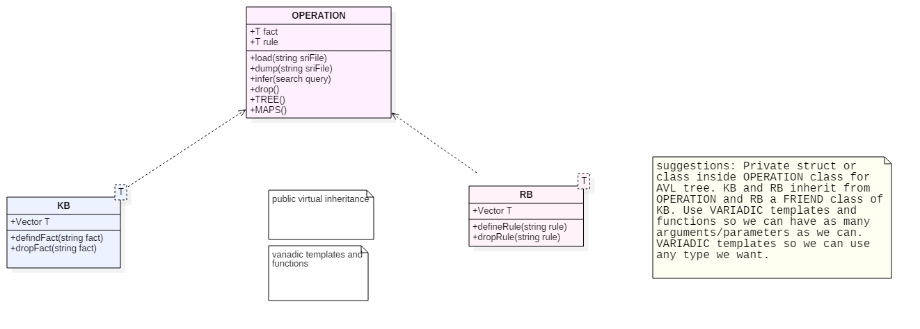**CLASS DIAGRAM**

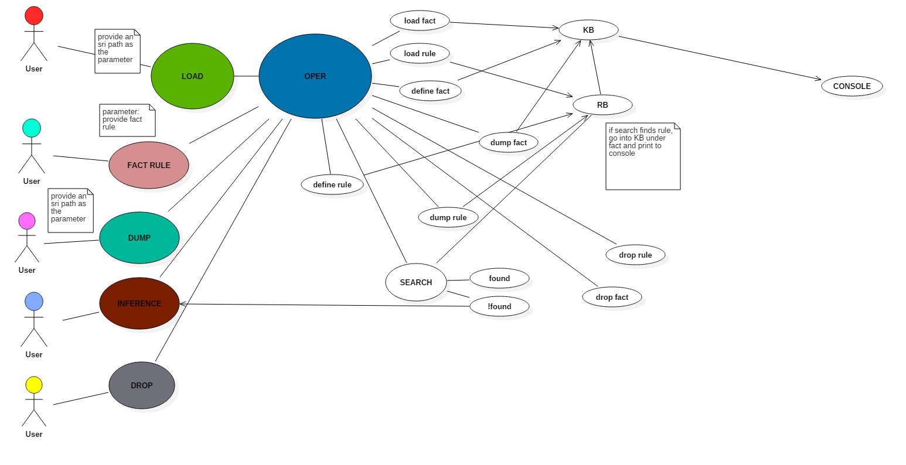**USE CASE DIAGRAM**

**SEQUENCE DIAGRAM**

**DROP**

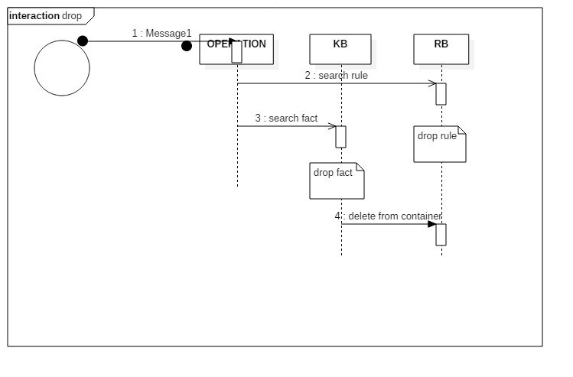

**INFERENCE**

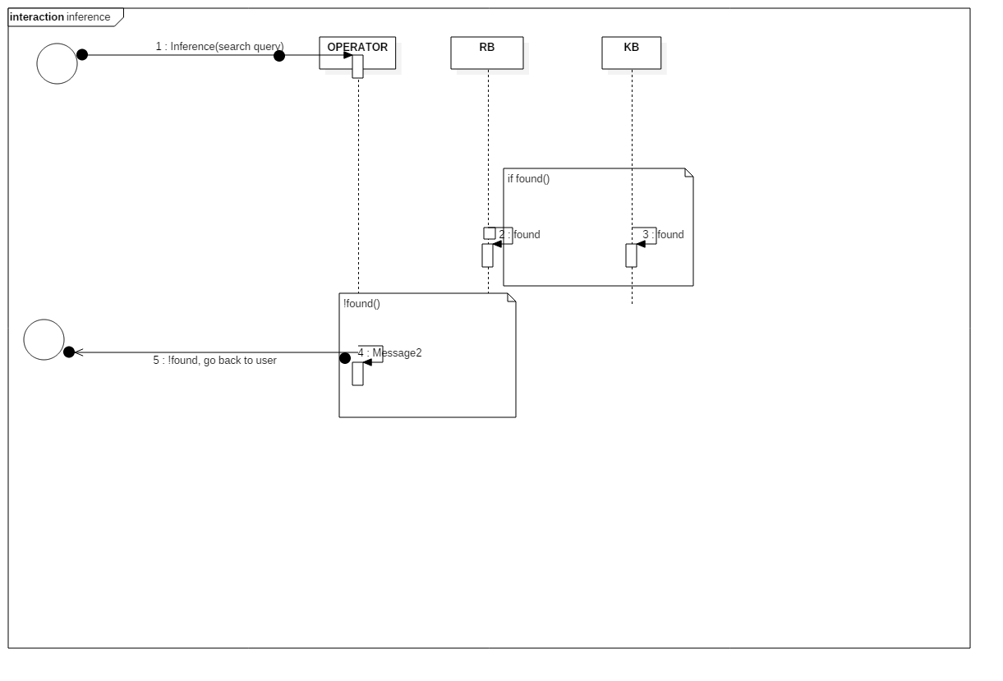

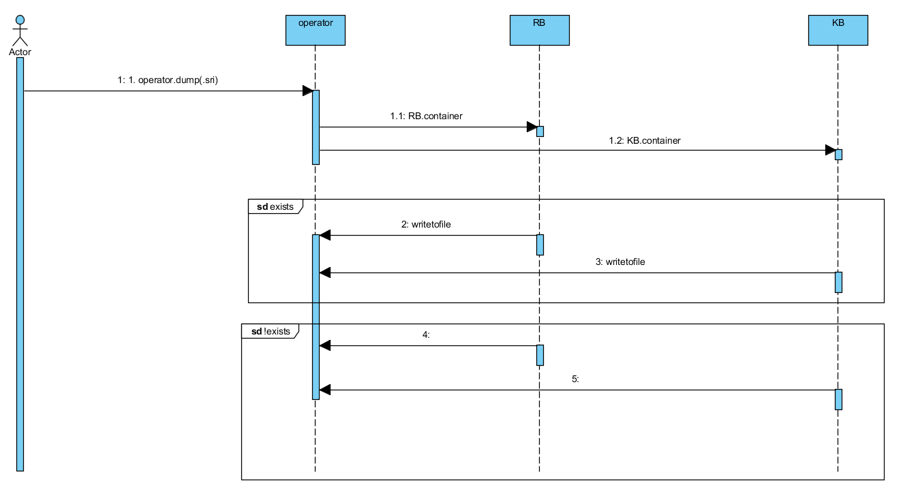**DUMP**

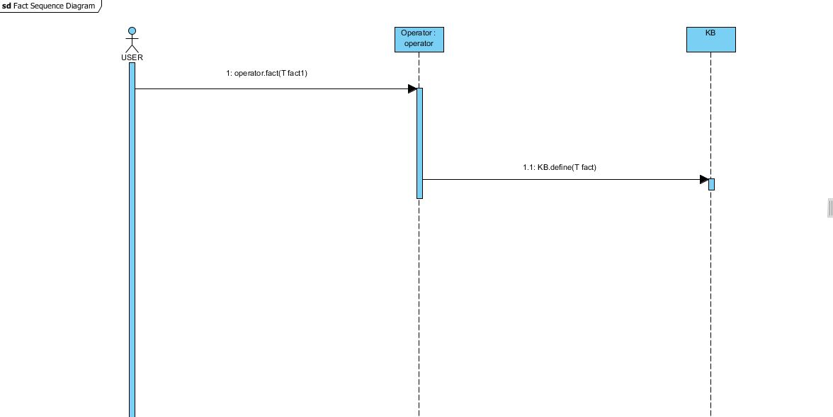**DEFINE FACT**

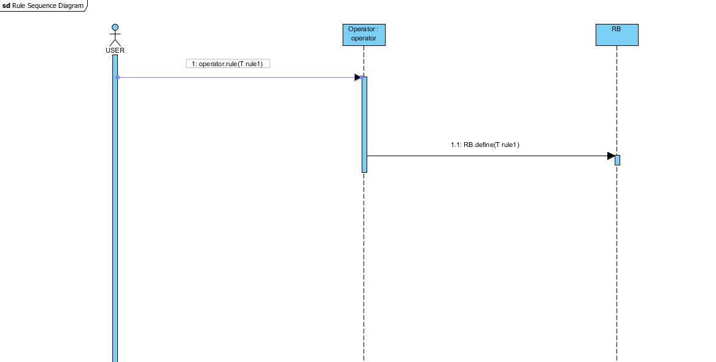**DEFINE RULE**

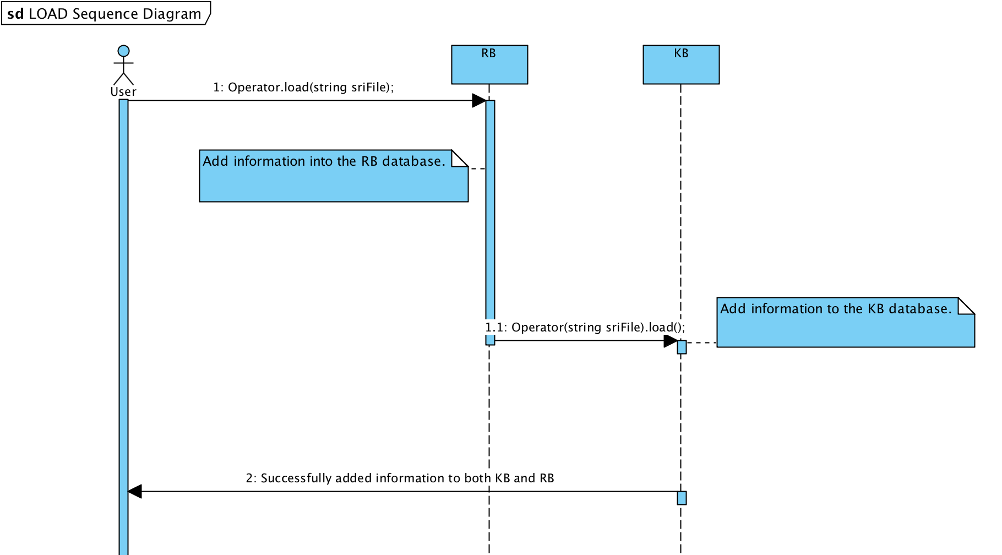**LOAD RULE/FACT**