Table CITY

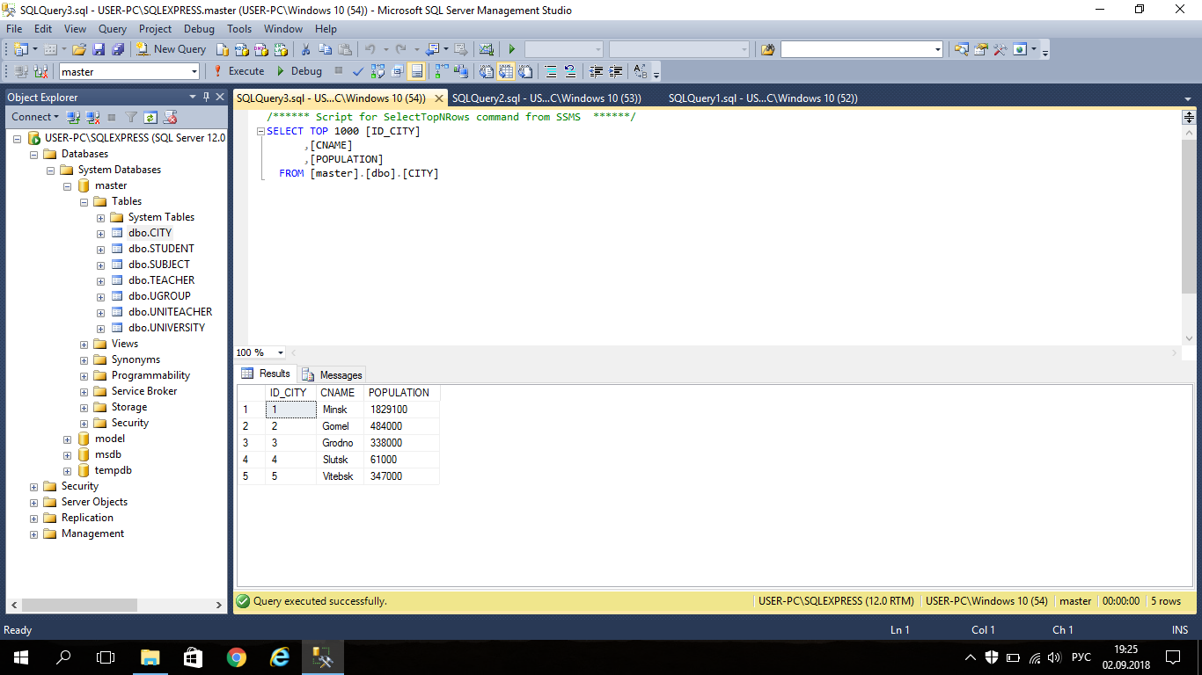

SELECT COUNT (POPULATION)

FROM CITY

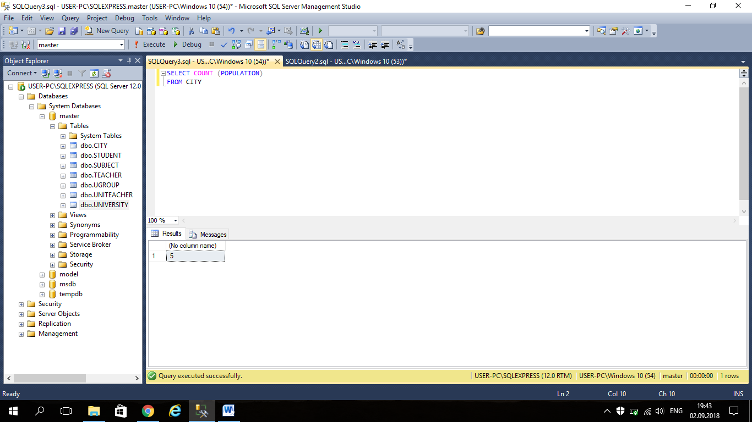

SELECT MAX (POPULATION)

FROM CITY

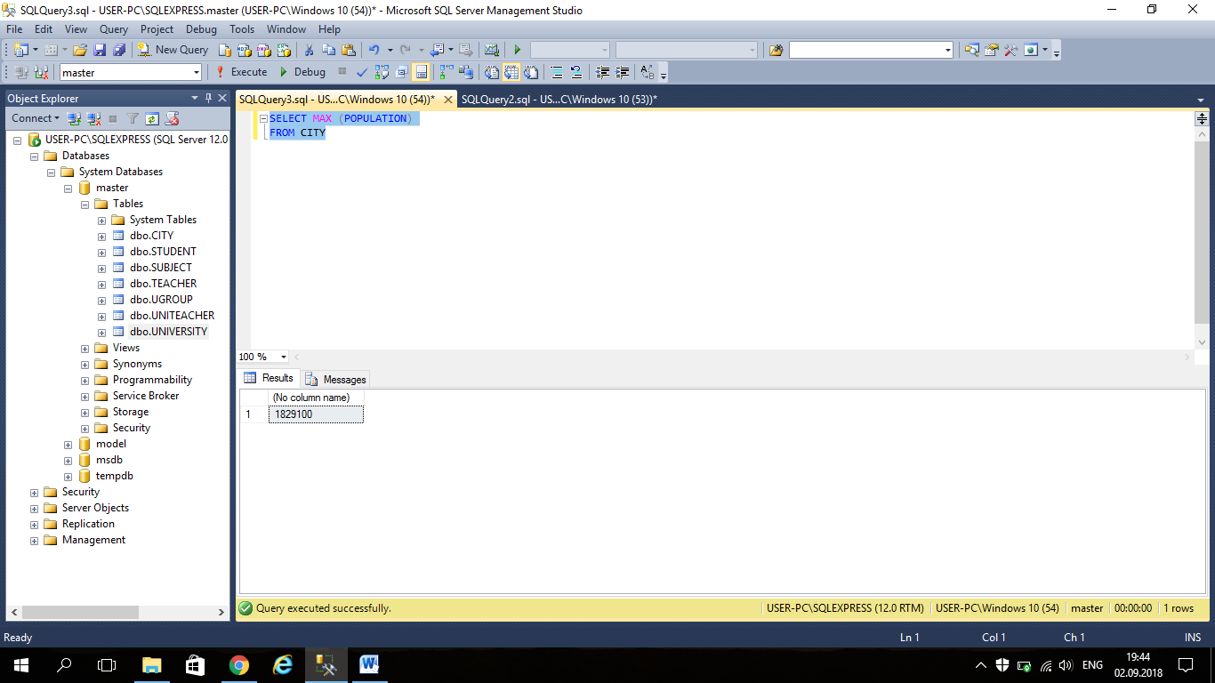

SELECT AVG (POPULATION)

FROM CITY

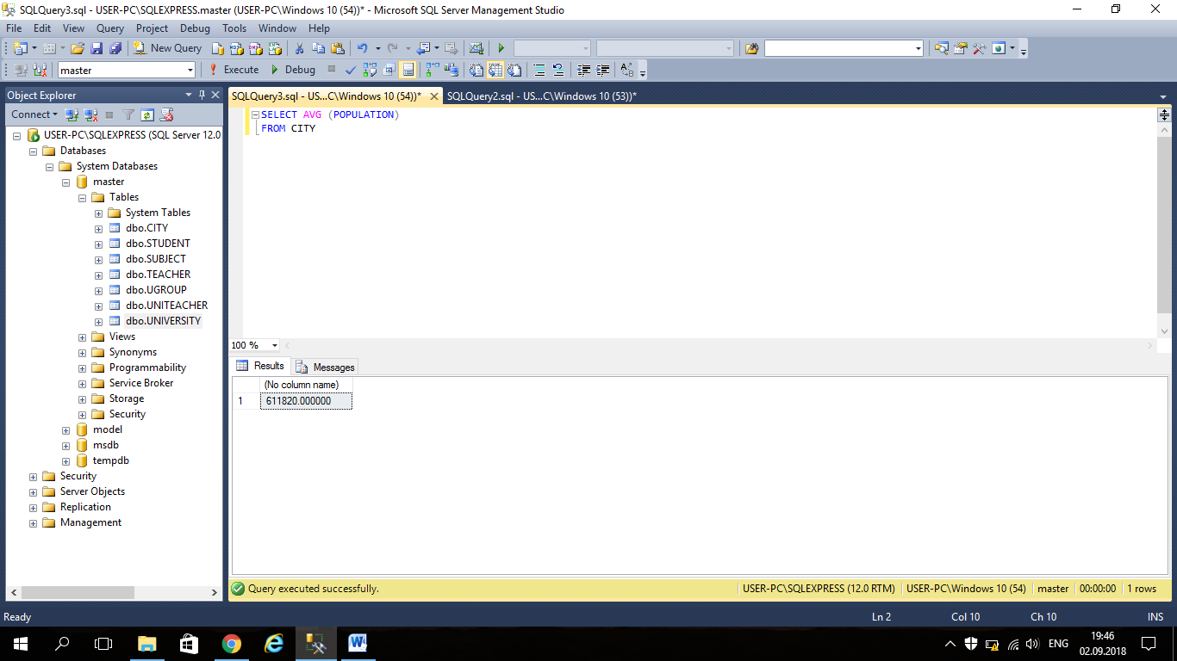

Table UNIVERSITY

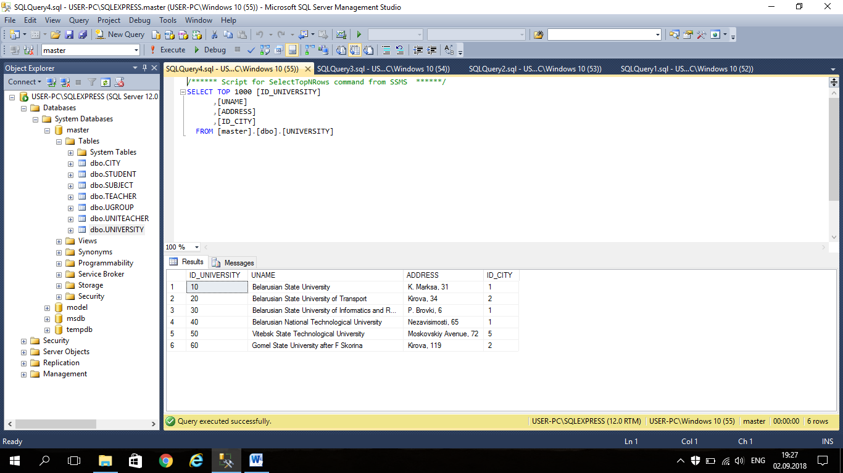

SELECT *

FROM CITY

LEFT JOIN UNIVERSITY ON CITY.ID_CITY=UNIVERSITY.ID_CITY

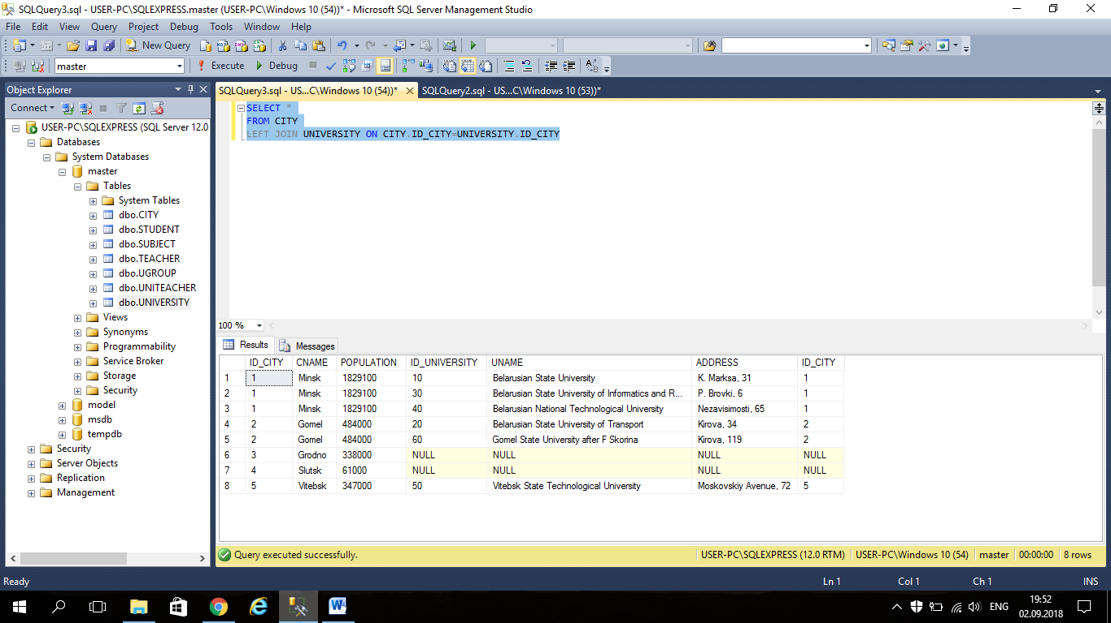

SELECT *

FROM CITY

RIGHT JOIN UNIVERSITY ON CITY.ID_CITY=UNIVERSITY.ID_CITY

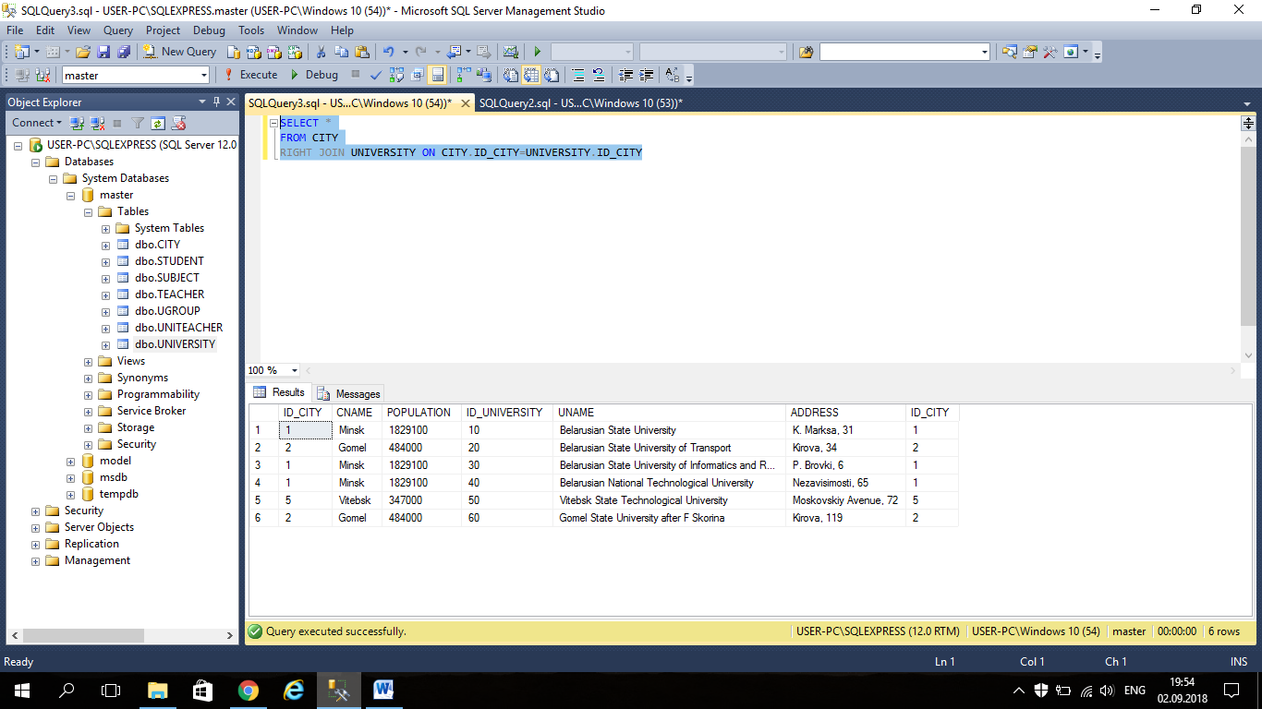

SELECT *

FROM CITY

INNER JOIN UNIVERSITY ON CITY.ID_CITY=UNIVERSITY.ID_CITY

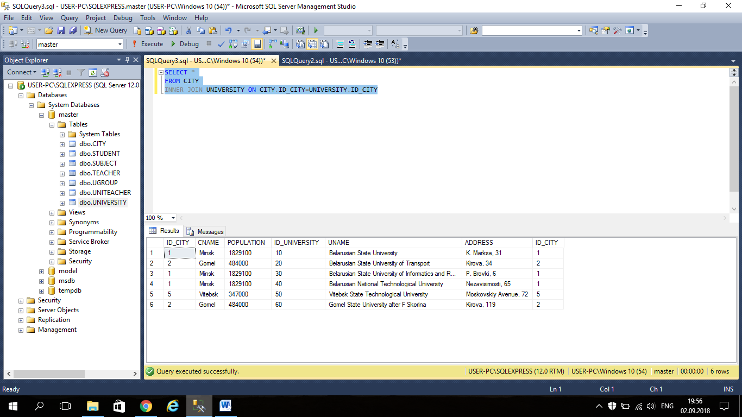

SELECT *

FROM CITY

FULL JOIN UNIVERSITY ON CITY.ID_CITY=UNIVERSITY.ID_CITY

