ProtoPos — Change Report
This document summarises all changes made to the ProtoPos PRO-seq analysis pipeline during the February 2026 review and refactoring session.

1. Bug Fixes

1.1 Pol II position logic was swapped (Protopos.py)
Severity: High — all Pol II positions were shifted by the full read length.
The original code used the 3′ end of the aligned read (reference_end – 1 for forward reads, reference_start for reverse reads). For standard PRO-seq, the Pol II active site corresponds to the 5′ end of the sequencing read (= 3′ end of the nascent RNA). The logic was swapped:
- is_reverse → reference_end – 1 (5′ of read in seq orientation)
- not reverse → reference_start (5′ of read in seq orientation)
The function was renamed from three_prime_position() to pol2_position() to clarify its biological meaning.

1.2 No UMI deduplication (proseqanalysis.sh)
Severity: High — PCR duplicates inflated the signal.
Modern PRO-seq protocols (Mahat et al., 2016) include UMIs. The pipeline was missing umi_tools extract (before trimming) and umi_tools dedup (after alignment). Both steps were added with configurable UMI_PATTERN and protocol-verification notes.

1.3 No adapter sequence specified in fastp
Severity: Low–medium.
fastp was relying on auto-detection. The standard PRO-seq 3′ RNA adapter (TGGAATTCTCGGGTGCCAAGG, Illumina TruSeq small RNA) is now explicitly specified via --adapter_sequence.

1.4 Unnecessary BAM → SAM conversion
Severity: Low (wasteful, not incorrect).
STAR output BAM was being converted to SAM for Protopos.py. Since pysam reads BAM natively, this step was removed entirely. All I/O now uses BAM format.

2. Aligner Change: STAR → Bowtie2
PRO-seq captures nascent unspliced RNA. A splice-aware aligner (STAR) is unnecessary and can introduce artefacts by trying to split reads across introns. The pipeline was switched to bowtie2 (--very-sensitive, single-end, splice-unaware), which is more appropriate for nascent RNA data and requires far less RAM (~200 MB for chr22 vs ~32 GB for STAR on the full genome).

3. Project Structure Overhaul

3.1 CLAUDE.md
A comprehensive CLAUDE.md was written following the POLYARIS template. It covers: project overview, directory structure, how to run, environment expectations, coding style (Google-style docstrings, full-stop comments, title/subtitle markers), biological correctness rules (Pol II position, strandedness, coordinate systems, UMI detection, aligner choice), the author header block convention, and git policy.

3.2 .gitignore
Rewritten following the POLYARIS pattern: each data directory has its contents ignored but its structure preserved via .gitkeep files. Large bioinformatics formats (*.bam, *.bai, *.bigWig, *.fa, *.gtf, etc.) are globally ignored.

3.3 .gitkeep files
Added to all output directories: data/, fastq/, umi/, fastp/, qc/, alignments/, bowtie2_index/, results/, scripts/.

3.4 Author header blocks
All Python files now include the POLYARIS-style author header block with authors, affiliation, script description, dependencies, and usage.

4. Pipeline Additions
Step | Tool | Notes
1. Download | fasterq-dump | From SRA, single-end or paired-end.
2. UMI extraction | umi_tools extract | Dual-UMI pattern NNNNNNX for qPRO-seq.
3. Adapter trimming | fastp | Explicit adapter + spacer-base trim.
4. Alignment | bowtie2 | Splice-unaware, --very-sensitive, MAPQ≥10.
5. Deduplication | umi_tools dedup | UMI-based; removes PCR duplicates.
6. Pol II extraction | Protopos.py | 5′ end of read = Pol II position.
7. Metagene figure | steady_state_figure.py | TSS-anchored, gene-body normalised.

5. Validation on Real Data

5.1 Non-UMI dataset (GSE181161, SRR15304569)
500K reads from K562 PRO-seq (no UMIs, confirmed by G-bias at position 1). Aligned to chr22 with bowtie2. Position-based dedup removed 6.7% duplicates. Pol II positions verified: forward reads use reference_start, reverse reads use reference_end – 1.

5.2 UMI dataset (GSE154746, SRR11793827 — qPRO-seq)
1M reads from qPRO-seq K562 (dual UMIs confirmed by uniform base composition at positions 1–6 of both R1 and R2). Pipeline summary:
Step | Count
Raw reads (R1) | 1,000,000
After UMI extraction | 1,000,000 (6+6 nt dual UMI → read name)
After fastp trimming | 886,165 (spacer base + adapter removed)
Mapped to chr22 (MAPQ≥10) | 38,029
After UMI dedup | 37,448 (1.5% PCR duplicates)
Pol II positions extracted | 37,448
Genes in metagene profile | 195 (chr22 protein-coding)

6. Steady-State Metagene Figure
The metagene plot below shows the normalised Pol II density around the TSS across 195 protein-coding genes on chr22. The sharp peak at +30–50 bp downstream of the TSS is the promoter-proximal pausing signal — the canonical hallmark of PRO-seq steady-state data. Signal is ~14-fold enriched over the gene body at the pause site.
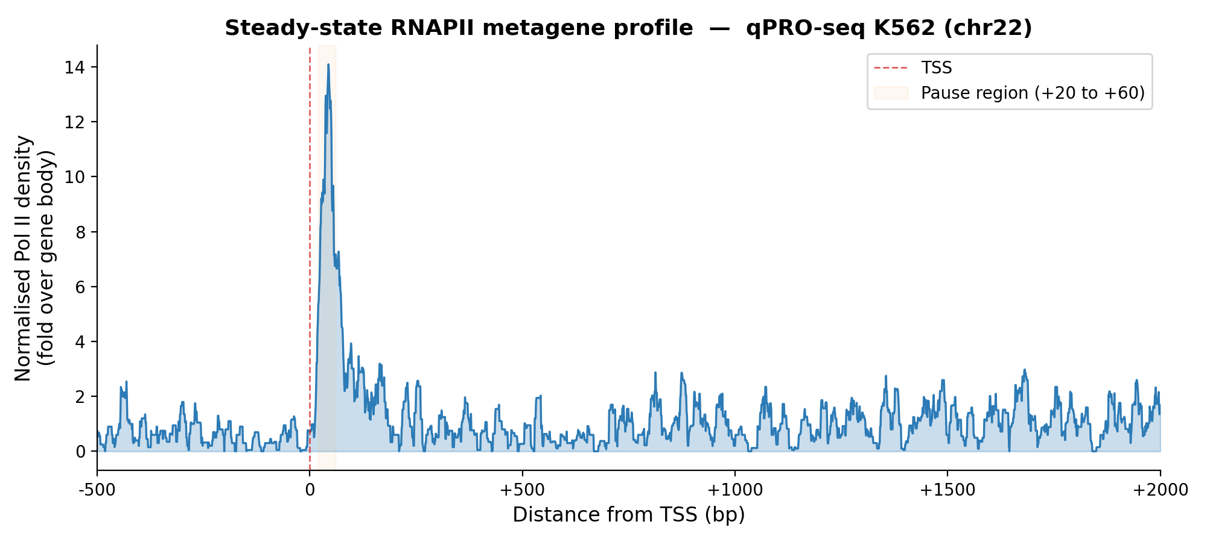

7. Files Changed
File | Change
Protopos.py | Swapped Pol II logic, BAM I/O, sort+index, author header, Google docstrings.
proseqanalysis.sh | STAR→bowtie2, UMI extract/dedup, explicit adapter, removed SAM conversion.
RNAPsignal.py | Unchanged (already correct).
.gitignore | Rewritten with POLYARIS-style .gitkeep pattern.
CLAUDE.md | New file, adapted from POLYARIS CLAUDE.md.
scripts/steady_state_figure.py | New file, metagene Pol II profile with strand-aware counting.
data/.gitkeep | New file.
fastq/.gitkeep | New file.
umi/.gitkeep | New file.
fastp/.gitkeep | New file.
qc/.gitkeep | New file.
alignments/.gitkeep | New file.
bowtie2_index/.gitkeep | New file.
results/.gitkeep | New file.
scripts/.gitkeep | New file.

The ProtoPos CLAUDE.md at ../Botos_Transcription_Simulation_Project/ProtoPos/ was also updated to fix the incorrect strand-handling statement and reflect the new directory structure.

