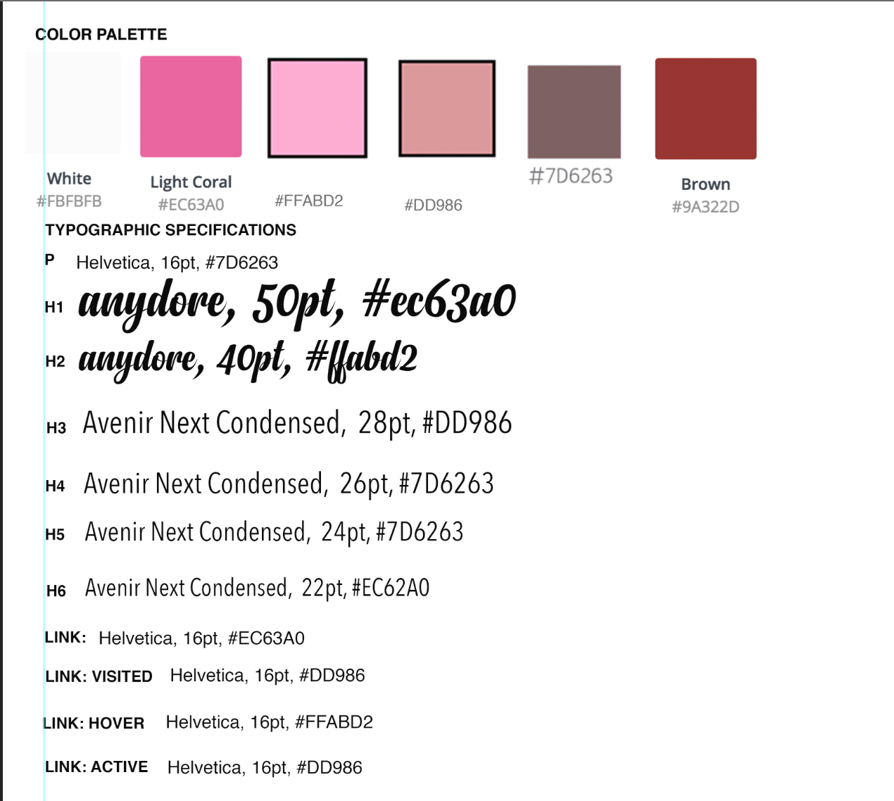
h1, h2
Anydore
h3-h6
Avenir Next Condensed
p
Helvetica

(Lateef)

COLOUR PALETTE
White
#fbfbfb
Light Coral
#ec63a0
#ffabd2
#dd986 / dc999c
#7d6263
Brown
#9a322d
fff4ec
#ffcccc

TYPOGRAPHY
text colour - #7d6263
p 16px
Open Sans, Helvetica
Source Sans Pro, Helvetica

h1 50px, h2 40px, h3 28px, h4 26px, h5 24px, h6 22px

Link: Normal - #ec63a0
Link: Active - #dd986
Link: Visit - #dd986
Link: Hover - #ffabd2

Alternative Font Avenir Next Condensed
Nunito (great alternative to Avenir)
Muli
Prompt
Poppins
Roboto Condensed
Open Sans Condensed
Josefin Sans
Karla
Lato

IMAGES
Portraits of beautiful women
Serene landscape and portraits
Woman relaxing
Feet being massaged
Organized interior of store
Rendering of Service
Before and after photos
Product Placement

