

horizontal line

# Fashion Should Be Inclusive

Teva footwear is evolving and offers inclusivity with a full range of widths and sizes

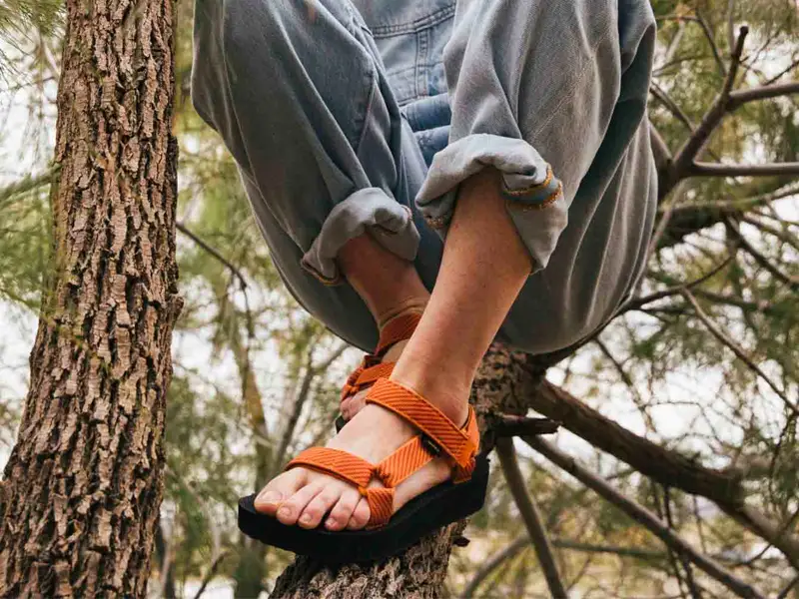

Inclusivity and sustainability are of upmost value, that is why our shoes are fully gender neutral with standard and wide sizing and are also created from traceable, verifiable recycled plastic. Teva will be your guide to adventure and will provide any style shoe to support your journey to self and world discovery. You have the freedom to choose. Check out the new rebranded website at [www.teva.com](http://www.teva.com).

horizontal line

@2021 Deckers Brands