1. What is Syntax analysis? Structure of parser.
2. Explain shift reduce parsing technique explain with example.
3. Give the difference between S attribute and L attribute with example. SLAPOIEN

|  |  |  |
| --- | --- | --- |
| Sr.No. | S attribute | L attribute |
| 1 | Associated with synthesized attributes. | Associated with both inherited and synthesized attributes. |
| 2 | Bottom-up parsing is used. | Top-down parsing is used. |
| 3 | Attributes calculated during reduction. | Attributes calculated during parsing. |
| 4 | Occurs in LR(1) & LALR(1) parsing. | Occurs in LL(1) parsing. |
| 5 | Attributes values determined by production rules. | Attributes values determined by semantic rules. |
| 6 | Implemented using shift reduce parsing. | Implemented using recursive descent parsing. |
| 7 | Inherited from parents. | Synthesized from children. |
| 8 | No circular dependencies. | Circular dependencies are possible. |
| 9 | Simple to implement. | Complex to implement. |
| 10 | Less expensive | More expensive |
| 11 | No need for symbol table. | Symbol table is required. |
| 12 | Suitable for simpler grammar. | Suitable for complex grammar. |
| 13 | Can not handle left recursion. | Can handle left recursion. |

1. What is intermediate code generation.
2. 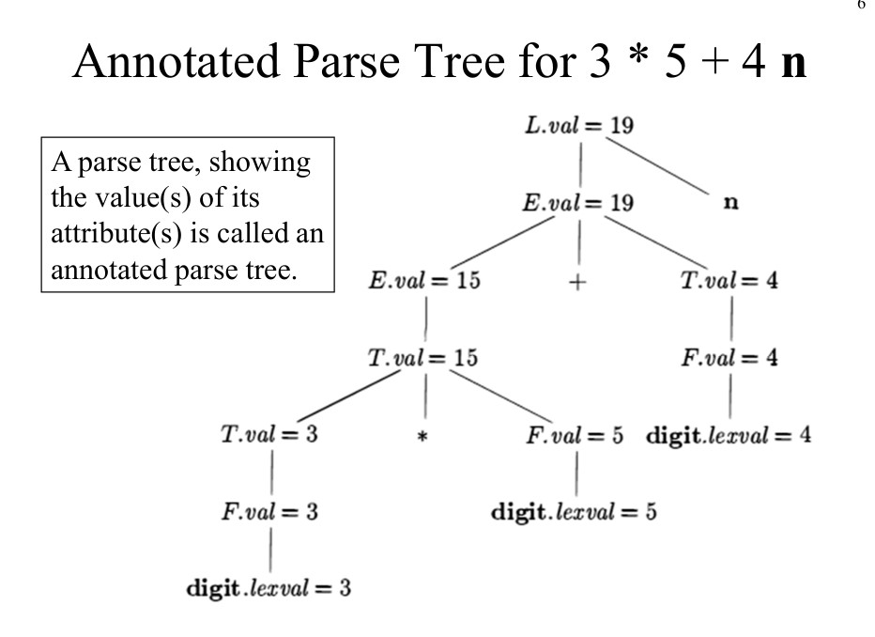Write a Construct annotated parse tree for 3*5+4 using S attribute definition.
3. Explain in detail Source of optimization.
4. Explain in detail peephole of optimization.
5. What are basic blocks?
6. What are loops in flow graphs?