The Garment.

Made by Son Ekaterina

Group 213

13/06/2022

Supervised by Zhulikov Georgiy Aleksandrovich.

Problem statement section.

During solving the problem, which I was given, I have learned a lot of interesting and exciting facts about creating a C++ GUI application using Qt Designer App based on Visual Studio Code. First of all, I have learned how to create main window, displaying all the data in the table. Also, now I know how to filter, and sort given data in several ways by using different kind of widgets, which were available to us.

Individual Problem Statement.

Specification, which I was given, required to create an app that can help a consumer to find appropriate clothes according to their preferences. Thus, I had to make an app, that gains some parameters and searches the right item in the database. Then, the app should show all the items that satisfy given parameters.



Implementation details section.

To deal with this problem I created a lot of different tools such as, sorting data according to the price(lower/upper) and the alphabetical order. Also, I made different kind of filtering the database by “Category”, “Brand”, “Sex”, “Size”, “Season”, “Color” through the “QComboBox” widget with ability to choose variable subtitles, by “Price” through the “QSlider” widget and searching by “SKU” number in the box with ability to write any sku number. As a necessary part of the project I created “Account” button which after clicking on it will show the logo of the app and my student number – 180. To see this wonderful project you follow the [link](https://github.com/katesv7/dsba-itop2022-hw.git) to Github repository, by clicking on the word.( In case, if you my [specification](https://drive.google.com/file/d/1lURh37WEzWzVmXK0TULyO0fGxoK3rCtJ/view?usp=sharing)) Now, you can see the visualization of the application bellow.



You can scroll it to define the price affordable for you

Here you can open filter requirements which you need to apply



To upload the data

To find the student number and the logo of the app



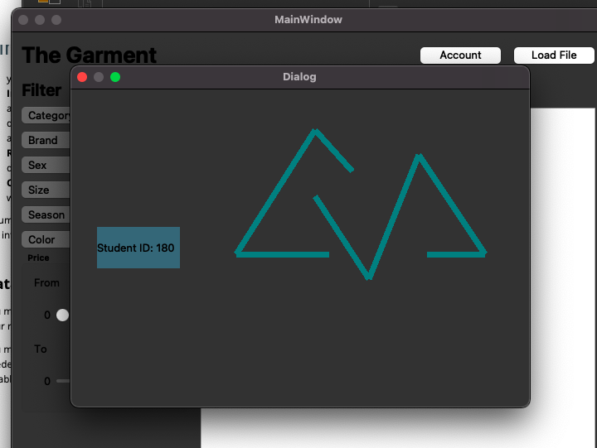



And Student ID probably

This is the logo, which represents mountains and freedom

Different kinds of filters



Results.



To sum up, I can say that I have gone through an amazing and invaluable experience, which will probably be needed in the future for work and study. Now I know how to use Qt Designer and how to connect it with other apps on my computer. I dealt with lots of problems due to fact that I have very old MacBook with insufficient memory capacity and lots of other problems. This project had a huge impact on my productivity and efficiency, as well as ability to improve my time management.

At the begging of learning Qt Creator, it was really difficult just to understand the logic of creating GUI application, but after doing tasks on workshops and practicing at home, I have started to understand what I need to do and how to realize it.