# Method #4: Opening and displaying images in envi

## Introduction:

We will use the ENVI software package to view, query, and manipulate images. You’ll need to learn about how images work in general, and, as with any software, how to think like ENVI to work with those images.

1. NUMBERS TO IMAGES
   1. Images are just numbers expressed on a screen, piece of paper, etc. The numbers are stored in a file on a disk or in memory, and the job of the image processing software is to convert those numbers into something you recognize, and then to help you further convert those into useful maps, etc.
   2. To display images on the screen, you have to understand something about how colors are displayed. Computer monitors and TVs make colors using combinations of three colors: Red, Green, and Blue. On your monitor, each “color gun” (a holdover from days when TVs actually shot electrons at the back of the screen) can be displayed at a range of intensities. Each color gun can display numbers from 0 to 255 (see “byte” type in data types below to see why).
   3. By combining these different colors in different intensities, other colors can be displayed. Here are some simple rules:
      1. Red + Green = Yellow
      2. Red + Blue = Magenta
      3. Blue + Green = Cyan.
      4. Red + Green + Blue = White
         1. Google “additive” and “subtractive” colors. A decent Youtube on this is at : <http://www.youtube.com/watch?v=5Z417hM-RAA>, but there are many. Additive color is what we’re dealing with on a monitor.
2. DATA TYPES IN ENVI
   1. Now that you’ve got the screen, you need to know about the numbers in the file that have to be rendered on that screen. They’re digital numbers, which means you need to know the basics of how computers store and handle numbers.
      * 1. A byte is the basic unit.
           1. One byte has 8 bits, and each bit can take on a value of only 0 or 1. Using base 2, 8 bits of 0,1 can store 256 unique values (28= 256).
        2. A file is a string of bytes, and you tell the computer whether it should treat all of those bytes as separate numbers, or whether to glue them into groups of two or four. Thus, the range of values in a given number is constrained by the number of bytes per number:
           1. One Byte: A number can have 256 values
           2. Two Bytes: A number can have 65536 values
           3. Four Bytes: A number can have 4294967296 values.
        3. You can tell the computer that all of those values should be zero or above (unsigned), or that they should include both negative and positive values (signed). Remember that Zero is a legitimate value, so the 256 values could only represent numbers for 0 to 255. Thus, the basic types of numbers you can store are:
           1. Unsigned Byte: 0-255
           2. Unsigned Integer: 0-65535
           3. Unsigned Long Integer: 0-4294967295
           4. Signed Byte: -127 to 128
           5. Signed Integer: -32767 to 32768
           6. Signed Long Integer: -2147483647 to 2147483648
           7. There are other more complicated number types. Of those the most important to know about is “Floating point” – this is the data type that stores decimal numbers. It does so in a clever way – it uses four bytes per number, and keeps track of two different numbers that, when divided by each other, resulting in the decimal number.
   2. ENVI has its own names for these different number types. They couldn’t make it easy, right? For our use, just remember these, in the format: ENVI type = real type.
      * 1. BYTE type = unsigned byte numbers
        2. INTEGER type = signed integer.
        3. LONG type = signed long integer
        4. FLOAT type = floating point.
3. GEOGRAPHIC VS FILE COORDINATES
   1. Just as ENVI has to make decisions about how to display the image file numbers on the screen, it also has to know *where* to place them. Thus, in addition to the numbers in the image file, we need to give it some way to convert those into a nice rectangular image and – ideally – to link each pixel to a place on the planet.
      1. File coordinates:
         1. We have to tell ENVI the X and Y dimension of the grid of the image. Ultimately, that kind of information comes along with the image from the sensor. It has to be passed along each time you manipulate the image
         2. The file coordinates are the X and Y position measured in units of pixels. Thus, if an image is 5000 by 4000 pixels, the file coordinates range from 1 to 5000 and 1 to 4000.
      2. Map coordinates
         1. If we give information to ENVI along with the file, it can know how these pixels are draped on the Earth.
            1. Please take a moment to make sure you have a general understanding of what a map projection and a geodetic datum are. They are not described well in our image processing texts, so I suggest taking a look in Wikipedia.
            2. Generally speaking, the PROJECTION is a mathematical means of displaying the curve of our Earth on a plane, such as a map paper or screen.
            3. The DATUM is a set of actual coordinate measurements referenced to a known location. The North American Datum 1927 was referenced to a starting point in Kansas. It was the standard mapping datum in the U.S. for decades. For the North American Datum 1983, the reference point was based on the assumed geodetic center of the Earth, based on a much better satellite-based representation of the shape of the planet.
            4. ***The key thing to remember is this:*** Much like the colors on the screen have no inherent meaning, but are a translation of the underlying data, the coordinates in all of our images really have no absolute reality – they are always referenced to some agreed-upon framework. Thus, the same location on the planet will show up as having different coordinates depending on the Projection and Datum you use.
4. STARTING ENVI FROM AN INTERACTIVE SHELL
   1. Type: **envi**
   2. Not much happens after it gets going: a thin menu bar appears at the top of the screen.
5. FILE CONVENTIONS IN ENVI
   1. In ENVI, each image has two files: The data themselves, and then a separate “header” file that tells ENVI how the data are arranged, what the geographic information is, etc.
   2. Read up on file formats: Jensen pages 101-104. We will mostly use the “band sequential” format, and the shorthand for that is “bsq”, but other formats also make sense in some situations.
   3. 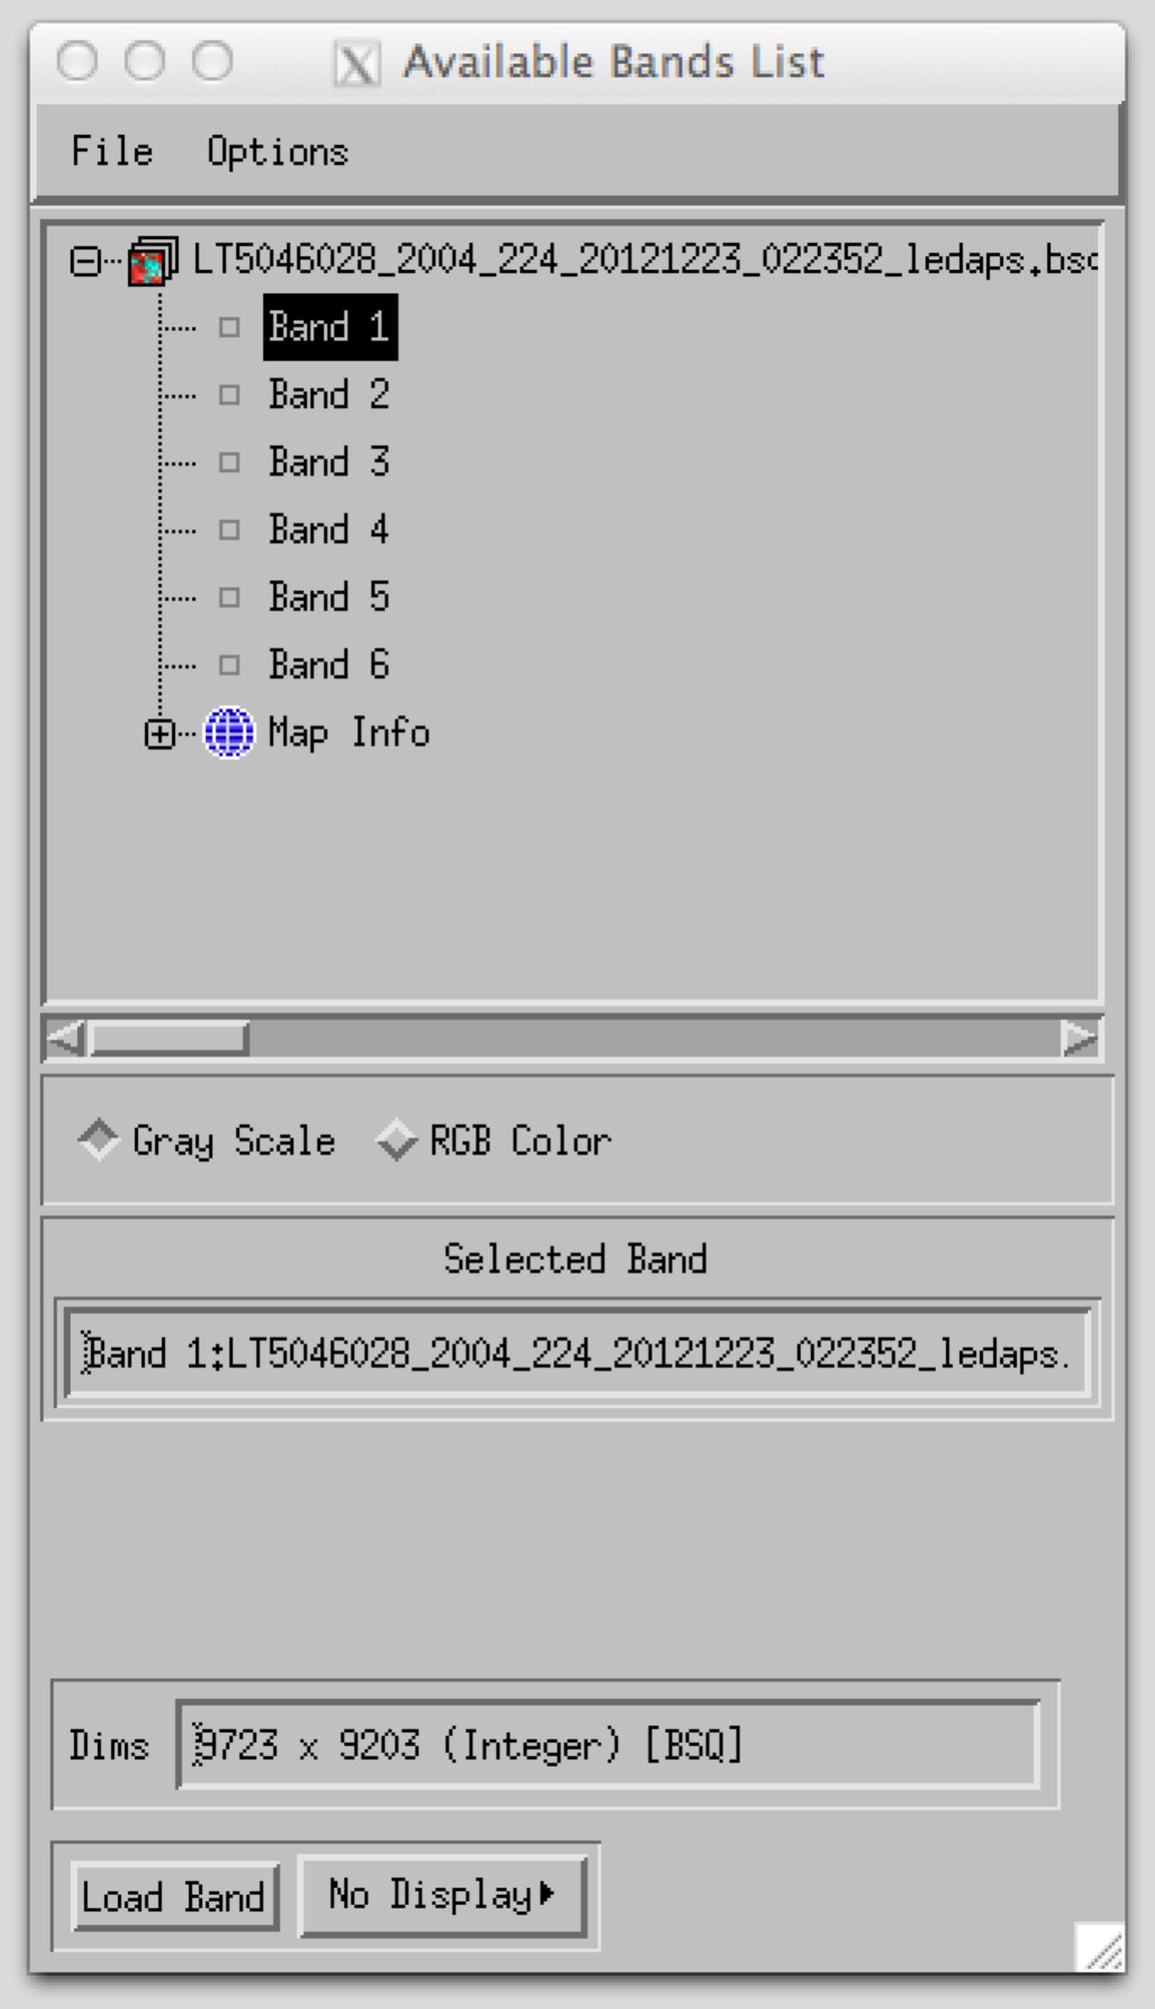Thus, for every image we work with, there should be two files that different only in their suffix – the part of the filename that comes after the period.
6. OPENING A FILE
   1. Go to “File\Open Image File\”
      1. A popup window should appear.
      2. In that window, navigate to the directory in which your image lives, select the file and hit OK.
      3. If you want, you may want to set the default input and output directories so you don’t have to type or navigate with the clunky interface to your directories. Use Prefere
      4. All that will happen is that the “Available bands list” popup will now appear.
      5. You’ll notice that the file is listed, and then underneath it all of the “bands” of the image.
         1. Recall that a spectral band refers to the measurements made by the sensor in a discrete part of the EM spectrum. Thus, we speak of the “visible bands”, the “near infrared bands”, etc.
7. DETERMINE FILE INFORMATION (AS NEEDED)
   1. Sometimes you will want to know details about the image at which you’re looking, such as the file size, the map information, the number of bands, the data type, etc.
      1. Geographic information:
         1. Click on the little blue globe thingie under the last band, and it will expand to show you the projection, pixel size, datum, and coordinates.
      2. From the “Available Bands” window, right-click on the file (not on one of the bands, but on the filename itself at the top of the list of bands)
      3. A dropdown menu should appear, and on that menu select “Edit header”
      4. A popup window will appear:

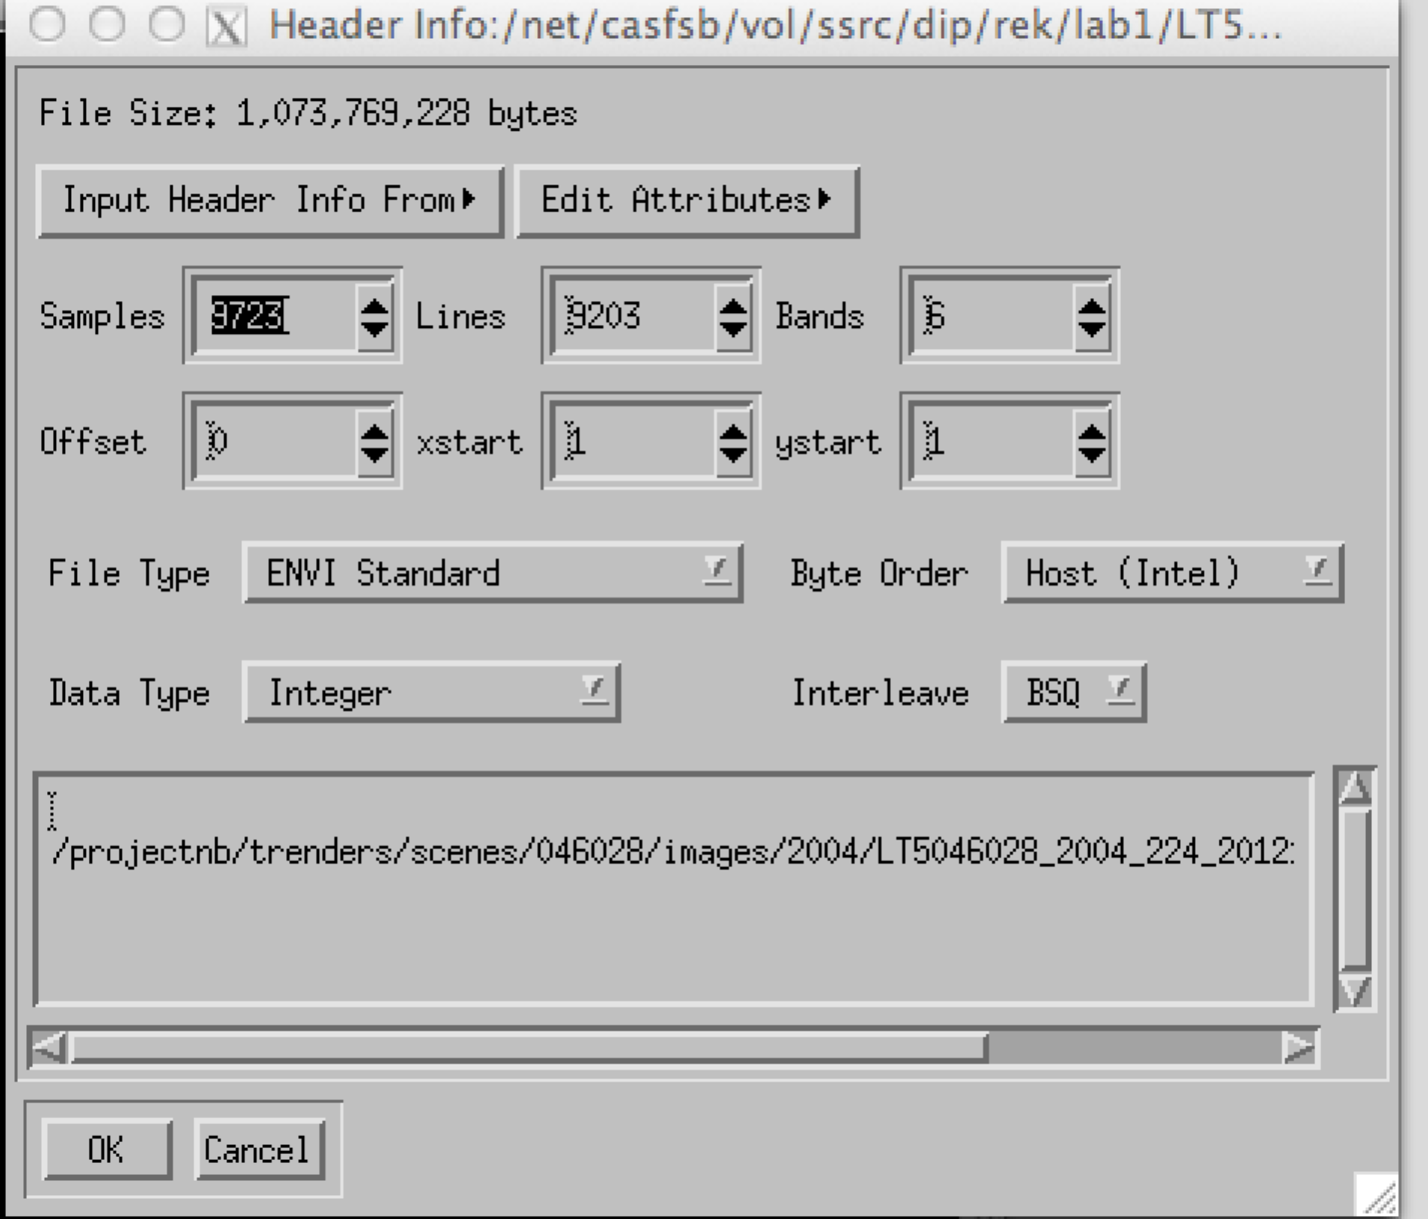

* + 1. Samples: The number of pixels across the image – the X dimension
    2. Lines: The number of pixels up and down the image – the Y dimension
    3. Bands: The number of separate image layers in the imag
    4. Don’t worry about offset, xstart, ystart. I won’t ask you about ‘em because I can’t remember the last time I used them.
    5. File type: We’ll mostly be working with ENVI standard images, but will run into other types (ENVI classifications, for example).
    6. Data type: See above.

1. DISPLAY A SINGLE BAND IN GRAY SCALE
   1. In the “Available bands” window, make sure the button for “Gray scale” is selected, and then click on the band you want to open.
      1. Each band corresponds to one band recorded by the Landsat sensor. May be a good time to review those!
   2. Note which Display will be active: At the beginning, it will be “Display #1”, but later you can add new ones. Fun!!
   3. Click on “Load Band”
   4. You’ll get three windows open for every image you use. ENVI likes lots of windows. It gets busy on the screen.
      1. The “image” window shows one chunk of that larger image at the native pixel resolution – in other words, with no magnification or aggregation.
      2. The “scroll” window shows a miniature version of the entire image. It’s your context image. There’s a red box that shows you the area that your “image” window is representing. If you click somewhere in that scroll window, the red box moves and the area shown in the “image” window changes.
      3. There’s also a “Zoom” window that shows you a little chunk of your “image” window in greater magnification. There’s a red box in the “image” window that shows where that is. Click a different place in the image window and the zoom window will show a different area.
         1. TIP: Turn on the “cross-hairs” in the zoom window. They’ll highlight a single pixel at the center of the window. Click on the little red box in the lower left – the third from the left.
         2. Change colors for the boxes and crosshairs by going into the VIEWER/File/Preferences and change “Display graphic color”.
2. 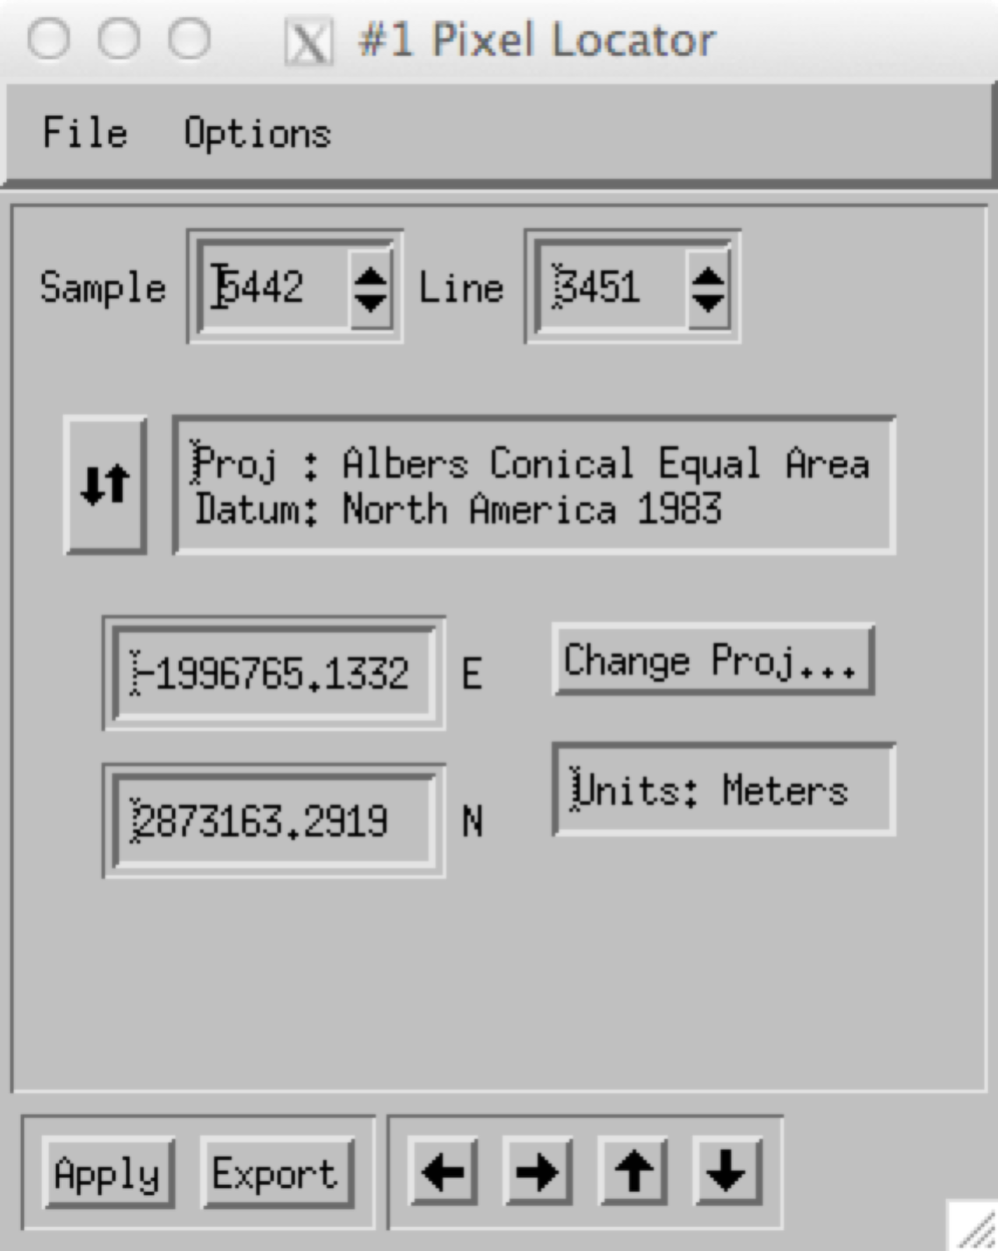MOVING AROUND IN AN IMAGE
   1. OPTION 1: Click in the scroll image to move where you are.
   2. OPTION 2: Turn on scroll bars.
      1. Right-click in the image viewer, then select “Toggle/Display scroll bars”
         1. Not very intuitive, is it?
   3. OPTION 3: Use the pixel locator and type in the coordinates where you want to go.
      1. In the image window, right-click and select “Pixel locator”
         1. A little window will open that gives you key information:
         2. Sample: The X position of the pixel in the center of the Zoom window.
         3. Line: The Y position.
      2. You can type the location you’d like to go to, hit apply, and then ENVI should take you there. Thus, if you want to come back to a place later, you can note the coordinates, or export them and re-import later.
3. STRETCHING IMAGES
   * 1. In the viewer, select “Enhance/[Image] Linear 2%”

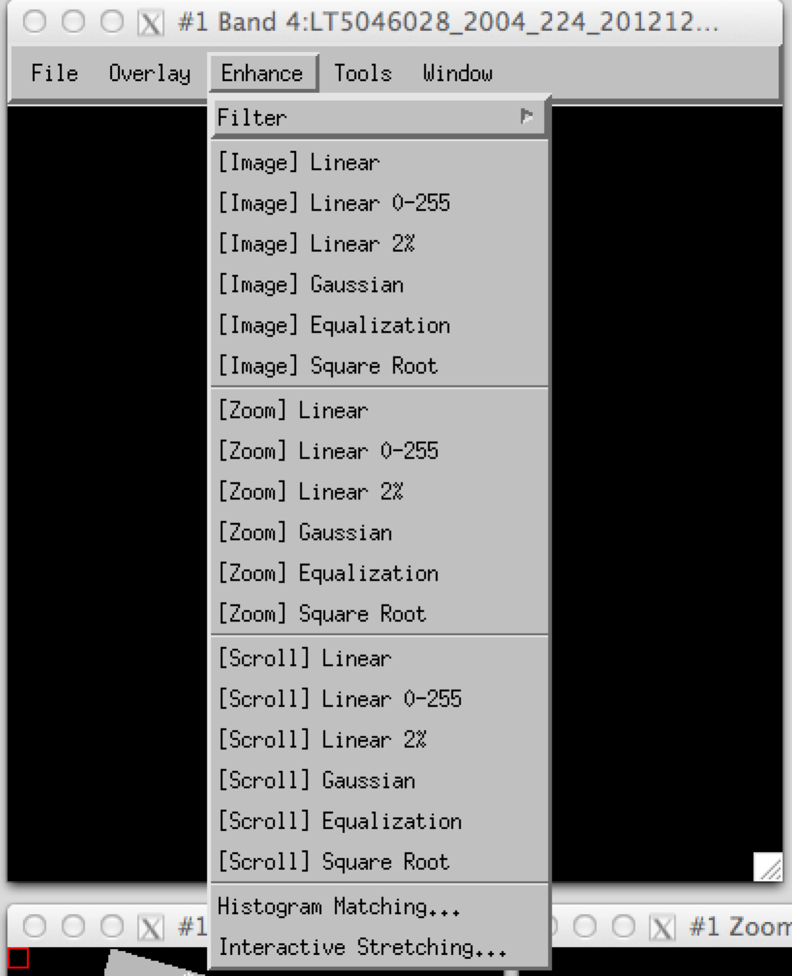

* 1. The first group of options all say [Image] – that means that they’re using only the pixels displayed in the image window to calculate the statistics for the stretch. Then you can pick whether you want a linear stretch, or a Linear stretch that ignores the most extreme 2%. That’s the one I like. You can read up on the others.
  2. So what you can do is move the position of that image display, and then select “[Images] Linear 2%”, and it will adjust the scale.
  3. Look in Jensen to get a sense what the other kinds of stretch mean (Gaussian, equalization, square root).

1. DISPLAY A SINGLE BAND IN GRADUATED COLORS
   1. Instead of saying that the display values from 0-255 are a ramp from black to white, ENVI can assign other colors to each number between 0 and 255 sent to the screen. This allows you to look at a single band as a color ramp.
   2. Select “Tools/Color mapping/ENVI Color Tables”, and play around with different options.
   3. Because humans can interpret many more shades of color than black and white, these so-called “color ramps” can often be used to accentuate certain things in your image better than black and white.
2. DISPLAY A SINGLE BAND USING DISCRETE COLORS
   1. You can also use a variant on that approach: pick blocks of values and color them all the same thing. Try “Tools/Color mapping/Density slice”.
      1. Here, you can specify exactly which colors you want to associate with different “slices” through your dataset – i.e. different ranges of values.
      2. ENVI will default to what it thinks you want, but it’s usually weird. You can manually change the values.
3. DISPLAY THREE BANDS IN RED, GREEN, BLUE COLOR COMPOSITE
   1. In the “Available bands” window, select the little “RGB” button near the bottom of the window.
   2. It will now have space for three different bands – one for Red, one for Green, and one for Blue.
      1. You can click on the little button next to each one and then click above in the available bands list to place that band into the color gun you’ve chosen.
      2. Or you can just let ENVI assume that you are going to give it bands in the red, green, blue order, and not both clicking on the little buttons. Just click on the band you want for red first, then the green one, then the blue one.
      3. Take care! ENVI keeps cycling through these, so if you accidentally get offset by one band, you may end up inadvertently putting the wrong bands in the wrong colors. If you ever open an image and the colors look weird, check to make sure that ENVI didn’t trick you.
4. INTERPRETING R,G,B COLOR COMPOSITES
   1. It’s critical to realize something about stretching R, G, B composites: Each band is stretched separately! Thus, each pixel’s display color is a representation of its value in that band *relative to the other pixels in that same band, not relative to the other two bands you’re using!*
   2. Thus, just because a given pixel looks Red on the display, it does NOT NECESSARILY mean that the actual data value is higher than the actual data values in the other bands. It just means that it’s relative score within the red band is high and that it is relatively low in green and blue bands. It all depends on the stretches applied to each band.
5. QUERYING PIXEL VALUES
   1. OPTION 1: You can query pixel values by right-clicking anywhere in the “image” window, and from the drop-down menu select “Cursor location/value”
      1. 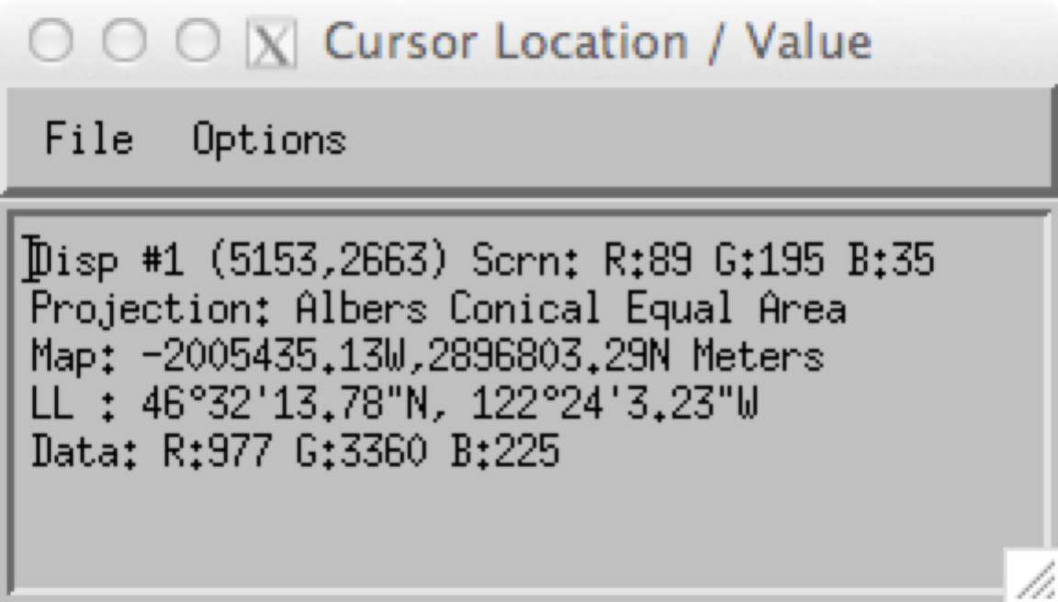Another little window opens, and reports the values of the pixels wherever you have your cursor floating.
      2. On the top line you’ll see that actual values of the display – note that these are always between 0 and 255.
         1. We’ll refer to these as the “display values”
      3. On the bottom line, you’ll see the actual “data values”
         1. These are the true values of the pixel in the file.
         2. If you change the stretch, the data values will stay the same, but the display values will change.
   2. OPTION 2: Use the Z-profile
      1. If you think of the image on the screen as having X and Y dimensions, the Z dimension is the third dimension: The number of bands in the image. Thus, in our Landsat Thematic Mapper image, we are using six bands: three visible (Bands 1-3), the near infrared (band 4), and two short wave infrared (Bands 5,7). This means that our image has 6 values in the “Z” dimension:



* 1. You can think of this as “drilling into” the image.
  2. To look at the values:
     1. Right-click in the image viewer, select “Z-profile”
     2. It should look something like this:
     3. 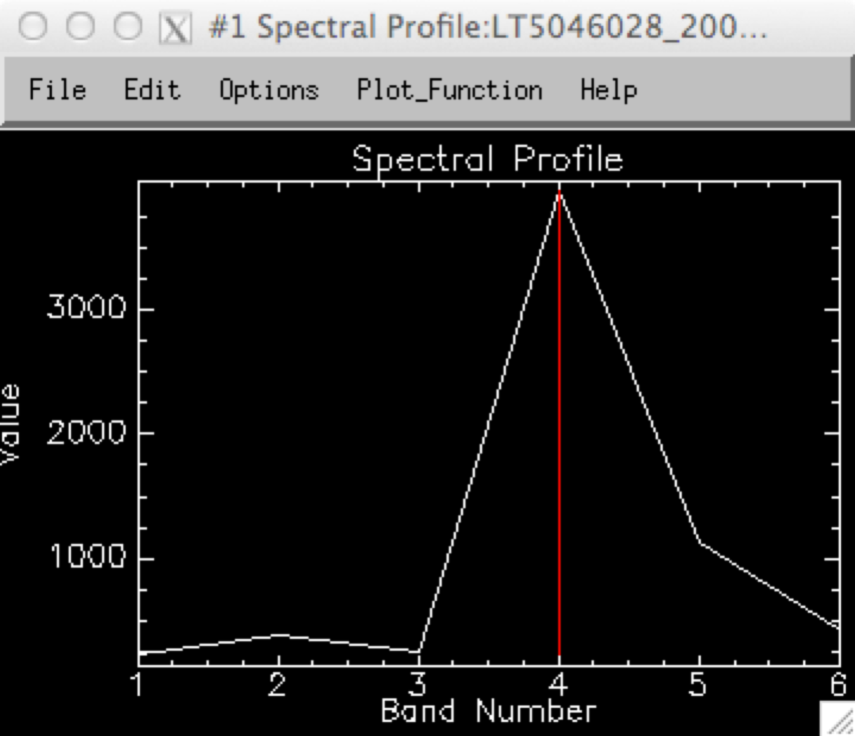
  3. This represents the pixel values in each band for a single pixel.
     1. What pixel does this correspond to?
        1. The one in the center of the Zoom window. Again, you will probably want to turn on the cross-hairs of the zoom window to do it.
     2. Where is band 7?
        1. Unless we tell it ahead of time, ENVI doesn’t know about the *actual* names of the bands. It just knows there are six of them. So from its perspective, it just names them bands 1-6.
        2. THUS, in Landsat Thematic Mapper world, the values in the file that sensor recorded in Landsat’s BAND 7 are listed in the Z-profile under Band 6.
           1. We do not have the REAL band 6 in this file. Band 6 on Thematic Mapper is the thermal band, but I chose not to include it here for our labs.

1. LINKING DISPLAYS
   1. Often, you’ll need to have two or maybe many more displays linked, so you can look at how two images relate for the same area of the image.
   2. OPTION 1: Geographic link
      1. Right-click in the image viewer display and select “Geolink”
         1. In the resulting window, select the displays you want to have connected.
         2. Once you do this, when you move around in one display, the cursor location in the other displays will track it.
         3. Pros: The cursor is linked correctly regardless of the size of the image file.
         4. Cons: Even though the cursor location (as represented by the cross-hairs in the scroll window) is linked, it’s not always the center of the display or zoom window – in other words, the footprint of the image that you look at may well be different for the two displays.
   3. OPTION 2: Link displays
      1. Right-click in the image viewer display and select “Geolink”
         1. Note: This only works when the images in the two displays have exactly the same X,Y size. Kind of a bummer.
         2. Select the ones you want, and pay attention to some of the options about which one you want to have “drive” the story.
            1. Note: Transparency defaults to “on”. Once you link, you can click in one display and the values for the other one pop in and out, so you can flicker between them.
         3. Pros: The area represented in each window is identical, and that flicker thing can be cool.
         4. Cons: The images have to be the same size.
         5. NOTE: You can sometimes get odd behavior if you have BOTH geolink and display link turned on. Pick one or the other and make sure the other is turned off.