# Method #5: Subsetting images in envi

## Introduction:

There are several situations where you’ll want to subset an image. For our labs, we don’t want to mess with full size Landsat images to understand the concepts of interest. For any change detection across images, ENVI requires that the images be EXACTLY same X and Y dimension, which Landsat images rarely are.

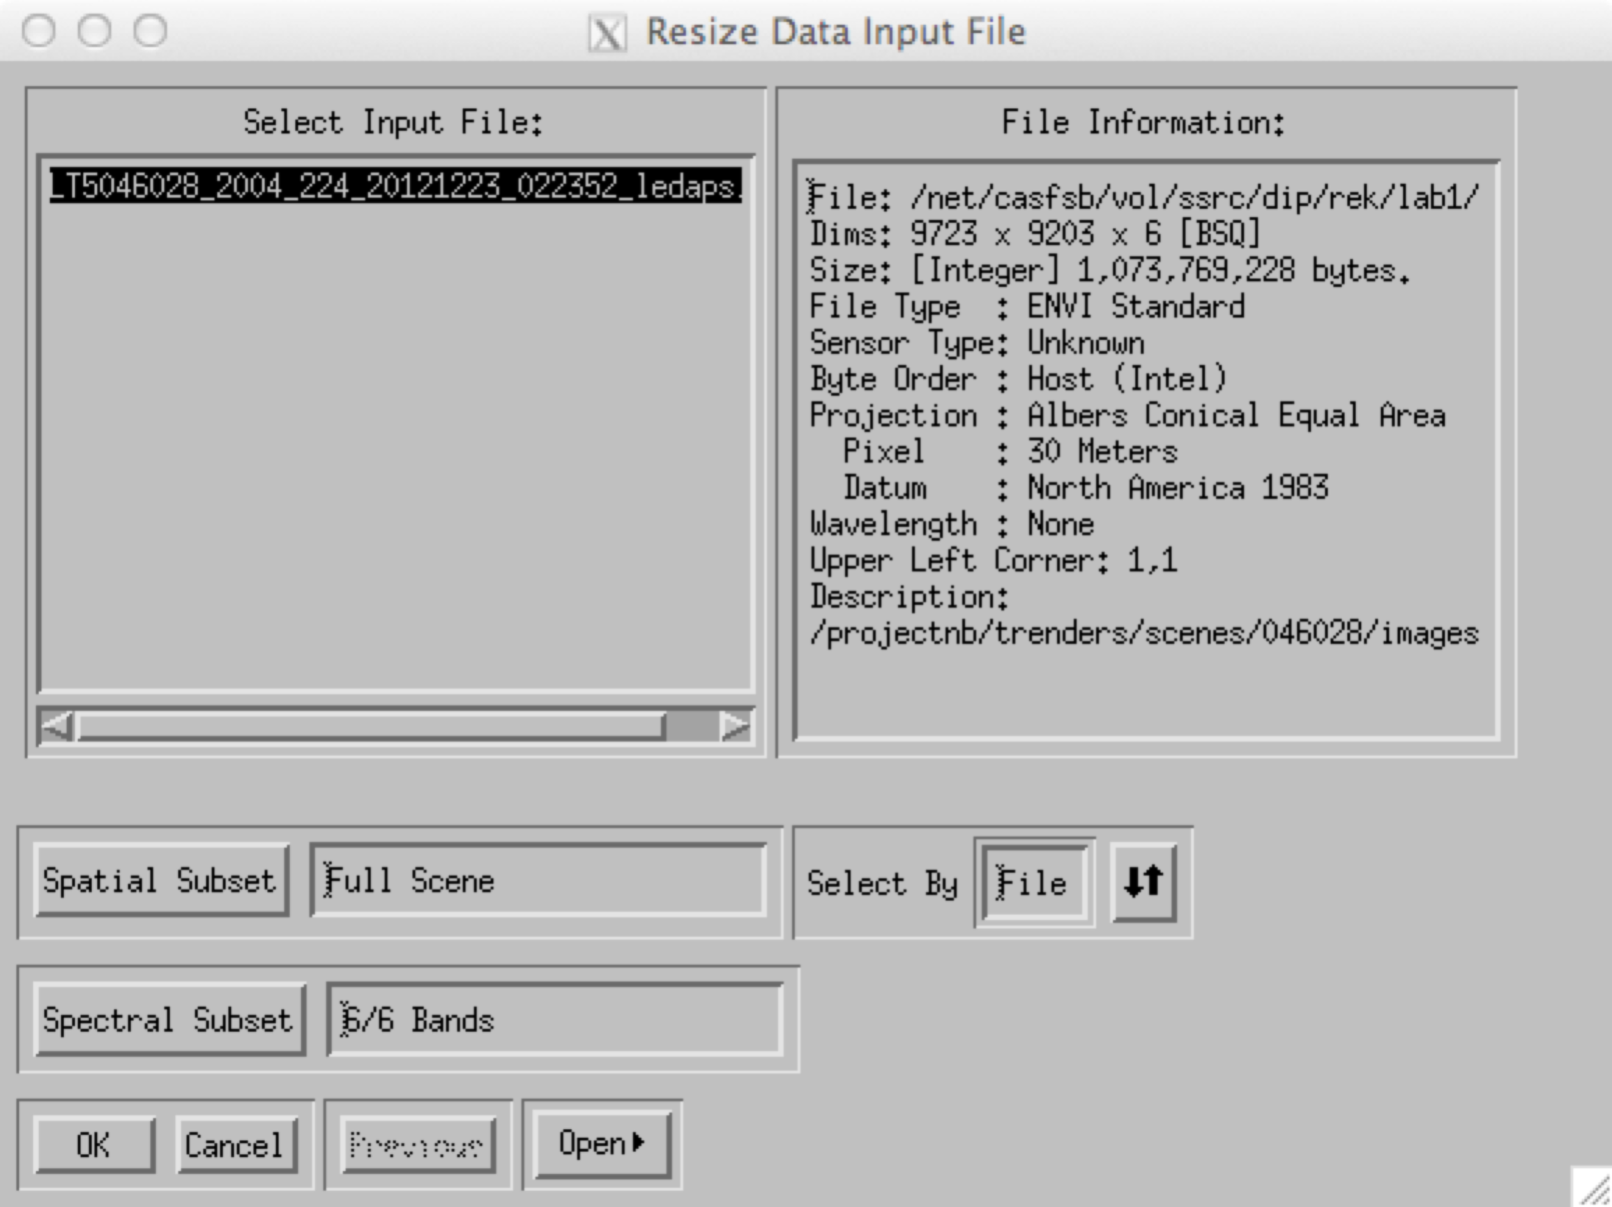

1. SUBSETTING IMAGES:
   1. Geographic:
   2. From the main ENVI menu bar, click on the “Basic tools” menu and select “Resize data”
      1. NOTE: There are a lot of core manipulation tools here that we’ll use later.
   3. Select your file of interest. Your window should now show “Spatial Subset” and “Spectral Subset”
   4. 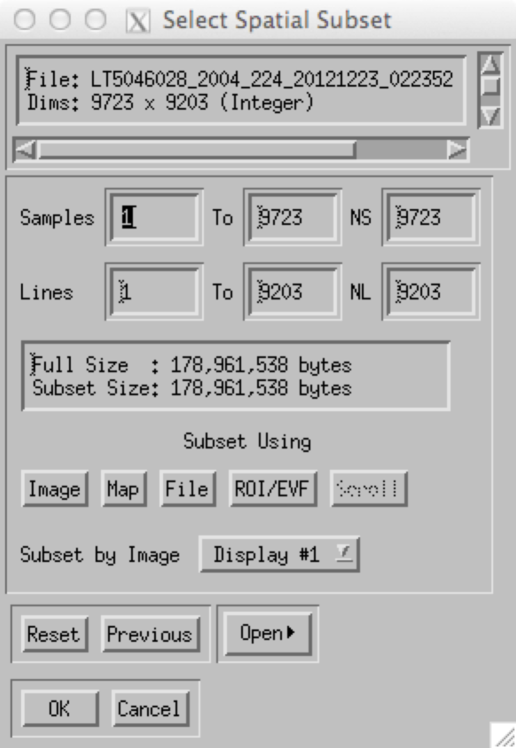Click on the Spatial Subset
   5. NOTE: The subset area is always rectangular!!!
      * 1. Why? Unlike a vector based GIS layer, for example, we have to story the image in a regular grid so that we can describe the position of each pixel compactly with a header that describes the upper left, pixel size, and X and Y dimensions.
2. The window on the right should appear.
3. NOTE: The file coordinates (samples and lines) are there, as well as the size in file pixels (NS, NL = Number of samples and lines, respectively).
4. You have several choices for how to subset your core image
   1. Image: You can draw the subset box on an interactive window.
   2. Map: You can manually define the upper left and lower right corners of the box
   3. File: You can use the bounds of a different image to subset this one. This is useful when you’re doing band math (manipulating two images in grid space), because ENVI needs them to be the same size.
   4. ROI/EVF: Find the smallest rectangle that surrounds an irregular Region of Interest (ROI) or ENVI Vector File (EVF). Those will come up later.
5. Once you select OK, you will be asked to name the output file.
   1. Follow good practices!!! Document the dimensions, the file name you choose, and the location in your journal. Use a file name that will allow you to clearly identify this image later – it should include some idea of both the source of the image (the original that you’re subsetting) and the fact that is has been subsetted (“subset” is not a bad choice to include in the filename, but you may have many of them for this image, so may need to number them).