|  |
| --- |
| Security class  Restricted |
| Title  **Software Development Process**  **The User Requirement Document for MIA.ph** |
| Summary  This report is a User Requirements Document used for the project MIA.ph containing the general description of the system and the specific requirements essential for the system to work. |

|  |  |  |  |  |
| --- | --- | --- | --- | --- |
| name | | Course | Date | signature Signature |
| prepared | Kathlene Acompaniado,  Shayne Meiko Abao  Raymund Pamatian | Computer Science  Computer Science  Computer Science | 09-01-18  09-01-18  09-01-18 |  |
| checked |  |  |  |  |
| agreed |  |  |  |  |
| approved |  |  |  |  |
| authorized |  |  |  |  |

**REVISION RECORD**

|  |  |  |
| --- | --- | --- |
| ­­­­Date | Pages Affected | Brief description of change |
| 1 Sept 2018 | All | First Draft |
| 7 Sept 2018 | All | Revisions |
| 12 Oct 2018 | 5, 7, 9, 10 | Revisions |

**Table of Contents**

**1** **INTRODUCTION 4**

1.1 Purpose of the document 4

1.3 Definitions, acronyms and abbreviations 4

*1.3.1* *[Definitions] 4*

*1.3.2* *[Acronyms] 4*

*1.3.3* *[Abbreviations] 4*

1.4 References 4

1.5 Overview of the document 4

**2** **GENERAL DESCRIPTION 5**

2.1 General capabilities 5

2.2 General constraints 5

2.3 User characteristics 5

2.4 Operational environment 5

**3** **SPECIFIC REQUIREMENTS 7**

3.1 Capability Requirements 7

*3.1.1* *[subsection] 8*

*3.1.2* *[ ... ] 9*

3.2 Constraint requirements 9

*3.2.1* *[subsection] 9*

*3.2.2* *[subsection] 9*

# 1 Introduction

## 1.1 Purpose of the document

The User Requirements Documentation (URD) contains the requirements for Meals In Action (MIA). The document conforms to the ESA standard. These requirements have been agreed upon by the development team. Any changes to the requirements will require the consent of all parties.

## 1.2 Definitions, acronyms and abbreviations

This section contains a list of definitions, acronyms, and abbreviations.

|  |  |
| --- | --- |
| UML | GUI - Graphical User Interface  UML - Unified Modelling Language |
| URD | URD - User Requirements Document |
|  |  |

## 1.3 References

|  |  |
| --- | --- |
| [1] | Guide to applying the ESA software engineering standaards to small software projects, ESA BSSC(96)2 Issue 1, May 1996.    From |
|  | <http://www.win.tue.nl/~mvdbrand/courses/se/0910/URDs/urd-ode.pdf> |

## 1.4 Overview of the document

The remainder of this document is divided into two chapters, General Description and Specific Requirements

The *General description* gives a clear and concise description of the project MIA. It consists of a short view on the product, a short summary of the general capabilities and a more in-depth view of the main parts of the system.

The *Specific requirements* are subdivided in capability requirements and constraint requirements, describing what the system should and could do, describing how the requirements should be implemented and the restrictions on how the system can be built and operated.

# 2 General Description

The general requirement of this project is to provide a better system for advertising, ordering and booking of the restaurants and cafes in Miagao, Iloilo. This system uses Data base to store information of the different users (further discussed in chapter 2.3) and the system as well. On this document, the general capabilities of the system, its constraints, user descriptions and operational environement is discussed. Capabilities of the different users and constraints of the system are further discussed in chapter 3 enumerating each requirement and their characteristics; priority, stability and verifyiablity.

## 2.1 General capabilities

The system will be able to let a group of users(owners) create and manage their accounts and another group of users(client) who can reserve and order meals through online.

## 2.2 General constraints

The system will be used in existing infrastructure and no new technology will be used.

## 2.3 User characteristics

There are four types of users that interact with the final product. The first group of users are the restaurants or cafeteria owners, they are the ones who will use the System for business purposes; use it to promote or advertise their businesses. They the capability to update the contents of their account; business and personal information from time to time. The second group of users are the customers, they are the residents residing in Miago ao looking for a better way to order food thats fast and easy, or they could be looking for a potential restaurant to held their events, they have the capability to place orders/book amenities in any restaurants or cafeterias using their accounts. Third, the group of users are the guests, they could be tourists on miagao looking for a guide on where to eat, they have the capability to view the meals, reviews, and announcements and also upload pictures and write reviews of the restaurants or cafeterias. They could also be Vloggers, Film Makers and restaurant critics who could boost the popularity of the restaurant/cafe and the town. Lastly the administrators or the programmers who has the capability to modify the product, they own the product and have the source code of the system and could share it to any programmers/developers who could participate in fixing existing bugs and wishes to be a part of the system.

## 2.4 Operational environment

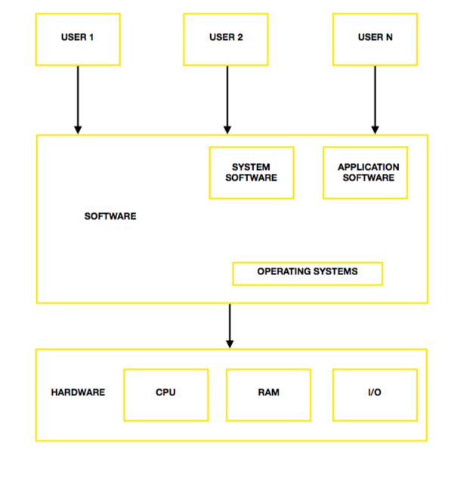The product will run on computer systems running either Windows, Ubuntu, or macOs as primary operating system.

3 **Specific Requirements**

This chapter covers the capability requirements and constraint requirements. Each requirement consists of a unique identifier, followed by a short description, a priority, a stability, a verifiability and a source either from a specific person or an external document. We will use the following priorities, stabilities and verifiabilities ordered from highest to lowest as follows:

Priorities:

***Must Have :*** these requirements are essential for the system.

***Should Have :*** these requirements are not that critical for the system to work, but not as important as the Must haves, thus they must be implemented if possible.

***Could Have :*** these requirements are not critical for the system to work. If they can be implemented with little development costs, they can increase customer satisfaction

Stabilities:

***Unstable:*** these requirements are subjected to change depending on the clients requirements or the developers satisfaction over the developing phase.

Verifiabilities:

***Must Check:*** these requirements must be checked first for they are essential for the system to work.

## Capability Requirements

***3.1.1 User (Owner)*** Sources

|  |  |  |  |  |
| --- | --- | --- | --- | --- |
| UR-O-0  The user can create a new account | Must Have |  | Must Check | Restaurant Owner |
| UR-O-1  The user can edit personal data (Address, number etc.) | Must Have |  | Must Check | Restaurant Owner |
| UR-O-2  The user can edit and update availability of meals and amenities. | Must Have |  | Must Check | Restaurant Owner |
| UR-O-3  The user can post announcements, events and discounts on their page | Could Have |  | Must Check | Restaurant Salesperson |
| UR-O-4  The user can upload pictures of their meals and amenities | Could Have |  | Must Check | Restaurant Owner |
| UR-O-5  The user can view ratings of their restaurant | Must Have |  | Must Check | Client |
| UR-O-6  The user can view other restaurants and their ratings | Must Have | Unstable |  | Client |
| UR-U-7  The user can edit available dates for tables and function halls | Must Have |  | Must Check | Restaurant Owner |
| UR-O-8  The user can update availability of delivering services | Must Have |  | Must Check | Restaurant Owner |
| UR-O-9  The user must indicate accepted payment methods | Must Have |  | Must Check | Client |

***3.1.2 User (Client)***

|  |  |  |  |  |
| --- | --- | --- | --- | --- |
| UR-C-1  The user can create a new account | Must Have |  | Must Check | Client |
| UR-C-2  The user can view and search different restaurants | Must Have |  | Must Check | Client |
| UR-C-3  The user can view available dates and times of each restaurant | Must Have |  | Must Check | Client |
| UR-C-4  The user can make a reservation for tables or amenities | Must Have |  | Must Check | Client |
| UR-C-5  The user can order in advance or for delivery | Must Have |  | Must Check | Client |
| UR-C-6  The user can upload pictures and write a review | Must Have | Unstable |  | Client |
| UR-C-7  The user can redeem coupons. | Must Have |  | Must Check | Client |
| UR-C-8  The user can pay through any payment methods indicate | Must Have |  | Must Check | Client |

***3.1.3 Administrator***

|  |  |  |  |  |
| --- | --- | --- | --- | --- |
| UR-A-0  The user can delete/erase the whole system | Must Have |  | Must Check | Administrator |
| UR-A-1  The user can modify parts and capabilities of the system | Must Have |  | Must Check | Administrator |
| UR-A-3  The user can add additional information and features on the system | Must Have |  | Must Check | Administrator |

***3.1.4 Guest***

|  |  |  |  |  |
| --- | --- | --- | --- | --- |
| UR-G-0  The user can search existing cafes and restaurants using the search bar | Must Have |  | Must Check | Administrator |
| UR-G-1  The user can open restaurant/cafes profile to read information about them | Must Have |  | Must Check | Administrator |
| UR-G-2  The user can read existing reviews on the restaurants and view their pictures | Must Have |  | Must Check | Administrator |
| UR-G-3  The user can upload a picture and write a review | Must Have | Unstable |  | Administrator |

## 3.2 Constraint requirements

|  |  |  |  |  |
| --- | --- | --- | --- | --- |
| UR-CR-0 The system should be available from 8am - 10pm Monday to Sunday |  |  |  |  |
| UR-CR-1 Information should be made available and be stored in a maximum of 3 seconds |  |  |  |  |
| UR-CR-2 The system should be able to hold a 100,000 customer records initially |  |  |  |  |
| UR-CR-3 The number of records a system should be able to hold |  |  |  |  |

**A [Appendix Heading]**