**Navigation Bar and Footer**

Task: Add navigation bar with dropdown menu, and footer with social media links.

Issue: The symbol of dropdown menu looks different on Safari, even it works well on Chrome.

Reason: Safari has font rendering problems with fixed position.

Solution: Add a line of CSS code which solves this problem.

Other solutions: Change the position into absolute, but then the navigation bar will not stay fixed on top.

Results:

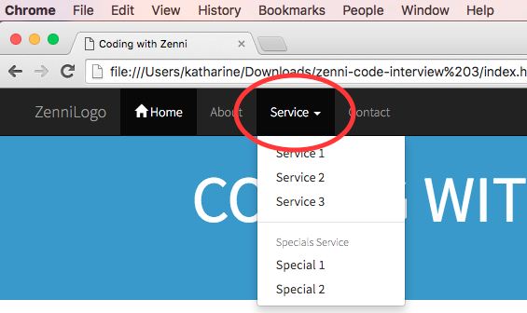

Figure 1: Screenshot for Chrome

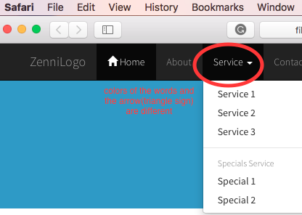

Figure 2: Screenshot for Safari before adding the code

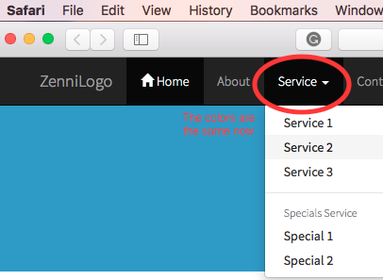

Figure 3: Screenshot for Safari after adding the code