**Scenario 1**

CODE

/*

UPDATE Loans

SET InterestRate = InterestRate * 0.99

WHERE CustomerID IN (

SELECT CustomerID

FROM Customers

WHERE MONTHS_BETWEEN(SYSDATE, DOB) / 12 > 30

);

--Task completed in 0.016 seconds

*/

/*

MERGE INTO Loans l

USING (

SELECT CustomerID

FROM Customers

WHERE MONTHS_BETWEEN(SYSDATE, DOB) / 12 > 30

)

ON (l.CustomerID = c.CustomerID)

WHEN MATCHED THEN

UPDATE SET l.InterestRate = l.InterestRate * 0.99;

--Time taken - 0.037 seconds

*/

DECLARE

BEGIN

FOR customer_record IN (

SELECT * FROM customers WHERE calc_age(dob) >= 30

) LOOP

UPDATE loans

SET interestrate = interestrate * 0.99

WHERE customerid = customer_record.customerid;

END LOOP;

COMMIT;

--Time taken - 0.065 seconds

END;

/

OUTPUT

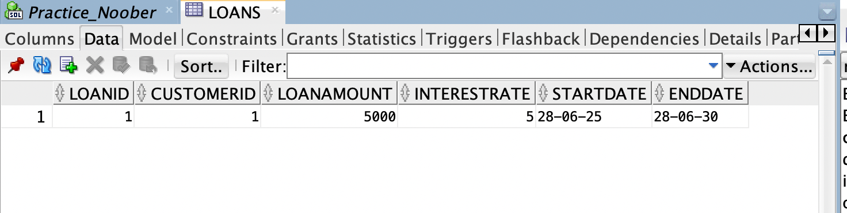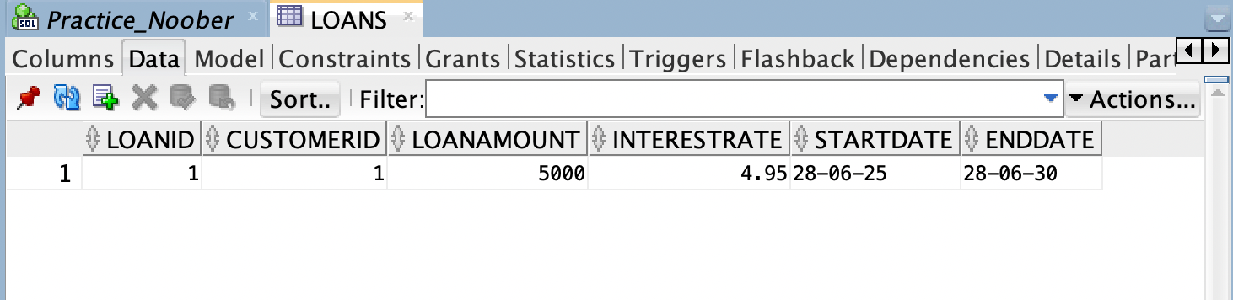

**Scenario 2**

**CODE:**

ALTER TABLE customers

ADD isvip VARCHAR2(5) DEFAULT 'No';

UPDATE customers

SET isvip = 'TRUE'

WHERE balance >= 60000;

**OUTPUT:**

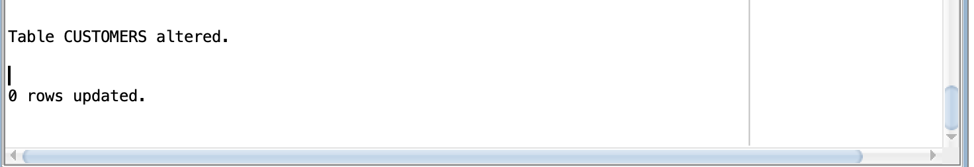

**Scenario 3**

**CODE:**

BEGIN

FOR jr IN (

SELECT c.customerid, c.name, l.loanid, l.enddate

FROM customers c

JOIN loans l

ON l.customerid = c.customerid

WHERE enddate - sysdate <= 30

) LOOP

DBMS_OUTPUT.PUT_LINE('Hi ' || jr.name || ' bearing customer_id ' || jr.customerid);

DBMS_OUTPUT.PUT_LINE('It is to inform that,');

DBMS_OUTPUT.PUT_LINE('Your loan ' || jr.loanid || '''s end date is ' || jr.enddate);

END LOOP;

END;

/

**OUTPUT:**

