ALGORITHM BATTLE-WHICH DATA STRUCTURE WINS?

Selected Application:
Student Record Search
Description:
A Student Record Search System is a simple real-world application used in colleges to store and search student information using a unique Student ID.
For example, a college maintains student details such as:
- Student ID
- Student Name
- Department
When a faculty member wants to find a student's details, they can enter the Student ID instead of manually checking all records.
Why did I select this application?
- It is a real-world application used in educational institutions.
- Every student has a unique Student ID.
- It requires frequent insertion and searching.
- It is suitable for comparing BST, AVL Tree and Hashing.

2.Implement Student Search Record using three data structures:-
- Binary Search Tree (BST)
- AVL Tree
- Hashing

- Binary Search Tree:- The BST implementation stores student records using Student IDs as keys. It supports insertion, searching and inorder traversal. The program also calculates search comparisons and tree height.
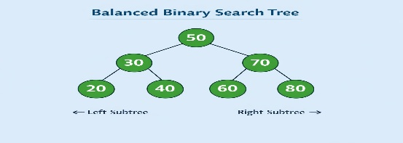
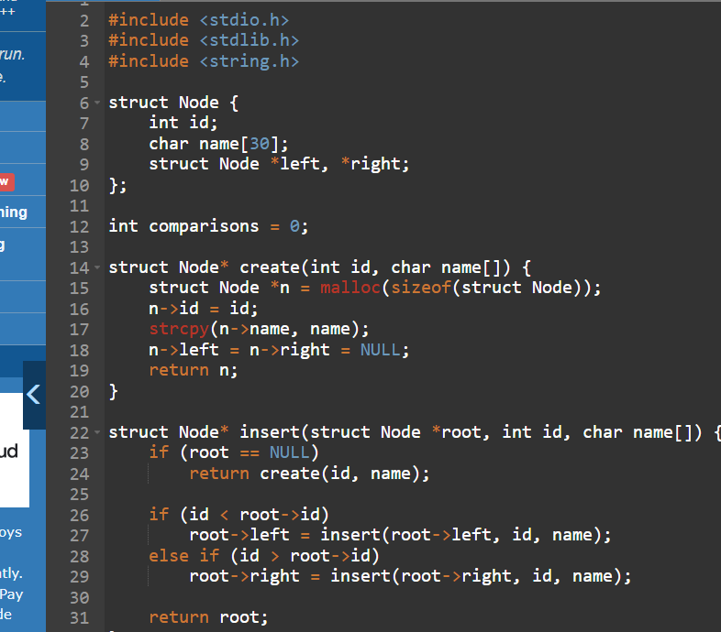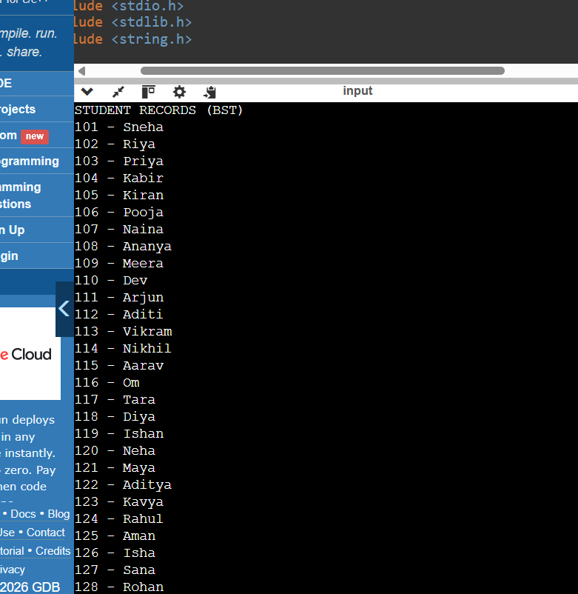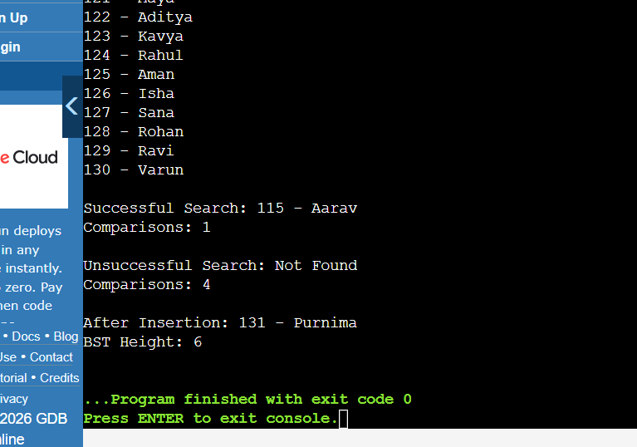

Result: The BST successfully stored 30 student records, performed successful and unsuccessful searches, inserted a new student record and calculated the tree height as 6.

AVL Tree:- It is a self-balancing Binary Search Tree. Unlike an ordinary BST, an AVL Tree automatically balances itself after insertion using rotations.
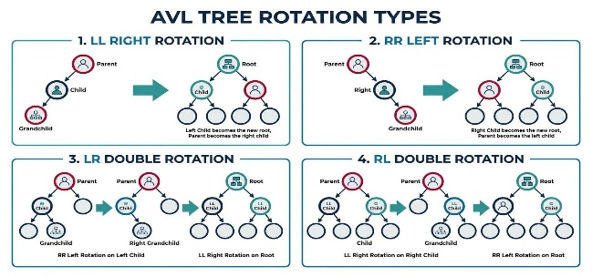
).
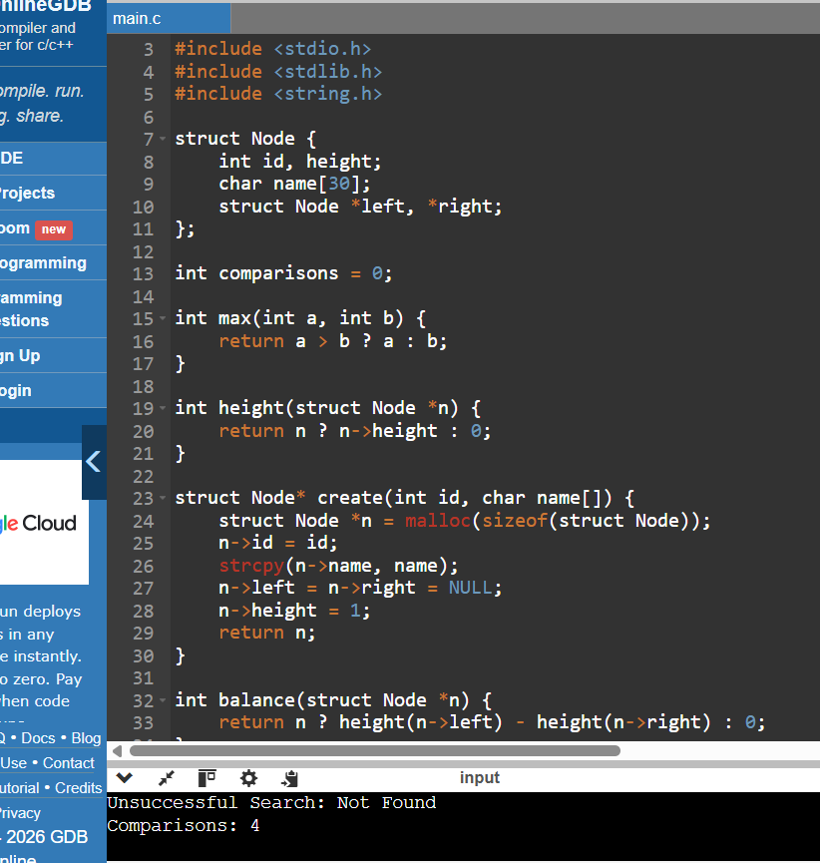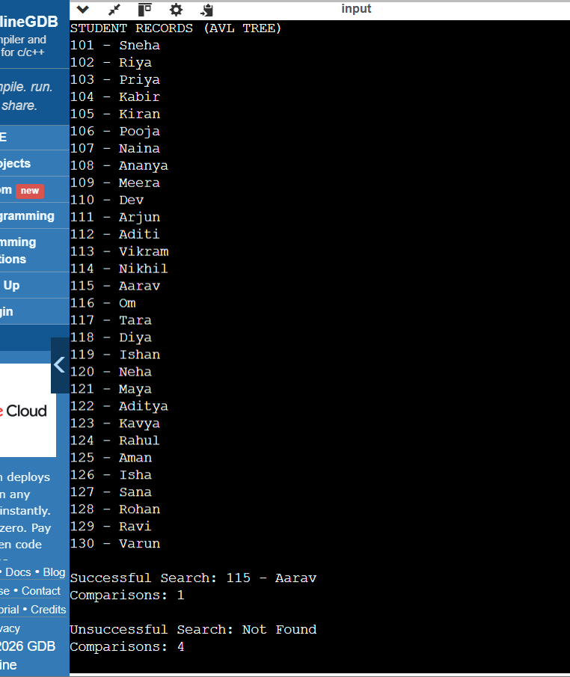
Result: Hence AVL Tree performed insertion of 30 student records, search using Student ID, In-order traversal, automatic balancing using rotations, successful and unsuccessful searches.

Hashing with Linear Probing:- A hash function calculates the index. If two IDs get the same index, a collision occurs. Linear Probing checks the next available position.
$$h\left(key\right)=key \% 50$$
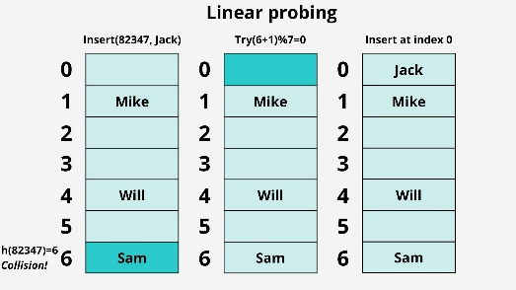
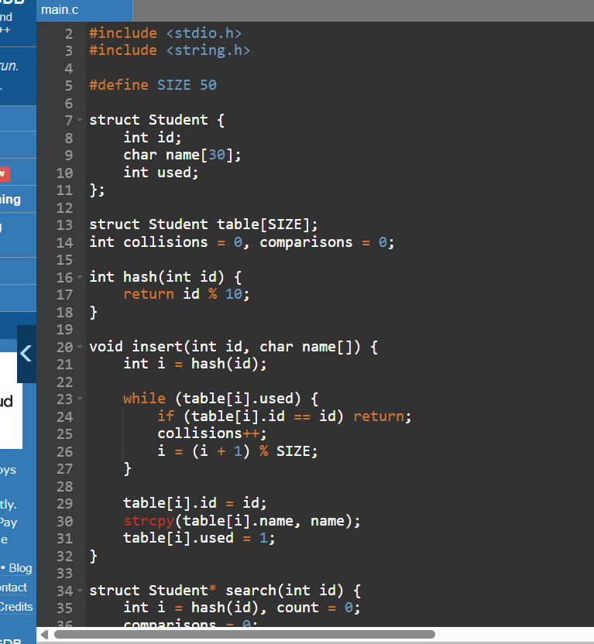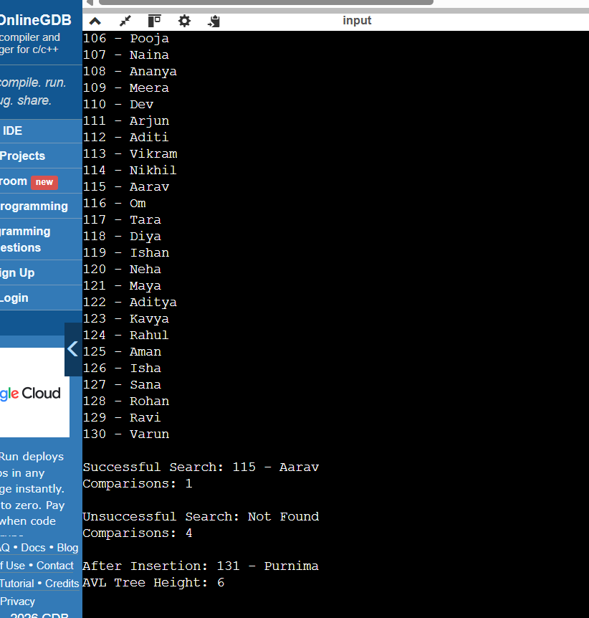
Result:- Hence, using the same student records , we performed successful and unsuccessful search tests.

3.Implement the Basic Operations
3(a). Insertion
Definition: Insertion is the process of adding a new student record into a data structure using a unique Student ID.
BST: Smaller IDs are inserted on the left and larger IDs on the right.
AVL: Records are inserted like BST, followed by balancing if required.
Hashing: A hash function calculates the index. If a collision occurs, Linear Probing finds the next available position.
3(b). Searching
Definition: Searching is the process of finding a student record using the Student ID.
BST: Compares the ID and moves left or right.
AVL: Searches using BST rules while maintaining a balanced tree.
Hashing: Calculates the hash index and checks subsequent positions if necessary.
3(c). Tree Traversal
Traversal is the process of visiting all nodes of a tree.
We use In-order Traversal for both BST and AVL.
Left-> Root-> Right
It displays student records in ascending order of Student ID.
3(d). Collision Handling using Linear Probing
Definition: A collision occurs when two or more Student IDs generate the same hash index.
We handle collisions using Linear Probing.
Hash function:
h(key)=key%10
If the calculated position is occupied, the next position is checked until an empty position is found.

4. Mini Experiment using Dataset
I performed the experiment by running all three C programs in Online GDB using the same 30 student records.
1. Experimental results
Metric | BST | AVL Tree | Hashing
Number of records | 30 | 30 | 30
Successful search (115) | 1 | 1 | 1
Unsuccessful search (999) | 4 | 4 | 21
Height | 6 | 6 | N/A
Initial collisions | N/A | N/A | 300
Total collisions after insertion | N/A | N/A | 329
Insertion of ID 131 | Successful | Successful | Successful
EXPERIMENT AND OBSERVATION
The experiment was conducted using Online GDB, an online C compiler. Three separate C programs were executed to compare Binary Search Tree (BST), AVL Tree and Hashing with Linear Probing.
The same dataset of 30 student records was used in all three implementations.
The following operations were tested:
- Insertion of 30 student records.
- Successful search for student ID 115.
- Unsuccessful search for student ID 999.
- Insertion of a new student record with ID 131 and name Purnima.
- Measurement of search comparisons, tree height and hash collisions.
Observations
- BST successfully searched for ID 115 in 1 comparison and ID 999 in 4 comparisons.
- AVL Tree successfully searched for ID 115 in 1 comparison and ID 999 in 4 comparisons.
- Hashing successfully searched for ID 115 in 1 comparison and required 21 comparisons for ID 999.
- The BST and AVL Tree both had a height of 6 after inserting the new record.
- Hashing recorded 300 collisions initially and 329 total collisions after the new insertion.
All three implementations successfully performed insertion and searching operations.
3. Comparison and recommendation
The AVL Tree is a suitable choice because it maintains balanced searching performance and avoids the possibility of a highly unbalanced tree. Hashing gives fast successful searches, but the selected hash function produces many collisions.
4. Conclusion
The experiment demonstrates that BST, AVL Tree and Hashing can all be used to manage student records. Each data structure has different advantages. Among the three methods, AVL Tree is a reliable choice because it maintains balanced structure and provides efficient searching. Hashing can also be highly efficient when a suitable hash function minimizes collisions. Thus, the experiment shows that the performance of a data structure depends on its organization, balancing and collision-handling technique.

Experimental Outputs:-
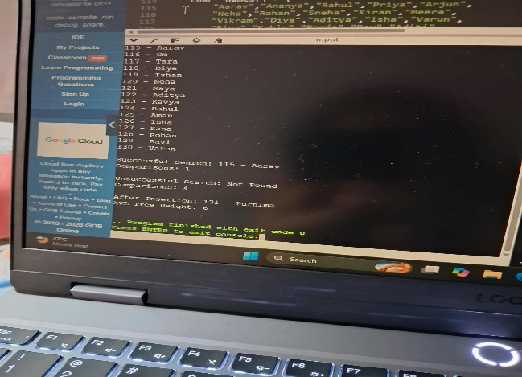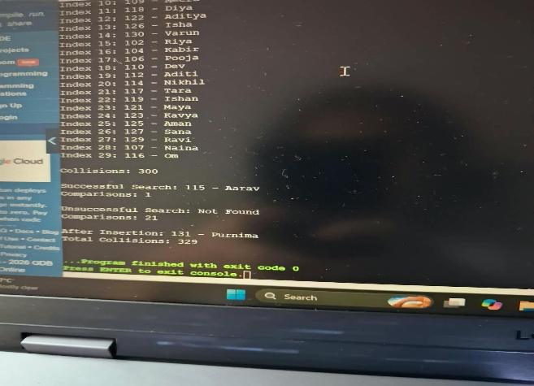
Fig 1: AVL Tree Experimental Output Fig 2: Hashing with Linear Probing Output
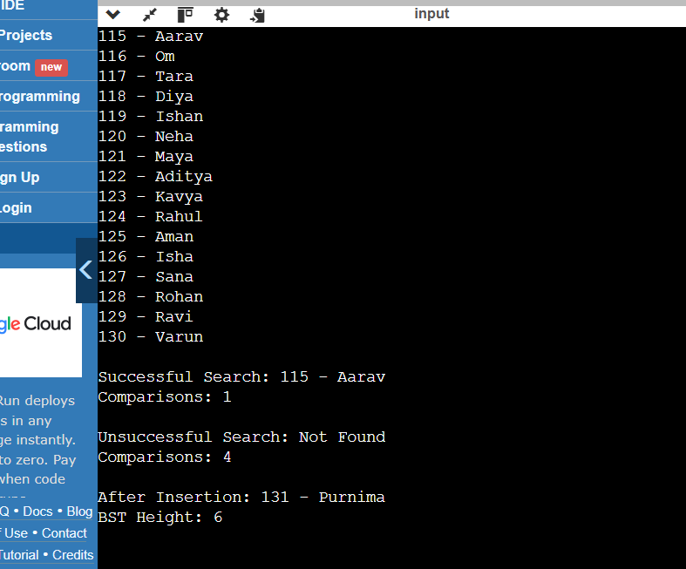
Fig 3: BST Experimental Output

5: Comparison of Data Structures
COMPARISON AND RECOMMENDATION
Comparison:-
Feature | BST | AVL Tree | Hashing
Data organization | Binary tree | Self-balancing binary tree | Hash table
Searching | Based on tree structure | Based on balanced tree | Based on hash function
Successful search comparisons | 1 | 1 | 1
Unsuccessful search comparisons | 4 | 4 | 21
Height | 6 | 6 | Not applicable
Collision handling | Not required | Not required | Linear Probing
Advantage | Simple implementation | Maintains balance | Fast direct access
Disadvantage | Can become unbalanced | Requires rotations | Collisions can increase search time
Recommendation:-
Based on the experiment, AVL Tree is recommended for applications where predictable searching performance is important because it maintains a balanced tree structure.
Hashing is suitable when fast record access is required and an effective hash function is available to minimize collisions.
BST is simple to implement but may become unbalanced depending on the insertion order.
Therefore, the choice of data structure depends on the application's requirements and the dataset.

