# Module 4 Assignment 1

## Katherine Schumann

### Classification Trees

parole <- read_csv("parole.csv")

##   
## -- Column specification --------------------------------------------------------  
## cols(  
## male = col_double(),  
## race = col_double(),  
## age = col_double(),  
## state = col_double(),  
## time.served = col_double(),  
## max.sentence = col_double(),  
## multiple.offenses = col_double(),  
## crime = col_double(),  
## violator = col_double()  
## )

parole = parole %>% mutate(male = as_factor(male)) %>% mutate(male = fct_recode(male, "Male" = "1", "Female" = "0"))  
  
  
parole = parole%>% mutate(race = as_factor(race))%>% mutate(race = fct_recode(race, "White" = "1", "Other" = "2"))  
  
parole = parole%>% mutate(state = as_factor(state))%>% mutate(state = fct_recode(state, "Other" = "1", "Kentucky" = "2", "Louisiana" = "3", "Virginia" = "4"))  
  
parole = parole%>% mutate(multiple.offenses = as_factor(multiple.offenses)) %>% mutate(multiple.offenses = fct_recode(multiple.offenses, "Yes" = "1", "No" = "0"))  
  
parole = parole%>% mutate(crime = as_factor(crime)) %>% mutate(crime = fct_recode(crime, "Other" = "1", "Larceny" = "2", "Drug-related" = "3", "Driving-related" = "4"))  
  
parole = parole %>% mutate(violator = as.character.numeric_version(violator)) %>% mutate(violator = fct_recode(violator, "Yes" = "1", "No" = "0"))

### Task 1

Split the data (training and testing)

set.seed(12345)  
parole_split = initial_split(parole, prop = 0.7, strata = violator) #70% in training  
train = training(parole_split)  
test = testing(parole_split)

### Task 2

Create regression tree

parole_recipe = recipe(violator ~., train)  
  
tree_model = decision_tree() %>%   
 set_engine("rpart", model = TRUE) %>% #don't forget the model = TRUE flag  
 set_mode("classification") #notice different mode here for a regression tree  
  
parole_wflow =   
 workflow() %>%   
 add_model(tree_model) %>%   
 add_recipe(parole_recipe)  
  
parole_fit = fit(parole_wflow, train)

Plot the tree

tree = parole_fit %>%   
 pull_workflow_fit() %>%   
 pluck("fit")  
  
fancyRpartPlot(tree, tweak=1.25)

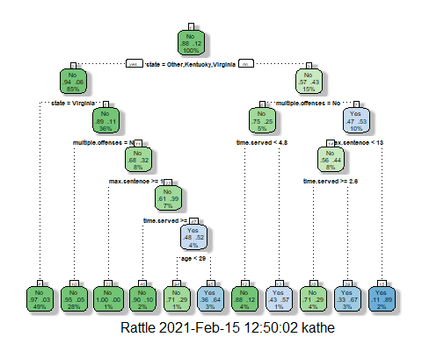

### Task 3

First, the state he is from is not Kentucky, Virginia, or Other, so I would go to the no-decision. Then the parolee has committed multiple offenses, so I would select no classification. With time served over 5 years, I would select the No, which has a probability of 88% not violating the parole. This means we would classify this parolee as not violating parole.

parole_fit$fit$fit$fit$cptable

## CP nsplit rel error xerror xstd  
## 1 0.05454545 0 1.0000000 1.000000 0.1267582  
## 2 0.01818182 4 0.7818182 1.090909 0.1316005  
## 3 0.01454545 5 0.7636364 1.090909 0.1316005  
## 4 0.01000000 10 0.6909091 1.127273 0.1334515

### Task 4

No, the tree is not associated with the optimal value. Since the classification tree that R used has 10 splits, we can see that this has one of the higher xerrors from the above cp table. The optimal cp value is .052, which has a xerror of 1, but a nsplit of 0, meaning no splits or a naive model.

### Task 5

Create our folds

set.seed(123)  
folds = vfold_cv(train, v = 5)

parole_recipe1 = recipe(violator ~., train)  
tree_model = decision_tree(cost_complexity = tune()) %>%   
 set_engine("rpart", model = TRUE) %>% #don't forget the model = TRUE flag  
 set_mode("classification") #notice different mode here for a regression tree  
  
tree_grid = grid_regular(cost_complexity(),  
 levels = 25) #try 25 sensible values for cp  
parole_wflow =   
 workflow() %>%   
 add_model(tree_model) %>%   
 add_recipe(parole_recipe1)  
  
tree_res =   
 parole_wflow %>%   
 tune_grid(  
 resamples = folds,  
 grid = tree_grid  
 )

##   
## Attaching package: 'rlang'

## The following objects are masked from 'package:purrr':  
##   
## %@%, as_function, flatten, flatten_chr, flatten_dbl, flatten_int,  
## flatten_lgl, flatten_raw, invoke, list_along, modify, prepend,  
## splice

##   
## Attaching package: 'vctrs'

## The following object is masked from 'package:dplyr':  
##   
## data_frame

## The following object is masked from 'package:tibble':  
##   
## data_frame

tree_res

## # Tuning results  
## # 5-fold cross-validation   
## # A tibble: 5 x 4  
## splits id .metrics .notes   
## <list> <chr> <list> <list>   
## 1 <split [378/95]> Fold1 <tibble [50 x 5]> <tibble [0 x 1]>  
## 2 <split [378/95]> Fold2 <tibble [50 x 5]> <tibble [0 x 1]>  
## 3 <split [378/95]> Fold3 <tibble [50 x 5]> <tibble [0 x 1]>  
## 4 <split [379/94]> Fold4 <tibble [50 x 5]> <tibble [0 x 1]>  
## 5 <split [379/94]> Fold5 <tibble [50 x 5]> <tibble [0 x 1]>

tree_res %>%  
 collect_metrics() %>%  
 ggplot(aes(cost_complexity, mean)) +  
 geom_line(size = 1.5, alpha = 0.6) +  
 geom_point(size = 2) +  
 facet_wrap(~ .metric, scales = "free", nrow = 2)

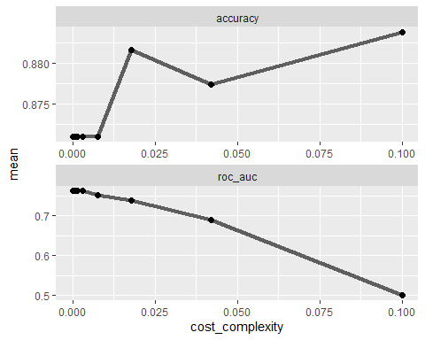

### Task 6

best_tree = tree_res %>%  
 select_best("accuracy")  
  
best_tree

## # A tibble: 1 x 2  
## cost_complexity .config   
## <dbl> <chr>   
## 1 0.1 Preprocessor1_Model25

The best tree yields a cp optimal, accurate value is .1.

### Task 7

final_wf =   
 parole_wflow %>%   
 finalize_workflow(best_tree)

final_fit = fit(final_wf, train)  
  
tree = final_fit %>%   
 pull_workflow_fit() %>%   
 pluck("fit")  
  
#fancyRpartPlot(tree, tweak = 1.5)

### Task 8

treepred = predict(final_fit, train, type = "class")  
head(treepred)

## # A tibble: 6 x 1  
## .pred_class  
## <fct>   
## 1 No   
## 2 No   
## 3 No   
## 4 No   
## 5 No   
## 6 No

Caret confusion matrix and accuracy, etc. calcs

confusionMatrix(treepred$.pred_class,train$violator,positive="Yes") #predictions first then actual

## Confusion Matrix and Statistics  
##   
## Reference  
## Prediction No Yes  
## No 418 55  
## Yes 0 0  
##   
## Accuracy : 0.8837   
## 95% CI : (0.8513, 0.9112)  
## No Information Rate : 0.8837   
## P-Value [Acc > NIR] : 0.5358   
##   
## Kappa : 0   
##   
## Mcnemar's Test P-Value : 3.305e-13   
##   
## Sensitivity : 0.0000   
## Specificity : 1.0000   
## Pos Pred Value : NaN   
## Neg Pred Value : 0.8837   
## Prevalence : 0.1163   
## Detection Rate : 0.0000   
## Detection Prevalence : 0.0000   
## Balanced Accuracy : 0.5000   
##   
## 'Positive' Class : Yes   
##

Since the optimal accuracy value is the naive model, we can use either the accuracy of 88.37% or the no information rate.

### Task 9

Blood <- read_csv("Blood.csv")

##   
## -- Column specification --------------------------------------------------------  
## cols(  
## Mnths_Since_Last = col_double(),  
## TotalDonations = col_double(),  
## Total_Donated = col_double(),  
## Mnths_Since_First = col_double(),  
## DonatedMarch = col_double()  
## )

Blood = Blood %>% mutate(DonatedMarch = as_factor(DonatedMarch)) %>% mutate(DonatedMarch = fct_recode(DonatedMarch, "No" = "0", "Yes" = "1"))

### Task 10

Split the data (training2 and testing2)

set.seed(1234)  
Blood_split = initial_split(Blood, prop = 0.7, strata = DonatedMarch) #70% in training  
train2 = training(Blood_split)  
test2 = testing(Blood_split)

Create our folds

set.seed(1234)  
folds2 = vfold_cv(train2, v = 5)

Blood_recipe = recipe(DonatedMarch ~., train2) %>%  
 step_dummy(all_nominal(),-all_outcomes())  
  
tree1_model = decision_tree(cost_complexity = tune()) %>%   
 set_engine("rpart", model = TRUE) %>% #don't forget the model = TRUE flag  
 set_mode("classification") #notice different mode here for a regression tree  
  
tree1_grid = grid_regular(cost_complexity(),  
 levels = 25) #try 25 sensible values for cp  
Blood_wflow =   
 workflow() %>%   
 add_model(tree1_model) %>%   
 add_recipe(Blood_recipe)  
  
tree1_res =   
 Blood_wflow %>%   
 tune_grid(  
 resamples = folds2,  
 grid = tree1_grid  
 )  
  
tree1_res

## # Tuning results  
## # 5-fold cross-validation   
## # A tibble: 5 x 4  
## splits id .metrics .notes   
## <list> <chr> <list> <list>   
## 1 <split [419/105]> Fold1 <tibble [50 x 5]> <tibble [0 x 1]>  
## 2 <split [419/105]> Fold2 <tibble [50 x 5]> <tibble [0 x 1]>  
## 3 <split [419/105]> Fold3 <tibble [50 x 5]> <tibble [0 x 1]>  
## 4 <split [419/105]> Fold4 <tibble [50 x 5]> <tibble [0 x 1]>  
## 5 <split [420/104]> Fold5 <tibble [50 x 5]> <tibble [0 x 1]>

tree1_res %>%  
 collect_metrics() %>%  
 ggplot(aes(cost_complexity, mean)) +  
 geom_line(size = 1.5, alpha = 0.6) +  
 geom_point(size = 2) +  
 facet_wrap(~ .metric, scales = "free", nrow = 2)

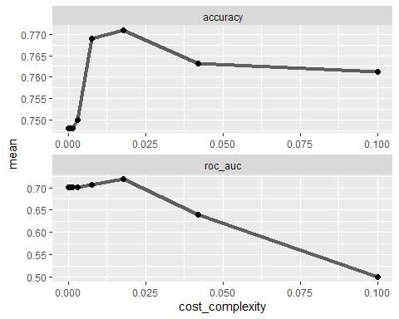

The CP hits an optimal around approx. .017, then it starts to go down and balance out.

best_tree1 = tree1_res %>%  
 select_best("accuracy")  
  
best_tree1

## # A tibble: 1 x 2  
## cost_complexity .config   
## <dbl> <chr>   
## 1 0.0178 Preprocessor1_Model23

### Task 11

final1_wf =   
 Blood_wflow %>%   
 finalize_workflow(best_tree1)

final1_fit = fit(final1_wf, train2)  
  
tree1 = final1_fit %>%   
 pull_workflow_fit() %>%   
 pluck("fit")  
  
fancyRpartPlot(tree1, tweak = 1.5)

### Task 12

Predictions on training set

tree1pred = predict(final1_fit, train2, type = "class")  
head(tree1pred)

## # A tibble: 6 x 1  
## .pred_class  
## <fct>   
## 1 Yes   
## 2 Yes   
## 3 Yes   
## 4 No   
## 5 No   
## 6 Yes

Caret confusion matrix and accuracy, etc. calcs

confusionMatrix(tree1pred$.pred_class,train2$DonatedMarch,positive="Yes") #predictions first then actual

## Confusion Matrix and Statistics  
##   
## Reference  
## Prediction No Yes  
## No 373 76  
## Yes 26 49  
##   
## Accuracy : 0.8053   
## 95% CI : (0.7688, 0.8384)  
## No Information Rate : 0.7615   
## P-Value [Acc > NIR] : 0.009409   
##   
## Kappa : 0.3789   
##   
## Mcnemar's Test P-Value : 1.224e-06   
##   
## Sensitivity : 0.39200   
## Specificity : 0.93484   
## Pos Pred Value : 0.65333   
## Neg Pred Value : 0.83073   
## Prevalence : 0.23855   
## Detection Rate : 0.09351   
## Detection Prevalence : 0.14313   
## Balanced Accuracy : 0.66342   
##   
## 'Positive' Class : Yes   
##

Predictions on testing set

tree1pred_test = predict(final1_fit, test2, type = "class")  
head(tree1pred_test)

## # A tibble: 6 x 1  
## .pred_class  
## <fct>   
## 1 Yes   
## 2 No   
## 3 Yes   
## 4 No   
## 5 No   
## 6 Yes

Caret confusion matrix and accuracy, etc. calcs

confusionMatrix(tree1pred_test$.pred_class,test2$DonatedMarch,positive="Yes") #predictions first then actual

## Confusion Matrix and Statistics  
##   
## Reference  
## Prediction No Yes  
## No 160 38  
## Yes 11 15  
##   
## Accuracy : 0.7812   
## 95% CI : (0.7213, 0.8336)  
## No Information Rate : 0.7634   
## P-Value [Acc > NIR] : 0.2944580   
##   
## Kappa : 0.2653   
##   
## Mcnemar's Test P-Value : 0.0002038   
##   
## Sensitivity : 0.28302   
## Specificity : 0.93567   
## Pos Pred Value : 0.57692   
## Neg Pred Value : 0.80808   
## Prevalence : 0.23661   
## Detection Rate : 0.06696   
## Detection Prevalence : 0.11607   
## Balanced Accuracy : 0.60935   
##   
## 'Positive' Class : Yes   
##

The model ran exceptionally well on the training set with an accuracy of 80.53%, a p-value of 0.009, and the naive model 76.15% accurate. However, the model did not do so well on the testing set. The accuracy was at 78.12%. The naive model of 76.34% with a p-value of .29, meaning that the model's difference to the naive model was insignificant. It did yield a two percent increase in accuracy but not quite enough to make it a significantly better predictor.