# Module 4 Assignment 2

## Katherine Schumann

### Random Forrest

drug = read_csv("drug_data-1.csv")

##   
## -- Column specification --------------------------------------------------------  
## cols(  
## .default = col_character(),  
## Column1 = col_double(),  
## Column2 = col_double(),  
## Column3 = col_double(),  
## Column4 = col_double(),  
## Column5 = col_double(),  
## Column6 = col_double(),  
## Column7 = col_double(),  
## Column8 = col_double(),  
## Column9 = col_double(),  
## Column10 = col_double(),  
## Column11 = col_double(),  
## Column12 = col_double(),  
## Column13 = col_double()  
## )  
## i Use `spec()` for the full column specifications.

names(drug) = c("ID", "Age", "Gender", "Education", "Country", "Ethnicity",  
"Nscore", "Escore", "Oscore", "Ascore", "Cscore", "Impulsive",  
"SS", "Alcohol", "Amphet", "Amyl", "Benzos", "Caff", "Cannabis",  
"Choc", "Coke", "Crack", "Ecstasy", "Heroin", "Ketamine", "Legalh",  
"LSD", "Meth", "Mushrooms", "Nicotine", "Semer", "VSA")

#str(drug)

drug[drug == "CL0"] = "No"  
drug[drug == "CL1"] = "No"  
drug[drug == "CL2"] = "Yes"  
drug[drug == "CL3"] = "Yes"  
drug[drug == "CL4"] = "Yes"  
drug[drug == "CL5"] = "Yes"  
drug[drug == "CL6"] = "Yes"

drug_clean = drug %>% mutate_at(vars(Age:Ethnicity), funs(as_factor)) %>%  
mutate(Age = factor(Age, labels = c("18_24", "25_34", "35_44",  
"45_54", "55_64", "65_"))) %>%  
mutate(Gender = factor(Gender, labels = c("Male", "Female"))) %>%  
mutate(Education = factor(Education, labels =  
c("Under16", "At16", "At17", "At18", "SomeCollege",  
"ProfessionalCert", "Bachelors", "Masters", "Doctorate"))) %>%  
mutate(Country = factor(Country,  
labels = c("USA", "NewZealand", "Other", "Australia",  
"Ireland","Canada","UK"))) %>%  
mutate(Ethnicity = factor(Ethnicity,  
labels = c("Black", "Asian", "White", "White/Black", "Other",  
"White/Asian", "Black/Asian"))) %>%  
mutate_at(vars(Alcohol:VSA), funs(as_factor)) %>%  
select(-ID)

str(drug_clean)

## tibble [1,885 x 31] (S3: tbl_df/tbl/data.frame)  
## $ Age : Factor w/ 6 levels "18_24","25_34",..: 3 2 3 1 3 6 4 3 3 5 ...  
## $ Gender : Factor w/ 2 levels "Male","Female": 2 1 1 2 2 2 1 1 2 1 ...  
## $ Education: Factor w/ 9 levels "Under16","At16",..: 6 9 6 8 9 4 8 2 6 8 ...  
## $ Country : Factor w/ 7 levels "USA","NewZealand",..: 7 7 7 7 7 6 1 7 6 7 ...  
## $ Ethnicity: Factor w/ 7 levels "Black","Asian",..: 6 3 3 3 3 3 3 3 3 3 ...  
## $ Nscore : num [1:1885] 0.313 -0.678 -0.467 -0.149 0.735 ...  
## $ Escore : num [1:1885] -0.575 1.939 0.805 -0.806 -1.633 ...  
## $ Oscore : num [1:1885] -0.5833 1.4353 -0.8473 -0.0193 -0.4517 ...  
## $ Ascore : num [1:1885] -0.917 0.761 -1.621 0.59 -0.302 ...  
## $ Cscore : num [1:1885] -0.00665 -0.14277 -1.0145 0.58489 1.30612 ...  
## $ Impulsive: num [1:1885] -0.217 -0.711 -1.38 -1.38 -0.217 ...  
## $ SS : num [1:1885] -1.181 -0.216 0.401 -1.181 -0.216 ...  
## $ Alcohol : Factor w/ 2 levels "Yes","No": 1 1 1 1 1 1 1 1 1 1 ...  
## $ Amphet : Factor w/ 2 levels "Yes","No": 1 1 2 2 2 2 2 2 2 2 ...  
## $ Amyl : Factor w/ 2 levels "No","Yes": 1 2 1 1 1 1 1 1 1 1 ...  
## $ Benzos : Factor w/ 2 levels "Yes","No": 1 2 2 1 2 2 2 2 2 2 ...  
## $ Caff : Factor w/ 2 levels "Yes","No": 1 1 1 1 1 1 1 1 1 1 ...  
## $ Cannabis : Factor w/ 2 levels "No","Yes": 1 2 2 2 2 1 1 1 1 1 ...  
## $ Choc : Factor w/ 2 levels "Yes","No": 1 1 1 1 1 1 1 1 1 1 ...  
## $ Coke : Factor w/ 2 levels "No","Yes": 1 2 1 2 1 1 1 1 1 1 ...  
## $ Crack : Factor w/ 2 levels "No","Yes": 1 1 1 1 1 1 1 1 1 1 ...  
## $ Ecstasy : Factor w/ 2 levels "No","Yes": 1 2 1 1 1 1 1 1 1 1 ...  
## $ Heroin : Factor w/ 2 levels "No","Yes": 1 1 1 1 1 1 1 1 1 1 ...  
## $ Ketamine : Factor w/ 2 levels "No","Yes": 1 2 1 2 1 1 1 1 1 1 ...  
## $ Legalh : Factor w/ 2 levels "No","Yes": 1 1 1 1 1 1 1 1 1 1 ...  
## $ LSD : Factor w/ 2 levels "No","Yes": 1 2 1 1 1 1 1 1 1 1 ...  
## $ Meth : Factor w/ 2 levels "No","Yes": 1 2 1 1 1 1 1 1 1 1 ...  
## $ Mushrooms: Factor w/ 2 levels "No","Yes": 1 1 1 1 2 1 1 1 1 1 ...  
## $ Nicotine : Factor w/ 2 levels "Yes","No": 1 1 2 1 1 1 1 2 1 1 ...  
## $ Semer : Factor w/ 2 levels "No","Yes": 1 1 1 1 1 1 1 1 1 1 ...  
## $ VSA : Factor w/ 2 levels "No","Yes": 1 1 1 1 1 1 1 1 1 1 ...

drug_clean = drug_clean %>% select(!(Alcohol:Mushrooms)) %>% select(!(Semer:VSA))  
names(drug_clean)

## [1] "Age" "Gender" "Education" "Country" "Ethnicity" "Nscore"   
## [7] "Escore" "Oscore" "Ascore" "Cscore" "Impulsive" "SS"   
## [13] "Nicotine"

### Task 1

skim(drug_clean)

Data summary

|  |  |
| --- | --- |
| Name | drug_clean |
| Number of rows | 1885 |
| Number of columns | 13 |
| _______________________ |  |
| Column type frequency: |  |
| factor | 6 |
| numeric | 7 |
| ________________________ |  |
| Group variables | None |

**Variable type: factor**

|  |  |  |  |  |  |
| --- | --- | --- | --- | --- | --- |
| skim_variable | n_missing | complete_rate | ordered | n_unique | top_counts |
| Age | 0 | 1 | FALSE | 6 | 18_: 643, 25_: 481, 35_: 356, 45_: 294 |
| Gender | 0 | 1 | FALSE | 2 | Mal: 943, Fem: 942 |
| Education | 0 | 1 | FALSE | 9 | Som: 506, Bac: 480, Mas: 283, Pro: 270 |
| Country | 0 | 1 | FALSE | 7 | UK: 1044, USA: 557, Oth: 118, Can: 87 |
| Ethnicity | 0 | 1 | FALSE | 7 | Whi: 1720, Oth: 63, Bla: 33, Asi: 26 |
| Nicotine | 0 | 1 | FALSE | 2 | Yes: 1264, No: 621 |

**Variable type: numeric**

|  |  |  |  |  |  |  |  |  |  |  |
| --- | --- | --- | --- | --- | --- | --- | --- | --- | --- | --- |
| skim_variable | n_missing | complete_rate | mean | sd | p0 | p25 | p50 | p75 | p100 | hist |
| Nscore | 0 | 1 | 0.00 | 1.00 | -3.46 | -0.68 | 0.04 | 0.63 | 3.27 | ▁▃▇▅▁ |
| Escore | 0 | 1 | 0.00 | 1.00 | -3.27 | -0.70 | 0.00 | 0.64 | 3.27 | ▁▃▇▃▁ |
| Oscore | 0 | 1 | 0.00 | 1.00 | -3.27 | -0.72 | -0.02 | 0.72 | 2.90 | ▁▃▇▆▁ |
| Ascore | 0 | 1 | 0.00 | 1.00 | -3.46 | -0.61 | -0.02 | 0.76 | 3.46 | ▁▃▇▃▁ |
| Cscore | 0 | 1 | 0.00 | 1.00 | -3.46 | -0.65 | -0.01 | 0.58 | 3.46 | ▁▃▇▃▁ |
| Impulsive | 0 | 1 | 0.01 | 0.95 | -2.56 | -0.71 | -0.22 | 0.53 | 2.90 | ▁▆▇▃▁ |
| SS | 0 | 1 | 0.00 | 0.96 | -2.08 | -0.53 | 0.08 | 0.77 | 1.92 | ▂▇▇▇▅ |

There is no missingness in the data set.

### Task 2

set.seed(1234)   
drug_split = initial_split(drug_clean, prop = 0.7, strata = Nicotine) #70% in training  
train = training(drug_split)  
test = testing(drug_split)

### Task 3

Visualization

p1 = ggplot(train, aes(x = Age, fill = Nicotine)) + geom_bar(position = "fill")  
p2 = ggplot(train, aes(x = Gender, fill = Nicotine)) + geom_bar(position = "fill")  
p3 = ggplot(train, aes(x = Education, fill = Nicotine)) + geom_bar(position = "fill")  
p4 = ggplot(train, aes(x = Country, fill = Nicotine)) + geom_bar(position = "fill")  
grid.arrange(p1,p2,p3,p4)

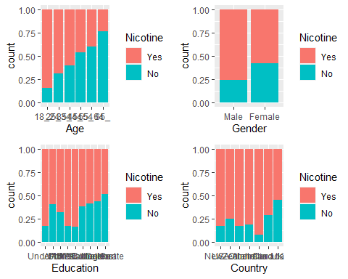

p5 = ggplot(train, aes(x = Ethnicity, fill = Nicotine)) + geom_bar(position = "fill")  
p5

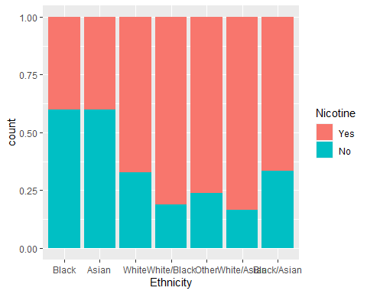

p1 = ggplot(train, aes(x = Nicotine, y = Nscore)) + geom_boxplot()  
p2 = ggplot(train, aes(x = Nicotine, y = Escore)) + geom_boxplot()  
p3 = ggplot(train, aes(x = Nicotine, y = Oscore)) + geom_boxplot()  
p4 = ggplot(train, aes(x = Nicotine, y = Ascore)) + geom_boxplot()  
grid.arrange(p1,p2,p3,p4)

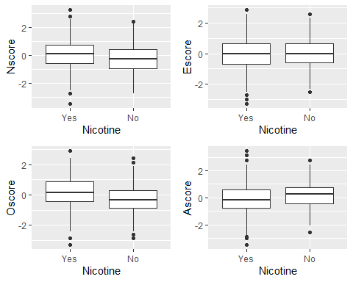

p1 = ggplot(train, aes(x = Nicotine, y = Cscore)) + geom_boxplot()  
p2 = ggplot(train, aes(x = Nicotine, y = Impulsive)) + geom_boxplot()  
p3 = ggplot(train, aes(x = Nicotine, y = SS)) + geom_boxplot()  
  
grid.arrange(p1,p2,p3, ncol=2)

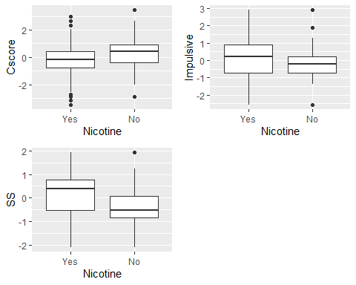

The age showed the most significant relationship between nicotine and age. Gender, country, education, and ethnicity; also tended to establish a connection between nicotine, but it was not as prevalent as age. Nscore(Neuroticism), Escore(Extraversion), Oscore(Openness), and Ascore(Agreeableness) tended to have a similar mean and were not too far apart from using or not using nicotine. Cscore(Conscientiousness) did manage to show closer quartiles and a bit of a higher score for not users. Impulsive due to the, yes, having a wide range did not give the impression of relevance. The SS(Sensation seeing) did have a significant jump from no to yes. I would say that SS, Cscore, and age are some of the most significant predictors.

### Task 4

Set up our folds for cross-validation

set.seed(123)  
rf_folds = vfold_cv(train, v = 5)

Random Forrest

drug_recipe = recipe(Nicotine ~., train) %>%  
 step_dummy(all_nominal(), -all_outcomes())  
  
rf_model = rand_forest(mtry = tune(), min_n = tune(), trees = 100) %>% #add tuning of mtry and min_n parameters  
 #setting trees to 100 here should also speed things up a bit, but more trees might be better  
 set_engine("ranger", importance = "permutation") %>% #added importance metric  
 set_mode("classification")  
  
drug_wflow =   
 workflow() %>%   
 add_model(rf_model) %>%   
 add_recipe(drug_recipe)  
  
rf_grid = grid_regular(  
 mtry(range = c(2, 8)), #these values determined through significant trial and error  
 min_n(range = c(5, 20)), #these values determined through significant trial and error  
 levels = 10  
)  
  
set.seed(123)  
rf_res = tune_grid(  
 drug_wflow,  
 resamples = rf_folds,  
 grid = 20 #try 20 different combinations of the random forest tuning parameters  
)

Look at parameter performance (borrowed from <https://juliasilge.com/blog/sf-trees-random-tuning/>)

rf_res %>%  
 collect_metrics() %>%  
 filter(.metric == "accuracy") %>%  
 select(mean, min_n, mtry) %>%  
 pivot_longer(min_n:mtry,  
 values_to = "value",  
 names_to = "parameter"  
 ) %>%  
 ggplot(aes(value, mean, color = parameter)) +  
 geom_point(show.legend = FALSE) +  
 facet_wrap(~parameter, scales = "free_x") +  
 labs(x = NULL, y = "Accuracy")

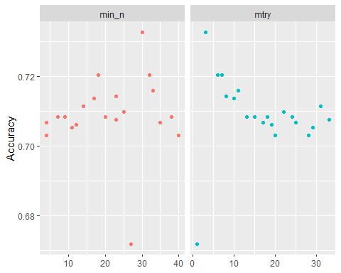

### Task 5

best_rf = select_best(rf_res, "accuracy")  
  
final_rf = finalize_workflow(  
 drug_wflow,  
 best_rf  
)  
  
final_rf

## == Workflow ====================================================================  
## Preprocessor: Recipe  
## Model: rand_forest()  
##   
## -- Preprocessor ----------------------------------------------------------------  
## 1 Recipe Step  
##   
## * step_dummy()  
##   
## -- model -----------------------------------------------------------------------  
## Random Forest Model Specification (classification)  
##   
## Main Arguments:  
## mtry = 3  
## trees = 100  
## min_n = 30  
##   
## Engine-Specific Arguments:  
## importance = permutation  
##   
## Computational engine: ranger

#fit the finalized workflow to our training data  
final_rf_fit = fit(final_rf, train)

Check out variable importance

final_rf_fit %>% pull_workflow_fit() %>% vip(geom = "point")

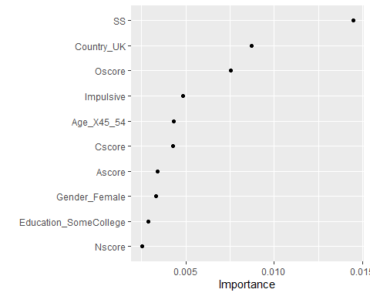

The Sensation Seeing score is the most important, and then the country UK and Openness to experience score. Surprisingly, age is not up there as a prevalent predictor.

### Task 6

Predictions

trainpredrf = predict(final_rf_fit, train)  
head(trainpredrf)

## # A tibble: 6 x 1  
## .pred_class  
## <fct>   
## 1 Yes   
## 2 Yes   
## 3 Yes   
## 4 No   
## 5 Yes   
## 6 Yes

Confusion matrix

confusionMatrix(trainpredrf$.pred_class, train$Nicotine,   
 positive = "Yes")

## Confusion Matrix and Statistics  
##   
## Reference  
## Prediction Yes No  
## Yes 846 189  
## No 39 246  
##   
## Accuracy : 0.8273   
## 95% CI : (0.8058, 0.8473)  
## No Information Rate : 0.6705   
## P-Value [Acc > NIR] : < 2.2e-16   
##   
## Kappa : 0.5716   
##   
## Mcnemar's Test P-Value : < 2.2e-16   
##   
## Sensitivity : 0.9559   
## Specificity : 0.5655   
## Pos Pred Value : 0.8174   
## Neg Pred Value : 0.8632   
## Prevalence : 0.6705   
## Detection Rate : 0.6409   
## Detection Prevalence : 0.7841   
## Balanced Accuracy : 0.7607   
##   
## 'Positive' Class : Yes   
##

Predictions on test

testpredrf = predict(final_rf_fit, test)  
head(testpredrf)

## # A tibble: 6 x 1  
## .pred_class  
## <fct>   
## 1 Yes   
## 2 No   
## 3 No   
## 4 Yes   
## 5 No   
## 6 Yes

confusionMatrix(testpredrf$.pred_class, test$Nicotine,   
 positive = "Yes")

## Confusion Matrix and Statistics  
##   
## Reference  
## Prediction Yes No  
## Yes 330 123  
## No 49 63  
##   
## Accuracy : 0.6956   
## 95% CI : (0.6558, 0.7333)  
## No Information Rate : 0.6708   
## P-Value [Acc > NIR] : 0.1129   
##   
## Kappa : 0.233   
##   
## Mcnemar's Test P-Value : 2.604e-08   
##   
## Sensitivity : 0.8707   
## Specificity : 0.3387   
## Pos Pred Value : 0.7285   
## Neg Pred Value : 0.5625   
## Prevalence : 0.6708   
## Detection Rate : 0.5841   
## Detection Prevalence : 0.8018   
## Balanced Accuracy : 0.6047   
##   
## 'Positive' Class : Yes   
##

The model did really well on the train set; it had an accuracy of 80.73% with a low p-value, less than .001, and a naive model of 67.05. However, the model did not perform well on the test set. It is still better than the naive model but only 2%, with a p-value of 1%, which means the findings are still significant but not nearly as good as the train set.

### Task 7

This model could be used in the real world to determine who the nicotine should market towards. Or in who physicians should be warning about the health risks of smoking. I would recommend using this model, but I would attempt to expand the forest to see if we could find better results on the test set. I would be concerned that there would be a false positive rate. (we can see in the confusion matrix that the prediction is yes, but the reference is no, and that is 123, which is double the correct amount of no samples) so that would have to be monitored and understood before using the model.