# Project Part 1

## Katherine Schumann

ames_student <- read_csv("C:/Users/kathe/OneDrive/Desktop/Ban 502/Project/ames_student.csv")

ames_clean = ames_student %>% mutate_at(vars(MS_SubClass:Above_Median), funs(as_factor)) %>%  
mutate(MS_SubClass = as_factor(MS_SubClass)) %>%  
mutate(MS_Zoning = as_factor(MS_Zoning))%>%  
mutate(Street = as_factor(Street))%>%  
mutate(Alley = as_factor(Alley))%>%  
mutate(Lot_Shape = as_factor(Lot_Shape))%>%  
mutate(Land_Contour = as_factor(Land_Contour))%>%  
 mutate(Utilities = as_factor(Utilities))%>%  
 mutate(Land_Slope = as_factor(Land_Slope))%>%  
 mutate(Neighborhood = as_factor(Neighborhood))%>%  
 mutate(Condition_1 = as_factor(Condition_1))%>%  
 mutate(Condition_2 = as_factor(Condition_2))%>%  
 mutate(Bldg_Type = as_factor(Bldg_Type))%>%  
 mutate(House_Style = as_factor(House_Style))%>%  
 mutate(Overall_Qual = as_factor(Overall_Qual))%>%  
 mutate(Overall_Cond = as_factor(Overall_Cond))%>%  
 mutate(Roof_Style = as_factor(Roof_Style))%>%  
 mutate(Roof_Matl = as_factor(Roof_Matl))%>%  
 mutate(Exterior_1st = as_factor(Exterior_1st))%>%  
 mutate(Exterior_2nd = as_factor(Exterior_2nd))%>%  
 mutate(Mas_Vnr_Type = as_factor(Mas_Vnr_Type))%>%  
 mutate(Exter_Cond = as_factor(Exter_Cond))%>%  
 mutate(Foundation = as_factor(Foundation))%>%  
 mutate(Bsmt_Qual = as_factor(Bsmt_Qual))%>%  
 mutate(Bsmt_Cond = as_factor(Bsmt_Cond))%>%  
 mutate(BsmtFin_Type_1 = as_factor(MS_Zoning))%>%  
 mutate(BsmtFin_Type_2 = as_factor(BsmtFin_Type_2))%>%  
 mutate(Heating = as_factor(Heating))%>%  
 mutate(Central_Air = as_factor(Central_Air))%>%  
 mutate(ElElectrical = as_factor(Electrical))%>%  
 mutate(Kitchen_Qual = as_factor(Kitchen_Qual))%>%  
 mutate(Functional = as_factor(Functional))%>%  
 mutate(Fireplace_Qu = as_factor(Fireplace_Qu))%>%  
 mutate(Garage_Type = as_factor(Garage_Type))%>%  
 mutate(Garage_Finish = as_factor(Garage_Finish))%>%  
 mutate(Garage_Qual = as_factor(Garage_Qual))%>%  
 mutate(Garage_Cond = as_factor(Garage_Cond))%>%  
 mutate(Paved_Drive = as_factor(Paved_Drive))%>%  
 mutate(Pool_QC = as_factor(Pool_QC))%>%  
 mutate(Misc_Feature = as_factor(Misc_Feature))%>%  
 mutate(Sale_Type = as_factor(Sale_Type))%>%  
 mutate(Sale_Condition = as_factor(Sale_Condition))%>%  
 mutate(Garage_Cars = factor(Garage_Cars, labels = c("0","1","2","3","4","5")))%>%  
mutate(Fireplaces = factor(Fireplaces, labels = c("0","1","2","3","4")))%>%  
mutate(Kitchen_AbvGr = factor(Kitchen_AbvGr, labels = c("1","2","3")))%>%  
 mutate(Bedroom_AbvGr = factor(Bedroom_AbvGr, labels = c("0","1","2","3","4","5","6")))%>%  
 mutate(Half_Bath = factor(Half_Bath, labels = c("0","1","2")))%>%  
 mutate(Full_Bath = factor(Full_Bath, labels = c("0","1","2","3","4")))%>%  
 mutate(Bsmt_Half_Bath = factor(Bsmt_Half_Bath, labels = c("0","1","2")))%>%  
 mutate(Bsmt_Full_Bath = factor(Bsmt_Full_Bath, labels = c("0","1","2","3")))%>%  
 mutate(BsmtFin_SF_1 = factor(BsmtFin_SF_1, labels = c("1","2","3","4","5","6", "7")))

skim(ames_clean)

Data summary

|  |  |
| --- | --- |
| Name | ames_clean |
| Number of rows | 2053 |
| Number of columns | 83 |
| _______________________ |  |
| Column type frequency: |  |
| factor | 82 |
| numeric | 1 |
| ________________________ |  |
| Group variables | None |

**Variable type: factor**

|  |  |  |  |  |  |
| --- | --- | --- | --- | --- | --- |
| skim_variable | n_missing | complete_rate | ordered | n_unique | top_counts |
| MS_SubClass | 0 | 1 | FALSE | 16 | One: 772, Two: 383, One: 204, One: 129 |
| MS_Zoning | 0 | 1 | FALSE | 7 | Res: 1600, Res: 326, Flo: 87, Res: 20 |
| Lot_Frontage | 0 | 1 | FALSE | 120 | 0: 349, 60: 213, 80: 103, 70: 87 |
| Lot_Area | 0 | 1 | FALSE | 1458 | 720: 36, 960: 35, 600: 28, 900: 20 |
| Street | 0 | 1 | FALSE | 2 | Pav: 2046, Grv: 7 |
| Alley | 0 | 1 | FALSE | 3 | No_: 1914, Gra: 94, Pav: 45 |
| Lot_Shape | 0 | 1 | FALSE | 4 | Reg: 1275, Sli: 714, Mod: 53, Irr: 11 |
| Land_Contour | 0 | 1 | FALSE | 4 | Lvl: 1833, HLS: 94, Bnk: 81, Low: 45 |
| Utilities | 0 | 1 | FALSE | 2 | All: 2052, NoS: 1 |
| Lot_Config | 0 | 1 | FALSE | 5 | Ins: 1495, Cor: 359, Cul: 135, FR2: 56 |
| Land_Slope | 0 | 1 | FALSE | 3 | Gtl: 1951, Mod: 89, Sev: 13 |
| Neighborhood | 0 | 1 | FALSE | 28 | Nor: 327, Col: 183, Old: 181, Edw: 129 |
| Condition_1 | 0 | 1 | FALSE | 9 | Nor: 1771, Fee: 113, Art: 67, RRA: 35 |
| Condition_2 | 0 | 1 | FALSE | 8 | Nor: 2027, Fee: 12, Pos: 4, Art: 4 |
| Bldg_Type | 0 | 1 | FALSE | 5 | One: 1706, Twn: 157, Dup: 76, Twn: 67 |
| House_Style | 0 | 1 | FALSE | 8 | One: 1052, Two: 590, One: 225, SLv: 90 |
| Overall_Qual | 0 | 1 | FALSE | 10 | Ave: 587, Abo: 518, Goo: 411, Ver: 237 |
| Overall_Cond | 0 | 1 | FALSE | 9 | Ave: 1143, Abo: 376, Goo: 286, Ver: 98 |
| Year_Built | 0 | 1 | FALSE | 114 | 200: 104, 200: 93, 200: 76, 200: 62 |
| Year_Remod_Add | 0 | 1 | FALSE | 61 | 195: 256, 200: 147, 200: 116, 200: 94 |
| Roof_Style | 0 | 1 | FALSE | 6 | Gab: 1607, Hip: 404, Gam: 14, Fla: 14 |
| Roof_Matl | 0 | 1 | FALSE | 6 | Com: 2023, Tar: 17, WdS: 8, WdS: 3 |
| Exterior_1st | 0 | 1 | FALSE | 16 | Vin: 705, Met: 319, Wd : 313, HdB: 303 |
| Exterior_2nd | 0 | 1 | FALSE | 17 | Vin: 699, Met: 317, Wd : 302, HdB: 277 |
| Mas_Vnr_Type | 0 | 1 | FALSE | 5 | Non: 1231, Brk: 638, Sto: 166, Brk: 17 |
| Mas_Vnr_Area | 0 | 1 | FALSE | 382 | 0: 1227, 16: 11, 120: 10, 72: 9 |
| Exter_Qual | 0 | 1 | FALSE | 4 | Typ: 1272, Goo: 682, Exc: 78, Fai: 21 |
| Exter_Cond | 0 | 1 | FALSE | 5 | Typ: 1787, Goo: 213, Fai: 43, Exc: 9 |
| Foundation | 0 | 1 | FALSE | 6 | PCo: 911, CBl: 880, Brk: 216, Sla: 36 |
| Bsmt_Qual | 0 | 1 | FALSE | 6 | Typ: 911, Goo: 849, Exc: 178, No_: 57 |
| Bsmt_Cond | 0 | 1 | FALSE | 6 | Typ: 1833, Goo: 80, Fai: 76, No_: 57 |
| Bsmt_Exposure | 0 | 1 | FALSE | 5 | No: 1331, Av: 284, Gd: 199, Mn: 179 |
| BsmtFin_Type_1 | 0 | 1 | FALSE | 7 | Res: 1600, Res: 326, Flo: 87, Res: 20 |
| BsmtFin_SF_1 | 0 | 1 | FALSE | 7 | 7: 602, 3: 578, 1: 298, 6: 216 |
| BsmtFin_Type_2 | 0 | 1 | FALSE | 7 | Unf: 1740, Rec: 79, LwQ: 64, No_: 58 |
| BsmtFin_SF_2 | 0 | 1 | FALSE | 210 | 0: 1798, 180: 5, 294: 4, 144: 3 |
| Bsmt_Unf_SF | 0 | 1 | FALSE | 947 | 0: 174, 384: 13, 728: 12, 672: 10 |
| Total_Bsmt_SF | 0 | 1 | FALSE | 892 | 0: 57, 864: 54, 672: 25, 912: 22 |
| Heating | 0 | 1 | FALSE | 6 | Gas: 2019, Gas: 21, Gra: 6, Wal: 5 |
| Heating_QC | 0 | 1 | FALSE | 5 | Exc: 1040, Typ: 618, Goo: 333, Fai: 61 |
| Central_Air | 0 | 1 | FALSE | 2 | Y: 1916, N: 137 |
| Electrical | 0 | 1 | FALSE | 5 | SBr: 1887, Fus: 126, Fus: 33, Fus: 6 |
| First_Flr_SF | 0 | 1 | FALSE | 942 | 864: 31, 104: 20, 912: 17, 672: 13 |
| Second_Flr_SF | 0 | 1 | FALSE | 508 | 0: 1192, 546: 18, 728: 14, 504: 11 |
| Low_Qual_Fin_SF | 0 | 1 | FALSE | 28 | 0: 2024, 80: 2, 360: 2, 53: 1 |
| Gr_Liv_Area | 0 | 1 | FALSE | 1057 | 864: 28, 109: 18, 104: 16, 120: 16 |
| Bsmt_Full_Bath | 0 | 1 | FALSE | 4 | 0: 1201, 1: 823, 2: 27, 3: 2 |
| Bsmt_Half_Bath | 0 | 1 | FALSE | 3 | 0: 1936, 1: 115, 2: 2 |
| Full_Bath | 0 | 1 | FALSE | 5 | 2: 1080, 1: 920, 3: 41, 0: 10 |
| Half_Bath | 0 | 1 | FALSE | 3 | 0: 1300, 1: 736, 2: 17 |
| Bedroom_AbvGr | 0 | 1 | FALSE | 7 | 3: 1105, 2: 527, 4: 297, 1: 73 |
| Kitchen_AbvGr | 0 | 1 | FALSE | 3 | 1: 1959, 2: 92, 3: 2 |
| Kitchen_Qual | 0 | 1 | FALSE | 5 | Typ: 1070, Goo: 790, Exc: 142, Fai: 50 |
| TotRms_AbvGrd | 0 | 1 | FALSE | 11 | 6: 589, 7: 468, 5: 416, 8: 245 |
| Functional | 0 | 1 | FALSE | 8 | Typ: 1896, Min: 54, Min: 51, Mod: 27 |
| Fireplaces | 0 | 1 | FALSE | 5 | 0: 993, 1: 891, 2: 161, 3: 7 |
| Fireplace_Qu | 0 | 1 | FALSE | 6 | No_: 993, Goo: 538, Typ: 409, Fai: 56 |
| Garage_Type | 0 | 1 | FALSE | 7 | Att: 1204, Det: 549, Bui: 127, No_: 108 |
| Garage_Finish | 0 | 1 | FALSE | 4 | Unf: 872, RFn: 563, Fin: 509, No_: 109 |
| Garage_Cars | 0 | 1 | FALSE | 6 | 2: 1131, 1: 539, 3: 261, 0: 108 |
| Garage_Area | 0 | 1 | FALSE | 523 | 0: 108, 576: 71, 440: 68, 240: 50 |
| Garage_Qual | 0 | 1 | FALSE | 6 | Typ: 1839, No_: 109, Fai: 85, Goo: 16 |
| Garage_Cond | 0 | 1 | FALSE | 6 | Typ: 1872, No_: 109, Fai: 53, Goo: 10 |
| Paved_Drive | 0 | 1 | FALSE | 3 | Pav: 1848, Dir: 163, Par: 42 |
| Wood_Deck_SF | 0 | 1 | FALSE | 321 | 0: 1084, 100: 55, 192: 49, 168: 45 |
| Open_Porch_SF | 0 | 1 | FALSE | 226 | 0: 907, 48: 37, 36: 36, 40: 30 |
| Enclosed_Porch | 0 | 1 | FALSE | 150 | 0: 1716, 112: 14, 144: 10, 96: 9 |
| Three_season_porch | 0 | 1 | FALSE | 24 | 0: 2025, 153: 3, 168: 2, 180: 2 |
| Screen_Porch | 0 | 1 | FALSE | 97 | 0: 1868, 144: 10, 120: 7, 192: 7 |
| Pool_Area | 0 | 1 | FALSE | 7 | 0: 2047, 144: 1, 228: 1, 368: 1 |
| Pool_QC | 0 | 1 | FALSE | 5 | No_: 2047, Exc: 2, Typ: 2, Fai: 1 |
| Fence | 0 | 1 | FALSE | 5 | No_: 1661, Min: 225, Goo: 81, Goo: 77 |
| Misc_Feature | 0 | 1 | FALSE | 5 | Non: 1978, She: 66, Gar: 5, Oth: 3 |
| Misc_Val | 0 | 1 | FALSE | 33 | 0: 1979, 400: 13, 500: 11, 700: 6 |
| Mo_Sold | 0 | 1 | FALSE | 12 | 6: 352, 7: 320, 5: 275, 4: 187 |
| Year_Sold | 0 | 1 | FALSE | 5 | 200: 499, 200: 456, 200: 445, 200: 442 |
| Sale_Type | 0 | 1 | FALSE | 10 | WD: 1789, New: 163, COD: 54, Con: 16 |
| Sale_Condition | 0 | 1 | FALSE | 6 | Nor: 1712, Par: 169, Abn: 121, Fam: 30 |
| Longitude | 0 | 1 | FALSE | 1970 | -93: 4, -93: 4, -93: 3, -93: 3 |
| Latitude | 0 | 1 | FALSE | 1965 | 42.: 5, 42.: 4, 42.: 4, 42.: 3 |
| Above_Median | 0 | 1 | FALSE | 2 | Yes: 1043, No: 1010 |
| ElElectrical | 0 | 1 | FALSE | 5 | SBr: 1887, Fus: 126, Fus: 33, Fus: 6 |

**Variable type: numeric**

|  |  |  |  |  |  |  |  |  |  |  |
| --- | --- | --- | --- | --- | --- | --- | --- | --- | --- | --- |
| skim_variable | n_missing | complete_rate | mean | sd | p0 | p25 | p50 | p75 | p100 | hist |
| X1 | 0 | 1 | 1027 | 592.79 | 1 | 514 | 1027 | 1540 | 2053 | ▇▇▇▇▇ |

Visualization

p1 = ggplot(ames_clean, aes(x = MS_SubClass, fill = Above_Median)) + geom_bar(position = "fill")  
p2 = ggplot(ames_clean, aes(x = MS_Zoning, fill = Above_Median)) + geom_bar(position = "fill")  
p3 = ggplot(ames_clean, aes(x = Street, fill = Above_Median)) + geom_bar(position = "fill")  
p4 = ggplot(ames_clean, aes(x = Alley, fill = Above_Median)) + geom_bar(position = "fill")  
grid.arrange(p1,p2,p3,p4)

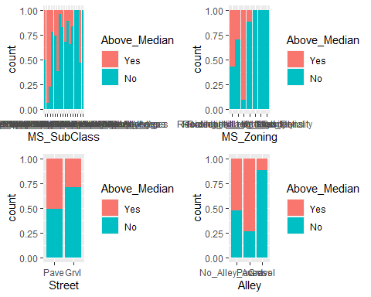

p1 = ggplot(ames_clean, aes(x = Lot_Shape, fill = Above_Median)) + geom_bar(position = "fill")  
p2 = ggplot(ames_clean, aes(x = Land_Contour, fill = Above_Median)) + geom_bar(position = "fill")  
p3 = ggplot(ames_clean, aes(x = Utilities, fill = Above_Median)) + geom_bar(position = "fill")  
p4 = ggplot(ames_clean, aes(x = Lot_Config, fill = Above_Median)) + geom_bar(position = "fill")  
grid.arrange(p1,p2,p3,p4)

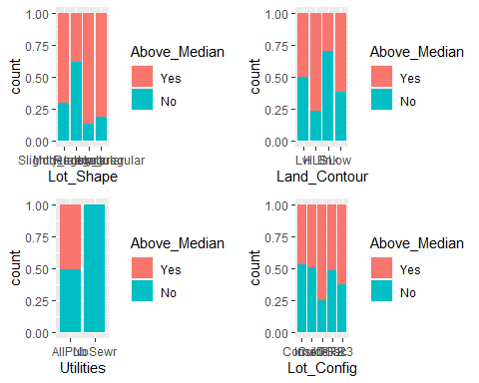

p1 = ggplot(ames_clean, aes(x = Land_Slope, fill = Above_Median)) + geom_bar(position = "fill")  
p2 = ggplot(ames_clean, aes(x = Neighborhood, fill = Above_Median)) + geom_bar(position = "fill")  
p3 = ggplot(ames_clean, aes(x = Condition_1, fill = Above_Median)) + geom_bar(position = "fill")  
p4 = ggplot(ames_clean, aes(x = Condition_2, fill = Above_Median)) + geom_bar(position = "fill")  
grid.arrange(p1,p2,p3,p4)

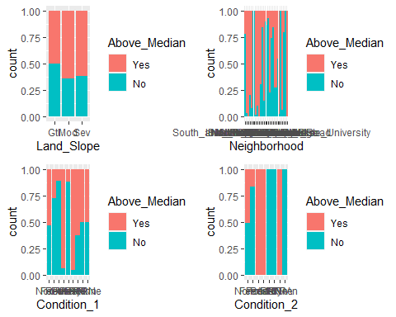

p1 = ggplot(ames_clean, aes(x = Bldg_Type, fill = Above_Median)) + geom_bar(position = "fill")  
p2 = ggplot(ames_clean, aes(x = House_Style, fill = Above_Median)) + geom_bar(position = "fill")  
p3 = ggplot(ames_clean, aes(x = Overall_Qual, fill = Above_Median)) + geom_bar(position = "fill")+theme(axis.text=element_text(size=7))  
p4 = ggplot(ames_clean, aes(x = Overall_Cond, fill = Above_Median)) + geom_bar(position = "fill")+theme(axis.text=element_text(size=7))  
grid.arrange(p1,p2,p3,p4)

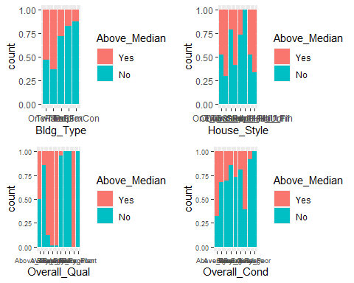

p1 = ggplot(ames_clean, aes(x = Roof_Style, fill = Above_Median)) + geom_bar(position = "fill")  
p2 = ggplot(ames_clean, aes(x = Roof_Matl, fill = Above_Median)) + geom_bar(position = "fill")  
p3 = ggplot(ames_clean, aes(x = Exterior_1st, fill = Above_Median)) + geom_bar(position = "fill")  
p4 = ggplot(ames_clean, aes(x = Exterior_2nd, fill = Above_Median)) + geom_bar(position = "fill")  
grid.arrange(p1,p2,p3,p4)

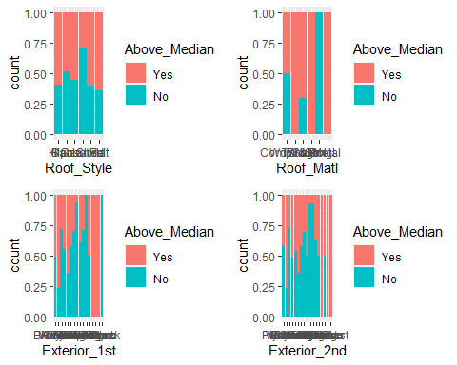

p1 = ggplot(ames_clean, aes(x = Mas_Vnr_Type, fill = Above_Median)) + geom_bar(position = "fill")  
p2 = ggplot(ames_clean, aes(x = Exter_Qual, fill = Above_Median)) + geom_bar(position = "fill")  
p3 = ggplot(ames_clean, aes(x = Exter_Cond, fill = Above_Median)) + geom_bar(position = "fill")  
p4 = ggplot(ames_clean, aes(x = Foundation, fill = Above_Median)) + geom_bar(position = "fill")  
grid.arrange(p1,p2,p3,p4)

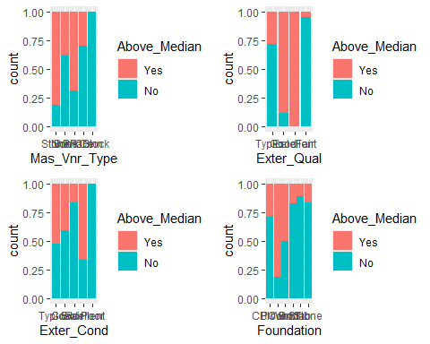

p1 = ggplot(ames_clean, aes(x = Bsmt_Qual, fill = Above_Median)) + geom_bar(position = "fill")  
p2 = ggplot(ames_clean, aes(x = Bsmt_Cond, fill = Above_Median)) + geom_bar(position = "fill")  
p3 = ggplot(ames_clean, aes(x = Bsmt_Exposure, fill = Above_Median)) + geom_bar(position = "fill")  
p4 = ggplot(ames_clean, aes(x = BsmtFin_Type_1, fill = Above_Median)) + geom_bar(position = "fill")  
grid.arrange(p1,p2,p3,p4)

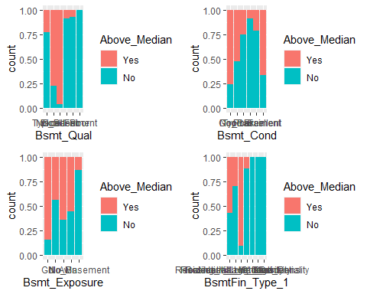

p1 = ggplot(ames_clean, aes(x = BsmtFin_Type_2, fill = Above_Median)) + geom_bar(position = "fill")  
p2 = ggplot(ames_clean, aes(x = Heating, fill = Above_Median)) + geom_bar(position = "fill")  
p3 = ggplot(ames_clean, aes(x = Central_Air, fill = Above_Median)) + geom_bar(position = "fill")  
p4 = ggplot(ames_clean, aes(x = Electrical, fill = Above_Median)) + geom_bar(position = "fill")  
grid.arrange(p1,p2,p3,p4)

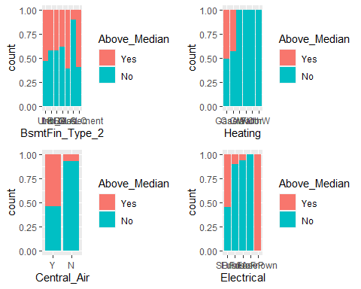

p1 = ggplot(ames_clean, aes(x = Kitchen_Qual, fill = Above_Median)) + geom_bar(position = "fill")  
p2 = ggplot(ames_clean, aes(x = Fireplace_Qu, fill = Above_Median)) + geom_bar(position = "fill")  
p3 = ggplot(ames_clean, aes(x = Garage_Type, fill = Above_Median)) + geom_bar(position = "fill")  
p4 = ggplot(ames_clean, aes(x = Garage_Finish, fill = Above_Median)) + geom_bar(position = "fill")  
grid.arrange(p1,p2,p3,p4)

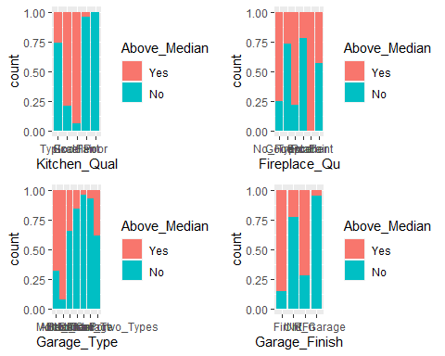

p1 = ggplot(ames_clean, aes(x = Garage_Qual, fill = Above_Median)) + geom_bar(position = "fill")  
p2 = ggplot(ames_clean, aes(x = Garage_Cond, fill = Above_Median)) + geom_bar(position = "fill")  
p3 = ggplot(ames_clean, aes(x = Paved_Drive, fill = Above_Median)) + geom_bar(position = "fill")  
p4 = ggplot(ames_clean, aes(x = Pool_QC, fill = Above_Median)) + geom_bar(position = "fill")  
grid.arrange(p1,p2,p3,p4)

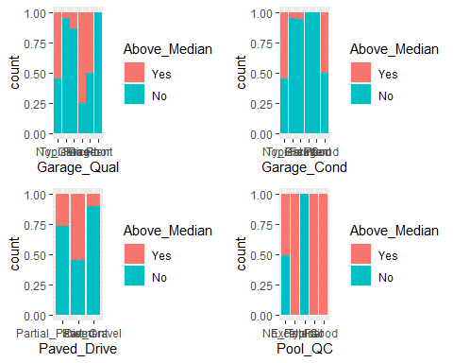

p1 = ggplot(ames_clean, aes(x = Fence, fill = Above_Median)) + geom_bar(position = "fill")  
p2 = ggplot(ames_clean, aes(x = Misc_Feature, fill = Above_Median)) + geom_bar(position = "fill")  
p3 = ggplot(ames_clean, aes(x = Sale_Type, fill = Above_Median)) + geom_bar(position = "fill")  
p4 = ggplot(ames_clean, aes(x = Sale_Condition, fill = Above_Median)) + geom_bar(position = "fill")  
grid.arrange(p1,p2,p3,p4)

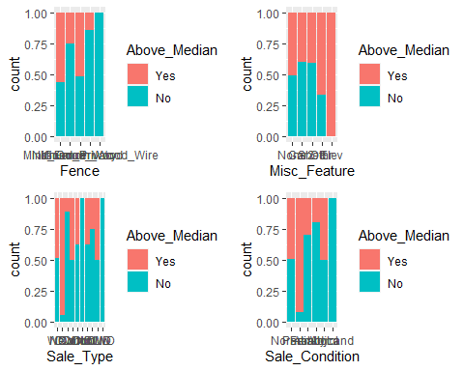

p1 = ggplot(ames_clean, aes(x = Garage_Cars, fill = Above_Median)) + geom_bar(position = "fill")  
p2 = ggplot(ames_clean, aes(x = Fireplaces, fill = Above_Median)) + geom_bar(position = "fill")  
p3 = ggplot(ames_clean, aes(x = Half_Bath, fill = Above_Median)) + geom_bar(position = "fill")  
p4 = ggplot(ames_clean, aes(x = Full_Bath, fill = Above_Median)) + geom_bar(position = "fill")  
grid.arrange(p1,p2,p3,p4)

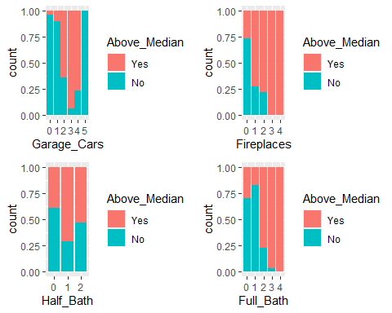

p1 = ggplot(ames_clean, aes(x = Bsmt_Half_Bath, fill = Above_Median)) + geom_bar(position = "fill")  
p2 = ggplot(ames_clean, aes(x = Bsmt_Full_Bath, fill = Above_Median)) + geom_bar(position = "fill")  
p3 = ggplot(ames_clean, aes(x = BsmtFin_SF_1, fill = Above_Median)) + geom_bar(position = "fill")  
grid.arrange(p1,p2,p3)

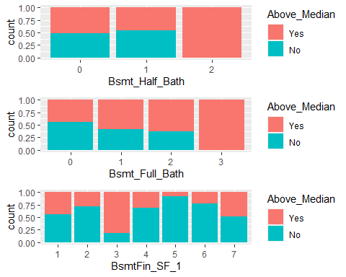

p1 = ggplot(ames_student, aes(x = Above_Median, y = Lot_Frontage)) + geom_boxplot(aes(fill = Above_Median)) + theme_bw()+geom_jitter(alpha = 0.1)  
p2 = ggplot(ames_student, aes(x = Above_Median, y = Lot_Area)) + geom_boxplot(aes(fill = Above_Median)) + theme_bw()+geom_jitter(alpha = 0.1)  
p3 = ggplot(ames_student, aes(x = Above_Median, y = Year_Built)) + geom_boxplot(aes(fill = Above_Median)) + theme_bw()+geom_jitter(alpha = 0.1)  
p4 = ggplot(ames_student, aes(x = Above_Median, y = Year_Remod_Add)) + geom_boxplot(aes(fill = Above_Median)) + theme_bw()+geom_jitter(alpha = 0.1)  
grid.arrange(p1,p2,p3,p4)

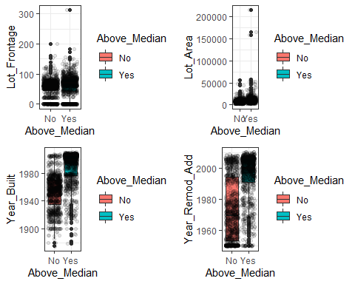

p1 = ggplot(ames_student, aes(x = Above_Median, y = Mas_Vnr_Area)) + geom_boxplot(aes(fill = Above_Median)) + theme_bw() +geom_jitter(alpha = 0.1)  
p2 = ggplot(ames_student, aes(x = Above_Median, y = BsmtFin_SF_1)) + geom_boxplot(aes(fill = Above_Median)) + theme_bw()+geom_jitter(alpha = 0.1)  
p3 = ggplot(ames_student, aes(x = Above_Median, y = BsmtFin_SF_2)) + geom_boxplot(aes(fill = Above_Median)) + theme_bw()+geom_jitter(alpha = 0.1)  
p4 = ggplot(ames_student, aes(x = Above_Median, y = Bsmt_Unf_SF)) + geom_boxplot(aes(fill = Above_Median)) + theme_bw()+geom_jitter(alpha = 0.1)  
grid.arrange(p1,p2,p3,p4)

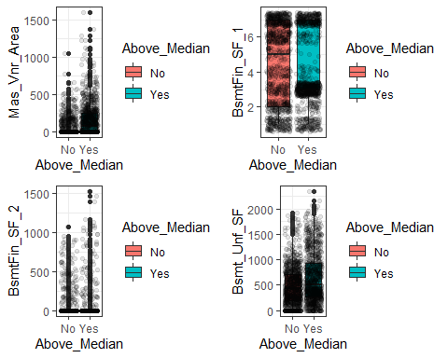

p1 = ggplot(ames_student, aes(x = Above_Median, y = Total_Bsmt_SF)) + geom_boxplot(aes(fill = Above_Median)) + theme_bw()+geom_jitter(alpha = 0.1)  
p2 = ggplot(ames_student, aes(x = Above_Median, y = First_Flr_SF)) + geom_boxplot(aes(fill = Above_Median)) + theme_bw()+geom_jitter(alpha = 0.1)  
p3 = ggplot(ames_student, aes(x = Above_Median, y = Second_Flr_SF)) + geom_boxplot(aes(fill = Above_Median)) + theme_bw()+geom_jitter(alpha = 0.1)  
p4 = ggplot(ames_student, aes(x = Above_Median, y = Low_Qual_Fin_SF)) + geom_boxplot(aes(fill = Above_Median)) + theme_bw()+geom_jitter(alpha = 0.1)  
grid.arrange(p1,p2,p3,p4)

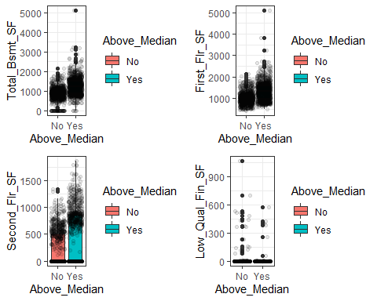

p1 = ggplot(ames_student, aes(x = Above_Median, y = Gr_Liv_Area)) + geom_boxplot(aes(fill = Above_Median)) + theme_bw()+geom_jitter(alpha = 0.1)  
p2 = ggplot(ames_student, aes(x = Above_Median, y = Bsmt_Full_Bath)) + geom_boxplot(aes(fill = Above_Median)) + theme_bw()+geom_jitter(alpha = 0.1)  
p3 = ggplot(ames_student, aes(x = Above_Median, y = Half_Bath)) + geom_boxplot(aes(fill = Above_Median)) + theme_bw()+geom_jitter(alpha = 0.1)  
p4 = ggplot(ames_student, aes(x = Above_Median, y = Bedroom_AbvGr)) + geom_boxplot(aes(fill = Above_Median)) + theme_bw()+geom_jitter(alpha = 0.1)  
grid.arrange(p1,p2,p3,p4)

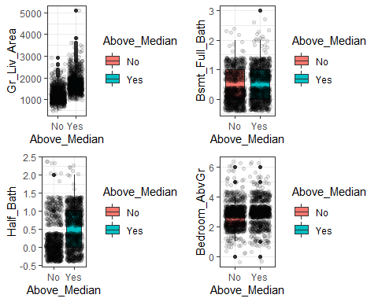

p1 = ggplot(ames_student, aes(x = Above_Median, y = Kitchen_AbvGr)) + geom_boxplot(aes(fill = Above_Median)) + theme_bw()+geom_jitter(alpha = 0.1)  
p2 = ggplot(ames_student, aes(x = Above_Median, y = TotRms_AbvGrd)) + geom_boxplot(aes(fill = Above_Median)) + theme_bw()+geom_jitter(alpha = 0.1)  
p3 = ggplot(ames_student, aes(x = Above_Median, y = Fireplaces)) + geom_boxplot(aes(fill = Above_Median)) + theme_bw()+geom_jitter(alpha = 0.1)  
p4 = ggplot(ames_student, aes(x = Above_Median, y = Garage_Cars)) + geom_boxplot(aes(fill = Above_Median)) + theme_bw()+geom_jitter(alpha = 0.1)  
grid.arrange(p1,p2,p3,p4)

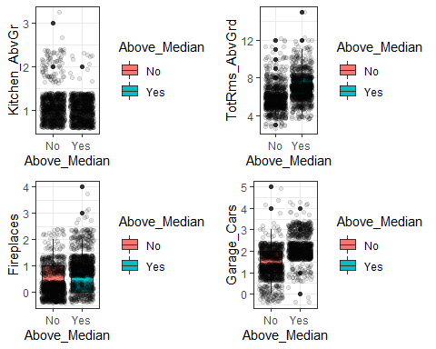

p1 = ggplot(ames_student, aes(x = Above_Median, y = Garage_Area)) + geom_boxplot(aes(fill = Above_Median)) + theme_bw()+geom_jitter(alpha = 0.1)  
p2 = ggplot(ames_student, aes(x = Above_Median, y = Wood_Deck_SF)) + geom_boxplot(aes(fill = Above_Median)) + theme_bw()+geom_jitter(alpha = 0.1)  
p3 = ggplot(ames_student, aes(x = Above_Median, y = Open_Porch_SF)) + geom_boxplot(aes(fill = Above_Median)) + theme_bw()+geom_jitter(alpha = 0.1)  
p4 = ggplot(ames_student, aes(x = Above_Median, y = Enclosed_Porch)) + geom_boxplot(aes(fill = Above_Median)) + theme_bw()+geom_jitter(alpha = 0.1)  
grid.arrange(p1,p2,p3,p4)

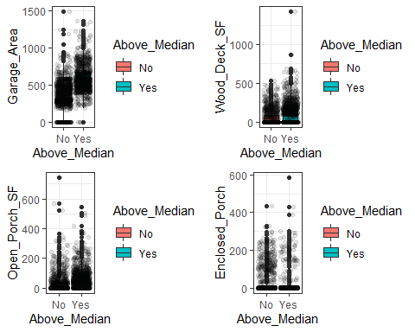

p1 = ggplot(ames_student, aes(x = Above_Median, y = Three_season_porch)) + geom_boxplot(aes(fill = Above_Median)) + theme_bw()+geom_jitter(alpha = 0.1)  
p2 = ggplot(ames_student, aes(x = Above_Median, y = Screen_Porch)) + geom_boxplot(aes(fill = Above_Median)) + theme_bw()+geom_jitter(alpha = 0.1)  
p3 = ggplot(ames_student, aes(x = Above_Median, y = Pool_Area)) + geom_boxplot(aes(fill = Above_Median)) + theme_bw()+geom_jitter(alpha = 0.1)  
p4 = ggplot(ames_student, aes(x = Above_Median, y = Misc_Val)) + geom_boxplot(aes(fill = Above_Median)) + theme_bw()+geom_jitter(alpha = 0.1)  
grid.arrange(p1,p2,p3,p4)

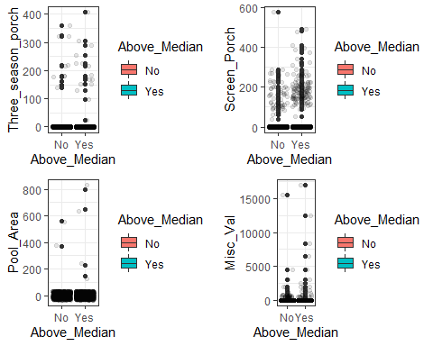

p1 = ggplot(ames_student, aes(x = Above_Median, y = Mo_Sold)) + geom_boxplot(aes(fill = Above_Median)) + theme_bw()+geom_jitter(alpha = 0.1)  
p2 = ggplot(ames_student, aes(x = Above_Median, y = Year_Sold)) + geom_boxplot(aes(fill = Above_Median)) + theme_bw()+geom_jitter(alpha = 0.1)  
p3 = ggplot(ames_student, aes(x = Above_Median, y = Longitude)) + geom_boxplot(aes(fill = Above_Median)) + theme_bw()+geom_jitter(alpha = 0.1)  
p4 = ggplot(ames_student, aes(x = Above_Median, y = Latitude)) + geom_boxplot(aes(fill = Above_Median)) + theme_bw()+geom_jitter(alpha = 0.1)  
grid.arrange(p1,p2,p3,p4)

