LAB 6

F74036069

1.

(1) True.

(2) False.

A has-a relationship is implemented by composition, while an is-a relationship represents inheritance.

(3) False.

The Student class inherits nothing from neither the Faculty nor the Couse class.

(4) False.

If we use the get member functions, we can get the private members of the base class.

(5) True.

2.

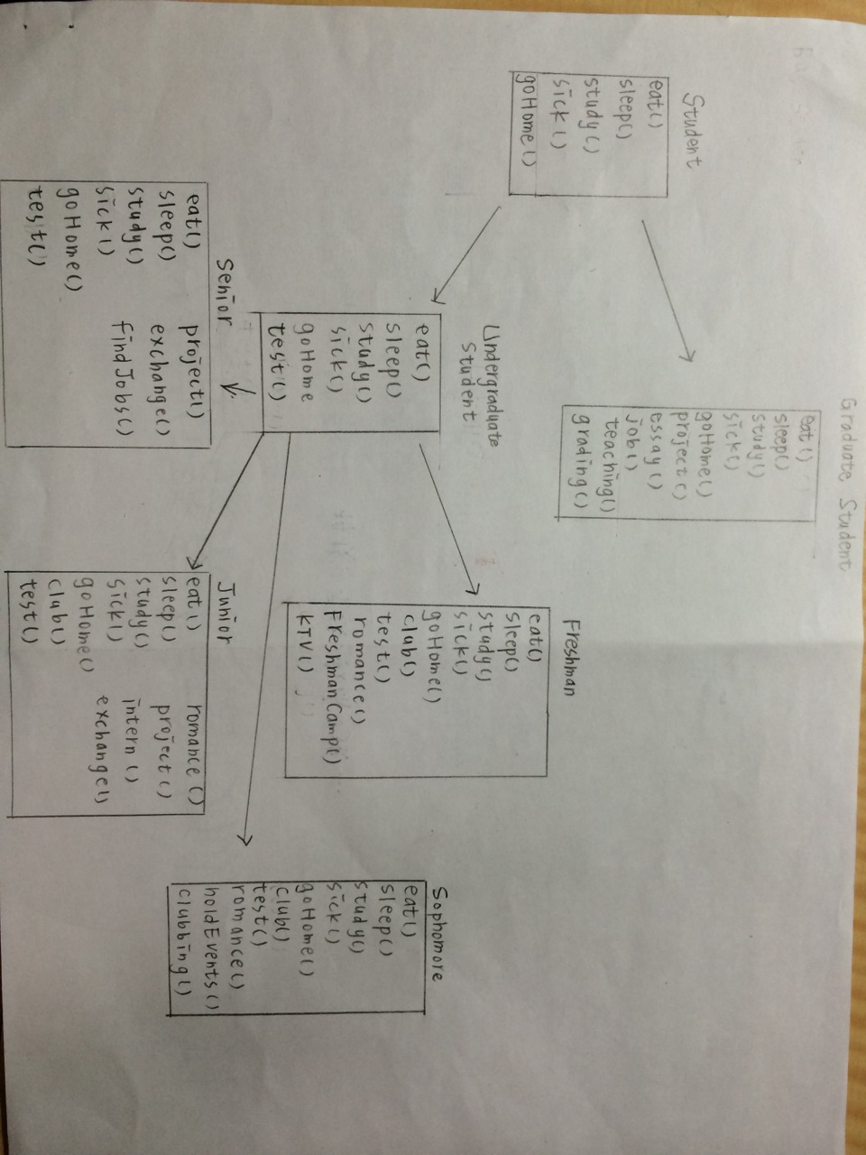

(1) For the Graduate Student class, it is a derived class which has a single inheritance to its direct base class, Student.

(2) For the Freshman class, Sophomore class, Junior class, Senior class, all of their direct base class is the Undergraduate Student class, and their indirect base class is the Student class. All of the inheritances are single.