SẮC KÝ v2
ACTION SPACE
PRODUCT, UX & UI IMPLEMENTATION SPECIFICATION v1.0
Capture → Plan → Reflect
Build baseline / Codex handoff

Module | Action Space
Replaces | Reminder (UI/product naming)
Core loop | Capture → Plan → Reflect
Create Action | MODAL — not a full-page flow
Notification | Out of v1
Recurrence | Out of v1
Gamification | Gentle / reflection-backed

0. Purpose
Action Space là nơi biến điều user vừa nhận ra thành một bước nhỏ có thể làm, đặt bước đó vào thời gian nếu muốn, rồi nhìn lại xem sau khi làm xong user thực sự cảm thấy thế nào.
Capture → Plan → Reflect
• Không phải project/task-management suite.
• Không tối ưu cho priority, productivity score, project, leaderboard hay deadline pressure.
• Canonical Action được dùng chung giữa Check-in, Home và Action Space.

1. Locked Product Decisions

1.1 Naming
• Navigation label là Action Space.
• Home có thể giữ section label thân thiện như Việc cần làm.
• Không dùng Reminder làm product concept chính nữa.

1.2 Canonical Action
• Action tạo từ Check-in suggestion, Check-in custom hay Action Space đều là cùng canonical object.
• Không copy Action thành nhiều object giữa module.

1.3 Fields
• Title bắt buộc.
• Description/Note optional.
• Schedule optional.
• Exact time optional.
• Current linked Check-in optional.

1.4 Planning scope
• Unscheduled hoàn toàn hợp lệ.
• Một ngày, date range và optional exact time đều được hỗ trợ.
• Date-range Action là một canonical row, không duplicate theo ngày.
• Notification và recurrence không thuộc v1.

1.5 No productivity taxonomy
• Không Priority High/Medium/Low.
• Không Project/Category/Folder.
• Không productivity score.

1.6 Linkage
• 1 Action tối đa 1 current linked Check-in.
• 1 Check-in tối đa 2 active linked Actions.
• Link/unlink/change Check-in được phép.
• Origin immutable dù linkage thay đổi.

1.7 Done / Reflection
• Done thành công → rewarding animation → Reflection popup luôn bật ngay.
• Reflection chỉ hỏi: “Làm xong, bạn thấy thế nào rồi?”
• Outcome bắt buộc nếu user chọn lưu; Note optional; Skip được.
• Undone không xóa reflection cycle cũ; Done lại tạo cycle mới.

1.8 Delete
• Delete Action là hard delete product semantics.
• Xóa Action + completion/reflection history của Action.
• Không xóa Check-in liên quan.

2. Product Architecture — Capture → Plan → Reflect

2.1 Capture
• Create Action là modal.
• Cho phép tạo chỉ với Title.
• Không bắt schedule.
• Unscheduled → Chưa lên lịch.

2.2 Plan
• Plan chỉ xử lý thời gian và current Check-in linkage.
• User có thể plan ngay khi tạo hoặc plan sau.
• Date / date range / exact time optional.

2.3 Reflect
• Done không kết thúc im lặng.
• Reflection popup tạo feedback loop.
• Về sau insight có thể trả lời “Những bước nào từng giúp mình?”

3. Conceptual Data Model

Action
• id
• user_id
• title
• description?
• status: active | done
• origin_type
• origin_ref_id?
• current_linked_checkin_id?
• schedule_type: none | date | date_range
• start_local_date?
• end_local_date?
• exact_local_time?
• created_at
• updated_at
• completed_at?

ActionCompletionCycle
• id
• action_id
• completed_at
• reopened_at?
• cycle_number

ActionReflection
• id
• action_id
• completion_cycle_id
• outcome_id
• outcome_snapshot?
• note?
• created_at
• updated_at
Existing DB table may still be named `reminders`. V1 does not require a risky database rename if current persistence works; semantic layer/UI should use Action.

4. Time & Sorting Semantics
• Unscheduled → Chưa lên lịch.
• One-day today → Hôm nay; future → Upcoming; past + active → Quá hạn.
• Date range appears once, not once per day.
• Today sorting: timed ascending, untimed, then active ranges.
• Upcoming: Tomorrow / This week / Later; date/time ascending.
• Unscheduled: created_at DESC.
• Completed: completed_at DESC.

5. Screen Inventory & Visual Authority

A01 — Action Space / Today
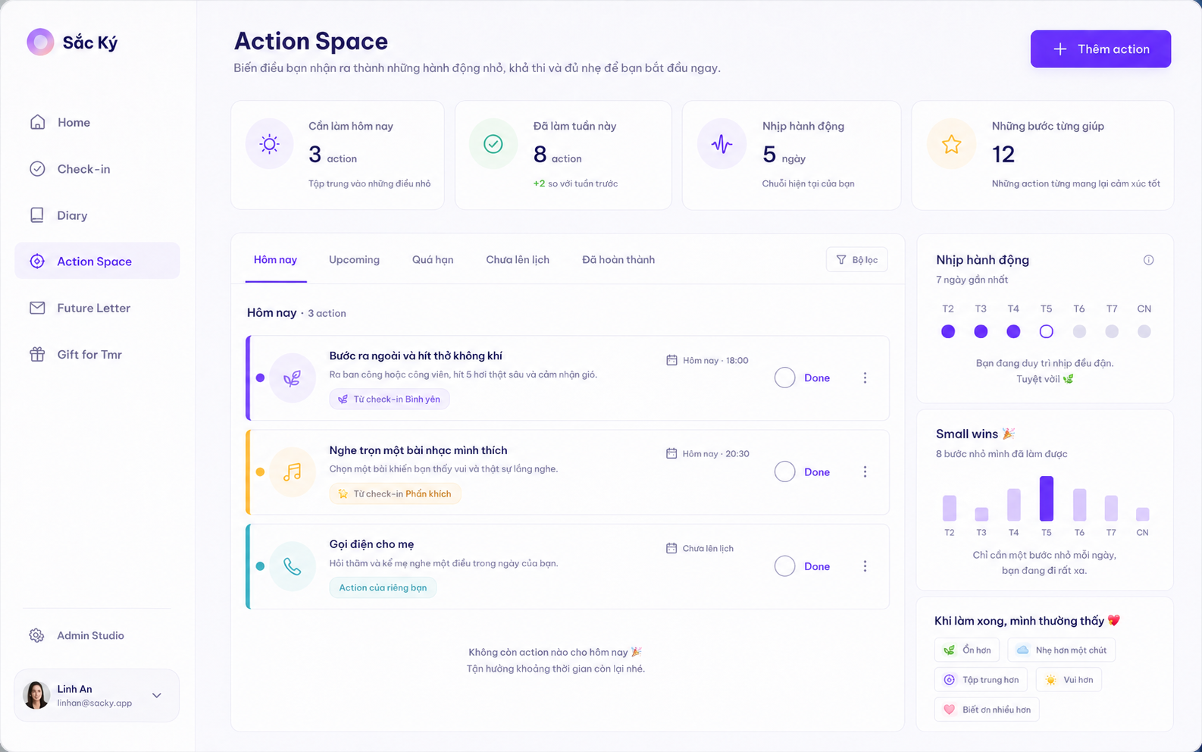
Approved directional mockup — A01 — Action Space / Today

Implementation requirements
• Dashboard max 4 metrics.
• 5 tabs.
• Compact Action cards with linked Check-in hex accents.
• Right rail supportive: rhythm, Small Wins, reflection pattern.
• Primary CTA + Thêm action.

A02 — Create Action Modal
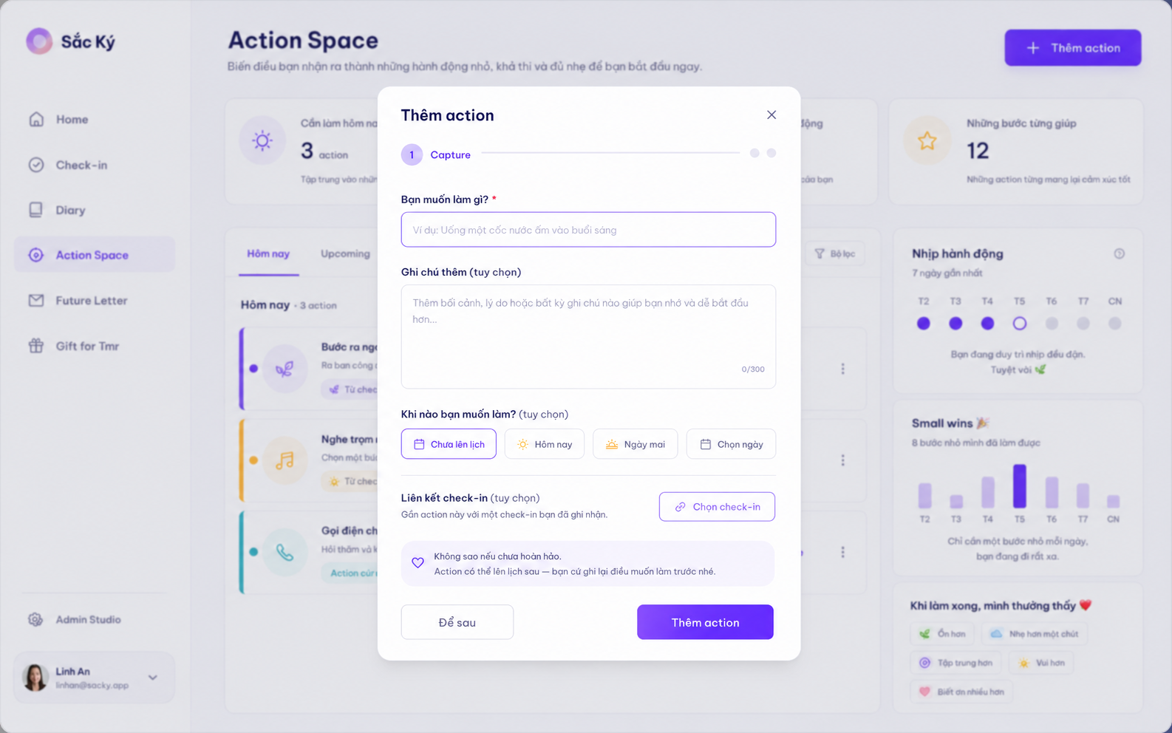
Approved directional mockup — A02 — Create Action Modal

Implementation requirements
• Canonical creation surface.
• Create Action is MODAL, not full page.
• Title required; note optional.
• Quick schedule + optional Check-in link.
• Advanced date/date-range/time may expand inside the overlay flow.

A03 — Upcoming
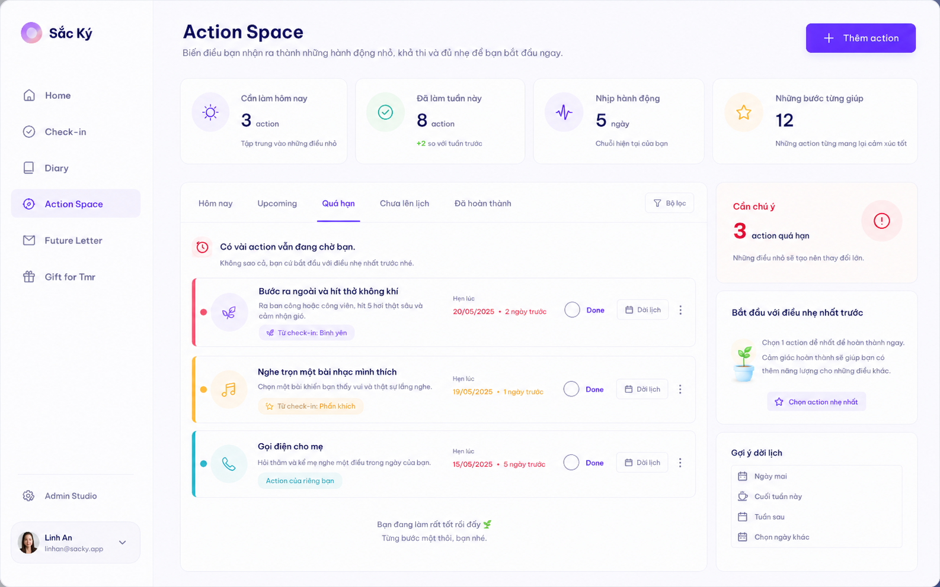
Approved directional mockup — A03 — Upcoming

Implementation requirements
• Group: Ngày mai / Tuần này / Sau đó.
• No range duplication.
• Future summary + gentle rhythm rail.

A04 — Overdue
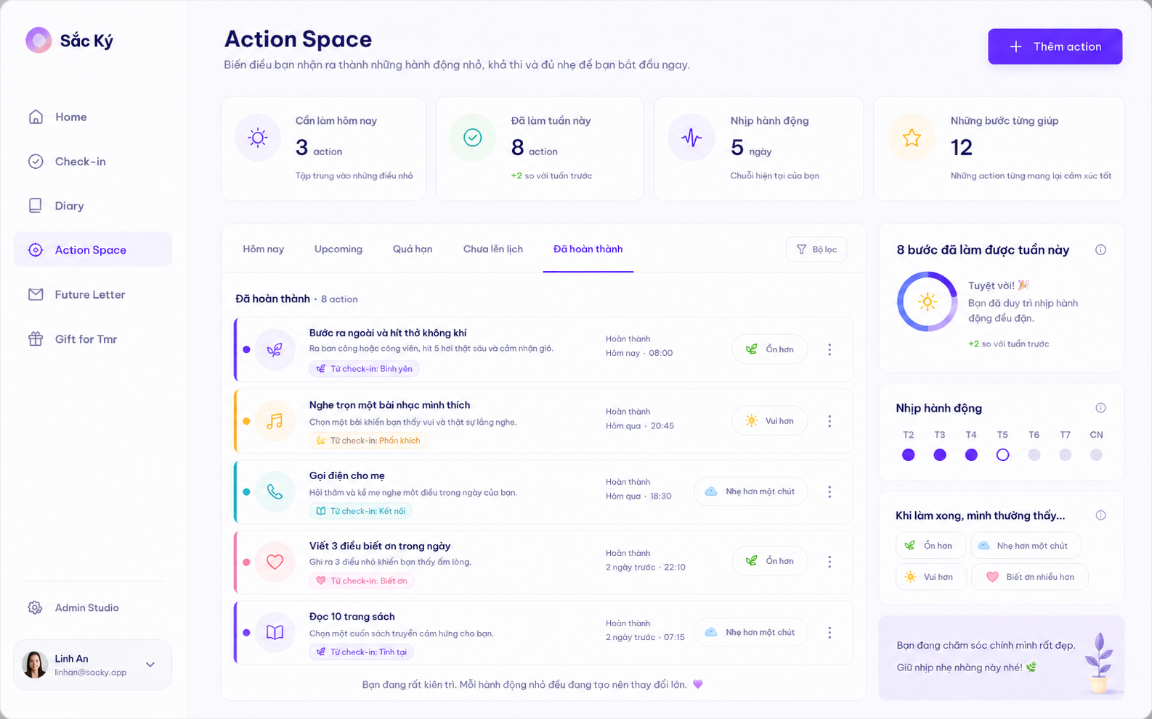
Approved directional mockup — A04 — Overdue

Implementation requirements
• Calm non-shaming copy.
• Done + Đổi lịch actions.
• Red only for genuine overdue state, not guilt-heavy styling.

A05 — Unscheduled
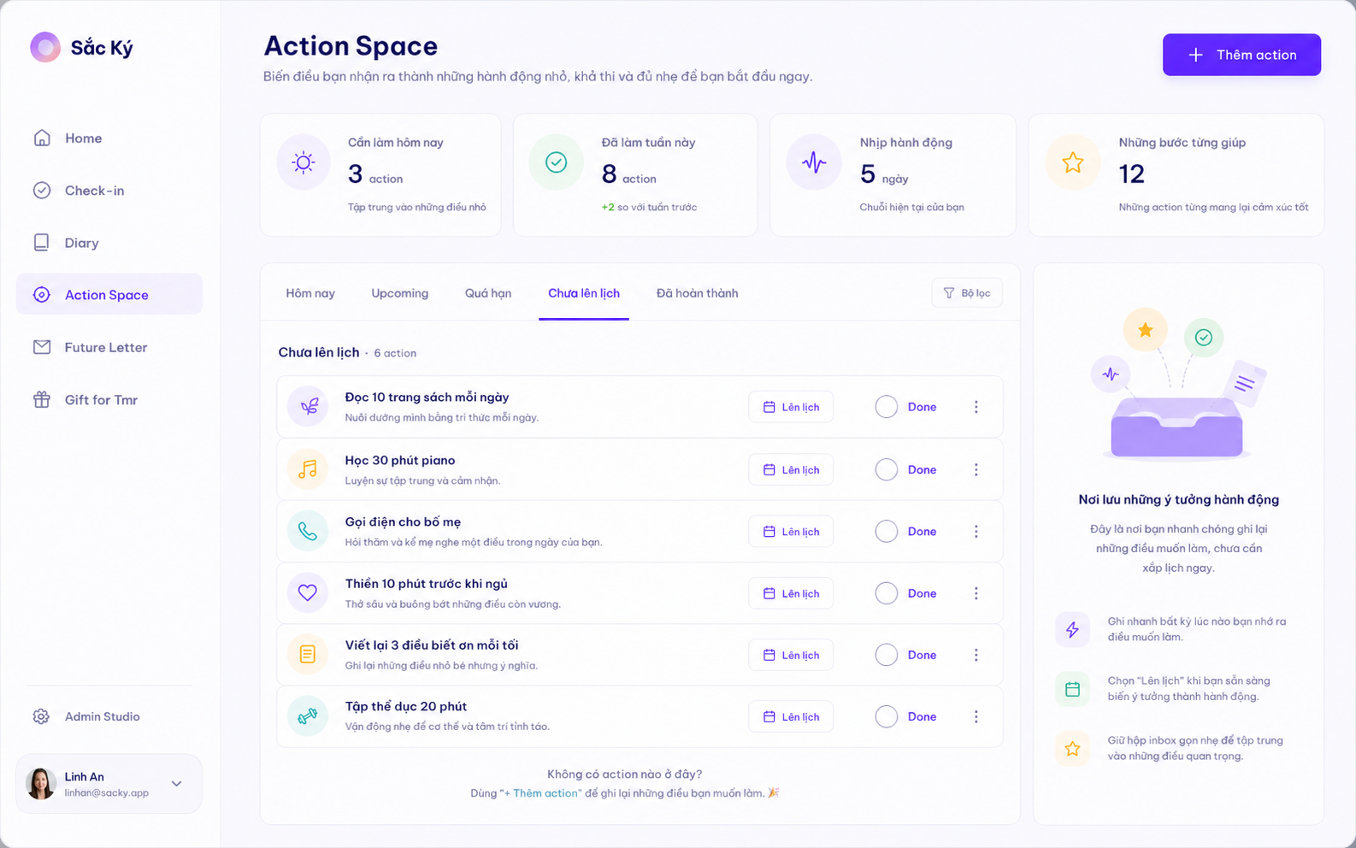
Approved directional mockup — A05 — Unscheduled

Implementation requirements
• Capture inbox.
• Lên lịch quick action.
• Done/Edit/Delete/Link Check-in remain available.
• Right rail explains Capture → Plan gently.

A06 — Completed
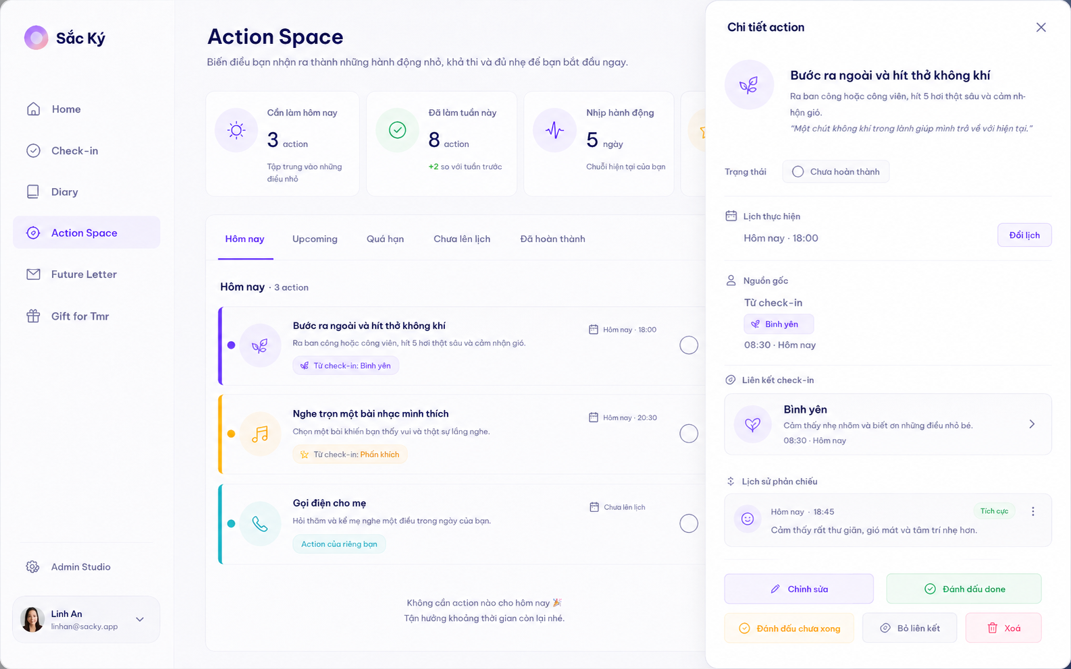
Approved directional mockup — A06 — Completed

Implementation requirements
• Completion archive by completed_at.
• Reflection outcome shown per row where available.
• Small Wins and reflection-backed insight rail.

A07 — Action Detail Drawer
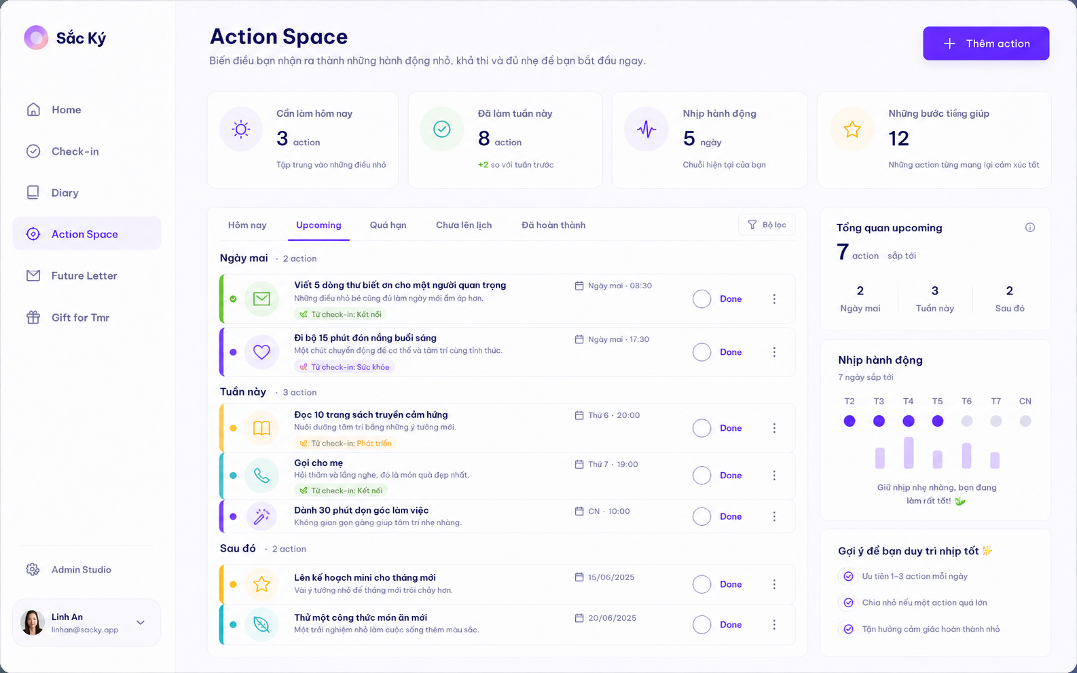
Approved directional mockup — A07 — Action Detail Drawer

Implementation requirements
• Desktop uses right-side drawer.
• Full description, schedule, origin, current Check-in, completion/reflection history.
• Edit / Done / Undone / Link / Unlink / Delete.

A08 — Reflection Modal
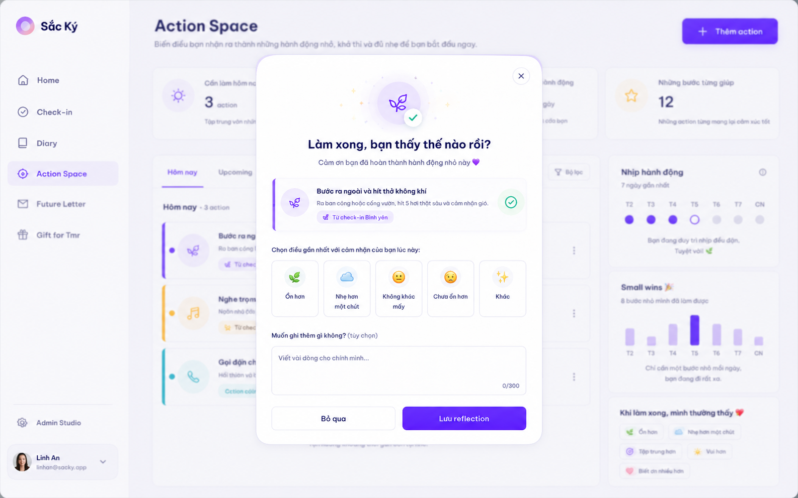
Approved directional mockup — A08 — Reflection Modal

Implementation requirements
• Popup always opens after successful Done.
• One question only.
• One outcome + optional note.
• Skip keeps Action Done.

A09 — Planning / Link Check-in Content Reference
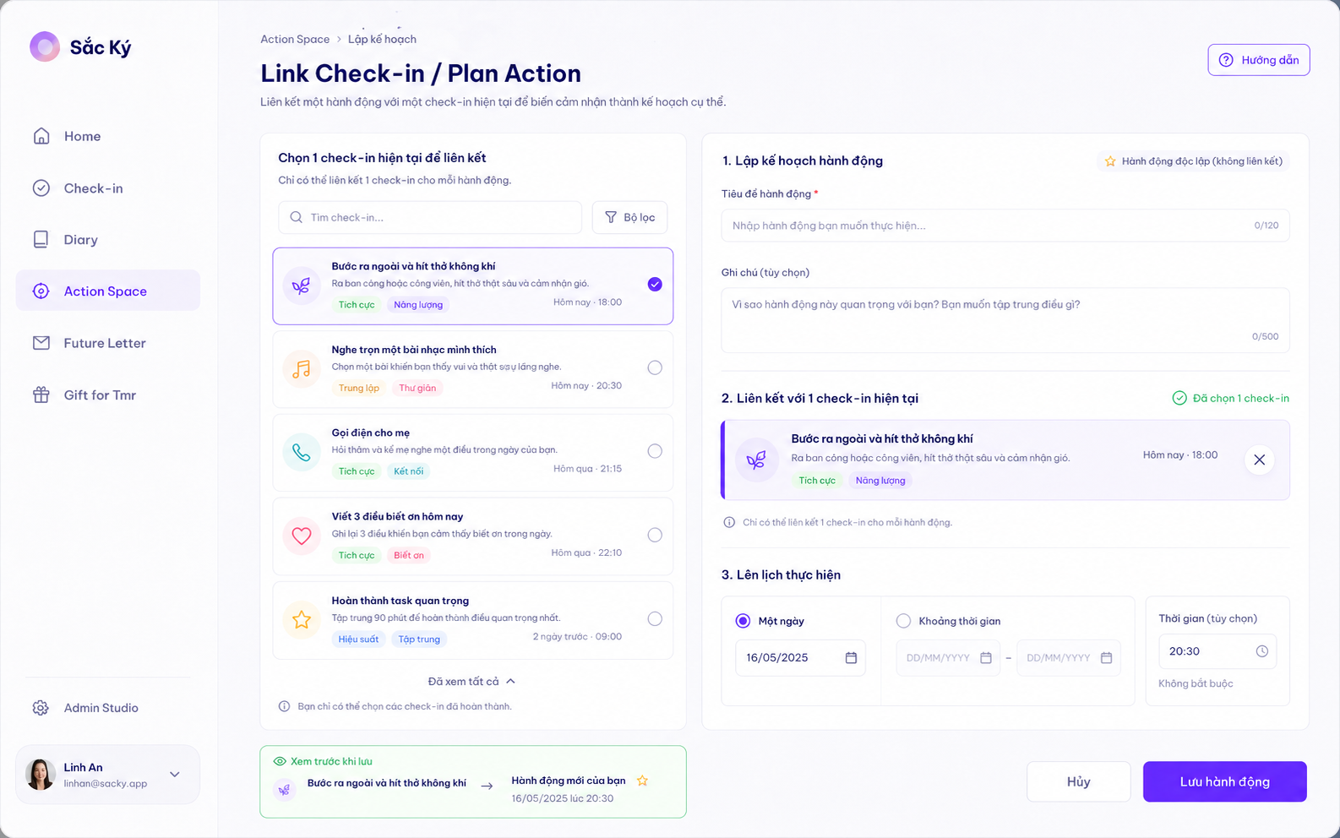
Approved directional mockup — A09 — Planning / Link Check-in Content Reference

Implementation requirements
• CONTENT REFERENCE ONLY.
• Do not implement as normal full-page Create Action.
• Adapt Check-in picker + date/range/time controls into Create/Edit modal or replacement panel.
• Avoid nested modal stacks.

6. Create Action Modal — Detailed Contract
• Default focus vào Title.
• Title required.
• Description optional.
• Quick schedule: Chưa lên lịch / Hôm nay / Ngày mai / Chọn ngày.
• Advanced: one date / date range / optional exact time.
• Check-in linkage optional.
• Creating unscheduled Action is fully valid.
• Escape/close safe; if content exists, preserve or confirm discard using canonical modal behavior.
• Do not open a second modal on top of Create if avoidable; replace modal content or use side panel for Check-in picker.

7. Link Check-in Picker
• Default recent 7–30 days; search older Check-ins.
• Emotion Check-in shows emoji, VN/EN name where space allows, local date/time, brief note, hex accent.
• Unknown shows title, brief note/summary and time.
• Max 1 selection.
• Selected border/tint uses Check-in color_hex with non-color cue.
• If Check-in already has 2 active Actions, linking is disabled with explanation.

8. Action Card
• Linked card: subtle left rail/dot/icon halo from Check-in color_hex.
• Independent card: teal/neutral Action accent.
• Compact scan-friendly rows; no giant inspirational cards.
• Shows title, optional description excerpt, origin/link badge, schedule, Done, overflow menu.

9. Action Detail & Edit
• Action opens right drawer on desktop; mobile may use full-screen sheet.
• Edit can reuse Create modal family.
• Origin is read-only.
• Done Action remains Done after ordinary edit.
• Only Đánh dấu chưa xong changes status back.

10. Done Interaction
• Successful Done mutation happens before reflection.
• Rewarding animation: check pulse + small scale/halo, ~250–450ms.
• Linked Action uses linked Check-in hex; independent uses teal Action pigment.
• No full-screen confetti.
• Reduced-motion alternative required.
• Reflection popup opens every time after successful Done.

11. Reflection Modal
Canonical question: “Làm xong, bạn thấy thế nào rồi?”
• Exactly one outcome selectable.
• Outcome taxonomy is reference/Admin Studio driven.
• Optional multiline note.
• Actions: Bỏ qua / Lưu reflection.
• Skip keeps Action Done.
• Reflection save failure must never undo successful Action completion.

12. Gentle Gamification

12.1 Nhịp hành động
• Recommended v1: count distinct local days in last 7 where ≥1 Action was completed.
• Show as seven dots/days.
• Rolling rhythm, not brittle streak reset.
• No failure/guilt copy.

12.2 Small Wins
• Count Action completions in selected period.
• Use language like “8 bước nhỏ mình đã làm được”, not “8 tasks completed”.

12.3 Những bước từng giúp
• Reflection-backed only.
• V1 lightweight metric: count completed Actions with positive/helpful outcome.
• Later may group by normalized Action/catalog item.
• Do not overclaim causality.

12.4 Prohibited gamification
• No XP.
• No coins.
• No leaderboard.
• No productivity score.
• No punitive streak loss.

13. Cross-Module Integration

13.1 Check-in → Action
• Suggested/custom Action from Check-in becomes canonical Action immediately.
• Same object appears in Action Space.

13.2 Home
• Home Việc cần làm is a projection of canonical Actions.
• Done from Home uses same mutation and same Reflection popup.

13.3 Check-in Detail
• Linked Action shown there is same object.
• Done there also triggers same reflection.

13.4 Delete Check-in with linked Action
• Ask: delete Action or keep independent.
• If kept: unlink current Check-in; origin remains immutable; visual accent falls back to independent Action treatment.

13.5 Delete Action
• Hard-delete Action and its completion/reflection history.
• Do not delete Check-in.

14. Error Handling
• Create/Edit failure preserves entered content and keeps modal open.
• Done mutation failure: do not open Reflection; restore interactive state.
• Reflection save failure: keep Action Done; preserve reflection input for retry where possible.
• Link failure: do not show linked state unless persistence succeeded.

15. Responsive
• Desktop: main workspace + supportive rail.
• Intermediate: collapse rail before squeezing cards.
• Mobile: single column; tabs can horizontally scroll; create/edit becomes sheet/full-screen modal; detail becomes sheet.
• All controls remain touch-friendly.

16. Implementation Recommendations
• If DB/repository still says Reminder, avoid one-shot rename; introduce Action semantic layer incrementally.
• Reuse canonical Modal, Drawer/Sheet, Tabs, Surface, Slider, StatusPill, Check-in picker cards.
• One canonical mutation service for Done/Undone/Update/Delete/Link/Unlink/Reflection.
• Do not duplicate mutation logic in Home or Check-in Detail.

17. QA / Acceptance Checklist
☐ Navigation says Action Space.
☐ Create Action opens modal, not full page.
☐ Title required; note optional; unscheduled allowed.
☐ Date/date-range/optional time supported.
☐ 5 tabs work correctly.
☐ Date-range Action not duplicated.
☐ Max 1 current Check-in / Action.
☐ Max 2 active Actions / Check-in.
☐ Origin immutable.
☐ Linked accent uses Check-in hex; independent uses teal/neutral.
☐ Done animation works and Reflection popup ALWAYS opens after successful Done.
☐ Reflection asks one question only; note optional.
☐ Skip keeps Action Done.
☐ Undone and redone completion cycle works.
☐ Editing Done does not reopen.
☐ Hard delete removes Action completion/reflection history.
☐ Notification absent in v1.
☐ Recurrence absent in v1.
☐ No priority/project taxonomy.
☐ Nhịp hành động is gentle rolling rhythm.
☐ Small Wins uses supportive wording.
☐ No XP/leaderboard/productivity score.
☐ Action from Check-in appears in Action Space immediately.
☐ Done from Home and Check-in Detail opens same Reflection.
☐ Lint/tests/build pass.
☐ Authenticated browser screenshots captured for Today/Create/Upcoming/Overdue/Unscheduled/Completed/Detail/Reflection.

18. Suggested Implementation Slices

Slice 1 — Semantic Rebase
• Reminder → Action Space UI/domain naming
• canonical Action types/service
• preserve existing DB safely

Slice 2 — Workspace
• 5 tabs
• card anatomy
• time grouping
• dashboard/right rails

Slice 3 — Create/Edit Modal
• Title/note
• unscheduled/date/range/time
• Check-in picker

Slice 4 — Done & Reflection
• Done mutation
• animation
• reflection modal
• completion cycles
• undo/redo

Slice 5 — Gentle Gamification
• 7-day rhythm
• Small Wins
• reflection-backed helpful counts

Slice 6 — Cross-module
• Home
• Check-in
• same-object sync
• delete semantics

Slice 7 — Hardening
• responsive
• accessibility
• errors
• regression tests
• hosted acceptance

19. Definition of Done
• Action Space replaces Reminder in product UI.
• Canonical Action is shared across modules.
• Create Action is modal.
• Unscheduled/date/date-range/time planning works.
• Link/unlink/change Check-in works with limits.
• All 5 tabs work.
• Done always triggers rewarding feedback + Reflection popup.
• Reflection is one-question + optional note.
• Undo/redo works.
• Hard delete works.
• Gentle gamification works without productivity pressure.
• Notifications/recurrence/priority/projects remain out of v1.
• Visual composition matches approved Action Space mockups.
• Lint/tests/build + authenticated browser acceptance pass.

