UNIVERSITY OF CALIFORNIA, DAVIS
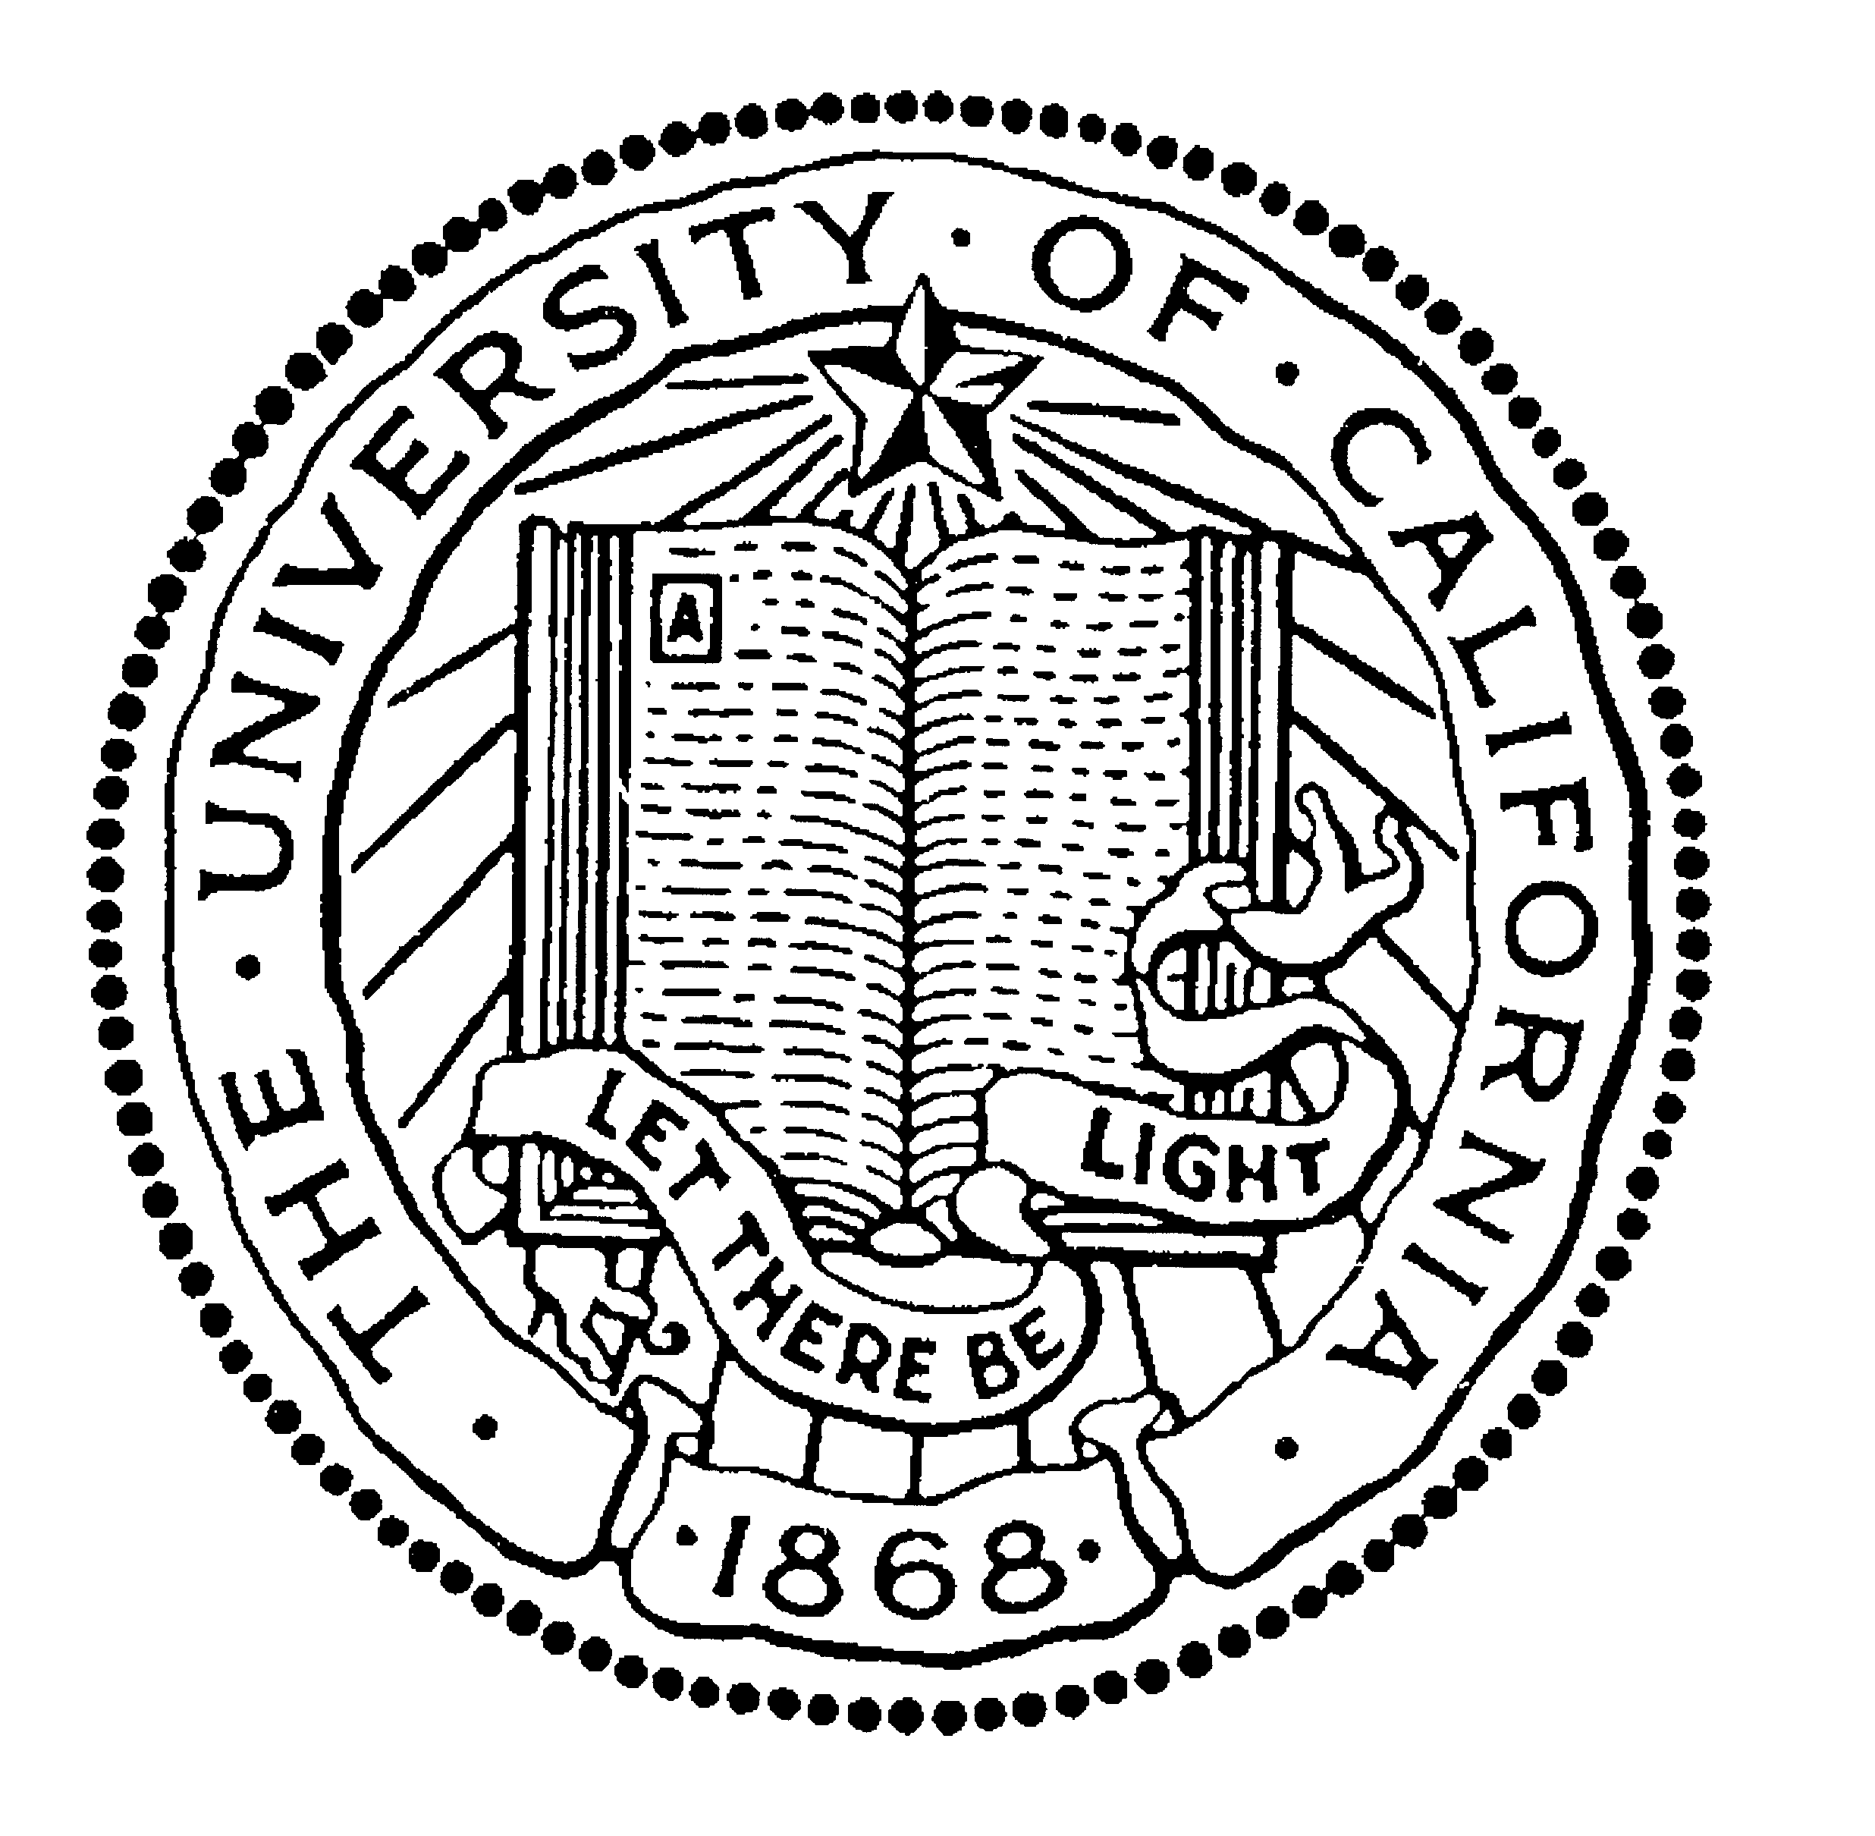

BERKELEY • DAVIS • IRVINE • LOS ANGELES • MERCED • RIVERSIDE • SAN DIEGO • SAN FRANCISCO SANTA BARBARA • SANTA CRUZ

11/22/2022
Re. Letter of recommendation for Yanshu Wang
Dear Colleagues,
We are writing to enthusiastically recommend Yanshu Wang as a graduate student at [name of university]. At UC Davis, Yanshu has excelled both as a student (earning a 3.69 GPA) and as an early-career researcher. Indeed, Yanshu has demonstrated a remarkable ability to work across disciplines, not only becoming proficient in field ecology skills in our lab but also conducting soil science research, focused on understanding the effects of drought on soil nutrients in agricultural systems.
Yanshu joined our lab in Spring 2022 as a research assistant for a large-scale study examining the effects of temperature spikes on wild birds in agricultural and natural environments. Yanshu took the initiative to seek out and apply for an internship with our group. Though the approaches and field methods we use were new to her, Yanshu’s care for the animals and passion for the science allowed her excel throughout the six-month-long field season. In the process, she gained experience with a wide variety of field ornithology skills including mist net use, bird handling and measurement, and meticulous data collection and curation. Over six months, she handled more than 100 nestling birds of three species, and, in the process, gained confidence and competence.
Previous to joining our lab, Yanshu already had years of research experience, including field experience, but in very different systems. For example, she developed grape cultivation and research skills while working at a vineyard in China. She also assisted with tobacco disease research at the Chinese Academy of Agricultural Sciences.
Beyond her research experience, Yanshu is a bright and enthusiastic community member. She helped keep morale up during hot and long days and built solid friendships with her co-workers. She also attended lab meetings during her volunteer tenure, which helped empower other undergraduate students to engage as well.
In summary, we believe that Yanshu is ready to take the next step in what is sure to be an exceptional career and begin working towards her graduate degree. She has developed an impressive array of skills and is also collegial and collaborative. She is an excellent candidate for the [Masters/PhD] program at [university].
Please feel free to contact me with any questions or concerns.
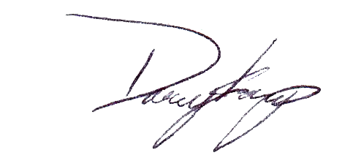
Sincerely,


Katherine S. Lauck, PhD Candidate Dr. Daniel S. Karp, Associate Professor
Wildlife, Fish, and Conservation Biology Wildlife, Fish, and Conservation Biology
University of California, Davis University of California, Davis
1072 Academic Surge; One Shields Ave. 1073 Academic Surge; One Shields Ave.
Davis, CA 95616 Davis, CA 95616
kslauck@ucdavis.edu; (540) 923-0228 dkarp@ucdavis.edu; (530) 219-9868

