CORT covariates
Katherine Lauck
2024-03-08
Objective: What factors affect CORT of adult female WEBL and TRES?

Adult Females

Distribution of the data

WEBL
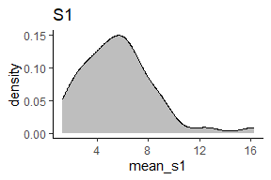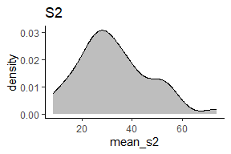

TRES
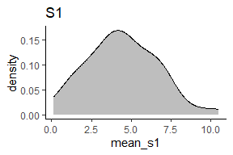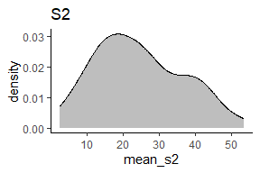

Cort coviariate candidates for adult females
- Brood size: larger broods require more care, which increases adult female baseline and stress response cort
- Body condition of female: This could be either low condition -> high baseline cort or high baseline cort -> low condition
  - Lower condition requires individuals to mobilize more emergency energy in order to reproduce, which requires increasing cort levels in blood
  - An exogenous source of stress (predation pressure, competition, low food supply) increases baseline cort, which mobilizes more stored energy, lowering body condition.
- Day of year: Later in the season, the weather is hotter and dryer, and food is less abundant, and females may have already had a first clutch, so they may have higher baseline cort later in the season.
- For this female, is this attempt 1 or 2 of this year?: Second attempts are later in the season, when the weather is hotter and dryer and food is less abundant, and females have already expended a lot of energy laying eggs during the first attempt, so they may have higher baseline cort during the second attempt.
To investigate these covariates, I ran a full model:
cort ~ brood_size * habitat + condition * habitat + juliandate or nestingattemptfemale
For each of the covariates, I:
- Plotted the distribution of the covariate
- Plotted how the covariate changed over julian date (seasonal variation) and how it was associated with female attempt number
- Plotted the observed correlation between the covariate and adult female cort
- Plotted the model-predicted relationship between the covariate and adult female cort
- Used maximum-likelihood model comparison to determine whether the inclusion of the covariate improves the model.
Plots and models are per species and separated between s1 & s2 where appropriate.

Summary of findings
First off, whether to use julian day or mother attempt number. I found very few differences in significance of covariates and no differences in model selection between models using julian day or mother attempt number (results compared throughout details of findings #1 and #2. I think julian day is more holistic and will soak up more unwanted variation, so I think that’s what we should use.
 |  |  | s1 |  |  |  | s2
model | seasonal | species | Brood size | Condition | Julian day | Mother attempt number | Brood size | Condition | Julian day | Mother attempt number
additive | Julian day | WEBL | Yes | No | No | NA | No | No | No | NA
interactive | Julian day | WEBL | No | No | NA | NA | No | No | NA | NA
additive | Mother attempt number | WEBL | Yes | No | NA | No | No | Yes | NA | No
interactive | Mother attempt number | WEBL | No | Yes | NA | NA | No | Yes | NA | NA
additive | Julian day | TRES | No | No | No | NA | No | No | No | NA
interactive | Julian day | TRES | No | No | NA | NA | Yes | No | NA | NA
additive | Mother attempt number | TRES | No | No | NA | No | No | No | NA | No
interactive | Mother attempt number | TRES | No | No | NA | NA | Yes | No | NA | NA
This table summarizes my findings. A “Yes” indicates a model in which the specified factor (the columns) significantly improved the parsimony of the model. I used likelihood ratio tests for all comparisons to compare a model with and without the factor in its linear or interactive form. The first column, model, describes whether the covariate under consideration is additive or interacted with habitat. I did not interact habitat with julian day or mother attempt number, so those significance indicators are NA. The second column, seasonal, describes whether the seasonal variation in cort was quantified using julian day of female capture or mother attempt number. The third column indicates the species under consideration. The column spanners indicate whether the measure was baseline or stressed cort, and the column names indicate the covariate under consideration. There don’t seem to be many patterns, other than that neither julian day nor mother attempt number improved the models. Maybe baseline cort is more related to chronic stressors than stressed cort? And there doesn’t seem to be a huge difference in pattern between julian day and mother attempt number. Because julian date is a better measure of seasonal variation for a lot of different things, and it appears to be capturing much the same information (except maybe for WEBL s2 condition?), I think I would prefer to use julian day moving forward. I was only able to directly determine the attempt number for a few females (not more than 4), and the rest were determined using the calculated peaks of the density distribution of mother capture date, so julian day and mother attempt number are very close to the same information anyways.

Details of findings

1. How does brood size relate to cort?

Distribution of brood size
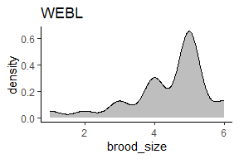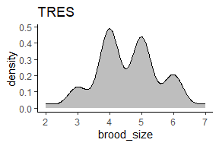

Seasonal variation in brood size
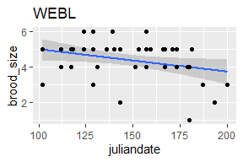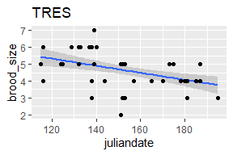

Variation between mother attempt number in brood size
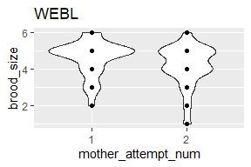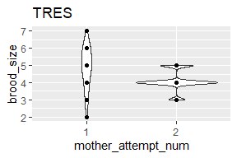

Correlation of brood size and cort

WEBL
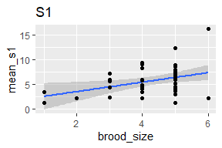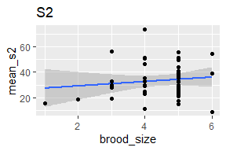

TRES
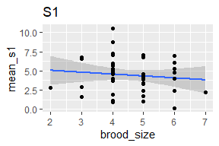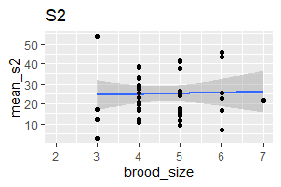

Model-predicted relationship between brood size and cort
Reminder: full model is - cort ~ brood_size * habitat + condition * habitat + juliandate and - cort ~ brood_size * habitat + condition * habitat + mother attempt number

WEBL
Baseline cort as response variable:
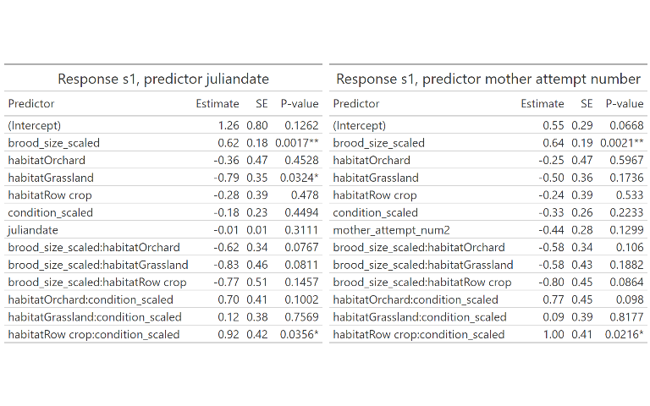
Personally, I think this model is rather overfitted: N = 42, but I left it as is so we could just see what the shape of the data is like with all of these terms involved. It looks like results are fairly similar between juliandate and mother attempt number.

Plot of predicted relationship between baseline cort and brood size:
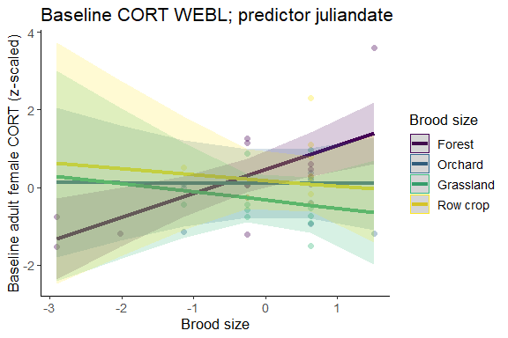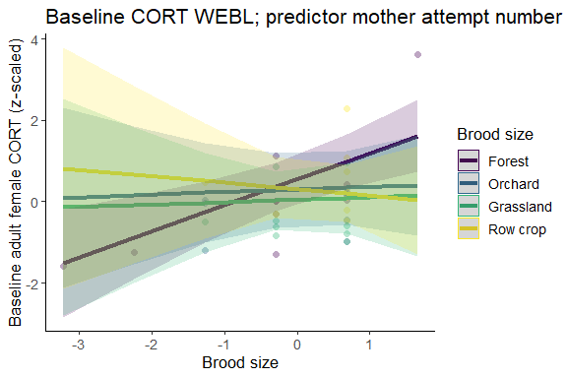

Does the inclusion of brood_size improve the model, and does the interaction brood_size * habitat further improve it?
Table 1: Response s1, predictor juliandate
model | Res.Df | RSS | Df | Sum of Sq | F | P-value
no brood_size | 33 | 25.94680 | NA | NA | NA | NA
brood_size + habitat | 32 | 22.31427 | 1 | 3.632525 | 5.790833 | 0.0227*
brood_size * habitat | 29 | 18.19138 | 3 | 4.122897 | 2.190855 | 0.1105
Table 1: Response s1, predictor mother attempt number
model | Res.Df | RSS | Df | Sum of Sq | F | P-value
no brood_size | 28 | 20.83991 | NA | NA | NA | NA
brood_size + habitat | 27 | 17.42623 | 1 | 3.413675 | 6.066930 | 0.0213*
brood_size * habitat | 24 | 13.50406 | 3 | 3.922167 | 2.323548 | 0.1004
This table compares three models: the full model, one with no interaction between habitat and brood_size, and one without brood_size in the model. Based on the table, it looks like including brood_size does improve the model, but including its interaction with habitat does not significantly improve the model. Overall results appear to be the same between julian day and mother attempt number.

Stressed cort as response variable:
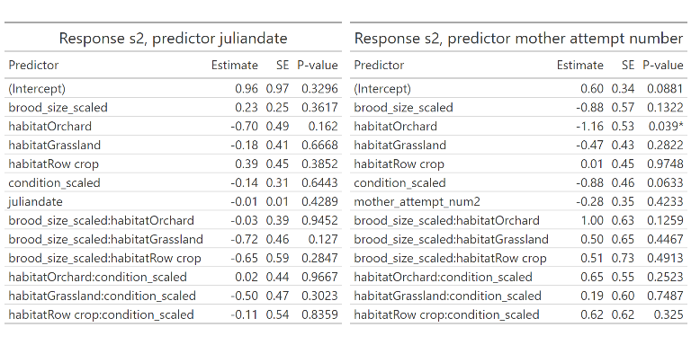
Personally, I think this model is rather overfitted: N = 44, but I left it as is so we could just see what the shape of the data is like with all of these terms involved. The results are pretty much the same between julian day and mother attempt number.

Plot of predicted relationship between stressed cort and brood size:
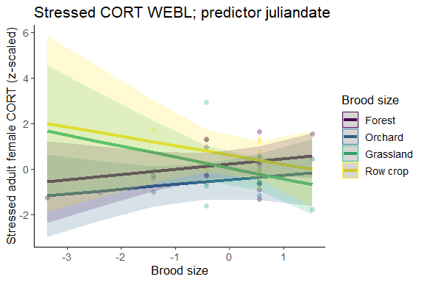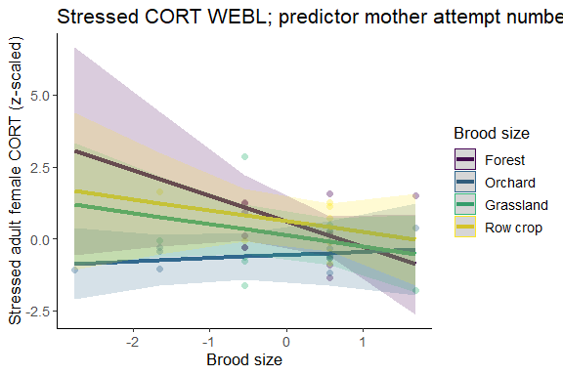

Does the inclusion of brood_size improve the model, and does the interaction brood_size * habitat further improve it?
Table 1: Response s2, predictor juliandate
model | Res.Df | RSS | Df | Sum of Sq | F | P-value
no brood_size | 35 | 33.34343 | NA | NA | NA | NA
brood_size + habitat | 34 | 33.27328 | 1 | 0.07015351 | 0.07277795 | 0.7891
brood_size * habitat | 31 | 29.88211 | 3 | 3.39116690 | 1.17267685 | 0.336
Table 1: Response s2, predictor mother attempt number
model | Res.Df | RSS | Df | Sum of Sq | F | P-value
no brood_size | 32 | 28.13389 | NA | NA | NA | NA
brood_size + habitat | 31 | 27.02107 | 1 | 1.112816 | 1.264921 | 0.2703
brood_size * habitat | 28 | 24.63304 | 3 | 2.388032 | 0.904813 | 0.4512
This table compares three models: the full model, one with no interaction between habitat and brood_size, and one without brood_size in the model. Based on the table, it looks like including brood_size, even as a linear term, does not improve the model. Results are similar between julian day and mother attempt number.

TRES
Baseline cort as response variable:
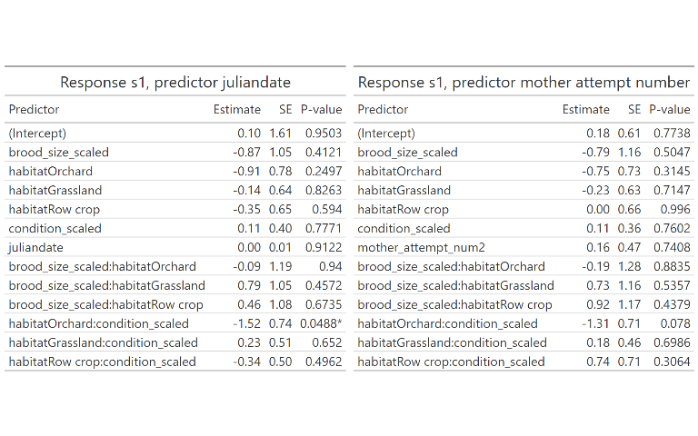
Personally, I think this model is rather overfitted: N = 44, but I left it as is so we could just see what the shape of the data is like with all of these terms involved. Responses are similar between julian day and mother attempt number.

Plot of predicted relationship between baseline cort and brood size:
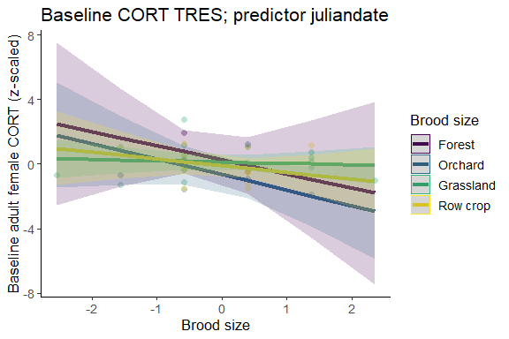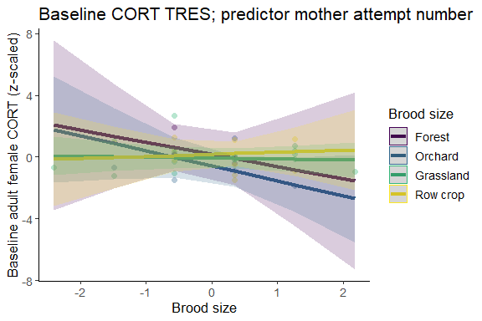

Does the inclusion of brood_size improve the model, and does the interaction brood_size * habitat further improve it?
Table 1: Response s1, predictor juliandate
model | Res.Df | RSS | Df | Sum of Sq | F | P-value
no brood_size | 35 | 34.00319 | NA | NA | NA | NA
brood_size + habitat | 34 | 32.62989 | 1 | 1.373297 | 1.4188767 | 0.2426
brood_size * habitat | 31 | 30.00417 | 3 | 2.625727 | 0.9042916 | 0.4502
Table 1: Response s1, predictor mother attempt number
model | Res.Df | RSS | Df | Sum of Sq | F | P-value
no brood_size | 28 | 26.03094 | NA | NA | NA | NA
brood_size + habitat | 27 | 25.50894 | 1 | 0.5220052 | 0.5511854 | 0.465
brood_size * habitat | 24 | 22.72942 | 3 | 2.7795203 | 0.9782988 | 0.4194
This table compares three models: the full model, one with no interaction between habitat and brood_size, and one without brood_size in the model. Based on the table, it looks like including brood_size does not improve the model. Responses are similar between julian day and mother attempt number.

Stressed cort as response variable:
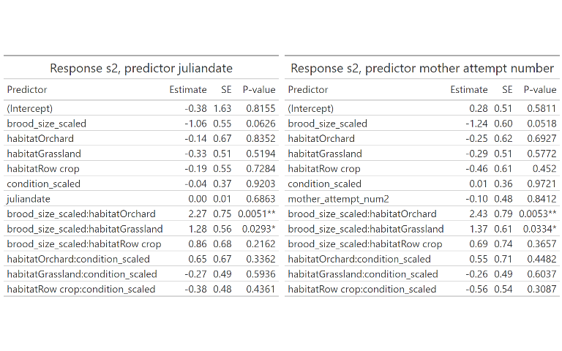
Personally, I think this model is rather overfitted: N = 42, but I left it as is so we could just see what the shape of the data is like with all of these terms involved. Results were similar for julian date and mother attempt number.

Plot of predicted relationship between stressed cort and brood size:

Does the inclusion of brood_size improve the model, and does the interaction brood_size * habitat further improve it?
Table 1: Response s2, predictor juliandate
model | Res.Df | RSS | Df | Sum of Sq | F | P-value
no brood_size | 33 | 37.64570 | NA | NA | NA | NA
brood_size + habitat | 32 | 36.99462 | 1 | 0.6510738 | 0.6895245 | 0.4131
brood_size * habitat | 29 | 27.38284 | 3 | 9.6117818 | 3.3931428 | 0.0311*
Table 1: Response s2, predictor mother attempt number
model | Res.Df | RSS | Df | Sum of Sq | F | P-value
no brood_size | 28 | 33.52211 | NA | NA | NA | NA
brood_size + habitat | 27 | 33.18225 | 1 | 0.339857 | 0.3474399 | 0.5611
brood_size * habitat | 24 | 23.47620 | 3 | 9.706051 | 3.3075373 | 0.0372*
This table compares three models: the full model, one with no interaction between habitat and brood_size, and one without brood_size in the model. Based on the table, it looks like including brood_size as an interaction between habitat and brood_size does improve the model. Results are similar between julian date and mother attempt number.

1. How does body condition relate to cort?

Distribution of condition
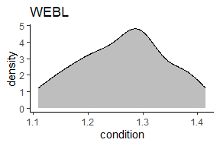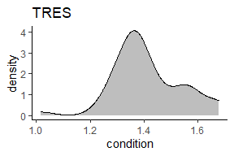

Seasonal variation in condition
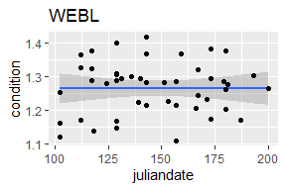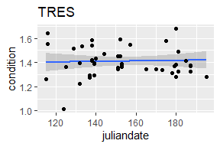

Variation between mother attempt number in condition
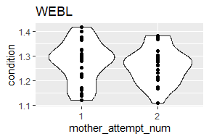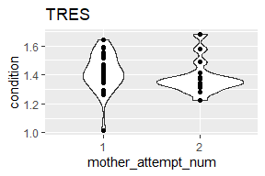

Correlation of condition and cort

WEBL
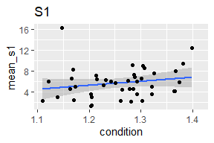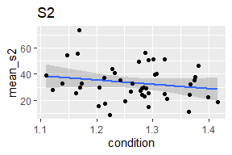

TRES
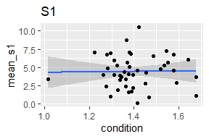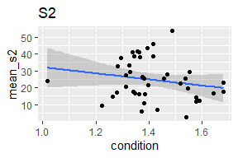

Model-predicted relationship between condition and cort
Reminder: full model is - cort ~ brood_size * habitat + condition * habitat + juliandate and - cort ~ brood_size * habitat + condition * habitat + mother attempt number

WEBL
Baseline cort as response variable:
Personally, I think this model is rather overfitted: N = 42, but I left it as is so we could just see what the shape of the data is like with all of these terms involved. It looks like results are fairly similar between juliandate and mother attempt number.

Plot of predicted relationship between baseline cort and condition:
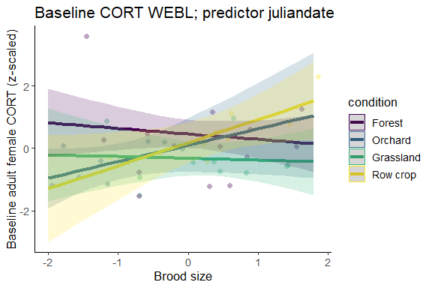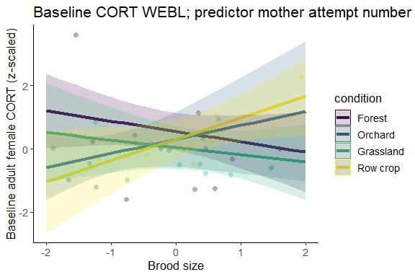

Does the inclusion of condition improve the model, and does the interaction condition * habitat further improve it?
Table 1: Response s1, predictor juliandate
model | Res.Df | RSS | Df | Sum of Sq | F | P-value
no condition | 33 | 22.93440 | NA | NA | NA | NA
condition + habitat | 32 | 22.32620 | 1 | 0.6081929 | 0.969558 | 0.3329
condition * habitat | 29 | 18.19138 | 3 | 4.1348276 | 2.197195 | 0.1097
Table 1: Response s1, predictor mother attempt number
model | Res.Df | RSS | Df | Sum of Sq | F | P-value
no condition | 28 | 19.20962 | NA | NA | NA | NA
condition + habitat | 27 | 19.04989 | 1 | 0.1597302 | 0.2838794 | 0.5991
condition * habitat | 24 | 13.50406 | 3 | 5.5458231 | 3.2854244 | 0.0381*
This table compares three models: the full model, one with no interaction between habitat and brood_size, and one without brood_size in the model. Based on the table, it looks like condition only improves the model when it is interacted with habitat, and then only when mother_attempt_num is a predictor.

Stressed cort as response variable:
Personally, I think this model is rather overfitted: N = 44, but I left it as is so we could just see what the shape of the data is like with all of these terms involved. The results are pretty much the same between julian day and mother attempt number.

Plot of predicted relationship between stressed cort and condition:
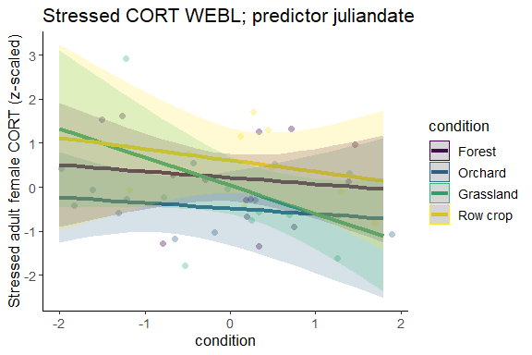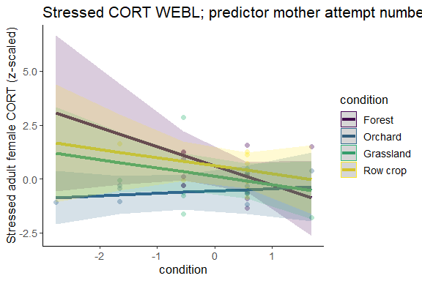

Does the inclusion of brood_size improve the model, and does the interaction brood_size * habitat further improve it?
Table 1: Response s2, predictor juliandate
model | Res.Df | RSS | Df | Sum of Sq | F | P-value
no condition | 35 | 33.64256 | NA | NA | NA | NA
condition + habitat | 34 | 31.26738 | 1 | 2.375185 | 2.4640404 | 0.1266
condition * habitat | 31 | 29.88211 | 3 | 1.385266 | 0.4790297 | 0.6992
Table 1: Response s2, predictor mother attempt number
model | Res.Df | RSS | Df | Sum of Sq | F | P-value
no condition | 32 | 31.07250 | NA | NA | NA | NA
condition + habitat | 31 | 26.07393 | 1 | 4.998566 | 5.6817937 | 0.0242*
condition * habitat | 28 | 24.63304 | 3 | 1.440893 | 0.5459471 | 0.655
This table compares three models: the full model, one with no interaction between habitat and condition, and one without condition in the model. Based on the table, it looks like including condition in the model only improves it when it is a linear term and then only when mother_attempt_number is included as a covariate.

TRES
Baseline cort as response variable:
Personally, I think this model is rather overfitted: N = 44, but I left it as is so we could just see what the shape of the data is like with all of these terms involved. Responses are similar between julian day and mother attempt number.

Plot of predicted relationship between baseline cort and condition:
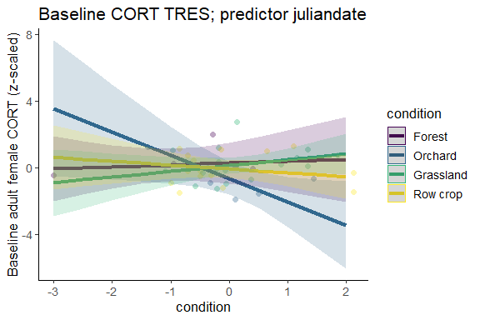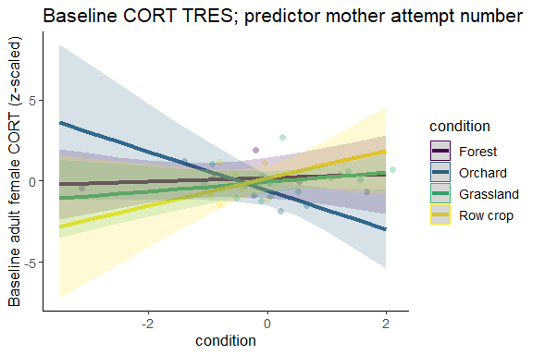

Does the inclusion of condition improve the model, and does the interaction condition * habitat further improve it?
Table 1: Response s1, predictor juliandate
model | Res.Df | RSS | Df | Sum of Sq | F | P-value
no condition | 35 | 36.68421 | NA | NA | NA | NA
condition + habitat | 34 | 36.62180 | 1 | 0.06241799 | 0.06448963 | 0.8012
condition * habitat | 31 | 30.00417 | 3 | 6.61762938 | 2.27908912 | 0.099
Table 1: Response s1, predictor mother attempt number
model | Res.Df | RSS | Df | Sum of Sq | F | P-value
no condition | 28 | 29.83778 | NA | NA | NA | NA
condition + habitat | 27 | 29.64105 | 1 | 0.1967349 | 0.2077325 | 0.6526
condition * habitat | 24 | 22.72942 | 3 | 6.9116264 | 2.4326627 | 0.0897
This table compares three models: the full model, one with no interaction between habitat and condition, and one without condition in the model. Based on the table, it looks like including condition does not improve the model. Responses are similar between julian day and mother attempt number.

Stressed cort as response variable:
Personally, I think this model is rather overfitted: N = 42, but I left it as is so we could just see what the shape of the data is like with all of these terms involved. Results were similar for julian date and mother attempt number.

Plot of predicted relationship between stressed cort and condition:

Does the inclusion of condition improve the model, and does the interaction condition * habitat further improve it?
Table 1: Response s2, predictor juliandate
model | Res.Df | RSS | Df | Sum of Sq | F | P-value
no condition | 33 | 31.09180 | NA | NA | NA | NA
condition + habitat | 32 | 30.06749 | 1 | 1.024308 | 1.084801 | 0.3062
condition * habitat | 29 | 27.38284 | 3 | 2.684648 | 0.947732 | 0.4305
Table 1: Response s2, predictor mother attempt number
model | Res.Df | RSS | Df | Sum of Sq | F | P-value
no condition | 28 | 26.63818 | NA | NA | NA | NA
condition + habitat | 27 | 26.12896 | 1 | 0.5092224 | 0.5205841 | 0.4776
condition * habitat | 24 | 23.47620 | 3 | 2.6527569 | 0.9039817 | 0.4537
This table compares three models: the full model, one with no interaction between habitat and condition, and one without condition in the model. Based on the table, it looks like including condition does not improve the model. Results are similar between julian date and mother attempt number.

3. How does julian day relate to cort?

Distribution of julian day
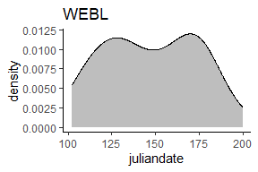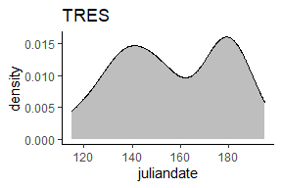

Correlation of julian day and cort

WEBL
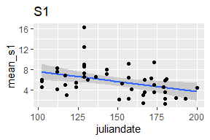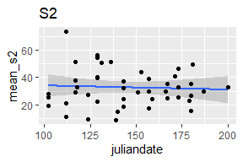

TRES
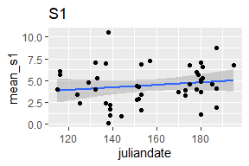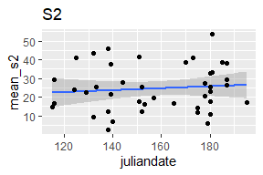

Model-predicted relationship between juliandate and cort
Reminder: full model is cort ~ brood_size * habitat + condition * habitat + juliandate

WEBL
Baseline cort as response variable:
Table 1: Model output: response variable is s1
Predictor | Estimate | SE | P-value
(Intercept) | 1.26 | 0.80 | 0.1262
brood_size_scaled | 0.62 | 0.18 | 0.0017**
habitatOrchard | -0.36 | 0.47 | 0.4528
habitatGrassland | -0.79 | 0.35 | 0.0324*
habitatRow crop | -0.28 | 0.39 | 0.478
condition_scaled | -0.18 | 0.23 | 0.4494
juliandate | -0.01 | 0.01 | 0.3111
brood_size_scaled:habitatOrchard | -0.62 | 0.34 | 0.0767
brood_size_scaled:habitatGrassland | -0.83 | 0.46 | 0.0811
brood_size_scaled:habitatRow crop | -0.77 | 0.51 | 0.1457
habitatOrchard:condition_scaled | 0.70 | 0.41 | 0.1002
habitatGrassland:condition_scaled | 0.12 | 0.38 | 0.7569
habitatRow crop:condition_scaled | 0.92 | 0.42 | 0.0356*
This is the same model as for other covariates. Personally, I think this model is rather overfitted: N = 42, but I left it as is so we could just see what the shape of the data is like with all of these terms involved.

Plot of predicted relationship between baseline cort and julian day:
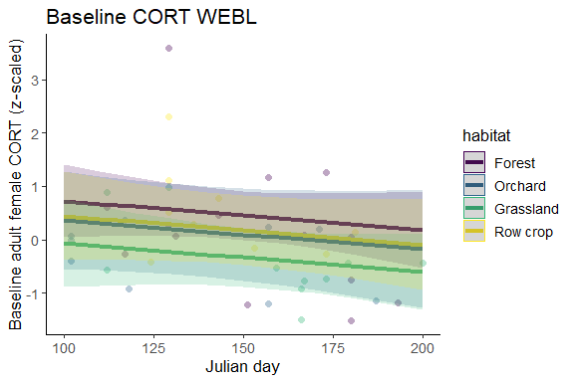

Does the inclusion of julian day improve the model?
model | Res.Df | RSS | Df | Sum of Sq | F | P-value
no julian day | 30 | 18.85797 | NA | NA | NA | NA
full model | 29 | 18.19138 | 1 | 0.6665897 | 1.062652 | 0.3111
This table compares two models: one without julian day and the full model. Based on the table, it looks like including julian day does not improve the model.

Stressed cort as response variable
Table 1: Model output: response variable is s2
Predictor | Estimate | SE | P-value
(Intercept) | 0.96 | 0.97 | 0.3296
brood_size_scaled | 0.23 | 0.25 | 0.3617
habitatOrchard | -0.70 | 0.49 | 0.162
habitatGrassland | -0.18 | 0.41 | 0.6668
habitatRow crop | 0.39 | 0.45 | 0.3852
condition_scaled | -0.14 | 0.31 | 0.6443
juliandate | -0.01 | 0.01 | 0.4289
brood_size_scaled:habitatOrchard | -0.03 | 0.39 | 0.9452
brood_size_scaled:habitatGrassland | -0.72 | 0.46 | 0.127
brood_size_scaled:habitatRow crop | -0.65 | 0.59 | 0.2847
habitatOrchard:condition_scaled | 0.02 | 0.44 | 0.9667
habitatGrassland:condition_scaled | -0.50 | 0.47 | 0.3023
habitatRow crop:condition_scaled | -0.11 | 0.54 | 0.8359
This is the same model as for other covariates. Personally, I think this model is rather overfitted: N = 44, but I left it as is so we could just see what the shape of the data is like with all of these terms involved.

Plot of predicted relationship between baseline cort and julian day:
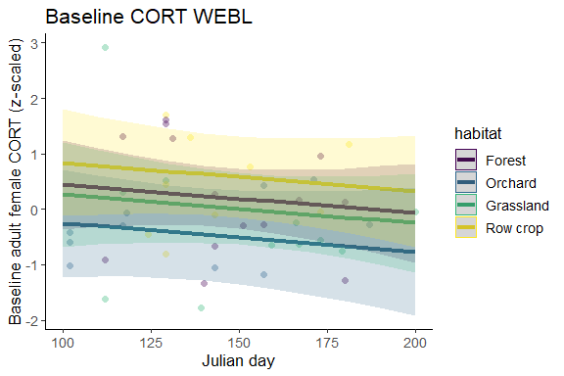

Does the inclusion of julian day improve the model?
model | Res.Df | RSS | Df | Sum of Sq | F | P-value
no julian day | 32 | 30.50147 | NA | NA | NA | NA
full model | 31 | 29.88211 | 1 | 0.6193604 | 0.6425307 | 0.4289
This table compares two models: one without julian day and the full model. Based on the table, it looks like including julian day does not improve the model.

TRES
Baseline cort as response variable:
Table 1: Model output: response variable is s1
Predictor | Estimate | SE | P-value
(Intercept) | 0.10 | 1.61 | 0.9503
brood_size_scaled | -0.87 | 1.05 | 0.4121
habitatOrchard | -0.91 | 0.78 | 0.2497
habitatGrassland | -0.14 | 0.64 | 0.8263
habitatRow crop | -0.35 | 0.65 | 0.594
condition_scaled | 0.11 | 0.40 | 0.7771
juliandate | 0.00 | 0.01 | 0.9122
brood_size_scaled:habitatOrchard | -0.09 | 1.19 | 0.94
brood_size_scaled:habitatGrassland | 0.79 | 1.05 | 0.4572
brood_size_scaled:habitatRow crop | 0.46 | 1.08 | 0.6735
habitatOrchard:condition_scaled | -1.52 | 0.74 | 0.0488*
habitatGrassland:condition_scaled | 0.23 | 0.51 | 0.652
habitatRow crop:condition_scaled | -0.34 | 0.50 | 0.4962
This is the same model as for other covariates. Personally, I think this model is rather overfitted: N = 44, but I left it as is so we could just see what the shape of the data is like with all of these terms involved.

Plot of predicted relationship between baseline cort and julian day:
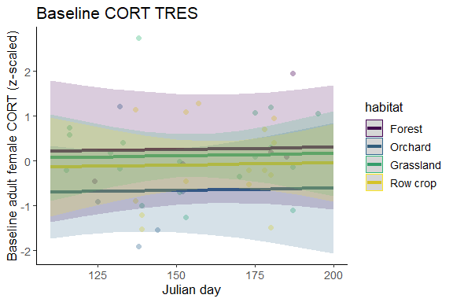

Does the inclusion of julian day improve the model?
model | Res.Df | RSS | Df | Sum of Sq | F | P-value
no julian day | 32 | 30.01612 | NA | NA | NA | NA
full model | 31 | 30.00417 | 1 | 0.01194986 | 0.01234648 | 0.9122
This table compares two models: one without julian day and the full model. Based on the table, it looks like including julian day does not improve the model.

Stressed cort as response variable
Table 1: Model output: response variable is s2
Predictor | Estimate | SE | P-value
(Intercept) | -0.38 | 1.63 | 0.8155
brood_size_scaled | -1.06 | 0.55 | 0.0626
habitatOrchard | -0.14 | 0.67 | 0.8352
habitatGrassland | -0.33 | 0.51 | 0.5194
habitatRow crop | -0.19 | 0.55 | 0.7284
condition_scaled | -0.04 | 0.37 | 0.9203
juliandate | 0.00 | 0.01 | 0.6863
brood_size_scaled:habitatOrchard | 2.27 | 0.75 | 0.0051**
brood_size_scaled:habitatGrassland | 1.28 | 0.56 | 0.0293*
brood_size_scaled:habitatRow crop | 0.86 | 0.68 | 0.2162
habitatOrchard:condition_scaled | 0.65 | 0.67 | 0.3362
habitatGrassland:condition_scaled | -0.27 | 0.49 | 0.5936
habitatRow crop:condition_scaled | -0.38 | 0.48 | 0.4361
This is the same model as for other covariates. Personally, I think this model is rather overfitted: N = 42, but I left it as is so we could just see what the shape of the data is like with all of these terms involved.

Plot of predicted relationship between baseline cort and julian day:
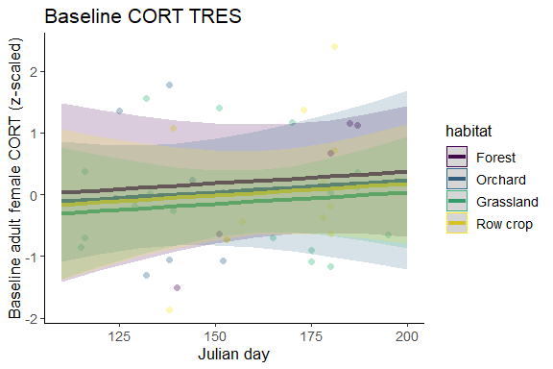

Does the inclusion of julian day improve the model?
model | Res.Df | RSS | Df | Sum of Sq | F | P-value
no julian day | 30 | 27.53995 | NA | NA | NA | NA
full model | 29 | 27.38284 | 1 | 0.1571049 | 0.1663831 | 0.6863
This table compares two models: one without julian day and the full model. Based on the table, it looks like including julian day does not improve the model.

4. How does attempt number by mother relate to cort?
To explore this question, I calculated attempt ID by mother. To do so, I assigned each mother an individual ID, which in all cases was her band number. I grouped female captures by year and individual ID, and for cases where the same female was caught twice in a year, I assigned attempt IDs. Then, I calculated the peaks of julian day for female captures for each year, and assigned each female the attempt number corresponding to the closest peak.

Distribution of cort over attempt number
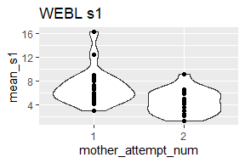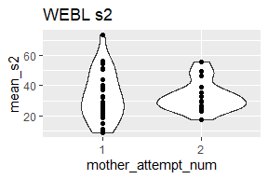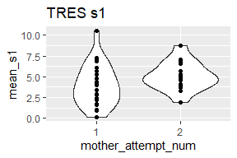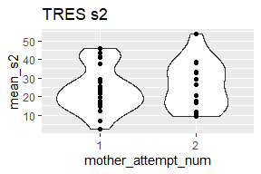

Model-predicted relationship between mother attempt number and cort
Reminder: full model is cort ~ brood_size * habitat + condition * habitat + mother_attempt_num

WEBL
Baseline cort as response variable:
Table 1: Model output: response variable is s1
Predictor | Estimate | SE | P-value
(Intercept) | 0.55 | 0.29 | 0.0668
brood_size_scaled | 0.64 | 0.19 | 0.0021**
habitatOrchard | -0.25 | 0.47 | 0.5967
habitatGrassland | -0.50 | 0.36 | 0.1736
habitatRow crop | -0.24 | 0.39 | 0.533
condition_scaled | -0.33 | 0.26 | 0.2233
mother_attempt_num2 | -0.44 | 0.28 | 0.1299
brood_size_scaled:habitatOrchard | -0.58 | 0.34 | 0.106
brood_size_scaled:habitatGrassland | -0.58 | 0.43 | 0.1882
brood_size_scaled:habitatRow crop | -0.80 | 0.45 | 0.0864
habitatOrchard:condition_scaled | 0.77 | 0.45 | 0.098
habitatGrassland:condition_scaled | 0.09 | 0.39 | 0.8177
habitatRow crop:condition_scaled | 1.00 | 0.41 | 0.0216*
This is the same model as for other covariates. Personally, I think this model is rather overfitted: N = 37, but I left it as is so we could just see what the shape of the data is like with all of these terms involved.

Plot of predicted relationship between baseline cort and julian day:
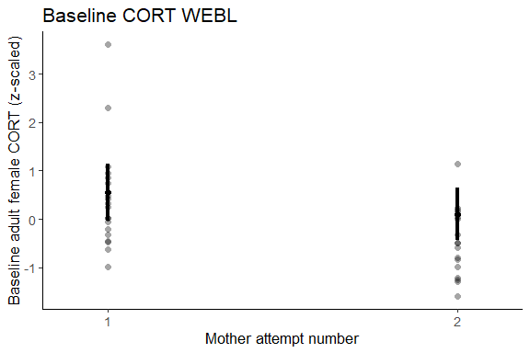

Does the inclusion of mother attempt number improve the model?
model | Res.Df | RSS | Df | Sum of Sq | F | P-value
no attempt number | 25 | 14.88802 | NA | NA | NA | NA
full model | 24 | 13.50406 | 1 | 1.383952 | 2.459618 | 0.1299
This table compares two models: one without mother attempt number and the full model. Based on the table, it looks like including mother attempt number does not improve the model.

Stressed cort as response variable
Table 1: Model output: response variable is s2
Predictor | Estimate | SE | P-value
(Intercept) | 0.60 | 0.34 | 0.0881
brood_size_scaled | -0.88 | 0.57 | 0.1322
habitatOrchard | -1.16 | 0.53 | 0.039*
habitatGrassland | -0.47 | 0.43 | 0.2822
habitatRow crop | 0.01 | 0.45 | 0.9748
condition_scaled | -0.88 | 0.46 | 0.0633
mother_attempt_num2 | -0.28 | 0.35 | 0.4233
brood_size_scaled:habitatOrchard | 1.00 | 0.63 | 0.1259
brood_size_scaled:habitatGrassland | 0.50 | 0.65 | 0.4467
brood_size_scaled:habitatRow crop | 0.51 | 0.73 | 0.4913
habitatOrchard:condition_scaled | 0.65 | 0.55 | 0.2523
habitatGrassland:condition_scaled | 0.19 | 0.60 | 0.7487
habitatRow crop:condition_scaled | 0.62 | 0.62 | 0.325
This is the same model as for other covariates. Personally, I think this model is rather overfitted: N = 41, but I left it as is so we could just see what the shape of the data is like with all of these terms involved.

Plot of predicted relationship between baseline cort and mother attempt number:
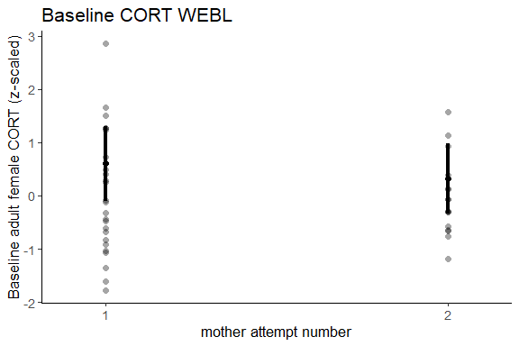

Does the inclusion of julian day improve the model?
model | Res.Df | RSS | Df | Sum of Sq | F | P-value
no mother attempt number | 29 | 25.21393 | NA | NA | NA | NA
full model | 28 | 24.63304 | 1 | 0.580885 | 0.6602831 | 0.4233
This table compares two models: one without mother attempt number and the full model. Based on the table, it looks like including mother attempt number does not improve the model.

TRES
Baseline cort as response variable:
Table 1: Model output: response variable is s1
Predictor | Estimate | SE | P-value
(Intercept) | 0.18 | 0.61 | 0.7738
brood_size_scaled | -0.79 | 1.16 | 0.5047
habitatOrchard | -0.75 | 0.73 | 0.3145
habitatGrassland | -0.23 | 0.63 | 0.7147
habitatRow crop | 0.00 | 0.66 | 0.996
condition_scaled | 0.11 | 0.36 | 0.7602
mother_attempt_num2 | 0.16 | 0.47 | 0.7408
brood_size_scaled:habitatOrchard | -0.19 | 1.28 | 0.8835
brood_size_scaled:habitatGrassland | 0.73 | 1.16 | 0.5357
brood_size_scaled:habitatRow crop | 0.92 | 1.17 | 0.4379
habitatOrchard:condition_scaled | -1.31 | 0.71 | 0.078
habitatGrassland:condition_scaled | 0.18 | 0.46 | 0.6986
habitatRow crop:condition_scaled | 0.74 | 0.71 | 0.3064
This is the same model as for other covariates. Personally, I think this model is rather overfitted: N = 37, but I left it as is so we could just see what the shape of the data is like with all of these terms involved.

Plot of predicted relationship between baseline cort and mother attempt number:
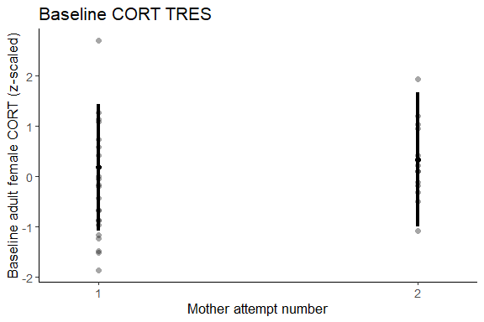

Does the inclusion of julian day improve the model?
model | Res.Df | RSS | Df | Sum of Sq | F | P-value
no mother attempt number | 25 | 22.83548 | NA | NA | NA | NA
full model | 24 | 22.72942 | 1 | 0.1060565 | 0.1119851 | 0.7408
This table compares two models: one without mother attempt number and the full model. Based on the table, it looks like including mother attempt number does not improve the model.

Stressed cort as response variable
Table 1: Model output: response variable is s2
Predictor | Estimate | SE | P-value
(Intercept) | 0.28 | 0.51 | 0.5811
brood_size_scaled | -1.24 | 0.60 | 0.0518
habitatOrchard | -0.25 | 0.62 | 0.6927
habitatGrassland | -0.29 | 0.51 | 0.5772
habitatRow crop | -0.46 | 0.61 | 0.452
condition_scaled | 0.01 | 0.36 | 0.9721
mother_attempt_num2 | -0.10 | 0.48 | 0.8412
brood_size_scaled:habitatOrchard | 2.43 | 0.79 | 0.0053**
brood_size_scaled:habitatGrassland | 1.37 | 0.61 | 0.0334*
brood_size_scaled:habitatRow crop | 0.69 | 0.74 | 0.3657
habitatOrchard:condition_scaled | 0.55 | 0.71 | 0.4482
habitatGrassland:condition_scaled | -0.26 | 0.49 | 0.6037
habitatRow crop:condition_scaled | -0.56 | 0.54 | 0.3087
This is the same model as for other covariates. Personally, I think this model is rather overfitted: N = 37, but I left it as is so we could just see what the shape of the data is like with all of these terms involved.

Plot of predicted relationship between baseline cort and mother attempt number:
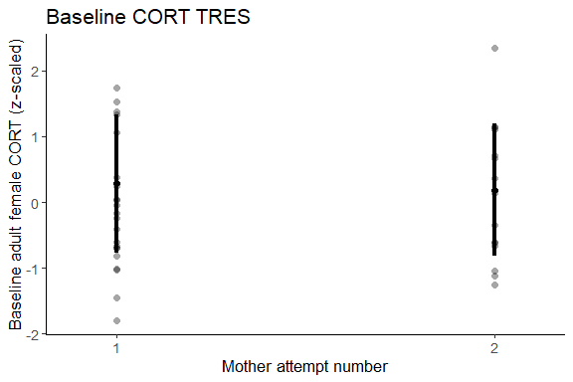

Does the inclusion of mother attempt number improve the model?
model | Res.Df | RSS | Df | Sum of Sq | F | P-value
no mother attempt number | 25 | 23.51632 | NA | NA | NA | NA
full model | 24 | 23.47620 | 1 | 0.04012247 | 0.04101768 | 0.8412
This table compares two models: one without mother attempt number and the full model. Based on the table, it looks like including mother attempt number does not improve the model.

