CORT covariates for chicks
Katherine Lauck
2024-03-13
Objective: What factors affect CORT of nestling WEBL and TRES?

Nestligs

Distribution of the data

WEBL
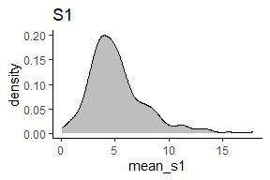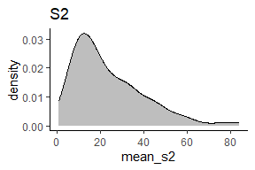

TRES
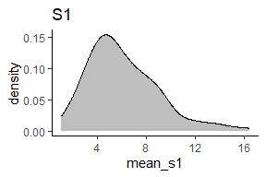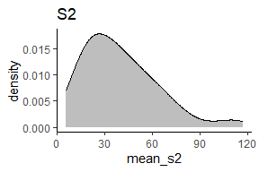

Cort coviariate candidates for nestlings
- Day of year: Later in the season, the weather is hotter and dryer, and food is less abundant, and females may have already had a first clutch, so they may have higher baseline cort later in the season.
- Mother cort
- Mother baseline cort: Mothers may pass on cort characteristics in eggs, or more stressed mothers may not provide optimal care to chicks
- Mother stressed cort: Mothers may pass on cort characteristics in eggs, or more stressed mothers may not provide optimal care to chicks.
- Mother stressed - baseline cort: Mothers may pass on cort characteristics in eggs, or more stressed mothers may not provide optimal care to chicks
N.B.: All three of these covariates will likely be part of the final analysis. I will choose one measure (likely baseline cort) to use for the following analyses.
- Whether the cort sample was taken on week 2 or week 3 of chick development: older chicks will have a more developed stress response. We expect baseline cort to be mostly the same but stressed cort to be more elevated in older chicks.
- Brood size: larger broods mean more competition, increasing nestlings’ baseline and stress response cort. This may interact with habitat (why?)
- Body condition of nestling: This could be either low condition -> high baseline cort or high baseline cort -> low condition. This may interact with habitat (why?)
  - Lower condition requires individuals to mobilize more emergency energy in order to compete with siblings, which requires increasing cort levels in blood
  - An exogenous source of stress (predation pressure, competition, low food supply) increases baseline cort, which mobilizes more stored energy, lowering body condition.
To investigate these covariates, I ran a full model:
cort ~ mother cort (s1, s2, or diff) + week2/week3 + brood_size * habitat + condition * habitat + juliandate or nestingattemptfemale + (1|attempt_id)
For each of the covariates, I:
- Plotted the distribution of the covariate
- Plotted how the covariate changed over julian date (seasonal variation) and how it was associated with female attempt number
- Plotted the observed correlation between the covariate and nestling
- Plotted the model-predicted relationship between the covariate and nestling cort
- Used maximum-likelihood model comparison to determine whether the inclusion of the covariate improves the model.
Plots and models are per species and separated between s1 & s2 where appropriate.

Summary of findings - not yet updated with full results
First off, whether to use julian day or mother attempt number. I found very few differences in significance of covariates and no differences in model selection between models using julian day or mother attempt number (results compared throughout details of findings #1 and #2. I think julian day is more holistic and will soak up more unwanted variation, so I think that’s what we should use.
 |  | s1 |  | s2 |  | s2-s1
species | factor | covar + habitat | covar * habitat | covar + habitat | covar * habitat | covar + habitat | covar * habitat
WEBL | Julian day | -0.05 | NA | -0.23. | NA | -0.22 | NA
TRES | Julian day | 0.12 | NA | 0.13 | NA | 0.05 | NA
WEBL | Mother cort | -0.24 | NA | 0.26. | NA | 0.21 | NA
TRES | Mother cort | -0.23* | NA | 0.39* | NA | 0.28 | NA
WEBL | occasion | 0.83*** | NA | 0.36 | NA | 0.39 | NA
TRES | occasion | 0.60* | NA | 0.34 | NA | -0.03 | NA
WEBL | Brood size | -0.34 | -0.36, 0.01, -0.12** | 0.36 | -0.43, 0.18, -0.27 | 0.62 | -0.87, -0.42, -0.78
TRES | Brood size | 0.11 | -0.43, 0.18, -0.27 | -0.03 | -0.36, 0.01, -0.12 | -1.62 | 1.57, 1.53, 1.20
WEBL | Condition | 0.30 | -1.26, -0.04, 0.11 | 0.07 | -0.17, 0.29, -0.20 | -0.11 | -0.02, 0.31, -0.03
TRES | Condition | 0.07. | -0.17, 0.29, -0.20. | 0.30 | -1.26, -0.04, 0.11 | 0.35 | 1.20, -1.39, -0.04*
This table summarizes my findings. The values present the mean effect size for each factor under investigation. A green fill indicates a model in which the specified factor (column 2) significantly improved the parsimony of the model. I used likelihood ratio tests for all comparisons to compare a model with and without the factor. For brood size and condition, I also compared a model with the additive factor to a model with the factor interacted with habitat (indicated by the column names). The column spanners indicate whether the response variable was baseline, stressed cort, or stressed - baseline cort. In all models, I used the same measure of mother cort and nestling cort, e.g. if response was baseline nestling cort, I used baseline mother cort as a covariate in that model.

Details of findings

1. How does juliandate relate to cort?

Distribution of juliandate
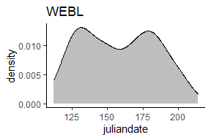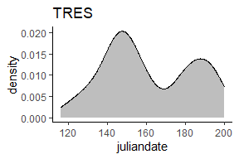

Variation in cort across juliandate
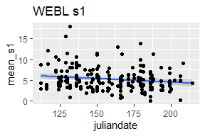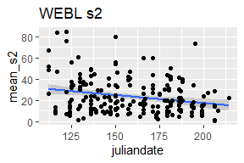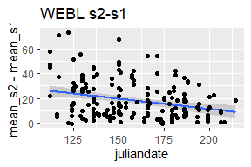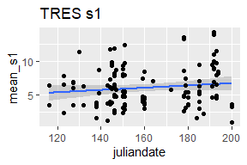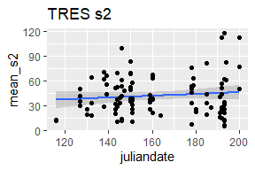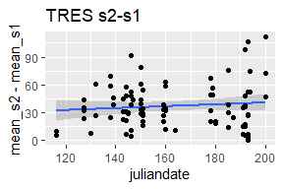

Variation in juliandate between occasions
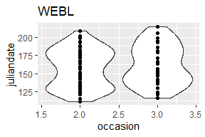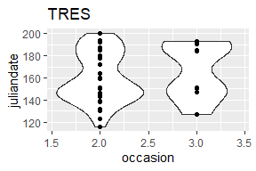

Model-predicted relationship between juliandate and cort
Reminder: full model is - cort ~ mother cort + week2/week3 + brood_size * habitat + condition * habitat + juliandate + rand(attempt_id)

WEBL
Baseline cort as response variable:
Table 1: Response s1, predictor juliandate
Predictor | Estimate | Std. Error | df | t value | P-value
(Intercept) | -0.12 | 0.42 | 13.41430 | -0.27750414 | 0.7856
cort_s1_mother_scaled | -0.24 | 0.18 | 17.57396 | -1.30267621 | 0.2095
occasion3 | 0.83 | 0.20 | 84.52825 | 4.14975081 | 1e-04*
brood_size_scaled | 0.59 | 0.33 | 14.41588 | 1.78349854 | 0.0956
habitatOrchard | -0.27 | 0.56 | 15.54342 | -0.48126523 | 0.637
habitatGrassland | -0.56 | 0.54 | 13.52310 | -1.03411098 | 0.3192
habitatRow crop | 0.01 | 0.52 | 11.86096 | 0.01985473 | 0.9845
condition_scaled | -0.33 | 0.19 | 83.20653 | -1.71660785 | 0.0898
juliandate_scaled | -0.05 | 0.18 | 17.59990 | -0.28931421 | 0.7757
brood_size_scaled:habitatOrchard | -0.94 | 0.39 | 14.15369 | -2.41891393 | 0.0296*
brood_size_scaled:habitatGrassland | -0.87 | 0.44 | 15.03241 | -1.97393111 | 0.0671
brood_size_scaled:habitatRow crop | 0.33 | 0.62 | 11.87745 | 0.54092510 | 0.5986
habitatOrchard:condition_scaled | 0.10 | 0.32 | 80.64649 | 0.30728174 | 0.7594
habitatGrassland:condition_scaled | 0.20 | 0.26 | 84.94840 | 0.73735901 | 0.4629
habitatRow crop:condition_scaled | 0.47 | 0.31 | 80.77260 | 1.49785420 | 0.1381
This table presents the full model results.

Plot of predicted relationship between baseline cort and juliandate:
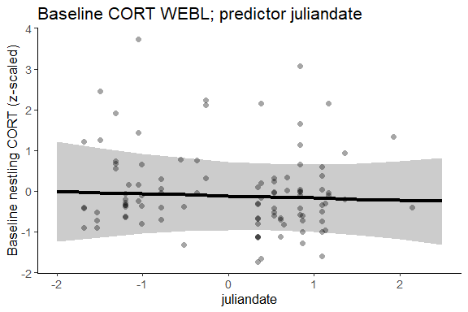

Does the inclusion of juliandate improve the model?
Table 1: Response s1, predictor juliandate
model | npar | AIC | BIC | logLik | deviance | Chisq | Df | P-value
no juliandate | 16 | 271.3989 | 313.2408 | -119.6994 | 239.3989 | NA | NA | NA
full model | 17 | 273.1233 | 317.5804 | -119.5617 | 239.1233 | 0.2755543 | 1 | 0.5996
Stressed cort as response variable:
Table 1: Response s2, predictor juliandate
Predictor | Estimate | Std. Error | df | t value | P-value
(Intercept) | -0.46 | 0.31 | 13.70012 | -1.49264707 | 0.1582
cort_s2_mother_scaled | 0.26 | 0.15 | 15.86733 | 1.71133928 | 0.1065
occasion3 | 0.36 | 0.18 | 93.05008 | 1.96247505 | 0.0527
brood_size_scaled | 0.11 | 0.37 | 22.42038 | 0.30726747 | 0.7615
habitatOrchard | 0.67 | 0.43 | 16.31562 | 1.53872778 | 0.143
habitatGrassland | -0.03 | 0.41 | 13.45014 | -0.06791861 | 0.9468
habitatRow crop | 0.60 | 0.44 | 12.89245 | 1.37545017 | 0.1924
condition_scaled | 0.07 | 0.15 | 93.37204 | 0.45923401 | 0.6471
juliandate_scaled | -0.23 | 0.16 | 15.87719 | -1.45743196 | 0.1645
brood_size_scaled:habitatOrchard | -0.43 | 0.42 | 21.16312 | -1.04103123 | 0.3096
brood_size_scaled:habitatGrassland | 0.18 | 0.43 | 19.55815 | 0.42274251 | 0.6771
brood_size_scaled:habitatRow crop | -0.27 | 0.64 | 13.84155 | -0.42554421 | 0.677
habitatOrchard:condition_scaled | -0.17 | 0.28 | 92.79325 | -0.61088055 | 0.5428
habitatGrassland:condition_scaled | 0.29 | 0.25 | 78.15003 | 1.15846622 | 0.2502
habitatRow crop:condition_scaled | -0.20 | 0.27 | 93.88283 | -0.74674444 | 0.4571
This table presents the full model results.

Plot of predicted relationship between stressed cort and juliandate:
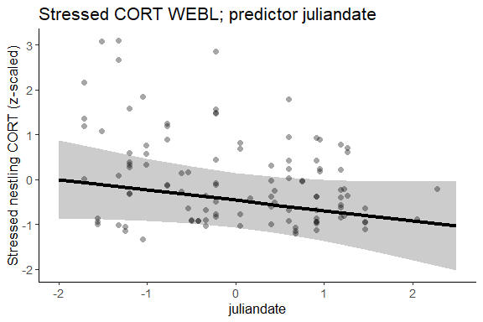

Does the inclusion of juliandate improve the model?
Table 1: Response s2, predictor juliandate
model | npar | AIC | BIC | logLik | deviance | Chisq | Df | P-value
no juliandate | 16 | 296.3536 | 339.4152 | -132.1768 | 264.3536 | NA | NA | NA
full model | 17 | 294.6140 | 340.3669 | -130.3070 | 260.6140 | 3.739609 | 1 | 0.0531
Stressed cort - baseline cort as response variable:
Table 1: Response s2-s1, predictor juliandate
Predictor | Estimate | Std. Error | df | t value | P-value
(Intercept) | -0.77 | 0.61 | 13.386461 | -1.26475392 | 0.2275
mother_cort_diff_scaled | 0.21 | 0.22 | 8.793796 | 0.96332384 | 0.3611
occasion3 | 0.39 | 0.21 | 56.953079 | 1.85272961 | 0.0691
brood_size_scaled | 0.62 | 0.52 | 13.587456 | 1.19695309 | 0.2518
habitatOrchard | 1.13 | 0.76 | 12.273954 | 1.48723912 | 0.1622
habitatGrassland | 0.22 | 0.73 | 11.942072 | 0.30369539 | 0.7666
habitatRow crop | 0.75 | 0.77 | 10.363987 | 0.97254891 | 0.3529
condition_scaled | -0.11 | 0.23 | 53.448139 | -0.46124047 | 0.6465
juliandate_scaled | -0.22 | 0.24 | 10.163297 | -0.91113216 | 0.3833
brood_size_scaled:habitatOrchard | -0.87 | 0.59 | 12.301377 | -1.47160874 | 0.1662
brood_size_scaled:habitatGrassland | -0.42 | 0.66 | 11.927710 | -0.63535259 | 0.5372
brood_size_scaled:habitatRow crop | -0.78 | 0.85 | 9.328940 | -0.92650397 | 0.3775
habitatOrchard:condition_scaled | -0.02 | 0.34 | 50.280607 | -0.04418803 | 0.9649
habitatGrassland:condition_scaled | 0.31 | 0.32 | 59.743478 | 0.97636974 | 0.3328
habitatRow crop:condition_scaled | -0.03 | 0.37 | 59.108625 | -0.07231261 | 0.9426
This table presents the full model results.

Plot of predicted relationship between stressed cort and juliandate:
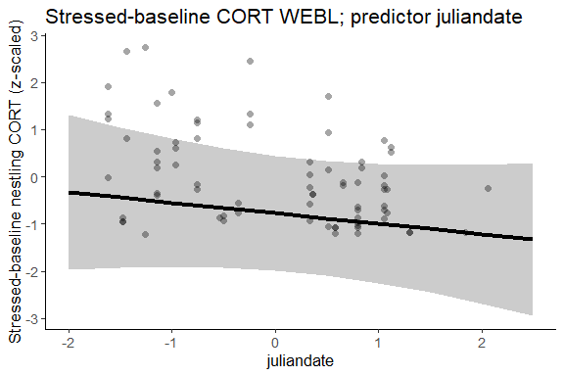

Does the inclusion of juliandate improve the model?
Table 1: Response s2-s1, predictor juliandate
model | npar | AIC | BIC | logLik | deviance | Chisq | Df | P-value
no juliandate | 16 | 205.1429 | 242.2227 | -86.57147 | 173.1429 | NA | NA | NA
full model | 17 | 204.7951 | 244.1924 | -85.39754 | 170.7951 | 2.347856 | 1 | 0.1255
This table compares a model with and without juliandate.

TRES
Baseline cort as response variable:
Table 1: Response s1, predictor juliandate
Predictor | Estimate | Std. Error | df | t value | P-value
(Intercept) | 1.55 | 0.68 | 71 | 2.29006214 | 0.025*
cort_s1_mother_scaled | -0.23 | 0.11 | 71 | -2.06536580 | 0.0425*
occasion3 | 0.60 | 0.26 | 71 | 2.34296503 | 0.0219*
brood_size_scaled | 1.50 | 1.38 | 71 | 1.08923524 | 0.2797
habitatOrchard | -2.41 | 0.78 | 71 | -3.07456469 | 0.003**
habitatGrassland | -1.82 | 0.69 | 71 | -2.63737860 | 0.0103*
habitatRow crop | -1.69 | 0.70 | 71 | -2.43174364 | 0.0176*
condition_scaled | 0.39 | 0.44 | 71 | 0.89121205 | 0.3758
juliandate_scaled | 0.12 | 0.14 | 71 | 0.83261907 | 0.4079
brood_size_scaled:habitatOrchard | -1.88 | 1.43 | 71 | -1.31891384 | 0.1914
brood_size_scaled:habitatGrassland | -1.35 | 1.36 | 71 | -0.99061420 | 0.3252
brood_size_scaled:habitatRow crop | -1.19 | 1.37 | 71 | -0.87419636 | 0.385
habitatOrchard:condition_scaled | -0.05 | 0.70 | 71 | -0.07457754 | 0.9408
habitatGrassland:condition_scaled | -0.45 | 0.47 | 71 | -0.95876615 | 0.3409
habitatRow crop:condition_scaled | 0.20 | 0.47 | 71 | 0.43131167 | 0.6675
This table presents the full model results.

Plot of predicted relationship between baseline cort and juliandate:
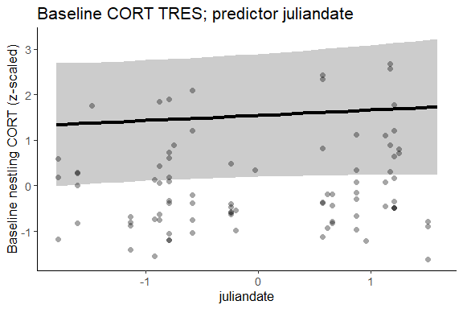
I do not know why the best fit line is above the data!! Really weird.

Does the inclusion of juliandate improve the model?
Table 1: Response s1, predictor juliandate
model | npar | AIC | BIC | logLik | deviance | Chisq | Df | P-value
no juliandate | 16 | 237.7206 | 276.9902 | -102.8603 | 205.7206 | NA | NA | NA
full model | 17 | 238.8850 | 280.6089 | -102.4425 | 204.8850 | 0.8356437 | 1 | 0.3606
Stressed cort as response variable:
Table 1: Response s2, predictor juliandate
Predictor | Estimate | Std. Error | df | t value | P-value
(Intercept) | 0.13 | 0.47 | 18.17637 | 0.28303974 | 0.7803
cort_s2_mother_scaled | 0.39 | 0.22 | 22.30038 | 1.76844876 | 0.0907
occasion3 | 0.34 | 0.36 | 37.54408 | 0.95429626 | 0.346
brood_size_scaled | -0.03 | 0.55 | 14.24346 | -0.05989613 | 0.9531
habitatOrchard | 0.77 | 0.68 | 16.81926 | 1.13012119 | 0.2743
habitatGrassland | -0.36 | 0.53 | 17.67201 | -0.66997018 | 0.5115
habitatRow crop | -0.49 | 0.58 | 13.57967 | -0.84351477 | 0.4136
condition_scaled | 0.30 | 0.45 | 13.59279 | 0.65553759 | 0.5231
juliandate_scaled | 0.13 | 0.23 | 14.25957 | 0.58971468 | 0.5646
brood_size_scaled:habitatOrchard | -0.36 | 0.74 | 19.96873 | -0.48971244 | 0.6297
brood_size_scaled:habitatGrassland | 0.01 | 0.61 | 16.03656 | 0.02414123 | 0.981
brood_size_scaled:habitatRow crop | -0.12 | 0.57 | 13.00988 | -0.20584878 | 0.8401
habitatOrchard:condition_scaled | -1.26 | 0.75 | 21.07471 | -1.67592189 | 0.1085
habitatGrassland:condition_scaled | -0.04 | 0.52 | 16.26196 | -0.06924917 | 0.9456
habitatRow crop:condition_scaled | 0.11 | 0.58 | 19.04602 | 0.19569854 | 0.8469
This table presents the full model results.

Plot of predicted relationship between stressed cort and juliandate:
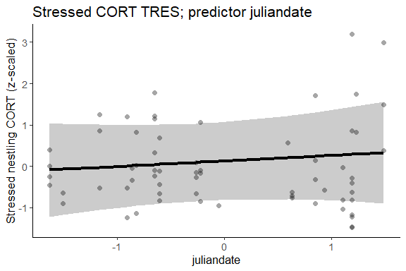

Does the inclusion of juliandate improve the model?
Table 1: Response s2, predictor juliandate
model | npar | AIC | BIC | logLik | deviance | Chisq | Df | P-value
no juliandate | 16 | 187.2425 | 221.7846 | -77.62124 | 155.2425 | NA | NA | NA
full model | 17 | 188.7514 | 225.4524 | -77.37569 | 154.7514 | 0.491117 | 1 | 0.4834
Stressed cort - baseline cort as response variable:
Table 1: Response s2-s1, predictor juliandate
Predictor | Estimate | Std. Error | df | t value | P-value
(Intercept) | -0.43 | 0.70 | 20.78491 | -0.61182741 | 0.5473
mother_cort_diff_scaled | 0.28 | 0.39 | 12.82389 | 0.72631583 | 0.4807
occasion3 | -0.03 | 0.45 | 24.69757 | -0.07250939 | 0.9428
brood_size_scaled | -1.62 | 1.44 | 17.08985 | -1.12308445 | 0.2769
habitatOrchard | 1.12 | 0.90 | 16.70469 | 1.24161680 | 0.2315
habitatGrassland | 0.49 | 0.75 | 19.52525 | 0.64421153 | 0.5269
habitatRow crop | 0.19 | 0.78 | 15.83649 | 0.24865525 | 0.8068
condition_scaled | 0.35 | 0.38 | 21.32555 | 0.90240215 | 0.3769
juliandate_scaled | 0.05 | 0.28 | 10.21464 | 0.19149983 | 0.8519
brood_size_scaled:habitatOrchard | 1.57 | 1.52 | 18.45931 | 1.02988234 | 0.3164
brood_size_scaled:habitatGrassland | 1.53 | 1.38 | 18.44346 | 1.10717926 | 0.2824
brood_size_scaled:habitatRow crop | 1.20 | 1.38 | 15.64782 | 0.86899723 | 0.398
habitatOrchard:condition_scaled | -1.39 | 0.71 | 17.73072 | -1.95653534 | 0.0663
habitatGrassland:condition_scaled | -0.04 | 0.42 | 22.72009 | -0.10426657 | 0.9179
This table presents the full model results.

Plot of predicted relationship between stressed cort and juliandate:
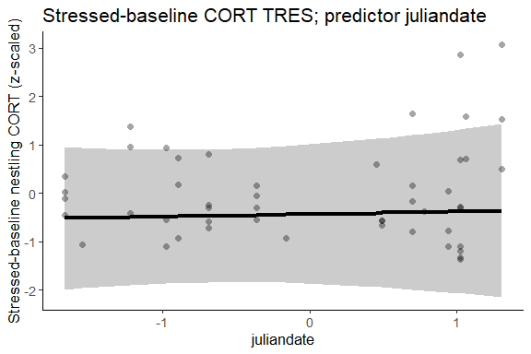

Does the inclusion of juliandate improve the model?
Table 1: Response s2-s1, predictor juliandate
model | npar | AIC | BIC | logLik | deviance | Chisq | Df | P-value
no juliandate | 15 | 139.1203 | 167.4976 | -54.56013 | 109.1203 | NA | NA | NA
full model | 16 | 141.1075 | 171.3766 | -54.55375 | 109.1075 | 0.01277407 | 1 | 0.91
This table compares models with and without juliandate.

2. How does mother attempt number relate to cort?

Distribution of mother attempt number over juliandate
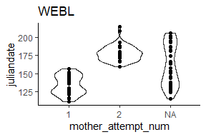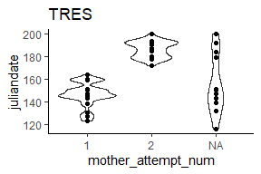

Variation in cort across mother attempt number
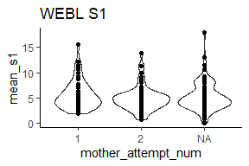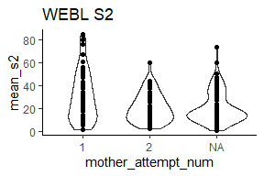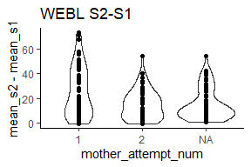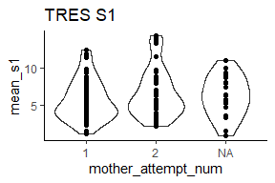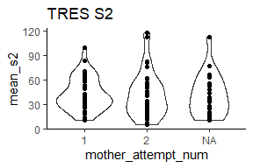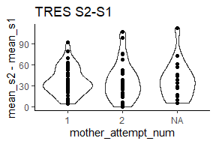

Model-predicted relationship between mother attempt number and cort
Reminder: full model is - cort ~ mother cort + week2/week3 + brood_size * habitat + condition * habitat + juliandate + rand(attempt_id)

WEBL
Baseline cort as response variable:
Table 1: Response s1, predictor mother attempt number
Predictor | Estimate | Std. Error | df | t value | P-value
(Intercept) | -0.09 | 0.53 | 15.50229 | -0.169628226 | 0.8675
cort_s1_mother_scaled | -0.23 | 0.18 | 16.79343 | -1.269714544 | 0.2215
occasion3 | 0.83 | 0.20 | 83.11823 | 4.113983890 | 1e-04*
brood_size_scaled | 0.59 | 0.34 | 14.24773 | 1.719247524 | 0.1072
habitatOrchard | -0.24 | 0.56 | 15.30090 | -0.428697634 | 0.6741
habitatGrassland | -0.54 | 0.54 | 13.28455 | -1.003370250 | 0.3336
habitatRow crop | 0.00 | 0.53 | 12.12393 | 0.004226055 | 0.9967
condition_scaled | -0.33 | 0.19 | 82.44151 | -1.724439683 | 0.0884
mother_attempt_num2 | -0.07 | 0.39 | 15.47594 | -0.168633832 | 0.8683
brood_size_scaled:habitatOrchard | -0.94 | 0.40 | 14.00974 | -2.349963322 | 0.034*
brood_size_scaled:habitatGrassland | -0.86 | 0.46 | 14.80702 | -1.847936426 | 0.0847
brood_size_scaled:habitatRow crop | 0.34 | 0.63 | 12.02486 | 0.535350444 | 0.6022
habitatOrchard:condition_scaled | 0.11 | 0.32 | 80.50433 | 0.332565590 | 0.7403
habitatGrassland:condition_scaled | 0.19 | 0.27 | 85.30933 | 0.727793435 | 0.4687
habitatRow crop:condition_scaled | 0.46 | 0.31 | 80.60350 | 1.477553466 | 0.1434
This table presents the full model results.

Plot of predicted relationship between baseline cort and mother attempt number:
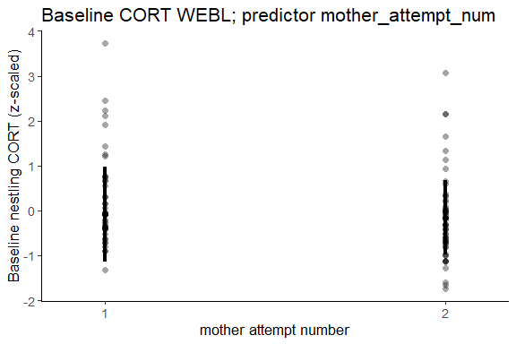

Does the inclusion of mother attempt number improve the model?
Table 1: Response s1, predictor mother attempt number
model | npar | AIC | BIC | logLik | deviance | Chisq | Df | P-value
no mother attempt number | 16 | 271.3989 | 313.2408 | -119.6994 | 239.3989 | NA | NA | NA
full model | 17 | 273.3489 | 317.8059 | -119.6744 | 239.3489 | 0.0500009 | 1 | 0.8231
Stressed cort as response variable:
Table 1: Response s2, predictor mother attempt number
Predictor | Estimate | Std. Error | df | t value | P-value
(Intercept) | -0.22 | 0.35 | 14.77430 | -0.645404827 | 0.5286
cort_s2_mother_scaled | 0.29 | 0.15 | 15.54219 | 1.923016442 | 0.073
occasion3 | 0.32 | 0.18 | 91.76012 | 1.744218577 | 0.0845
brood_size_scaled | 0.06 | 0.38 | 23.22931 | 0.161915958 | 0.8728
habitatOrchard | 0.77 | 0.42 | 15.94390 | 1.831464306 | 0.0858
habitatGrassland | 0.00 | 0.41 | 13.56829 | 0.006399535 | 0.995
habitatRow crop | 0.57 | 0.44 | 12.90073 | 1.295855399 | 0.2177
condition_scaled | 0.07 | 0.15 | 93.35919 | 0.494625054 | 0.622
mother_attempt_num2 | -0.50 | 0.32 | 14.37785 | -1.550498672 | 0.1427
brood_size_scaled:habitatOrchard | -0.37 | 0.43 | 21.33719 | -0.861114603 | 0.3987
brood_size_scaled:habitatGrassland | 0.25 | 0.44 | 19.92814 | 0.578950067 | 0.5691
brood_size_scaled:habitatRow crop | -0.29 | 0.64 | 13.89279 | -0.461101222 | 0.6519
habitatOrchard:condition_scaled | -0.19 | 0.28 | 92.73810 | -0.655354492 | 0.5139
habitatGrassland:condition_scaled | 0.28 | 0.25 | 78.34880 | 1.118545413 | 0.2668
habitatRow crop:condition_scaled | -0.23 | 0.26 | 93.99197 | -0.861487776 | 0.3912
This table presents the full model results.

Plot of predicted relationship between stressed cort and juliandate:
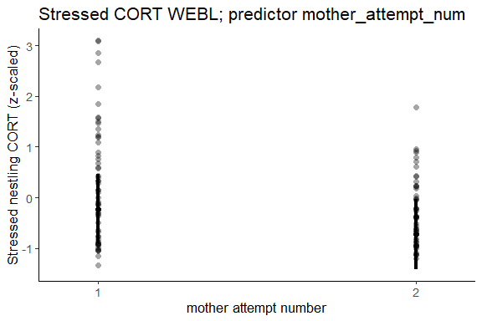

Does the inclusion of mother attempt number improve the model?
Table 1: Response s2, predictor mother attempt number
model | npar | AIC | BIC | logLik | deviance | Chisq | Df | P-value
no mother attempt number | 16 | 296.3536 | 339.4152 | -132.1768 | 264.3536 | NA | NA | NA
full model | 17 | 294.3417 | 340.0946 | -130.1708 | 260.3417 | 4.011979 | 1 | 0.0452*
Stressed-baseline cort as response variable:
Table 1: Response s2-s1, predictor mother attempt number
Predictor | Estimate | Std. Error | df | t value | P-value
(Intercept) | -0.41 | 0.72 | 13.023256 | -0.57537495 | 0.5748
mother_cort_diff_scaled | 0.20 | 0.22 | 8.502394 | 0.92645409 | 0.3798
occasion3 | 0.35 | 0.21 | 54.721310 | 1.67086854 | 0.1005
brood_size_scaled | 0.54 | 0.53 | 13.450921 | 1.01853648 | 0.3264
habitatOrchard | 1.09 | 0.75 | 12.321183 | 1.44439615 | 0.1736
habitatGrassland | 0.24 | 0.72 | 11.804739 | 0.33343875 | 0.7447
habitatRow crop | 0.66 | 0.76 | 10.335850 | 0.86038390 | 0.4091
condition_scaled | -0.09 | 0.23 | 52.786863 | -0.38150780 | 0.7044
mother_attempt_num2 | -0.53 | 0.51 | 9.092244 | -1.04050263 | 0.325
brood_size_scaled:habitatOrchard | -0.79 | 0.59 | 12.323069 | -1.32862426 | 0.2081
brood_size_scaled:habitatGrassland | -0.24 | 0.67 | 11.798940 | -0.36347148 | 0.7227
brood_size_scaled:habitatRow crop | -0.81 | 0.84 | 9.184157 | -0.96716557 | 0.3582
habitatOrchard:condition_scaled | -0.03 | 0.34 | 49.919971 | -0.09038525 | 0.9283
habitatGrassland:condition_scaled | 0.29 | 0.32 | 59.713674 | 0.90679913 | 0.3682
habitatRow crop:condition_scaled | -0.06 | 0.36 | 58.822283 | -0.15801400 | 0.875
This table presents the full model results.

Plot of predicted relationship between stressed - baseline nestling cort and mother attempt number:
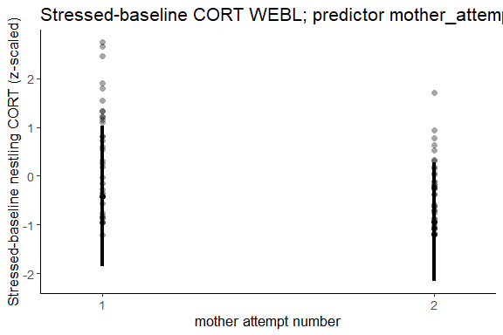

Does the inclusion of mother attempt number improve the model?
Table 1: Response s2, predictor mother attempt number
model | npar | AIC | BIC | logLik | deviance | Chisq | Df | P-value
no mother attempt number | 16 | 205.1429 | 242.2227 | -86.57147 | 173.1429 | NA | NA | NA
full model | 17 | 204.1718 | 243.5691 | -85.08589 | 170.1718 | 2.971162 | 1 | 0.0848
This table compares models with and without mother attempt number.

TRES
Baseline cort as response variable:
Table 1: Response s1, predictor mother attempt number
Predictor | Estimate | Std. Error | df | t value | P-value
(Intercept) | 1.49 | 0.73 | 69 | 2.05540444 | 0.0436*
cort_s1_mother_scaled | -0.23 | 0.11 | 69 | -2.07712757 | 0.0415*
occasion3 | 0.45 | 0.28 | 69 | 1.62901401 | 0.1079
brood_size_scaled | 1.10 | 1.23 | 69 | 0.89760536 | 0.3725
habitatOrchard | -2.53 | 0.83 | 69 | -3.03773909 | 0.0034**
habitatGrassland | -1.79 | 0.74 | 69 | -2.40578119 | 0.0188*
habitatRow crop | -1.64 | 0.75 | 69 | -2.19146641 | 0.0318*
condition_scaled | 0.31 | 0.44 | 69 | 0.71439976 | 0.4774
mother_attempt_num2 | 0.07 | 0.28 | 69 | 0.26117029 | 0.7947
brood_size_scaled:habitatOrchard | -1.49 | 1.29 | 69 | -1.16091748 | 0.2497
brood_size_scaled:habitatGrassland | -0.98 | 1.22 | 69 | -0.80436261 | 0.424
brood_size_scaled:habitatRow crop | -1.23 | 1.23 | 69 | -0.99508477 | 0.3232
habitatOrchard:condition_scaled | 0.06 | 0.70 | 69 | 0.08260995 | 0.9344
habitatGrassland:condition_scaled | -0.38 | 0.48 | 69 | -0.78849982 | 0.4331
habitatRow crop:condition_scaled | 0.33 | 0.47 | 69 | 0.70256699 | 0.4847
This table presents the full model results.

Plot of predicted relationship between baseline cort and mother attempt number:
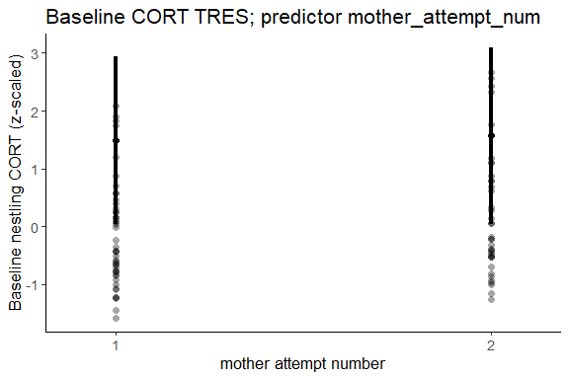

Does the inclusion of mother attempt number improve the model?
Table 1: Response s1, predictor mother attempt number
model | npar | AIC | BIC | logLik | deviance | Chisq | Df | P-value
no mother attempt number | 16 | 230.8261 | 269.7192 | -99.41307 | 198.8261 | NA | NA | NA
full model | 17 | 232.7431 | 274.0670 | -99.37157 | 198.7431 | 0.08299715 | 1 | 0.7733
Stressed cort as response variable:
Table 1: Response s2, predictor mother attempt number
Predictor | Estimate | Std. Error | df | t value | P-value
(Intercept) | 0.03 | 0.49 | 17.11753 | 0.06211836 | 0.9512
cort_s2_mother_scaled | -0.10 | 0.23 | 18.69755 | -0.44320461 | 0.6627
occasion3 | 0.05 | 0.41 | 35.03503 | 0.11400812 | 0.9099
brood_size_scaled | -0.33 | 0.57 | 14.48512 | -0.57844293 | 0.5718
habitatOrchard | 1.13 | 0.69 | 16.12014 | 1.62825882 | 0.1229
habitatGrassland | -0.42 | 0.51 | 16.12108 | -0.83270061 | 0.4172
habitatRow crop | -0.36 | 0.57 | 11.50292 | -0.62407270 | 0.5448
condition_scaled | 0.29 | 0.44 | 11.57931 | 0.66398990 | 0.5197
mother_attempt_num2 | 0.55 | 0.58 | 13.56377 | 0.96195026 | 0.3529
brood_size_scaled:habitatOrchard | 0.21 | 0.80 | 19.45160 | 0.26417561 | 0.7944
brood_size_scaled:habitatGrassland | 0.51 | 0.60 | 16.17858 | 0.85070202 | 0.4073
brood_size_scaled:habitatRow crop | 0.67 | 0.67 | 10.31852 | 1.00531433 | 0.3377
habitatOrchard:condition_scaled | -1.40 | 0.76 | 19.98972 | -1.83663473 | 0.0812
habitatGrassland:condition_scaled | 0.15 | 0.50 | 13.57867 | 0.29866377 | 0.7697
habitatRow crop:condition_scaled | 0.03 | 0.58 | 16.76858 | 0.04660447 | 0.9634
This table presents the full model results.

Plot of predicted relationship between stressed cort and mother attempt number:
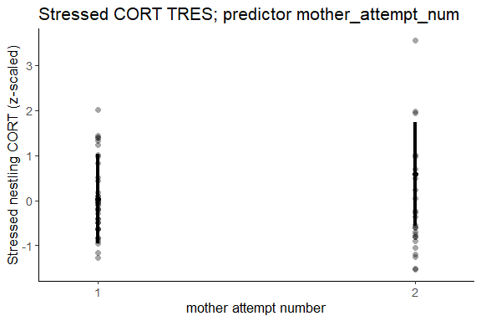

Does the inclusion of mother attempt number improve the model?
Table 1: Response s2, predictor mother attempt number
model | npar | AIC | BIC | logLik | deviance | Chisq | Df | P-value
no mother attempt number | 16 | 188.7768 | 222.8110 | -78.38841 | 156.7768 | NA | NA | NA
full model | 17 | 189.3655 | 225.5268 | -77.68274 | 155.3655 | 1.411351 | 1 | 0.2348
Stressed-baseline cort as response variable:
Table 1: Response s2-s1, predictor mother attempt number
Predictor | Estimate | Std. Error | df | t value | P-value
(Intercept) | -0.75 | 0.83 | 22.52228 | -0.9021145 | 0.3765
mother_cort_diff_scaled | 0.06 | 0.26 | 11.93852 | 0.2285787 | 0.8231
occasion3 | 0.07 | 0.49 | 20.60812 | 0.1376754 | 0.8918
brood_size_scaled | -1.49 | 1.36 | 17.50179 | -1.0987991 | 0.2867
habitatOrchard | 1.65 | 1.05 | 16.88176 | 1.5680809 | 0.1354
habitatGrassland | 0.27 | 0.92 | 20.92146 | 0.2968565 | 0.7695
habitatRow crop | 0.37 | 0.90 | 16.97282 | 0.4088877 | 0.6877
condition_scaled | -0.19 | 0.54 | 30.56575 | -0.3555852 | 0.7246
mother_attempt_num2 | 0.85 | 0.80 | 11.63001 | 1.0517765 | 0.3143
brood_size_scaled:habitatOrchard | 1.53 | 1.48 | 18.32505 | 1.0287925 | 0.317
brood_size_scaled:habitatGrassland | 1.67 | 1.27 | 18.98030 | 1.3127937 | 0.2049
brood_size_scaled:habitatRow crop | 2.76 | 1.52 | 16.37925 | 1.8207444 | 0.087
habitatOrchard:condition_scaled | -1.04 | 0.84 | 20.88835 | -1.2313120 | 0.2319
habitatGrassland:condition_scaled | 0.70 | 0.60 | 32.53928 | 1.1826760 | 0.2455
This table presents the full model results.

Plot of predicted relationship between stressed - baseline nestling cort and mother attempt number:
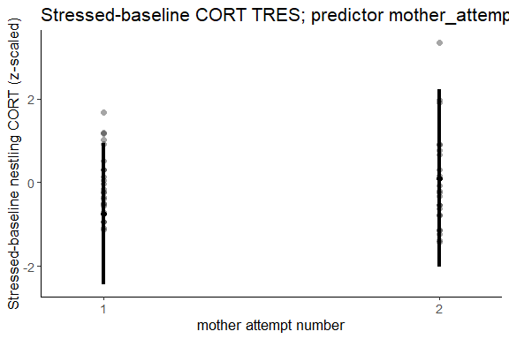

Does the inclusion of mother attempt number improve the model?
Table 1: Response s2, predictor mother attempt number
model | npar | AIC | BIC | logLik | deviance | Chisq | Df | P-value
no mother attempt number | 15 | 142.8913 | 170.6436 | -56.44567 | 112.8913 | NA | NA | NA
full model | 16 | 143.4709 | 173.0732 | -55.73544 | 111.4709 | 1.420457 | 1 | 0.2333
This table compares models with and without mother attempt number.

3. How does mother cort relate to nestling cort?

Distribution of mother cort
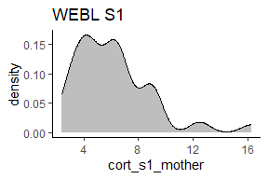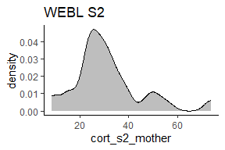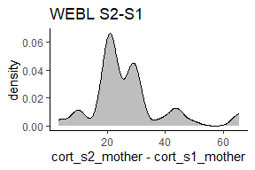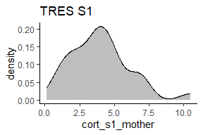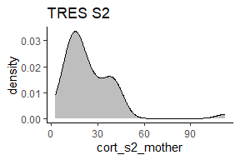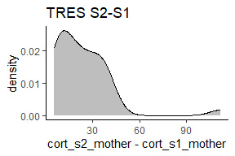

Variation in mother cort across nestling cort
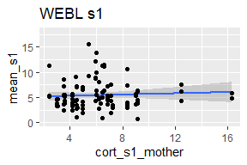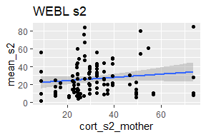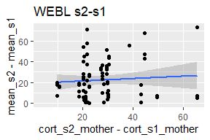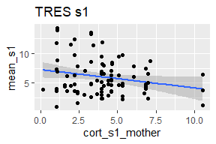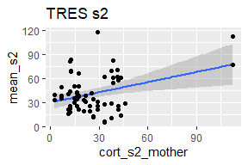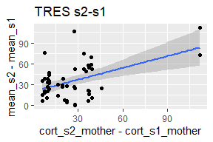

Model-predicted relationship between mother cort and nestling cort
Reminder: full model is - cort ~ mother cort + week2/week3 + brood_size * habitat + condition * habitat + juliandate + rand(attempt_id)

WEBL
Baseline cort as response variable:
Table 1: Response s1, predictor juliandate
Predictor | Estimate | Std. Error | df | t value | P-value
(Intercept) | -0.12 | 0.42 | 13.41430 | -0.27750414 | 0.7856
cort_s1_mother_scaled | -0.24 | 0.18 | 17.57396 | -1.30267621 | 0.2095
occasion3 | 0.83 | 0.20 | 84.52825 | 4.14975081 | 1e-04*
brood_size_scaled | 0.59 | 0.33 | 14.41588 | 1.78349854 | 0.0956
habitatOrchard | -0.27 | 0.56 | 15.54342 | -0.48126523 | 0.637
habitatGrassland | -0.56 | 0.54 | 13.52310 | -1.03411098 | 0.3192
habitatRow crop | 0.01 | 0.52 | 11.86096 | 0.01985473 | 0.9845
condition_scaled | -0.33 | 0.19 | 83.20653 | -1.71660785 | 0.0898
juliandate_scaled | -0.05 | 0.18 | 17.59990 | -0.28931421 | 0.7757
brood_size_scaled:habitatOrchard | -0.94 | 0.39 | 14.15369 | -2.41891393 | 0.0296*
brood_size_scaled:habitatGrassland | -0.87 | 0.44 | 15.03241 | -1.97393111 | 0.0671
brood_size_scaled:habitatRow crop | 0.33 | 0.62 | 11.87745 | 0.54092510 | 0.5986
habitatOrchard:condition_scaled | 0.10 | 0.32 | 80.64649 | 0.30728174 | 0.7594
habitatGrassland:condition_scaled | 0.20 | 0.26 | 84.94840 | 0.73735901 | 0.4629
habitatRow crop:condition_scaled | 0.47 | 0.31 | 80.77260 | 1.49785420 | 0.1381
This table presents the full model results.

Plot of predicted relationship between baseline cort and juliandate:
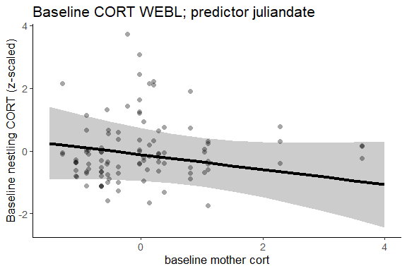

Does the inclusion of mother cort improve the model?
Table 1: Response s1, predictor juliandate
model | npar | AIC | BIC | logLik | deviance | Chisq | Df | P-value
no mother baseline cort | 16 | 273.7762 | 315.6181 | -120.8881 | 241.7762 | NA | NA | NA
full model | 17 | 273.1233 | 317.5804 | -119.5617 | 239.1233 | 2.652858 | 1 | 0.1034
Stressed cort as response variable:
Table 1: Response s2, predictor juliandate
Predictor | Estimate | Std. Error | df | t value | P-value
(Intercept) | -0.46 | 0.31 | 13.70012 | -1.49264707 | 0.1582
cort_s2_mother_scaled | 0.26 | 0.15 | 15.86733 | 1.71133928 | 0.1065
occasion3 | 0.36 | 0.18 | 93.05008 | 1.96247505 | 0.0527
brood_size_scaled | 0.11 | 0.37 | 22.42038 | 0.30726747 | 0.7615
habitatOrchard | 0.67 | 0.43 | 16.31562 | 1.53872778 | 0.143
habitatGrassland | -0.03 | 0.41 | 13.45014 | -0.06791861 | 0.9468
habitatRow crop | 0.60 | 0.44 | 12.89245 | 1.37545017 | 0.1924
condition_scaled | 0.07 | 0.15 | 93.37204 | 0.45923401 | 0.6471
juliandate_scaled | -0.23 | 0.16 | 15.87719 | -1.45743196 | 0.1645
brood_size_scaled:habitatOrchard | -0.43 | 0.42 | 21.16312 | -1.04103123 | 0.3096
brood_size_scaled:habitatGrassland | 0.18 | 0.43 | 19.55815 | 0.42274251 | 0.6771
brood_size_scaled:habitatRow crop | -0.27 | 0.64 | 13.84155 | -0.42554421 | 0.677
habitatOrchard:condition_scaled | -0.17 | 0.28 | 92.79325 | -0.61088055 | 0.5428
habitatGrassland:condition_scaled | 0.29 | 0.25 | 78.15003 | 1.15846622 | 0.2502
habitatRow crop:condition_scaled | -0.20 | 0.27 | 93.88283 | -0.74674444 | 0.4571
This table presents the full model results.

Plot of predicted relationship between stressed nestling cort and stressed mother cort:
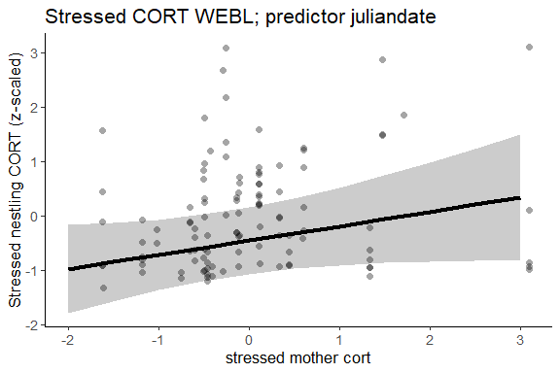

Does the inclusion of mother cort improve the model?
Table 1: Response s2, predictor juliandate
model | npar | AIC | BIC | logLik | deviance | Chisq | Df | P-value
no mother cort | 16 | 296.4254 | 339.4870 | -132.2127 | 264.4254 | NA | NA | NA
full model | 17 | 294.6140 | 340.3669 | -130.3070 | 260.6140 | 3.811408 | 1 | 0.0509
Stressed-baseline cort as response variable:
Table 1: Response s2-s1, predictor mother attempt number
Predictor | Estimate | Std. Error | df | t value | P-value
(Intercept) | -0.77 | 0.61 | 13.386461 | -1.26475392 | 0.2275
mother_cort_diff_scaled | 0.21 | 0.22 | 8.793796 | 0.96332384 | 0.3611
occasion3 | 0.39 | 0.21 | 56.953079 | 1.85272961 | 0.0691
brood_size_scaled | 0.62 | 0.52 | 13.587456 | 1.19695309 | 0.2518
habitatOrchard | 1.13 | 0.76 | 12.273954 | 1.48723912 | 0.1622
habitatGrassland | 0.22 | 0.73 | 11.942072 | 0.30369539 | 0.7666
habitatRow crop | 0.75 | 0.77 | 10.363987 | 0.97254891 | 0.3529
condition_scaled | -0.11 | 0.23 | 53.448139 | -0.46124047 | 0.6465
juliandate_scaled | -0.22 | 0.24 | 10.163297 | -0.91113216 | 0.3833
brood_size_scaled:habitatOrchard | -0.87 | 0.59 | 12.301377 | -1.47160874 | 0.1662
brood_size_scaled:habitatGrassland | -0.42 | 0.66 | 11.927710 | -0.63535259 | 0.5372
brood_size_scaled:habitatRow crop | -0.78 | 0.85 | 9.328940 | -0.92650397 | 0.3775
habitatOrchard:condition_scaled | -0.02 | 0.34 | 50.280607 | -0.04418803 | 0.9649
habitatGrassland:condition_scaled | 0.31 | 0.32 | 59.743478 | 0.97636974 | 0.3328
habitatRow crop:condition_scaled | -0.03 | 0.37 | 59.108625 | -0.07231261 | 0.9426
This table presents the full model results.

Plot of predicted relationship between stressed - baseline nestling cort and stressed-baseline mother cort:
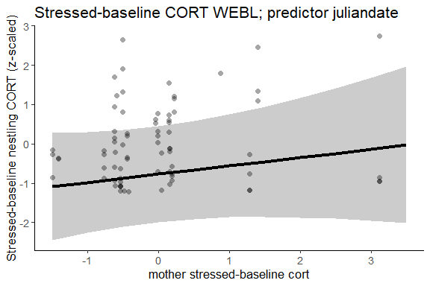

Does the inclusion of mother cort improve the model?
Table 1: Response s2-s1, predictor juliandate
model | npar | AIC | BIC | logLik | deviance | Chisq | Df | P-value
no mother cort | 16 | 204.2260 | 241.3058 | -86.11298 | 172.2260 | NA | NA | NA
full model | 17 | 204.7951 | 244.1924 | -85.39754 | 170.7951 | 1.430887 | 1 | 0.2316
This table presents results with and without mother cort.

TRES
Baseline cort as response variable:
Table 1: Response s1, predictor juliandate
Predictor | Estimate | Std. Error | df | t value | P-value
(Intercept) | 1.55 | 0.68 | 71 | 2.29006214 | 0.025*
cort_s1_mother_scaled | -0.23 | 0.11 | 71 | -2.06536580 | 0.0425*
occasion3 | 0.60 | 0.26 | 71 | 2.34296503 | 0.0219*
brood_size_scaled | 1.50 | 1.38 | 71 | 1.08923524 | 0.2797
habitatOrchard | -2.41 | 0.78 | 71 | -3.07456469 | 0.003**
habitatGrassland | -1.82 | 0.69 | 71 | -2.63737860 | 0.0103*
habitatRow crop | -1.69 | 0.70 | 71 | -2.43174364 | 0.0176*
condition_scaled | 0.39 | 0.44 | 71 | 0.89121205 | 0.3758
juliandate_scaled | 0.12 | 0.14 | 71 | 0.83261907 | 0.4079
brood_size_scaled:habitatOrchard | -1.88 | 1.43 | 71 | -1.31891384 | 0.1914
brood_size_scaled:habitatGrassland | -1.35 | 1.36 | 71 | -0.99061420 | 0.3252
brood_size_scaled:habitatRow crop | -1.19 | 1.37 | 71 | -0.87419636 | 0.385
habitatOrchard:condition_scaled | -0.05 | 0.70 | 71 | -0.07457754 | 0.9408
habitatGrassland:condition_scaled | -0.45 | 0.47 | 71 | -0.95876615 | 0.3409
habitatRow crop:condition_scaled | 0.20 | 0.47 | 71 | 0.43131167 | 0.6675
This table presents the full model results.

Plot of predicted relationship between baseline cort and juliandate:
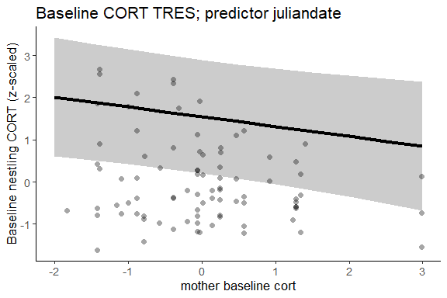
I do not know why the best fit line is above the data!! Really weird.

Does the inclusion of juliandate improve the model?
Table 1: Response s1, predictor juliandate
model | npar | AIC | BIC | logLik | deviance | Chisq | Df | P-value
no mother baseline cort | 16 | 241.9026 | 281.1722 | -104.9513 | 209.9026 | NA | NA | NA
full model | 17 | 238.8850 | 280.6089 | -102.4425 | 204.8850 | 5.01768 | 1 | 0.0251*
Stressed cort as response variable:
Table 1: Response s2, predictor juliandate
Predictor | Estimate | Std. Error | df | t value | P-value
(Intercept) | 0.13 | 0.47 | 18.17637 | 0.28303974 | 0.7803
cort_s2_mother_scaled | 0.39 | 0.22 | 22.30038 | 1.76844876 | 0.0907
occasion3 | 0.34 | 0.36 | 37.54408 | 0.95429626 | 0.346
brood_size_scaled | -0.03 | 0.55 | 14.24346 | -0.05989613 | 0.9531
habitatOrchard | 0.77 | 0.68 | 16.81926 | 1.13012119 | 0.2743
habitatGrassland | -0.36 | 0.53 | 17.67201 | -0.66997018 | 0.5115
habitatRow crop | -0.49 | 0.58 | 13.57967 | -0.84351477 | 0.4136
condition_scaled | 0.30 | 0.45 | 13.59279 | 0.65553759 | 0.5231
juliandate_scaled | 0.13 | 0.23 | 14.25957 | 0.58971468 | 0.5646
brood_size_scaled:habitatOrchard | -0.36 | 0.74 | 19.96873 | -0.48971244 | 0.6297
brood_size_scaled:habitatGrassland | 0.01 | 0.61 | 16.03656 | 0.02414123 | 0.981
brood_size_scaled:habitatRow crop | -0.12 | 0.57 | 13.00988 | -0.20584878 | 0.8401
habitatOrchard:condition_scaled | -1.26 | 0.75 | 21.07471 | -1.67592189 | 0.1085
habitatGrassland:condition_scaled | -0.04 | 0.52 | 16.26196 | -0.06924917 | 0.9456
habitatRow crop:condition_scaled | 0.11 | 0.58 | 19.04602 | 0.19569854 | 0.8469
This table presents the full model results.

Plot of predicted relationship between stressed nestling cort and stressed mother cort:
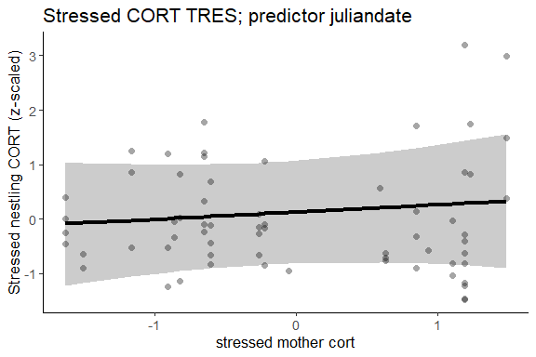

Does the inclusion of stressed mother cort improve the model?
Table 1: Response s2, predictor juliandate
model | npar | AIC | BIC | logLik | deviance | Chisq | Df | P-value
no mother stressed cort | 16 | 191.9261 | 226.4682 | -79.96303 | 159.9261 | NA | NA | NA
full model | 17 | 188.7514 | 225.4524 | -77.37569 | 154.7514 | 5.174686 | 1 | 0.0229*
Stressed-baseline cort as response variable:
Table 1: Response s2-s1, predictor mother attempt number
Predictor | Estimate | Std. Error | df | t value | P-value
(Intercept) | -0.43 | 0.70 | 20.78491 | -0.61182741 | 0.5473
mother_cort_diff_scaled | 0.28 | 0.39 | 12.82389 | 0.72631583 | 0.4807
occasion3 | -0.03 | 0.45 | 24.69757 | -0.07250939 | 0.9428
brood_size_scaled | -1.62 | 1.44 | 17.08985 | -1.12308445 | 0.2769
habitatOrchard | 1.12 | 0.90 | 16.70469 | 1.24161680 | 0.2315
habitatGrassland | 0.49 | 0.75 | 19.52525 | 0.64421153 | 0.5269
habitatRow crop | 0.19 | 0.78 | 15.83649 | 0.24865525 | 0.8068
condition_scaled | 0.35 | 0.38 | 21.32555 | 0.90240215 | 0.3769
juliandate_scaled | 0.05 | 0.28 | 10.21464 | 0.19149983 | 0.8519
brood_size_scaled:habitatOrchard | 1.57 | 1.52 | 18.45931 | 1.02988234 | 0.3164
brood_size_scaled:habitatGrassland | 1.53 | 1.38 | 18.44346 | 1.10717926 | 0.2824
brood_size_scaled:habitatRow crop | 1.20 | 1.38 | 15.64782 | 0.86899723 | 0.398
habitatOrchard:condition_scaled | -1.39 | 0.71 | 17.73072 | -1.95653534 | 0.0663
habitatGrassland:condition_scaled | -0.04 | 0.42 | 22.72009 | -0.10426657 | 0.9179
This table presents the full model results.

Plot of predicted relationship between stressed - baseline nestling cort and stressed-baseline mother cort:
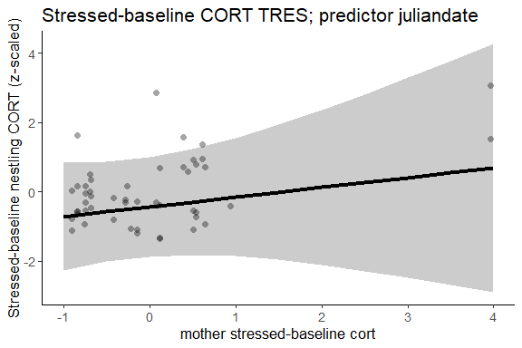

Does the inclusion of mother cort improve the model?
Table 1: Response s2-s1, predictor juliandate
model | npar | AIC | BIC | logLik | deviance | Chisq | Df | P-value
no mother cort | 15 | 139.6297 | 168.0070 | -54.81485 | 109.6297 | NA | NA | NA
full model | 16 | 141.1075 | 171.3766 | -54.55375 | 109.1075 | 0.5222147 | 1 | 0.4699
This table presents models with and without mother cort.

4. How does occasion relate to cort?

Distribution of occasion over juliandate
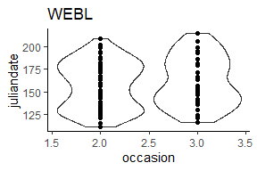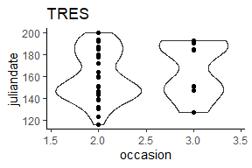

Variation in cort across occasion
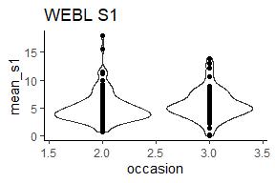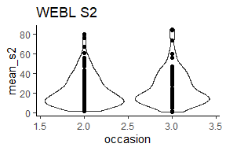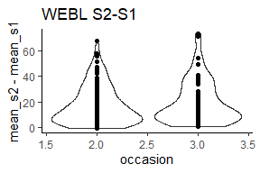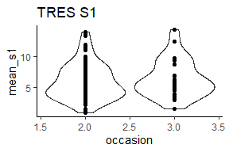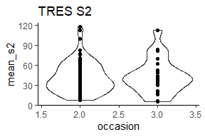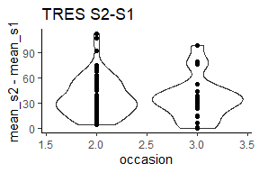

Model-predicted relationship between occasion and cort
Reminder: full model is - cort ~ mother cort + week2/week3 + brood_size * habitat + condition * habitat + juliandate + rand(attempt_id)

WEBL
Baseline cort as response variable:
Table 1: Response s1, predictor occasion
Predictor | Estimate | Std. Error | df | t value | P-value
(Intercept) | -0.12 | 0.42 | 13.41430 | -0.27750414 | 0.7856
cort_s1_mother_scaled | -0.24 | 0.18 | 17.57396 | -1.30267621 | 0.2095
occasion3 | 0.83 | 0.20 | 84.52825 | 4.14975081 | 1e-04*
brood_size_scaled | 0.59 | 0.33 | 14.41588 | 1.78349854 | 0.0956
habitatOrchard | -0.27 | 0.56 | 15.54342 | -0.48126523 | 0.637
habitatGrassland | -0.56 | 0.54 | 13.52310 | -1.03411098 | 0.3192
habitatRow crop | 0.01 | 0.52 | 11.86096 | 0.01985473 | 0.9845
condition_scaled | -0.33 | 0.19 | 83.20653 | -1.71660785 | 0.0898
juliandate_scaled | -0.05 | 0.18 | 17.59990 | -0.28931421 | 0.7757
brood_size_scaled:habitatOrchard | -0.94 | 0.39 | 14.15369 | -2.41891393 | 0.0296*
brood_size_scaled:habitatGrassland | -0.87 | 0.44 | 15.03241 | -1.97393111 | 0.0671
brood_size_scaled:habitatRow crop | 0.33 | 0.62 | 11.87745 | 0.54092510 | 0.5986
habitatOrchard:condition_scaled | 0.10 | 0.32 | 80.64649 | 0.30728174 | 0.7594
habitatGrassland:condition_scaled | 0.20 | 0.26 | 84.94840 | 0.73735901 | 0.4629
habitatRow crop:condition_scaled | 0.47 | 0.31 | 80.77260 | 1.49785420 | 0.1381
This table presents the full model results.

Plot of predicted relationship between baseline cort and occasion:
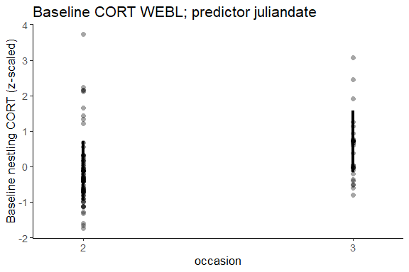

Does the inclusion of occasion improve the model?
Table 1: Response s1, predictor juliandate
model | npar | AIC | BIC | logLik | deviance | Chisq | Df | P-value
no occasion | 16 | 284.5364 | 326.3784 | -126.2682 | 252.5364 | NA | NA | NA
full model | 17 | 273.1233 | 317.5804 | -119.5617 | 239.1233 | 13.41308 | 1 | 2e-04*
Stressed cort as response variable:
Table 1: Response s2, predictor juliandate
Predictor | Estimate | Std. Error | df | t value | P-value
(Intercept) | -0.46 | 0.31 | 13.70012 | -1.49264707 | 0.1582
cort_s2_mother_scaled | 0.26 | 0.15 | 15.86733 | 1.71133928 | 0.1065
occasion3 | 0.36 | 0.18 | 93.05008 | 1.96247505 | 0.0527
brood_size_scaled | 0.11 | 0.37 | 22.42038 | 0.30726747 | 0.7615
habitatOrchard | 0.67 | 0.43 | 16.31562 | 1.53872778 | 0.143
habitatGrassland | -0.03 | 0.41 | 13.45014 | -0.06791861 | 0.9468
habitatRow crop | 0.60 | 0.44 | 12.89245 | 1.37545017 | 0.1924
condition_scaled | 0.07 | 0.15 | 93.37204 | 0.45923401 | 0.6471
juliandate_scaled | -0.23 | 0.16 | 15.87719 | -1.45743196 | 0.1645
brood_size_scaled:habitatOrchard | -0.43 | 0.42 | 21.16312 | -1.04103123 | 0.3096
brood_size_scaled:habitatGrassland | 0.18 | 0.43 | 19.55815 | 0.42274251 | 0.6771
brood_size_scaled:habitatRow crop | -0.27 | 0.64 | 13.84155 | -0.42554421 | 0.677
habitatOrchard:condition_scaled | -0.17 | 0.28 | 92.79325 | -0.61088055 | 0.5428
habitatGrassland:condition_scaled | 0.29 | 0.25 | 78.15003 | 1.15846622 | 0.2502
habitatRow crop:condition_scaled | -0.20 | 0.27 | 93.88283 | -0.74674444 | 0.4571
This table presents the full model results.

Plot of predicted relationship between stressed cort and juliandate:
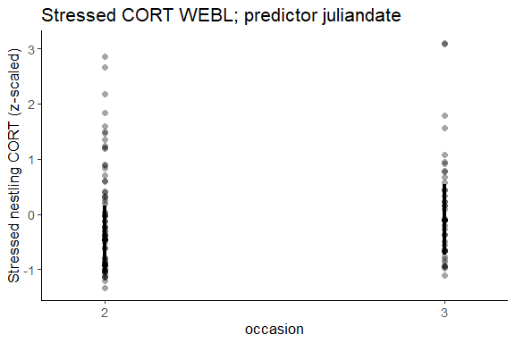

Does the inclusion of occasion improve the model?
Table 1: Response s2, predictor occasion
model | npar | AIC | BIC | logLik | deviance | Chisq | Df | P-value
no occasion | 16 | 294.9743 | 338.0358 | -131.4871 | 262.9743 | NA | NA | NA
full model | 17 | 294.6140 | 340.3669 | -130.3070 | 260.6140 | 2.360233 | 1 | 0.1245
Stressed-baseline cort as response variable:
Table 1: Response s2-s1, predictor mother attempt number
Predictor | Estimate | Std. Error | df | t value | P-value
(Intercept) | -0.77 | 0.61 | 13.386461 | -1.26475392 | 0.2275
mother_cort_diff_scaled | 0.21 | 0.22 | 8.793796 | 0.96332384 | 0.3611
occasion3 | 0.39 | 0.21 | 56.953079 | 1.85272961 | 0.0691
brood_size_scaled | 0.62 | 0.52 | 13.587456 | 1.19695309 | 0.2518
habitatOrchard | 1.13 | 0.76 | 12.273954 | 1.48723912 | 0.1622
habitatGrassland | 0.22 | 0.73 | 11.942072 | 0.30369539 | 0.7666
habitatRow crop | 0.75 | 0.77 | 10.363987 | 0.97254891 | 0.3529
condition_scaled | -0.11 | 0.23 | 53.448139 | -0.46124047 | 0.6465
juliandate_scaled | -0.22 | 0.24 | 10.163297 | -0.91113216 | 0.3833
brood_size_scaled:habitatOrchard | -0.87 | 0.59 | 12.301377 | -1.47160874 | 0.1662
brood_size_scaled:habitatGrassland | -0.42 | 0.66 | 11.927710 | -0.63535259 | 0.5372
brood_size_scaled:habitatRow crop | -0.78 | 0.85 | 9.328940 | -0.92650397 | 0.3775
habitatOrchard:condition_scaled | -0.02 | 0.34 | 50.280607 | -0.04418803 | 0.9649
habitatGrassland:condition_scaled | 0.31 | 0.32 | 59.743478 | 0.97636974 | 0.3328
habitatRow crop:condition_scaled | -0.03 | 0.37 | 59.108625 | -0.07231261 | 0.9426
This table presents the full model results.

Plot of predicted relationship between stressed - baseline nestling cort and occasion:
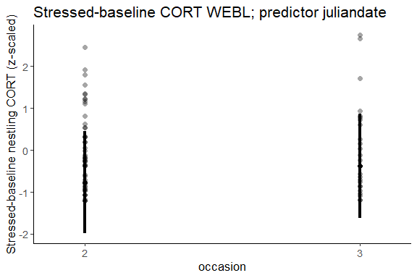

Does the inclusion of occasion improve the model?
Table 1: Response s2-s1, predictor occasion
model | npar | AIC | BIC | logLik | deviance | Chisq | Df | P-value
no occasion | 16 | 203.9883 | 241.0681 | -85.99414 | 171.9883 | NA | NA | NA
full model | 17 | 204.7951 | 244.1924 | -85.39754 | 170.7951 | 1.193203 | 1 | 0.2747
This table compares models with and without occasion.

TRES
Baseline cort as response variable:
Table 1: Response s1, predictor occasion
Predictor | Estimate | Std. Error | df | t value | P-value
(Intercept) | 1.55 | 0.68 | 71 | 2.29006214 | 0.025*
cort_s1_mother_scaled | -0.23 | 0.11 | 71 | -2.06536580 | 0.0425*
occasion3 | 0.60 | 0.26 | 71 | 2.34296503 | 0.0219*
brood_size_scaled | 1.50 | 1.38 | 71 | 1.08923524 | 0.2797
habitatOrchard | -2.41 | 0.78 | 71 | -3.07456469 | 0.003**
habitatGrassland | -1.82 | 0.69 | 71 | -2.63737860 | 0.0103*
habitatRow crop | -1.69 | 0.70 | 71 | -2.43174364 | 0.0176*
condition_scaled | 0.39 | 0.44 | 71 | 0.89121205 | 0.3758
juliandate_scaled | 0.12 | 0.14 | 71 | 0.83261907 | 0.4079
brood_size_scaled:habitatOrchard | -1.88 | 1.43 | 71 | -1.31891384 | 0.1914
brood_size_scaled:habitatGrassland | -1.35 | 1.36 | 71 | -0.99061420 | 0.3252
brood_size_scaled:habitatRow crop | -1.19 | 1.37 | 71 | -0.87419636 | 0.385
habitatOrchard:condition_scaled | -0.05 | 0.70 | 71 | -0.07457754 | 0.9408
habitatGrassland:condition_scaled | -0.45 | 0.47 | 71 | -0.95876615 | 0.3409
habitatRow crop:condition_scaled | 0.20 | 0.47 | 71 | 0.43131167 | 0.6675
This table presents the full model results.

Plot of predicted relationship between baseline cort and occasion:
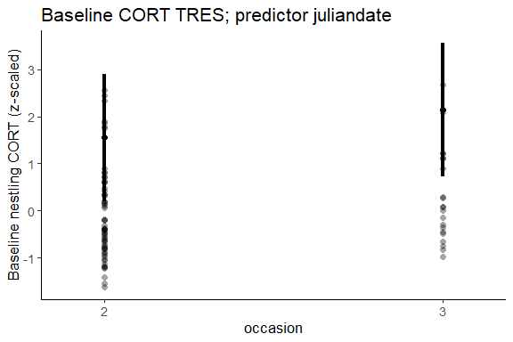

Does the inclusion of occasion improve the model?
Table 1: Response s1, predictor juliandate
model | npar | AIC | BIC | logLik | deviance | Chisq | Df | P-value
no occasion | 16 | 243.2897 | 282.5592 | -105.6448 | 211.2897 | NA | NA | NA
full model | 17 | 238.8850 | 280.6089 | -102.4425 | 204.8850 | 6.404713 | 1 | 0.0114*
Stressed cort as response variable:
Table 1: Response s2, predictor juliandate
Predictor | Estimate | Std. Error | df | t value | P-value
(Intercept) | 0.13 | 0.47 | 18.17637 | 0.28303974 | 0.7803
cort_s2_mother_scaled | 0.39 | 0.22 | 22.30038 | 1.76844876 | 0.0907
occasion3 | 0.34 | 0.36 | 37.54408 | 0.95429626 | 0.346
brood_size_scaled | -0.03 | 0.55 | 14.24346 | -0.05989613 | 0.9531
habitatOrchard | 0.77 | 0.68 | 16.81926 | 1.13012119 | 0.2743
habitatGrassland | -0.36 | 0.53 | 17.67201 | -0.66997018 | 0.5115
habitatRow crop | -0.49 | 0.58 | 13.57967 | -0.84351477 | 0.4136
condition_scaled | 0.30 | 0.45 | 13.59279 | 0.65553759 | 0.5231
juliandate_scaled | 0.13 | 0.23 | 14.25957 | 0.58971468 | 0.5646
brood_size_scaled:habitatOrchard | -0.36 | 0.74 | 19.96873 | -0.48971244 | 0.6297
brood_size_scaled:habitatGrassland | 0.01 | 0.61 | 16.03656 | 0.02414123 | 0.981
brood_size_scaled:habitatRow crop | -0.12 | 0.57 | 13.00988 | -0.20584878 | 0.8401
habitatOrchard:condition_scaled | -1.26 | 0.75 | 21.07471 | -1.67592189 | 0.1085
habitatGrassland:condition_scaled | -0.04 | 0.52 | 16.26196 | -0.06924917 | 0.9456
habitatRow crop:condition_scaled | 0.11 | 0.58 | 19.04602 | 0.19569854 | 0.8469
This table presents the full model results.

Plot of predicted relationship between stressed cort and juliandate:
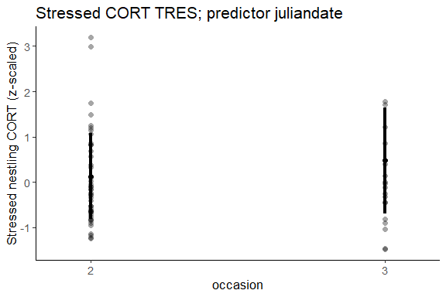

Does the inclusion of occasion improve the model?
Table 1: Response s2, predictor occasion
model | npar | AIC | BIC | logLik | deviance | Chisq | Df | P-value
no occasion | 16 | 188.0893 | 222.6314 | -78.04465 | 156.0893 | NA | NA | NA
full model | 17 | 188.7514 | 225.4524 | -77.37569 | 154.7514 | 1.337922 | 1 | 0.2474
Stressed-baseline cort as response variable:
Table 1: Response s2-s1, predictor mother attempt number
Predictor | Estimate | Std. Error | df | t value | P-value
(Intercept) | -0.43 | 0.70 | 20.78491 | -0.61182741 | 0.5473
mother_cort_diff_scaled | 0.28 | 0.39 | 12.82389 | 0.72631583 | 0.4807
occasion3 | -0.03 | 0.45 | 24.69757 | -0.07250939 | 0.9428
brood_size_scaled | -1.62 | 1.44 | 17.08985 | -1.12308445 | 0.2769
habitatOrchard | 1.12 | 0.90 | 16.70469 | 1.24161680 | 0.2315
habitatGrassland | 0.49 | 0.75 | 19.52525 | 0.64421153 | 0.5269
habitatRow crop | 0.19 | 0.78 | 15.83649 | 0.24865525 | 0.8068
condition_scaled | 0.35 | 0.38 | 21.32555 | 0.90240215 | 0.3769
juliandate_scaled | 0.05 | 0.28 | 10.21464 | 0.19149983 | 0.8519
brood_size_scaled:habitatOrchard | 1.57 | 1.52 | 18.45931 | 1.02988234 | 0.3164
brood_size_scaled:habitatGrassland | 1.53 | 1.38 | 18.44346 | 1.10717926 | 0.2824
brood_size_scaled:habitatRow crop | 1.20 | 1.38 | 15.64782 | 0.86899723 | 0.398
habitatOrchard:condition_scaled | -1.39 | 0.71 | 17.73072 | -1.95653534 | 0.0663
habitatGrassland:condition_scaled | -0.04 | 0.42 | 22.72009 | -0.10426657 | 0.9179
This table presents the full model results.

Plot of predicted relationship between stressed - baseline nestling cort and occasion:
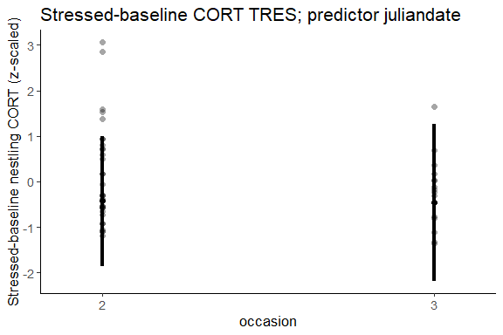

Does the inclusion of occasion improve the model?
Table 1: Response s2-s1, predictor occasion
model | npar | AIC | BIC | logLik | deviance | Chisq | Df | P-value
no occasion | 15 | 139.2060 | 167.5833 | -54.60300 | 109.2060 | NA | NA | NA
full model | 16 | 141.1075 | 171.3766 | -54.55375 | 109.1075 | 0.0985101 | 1 | 0.7536
This table compares models with and without occasion.

5. How does brood size relate to cort?

Distribution of brood size
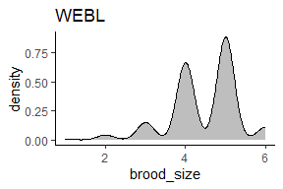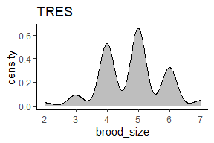

Seasonal variation in brood size
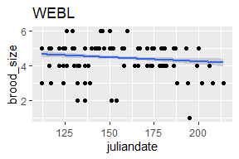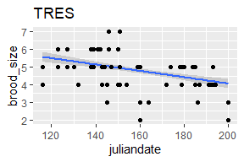

Correlation of brood size and cort

WEBL
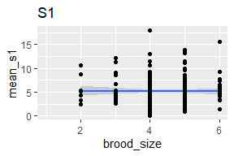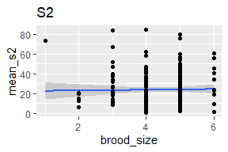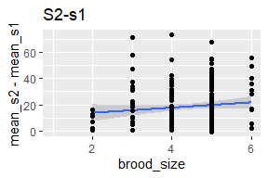

TRES
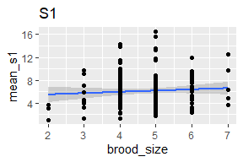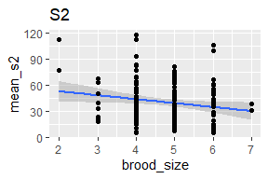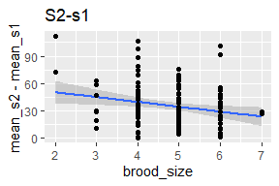

Model-predicted relationship between brood size and cort
Reminder: full model is - cort ~ mother cort + week2/week3 + brood_size * habitat + condition * habitat + juliandate - cort ~ mother cort + week2/week3 + brood_size * habitat + condition * habitat + mother attempt number

WEBL
Baseline cort as response variable:
Table 1: Response s1, predictor juliandate
Predictor | Estimate | Std. Error | df | t value | P-value
(Intercept) | 0.13 | 0.47 | 18.17637 | 0.28303974 | 0.7803
cort_s2_mother_scaled | 0.39 | 0.22 | 22.30038 | 1.76844876 | 0.0907
occasion3 | 0.34 | 0.36 | 37.54408 | 0.95429626 | 0.346
brood_size_scaled | -0.03 | 0.55 | 14.24346 | -0.05989613 | 0.9531
habitatOrchard | 0.77 | 0.68 | 16.81926 | 1.13012119 | 0.2743
habitatGrassland | -0.36 | 0.53 | 17.67201 | -0.66997018 | 0.5115
habitatRow crop | -0.49 | 0.58 | 13.57967 | -0.84351477 | 0.4136
condition_scaled | 0.30 | 0.45 | 13.59279 | 0.65553759 | 0.5231
juliandate_scaled | 0.13 | 0.23 | 14.25957 | 0.58971468 | 0.5646
brood_size_scaled:habitatOrchard | -0.36 | 0.74 | 19.96873 | -0.48971244 | 0.6297
brood_size_scaled:habitatGrassland | 0.01 | 0.61 | 16.03656 | 0.02414123 | 0.981
brood_size_scaled:habitatRow crop | -0.12 | 0.57 | 13.00988 | -0.20584878 | 0.8401
habitatOrchard:condition_scaled | -1.26 | 0.75 | 21.07471 | -1.67592189 | 0.1085
habitatGrassland:condition_scaled | -0.04 | 0.52 | 16.26196 | -0.06924917 | 0.9456
habitatRow crop:condition_scaled | 0.11 | 0.58 | 19.04602 | 0.19569854 | 0.8469
This table presents the full model results.

Plot of predicted relationship between baseline cort and brood size:
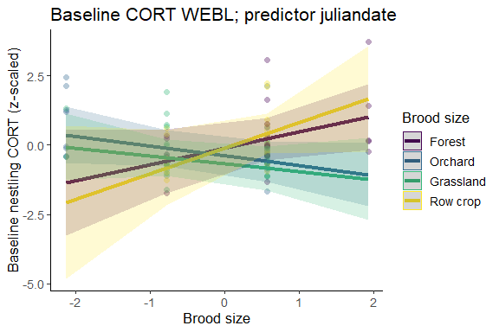

Does the inclusion of brood_size improve the model, and does the interaction brood_size * habitat further improve it?
Table 1: Response s1, predictor juliandate
model | npar | AIC | BIC | logLik | deviance | Chisq | Df | P-value
no brood_size | 13 | 278.2556 | 312.2521 | -126.1278 | 252.2556 | NA | NA | NA
brood_size + habitat | 14 | 279.9451 | 316.5568 | -125.9725 | 251.9451 | 0.3104969 | 1 | 0.5774
brood_size * habitat | 17 | 273.1233 | 317.5804 | -119.5617 | 239.1233 | 12.8217232 | 3 | 0.005**
This table compares three models: the full model, one with no interaction between habitat and brood_size, and one without brood_size in the model.

Stressed cort as response variable:
Table 1: Response s2, predictor juliandate
Predictor | Estimate | Std. Error | df | t value | P-value
(Intercept) | -0.46 | 0.31 | 13.70012 | -1.49264707 | 0.1582
cort_s2_mother_scaled | 0.26 | 0.15 | 15.86733 | 1.71133928 | 0.1065
occasion3 | 0.36 | 0.18 | 93.05008 | 1.96247505 | 0.0527
brood_size_scaled | 0.11 | 0.37 | 22.42038 | 0.30726747 | 0.7615
habitatOrchard | 0.67 | 0.43 | 16.31562 | 1.53872778 | 0.143
habitatGrassland | -0.03 | 0.41 | 13.45014 | -0.06791861 | 0.9468
habitatRow crop | 0.60 | 0.44 | 12.89245 | 1.37545017 | 0.1924
condition_scaled | 0.07 | 0.15 | 93.37204 | 0.45923401 | 0.6471
juliandate_scaled | -0.23 | 0.16 | 15.87719 | -1.45743196 | 0.1645
brood_size_scaled:habitatOrchard | -0.43 | 0.42 | 21.16312 | -1.04103123 | 0.3096
brood_size_scaled:habitatGrassland | 0.18 | 0.43 | 19.55815 | 0.42274251 | 0.6771
brood_size_scaled:habitatRow crop | -0.27 | 0.64 | 13.84155 | -0.42554421 | 0.677
habitatOrchard:condition_scaled | -0.17 | 0.28 | 92.79325 | -0.61088055 | 0.5428
habitatGrassland:condition_scaled | 0.29 | 0.25 | 78.15003 | 1.15846622 | 0.2502
habitatRow crop:condition_scaled | -0.20 | 0.27 | 93.88283 | -0.74674444 | 0.4571
This table presents the full model results.

Plot of predicted relationship between stressed cort and brood size:
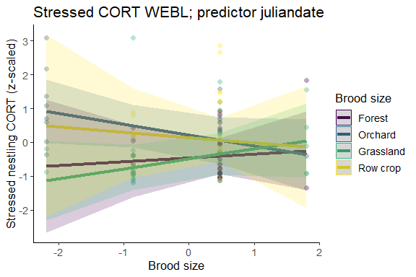

Does the inclusion of brood_size improve the model, and does the interaction brood_size * habitat further improve it?
Table 1: Response s2, predictor juliandate
model | npar | AIC | BIC | logLik | deviance | Chisq | Df | P-value
no brood_size | 13 | 293.1417 | 328.1292 | -133.5709 | 267.1417 | NA | NA | NA
brood_size + habitat | 14 | 294.8456 | 332.5244 | -133.4228 | 266.8456 | 0.2961704 | 1 | 0.5863
brood_size * habitat | 17 | 294.6140 | 340.3669 | -130.3070 | 260.6140 | 6.2315235 | 3 | 0.1009
This table compares three models: the full model, one with no interaction between habitat and brood_size, and one without brood_size in the model.
Stressed - baseline cort as response variable
Table 1: Response s2, predictor juliandate
Predictor | Estimate | Std. Error | df | t value | P-value
(Intercept) | -0.77 | 0.61 | 13.386461 | -1.26475392 | 0.2275
mother_cort_diff_scaled | 0.21 | 0.22 | 8.793796 | 0.96332384 | 0.3611
occasion3 | 0.39 | 0.21 | 56.953079 | 1.85272961 | 0.0691
brood_size_scaled | 0.62 | 0.52 | 13.587456 | 1.19695309 | 0.2518
habitatOrchard | 1.13 | 0.76 | 12.273954 | 1.48723912 | 0.1622
habitatGrassland | 0.22 | 0.73 | 11.942072 | 0.30369539 | 0.7666
habitatRow crop | 0.75 | 0.77 | 10.363987 | 0.97254891 | 0.3529
condition_scaled | -0.11 | 0.23 | 53.448139 | -0.46124047 | 0.6465
juliandate_scaled | -0.22 | 0.24 | 10.163297 | -0.91113216 | 0.3833
brood_size_scaled:habitatOrchard | -0.87 | 0.59 | 12.301377 | -1.47160874 | 0.1662
brood_size_scaled:habitatGrassland | -0.42 | 0.66 | 11.927710 | -0.63535259 | 0.5372
brood_size_scaled:habitatRow crop | -0.78 | 0.85 | 9.328940 | -0.92650397 | 0.3775
habitatOrchard:condition_scaled | -0.02 | 0.34 | 50.280607 | -0.04418803 | 0.9649
habitatGrassland:condition_scaled | 0.31 | 0.32 | 59.743478 | 0.97636974 | 0.3328
habitatRow crop:condition_scaled | -0.03 | 0.37 | 59.108625 | -0.07231261 | 0.9426
This table presents the full model results.

Plot of predicted relationship between stressed-baseline cort and brood size:
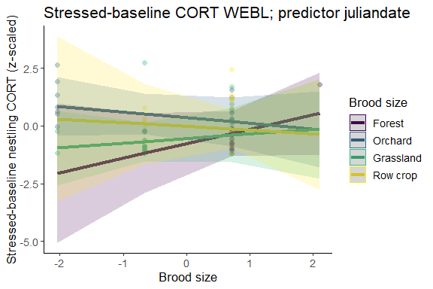

Does the inclusion of brood_size improve the model, and does the interaction brood_size * habitat further improve it?
Table 1: Response s2-s1, predictor juliandate
model | npar | AIC | BIC | logLik | deviance | Chisq | Df | P-value
no brood_size | 13 | 201.7932 | 231.9205 | -87.89658 | 175.7932 | NA | NA | NA
brood_size + habitat | 14 | 203.7505 | 236.1953 | -87.87523 | 175.7505 | 0.04271229 | 1 | 0.8363
brood_size * habitat | 17 | 204.7951 | 244.1924 | -85.39754 | 170.7951 | 4.95537824 | 3 | 0.1751
This table compares three models: the full model, one with no interaction between habitat and brood_size, and one without brood_size in the model.

TRES
Baseline cort as response variable:
Table 1: Response s1, predictor juliandate
Predictor | Estimate | Std. Error | df | t value | P-value
(Intercept) | -0.46 | 0.31 | 13.70012 | -1.49264707 | 0.1582
cort_s2_mother_scaled | 0.26 | 0.15 | 15.86733 | 1.71133928 | 0.1065
occasion3 | 0.36 | 0.18 | 93.05008 | 1.96247505 | 0.0527
brood_size_scaled | 0.11 | 0.37 | 22.42038 | 0.30726747 | 0.7615
habitatOrchard | 0.67 | 0.43 | 16.31562 | 1.53872778 | 0.143
habitatGrassland | -0.03 | 0.41 | 13.45014 | -0.06791861 | 0.9468
habitatRow crop | 0.60 | 0.44 | 12.89245 | 1.37545017 | 0.1924
condition_scaled | 0.07 | 0.15 | 93.37204 | 0.45923401 | 0.6471
juliandate_scaled | -0.23 | 0.16 | 15.87719 | -1.45743196 | 0.1645
brood_size_scaled:habitatOrchard | -0.43 | 0.42 | 21.16312 | -1.04103123 | 0.3096
brood_size_scaled:habitatGrassland | 0.18 | 0.43 | 19.55815 | 0.42274251 | 0.6771
brood_size_scaled:habitatRow crop | -0.27 | 0.64 | 13.84155 | -0.42554421 | 0.677
habitatOrchard:condition_scaled | -0.17 | 0.28 | 92.79325 | -0.61088055 | 0.5428
habitatGrassland:condition_scaled | 0.29 | 0.25 | 78.15003 | 1.15846622 | 0.2502
habitatRow crop:condition_scaled | -0.20 | 0.27 | 93.88283 | -0.74674444 | 0.4571
This table presents the full model results.

Plot of predicted relationship between baseline cort and brood size:
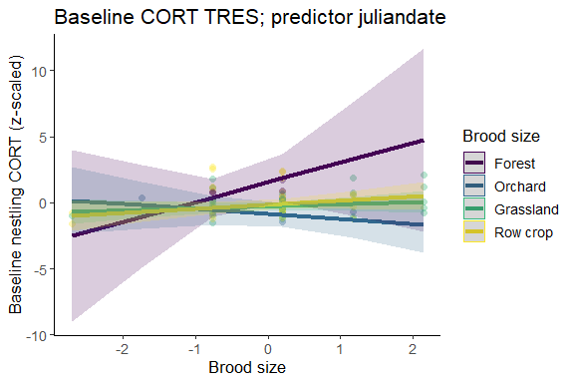

Does the inclusion of brood_size improve the model, and does the interaction brood_size * habitat further improve it?
Table 1: Response s1, predictor juliandate
model | npar | AIC | BIC | logLik | deviance | Chisq | Df | P-value
no brood_size | 13 | 235.7066 | 267.6131 | -104.8533 | 209.7066 | NA | NA | NA
brood_size + habitat | 14 | 236.3624 | 270.7232 | -104.1812 | 208.3624 | 1.344277 | 1 | 0.2463
brood_size * habitat | 17 | 238.8850 | 280.6089 | -102.4425 | 204.8850 | 3.477392 | 3 | 0.3237
This table compares three models: the full model, one with no interaction between habitat and brood_size, and one without brood_size in the model.

Stressed cort as response variable:
Table 1: Response s2, predictor juliandate
Predictor | Estimate | Std. Error | df | t value | P-value
(Intercept) | 0.13 | 0.47 | 18.17637 | 0.28303974 | 0.7803
cort_s2_mother_scaled | 0.39 | 0.22 | 22.30038 | 1.76844876 | 0.0907
occasion3 | 0.34 | 0.36 | 37.54408 | 0.95429626 | 0.346
brood_size_scaled | -0.03 | 0.55 | 14.24346 | -0.05989613 | 0.9531
habitatOrchard | 0.77 | 0.68 | 16.81926 | 1.13012119 | 0.2743
habitatGrassland | -0.36 | 0.53 | 17.67201 | -0.66997018 | 0.5115
habitatRow crop | -0.49 | 0.58 | 13.57967 | -0.84351477 | 0.4136
condition_scaled | 0.30 | 0.45 | 13.59279 | 0.65553759 | 0.5231
juliandate_scaled | 0.13 | 0.23 | 14.25957 | 0.58971468 | 0.5646
brood_size_scaled:habitatOrchard | -0.36 | 0.74 | 19.96873 | -0.48971244 | 0.6297
brood_size_scaled:habitatGrassland | 0.01 | 0.61 | 16.03656 | 0.02414123 | 0.981
brood_size_scaled:habitatRow crop | -0.12 | 0.57 | 13.00988 | -0.20584878 | 0.8401
habitatOrchard:condition_scaled | -1.26 | 0.75 | 21.07471 | -1.67592189 | 0.1085
habitatGrassland:condition_scaled | -0.04 | 0.52 | 16.26196 | -0.06924917 | 0.9456
habitatRow crop:condition_scaled | 0.11 | 0.58 | 19.04602 | 0.19569854 | 0.8469
This table presents the full model results.

Plot of predicted relationship between stressed cort and brood size:
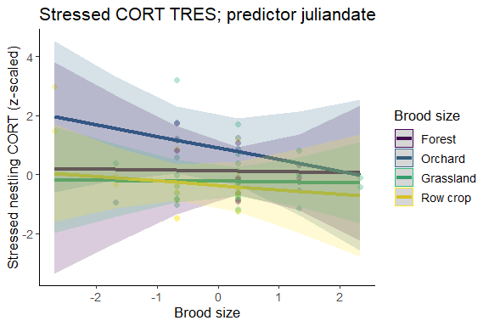

Does the inclusion of brood_size improve the model, and does the interaction brood_size * habitat further improve it?
Table 1: Response s2, predictor juliandate
model | npar | AIC | BIC | logLik | deviance | Chisq | Df | P-value
no brood_size | 13 | 182.5069 | 210.5724 | -78.25347 | 156.5069 | NA | NA | NA
brood_size + habitat | 14 | 183.8155 | 214.0399 | -77.90776 | 155.8155 | 0.6914114 | 1 | 0.4057
brood_size * habitat | 17 | 188.7514 | 225.4524 | -77.37569 | 154.7514 | 1.0641575 | 3 | 0.7857
This table compares three models: the full model, one with no interaction between habitat and brood_size, and one without brood_size in the model.
Stressed - baseline cort as response variable
Table 1: Response s2-s1, predictor juliandate
Predictor | Estimate | Std. Error | df | t value | P-value
(Intercept) | -0.43 | 0.70 | 20.78491 | -0.61182741 | 0.5473
mother_cort_diff_scaled | 0.28 | 0.39 | 12.82389 | 0.72631583 | 0.4807
occasion3 | -0.03 | 0.45 | 24.69757 | -0.07250939 | 0.9428
brood_size_scaled | -1.62 | 1.44 | 17.08985 | -1.12308445 | 0.2769
habitatOrchard | 1.12 | 0.90 | 16.70469 | 1.24161680 | 0.2315
habitatGrassland | 0.49 | 0.75 | 19.52525 | 0.64421153 | 0.5269
habitatRow crop | 0.19 | 0.78 | 15.83649 | 0.24865525 | 0.8068
condition_scaled | 0.35 | 0.38 | 21.32555 | 0.90240215 | 0.3769
juliandate_scaled | 0.05 | 0.28 | 10.21464 | 0.19149983 | 0.8519
brood_size_scaled:habitatOrchard | 1.57 | 1.52 | 18.45931 | 1.02988234 | 0.3164
brood_size_scaled:habitatGrassland | 1.53 | 1.38 | 18.44346 | 1.10717926 | 0.2824
brood_size_scaled:habitatRow crop | 1.20 | 1.38 | 15.64782 | 0.86899723 | 0.398
habitatOrchard:condition_scaled | -1.39 | 0.71 | 17.73072 | -1.95653534 | 0.0663
habitatGrassland:condition_scaled | -0.04 | 0.42 | 22.72009 | -0.10426657 | 0.9179
This table presents the full model results.

Plot of predicted relationship between stressed-baseline cort and brood size:
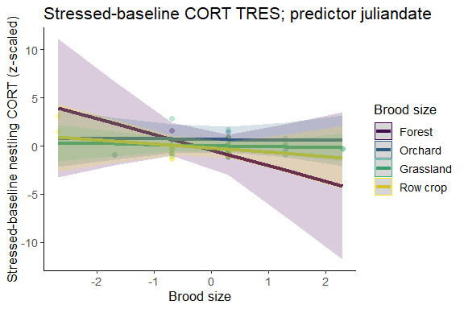

Does the inclusion of brood_size improve the model, and does the interaction brood_size * habitat further improve it?
Table 1: Response s2-s1, predictor juliandate
model | npar | AIC | BIC | logLik | deviance | Chisq | Df | P-value
no brood_size | 13 | 136.8241 | 161.4177 | -55.41204 | 110.8241 | NA | NA | NA
brood_size + habitat | 14 | 137.7995 | 164.2850 | -54.89975 | 109.7995 | 1.0245778 | 1 | 0.3114
brood_size * habitat | 16 | 141.1075 | 171.3766 | -54.55375 | 109.1075 | 0.6920025 | 2 | 0.7075
This table compares three models: the full model, one with no interaction between habitat and brood_size, and one without brood_size in the model.

6. How does body condition relate to cort?

Distribution of condition
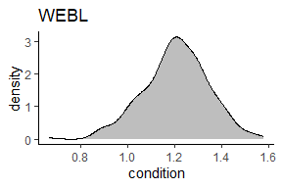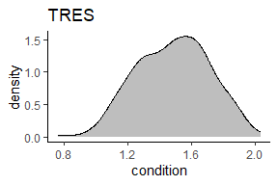

Seasonal variation in condition
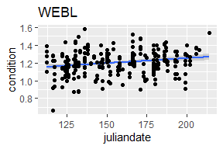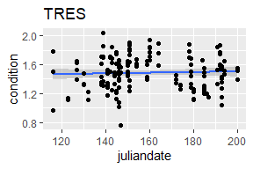

Correlation of condition and cort

WEBL
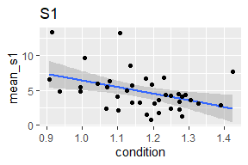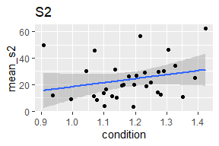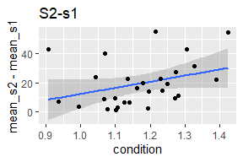

TRES
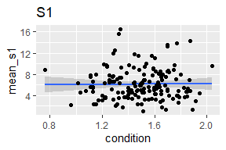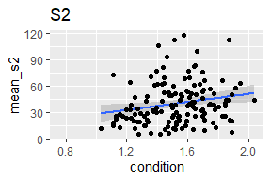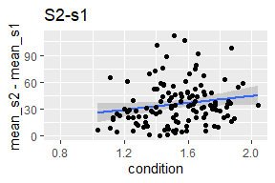

Model-predicted relationship between condition and cort
Reminder: full model is - cort ~ mother cort + week2/week3 + brood_size * habitat + condition * habitat + juliandate + rand(attempt_id)

WEBL
Baseline cort as response variable:
Table 1: Response s1, predictor juliandate
Predictor | Estimate | Std. Error | df | t value | P-value
(Intercept) | 0.13 | 0.47 | 18.17637 | 0.28303974 | 0.7803
cort_s2_mother_scaled | 0.39 | 0.22 | 22.30038 | 1.76844876 | 0.0907
occasion3 | 0.34 | 0.36 | 37.54408 | 0.95429626 | 0.346
brood_size_scaled | -0.03 | 0.55 | 14.24346 | -0.05989613 | 0.9531
habitatOrchard | 0.77 | 0.68 | 16.81926 | 1.13012119 | 0.2743
habitatGrassland | -0.36 | 0.53 | 17.67201 | -0.66997018 | 0.5115
habitatRow crop | -0.49 | 0.58 | 13.57967 | -0.84351477 | 0.4136
condition_scaled | 0.30 | 0.45 | 13.59279 | 0.65553759 | 0.5231
juliandate_scaled | 0.13 | 0.23 | 14.25957 | 0.58971468 | 0.5646
brood_size_scaled:habitatOrchard | -0.36 | 0.74 | 19.96873 | -0.48971244 | 0.6297
brood_size_scaled:habitatGrassland | 0.01 | 0.61 | 16.03656 | 0.02414123 | 0.981
brood_size_scaled:habitatRow crop | -0.12 | 0.57 | 13.00988 | -0.20584878 | 0.8401
habitatOrchard:condition_scaled | -1.26 | 0.75 | 21.07471 | -1.67592189 | 0.1085
habitatGrassland:condition_scaled | -0.04 | 0.52 | 16.26196 | -0.06924917 | 0.9456
habitatRow crop:condition_scaled | 0.11 | 0.58 | 19.04602 | 0.19569854 | 0.8469
This table presents the full model results.

Plot of predicted relationship between baseline cort and brood size:
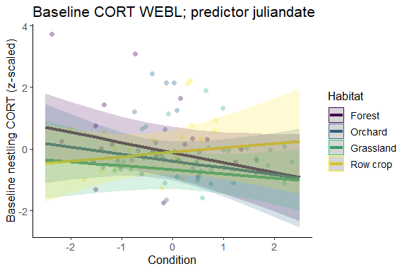

Does the inclusion of condition improve the model, and does the interaction condition * habitat further improve it?
Table 1: Response s1, predictor juliandate
model | npar | AIC | BIC | logLik | deviance | Chisq | Df | P-value
no condition | 13 | 269.2889 | 303.2855 | -121.6445 | 243.2889 | NA | NA | NA
condition + habitat | 14 | 269.8964 | 306.5081 | -120.9482 | 241.8964 | 1.392489 | 1 | 0.238
condition * habitat | 17 | 273.1233 | 317.5804 | -119.5617 | 239.1233 | 2.773094 | 3 | 0.4279
This table compares three models: the full model, one with no interaction between habitat and brood_size, and one without brood_size in the model.

Stressed cort as response variable:
Table 1: Response s2, predictor juliandate
Predictor | Estimate | Std. Error | df | t value | P-value
(Intercept) | -0.46 | 0.31 | 13.70012 | -1.49264707 | 0.1582
cort_s2_mother_scaled | 0.26 | 0.15 | 15.86733 | 1.71133928 | 0.1065
occasion3 | 0.36 | 0.18 | 93.05008 | 1.96247505 | 0.0527
brood_size_scaled | 0.11 | 0.37 | 22.42038 | 0.30726747 | 0.7615
habitatOrchard | 0.67 | 0.43 | 16.31562 | 1.53872778 | 0.143
habitatGrassland | -0.03 | 0.41 | 13.45014 | -0.06791861 | 0.9468
habitatRow crop | 0.60 | 0.44 | 12.89245 | 1.37545017 | 0.1924
condition_scaled | 0.07 | 0.15 | 93.37204 | 0.45923401 | 0.6471
juliandate_scaled | -0.23 | 0.16 | 15.87719 | -1.45743196 | 0.1645
brood_size_scaled:habitatOrchard | -0.43 | 0.42 | 21.16312 | -1.04103123 | 0.3096
brood_size_scaled:habitatGrassland | 0.18 | 0.43 | 19.55815 | 0.42274251 | 0.6771
brood_size_scaled:habitatRow crop | -0.27 | 0.64 | 13.84155 | -0.42554421 | 0.677
habitatOrchard:condition_scaled | -0.17 | 0.28 | 92.79325 | -0.61088055 | 0.5428
habitatGrassland:condition_scaled | 0.29 | 0.25 | 78.15003 | 1.15846622 | 0.2502
habitatRow crop:condition_scaled | -0.20 | 0.27 | 93.88283 | -0.74674444 | 0.4571
This table presents the full model results.

Plot of predicted relationship between stressed cort and condition:
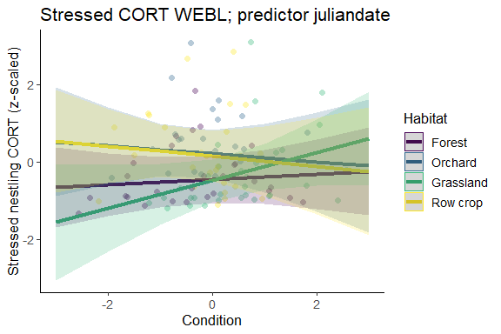

Does the inclusion of condition improve the model, and does the interaction condition * habitat further improve it?
Table 1: Response s2, predictor juliandate
model | npar | AIC | BIC | logLik | deviance | Chisq | Df | P-value
no condition | 13 | 292.2538 | 327.2413 | -133.1269 | 266.2538 | NA | NA | NA
condition + habitat | 14 | 293.1652 | 330.8440 | -132.5826 | 265.1652 | 1.088651 | 1 | 0.2968
condition * habitat | 17 | 294.6140 | 340.3669 | -130.3070 | 260.6140 | 4.551133 | 3 | 0.2078
This table compares three models: the full model, one with no interaction between habitat and condition, and one without condition in the model.
Stressed - baseline cort as response variable
Table 1: Response s2-s1, predictor juliandate
Predictor | Estimate | Std. Error | df | t value | P-value
(Intercept) | -0.77 | 0.61 | 13.386461 | -1.26475392 | 0.2275
mother_cort_diff_scaled | 0.21 | 0.22 | 8.793796 | 0.96332384 | 0.3611
occasion3 | 0.39 | 0.21 | 56.953079 | 1.85272961 | 0.0691
brood_size_scaled | 0.62 | 0.52 | 13.587456 | 1.19695309 | 0.2518
habitatOrchard | 1.13 | 0.76 | 12.273954 | 1.48723912 | 0.1622
habitatGrassland | 0.22 | 0.73 | 11.942072 | 0.30369539 | 0.7666
habitatRow crop | 0.75 | 0.77 | 10.363987 | 0.97254891 | 0.3529
condition_scaled | -0.11 | 0.23 | 53.448139 | -0.46124047 | 0.6465
juliandate_scaled | -0.22 | 0.24 | 10.163297 | -0.91113216 | 0.3833
brood_size_scaled:habitatOrchard | -0.87 | 0.59 | 12.301377 | -1.47160874 | 0.1662
brood_size_scaled:habitatGrassland | -0.42 | 0.66 | 11.927710 | -0.63535259 | 0.5372
brood_size_scaled:habitatRow crop | -0.78 | 0.85 | 9.328940 | -0.92650397 | 0.3775
habitatOrchard:condition_scaled | -0.02 | 0.34 | 50.280607 | -0.04418803 | 0.9649
habitatGrassland:condition_scaled | 0.31 | 0.32 | 59.743478 | 0.97636974 | 0.3328
habitatRow crop:condition_scaled | -0.03 | 0.37 | 59.108625 | -0.07231261 | 0.9426
This table presents the full model results.

Plot of predicted relationship between stressed-baseline cort and brood size:
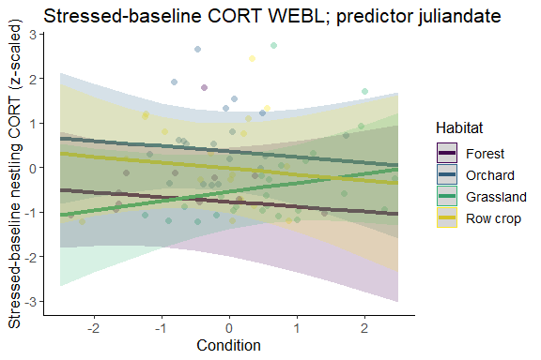

Does the inclusion of condition improve the model, and does the interaction condition * habitat further improve it?
Table 1: Response s2-s1, predictor juliandate
model | npar | AIC | BIC | logLik | deviance | Chisq | Df | P-value
no condition | 13 | 199.4156 | 229.5430 | -86.70781 | 173.4156 | NA | NA | NA
condition + habitat | 14 | 201.1175 | 233.5623 | -86.55875 | 173.1175 | 0.2981207 | 1 | 0.5851
condition * habitat | 17 | 204.7951 | 244.1924 | -85.39754 | 170.7951 | 2.3224200 | 3 | 0.5082
This table compares three models: the full model, one with no interaction between habitat and brood_size, and one without brood_size in the model.

TRES
Baseline cort as response variable:
Table 1: Response s1, predictor juliandate
Predictor | Estimate | Std. Error | df | t value | P-value
(Intercept) | -0.46 | 0.31 | 13.70012 | -1.49264707 | 0.1582
cort_s2_mother_scaled | 0.26 | 0.15 | 15.86733 | 1.71133928 | 0.1065
occasion3 | 0.36 | 0.18 | 93.05008 | 1.96247505 | 0.0527
brood_size_scaled | 0.11 | 0.37 | 22.42038 | 0.30726747 | 0.7615
habitatOrchard | 0.67 | 0.43 | 16.31562 | 1.53872778 | 0.143
habitatGrassland | -0.03 | 0.41 | 13.45014 | -0.06791861 | 0.9468
habitatRow crop | 0.60 | 0.44 | 12.89245 | 1.37545017 | 0.1924
condition_scaled | 0.07 | 0.15 | 93.37204 | 0.45923401 | 0.6471
juliandate_scaled | -0.23 | 0.16 | 15.87719 | -1.45743196 | 0.1645
brood_size_scaled:habitatOrchard | -0.43 | 0.42 | 21.16312 | -1.04103123 | 0.3096
brood_size_scaled:habitatGrassland | 0.18 | 0.43 | 19.55815 | 0.42274251 | 0.6771
brood_size_scaled:habitatRow crop | -0.27 | 0.64 | 13.84155 | -0.42554421 | 0.677
habitatOrchard:condition_scaled | -0.17 | 0.28 | 92.79325 | -0.61088055 | 0.5428
habitatGrassland:condition_scaled | 0.29 | 0.25 | 78.15003 | 1.15846622 | 0.2502
habitatRow crop:condition_scaled | -0.20 | 0.27 | 93.88283 | -0.74674444 | 0.4571
This table presents the full model results.

Plot of predicted relationship between baseline cort and brood size:
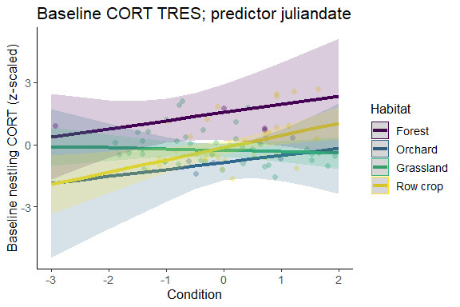

Does the inclusion of condition improve the model, and does the interaction condition * habitat further improve it?
Table 1: Response s1, predictor juliandate
model | npar | AIC | BIC | logLik | deviance | Chisq | Df | P-value
no condition | 13 | 240.9287 | 272.8352 | -107.4643 | 214.9287 | NA | NA | NA
condition + habitat | 14 | 239.4275 | 273.7883 | -105.7137 | 211.4275 | 3.501216 | 1 | 0.0613
condition * habitat | 17 | 238.8850 | 280.6089 | -102.4425 | 204.8850 | 6.542493 | 3 | 0.088
This table compares three models: the full model, one with no interaction between habitat and brood_size, and one without brood_size in the model.

Stressed cort as response variable:
Table 1: Response s2, predictor juliandate
Predictor | Estimate | Std. Error | df | t value | P-value
(Intercept) | 0.13 | 0.47 | 18.17637 | 0.28303974 | 0.7803
cort_s2_mother_scaled | 0.39 | 0.22 | 22.30038 | 1.76844876 | 0.0907
occasion3 | 0.34 | 0.36 | 37.54408 | 0.95429626 | 0.346
brood_size_scaled | -0.03 | 0.55 | 14.24346 | -0.05989613 | 0.9531
habitatOrchard | 0.77 | 0.68 | 16.81926 | 1.13012119 | 0.2743
habitatGrassland | -0.36 | 0.53 | 17.67201 | -0.66997018 | 0.5115
habitatRow crop | -0.49 | 0.58 | 13.57967 | -0.84351477 | 0.4136
condition_scaled | 0.30 | 0.45 | 13.59279 | 0.65553759 | 0.5231
juliandate_scaled | 0.13 | 0.23 | 14.25957 | 0.58971468 | 0.5646
brood_size_scaled:habitatOrchard | -0.36 | 0.74 | 19.96873 | -0.48971244 | 0.6297
brood_size_scaled:habitatGrassland | 0.01 | 0.61 | 16.03656 | 0.02414123 | 0.981
brood_size_scaled:habitatRow crop | -0.12 | 0.57 | 13.00988 | -0.20584878 | 0.8401
habitatOrchard:condition_scaled | -1.26 | 0.75 | 21.07471 | -1.67592189 | 0.1085
habitatGrassland:condition_scaled | -0.04 | 0.52 | 16.26196 | -0.06924917 | 0.9456
habitatRow crop:condition_scaled | 0.11 | 0.58 | 19.04602 | 0.19569854 | 0.8469
This table presents the full model results.

Plot of predicted relationship between stressed cort and condition:
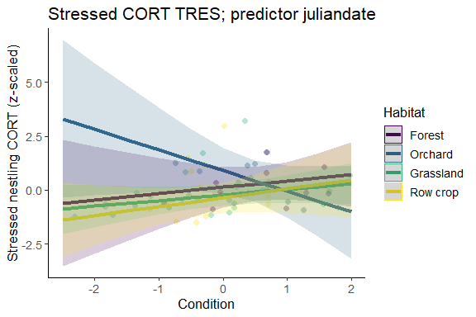

Does the inclusion of brood_size improve the model, and does the interaction brood_size * habitat further improve it?
Table 1: Response s2, predictor juliandate
model | npar | AIC | BIC | logLik | deviance | Chisq | Df | P-value
no condition | 13 | 188.4744 | 216.5398 | -81.23718 | 162.4744 | NA | NA | NA
condition + habitat | 14 | 188.5426 | 218.7670 | -80.27132 | 160.5426 | 1.931724 | 1 | 0.1646
condition * habitat | 17 | 188.7514 | 225.4524 | -77.37569 | 154.7514 | 5.791273 | 3 | 0.1222
This table compares three models: the full model, one with no interaction between habitat and brood_size, and one without brood_size in the model.
Stressed - baseline cort as response variable
Table 1: Response s2-s1, predictor juliandate
Predictor | Estimate | Std. Error | df | t value | P-value
(Intercept) | -0.43 | 0.70 | 20.78491 | -0.61182741 | 0.5473
mother_cort_diff_scaled | 0.28 | 0.39 | 12.82389 | 0.72631583 | 0.4807
occasion3 | -0.03 | 0.45 | 24.69757 | -0.07250939 | 0.9428
brood_size_scaled | -1.62 | 1.44 | 17.08985 | -1.12308445 | 0.2769
habitatOrchard | 1.12 | 0.90 | 16.70469 | 1.24161680 | 0.2315
habitatGrassland | 0.49 | 0.75 | 19.52525 | 0.64421153 | 0.5269
habitatRow crop | 0.19 | 0.78 | 15.83649 | 0.24865525 | 0.8068
condition_scaled | 0.35 | 0.38 | 21.32555 | 0.90240215 | 0.3769
juliandate_scaled | 0.05 | 0.28 | 10.21464 | 0.19149983 | 0.8519
brood_size_scaled:habitatOrchard | 1.57 | 1.52 | 18.45931 | 1.02988234 | 0.3164
brood_size_scaled:habitatGrassland | 1.53 | 1.38 | 18.44346 | 1.10717926 | 0.2824
brood_size_scaled:habitatRow crop | 1.20 | 1.38 | 15.64782 | 0.86899723 | 0.398
habitatOrchard:condition_scaled | -1.39 | 0.71 | 17.73072 | -1.95653534 | 0.0663
habitatGrassland:condition_scaled | -0.04 | 0.42 | 22.72009 | -0.10426657 | 0.9179
This table presents the full model results.

Plot of predicted relationship between stressed-baseline cort and brood size:
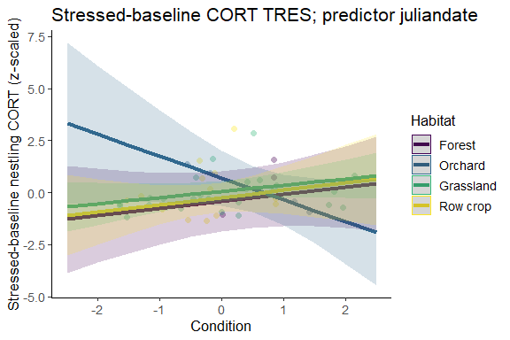

Does the inclusion of condition improve the model, and does the interaction condition * habitat further improve it?
Table 1: Response s2-s1, predictor juliandate
model | npar | AIC | BIC | logLik | deviance | Chisq | Df | P-value
no condition | 13 | 142.8932 | 167.4869 | -58.44659 | 116.8932 | NA | NA | NA
condition + habitat | 14 | 144.1220 | 170.6075 | -58.06102 | 116.1220 | 0.7711494 | 1 | 0.3799
condition * habitat | 16 | 141.1075 | 171.3766 | -54.55375 | 109.1075 | 7.0145467 | 2 | 0.03*
This table compares three models: the full model, one with no interaction between habitat and brood_size, and one without brood_size in the model.

