Effects of Anthropogenic Disturbances on Habitat Use of Bornean Birds

Katherine Lauck1,2, Sarah L. Carroll3, Elly Mufliati4, Sadtata Noor Adirahmanta 5, Novia Sagita4, Siti Kartikawati4, Adam Miller2,4

1US Fulbright Program

2Planet Indonesia – USA

3 Graduate Degree Program in Ecology, 1476 Campus Delivery, Colorado State University, Fort Collins, CO, U.S.A., 80523

4Yayasan Planet Indonesia

5Universitas Tanjungpura

6Balai Konservasi Sumber Daya Alam

Abstract

1.0 Introduction

The tropical forests of Indonesia are some of the most biodiverse ecosystems on our planet (Myers et al 2000; Brooks et al 2002; XX+). Over the past two decades Indonesia has seen extensive loss of forests from anthropogenic disturbances such as agricultural expansion, logging, and fires (Achard et al 2002; Sodhi et al 2004; Hansen et al 2013; Margono et al 2014; Abood et al 2015). These forces combined with hunting, trapping, and the illegal wildlife trade are major drivers of species loss across the archipelago (Nijman 2010; Symes et al 2018).

The wildlife trade is a billion-dollar industry and a major conservation threat in Indonesia (Shepherd, 2006; Wilson- Wilde, 2010; Nijman et al 2012). Indonesia’s avifauna are one of the most highly threatened groups within this trade (Bush et al., 2014; Ripple et al., 2017). The wild bird trade includes thousands of species and millions of individuals (Jepson & Ladle, 2005; Rentschlar et a. 2017). Bird-keeping is popular among Indonesians as both a popular hobby as well as a sign of sophistication and wealth. (Jepson & Ladle, 2005; Jepson, Ladle, & Sujatnika, 2011). Chng et al (2015) found 19,000 birds for sale during a 3-day inventory of the nation’s capital, Jakarta’s, three largest markets. Chng and Eaton (2016) found 22,000 individuals in just five markets in Central and Eastern Java, underscoring the massive scale of the trade. Rentschlar et al (2017) represented one of the first studies to measure the scale of the caged bird trade outside of Java and revealed over 25,000 individuals for sale from over 150 species in Indonesian – Borneo (Kalimantan) 5 provinces. Outside of markets one study provided multiple lines of evidence that Sumatran wild populations were in heavy decline from the impacts of the caged-bird trade (Harris et al 2017). The caged bird trade and Indonesia’s rapid rate of forest decline have been implicated in avian species declines and disappearances (Collar, Crosby, & Statterfield, 1994; Collar & Juniper, 1992; Wright et al., 2001; Jepson & Ladle, 2005; Harris et al., 2017) however, our understanding of how these two disturbances interact and their severity is limited.

Symes et al (2018) represents one of the first studies to quantify the combined impacts of habitat loss and the exploitation for wildlife trade on Sundaland’s avifauna. The average decline for exploited species from deforestation alone was 15.3%, but increased to 51.9% when combining the impacts of both forest loss and exploitation together. Their findings highlighted the importance for policy-makers and practitioners to consider the combination of these impacts when designing conservation strategies.

Kalimantan has been at the forefront of deforestation within Indonesia with an estimated 15.4% of forest loss between 2000-2010 alone (Miettinen et al 2011; Miettinen et al 2012). This can be attributed to the massive expansion of agricultural enterprises such as oil palm combined with negative impacts of forest fires (Curan et. al. 2004). In 2016 throughout West Kalimantan alone it was estimated that 286 kha hectares of tree cover was loss due to forest and peatswamp burning (Global Forest Watch 2018). Our understanding of how this forest loss interacts with the sizeable local and national (Rentschlar et al 2017) caged bird trade is limited. Furthermore, there are few studies investigating how habitat-use is correlated with site-level characteristics making it difficult to predict exactly how habitat loss impacts Indonesia’s avifauna.

Given the lack of this information our study focused on measuring the impacts of environmental and anthropogenic variables on the habitat-use of Bornean forest-dependent birds. We used an occupancy modeling framework to measure the impact of various environmental and anthropogenic disturbances on the habitat use of XX species of songbirds in the Gunung Niut Nature Reserve in West Kalimantan, Indonesia. Our study represents one of the first quantitative assessments at the protected area level that provides insights into the interactions and impacts of both environmental and anthropogenic disturbances on wild populations of Indonesia’s songbirds.

2.0 Methods

*2.1 Study area*

Cagar Alam Gunung Niyut is an isolated preserve in the northwest corner of West Kalimantan, Indonesia. Its 124,500 hectares protect an island of intact forest surrounded by agricultural land. Of particular interest are its ~20 square kilometers of intact lowland forest in Kabupaten Landak to the southeast. Little remains of West Kalimantan’s lowland primary forest, and this section has the potential to support threatened primary forest species, and in particular, songbird species valuable in the wild bird trade. We accessed this section through the border village Tauk (Fig. 1).

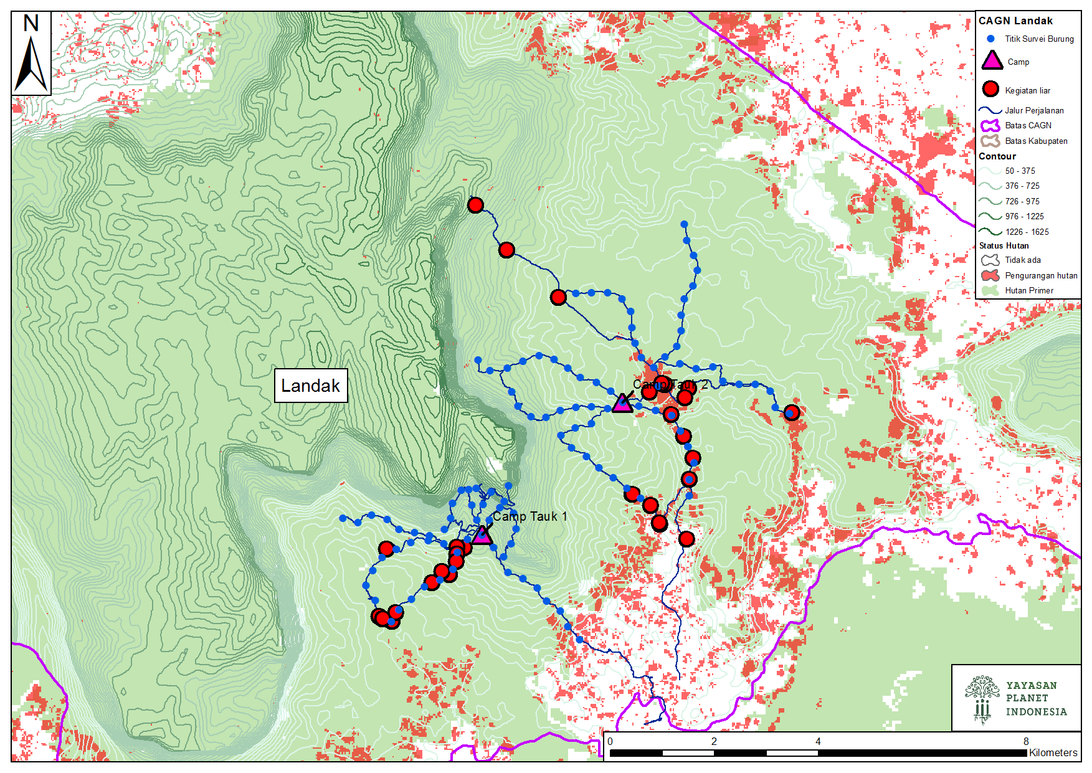

Figure 1. Study sites in Cagar Alam Gunung Niyut, Kabupaten Landak.

*2.2 Point counts*

Two teams of three to four people, consisting of two trained observers, one local guide, and sometimes one accompanying government employee, conducted 10-minute 100 m radius point counts at points every 300 m along each of 14 trails, between 5:30 and 10am. These trails were spread in an approximately radial pattern around two base camps approximately 5 km apart, but isolated by topography. On average, each trail contained 8 points, for a total of 115 points. In October, November, and February, team 1 surveyed the 6 A trails, and in December and January the 8 B trails, with team 2 surveying the remaining trails (refer to same map as study area map). At each point, the teams recorded the time, date, weather, and observer, then sat silently for 5 minutes before beginning to collect data. All point counts were digitally recorded. All detected individuals were recorded along with the detection method (visual or auditory) including individuals that could not be identified. For each unknown individual, time relative to the start of the point count was recorded.

After data collection in the field, the primary recordist for each point count listened to the recording a second time to verify species identification and to identify calls that could not be identified in the field. These point counts were then processed using R 3.6.0 (script in supplemental material) into “encounter histories” required for site occupancy modeling using RPresence (MacKenzie and Hines 2018). For each species, a 5 by 115 matrix of 1’s (detected), 0’s (not detected), and NA’s (no survey) was produced, with the columns describing detection within one sampling occasion, and the rows describing the detection for one site over all sampling occasions.

*2.3 Development of Habitat Covariates*

In May 2018, a team of three observers recorded elevation, an index of understory complexity from 0 (no plants at all) to 3 (unable to see the shape of the land under the canopy), and percent water cover at each of 115 point count locations. In addition, we utilized remotely sensed data and GIS to characterize forest structure and condition, topography, and measures of anthropogenic disturbance hypothesized to influence avian occupancy dynamics (Table 1). Landsat 8 Surface Reflectance NDVI images were composited and cloud masked in Google Earth Engine for the study period (October 2017- February 2018) to produce mean NDVI values across the study area (Vermote et. al 2016; Gorelick et al. 2017). We calculated forest canopy disturbance metrics utilizing LandTrendr implemented in Google Earth Engine (Kennedy et al. 2018). LandTrendr is an algorithm that uses time series analysis of Landsat imagery to fit pixel-wise change trajectories of vegetation indices to identify and map forest canopy disturbance events (Kennedy et al. 2010; Lorenz et. al. 2015; Cohen et al. 2018). We considered disturbance that occurred within the last ten years to be recent for primary tropical forest in Asia and so we calculated LandTrendr disturbance metrics for 2007-2017 (Canterbury et al. 2000; Cole et al. 2014) We hypothesized that species’ response to forest structure and condition may change with territory size, so these covariates were assessed at multiple spatial scales (Pearman 2002; Glisson et al. 2017) We calculated the average value of NDVI, forest height, proportion of disturbed canopy, and proportion of intact forest across buffers with radii of 100m, 500m, 1000m, and 1500m from each point count location (Glisson et al. 2017).

We calculated Euclidean distance to the nearest roads and other human disturbances including agricultural clearings, illegal logging areas, and dwellings/structures located during surveys. All spatial covariate data were processed and extracted for point count locations using ArcMap v10.6(ESRI). To determine which variables to include in our starting model set, we assessed collinearity of habitat variables using the lattice R package [SOURCE]. One variable out of each set of collinear variables were included in the starting model set for occupancy (Elbroch and Wittmer 2012). All covariates were scaled to 0-1 as recommended by MacKenzie and Hines (2018).

.

Table 1. Habitat covariates developed for occupancy models.

|  |  |  |  |  |
| --- | --- | --- | --- | --- |
| Habitat  Covariate | Hypothesized  Effect | Data Product  Satellite and Sensor | Spatial Resolution | Sources |
| Normalized Difference Vegetation Index (NDVI) |  | Landsat 8 Surface Reflectance OLI/TIRS | 30m | Vermote et al. 2016; Gorelick et al. 2017 |
| Elevation, slope,  and aspect |  | ASTER Global Digital Elevation Model V002 | 30m | NASA LPDAAC 2011 |
| Forest canopy height  ( canopy cover > 5m) |  | Forest Canopy Height Map; derived from Geoscience Laser Altimeter System (GLAS) LiDAR | 1000m | Simard et al. 2011 |
| Proportion of canopy recently disturbed (2007-2017) | Species specific response to disturbance levels | LandTrendr disturbance metrics: Landsat 7 TM & Landsat 8 OLI/TIRS TOA b | 30m | Kennedy et al. 2018; Kennedy et al. 2010 |
| Proportion of intact forest in 2016 |  | REG Borneo Forest Cover 2016; derived from Landsat 5,7, & 8 | 30m | Center for International Forestry Research CIFOR); Gaveau et al. 2016 |
| Distance to roads |  | Open Street Map Kalimantan roads layer | 30m | OpenStreetMap contributors (2015) |

*P (detection) covariates*

*2.4 Data Analysis*

All analyses were conducted in R 3.6.0 (R 2019). All occupancy modeling was conducted using package RPresence 2.12.31 (McKenzie and Hines 2018). Scripts may be found in the supplementary material.

We used single season occupancy models to investigate the influence of environmental and anthropogenic factors on the probability that forest-dependent Bornean avian species occupy a given location (psi) (MacKenzie et al. 2006). We used a stepwise hierarchical model selection process to determine the global model appropriate for each species: 1) Determine detection structures. Fix psi, fit all possible combinations of survey-specific detection covariates to data, and retain those with delta AICc <= 2. We used the resulting well-supported models as the only allowed structures for detection in all the following steps. 2) Determine correct scale for each covariate and species. Because remotely gathered covariates were calculated at as many as four scales, and each species might respond to different covariates at different scales, we built 16 candidate global psi models structures corresponding to every top-order combination of all scale-dependent covariates. We did not include distance from roads or canopy height in this step. We retained only the top-supported psi structure for each species, and considered this structure to be the global model appropriate to describe the relationship between each species’ habitat and its occupancy of that habitat. 3) Finally, we included roads and canopy height.

Every combination and lower-order combination of occupancy covariates were fit to the species-specific detection history data obtained from our point counts. Then, we calculated model-averaged estimates of site-specific occupancy per species for two sets of hypothetical points. The hypothetical points’ site-specific covariates were held constant at the observed means of the sample site-specific covariates, except for distance from roads in the first set and canopy height in the second, which were allowed to vary across their observed range. Then, we compared the mean of the linear slope of psi ~ distance from roads between species considered to be commercially valuable and widespread in markets and species considered to be generally not threatened by the bird trade.

We expected birds particularly vulnerable to the bird trade to be found further from roads than birds not as affected by the bird trade. We considered the relationship between occupancy and distance to roads of species not as affected by the bird trade to be the null hypothesis, and used a Welch’s t-test to test whether the mean slope of traded species’ relationship between occupancy and distance from roads was greater than the mean slope of untraded species’ relationship between occupancy and distance from roads.

3.0 Results

Team 1 observed 147 species and Team 2 observed 186 species, with 95 and 291 unidentified detections respectively. The five most frequently observed species for Team 1 were *Psilopogon australis*, *Psilopogon chrysopogon*, *Psilopogon mystacophanos*, *Alcippe brunneicauda*, and *Psilopogon henricii.* Similarly, Team 2 observed *Psilopogon australis, Psilopogon chrysopogon*, *Arachnothera longirostra*, *Psilopogon mystacophanos*, and *Pycnonotus erythropthalmos* most frequently. We detected eight species of particular concern: *Alophoixus tephrogenys* (10 detections), *Chloropsis sonnerati* (11 detections), *Copsychus malabaricus* (39 detections), *Hydrornis schwaneri* (1 detection), *Irena puella* (64 detections), *Loriculus galgulus* (83 detections), *Platylophus galericulatus* (2 detections),  *Rhinoplax vigil* (74 detections), and *Spilornis cheela* (20 detections). Based on the findings of Rentschlar *et al.* (2018) and the recommendations of Lee *et al.* (2016), we considered all but *R. vigil* and *S. cheela* to be particularly vulnerable to the Indonesian wild bird trade. However, because *P*. *galericulatus* and *H. schwaneri* were only detected 2 and 1 times respectively, we did not have enough data on these species to produce trustworthy results using occupancy modeling. Furthermore, *R. vigil*’s extremely mobile lifestyle and far-reaching call ensure that our point counts were not far enough apart for spatial independence, which violates one of the key assumptions of occupancy modeling, and therefore we do not report on it further in this study.

*3.1 Habitat preferences*

Full evidence ratio tables for species and covariates may be found in the supplementary information. Here we present a more detailed look at the species of particular concern named earlier in the Results, excluding *Rhinoplax vigil* (Table 1).

Table 1. Evidence ratios for habitat covariates for six species of particular concern. A larger evidence ratio indicates that the covariate more strongly explained variation in the species’ occupancy rates.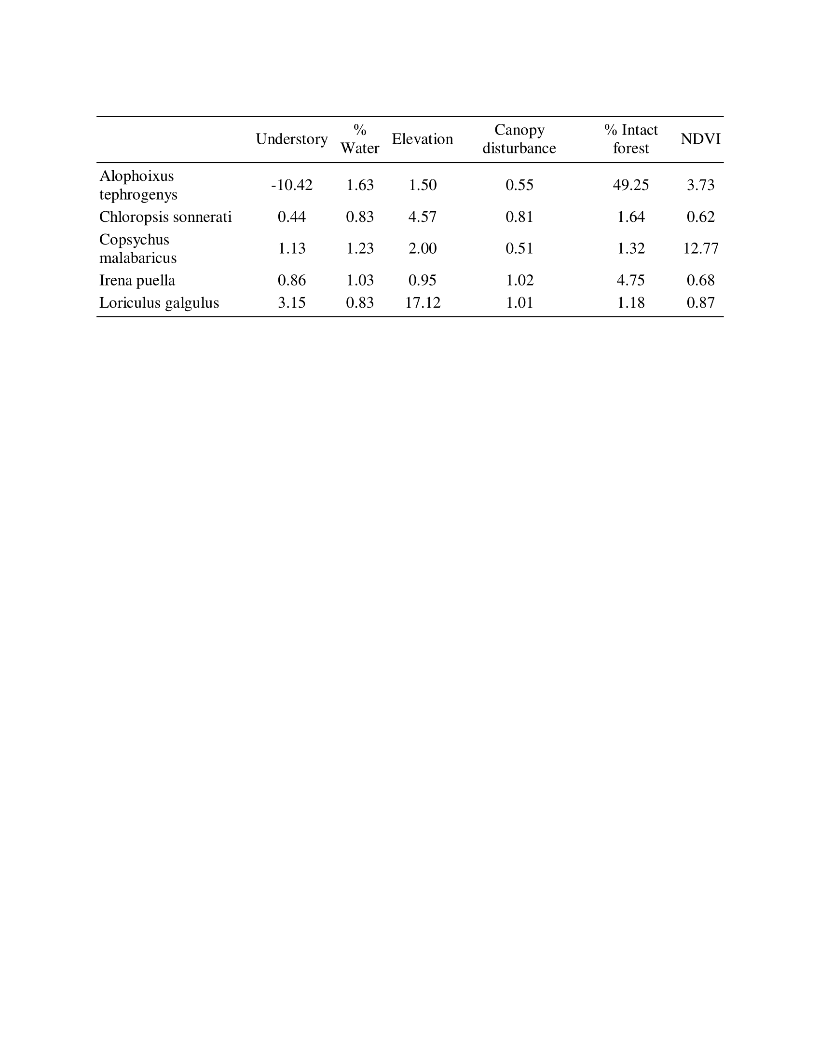

A larger evidence ratio indicates a stronger role in explaining the variation in a species’ occupancy rates. *A. tephrogenys* and *I. puella* appear to be heavily affected by the presence of intact forest. Surprisingly, *C. malabaricus* is not; instead, it appears to be more affected by the NDVI, or Normalized Difference Vegetation Index, a measure of the density of green vegetation. *L. galgulus* and *C. sonnerati* instead appear to be affected mostly by elevation.

*3.2 Responses to distance from roads*

We found that the mean slope of occupancy ~ distance from roads for species trapped for the pet bird trade was significantly higher than the mean slope of occupancy ~ distance from roads for species generally not trapped for the pet bird trade (df = 8.684, p = 0.0152, Fig. 2). Furthermore, we found that the mean slope of occupancy ~ distance from roads for untrapped species was not significantly different from 0, and that the mean slope of occupancy ~ distance from roads for trapped species was significantly greater than 0. When we excluded untrapped species with fewer than 40 detections, the differences became more significant (p = 0.0032).

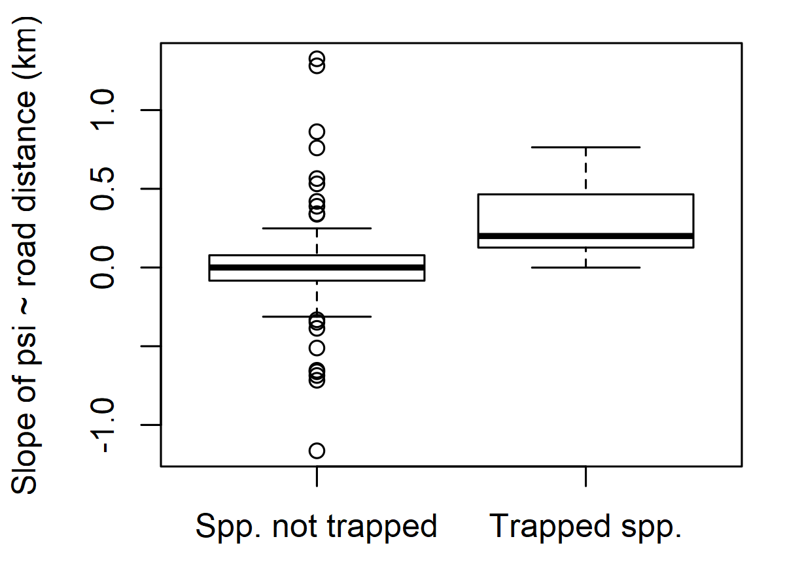

Figure 2. Comparison of linear slopes of the relationship between occupancy rates and distance from road for untrapped and trapped species. The mean for trapped species was significantly higher than the mean for untrapped species (df = 8.684, p = 0.0152).

*Responses to tree height*

We did not find a significant difference between the relationships of the occupancy rates of cup nesters and cavity nesters to canopy height (df = 13.418, p-value = 0.9431).

4.0 Discussion

*Habitat preferences*

No coherent pattern emerged from the exploration of habitat preferences among species of conservation concern. A more in-depth look at the data regarding other species is required.

*Responses to road distance*

As expected, species valuable in the pet bird trade lived further from roads than other primary rainforest bird species. This result indicates that valuable species are being trapped, despite being protected by the legal status of a Cagar Alam, or Nature Preserve. Furthermore, these valuable birds are being trapped at a rate that exceeds their ability to repopulate vacant territories. Because we did not investigate the rate of change over time, we are unable to exclude the possibility that these valuable birds are being trapped further into the forest each year. The current state could also be an equilibrium between the profit gained by selling the birds and the cost inherent in trekking kilometers into the forest to trap.

*Biases and possible weaknesses of this study*

Team 1 frequently observed some species that were not expected to be common and were very rarely observed by Team 2 (e.g. Arachnothera flavigaster observed 26 times by Team 1 and 1 time by Team 2, and expected to be “uncommon” based on Birds of the Indonesian Archipelago). In addition, Team 2 observed many common species many more times than Team 1 (e.g. Loriculus galgulus observed 0 times by Team 1 and 83 times by Team 2, and expected to be “fairly common” based on Birds of the Indonesian Archipelago). Team 2 was lead by Katherine Lauck, who had 2+ years of experience identifying Bornean bird calls, and Team 1 had participated in the month-long training provided before the start of the project, so this bias is expected to relate to misidentification and detection that is biased towards loud and complex song types. Indeed, species underreported by Team 1 tended to have quieter, simpler, and/or higher-pitched calls, or were extremely common (e.g. all of the Prionochilus, Loriculus galgulus, Dicaeum trigonostigma, Cyanoderma rufifrons, Arachnothera longirostra, Aegithina viridissima).

Recommendations

As highlighted by Rentschlar (2018), strategies to mitigate illegal poaching of songbirds must be multi-pronged and engage all stakeholders. Most critically, these songbirds must be nationally protected. Regrettably, after the Conservation Act No. 5 of 1990 was updated in 2018, a number of valuable species were afterwards removed from the protected list following pressure from song bird enthusiasts. This unfortunate about-face puts these birds at risk once again and highlights the massive domestic demand for them. We echo calls by many others (Chng and Eaton 2016, Chng *et al*. 2015, Jepson and Ladle 2005) for Indonesia to finally protect the species of concern recommended by the Asian Songbird Crisis Summit (Lee *et al*. 2015).

At a more regional scale, the demand for songbirds continues to be poorly understood. Until education and behavior change campaigns are able to address the root causes, prices for rare birds will continue to rise and tempt poachers into protected areas. We also echo Rentschlar *et al*. (2018) in their assertion that captive breeding cannot mitigate demand for wild birds in Kalimantan in the absence of comprehensive regulation and enforcement.

Although we did not find a coherent pattern in the habitat preferences of species of concern, we surveyed mainly intact primary forest. These species depend on primary forest for their survival, and therefore, any ongoing deforestation of Cagar Alam Gunung Niyut (CAGN) must halt immediately. Though Gavaeu (2017 estimates that 50% of the island remains forested, CAGN is an island of forest in an area that was deforested mainly in the 1980s and 1990s (Global Forest Watch), and remains one of West Kalimantan’s last large plots of intact forest. This remnant habitat must be protected. To reach this objective, conservationists and must work with communities living in and near CAGN to understand the proximate causes of deforestation and help alleviate the poverty that may drive local people to log and trap.

This study highlights the effects of illegal trapping activity on wild populations of threatened songbirds. Despite residing within a Cagar Alam, valuable songbird populations are showing signs of depletion in this isolated park. Furthermore, we detected no individuals of Straw-headed Bulbul during this study, which indicates that past trapping pressure reached deep into the park. If indeed the whole park was trapped in the past, the very presence of threatened songbirds further highlights the need to protect what could be one of their last strongholds in West Kalimantan.

Literature

Abood, S. A., Lee, J. S. H., Burivalova, Z., Garcia‐Ulloa, J., & Koh, L. P. (2015). Relative contributions of the logging, fiber, oil palm, and mining industries to forest loss in Indonesia. *Conservation Letters*, *8*(1), 58-67.

Achard, F. et al. (2002) Determination of deforestation rates of the world’s humid tropical forests. Science 297, 999–1002.

Brooks, T. M., Mittermeier, R. A., Mittermeier, C. G., Da Fonseca, G. A., Rylands, A. B., Konstant, W. R., ... & Hilton‐Taylor, C. (2002). Habitat loss and extinction in the hotspots of biodiversity. Conservation biology, 16(4), 909-923.

Canterbury, G. E., Martin, T. E., Petit, D. R., Petit, L. J. and Bradford, D. F. (2000), Bird Communities and Habitat as Ecological Indicators of Forest Condition in Regional Monitoring. Conservation Biology, 14: 544-558. doi:[10.1046/j.1523-1739.2000.98235.x](https://doi.org/10.1046/j.1523-1739.2000.98235.x)

Chng, S.C.L and Eaton, J.A. (2016a). Snapshot of an on-going trade: an inventory of birds for sale in Chatuchak weekend market, Bangkok, Thailand. *BirdingASIA* 24: 24–29.

Chng, S.C.L and Eaton, J.A. (2016b). *In the market for extinction: Eastern and Central Java*. TRAFFIC Southeast Asia, Petaling Jaya, Selangor, Malaysia.

Chng, S.C.L., Eaton, J.A., Krishnasamy, K., Shepherd, C.R. and Nijman, V. (2015). *In the market for extinction: an inventory of Jakarta's bird markets*. TRAFFIC Southeast Asia, Petaling Jaya, Selangor, Malaysia.

Chng, S.C.L., Guciano, M. and Eaton, J.A. (2016). In the market for extinction: Sukahaji, Bandung, Java, Indonesia. *BirdingAsia*26: 22–28.

Chng, S.C.L., Shepherd, C.R.S. and Eaton, J.A. (2018). In the market for extinction: birds for sale in selected outlets in Sumatra. *TRAFFIC Bulletin*30(1): 15–22.

Cohen, W. B., Yang, Z., Healey, S. P., Kennedy, R. E., & Gorelick, N. (2018). A LandTrendr multispectral ensemble for forest disturbance detection. Remote Sensing of Environment, 205, 131-140.

Collar, N. J. (2005). Family Turdidae (Thrushes). In: del Hoyo, J., Elliott, A. and Christie, C. (eds), *Handbook of birds of the world Vol. 10*, pp. 514-807. Lynx Edicions, Barcelona, Spain.

Cole, L. E. S., Bhagwat, S. A. & Willis, K. J.(2014). Recovery and resilience of tropical forests after disturbance. *Nature Communications* **5**, 3906.

Eaton, J.A., Shepherd, C.R., Rheindt, F.E., Harris, J.B.C., van Balen, S.B., Wilcove, D.S. and Collar, N.J. (2015). Trade-driven extinctions and near-extinctions of avian taxa in Sundaic Indonesia. *Forktail*31: 1–12.

Environmental Systems Research Institute (ESRI). ArcGIS 10.6.; Environmental Systems Research Institute

(ESRI): Redlands, CA, USA, 2004.

Curran, L. M., Trigg, S. N., McDonald, A. K., Astiani, D., Hardiono, Y. M., Siregar, P., ... & Kasischke, E. (2004). Lowland forest loss in protected areas of Indonesian Borneo. *Science*, *303*(5660), 1000-1003.

Eaton, J.A., Leupen, B.T.C. and Krishnasamy, K. (2017a). Songsters of Singapore: *An overview of the bird species in Singapore pet shops*. TRAFFIC Southeast Asia, Petaling Jaya, Selangor, Malaysia.

Eaton, J.A., Nguyen, M.D.T., Willemsen, M., Lee, J. and Chng, S.C.L. (2017b). Caged in the city: an inventory of birds for sale in Ha Noi and Ho Chi Minh City, Viet Nam. TRAFFIC Southeast Asia, Petaling Jaya, Selangor, Malaysia.

Gaveau, D.L.A.; Salim, M.; Arjasakusuma, S., 2016, "Deforestation and industrial plantations development in Borneo", [https://doi.org/10.17528/CIFOR/DATA.00049](https://doi.org/10.17528/CIFOR/DATA.00049" \t "_blank), Center for International Forestry Research (CIFOR), V2; REGBorneo\_ForestCover\_2016\_CIFOR.7z [fileName]

Glisson, W. J., Conway, C. J., Nadeau, C. P., and Borgmann, K. L.. 2017. Habitat models to predict wetland bird occupancy influenced by scale, anthropogenic disturbance, and imperfect detection. *Ecosphere* 8( 6):e01837. [10.1002/ecs2.1837](https://doi.org/10.1002/ecs2.1837" \o "Link to external resource: 10.1002/ecs2.1837" \t "_blank)

Global Forest Watch. “Tree cover loss in Kalimantan Barat”. Accessed on November 6th 2018 from [www.globalforestwatch.org](http://www.globalforestwatch.org).

Gorelick, N. *et al.* Google Earth Engine: planetary-scale geospatial analysis for everyone. *Remote Sens. Environ.* 202, 18–27 (2017)

Hansen MC, Potapov PV, Moore R, Hancher M, Turubanova SA, Tyukavina A, Thau D, Stehman SV, Goetz SJ, Love- land TR, Kommareddy A, Egorov A, Chini L, Justice CO, Townshend JR (2013) High-resolution global maps of 21st-century forest cover change. Science 342(6160):850–853.

Harris, J. B. C., Tingley, M. W., Hua, F., Yong, D. L., Adeney, J. M., Lee, T. M., ... & Wilcove, D. S. (2017). Measuring the impact of the pet trade on Indonesian birds. *Conservation Biology*, *31*(2), 394-405.

Jepson, P. and Ladle, R.J. (2005). Bird-keeping in Indonesia: conservation impacts and the potential substitution-based conservation responses. *Oryx*39: 1–6. ttp://dx.doi.org/10.1017/S0030605305001110.

Kennedy, R., Yang, Z., Gorelick, N., Braaten, J., Cavalcante, L., Cohen, W., & Healey, S. (2018). Implementation of the LandTrendr Algorithm on Google Earth Engine. Remote Sensing, 10(5), 691.

Lee, J.G.H., Chng, S.C.L. and Eaton, J.A. (2016). *Conservation strategy for Southeast Asian Songbirds in trade: recommendations from the first Asian Songbird Trade Crisis Summit 2015 held in Jurong Bird Park, Singapore, 27–29 September 2015*. Wildlife Reserves Singapore, Singapore; TRAFFIC Southeast Asia, Selangor, Malaysia.

Lorenz T.J, Vierling K.T., Kozma J.M., Millard, J.E., Raphael, M.G.(2015). Space Use by White-Headed Woodpeckers and Selection for Recent Forest Distubances. The Journal of Wildlife Management, 79(8), 1286-1297.

Margono, B. A., Potapov, P. V., Turubanova, S., Stolle, F., & Hansen, M. C. (2014). Primary forest cover loss in Indonesia over 2000–2012. *Nature Climate Change*, *4*(8), 730.

Miettinen J, Shi C, Liew SC (2011) Deforestation rates in insular Southeast Asia between 2000 and 2010. Glob Change Biol 17(7):2261–2270 .

Miettinen J, Shi C, Tan WJ, Liew SC (2012) 2010 land cover map of insular Southeast Asia in 250-m spatial resolution. Remote Sens Lett 3(1):11–20.

Myers, N. et al. (2000) Biodiversity hotspots for conservation priorities. Nature 403, 853–858.

NASA LP DAAC. 2011. ASTER Global Digital Elevation Model. Version 2. NASA EOSDIS Land Processes DAAC, USGS Earth Resources Observation and Science (EROS) Center, Sioux Falls, South Dakota ([https://lpdaac.usgs.gov](https://lpdaac.usgs.gov/)), accessed [MM DD, YYYY], at http:// dx.doi.org/10.5067/ASTER/ASTGTM.002

Nash, S.V. (1993). *Sold for a song: the trade in Southeast Asian non-CITES birds*. TRAFFIC International, Cambridge, UK.

Nijman, V. (2010). *An overview of international wildlife trade from Southeast Asia. Biodiversity and Conservation* 19(4):1101–1114.

MacKenzie D.,Hines J. (2018). RPresence: R Interface for Program

PRESENCE. R package version 2.12.31.

Nijman, V. (2010). An overview of international wildlife trade from Southeast Asia. *Biodiversity and conservation*, *19*(4), 1101-1114.

Pearman, P.B. (2002). The Scale of Community Structure: Habitat Variation and Avian Guilds in Tropical Forest Understory*. Ecological Monographs*, 72(1), 19-39.

R Core Team (2019). R: A language and environment for statistical computing. R

Foundation for Statistical Computing, Vienna, Austria. URL

[https://www.R-project.org/](https://www.r-project.org/).

Rentschlar K.A., Miller A.E., Lauck K.S., Rodiansyah M., Bobby, Muflihati, and Kartikawati (2018). A silent morning: The songbird trade in Kalimantan, Indonesia. *Tropical Conservation Science.* <https://doi.org/10.1177/1940082917753909>.

Simard, M., Pinto, N., Fisher, J., Baccini, A. 2011. Mapping forest canopy height globally with spaceborne lidar. Journal of Geophysical Research. 116: G04021. [doi:10.1029/2011JG001708] (<http://dx.doi.org/10.1029/2011JG001708>)

Shepherd, C. R., Sukumaran, J. and Wich, S. A. (2004). *Open Season: An analysis of the pet trade in Medan, Sumatra 1997-2001*. TRAFFIC Southeast Asia. Petaling Jaya, Malaysia.Shepherd, C. R. (2006). The bird trade in Medan, North Sumatra: an overview. *BirdingASIA* 5:16–24.

Shepherd, C.R. and Chng, S.C.L (2017). Second South-East Asian Songbird Trade Crisis Summit. *TRAFFIC Bulletin*29(1): 3–4.

Shepherd, C. R., Sukumaran, J. and Wich, S. A. (2004). *Open season: An analysis of the pet trade in Medan, Sumatra 1997-2001.* TRAFFIC Southeast Asia, Petaling Jaya, Selangor, Malaysia.

Sodhi, N. S., Koh, L. P., Brook, B. W., & Ng, P. K. (2004). Southeast Asian biodiversity: an impending disaster. Trends in ecology & evolution, 19(12), 654-660.

Vermote, E., Justice, C., Claverie, M., & Franch, B. (2016). Preliminary analysis of the performance of the Landsat 8/OLI land surface reflectance product. Remote Sensing of Environment, 185, 46-56.

Supplementary information

