Day 4/11/26
Snowflake
Verifying the table creation
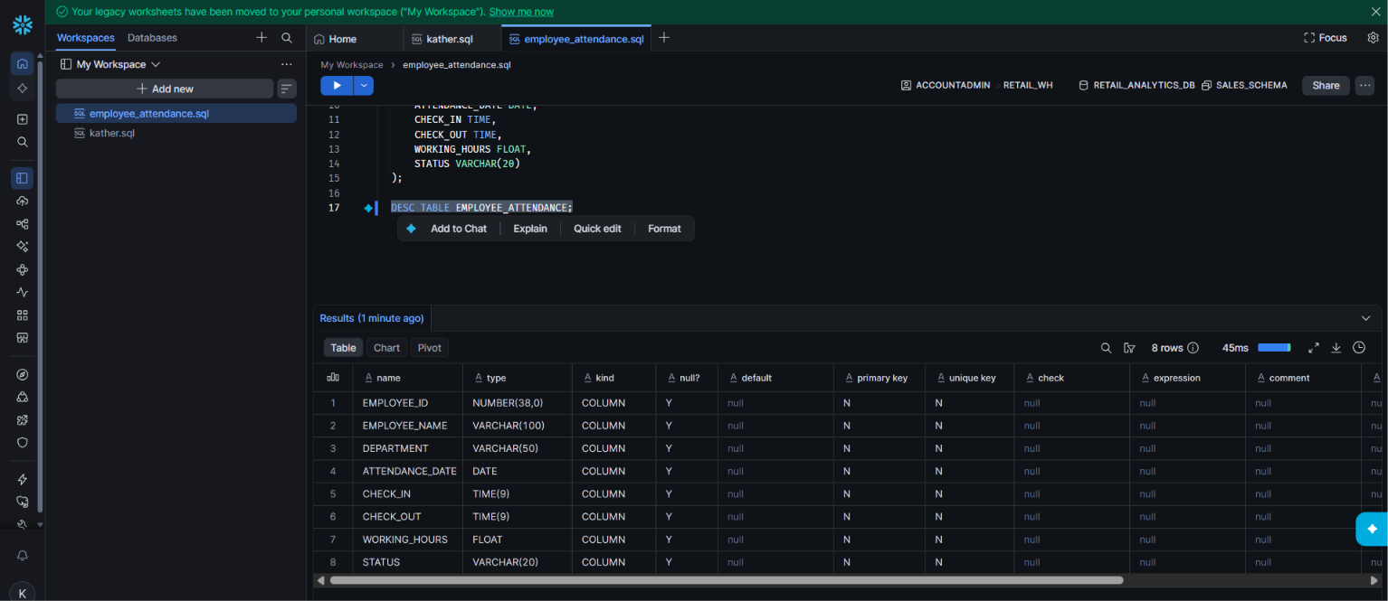

Verifying file in stage
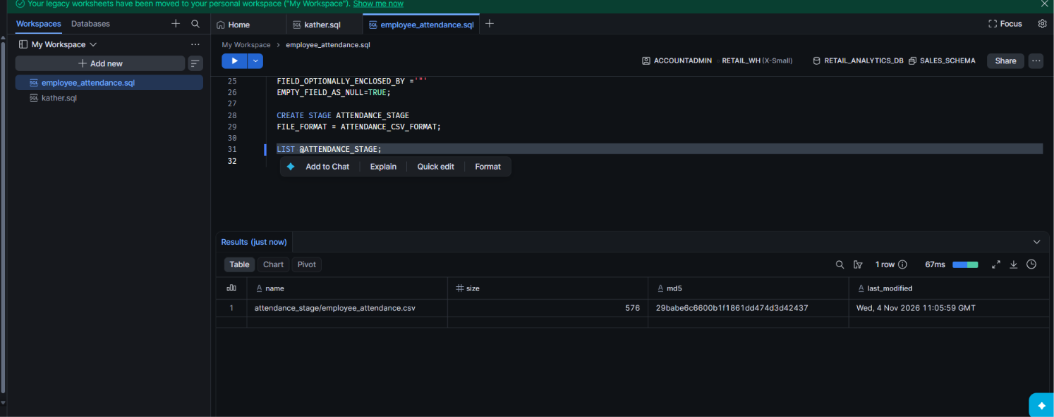

Query 1: Display all attendance records

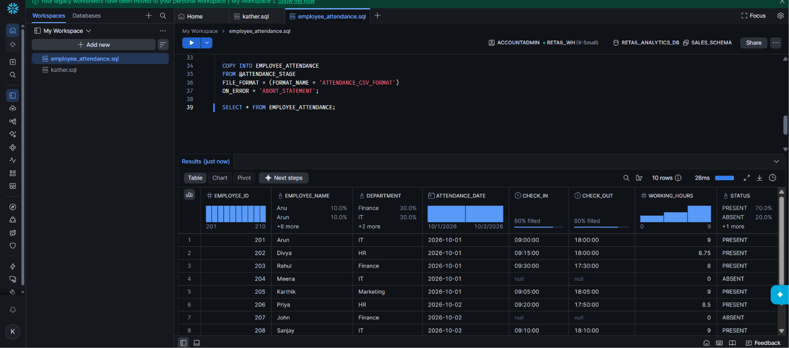

Query 2: Display employees from a specific department
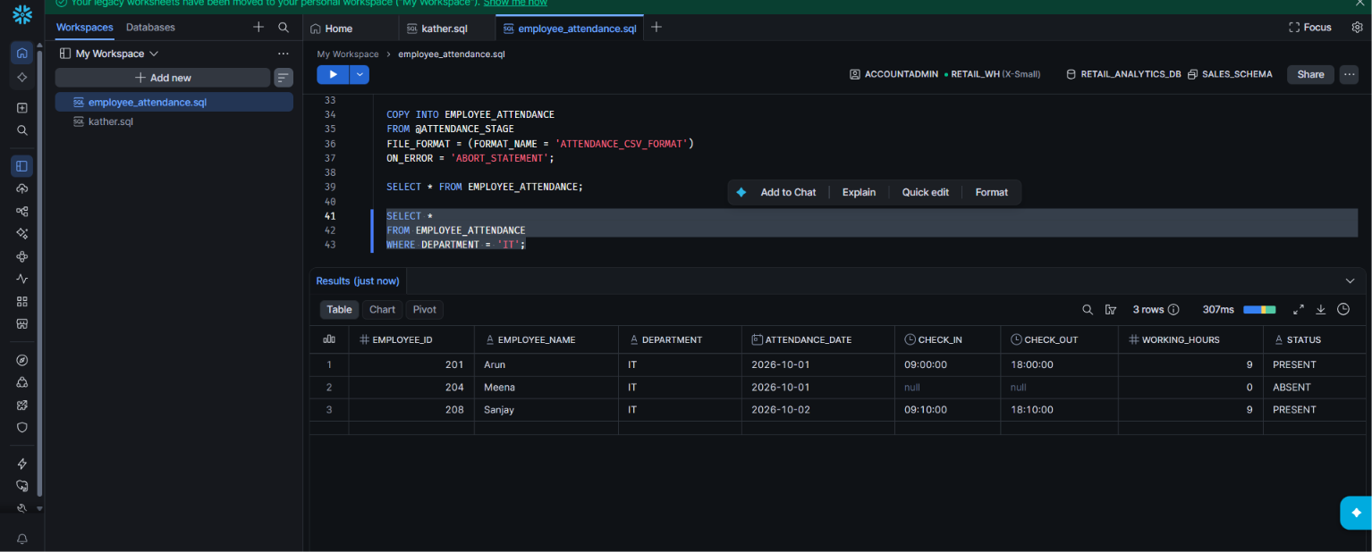

Query 3: Calculate total working hours
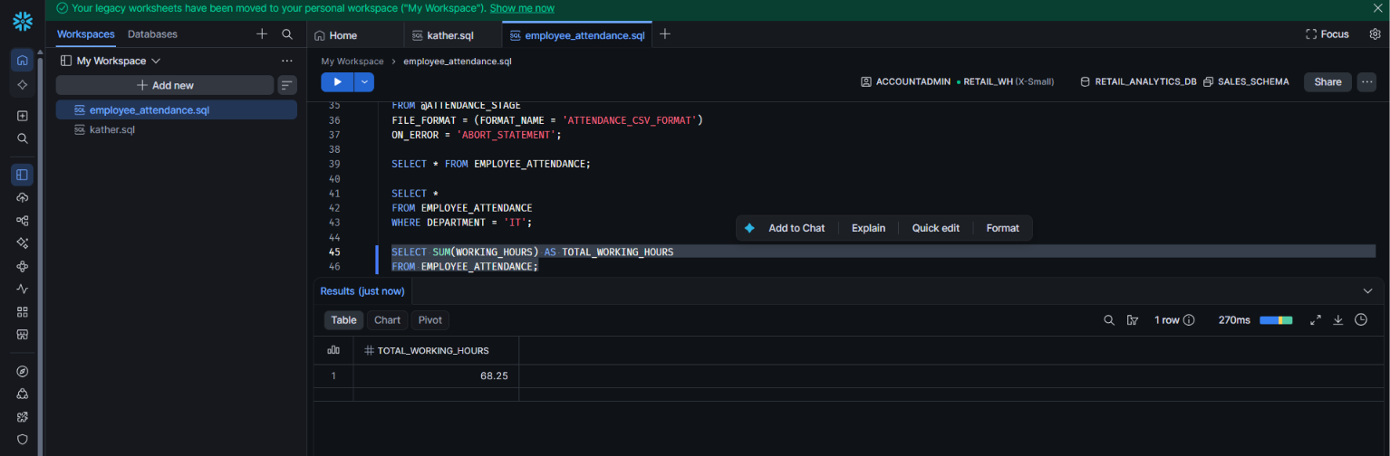
Query 4: Calculate department-wise working hours
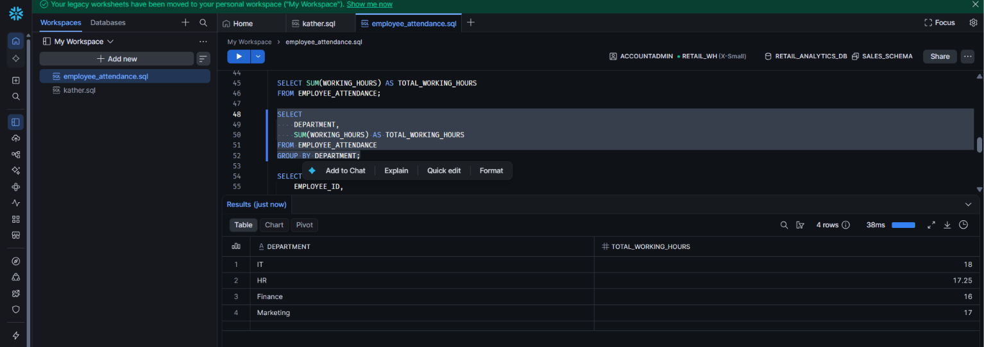

Query 5: Find employee-wise attendance details
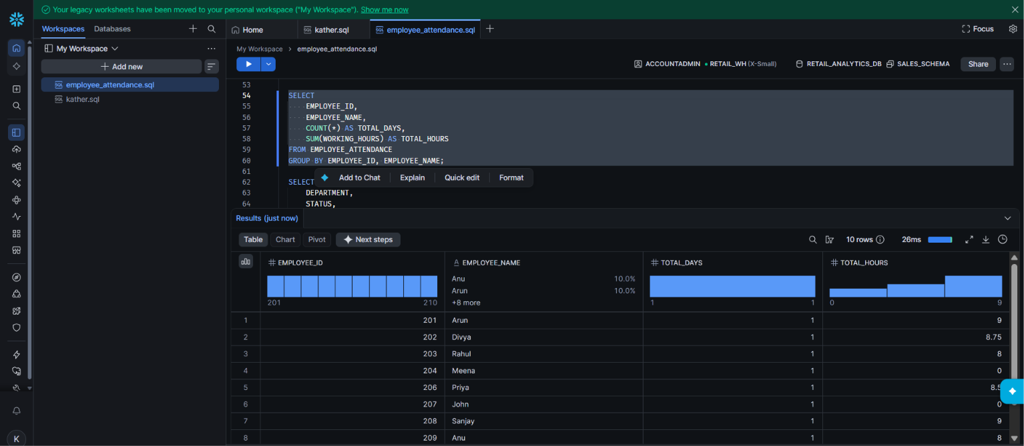

Query 6: Find total attendance by department and status


