Streaming and data warehousing – snowflake

Snowflake account creation and role changed to sysadmin
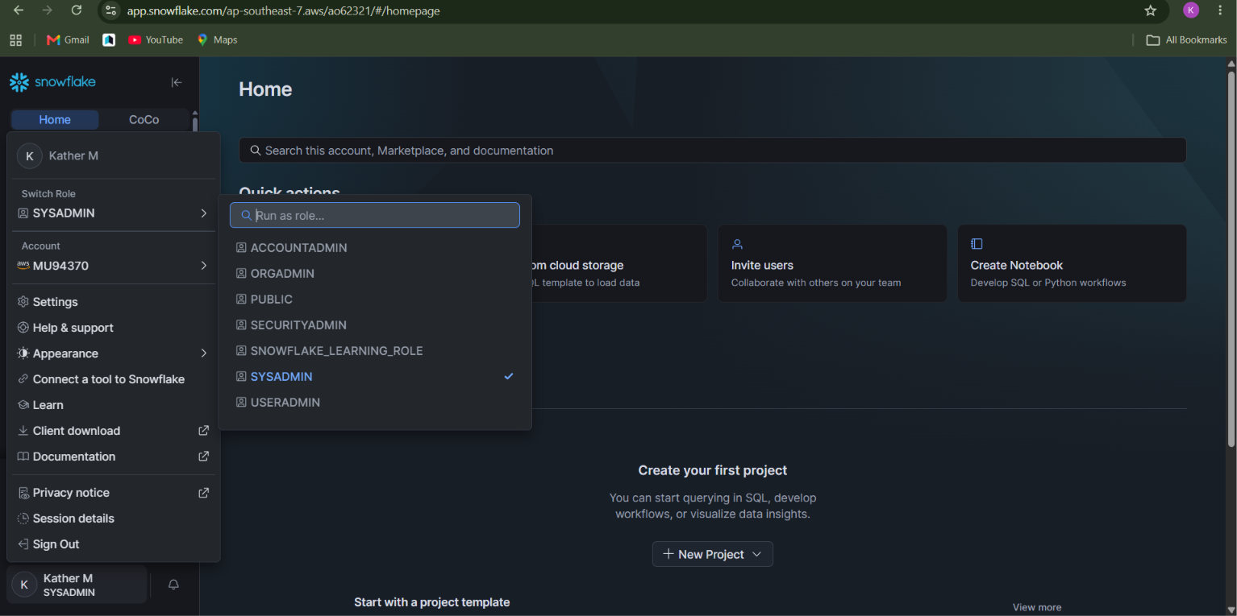

Create an db and an schema for it
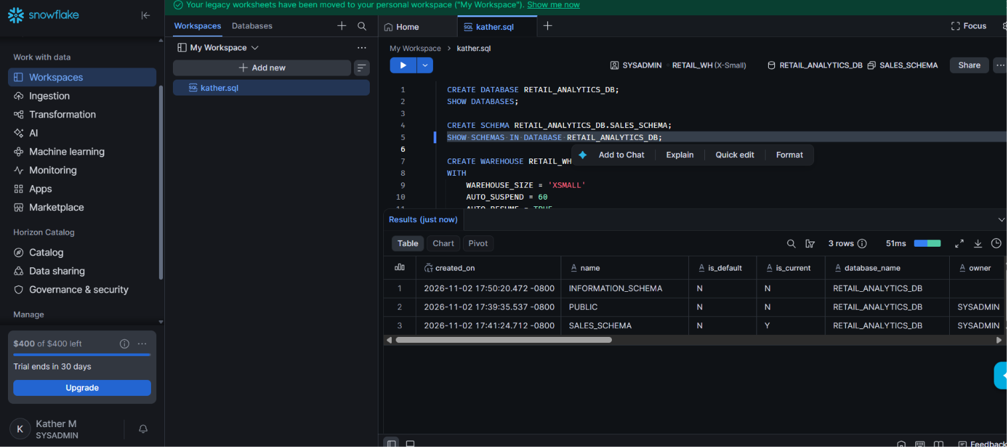

This is the entire sql workspace code

CREATE DATABASE RETAIL_ANALYTICS_DB;
SHOW DATABASES;

CREATE SCHEMA RETAIL_ANALYTICS_DB.SALES_SCHEMA;
SHOW SCHEMAS IN DATABASE RETAIL_ANALYTICS_DB;

CREATE WAREHOUSE RETAIL_WH
WITH
WAREHOUSE_SIZE = 'XSMALL'
AUTO_SUSPEND = 60
AUTO_RESUME = TRUE
INITIALLY_SUSPENDED = TRUE;

USE WAREHOUSE RETAIL_WH;

USE DATABASE RETAIL_ANALYTICS_DB;
USE SCHEMA SALES_SCHEMA;

CREATE TABLE SALES (
ORDER_ID INT,
ORDER_DATE DATE,
CUSTOMER_NAME VARCHAR(100),
PRODUCT_NAME VARCHAR(100),
CATEGORY VARCHAR(50),
QUANTITY INT,
PRICE FLOAT,
CITY VARCHAR(50)
);

CREATE FILE FORMAT SALES_CSV_FORMAT
TYPE = 'CSV'
FIELD_DELIMITER = ','
SKIP_HEADER = 1
FIELD_OPTIONALLY_ENCLOSED_BY = '"'
EMPTY_FIELD_AS_NULL = TRUE;

CREATE STAGE SALES_STAGE
FILE_FORMAT = SALES_CSV_FORMAT;
SHOW STAGES;

Upload the csv files here
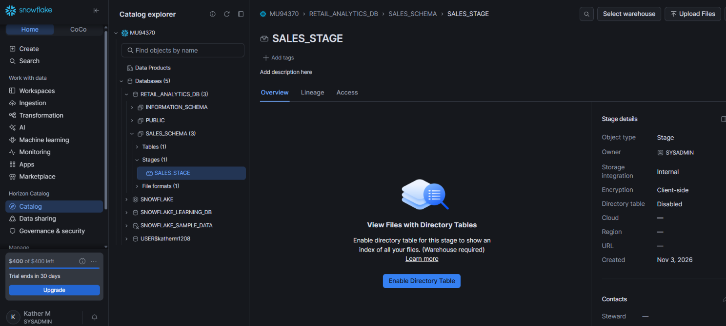

Verify the staged file
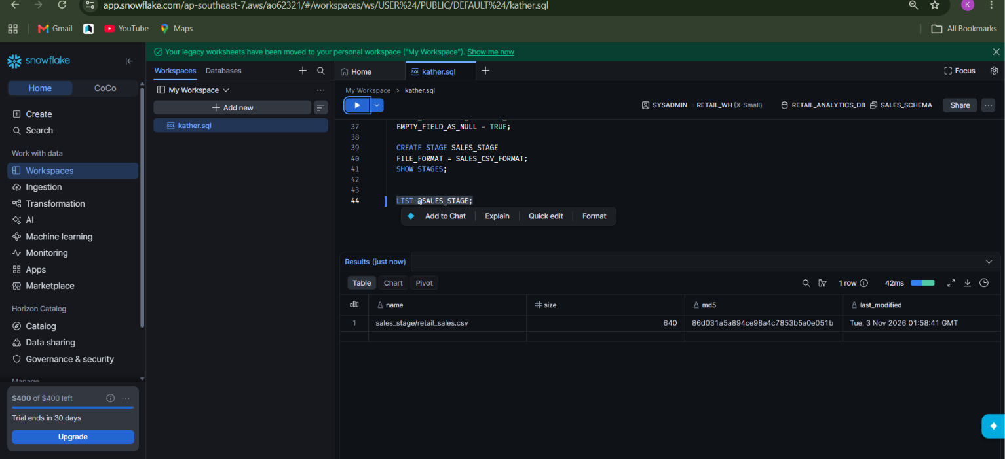

Load csv into table
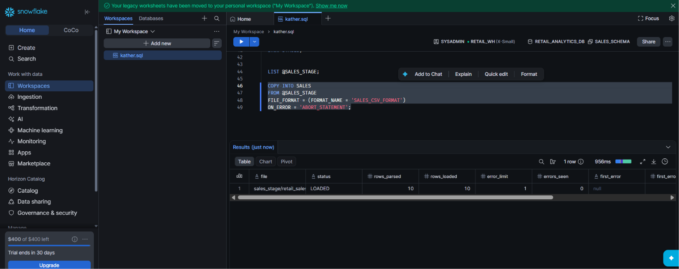

Sales data
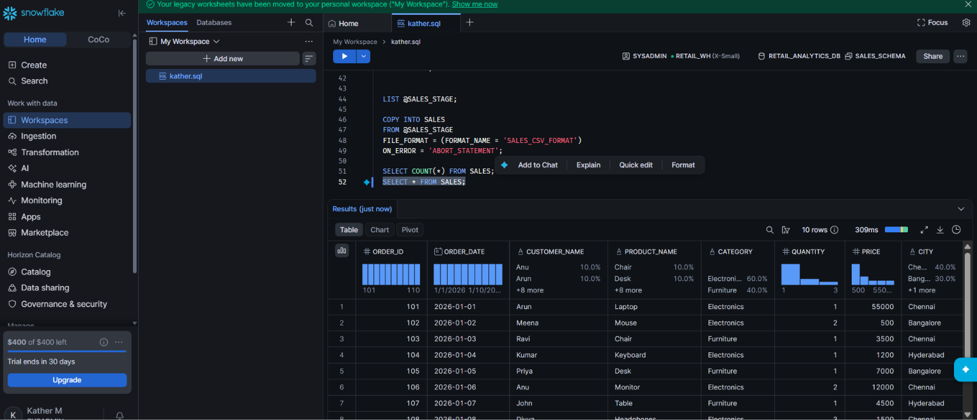

Table structure
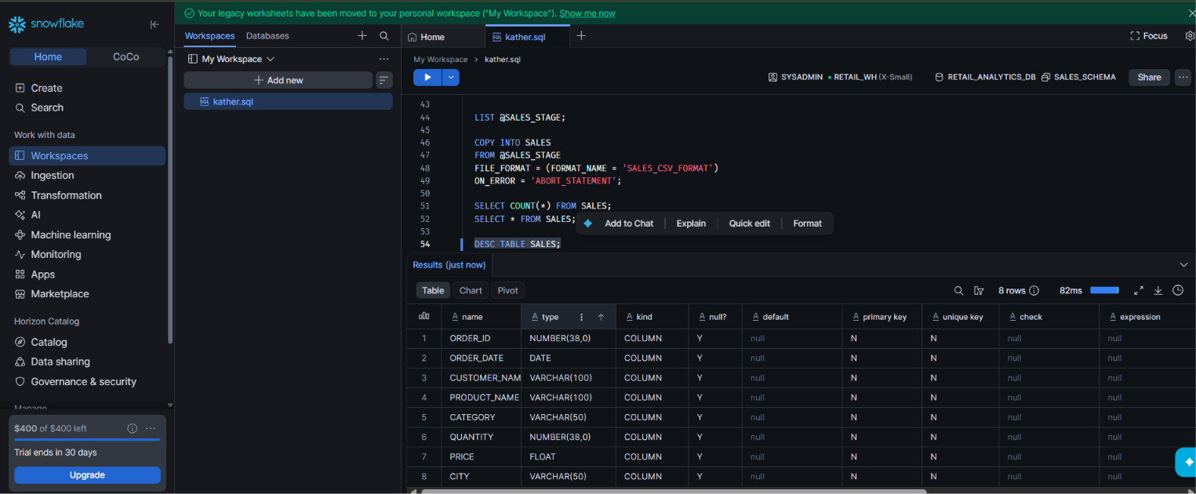

Drop db and warehouse


