**Lab – Using Wireshark to Examine Ethernet Frames This lab has been updated for use on NETLAB+**

**Topology**

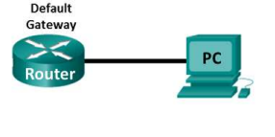

**Objectives**

**Part 1: Examine the Header Fields in an Ethernet II Frame**

**Part 2: Configure the PC and Router**

**Part 3: Use Wireshark to Capture and Analyze Ethernet Frames**

**Background / Scenario**

When upper layer protocols communicate with each other, data flows down the Open Systems Interconnection (OSI) layers and is encapsulated into a Layer 2 frame. The frame composition is dependent on the media access type. For example, if the upper layer protocols are TCP and IP and the media access is Ethernet, then the Layer 2 frame encapsulation will be Ethernet II. This is typical for a LAN environment.

When learning about Layer 2 concepts, it is helpful to analyze frame header information. In the first part of this lab, you will review the fields contained in an Ethernet II frame. In Part 2, you will use Wireshark to capture and analyze Ethernet II frame header fields for local and remote traffic.

**Part 1: Examine the Header Fields in an Ethernet II Frame**

In Part 1, you will examine the header fields and content in an Ethernet II Frame. A Wireshark capture will be used to examine the contents in those fields.

**Note**: The data presented in Part 1 has been previously captured for analytical purposes.

and/or its affiliates. All rights reserved. This document is Cisco Public. Page **1** of **7**

**Lab – Using Wireshark to Examine Ethernet Frames**

**Step 1: Review the Ethernet II header field descriptions and lengths.**

| **Preamble** | **Destination**  **Address** | **Source**  **Address** | **Frame**  **Type** | **Data** | **FCS** |
| --- | --- | --- | --- | --- | --- |
| 8 Bytes | 6 Bytes | 6 Bytes | 2 Bytes | 46 – 1500 Bytes | 4 Bytes |

**Step 2: Examine the network configuration of the PC.**

This PC host IP address is 192.168.1.17 255.255.255.0 and the default gateway has an IP address of 192.168.1.1. The Router port G0/0 connected to the PC has an IP address of 192.168.1.1 255.255.255.0.

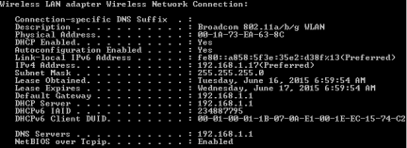

**Step 3: Examine Ethernet frames in a Wireshark capture.**

The Wireshark capture below shows the packets generated by a ping being issued from a PC host to its default gateway. A filter has been applied to Wireshark to view the ARP and ICMP protocols only. The session begins with an ARP query for the MAC address of the gateway router, followed by four ping requests and replies.

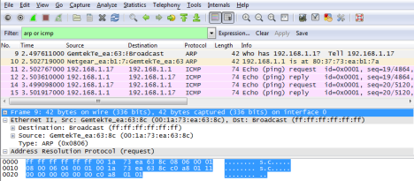© 2015 Cisco and/or its affiliates. All rights reserved. This document is Cisco Public. Page **2** of **7**

**Lab – Using Wireshark to Examine Ethernet Frames**

**Step 4: Examine the Ethernet II header contents of an ARP request.**

The following table takes the first frame in the Wireshark capture and displays the data in the Ethernet II header fields.

| **Field** | **Value** | **Description** |
| --- | --- | --- |
| Preamble | Not shown in capture | This field contains synchronizing bits, processed by the NIC hardware. |
| Destination Address | Broadcast  (ff:ff:ff:ff:ff:ff) | Layer 2 addresses for the frame. Each address is 48 bits long, or 6 octets, expressed as 12 hexadecimal digits, 0- 9,A-F.  A common format is 12:34:56:78:9A:BC.  The first six hex numbers indicate the manufacturer of the network interface card (NIC), the last six hex numbers are the serial number of the NIC.  The destination address may be a broadcast, which contains all ones, or a unicast. The source address is always unicast. |
| Source Address | GemtekTe_ea:63:8c (00:1a:73:ea:63:8c) |
| Frame Type | 0x0806 | For Ethernet II frames, this field contains a hexadecimal value that is used to indicate the type of upper-layer protocol in the data field. There are numerous upper-layer protocols supported by Ethernet II. Two common frame types are: Value Description  0x0800 IPv4 Protocol  0x0806 Address resolution protocol (ARP) |
| Data | ARP | Contains the encapsulated upper-level protocol. The data field is between 46 – 1,500 bytes. |
| FCS | Not shown in capture | Frame Check Sequence, used by the NIC to identify errors during transmission. The value is computed by the sending machine, encompassing frame addresses, type, and data field. It is verified by the receiver. |

What is significant about the contents of the destination address field?

All hosts on the LAN will receive this broadcast frame. The host with the IP address of 192.168.1.1 (default gateway) will send a unicast reply to the source (PC host). This reply contains the MAC address of the NIC of the default gateway._ Why does the PC send out a broadcast ARP prior to sending the first ping request?

Before the PC can send a ping request to a host, it needs to determine the destination MAC address before it can build the frame header for that ping request. The ARP broadcast is used to request the MAC address of the host with the IP address contained in the ARP_ What is the MAC address of the source in the first frame?14:91:82:9f:6b:8c

What is the Vendor ID (OUI) of the Source’s NIC? BelkinIn (Belkin International Inc.)

What portion of the MAC address is the OUI?

The first 3 octets of the MAC address indicate the OUI.

_ What is the Source’s NIC serial number? 9f:6b:8c

© 2015 Cisco and/or its affiliates. All rights reserved. This document is Cisco Public. Page **3** of **7**

**Lab – Using Wireshark to Examine Ethernet Frames**

**Part 2: Configure the PC and Router**

In Part 2, you will configure IP addresses on the router and PC.

**Step 1: Configure an IP address on the router.**

a. Click on the **Router**.

b. Assign the IP address and subnet mask to the router. The procedure for assigning an IP address is described below:

Router> **enable**

Router# **configure terminal**

Router#(config)# **interface g0/0**

Router(config-if)# **ip address 192.168.1.1 255.255.255.0**

Router(config-if)# **no shut**

Router(config-if)# **exit**

**Step 2: Configure an IP address on PC.**

a. Click on the **PC**.

b. Assign the IP address, default gateway and subnet mask to the PC. The procedure for assigning an IP address on a PC running Windows 7 is described below:

1) Click the **Windows Start** icon > **Control Panel**.

2) Click **View By:** > **Category**.

3) Choose **View network status and tasks** > **Change adapter settings**.

4) Right-click **Local Area Network Connection** and select **Properties**.

5) Choose **Internet Protocol Version 4 (TCP/IPv4)**, click **Properties**.

6) Click the **Use the following IP address** radio button and enter the IP address, subnet mask and default gateway respectively.

7) **192.168.1.17 / 255.255.255.0 / 192.168.1.1**

8) Click **OK**.

9) Click **Close**.

**Part 3: Use Wireshark to Capture and Analyze Ethernet Frames**

In Part 3, you will use Wireshark to capture local and remote Ethernet frames. You will then examine the information that is contained in the frame header fields.

**Step 1: Start capturing traffic on your PC’s NIC.**

a. Click on the **PC**.

b. Open **Wireshark**.

c. On the Wireshark Network Analyzer toolbar, click the **Interface List** icon.

© 2015 Cisco and/or its affiliates. All rights reserved. This document is Cisco Public. Page **4** of **7**

**Lab – Using Wireshark to Examine Ethernet Frames**



d. On the Wireshark: Capture Interfaces window, select the interface to start traffic capturing by clicking the appropriate check box, and then click **Start**. If you are uncertain of what interface to check, click **Details** for more information about each interface listed.

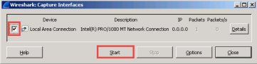

**Step 2: Filter Wireshark to display only ICMP traffic.**

You can use the filter in Wireshark to block visibility of unwanted traffic. The filter does not block the capture of unwanted data; it only filters what to display on the screen. For now, only ICMP traffic is to be displayed.

In the Wireshark **Filter** box, type **icmp**. The box should turn green if you typed the filter correctly. If the box is green, click **Apply** to apply the filter.

**Step 3: From the command prompt window, ping the default gateway of your PC.** Open the command prompt on the PC and ping the default gateway.

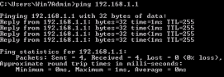

**Step 4: Stop capturing traffic on the NIC.**

Click the **Stop Capture** icon to stop capturing traffic.



© 2015 Cisco and/or its affiliates. All rights reserved. This document is Cisco Public. Page **5** of **7**

**Lab – Using Wireshark to Examine Ethernet Frames**

**Step 5: Examine the first Echo (ping) request in Wireshark.**

The Wireshark main window is divided into three sections: the Packet List pane (top), the Packet Details pane (middle), and the Packet Bytes pane (bottom). If you selected the correct interface for packet capturing in Step 3, Wireshark should display the ICMP information in the Packet List pane of Wireshark, similar to the following example.

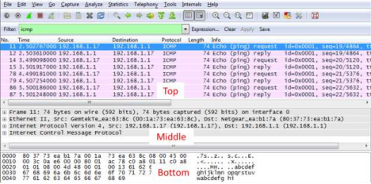

a. In the Packet List pane (top section), click the first frame listed. You should see **Echo (ping) request** under the **Info** heading. This should highlight the line blue.

b. Examine the first line in the Packet Details pane (middle section). This line displays the length of the frame; 74 bytes in this example.

c. The second line in the Packet Details pane shows that it is an Ethernet II frame. The source and destination MAC addresses are also displayed.

What is the MAC address of the PC’s NIC? 00:26:b9:dd:00:91

What is the default gateway’s MAC address? 14:91:82:9f:6b:8c

d. You can click the plus (+) sign at the beginning of the second line to obtain more information about the Ethernet II frame. Notice that the plus sign changes to a minus (-) sign.

What type of frame is displayed? 0x0800 or an IPv4 frame type.

e. The last two lines displayed in the middle section provide information about the data field of the frame. Notice that the data contains the source and destination IPv4 address information.

What is the source IP address? 192.168.1.147

What is the destination IP address? 192.168.1.1

f. You can click any line in the middle section to highlight that part of the frame (hex and ASCII) in the Packet Bytes pane (bottom section). Click the **Internet Control Message Protocol** line in the middle section and examine what is highlighted in the Packet Bytes pane.

© 2015 Cisco and/or its affiliates. All rights reserved. This document is Cisco Public. Page **6** of **7**

**Lab – Using Wireshark to Examine Ethernet Frames**

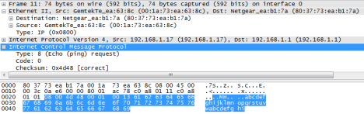

What do the last two highlighted octets spell? ______

g. Click the next frame in the top section and examine an Echo reply frame. Notice that the source and destination MAC addresses have reversed, because this frame was sent from the default gateway router as a reply to the first ping.

What device and MAC address is displayed as the destination address?

PC, 00:26:b9:dd:00:91

**Reflection**

Wireshark does not display the preamble field of a frame header. What does the preamble contain?

The preamble field contains seven octets of alternating 1010 sequences, and one octet that signals the beginning of the frame, 10101011.

© 2015 Cisco and/or its affiliates. All rights reserved. This document is Cisco Public. Page **7** of **7**