*Project Goals*

The goal of this project was to receive some insight on the traffic conditions in Ann Arbor, and how they correlate with the weather conditions. Using OpenWeather API and TomTom API, we hope to use our newfound Python skills to gather data from the APIs, create databases in SQLite3, edit those databases, and calculate something from the gathered data. We will hopefully get information on live traffic data and incident data and see how the weather conditions (temperature and descriptions) influence that data. Once we have gathered this data, we hope to use Matplotlib to create graphs of the yearly weather in Michigan, the yearly incident data in Michigan, and then a graph showing the correlation between the two.

*Achieved Goals*

Unfortunately, we were not able to use the incident data API from TomTom, nor could we get the previous year’s weather or traffic data because the API did not store a year’s worth of data. Instead, we pivoted our project to get data from 12-04-19 to 12-11-19 on live traffic and weather data. We were able to collect data on traffic conditions, including speed, travel time, road closures, and the confidence of the predicted traffic data. We were also able to collect weather data including the current temperate, the maximum temperature for that day, the minimum temperature for that day, the general weather conditions, and then a description of those weather conditions. From that data, we were able to calculate the average confidence of traffic conditions, the average speed, the average temperature, and average weather condition.

To better understand this calculated data, we created four visualizations. The first is the average confidence level in traffic reports given the weather conditions (bar graph), which showed that the confidence was highest when snowing, second highest when cloudy, and least confident when raining.

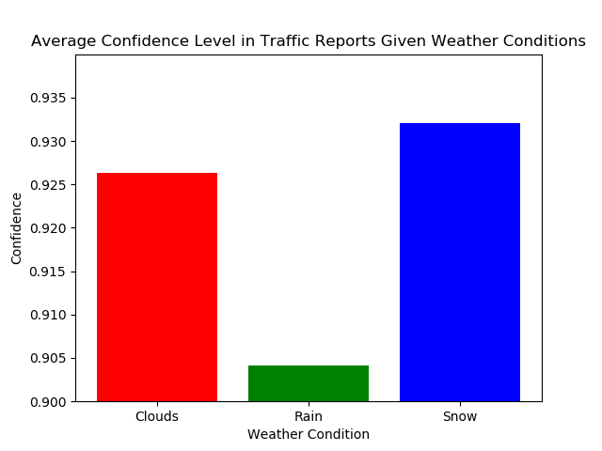

Figure

The second visualization used a double line graph to show the average temperature versus the average speed per day from 12-4-19 to 12-11-19. This highlighted that when the

temperature was higher, so was the average speed, and when the temperature was lower, so 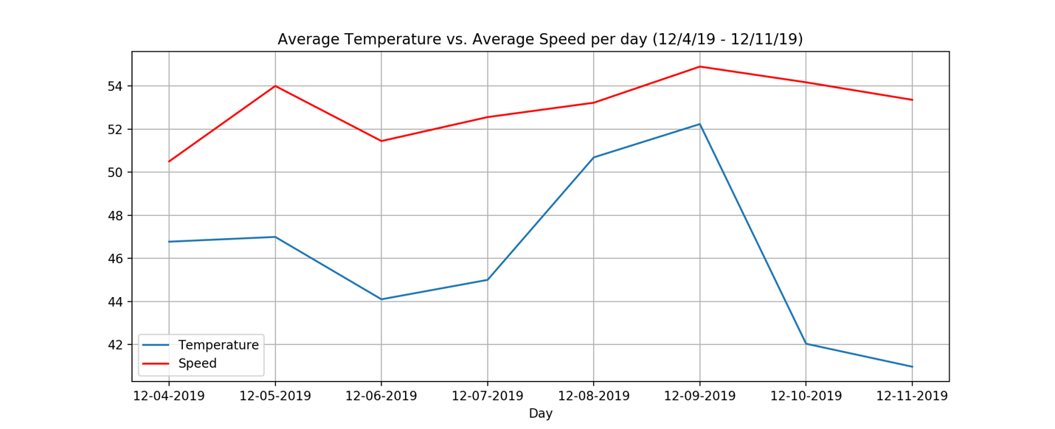was the average speed.

Figure

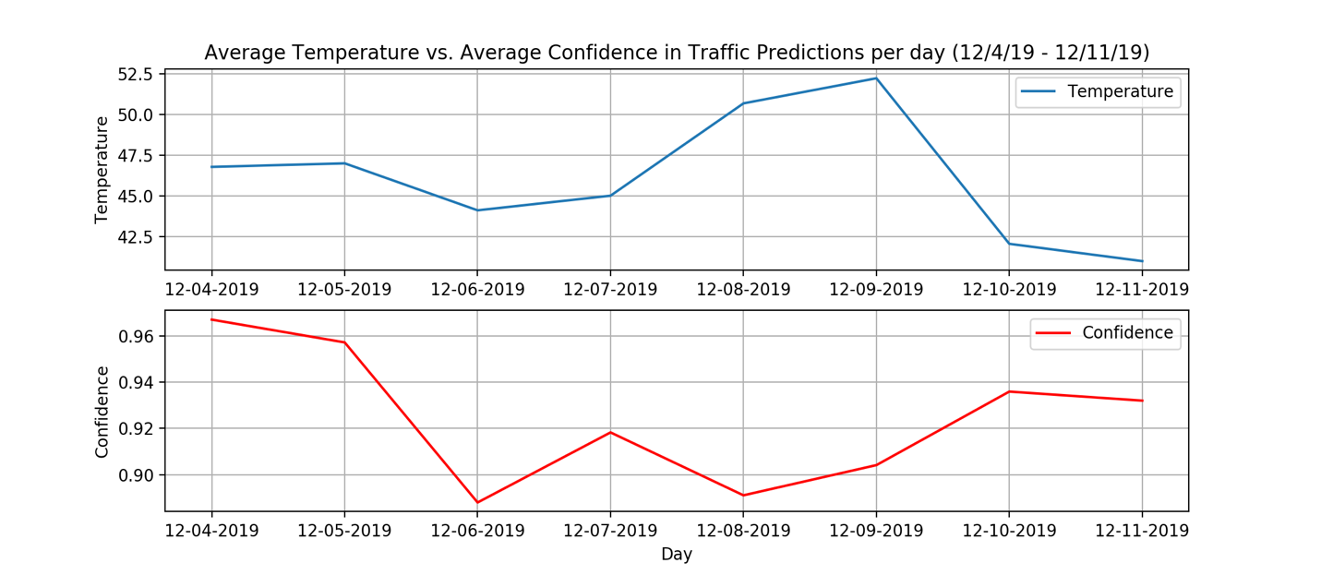The third visualization utilized a line graph with two subplots, due to the y axis values being so far apart and graphed the temperature versus the average confidence in traffic conditions per day. This graph showed that when the temperature was higher, the confidence in traffic predictions was lower.

Figure

The final graph, a pie chart, showed the average weather conditions from 12-4-19 to 12-11-19. It reported that 75% of the time, the weather reported clouds, 12.5% of the time it reported snow, and the other 12.5% of the time, it reported rain.

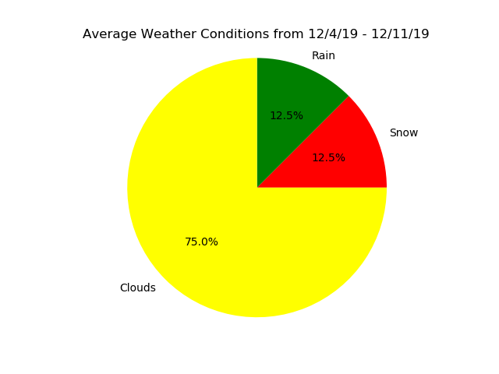

Figure

*The Problems Faced*

One of the first problems we faced in this project was that we were unable to get the live incident data from the TomTom API.This was due to the fact that when we input a versionNumber (as we were required to according to their documentation for the API), it would cause an error. We were also unable to retrieve the past years live traffic data, because the API did not store this data. However, we were still able to complete the project without either of these data points.

In order to collect the live traffic data, we had to create a bounding box, an area for the traffic data to be collected between, in Ann Arbor. We chose coordinates on Washtenaw Ave, Packard & Hill, W. Stadium Blvd, Saline Road, and N. Maple Road. However, because of the way that the TomTom API is set up, we had to convert the latitude and longitude to the World Geodetic System (1984) using an online converter. This took some time to understand, but once completed we were able to move forward with the project.

After we had gathered all of our data, we realized that we had collected the datetime in a different format in the traffic data than we had in the weather data. The weather data datetime was already available in the OpenWeather API, but the traffic data datetime was not available so we had to generate our own. We ended up gathering the weather data in Unix epoch time, and the traffic data in human-readable data. After we converted the date times, we realized that the time stamps were also recording minutes and seconds. Because the code runs top to bottom, it meant that not all of our timestamps would match up, even if they were run at roughly the same time. Because of this, we decided to collect the data per day, rather than per hour, minute or second. This was crucial to us being able to successfully do the database join and get matches for the data.

When we went to make a pie chart out of the weather descriptions, we realized that we would need to calculate the percent of each weather description using a counter in order to use the calculated average data, since the data is not numerical. This was not a tough problem to solve, and we were able to use our Python skills to implement the necessary code. For the sub-plot line graph that we created (Figure 3), we had initially intended to create this as a double line graph. However, because the Y axis values for temperature (in the 40s) was so different from the Y axis values for the confidence (all below 1), we decided to split the plot into two sub plots, while still allowing for an effective visualization of the data.

*Instructions for running the code*

Within the code, there are instructions as well, instructing users what to uncomment. Here are also the detailed steps that we took to collect the data, calculate the averages, and then visualize the output.

1. The first four functions (weather_conditions, min_max_temp, traffic_Data, and report_confidence) all have print statements underneath them. The weather data is collected by the first two functions and allows for users to input any location, and then collect that data if they uncomment lines 56 and 57. The traffic data is collected within the second two functions. If users wished to set a different boundary box than we have set, they must edit the value of the coordinate’s variable (line 62). Then, they could uncomment lines 125 and 126 to run the code and collect the data.
2. After collecting as much data as the user needs, they can move onto the clean_data function, where all of the timestamps will be converted to a uniform, human-readable format. In order to run this function, they must uncomment line 196.
3. To take the average of the traffic speed per day, users must uncomment line 231.
4. To take the average of the temperature averages per day, users must uncomment line 266.
5. To take the average of the confidence in traffic data per day, users must uncomment line 302.
6. To take the average of the weather description per day, users must uncomment line 342.
7. To join the data of all of the averages, users must uncomment line 399.

FINISH INSTRUCTIONS ONCE THE WRITE TXT FILE IS FIXED

*Documentation for each function written (input/output for each)*

The expected input, function, and output of each function is also located beneath each class name in the code. It is further detailed here.

|  |  |  |  |
| --- | --- | --- | --- |
| **Class Name** | **Input** | **Function** | **Output** |
| weather_conditions | Query to select location to search on weather API (EX: ‘Ann+Arbor’) | Calls to OpenWeather API and collects weather data (query, datetime, main, description) for given query and inserts them into table Weather. | Returns success statement re. adding data into the database |
| min_max_temp | Query to select location to search on weather API (EX: ‘Ann+Arbor’) | Calls to OpenWeather API and collects temperature data (query, datetime, temp, max_temp, min_temp) for given query and inserts them into table Temperature. | Returns success statement re. adding data into the database |
| traffic_Data | Takes in a list of coordinates to select locations to search for on traffic data API. Must be in the World Geodectic System (1984) format and include 5 coordinate tuples | Calls to TomTom Developer API and collects traffic data (coordinates, datetime, speed, travel_time, & road_closure) for the given coordinates and inserts them into table TrafficFlow. | Returns success statement re. adding data into the database |
| report_confidence | Takes in a list of coordinates to select locations to search for on traffic data API. Must be in the World Geodectic System (1984) format and include 5 coordinate tuples | Calls to TomTom Developer API and collects traffic data (coordinates, datetime, confidence) for the given coordinates and inserts them into data table Confidence. | Returns success statement re. adding data into the database |
| clean_data | None | Cleans data by converting timestamps to uniform human-readable format and inserting them into tables (temp_clean, traffic_clean, confidence_clean, weather_clean) | None |
| take_traffic_averages | None | Takes the data from traffic_clean and generates the average traffic speed per day. Then adds this data to table traffic_averages. | Dictionary with traffic averages per day, with the day as keys and the traffic average as values. |
| take_temp_averages |  |  |  |

*Documentation for resources used*

1. The visualization that you created
2. Instructions for running your code
3. Documentation for each function you wrote. This includes the input and output for each function.
4. Documentation of all resources that were used

* Mat plot lib pie chart website
* Conversion for lat long website
* Conversion for date time website
* Tomtom data API information website
* Openweather API information website
* Mat plotlib double line chart

|  |  |  |  |
| --- | --- | --- | --- |
| **Date** | **Issue Description** | **Location of Resource** | **Result (did it solve the issue)?** |
|  |  |  |  |