**Members:**

Austria, Aira Joy Q.

Balanag, Katherine Grace L.

Brito, Jaztine Joy C.

**SAMPLE OUTPUT**

[Welcome Page]



[Players’ Details]

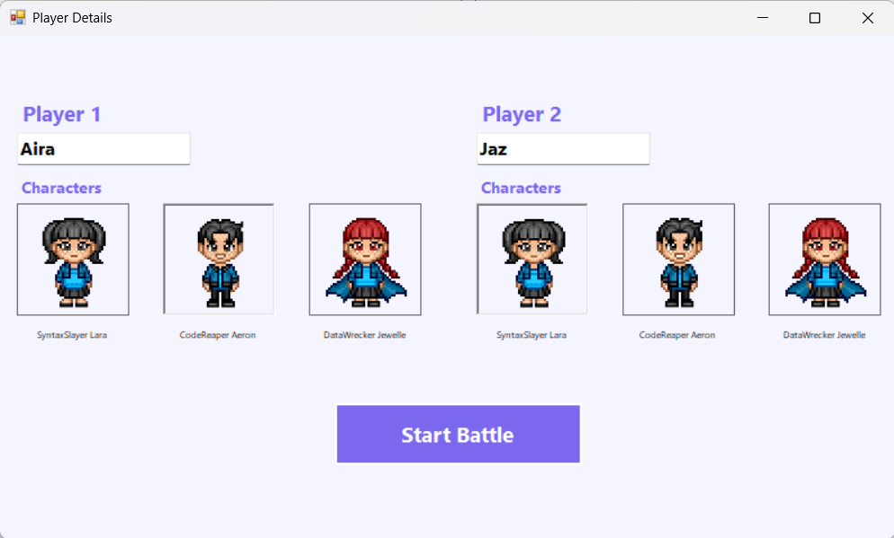

[Battle Page]

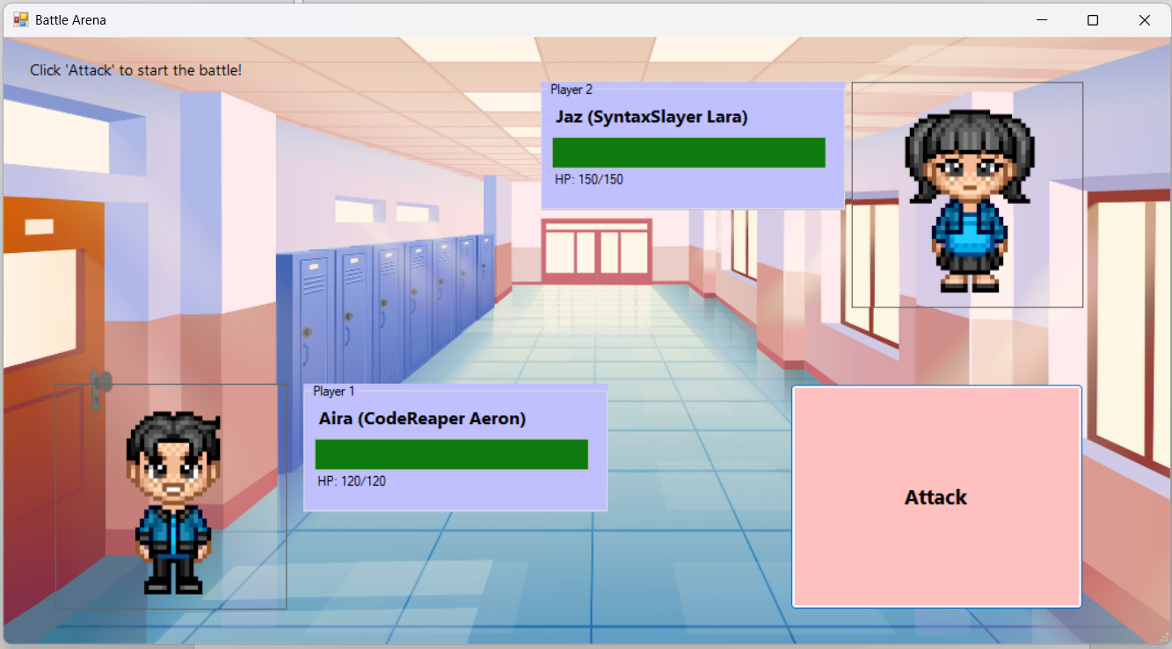

[Winner’s Page]

