


Distance-based accessibility of Green Spaces in Graz

Midterm Project

at Karl-Franzens-University Graz
in Course
VU GIS Analysis Techniques 2
Course-Number GST.200UB

written by

Michael GaLITSCHITSCH, 1210807
Katharina KOSCHU,
David LAMBERT,
Florian Zaar, 11803460

at Institute of Geography

Supervisor:
Prof. Thibaut Chassin, PhD

Graz, December 2025

Introduction
(Heikinheimo et al. 2023)

Data

Data preparation
The initial landcover classification dataset contained multiple land use classes. First, classes 1, 3, and 6 from the landcover classification were identified as representing green space categories suitable for public access and recreation. These classes were combined into a single unified class to create a homogeneous green space layer. All other landcover classes were excluded from further analysis as they did not represent accessible green spaces. To ensure analytical relevance and reduce computational complexity, a minimum area threshold was applied. Polygons smaller than 100 square meters were removed from the dataset.
The OSM leisure data were filtered to retain only polygon geometries, as point and line features do not adequately represent accessible green space areas. Consistent with the landcover processing, the same 100 square meter minimum area threshold was applied to the OSM features. All OSM leisure features were assigned to the same class identifier as the combined landcover classes to ensure consistency across data sources. The filtered landcover and OSM datasets were then merged into a unified green space layer. A dissolve operation was performed to merge green space features.
For accurate distance calculations along the pedestrian network, entry points were generated for each green space polygon. Rather than using simple polygon centroids, which may not accurately represent access locations, entry points were created at regular intervals along the boundaries of each green space. Points were placed approximately every 50 meters along polygon boundaries, with a minimum of four entry points per polygon regardless of size. This approach provides a more realistic representation of multiple access locations to larger green spaces while maintaining computational efficiency.
Building footprints were used as analysis points to represent the origins for accessibility calculations. Building data were extracted from OSM for the Graz study area, and building centroids were calculated to represent point locations. All point datasets, including green space entry points and building analysis points, were snapped to their nearest nodes in the pedestrian network.

Data analysis
The goal of the analysis is to quantify the accessibility of green spaces in Graz for pedestrians. Based on the methodology described in Heikinheimo et al. 2023, we replicated the core workflow using openly available geospatial data and network analysis techniques. The analytic component consists of two central steps: computing walking distances along the pedestrian network dataset, and aggregating and averaging the distances into a grid.
The walking distances were computed using the multi-source Dijkstra algorithm implemented in the Python library Networkx. While the original study used the Pandana library, repeated datatype-related errors made this tool not usable in this case. The source nodes for the algorithm were extracted attached to the network with ‘nearest node’ in the previous step. Therefore, the distances could be calculated very easily with length as the weight and a cutoff distance of 10.000m as was done in the paper. Then, the distances were assigned to the centroids of the buildings in Graz via their nearest node, to estimate the distribution of population, since exact population data was not available.
Finally, the resulting values were spatially joined to a 100x100m grid, extending over the city of Graz. Based on the index of the grid cell, the average walking distance per cell was calculated. Grid cells with no building within them were dropped from the dataset, so the results only include potentially inhabited cells, highlighting green spaces and their distribution in different regions of Graz.

Results and visualization
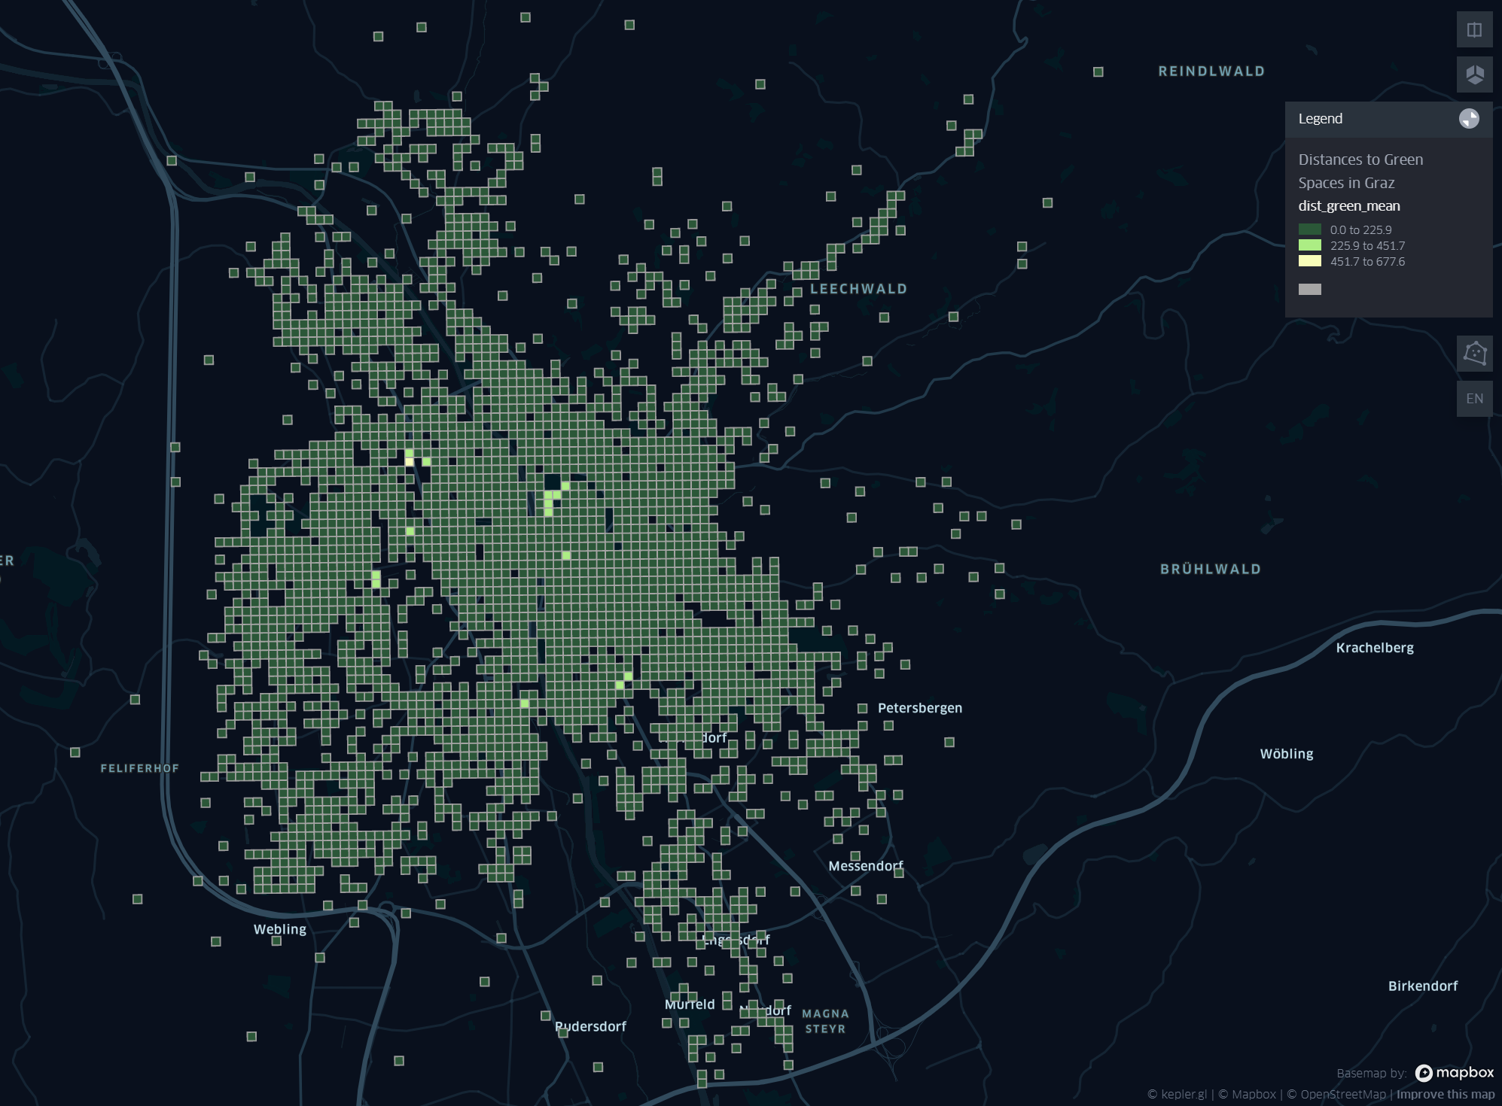
Figure 1: Result of the average walking distance from grid cell containing buildings to green spaces in Graz
Results in figure 1 show only one grid cell with a walking distance greater than about 450m to the nearest green space and barely any that are farther than 225m away. Result depends strongly on selection of routing network and what kind of green spaces (forest, park, private gardens or courtyards) are included in the analysis.

Source
Heikinheimo, Vuokko; Tiitu, Maija; Viinikka, Arto (2023): Data on different types of green spaces and their accessibility in the seven largest urban regions in Finland. In: Data in brief 50, S. 109458. DOI: 10.1016/j.dib.2023.109458.

