 

DISEÑO EXPERIMENTAL

Laboratorio: DCA

ALUMNA: Kathia Marisol Villarreal Arriaga

Matricula: 2123911

25/05/2023

Introducir los datos al excel guardar el excel como germinacion delimitado por comas csv

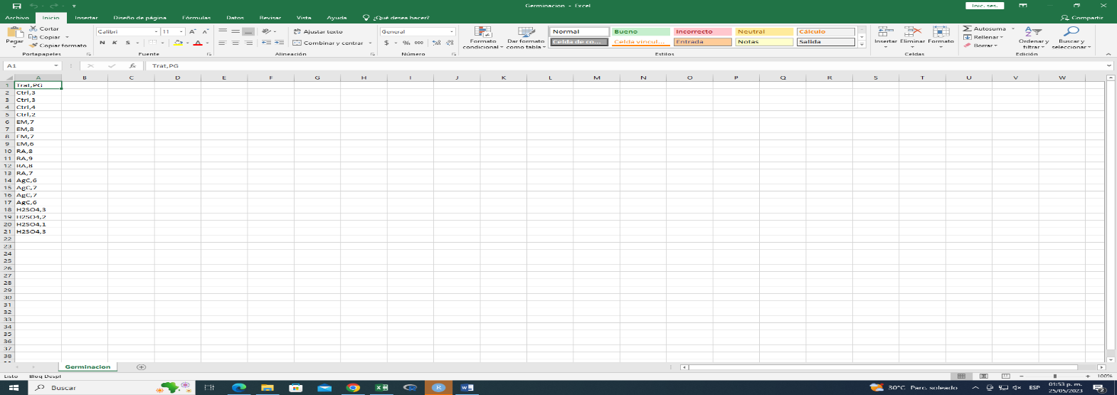

Abrir RStudio importer los datos

germinacion1.R

Usuario

2023-05-25

# KMVA  
# 25/05/2023  
  
  
# Importar datos ----------------------------------------------------------------------  
setwd("C:/Repositorio Gif/D-experimental/SCIPS/")  
Germ <- read.csv("Germinacion.Csv", header = T)  
Germ$Trat <- as.factor(Germ$Trat)  
  
  
# Grafica ----------------------------------------------------------------------------  
  
boxplot(Germ$PG ~ Germ$Trat,  
 col="PINK",  
 xlab = "Tratamientos Germinativos",  
 ylab = "% Germinacion")

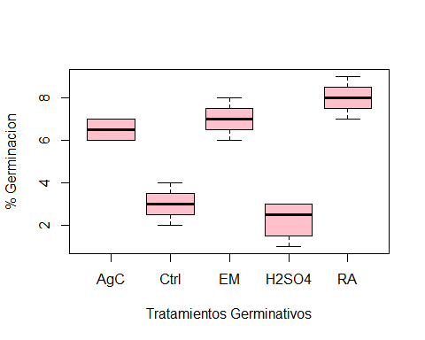

# ordenar tratamientos  
levels(Germ$Trat)

## [1] "AgC" "Ctrl" "EM" "H2SO4" "RA"

levels(Germ$Trat)

## [1] "AgC" "Ctrl" "EM" "H2SO4" "RA"

boxplot(Germ$PG ~ Germ$Trat,  
 col="PINK")

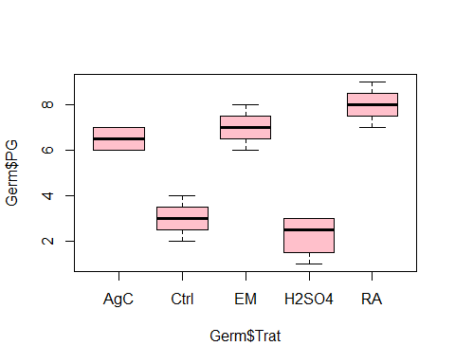

# funcion tapply  
tapply(Germ$PG, Germ$Trat, mean)

## AgC Ctrl EM H2SO4 RA   
## 6.50 3.00 7.00 2.25 8.00

tapply(Germ$PG, Germ$Trat, var)

## AgC Ctrl EM H2SO4 RA   
## 0.3333333 0.6666667 0.6666667 0.9166667 0.6666667

# ANOVA -----------------------------------------------------------------------------  
  
  
  
Germ.oav <- aov(Germ$PG ~ Germ$Trat)  
summary(Germ.oav)

## Df Sum Sq Mean Sq F value Pr(>F)   
## Germ$Trat 4 104.80 26.20 40.31 7.42e-08 ***  
## Residuals 15 9.75 0.65   
## ---  
## Signif. codes: 0 '***' 0.001 '**' 0.01 '*' 0.05 '.' 0.1 ' ' 1

# prueba de Tuckey ------------------------------------------------------------------  
  
TukeyHSD(Germ.oav, conf.level = 0.95)

## Tukey multiple comparisons of means  
## 95% family-wise confidence level  
##   
## Fit: aov(formula = Germ$PG ~ Germ$Trat)  
##   
## $`Germ$Trat`  
## diff lwr upr p adj  
## Ctrl-AgC -3.50 -5.2603878 -1.739612 0.0001587  
## EM-AgC 0.50 -1.2603878 2.260388 0.9009428  
## H2SO4-AgC -4.25 -6.0103878 -2.489612 0.0000175  
## RA-AgC 1.50 -0.2603878 3.260388 0.1140897  
## EM-Ctrl 4.00 2.2396122 5.760388 0.0000356  
## H2SO4-Ctrl -0.75 -2.5103878 1.010388 0.6862491  
## RA-Ctrl 5.00 3.2396122 6.760388 0.0000024  
## H2SO4-EM -4.75 -6.5103878 -2.989612 0.0000045  
## RA-EM 1.00 -0.7603878 2.760388 0.4332120  
## RA-H2SO4 5.75 3.9896122 7.510388 0.0000004

plot(TukeyHSD(Germ.oav), las =1, col="red")

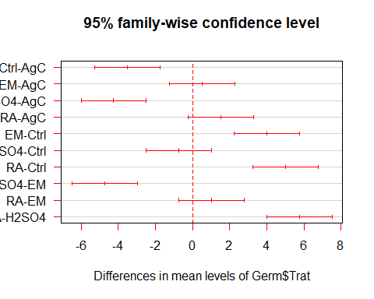

boxplot(Germ$PG ~ Germ$Trat,  
 col="PINK",  
 xlab = "Tratamientos Germinativos",  
 ylab = "% Germinacion",  
 ylim=c(0,10))  
text(1,4.3, "a", col="red")  
text(2, 8.3, "b", col="blue")  
text(3, 9.3, "b", col="blue")  
text(4, 7.3, "b", col="blue")  
text(5, 3.3, "a", col="red")

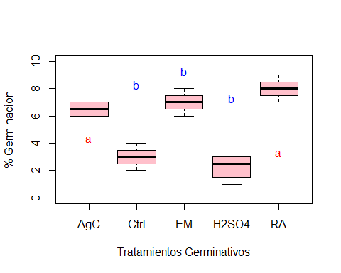

getwd()

## [1] "C:/Repositorio Gif/D-experimental/SCIPS"