LAB-5
1.MERGE SORT
#include <stdio.h>

void merge(int a[], int l, int m, int r) {
int i = l, j = m + 1, k = 0, b[100];
while (i <= m && j <= r) {
b[k++] = (a[i] < a[j]) ? a[i++] : a[j++];
}
while (i <= m) {
b[k++] = a[i++];
}
while (j <= r) {
b[k++] = a[j++];
}
for (i = 0; i < k; i++) {
a[l + i] = b[i];
}
}

void mergesort(int a[], int l, int r) {
if (l < r) {
int m = (l + r) / 2;
mergesort(a, l, m);
mergesort(a, m + 1, r);
merge(a, l, m, r);
}
}

int main() {
int a[] = {6, 9, 8, 11, 33};
int n = 5;
mergesort(a, 0, n - 1);
for (int i = 0; i < n; i++) {
printf("%d ", a[i]);
}
}

OUTPUT
6 8 9 11 33

2.BUCKET SORT
#include <stdio.h>

void bucketsort(int a[], int n) {
int bucket[100] = {0};
for (int i = 0; i < n; i++) {
bucket[a[i]]++;
}
for (int i = 0, k = 0; i < 100; i++) {
while (bucket[i]--) {
a[k++] = i;
}
}
}

int main() {
int a[] = {56, 23, 81, 15, 39, 24};
int n = 6;
bucketsort(a, n);
for (int i = 0; i < n; i++) {
printf("%d ", a[i]);
}
}

OUTPUT
15 23 24 39 56 81

3.QUICK SORT
#include <stdio.h>

void quicksort(int a[], int l, int r) {
if (l < r) {
int i = l, j = r, p = a[l], t;
while (i < j) {
while (a[i] <= p && i < r)
i++;
while (a[j] > p)
j--;
if (i < j) {
t = a[i];
a[i] = a[j];
a[j] = t;
}
}
a[l] = a[j];
a[j] = p;
quicksort(a, l, j - 1);
quicksort(a, j + 1, r);
}
}

int main() {
int a[] = {5, 12, 8, 11, 33};
int n = 5;
quicksort(a, 0, n - 1);
for (int i = 0; i < n; i++) {
printf("%d ", a[i]);
}
}

OUTPUT
5 8 11 12 33

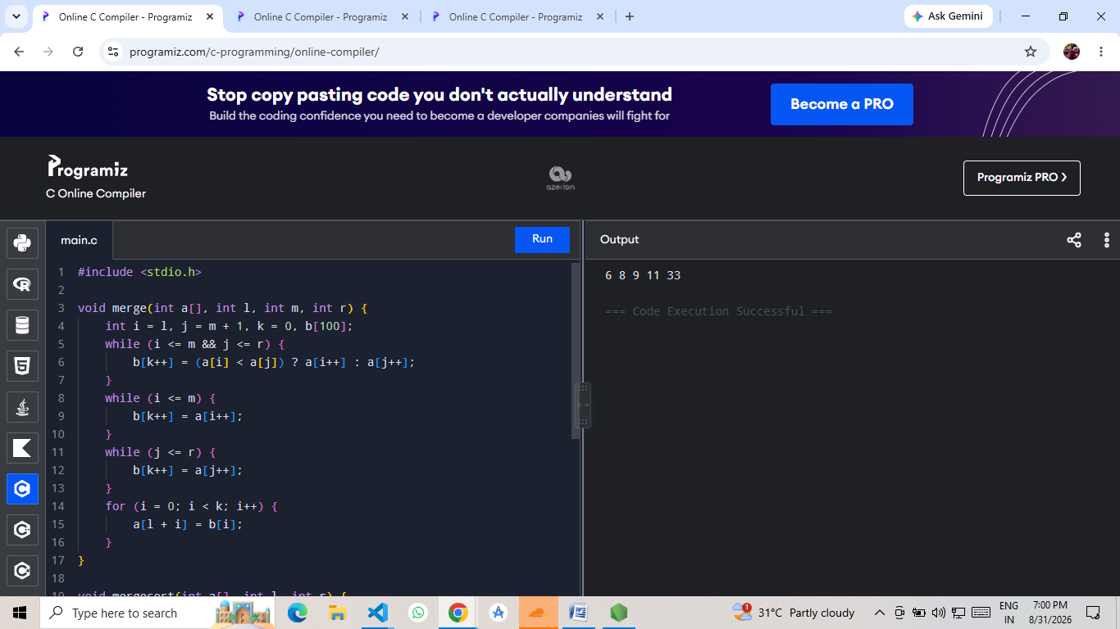
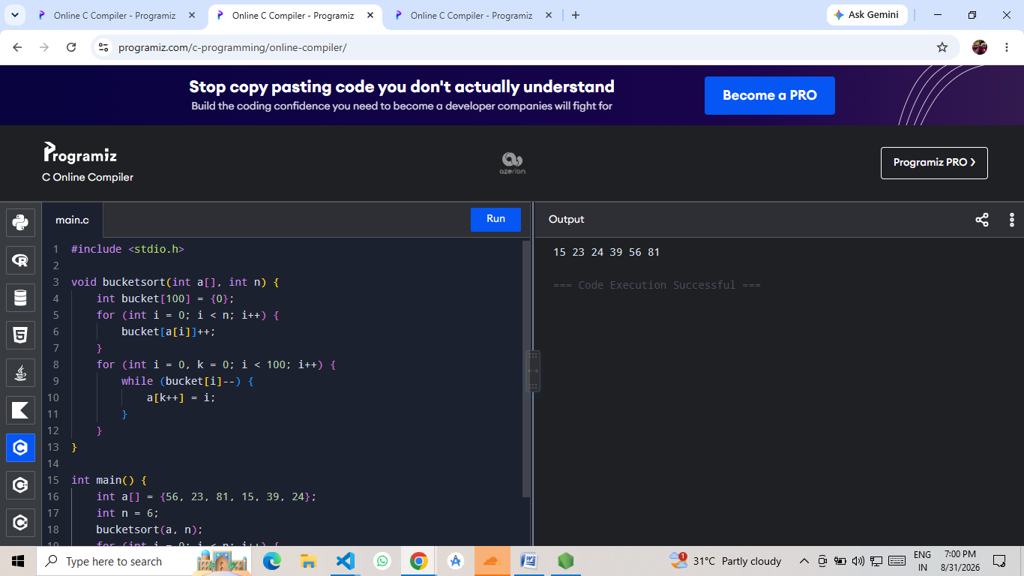
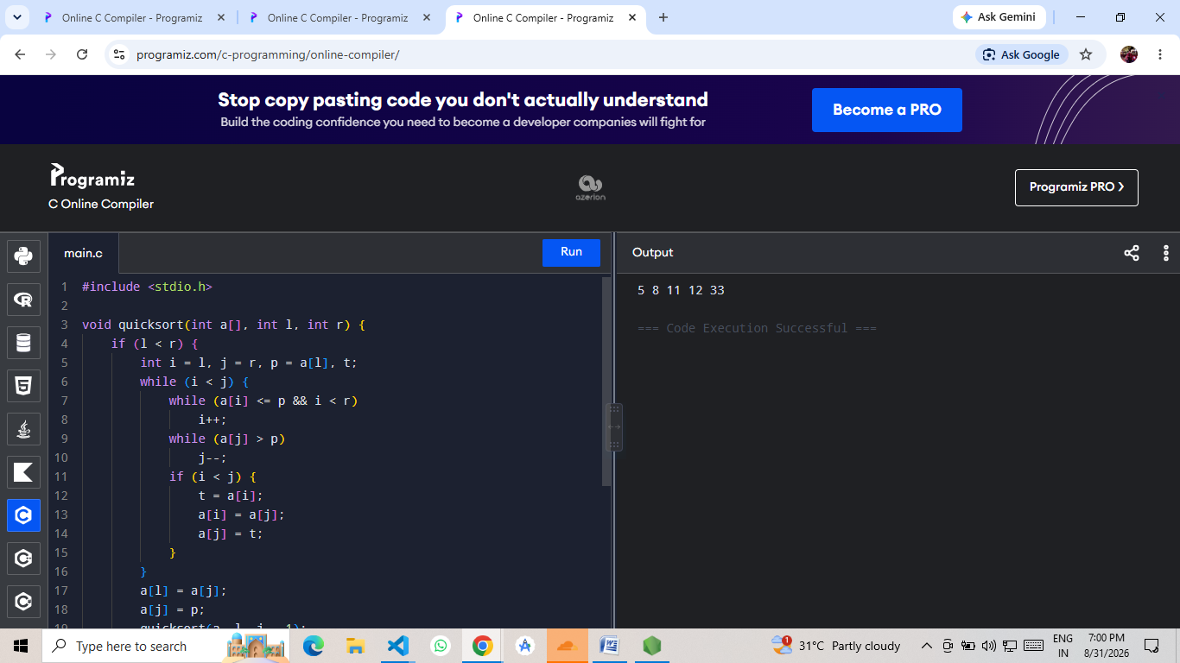

GITHUB: https://github.com/kathichetanreddy8106-ui/DESIGN-AND-ANALYSIS-OF-ALGORITHMS

