1.A TOWER_0F_HANOI_WITH_RECURSION
#include <stdio.h>
void TOH (int n, char a, char b, char c) {
if (n == 1) {
printf("move disk 1 from %c to %c\n", a, c);
return;
}
else {
TOH (n-1, a, c, b);
printf("move disk %d from %c to %c\n", n, a, c);
TOH (n-1, b, a, c);
}
}

int main () {
int x = 3;
TOH (x, 'A', 'B', 'C');
return 0;
}
1.B TOWER_0F_HANOI_WITHOUT_RECURSION
#include <stdio.h>
void move (char a, char b) {
printf("move from %c to %c\n", a, b);
}

int main () {
int n = 3;
int total = (1 << n) - 1;
char a = 'A', b = 'B', c = 'C', t;

if (n % 2 == 0) {
t = b;
b = c;
c = t;
}
for (int i = 1; i <= total; i++) {
if (i % 3 == 1) {
move (a, c);
}
else if (i % 3 == 2) {
move (a, b);
}
else if (i % 3 == 0) {
move (b, c);
}
}
return 0;
}
2. STACK_USING_LINKEDLIST
#include <stdio.h>
#include <stdlib.h>
struct Node {
int data;
struct Node *next;
};
struct Node *top = NULL;

void push (int x) {
struct Node *p = (struct Node *)malloc(sizeof(struct Node));
if (p == NULL) {
printf("stack overflow\n");
return;
}
p->data = x;
p->next = top;
top = p;
}

void pop () {
if (top == NULL) {
printf("underflow\n");
}
else {
struct Node *p = top;
printf("popped = %d\n", p->data);
top = top->next;
free (p);
}
}

void display () {
struct Node *p = top;
while (p) {
printf("%d -> ", p->data);
p = p->next;
}
printf("NULL\n");
}

int main () {
push (10);
push (20);
push (30);
pop ();
push (40);
push (50);
display ();
return 0;
}
3. QUEUE_USING_LINKEDLIST
#include <stdio.h>
#include <stdlib.h>
struct Node {
int data;
struct Node *next;
};
struct Node *f = NULL, *r = NULL;

void NQ (int x) {
struct Node *p = (struct Node *)malloc(sizeof(struct Node));
p->data = x;
p->next = NULL;
if (f == NULL) {
f = r = p;
}
else {
r->next = p;
r = p;
}
}

void DQ () {
if (f == NULL) {
printf("underflow\n");
}
else {
struct Node *p = f;
printf("DQ = %d\n", p->data);
f = f->next;
if (f == NULL) {
r = NULL;
}
free (p);
}
}

void display () {
struct Node *p = f;
while (p) {
printf("%d ", p->data);
p = p->next;
}
}

int main () {
NQ (10);
NQ (20);
NQ (30);
display ();
DQ ();
return 0;
}

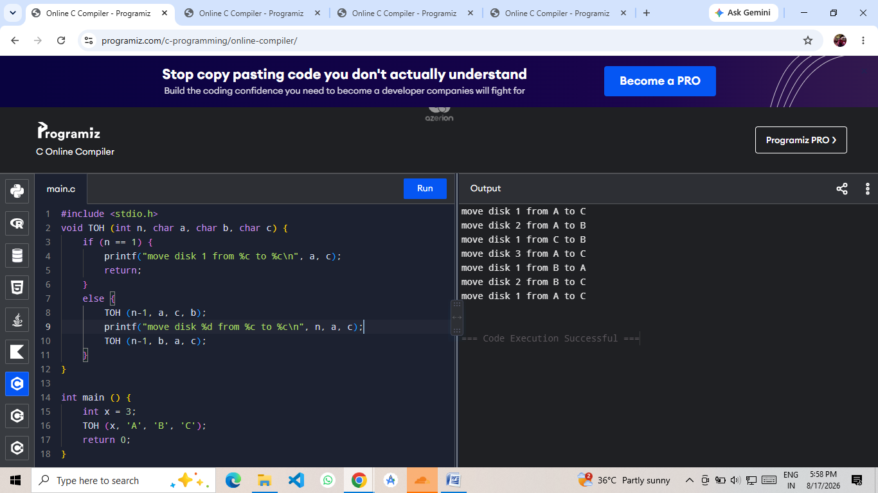
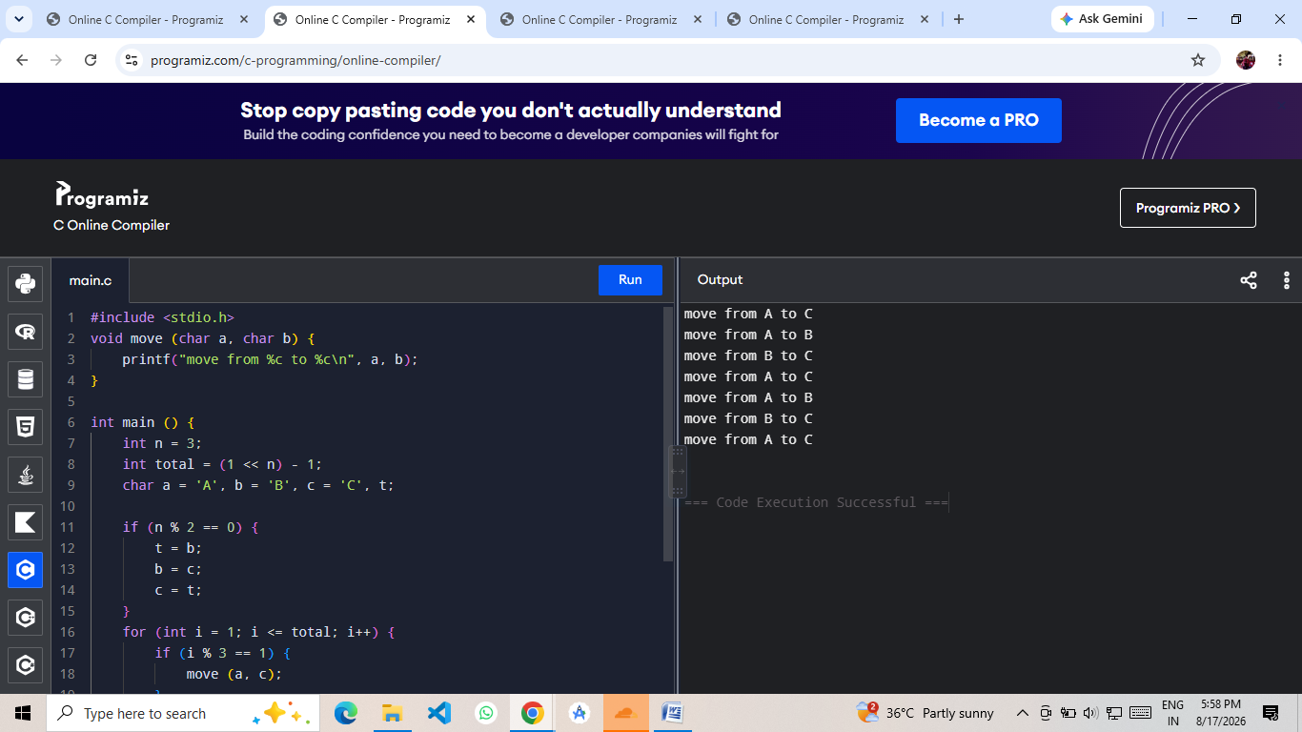
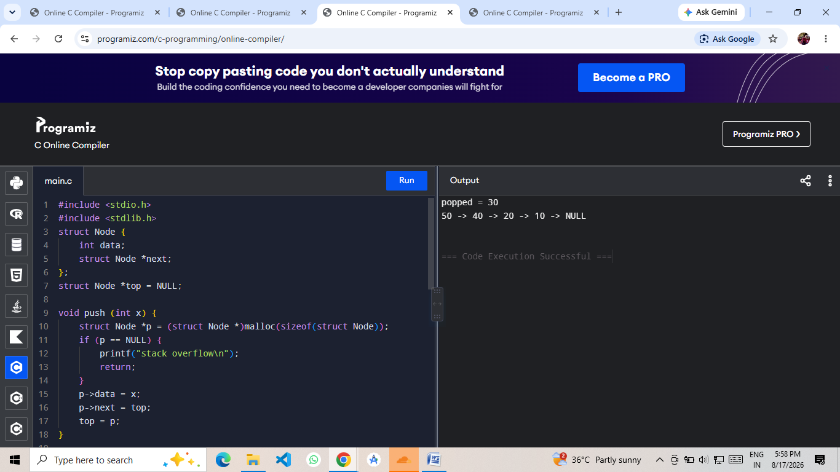
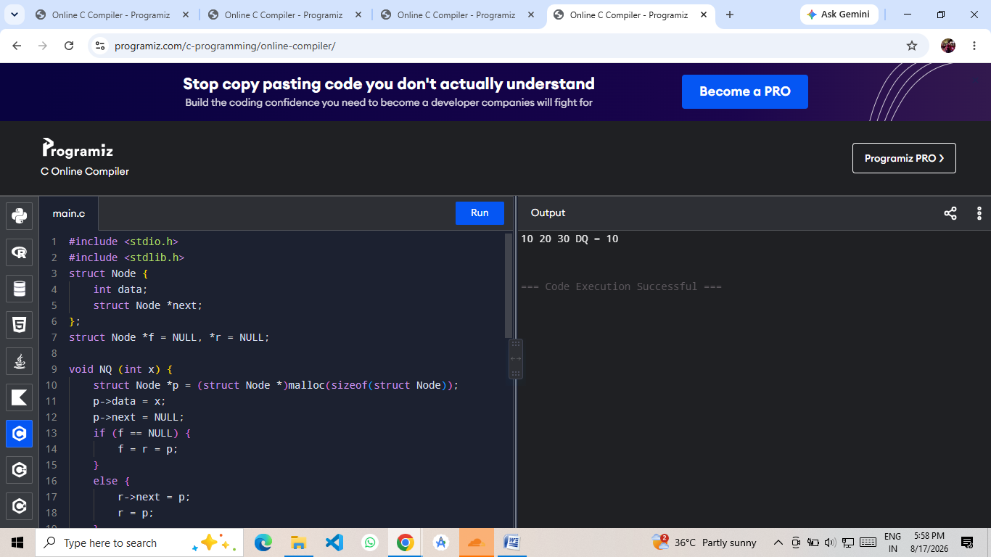

GITHUB : https://github.com/kathichetanreddy8106-ui/DESIGN-AND-ANALYSIS-OF-ALGORITHMS

