LAB-4
1.LINEAR PROBING
#include <stdio.h>
#define SIZE 10

int main() {
int h[SIZE], i, x, n, index;

for (i = 0; i < SIZE; i++)
h[i] = -1;

printf("enter number of elements = ");
scanf("%d", &n);

for (i = 0; i < n; i++) {
scanf("%d", &x);
index = x % SIZE;
while (h[index] != -1)
index = (index + 1) % SIZE;
h[index] = x;
}

for (i = 0; i < SIZE; i++)
printf("Index %d : %d\n", i, h[i]);

return 0;
}

OUTPUT
enter number of elements = 4
11 43 64 36
Index 0 : -1
Index 1 : 11
Index 2 : -1
Index 3 : 43
Index 4 : 64
Index 5 : -1
Index 6 : 36
Index 7 : -1
Index 8 : -1
Index 9 : -1

2.QUADRATIC PROBING
#include <stdio.h>
#define SIZE 10

int main() {
int h[SIZE], i, x, n, index, c;

for (i = 0; i < SIZE; i++)
h[i] = -1;

printf("enter number of elements = ");
scanf("%d", &n);

for (i = 0; i < n; i++) {
scanf("%d", &x);
c = 0;
do {
index = (x % SIZE + c * c) % SIZE;
c++;
} while (h[index] != -1);
h[index] = x;
}

for (i = 0; i < SIZE; i++)
printf("Index %d : %d\n", i, h[i]);

return 0;
}
OUTPUT
enter number of elements = 5
22 67 77 98 38
Index 0 : -1
Index 1 : -1
Index 2 : 22
Index 3 : -1
Index 4 : 38
Index 5 : -1
Index 6 : -1
Index 7 : 67
Index 8 : 77
Index 9 : 98
3.ARRAY AND TARGET VALUE
#include <stdio.h>
#define SIZE 100

int main() {
int a[SIZE], h[SIZE] = {0};
int n, T, i, x;

scanf("%d", &n);

for (i = 0; i < n; i++) {
scanf("%d", &a[i]);
}
scanf("%d", &T);

for (i = 0; i < n; i++) {
x = T - a[i];
if (x >= 0 && x < SIZE && h[x]) {
printf("yes");
return 0;
}
if (a[i] >= 0 && a[i] < SIZE) {
h[a[i]] = 1;
}
}

printf("No");
return 0;
}

OUTPUT
5
1 2 3 6 5
9
yes

4.FREQUENCY OF EVERY DISTINCT ELEMENT USING HASHING

#include <stdio.h>
#define SIZE 100

int main() {
int a[SIZE], h[SIZE] = {0};
int n, i;

scanf("%d", &n);

for (i = 0; i < n; i++) {
scanf("%d", &a[i]);
h[a[i]]++;
}

for (i = 0; i < SIZE; i++) {
if (h[i] > 0) {
printf("%d : %d\n", i, h[i]);
}
}

return 0;
}
OUTPUT
5
12 34 56 78 90
12 : 1
34 : 1
56 : 1
78 : 1
90 : 1

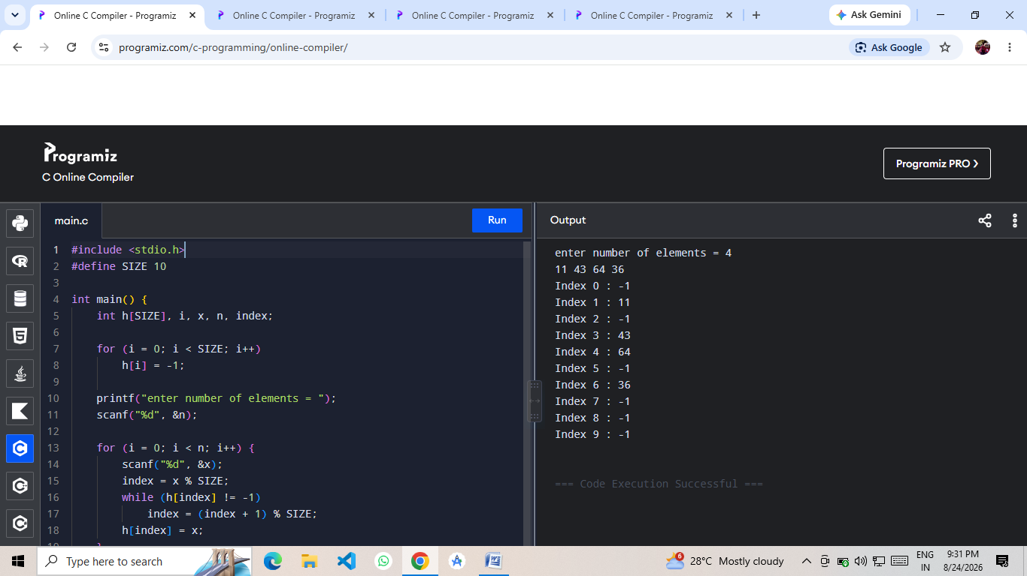
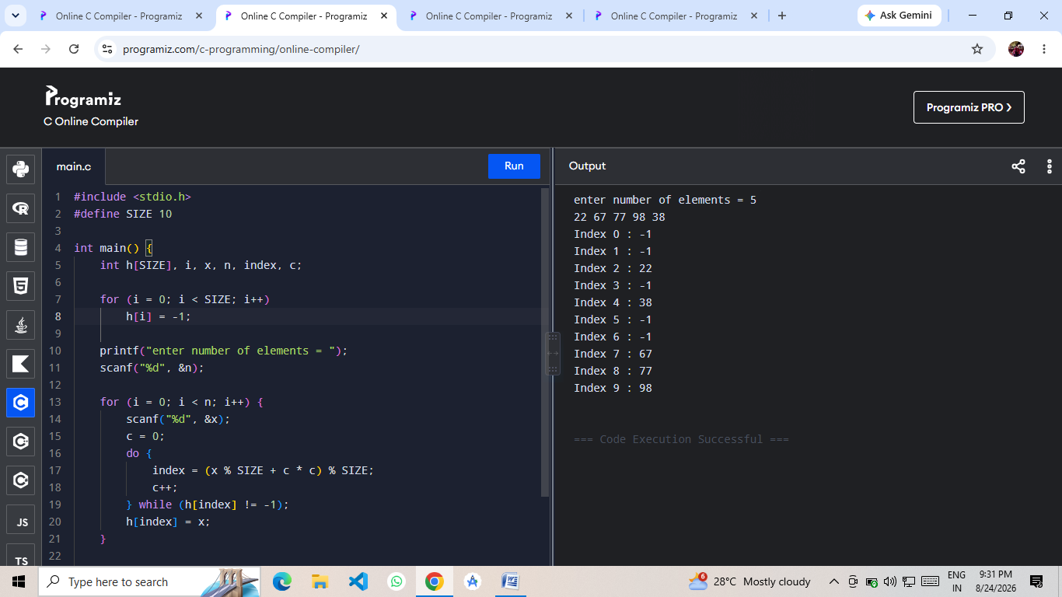

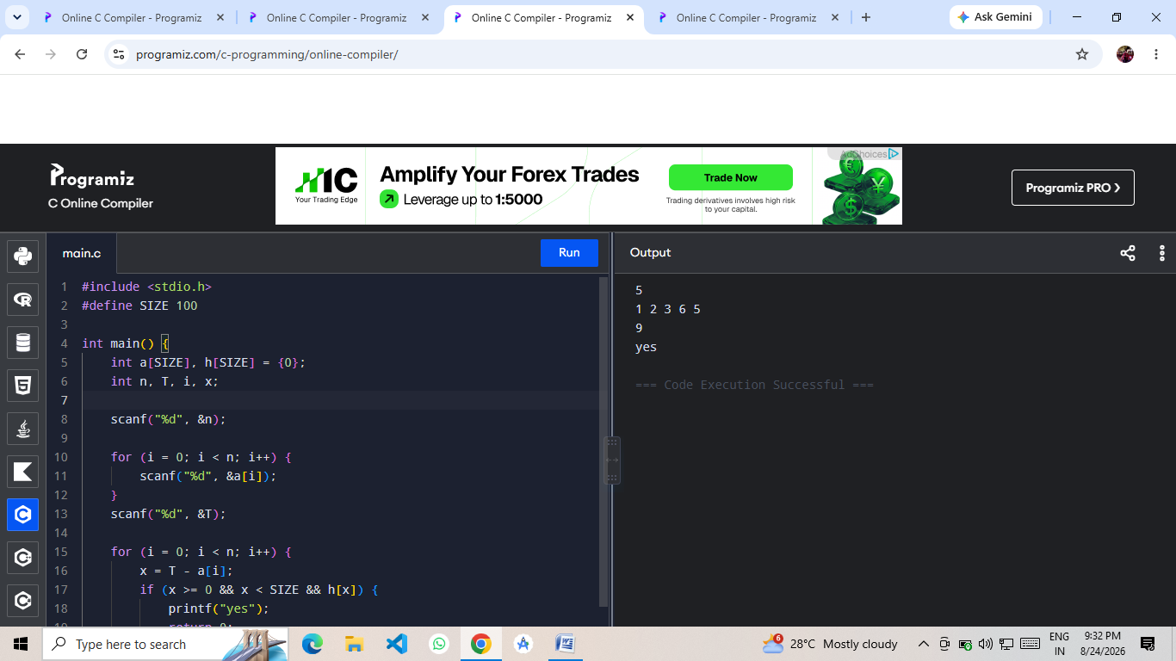
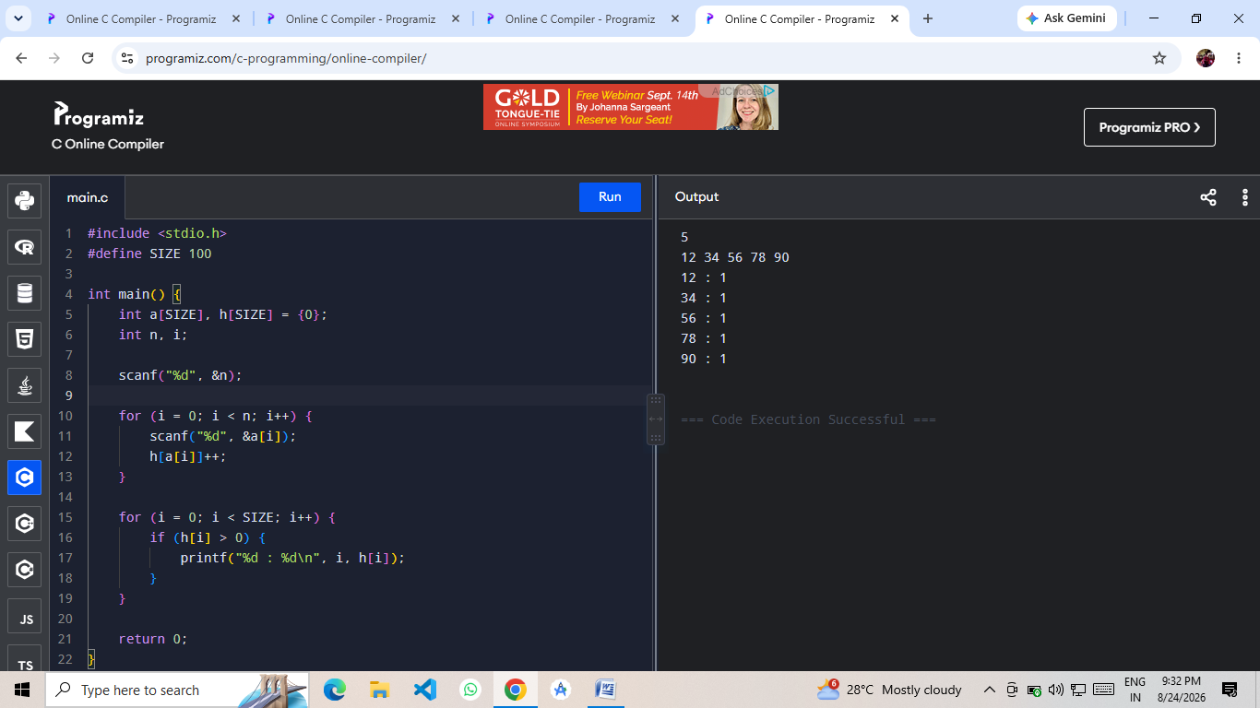

GITHUB : https://github.com/kathichetanreddy8106-ui/DESIGN-AND-ANALYSIS-OF-ALGORITHMS

