Analysis_birdsdata

Cheyenne, Kathina & Lina

4/7/2021

This document have been created to include all relevant parts in the analysis of our animal diversity project.

##Data preparation and data observation

The first code’s chunk will be used to load all libraries needed to proceed.

library(tidyverse)

## Warning: package 'tidyverse' was built under R version 4.0.5

## -- Attaching packages --------------------------------------- tidyverse 1.3.1 --

## v ggplot2 3.3.5 v purrr 0.3.4  
## v tibble 3.1.2 v dplyr 1.0.7  
## v tidyr 1.1.3 v stringr 1.4.0  
## v readr 2.0.1 v forcats 0.5.1

## Warning: package 'ggplot2' was built under R version 4.0.5

## Warning: package 'tibble' was built under R version 4.0.5

## Warning: package 'tidyr' was built under R version 4.0.5

## Warning: package 'readr' was built under R version 4.0.5

## Warning: package 'forcats' was built under R version 4.0.5

## -- Conflicts ------------------------------------------ tidyverse_conflicts() --  
## x dplyr::filter() masks stats::filter()  
## x dplyr::lag() masks stats::lag()

library(vegan)

## Warning: package 'vegan' was built under R version 4.0.4

## Loading required package: permute

## Loading required package: lattice

## This is vegan 2.5-7

library(nlme)

## Warning: package 'nlme' was built under R version 4.0.5

##   
## Attaching package: 'nlme'

## The following object is masked from 'package:dplyr':  
##   
## collapse

library(MASS)

## Warning: package 'MASS' was built under R version 4.0.5

##   
## Attaching package: 'MASS'

## The following object is masked from 'package:dplyr':  
##   
## select

library(MuMIn)

## Warning: package 'MuMIn' was built under R version 4.0.5

In this second chunk, the data to be used will be loaded into a data frame and transferred into adequate data types.

dat <- read.csv("data/birds_dataset.csv", sep=";")  
parks <- read.csv("data/parks.csv", sep=";")  
forest <- read.csv("data/forest.csv", sep=";")  
dat$category <- as.factor(dat$category)  
dat$site <- as.factor(dat$site)

Following, species richness, species abundance and rarefied richness of species will be calculated.

dat$species_richness <- specnumber(dat[,4:31]) #species richness  
dat$species_abund <- rowSums(dat[,4:31]) #abundances  
dat$rarefied_richness <- rarefy(dat[,4:31],min(dat$species_abund)) #rarefied richness based on the subsample with the lowest number of individuals  
  
dat$species_richnessparks <- specnumber(parks[,4:31]) #species richness  
dat$species_richnessforest <- specnumber(forest[,4:31]) #species richness

subsets for forest and park + median, mean, min max…

forest <- subset(dat, category=="forest")  
park <- subset(dat, category=="park")  
median(forest$species_abund)

## [1] 16

median(park$species_abund)

## [1] 24

After, data is observed comparing the plots from parks and forests.

hist(dat$species_richness) # not normally distributed

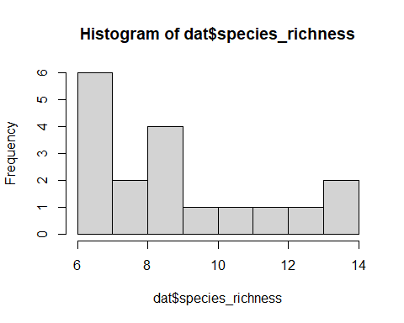

kruskal.test(dat$species_richness, dat$category) #p-value = 0.01533

##   
## Kruskal-Wallis rank sum test  
##   
## data: dat$species_richness and dat$category  
## Kruskal-Wallis chi-squared = 5.8783, df = 1, p-value = 0.01533

boxplot(species_richness~category, data=dat, xlab= "Category", ylab= "Observed species richness")  
text(1,13.6,labels = "p-value: 0.015", cex = 0.8)

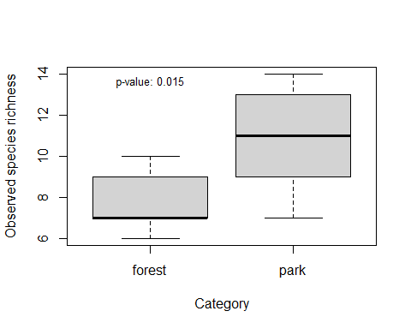

hist(dat$species_abund) # not normally distributed

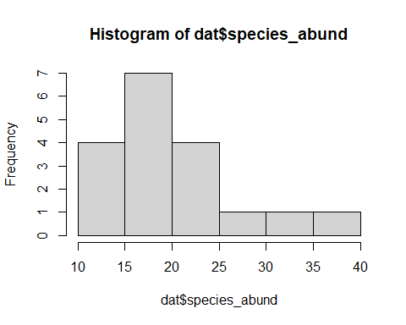

kruskal.test(dat$species_abund, dat$category) #p-value = 0.0046

##   
## Kruskal-Wallis rank sum test  
##   
## data: dat$species_abund and dat$category  
## Kruskal-Wallis chi-squared = 8.0175, df = 1, p-value = 0.004633

boxplot(log(species_abund)~category, data=dat, xlab= "Category", ylab= "Species abundance")  
text(1,3.53,labels = "p-value: 0.005", cex = 0.8)

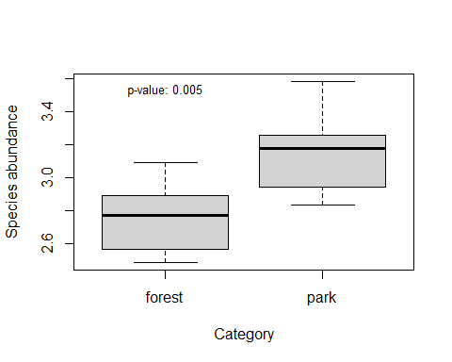

hist(dat$rarefied_richness) # normally distributed

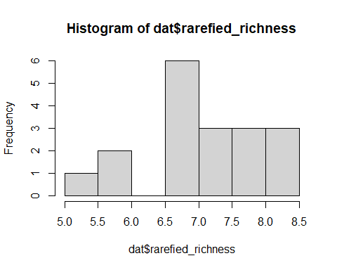

mod<-aov(dat$rarefied_richness ~ dat$category)  
summary(mod) #p-value: 0.291

## Df Sum Sq Mean Sq F value Pr(>F)  
## dat$category 1 0.941 0.9405 1.194 0.291  
## Residuals 16 12.605 0.7878

boxplot(rarefied_richness~category, data=dat, xlab= "Category", ylab= "Rarefied richness")  
text(1,5.5,labels = "p-value: 0.291", cex = 0.8)

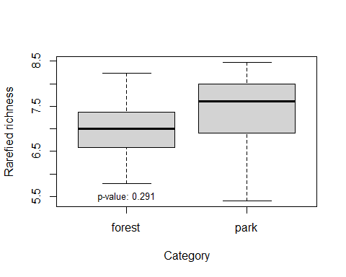

hist(dat$species_richnessparks)

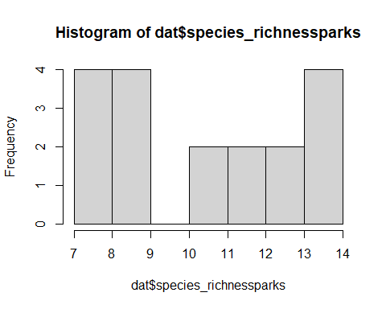

hist(dat$species_richnessforest)

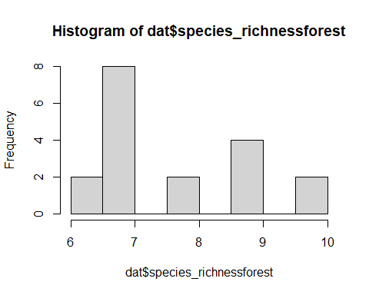

layout(matrix(c(1:4), nrow=2, byrow=FALSE))  
boxplot(species_richness~category, data=dat, xlab= "Category", ylab= "Species richness")  
boxplot(log(species_abund+1)~category, data=dat, xlab= "Category", ylab= "Species abundance")  
?boxplot

## starting httpd help server ... done

boxplot(rarefied_richness~category, data=dat, xlab= "Category", ylab= "Rarefied richness")  
layout(matrix(c(1:4), nrow=2, byrow=FALSE))

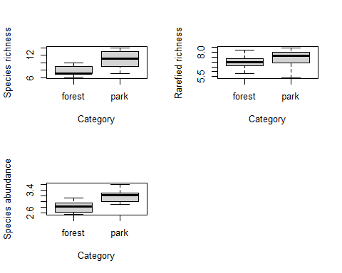

boxplot(species_richness~category, data=dat, xlab= "Category", ylab= "Species richness", col= c("lightgreen", "lightblue"))  
boxplot(log(species_abund+1)~category, data=dat, xlab= "Category", ylab= "Species abundance", col= c("lightgreen", "lightblue"))  
?boxplot  
boxplot(rarefied_richness~category, data=dat, xlab= "Category", ylab= "Rarefied richness", col= c("lightgreen", "lightblue"))

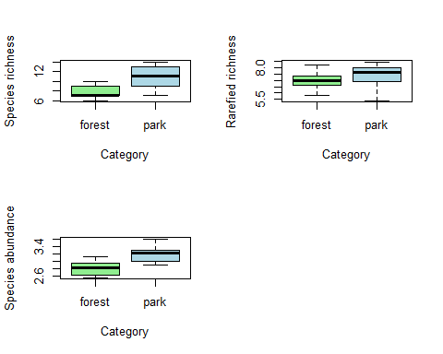

boxplot(species_richness~category, data=dat, xlab= "Category", ylab= "Species richness")

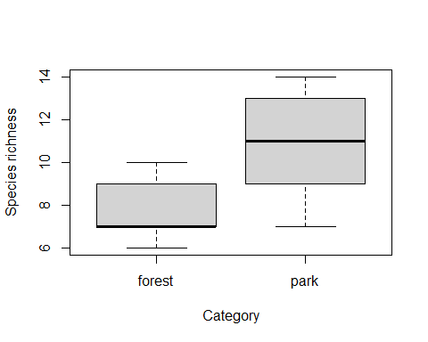

boxplot(log(species_abund+1)~category, data=dat, xlab= "Category", ylab= "Species abundance")

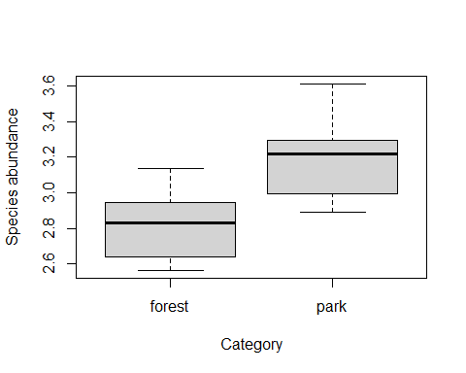

?boxplot  
boxplot(rarefied_richness~category, data=dat, xlab= "Category", ylab= "Rarefied richness")

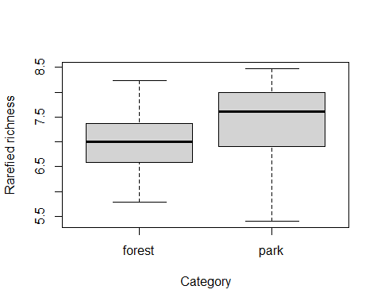

boxplot(species_richness~category, data=dat, xlab= "Category", ylab= "Species richness", col= c("lightgreen", "lightblue"))

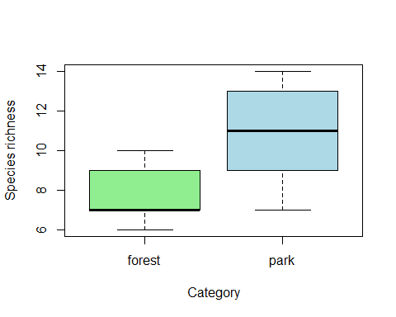

boxplot(log(species_abund+1)~category, data=dat, xlab= "Category", ylab= "Species abundance", col= c("lightgreen", "lightblue"))

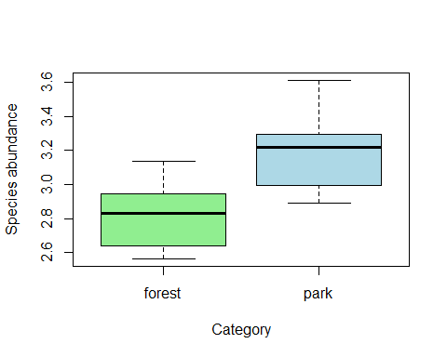

?boxplot  
boxplot(rarefied_richness~category, data=dat, xlab= "Category", ylab= "Rarefied richness", col= c("lightgreen", "lightblue"))

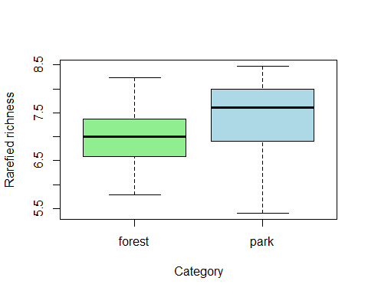

##Now let’s begin with the data analysis

#2a linear models: to check for difference between habitat types with the implementation of mixed effect models.

mod1 <- lme(species_richness~category, random = (~1|site), data=dat) #model structure, random=... specifies how the data are structured (subsamples nested in study site)  
summary(mod1) #model output - important is the "fixed effects" part. Here "forest" is hiding in the "Intercept" and the categorypark-row is showing the difference between park and forest

## Linear mixed-effects model fit by REML  
## Data: dat   
## AIC BIC logLik  
## 78.65584 81.7462 -35.32792  
##   
## Random effects:  
## Formula: ~1 | site  
## (Intercept) Residual  
## StdDev: 1.459325 1.649916  
##   
## Fixed effects: species_richness ~ category   
## Value Std.Error DF t-value p-value  
## (Intercept) 7.777778 1.006154 12 7.730207 0.0000  
## categorypark 3.000000 1.422916 4 2.108346 0.1027  
## Correlation:   
## (Intr)  
## categorypark -0.707  
##   
## Standardized Within-Group Residuals:  
## Min Q1 Med Q3 Max   
## -1.5969444 -0.5205776 -0.1919700 0.8175666 1.4335132   
##   
## Number of Observations: 18  
## Number of Groups: 6

plot(mod1) #check for homogeneity of variances (data points should have similar vertical spread along the x-axis)

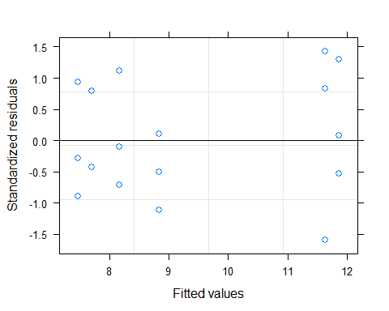

qqnorm(mod1, ~resid(.,type="p"), abline = c(0,1)) #check for normality of residuals (should not be completely off the line)

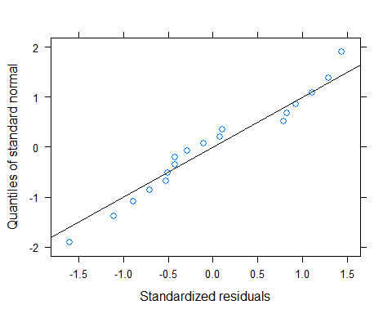

#2b linear models to include environmental variables and see the variation of the data with each of them.

### MIXED EFFECTS MODEL WITH SPECIES RICHNESS  
  
round(cor(dat[,32:45]),2) #check which predictor variables are strongly correlated (below -0.7 or above 0.7) - highly correlated variables should not be included together in the same model (select only one of them, e.g. the one more strongly related to the response variable)

## canopy_cover n_tree_spec n_tree_ind dbh_min dbh_min5 dbh_mean  
## canopy_cover 1.00 -0.68 0.22 -0.43 -0.38 -0.42  
## n_tree_spec -0.68 1.00 -0.42 0.30 0.18 0.31  
## n_tree_ind 0.22 -0.42 1.00 -0.12 -0.51 -0.49  
## dbh_min -0.43 0.30 -0.12 1.00 0.37 0.68  
## dbh_min5 -0.38 0.18 -0.51 0.37 1.00 0.71  
## dbh_mean -0.42 0.31 -0.49 0.68 0.71 1.00  
## dbh_max -0.33 0.23 -0.52 0.26 0.57 0.83  
## dbh_median -0.29 0.29 -0.56 0.30 0.89 0.74  
## dbh_sd -0.69 0.78 -0.63 0.09 0.39 0.36  
## n_microhabitats 0.30 -0.42 -0.12 -0.06 0.44 0.27  
## latitude 0.30 -0.60 0.22 -0.23 0.04 -0.08  
## longitude 0.71 -0.64 0.32 -0.57 -0.50 -0.42  
## size 0.64 -0.52 0.35 -0.33 -0.55 -0.52  
## temperature -0.02 0.03 0.44 -0.29 -0.49 -0.26  
## dbh_max dbh_median dbh_sd n_microhabitats latitude longitude  
## canopy_cover -0.33 -0.29 -0.69 0.30 0.30 0.71  
## n_tree_spec 0.23 0.29 0.78 -0.42 -0.60 -0.64  
## n_tree_ind -0.52 -0.56 -0.63 -0.12 0.22 0.32  
## dbh_min 0.26 0.30 0.09 -0.06 -0.23 -0.57  
## dbh_min5 0.57 0.89 0.39 0.44 0.04 -0.50  
## dbh_mean 0.83 0.74 0.36 0.27 -0.08 -0.42  
## dbh_max 1.00 0.57 0.47 0.14 0.03 -0.19  
## dbh_median 0.57 1.00 0.44 0.49 -0.06 -0.39  
## dbh_sd 0.47 0.44 1.00 -0.32 -0.40 -0.58  
## n_microhabitats 0.14 0.49 -0.32 1.00 0.30 0.21  
## latitude 0.03 -0.06 -0.40 0.30 1.00 0.14  
## longitude -0.19 -0.39 -0.58 0.21 0.14 1.00  
## size -0.52 -0.48 -0.61 0.22 -0.09 0.80  
## temperature -0.06 -0.38 -0.02 -0.45 0.05 0.23  
## size temperature  
## canopy_cover 0.64 -0.02  
## n_tree_spec -0.52 0.03  
## n_tree_ind 0.35 0.44  
## dbh_min -0.33 -0.29  
## dbh_min5 -0.55 -0.49  
## dbh_mean -0.52 -0.26  
## dbh_max -0.52 -0.06  
## dbh_median -0.48 -0.38  
## dbh_sd -0.61 -0.02  
## n_microhabitats 0.22 -0.45  
## latitude -0.09 0.05  
## longitude 0.80 0.23  
## size 1.00 -0.07  
## temperature -0.07 1.00

mod1 <- lme(species_richness ~ category*size + canopy_cover + n_tree_spec + n_tree_ind + log(dbh_min) + dbh_min5 + n_microhabitats + temperature, random = (~1|site), data=dat, method="ML") #initial, full model with all potential predictor variables  
summary(mod1)

## Linear mixed-effects model fit by maximum likelihood  
## Data: dat   
## AIC BIC logLik  
## 79.34161 90.91644 -26.6708  
##   
## Random effects:  
## Formula: ~1 | site  
## (Intercept) Residual  
## StdDev: 4.101158e-05 1.064785  
##   
## Fixed effects: species_richness ~ category * size + canopy_cover + n_tree_spec + n_tree_ind + log(dbh_min) + dbh_min5 + n_microhabitats + temperature   
## Value Std.Error DF t-value p-value  
## (Intercept) 13.449991 5.833096 6 2.3058067 0.0606  
## categorypark 0.925977 3.442663 1 0.2689712 0.8327  
## size -0.004229 0.011728 1 -0.3606218 0.7797  
## canopy_cover -0.042049 0.027271 6 -1.5418946 0.1740  
## n_tree_spec -0.372451 0.390288 6 -0.9542969 0.3768  
## n_tree_ind -0.015531 0.161447 6 -0.0961977 0.9265  
## log(dbh_min) 1.622178 0.851637 6 1.9047752 0.1055  
## dbh_min5 -0.051502 0.070771 6 -0.7277286 0.4942  
## n_microhabitats 0.029756 0.114604 6 0.2596375 0.8038  
## temperature -0.201717 0.171316 1 -1.1774589 0.4482  
## categorypark:size 0.004324 0.062229 1 0.0694820 0.9558  
## Correlation:   
## (Intr) ctgryp size cnpy_c n_tr_s n_tr_n lg(d_) dbh_m5  
## categorypark -0.139   
## size -0.306 0.593   
## canopy_cover -0.552 0.312 0.025   
## n_tree_spec -0.447 -0.589 -0.291 0.096   
## n_tree_ind -0.481 0.067 -0.027 0.134 0.430   
## log(dbh_min) -0.401 -0.217 -0.125 0.033 0.261 0.049   
## dbh_min5 -0.169 -0.578 0.013 -0.050 0.412 0.135 -0.207   
## n_microhabitats -0.099 0.425 0.029 0.093 -0.257 -0.176 0.020 -0.663  
## temperature -0.335 0.142 0.333 0.151 -0.282 -0.499 0.074 0.045  
## categorypark:size 0.200 0.045 0.019 0.163 -0.424 -0.503 -0.438 0.032  
## n_mcrh tmprtr  
## categorypark   
## size   
## canopy_cover   
## n_tree_spec   
## n_tree_ind   
## log(dbh_min)   
## dbh_min5   
## n_microhabitats   
## temperature 0.328   
## categorypark:size 0.299 0.468  
##   
## Standardized Within-Group Residuals:  
## Min Q1 Med Q3 Max   
## -1.4774299 -0.8641612 -0.1156606 0.4119055 2.3217607   
##   
## Number of Observations: 18  
## Number of Groups: 6

mod1.1 <- stepAIC(mod1) #model simplification based on AIC-value of the model

## Start: AIC=79.34  
## species_richness ~ category * size + canopy_cover + n_tree_spec +   
## n_tree_ind + log(dbh_min) + dbh_min5 + n_microhabitats +   
## temperature  
##   
## Df AIC  
## - category:size 1 77.354  
## - n_tree_ind 1 77.365  
## - n_microhabitats 1 77.514  
## - dbh_min5 1 78.654  
## <none> 79.342  
## - n_tree_spec 1 79.543  
## - temperature 1 80.594  
## - canopy_cover 1 82.605  
## - log(dbh_min) 1 84.858  
##   
## Step: AIC=77.35  
## species_richness ~ category + size + canopy_cover + n_tree_spec +   
## n_tree_ind + log(dbh_min) + dbh_min5 + n_microhabitats +   
## temperature  
##   
## Df AIC  
## - n_tree_ind 1 75.367  
## - n_microhabitats 1 75.514  
## - category 1 75.535  
## - size 1 75.688  
## - dbh_min5 1 76.675  
## <none> 77.354  
## - n_tree_spec 1 77.852  
## - temperature 1 79.622  
## - canopy_cover 1 80.806  
## - log(dbh_min) 1 84.496  
##   
## Step: AIC=75.37  
## species_richness ~ category + size + canopy_cover + n_tree_spec +   
## log(dbh_min) + dbh_min5 + n_microhabitats + temperature  
##   
## Df AIC  
## - n_microhabitats 1 73.524  
## - category 1 73.560  
## - size 1 73.703  
## - dbh_min5 1 74.683  
## <none> 75.367  
## - n_tree_spec 1 75.961  
## - temperature 1 78.287  
## - canopy_cover 1 79.003  
## - log(dbh_min) 1 82.760  
##   
## Step: AIC=73.52  
## species_richness ~ category + size + canopy_cover + n_tree_spec +   
## log(dbh_min) + dbh_min5 + temperature  
##   
## Df AIC  
## - category 1 71.611  
## - size 1 71.869  
## - dbh_min5 1 73.033  
## <none> 73.524  
## - n_tree_spec 1 73.980  
## - temperature 1 76.975  
## - canopy_cover 1 77.237  
## - log(dbh_min) 1 80.787  
##   
## Step: AIC=71.61  
## species_richness ~ size + canopy_cover + n_tree_spec + log(dbh_min) +   
## dbh_min5 + temperature  
##   
## Df AIC  
## - size 1 70.645  
## - dbh_min5 1 71.139  
## <none> 71.611  
## - n_tree_spec 1 72.982  
## - temperature 1 75.195  
## - canopy_cover 1 76.107  
## - log(dbh_min) 1 80.025  
##   
## Step: AIC=70.65  
## species_richness ~ canopy_cover + n_tree_spec + log(dbh_min) +   
## dbh_min5 + temperature  
##   
## Df AIC  
## - dbh_min5 1 69.299  
## <none> 70.645  
## - n_tree_spec 1 71.260  
## - temperature 1 73.198  
## - canopy_cover 1 76.119  
## - log(dbh_min) 1 79.032  
##   
## Step: AIC=69.3  
## species_richness ~ canopy_cover + n_tree_spec + log(dbh_min) +   
## temperature  
##   
## Df AIC  
## <none> 69.299  
## - n_tree_spec 1 69.688  
## - temperature 1 71.200  
## - canopy_cover 1 74.131  
## - log(dbh_min) 1 77.308

summary(mod1.1) #final model which includes only the most important predictors

## Linear mixed-effects model fit by maximum likelihood  
## Data: dat   
## AIC BIC logLik  
## 69.29947 75.53207 -27.64974  
##   
## Random effects:  
## Formula: ~1 | site  
## (Intercept) Residual  
## StdDev: 2.762129e-05 1.124297  
##   
## Fixed effects: species_richness ~ canopy_cover + n_tree_spec + log(dbh_min) + temperature   
## Value Std.Error DF t-value p-value  
## (Intercept) 11.366118 3.314519 9 3.429190 0.0075  
## canopy_cover -0.044574 0.018196 9 -2.449668 0.0368  
## n_tree_spec -0.241219 0.177235 9 -1.361014 0.2066  
## log(dbh_min) 1.542315 0.496008 9 3.109455 0.0125  
## temperature -0.160682 0.090601 4 -1.773506 0.1508  
## Correlation:   
## (Intr) cnpy_c n_tr_s lg(d_)  
## canopy_cover -0.791   
## n_tree_spec -0.495 0.595   
## log(dbh_min) -0.759 0.467 -0.013   
## temperature -0.681 0.241 -0.024 0.519  
##   
## Standardized Within-Group Residuals:  
## Min Q1 Med Q3 Max   
## -1.67276372 -0.80102592 -0.08660587 0.68432847 2.15093491   
##   
## Number of Observations: 18  
## Number of Groups: 6

mod1.2 <- update(mod1.1, ~.-n_tree_spec)  
summary(mod1.2)

## Linear mixed-effects model fit by maximum likelihood  
## Data: dat   
## AIC BIC logLik  
## 69.68834 75.03057 -28.84417  
##   
## Random effects:  
## Formula: ~1 | site  
## (Intercept) Residual  
## StdDev: 0.1799486 1.188182  
##   
## Fixed effects: species_richness ~ canopy_cover + log(dbh_min) + temperature   
## Value Std.Error DF t-value p-value  
## (Intercept) 9.140053 2.9508347 10 3.097447 0.0113  
## canopy_cover -0.029890 0.0150141 10 -1.990770 0.0745  
## log(dbh_min) 1.532576 0.5067240 10 3.024479 0.0128  
## temperature -0.163764 0.0945977 4 -1.731167 0.1585  
## Correlation:   
## (Intr) cnpy_c lg(d_)  
## canopy_cover -0.700   
## log(dbh_min) -0.875 0.574   
## temperature -0.797 0.303 0.507  
##   
## Standardized Within-Group Residuals:  
## Min Q1 Med Q3 Max   
## -1.47877950 -0.81708368 0.01400286 0.42067808 2.51962252   
##   
## Number of Observations: 18  
## Number of Groups: 6

anova(mod1.1, mod1.2)

## Model df AIC BIC logLik Test L.Ratio p-value  
## mod1.1 1 7 69.29947 75.53207 -27.64973   
## mod1.2 2 6 69.68834 75.03057 -28.84417 1 vs 2 2.38887 0.1222

mod1.3 <- update(mod1.2, ~.-temperature)  
summary(mod1.3)

## Linear mixed-effects model fit by maximum likelihood  
## Data: dat   
## AIC BIC logLik  
## 70.90548 75.35733 -30.45274  
##   
## Random effects:  
## Formula: ~1 | site  
## (Intercept) Residual  
## StdDev: 0.550221 1.212528  
##   
## Fixed effects: species_richness ~ canopy_cover + log(dbh_min)   
## Value Std.Error DF t-value p-value  
## (Intercept) 5.562682 1.8467347 10 3.012172 0.0131  
## canopy_cover -0.025139 0.0152642 10 -1.646896 0.1306  
## log(dbh_min) 1.862918 0.4588731 10 4.059768 0.0023  
## Correlation:   
## (Intr) cnpy_c  
## canopy_cover -0.756   
## log(dbh_min) -0.882 0.427  
##   
## Standardized Within-Group Residuals:  
## Min Q1 Med Q3 Max   
## -1.6480211 -0.6031499 -0.2136438 0.7787394 1.8252090   
##   
## Number of Observations: 18  
## Number of Groups: 6

anova(mod1.2, mod1.3) #close to significcance effect with these variables (species increasing with increasing dbh min.)

## Model df AIC BIC logLik Test L.Ratio p-value  
## mod1.2 1 6 69.68834 75.03057 -28.84417   
## mod1.3 2 5 70.90548 75.35733 -30.45274 1 vs 2 3.217136 0.0729

mod1.4 <- update(mod1.3, ~.-canopy_cover)  
summary(mod1.4)

## Linear mixed-effects model fit by maximum likelihood  
## Data: dat   
## AIC BIC logLik  
## 71.50383 75.06532 -31.75191  
##   
## Random effects:  
## Formula: ~1 | site  
## (Intercept) Residual  
## StdDev: 0.0001335345 1.41207  
##   
## Fixed effects: species_richness ~ log(dbh_min)   
## Value Std.Error DF t-value p-value  
## (Intercept) 2.833014 1.1783306 11 2.404261 0.0350  
## log(dbh_min) 2.342352 0.4085936 11 5.732719 0.0001  
## Correlation:   
## (Intr)  
## log(dbh_min) -0.954  
##   
## Standardized Within-Group Residuals:  
## Min Q1 Med Q3 Max   
## -2.06423425 -0.69965226 0.06165372 0.63232038 1.83834164   
##   
## Number of Observations: 18  
## Number of Groups: 6

anova(mod1.3,mod1.4)

## Model df AIC BIC logLik Test L.Ratio p-value  
## mod1.3 1 5 70.90548 75.35733 -30.45274   
## mod1.4 2 4 71.50383 75.06532 -31.75191 1 vs 2 2.598353 0.107

#final model:  
#lme(species_richness ~ log(dbh_min), random = (~1|site), data=dat, method="ML")  
#https://jonlefcheck.net/2013/03/13/r2-for-linear-mixed-effects-models/  
r.squaredGLMM(mod1.4)

## Warning: 'r.squaredGLMM' now calculates a revised statistic. See the help page.

## R2m R2c  
## [1,] 0.6850223 0.6850223

plot(mod1.4) #check for homogeneity of variances (data points should have similar vertical spread along the x-axis)

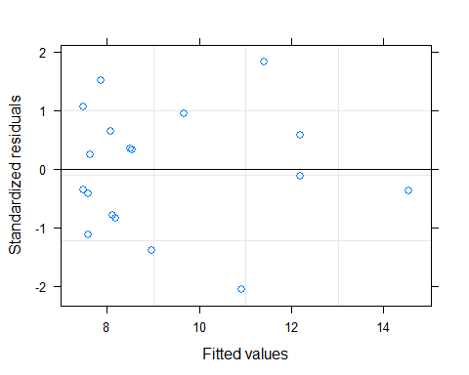

qqnorm(mod1.4, ~resid(.,type="p"), abline=c(0,1)) #check for normality of residuals (should not be completely off the line)

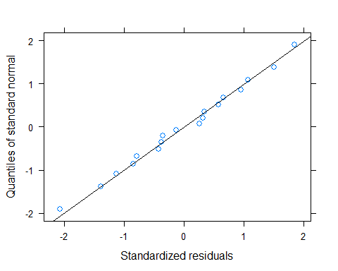

#standard deviation, coefficient of variation (sd/mean) to make variation independent from out mean value of dbh_mean in this case, and check whether is correlated with the other variables and if this is the case we would need to include it in mod2 and check correlation with (vif for the model) and cor for correlation  
  
#dat$sddbh_mean <- sd() we can try as alternative  
library(car)

## Warning: package 'car' was built under R version 4.0.5

## Loading required package: carData

##   
## Attaching package: 'car'

## The following object is masked from 'package:dplyr':  
##   
## recode

## The following object is masked from 'package:purrr':  
##   
## some

vif(mod1.2)

## canopy_cover log(dbh_min) temperature   
## 1.492654 1.824734 1.346892

ggplot(dat, aes(x = log(dbh_min), y = species_richness))+  
 geom_point() +  
 geom_smooth(method = lm,se = TRUE, colour = 'green', size = 1.5) +  
 geom_text(x=2.6, y=16, label="p-value: 0.0001", size=3.5) +  
 geom_text(x=2.51,y=15.3,label=expression(paste("R"^2,"c: 0.6851")), size=3.5) +  
 labs(x="log(mininmal dbh [cm])", y="observed species richness")

## `geom_smooth()` using formula 'y ~ x'

## Warning in is.na(x): is.na() aplicado a un objeto que no es (lista o vector) de  
## tipo 'expression

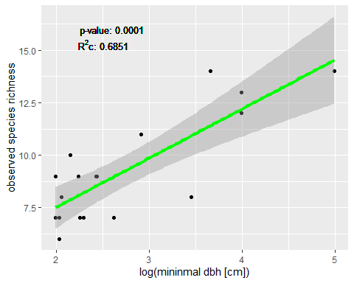

#2c Linear Mixed Effect models

### MIXED EFFECTS MODEL WITH BIRD ABUNDANCE  
mod2.1 <- lme(species_abund ~ category*size + canopy_cover + n_tree_spec + n_tree_ind + log(dbh_min) + dbh_min5 + log(n_microhabitats) + temperature, random = (~1|site), data=dat, method="ML") #initial, full model with all potential predictor variables  
summary(mod2.1)

## Linear mixed-effects model fit by maximum likelihood  
## Data: dat   
## AIC BIC logLik  
## 110.9826 122.5575 -42.49131  
##   
## Random effects:  
## Formula: ~1 | site  
## (Intercept) Residual  
## StdDev: 5.575945e-05 2.564311  
##   
## Fixed effects: species_abund ~ category * size + canopy_cover + n_tree_spec + n_tree_ind + log(dbh_min) + dbh_min5 + log(n_microhabitats) + temperature   
## Value Std.Error DF t-value p-value  
## (Intercept) 18.087181 17.052295 6 1.0606890 0.3296  
## categorypark 1.639039 8.730317 1 0.1877410 0.8819  
## size -0.018921 0.028943 1 -0.6537125 0.6314  
## canopy_cover -0.092920 0.069269 6 -1.3414462 0.2283  
## n_tree_spec -0.246951 0.918143 6 -0.2689682 0.7970  
## n_tree_ind 0.022661 0.386631 6 0.0586127 0.9552  
## log(dbh_min) 2.407254 2.053033 6 1.1725356 0.2854  
## dbh_min5 0.047614 0.138542 6 0.3436810 0.7428  
## log(n_microhabitats) 2.742905 2.485440 6 1.1035893 0.3121  
## temperature -0.208719 0.485090 1 -0.4302687 0.7413  
## categorypark:size -0.005155 0.182488 1 -0.0282467 0.9820  
## Correlation:   
## (Intr) ctgryp size cnpy_c n_tr_s n_tr_n lg(d_) dbh_m5  
## categorypark -0.369   
## size -0.369 0.650   
## canopy_cover -0.613 0.414 0.094   
## n_tree_spec -0.314 -0.541 -0.315 0.068   
## n_tree_ind -0.332 0.063 -0.053 0.097 0.417   
## log(dbh_min) -0.301 -0.239 -0.133 0.014 0.279 0.059   
## dbh_min5 -0.014 -0.545 -0.047 -0.115 0.361 0.077 -0.219   
## log(n_microhabitats) -0.573 0.511 0.220 0.330 -0.146 -0.141 -0.049 -0.390  
## temperature -0.553 0.306 0.399 0.293 -0.259 -0.461 0.028 0.042  
## categorypark:size -0.200 0.254 0.145 0.310 -0.383 -0.460 -0.395 -0.010  
## lg(n_) tmprtr  
## categorypark   
## size   
## canopy_cover   
## n_tree_spec   
## n_tree_ind   
## log(dbh_min)   
## dbh_min5   
## log(n_microhabitats)   
## temperature 0.595   
## categorypark:size 0.621 0.628  
##   
## Standardized Within-Group Residuals:  
## Min Q1 Med Q3 Max   
## -1.6063561 -0.7198577 -0.2194506 0.9435601 1.8810180   
##   
## Number of Observations: 18  
## Number of Groups: 6

mod2.2 <- stepAIC(mod2.1) #model simplification based on AIC-value of the model

## Start: AIC=110.98  
## species_abund ~ category * size + canopy_cover + n_tree_spec +   
## n_tree_ind + log(dbh_min) + dbh_min5 + log(n_microhabitats) +   
## temperature  
##   
## Df AIC  
## - category:size 1 108.98  
## - n_tree_ind 1 108.99  
## - n_tree_spec 1 109.17  
## - dbh_min5 1 109.28  
## - temperature 1 109.45  
## <none> 110.98  
## - log(n_microhabitats) 1 111.87  
## - log(dbh_min) 1 112.21  
## - canopy_cover 1 113.10  
##   
## Step: AIC=108.98  
## species_abund ~ category + size + canopy_cover + n_tree_spec +   
## n_tree_ind + log(dbh_min) + dbh_min5 + log(n_microhabitats) +   
## temperature  
##   
## Df AIC  
## - n_tree_ind 1 106.99  
## - category 1 107.09  
## - n_tree_spec 1 107.22  
## - dbh_min5 1 107.28  
## - temperature 1 107.69  
## - size 1 108.06  
## <none> 108.98  
## - log(dbh_min) 1 110.69  
## - canopy_cover 1 111.44  
## - log(n_microhabitats) 1 111.60  
##   
## Step: AIC=106.99  
## species_abund ~ category + size + canopy_cover + n_tree_spec +   
## log(dbh_min) + dbh_min5 + log(n_microhabitats) + temperature  
##   
## Df AIC  
## - category 1 105.09  
## - n_tree_spec 1 105.27  
## - dbh_min5 1 105.29  
## - temperature 1 105.71  
## - size 1 106.07  
## <none> 106.99  
## - log(dbh_min) 1 108.81  
## - log(n_microhabitats) 1 109.73  
## - canopy_cover 1 109.87  
##   
## Step: AIC=105.09  
## species_abund ~ size + canopy_cover + n_tree_spec + log(dbh_min) +   
## dbh_min5 + log(n_microhabitats) + temperature  
##   
## Df AIC  
## - n_tree_spec 1 103.27  
## - dbh_min5 1 103.89  
## - temperature 1 104.00  
## <none> 105.09  
## - size 1 105.64  
## - log(dbh_min) 1 107.08  
## - log(n_microhabitats) 1 108.21  
## - canopy_cover 1 108.85  
##   
## Step: AIC=103.27  
## species_abund ~ size + canopy_cover + log(dbh_min) + dbh_min5 +   
## log(n_microhabitats) + temperature  
##   
## Df AIC  
## - temperature 1 102.03  
## - dbh_min5 1 102.10  
## <none> 103.27  
## - size 1 103.67  
## - log(dbh_min) 1 105.57  
## - canopy_cover 1 107.32  
## - log(n_microhabitats) 1 108.41  
##   
## Step: AIC=102.04  
## species_abund ~ size + canopy_cover + log(dbh_min) + dbh_min5 +   
## log(n_microhabitats)  
##   
## Df AIC  
## - dbh_min5 1 101.49  
## - size 1 101.81  
## <none> 102.03  
## - canopy_cover 1 105.76  
## - log(dbh_min) 1 106.20  
## - log(n_microhabitats) 1 108.22  
##   
## Step: AIC=101.49  
## species_abund ~ size + canopy_cover + log(dbh_min) + log(n_microhabitats)  
##   
## Df AIC  
## <none> 101.49  
## - size 1 103.86  
## - canopy_cover 1 105.00  
## - log(dbh_min) 1 111.47  
## - log(n_microhabitats) 1 112.79

summary(mod2.2) #final model which includes only the most important predictors

## Linear mixed-effects model fit by maximum likelihood  
## Data: dat   
## AIC BIC logLik  
## 101.4876 107.7202 -43.74381  
##   
## Random effects:  
## Formula: ~1 | site  
## (Intercept) Residual  
## StdDev: 6.353355e-05 2.749099  
##   
## Fixed effects: species_abund ~ size + canopy_cover + log(dbh_min) + log(n_microhabitats)   
## Value Std.Error DF t-value p-value  
## (Intercept) 11.127950 4.317066 9 2.577665 0.0298  
## size -0.026102 0.013803 4 -1.891107 0.1316  
## canopy_cover -0.090785 0.042043 9 -2.159361 0.0591  
## log(dbh_min) 3.715107 1.059513 9 3.506431 0.0067  
## log(n_microhabitats) 3.660144 0.964060 9 3.796592 0.0042  
## Correlation:   
## (Intr) size cnpy_c lg(d_)  
## size -0.087   
## canopy_cover -0.533 -0.439   
## log(dbh_min) -0.896 0.203 0.311   
## log(n_microhabitats) -0.143 -0.152 -0.326 0.003  
##   
## Standardized Within-Group Residuals:  
## Min Q1 Med Q3 Max   
## -1.66990039 -0.84208140 0.03715311 0.85684838 1.71424488   
##   
## Number of Observations: 18  
## Number of Groups: 6

anova(mod2.1, mod2.2)

## Model df AIC BIC logLik Test L.Ratio p-value  
## mod2.1 1 13 110.9826 122.5575 -42.49131   
## mod2.2 2 7 101.4876 107.7202 -43.74381 1 vs 2 2.505011 0.8679

#mod2.3 <- update(mod2.2, ~.-size)  
#summary(mod2.3)  
#anova(mod2.2, mod2.3)  
  
#mod2.4<-update(mod2.3, ~.-canopy_cover)  
#summary(mod2.4)  
#anova(mod2.3,mod2.4)

#2d Plotting

# plot model for abundance vs. size  
mod_size<-lme(species_abund ~ size, random = (~1|site), data=dat, method="ML")  
r.squaredGLMM(mod_size)

## R2m R2c  
## [1,] 0.3340045 0.4465148

ggplot(dat, aes(x = size, y = species_abund))+  
 geom_point() +  
 geom_smooth(method = lm, se = TRUE, colour = 'green', size = 1.5) +  
 geom_text(x=70, y=35, label="p-value: 0.0136", size=3.5) +  
 geom_text(x=72,y=33.5, label=expression(paste("R"^2,"c: 0.4465")), size=3.5) +  
 labs(x="Site", y="observed species abundance")

## `geom_smooth()` using formula 'y ~ x'

## Warning in is.na(x): is.na() aplicado a un objeto que no es (lista o vector) de  
## tipo 'expression

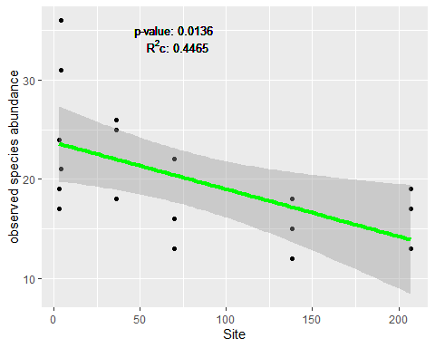

# plot model for abundance vs. canopy cover  
mod_can<-lme(species_abund ~ canopy_cover, random = (~1|site), data=dat, method="ML")  
r.squaredGLMM(mod_can)

## R2m R2c  
## [1,] 0.3208035 0.5312365

ggplot(dat, aes(x = canopy_cover, y = species_abund))+  
 geom_point() +  
 geom_smooth(method = lm, se = TRUE, colour = 'green', size = 1.5) +  
 geom_text(x=70, y=35, label="p-value: 0.0136", size=3.5) +  
 geom_text(x=72,y=33.5, label=expression(paste("R"^2,"c: 0.5312")), size=3.5) +  
 labs(x="canopy cover [%]", y="observed species abundance")

## `geom_smooth()` using formula 'y ~ x'

## Warning in is.na(x): is.na() aplicado a un objeto que no es (lista o vector) de  
## tipo 'expression

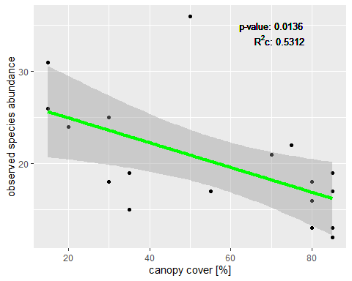

#plot model for abundance vs. minimal dbh  
mod_dbh<-lme(species_abund ~ log(dbh_min), random = (~1|site), data=dat, method="ML")  
r.squaredGLMM(mod_dbh)

## R2m R2c  
## [1,] 0.506479 0.5225862

ggplot(dat, aes(x = log(dbh_min), y = species_abund))+  
 geom_point() +  
 geom_smooth(method = lm, se = TRUE, colour = 'green', size = 1.5) +  
 geom_text(x=2.5, y=35, label="p-value: 0.0053", size=3.5) +  
 geom_text(x=2.41,y=33.5, label=expression(paste("R"^2,"c: 0.5226")), size=3.5) +  
 labs(x="log(mininmal dbh [cm])", y="observed species abundance")

## `geom_smooth()` using formula 'y ~ x'

## Warning in is.na(x): is.na() aplicado a un objeto que no es (lista o vector) de  
## tipo 'expression

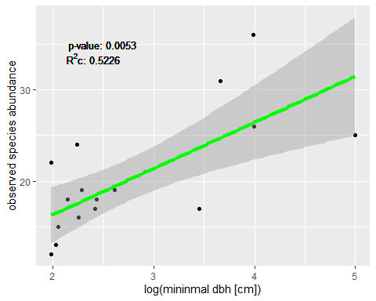

# plot model for abundance vs. microhabitats  
mod_mic<-lme(species_abund ~ log(n_microhabitats), random = (~1|site), data=dat, method="ML")  
r.squaredGLMM(mod_mic)

## R2m R2c  
## [1,] 0.1144617 0.6382438

ggplot(dat, aes(x = log(n_microhabitats)+1, y = species_abund))+  
 geom_point() +  
 geom_smooth(method = lm, se = TRUE, colour = 'green', size = 1.5) +  
 geom_text(x=1.6, y=35, label="p-value: 0.0098", size=3.5) +  
 geom_text(x=1.51,y=33.5, label=expression(paste("R"^2,"c: 0.6383")), size=3.5) +  
 labs(x="log(number of microhabitats)", y="observed species abundance")

## `geom_smooth()` using formula 'y ~ x'

## Warning in is.na(x): is.na() aplicado a un objeto que no es (lista o vector) de  
## tipo 'expression

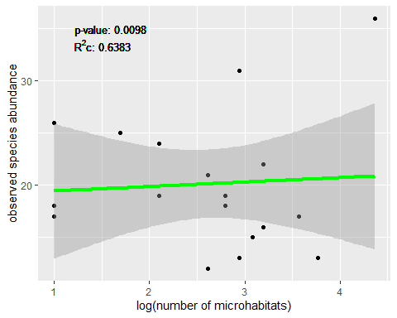

### MIXED EFFECTS MODEL WITH RAREFIED RICHNESS  
mod3 <- lme(rarefied_richness ~ category*size + canopy_cover + n_tree_spec + n_tree_ind + log(dbh_min) + n_microhabitats + temperature, random = (~1|site), data=dat, method="ML") #initial, full model with all potential predictor variables  
summary(mod3)

## Linear mixed-effects model fit by maximum likelihood  
## Data: dat   
## AIC BIC logLik  
## 58.56492 69.24938 -17.28246  
##   
## Random effects:  
## Formula: ~1 | site  
## (Intercept) Residual  
## StdDev: 2.442777e-05 0.6320405  
##   
## Fixed effects: rarefied_richness ~ category * size + canopy_cover + n_tree_spec + n_tree_ind + log(dbh_min) + n_microhabitats + temperature   
## Value Std.Error DF t-value p-value  
## (Intercept) 8.419457 3.192485 7 2.6372736 0.0336  
## categorypark -0.269752 1.559754 1 -0.1729449 0.8910  
## size -0.000680 0.006511 1 -0.1044220 0.9338  
## canopy_cover -0.009324 0.015123 7 -0.6165055 0.5571  
## n_tree_spec -0.193305 0.197460 7 -0.9789587 0.3602  
## n_tree_ind -0.026853 0.088828 7 -0.3022983 0.7712  
## log(dbh_min) 0.459643 0.462676 7 0.9934439 0.3536  
## n_microhabitats -0.007390 0.047624 7 -0.1551677 0.8811  
## temperature -0.019742 0.095026 1 -0.2077477 0.8696  
## categorypark:size 0.017530 0.034535 1 0.5076063 0.7010  
## Correlation:   
## (Intr) ctgryp size cnpy_c n_tr_s n_tr_n lg(d_) n_mcrh  
## categorypark -0.294   
## size -0.308 0.736   
## canopy_cover -0.569 0.348 0.026   
## n_tree_spec -0.420 -0.472 -0.325 0.128   
## n_tree_ind -0.469 0.179 -0.029 0.142 0.415   
## log(dbh_min) -0.452 -0.421 -0.125 0.023 0.388 0.079   
## n_microhabitats -0.285 0.068 0.051 0.079 0.023 -0.117 -0.160   
## temperature -0.333 0.206 0.332 0.154 -0.330 -0.510 0.085 0.478  
## categorypark:size 0.209 0.078 0.018 0.165 -0.480 -0.512 -0.441 0.428  
## tmprtr  
## categorypark   
## size   
## canopy_cover   
## n_tree_spec   
## n_tree_ind   
## log(dbh_min)   
## n_microhabitats   
## temperature   
## categorypark:size 0.467  
##   
## Standardized Within-Group Residuals:  
## Min Q1 Med Q3 Max   
## -2.1905486 -0.3771982 0.1406606 0.6747755 1.9225911   
##   
## Number of Observations: 18  
## Number of Groups: 6

mod3.1 <- stepAIC(mod3) #model simplification based on AIC-value of the model

## Start: AIC=58.56  
## rarefied_richness ~ category * size + canopy_cover + n_tree_spec +   
## n_tree_ind + log(dbh_min) + n_microhabitats + temperature  
##   
## Df AIC  
## - n_microhabitats 1 56.619  
## - temperature 1 56.662  
## - n_tree_ind 1 56.769  
## - category:size 1 57.136  
## - canopy_cover 1 57.400  
## - n_tree_spec 1 58.543  
## <none> 58.565  
## - log(dbh_min) 1 58.659  
##   
## Step: AIC=56.62  
## rarefied_richness ~ category + size + canopy_cover + n_tree_spec +   
## n_tree_ind + log(dbh_min) + temperature + category:size  
##   
## Df AIC  
## - temperature 1 54.671  
## - n_tree_ind 1 54.851  
## - canopy_cover 1 55.425  
## - category:size 1 55.502  
## - n_tree_spec 1 56.591  
## <none> 56.619  
## - log(dbh_min) 1 56.659  
##   
## Step: AIC=54.67  
## rarefied_richness ~ category + size + canopy_cover + n_tree_spec +   
## n_tree_ind + log(dbh_min) + category:size  
##   
## Df AIC  
## - n_tree_ind 1 53.159  
## - canopy_cover 1 53.436  
## - category:size 1 53.814  
## <none> 54.671  
## - log(dbh_min) 1 54.890  
## - n_tree_spec 1 55.119  
##   
## Step: AIC=53.16  
## rarefied_richness ~ category + size + canopy_cover + n_tree_spec +   
## log(dbh_min) + category:size  
##   
## Df AIC  
## - canopy_cover 1 51.664  
## - category:size 1 51.880  
## <none> 53.159  
## - n_tree_spec 1 53.213  
## - log(dbh_min) 1 53.774  
##   
## Step: AIC=51.66  
## rarefied_richness ~ category + size + n_tree_spec + log(dbh_min) +   
## category:size  
##   
## Df AIC  
## - category:size 1 50.738  
## - n_tree_spec 1 51.381  
## <none> 51.664  
## - log(dbh_min) 1 52.136  
##   
## Step: AIC=50.74  
## rarefied_richness ~ category + size + n_tree_spec + log(dbh_min)  
##   
## Df AIC  
## - size 1 48.740  
## - category 1 48.753  
## - n_tree_spec 1 49.576  
## <none> 50.738  
## - log(dbh_min) 1 53.379  
##   
## Step: AIC=48.74  
## rarefied_richness ~ category + n_tree_spec + log(dbh_min)  
##   
## Df AIC  
## - category 1 46.758  
## - n_tree_spec 1 47.633  
## <none> 48.740  
## - log(dbh_min) 1 51.712  
##   
## Step: AIC=46.76  
## rarefied_richness ~ n_tree_spec + log(dbh_min)  
##   
## Df AIC  
## - n_tree_spec 1 46.091  
## <none> 46.758  
## - log(dbh_min) 1 52.240  
##   
## Step: AIC=46.09  
## rarefied_richness ~ log(dbh_min)  
##   
## Df AIC  
## <none> 46.091  
## - log(dbh_min) 1 50.433

summary(mod3.1) #final model which includes only the most important predictors

## Linear mixed-effects model fit by maximum likelihood  
## Data: dat   
## AIC BIC logLik  
## 46.09053 49.65202 -19.04527  
##   
## Random effects:  
## Formula: ~1 | site  
## (Intercept) Residual  
## StdDev: 0.3015021 0.6402719  
##   
## Fixed effects: rarefied_richness ~ log(dbh_min)   
## Value Std.Error DF t-value p-value  
## (Intercept) 5.551859 0.6230627 11 8.910594 0.0000  
## log(dbh_min) 0.567502 0.2136461 11 2.656270 0.0223  
## Correlation:   
## (Intr)  
## log(dbh_min) -0.943  
##   
## Standardized Within-Group Residuals:  
## Min Q1 Med Q3 Max   
## -1.78828290 -0.39209673 0.05314066 0.66857616 1.81864161   
##   
## Number of Observations: 18  
## Number of Groups: 6

# plot model for rarefied richness vs. min dbh  
mod_dbh<-lme(rarefied_richness ~ log(dbh_min), random = (~1|site), data=dat, method="ML")  
r.squaredGLMM(mod3.1)

## R2m R2c  
## [1,] 0.33697 0.4573085

ggplot(dat, aes(x = rarefied_richness, y = log(dbh_min)))+  
 geom_point() +  
 geom_smooth(method = lm, se = TRUE, colour = 'green', size = 1.5) +  
 geom_text(x=6, y=4.8, label="p-value: 0.0223", size=3.5) +  
 geom_text(x=5.92,y=4.55, label=expression(paste("R"^2,"c: 0.4573")), size=3.5) +  
 labs(x="log(minimal dbh [cm])", y="rarefied species richness")

## `geom_smooth()` using formula 'y ~ x'

## Warning in is.na(x): is.na() aplicado a un objeto que no es (lista o vector) de  
## tipo 'expression

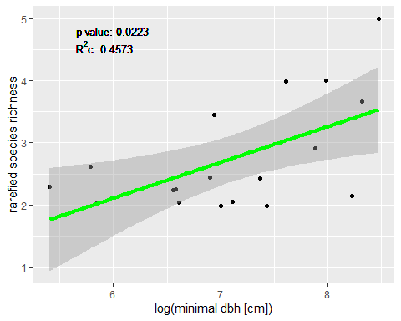

#plot(log(dbh_min)~rarefied_richness, data=dat, ylim=c(0,5))  
#mod<-lm(rarefied_richness ~ log(dbh_min), data=dat, poly(degree = 2))

plot graphs

a <- ggplot(dat, aes(x = log(dbh_min), y = species_richness))+  
 geom_point() +  
 geom_smooth(method = lm,se = TRUE, colour = 'green', size = 1.5) +  
 geom_text(x=2.6, y=16, label="p-value: 0.0001", size=3.5) +  
 geom_text(x=2.51,y=15.3,label=expression(paste("R"^2,"c: 0.6851")), size=3.5) +  
 labs(x="log(mininmal dbh [cm])", y="observed species richness")  
  
b <- ggplot(dat, aes(x = size, y = species_abund))+  
 geom_point() +  
 geom_smooth(method = lm, se = TRUE, colour = 'green', size = 1.5) +  
 geom_text(x=70, y=35, label="p-value: 0.0136", size=3.5) +  
 geom_text(x=72,y=33.5, label=expression(paste("R"^2,"c: 0.4465")), size=3.5) +  
 labs(x="Site", y="observed species abundance")  
  
c <-ggplot(dat, aes(x = canopy_cover, y = species_abund))+  
 geom_point() +  
 geom_smooth(method = lm, se = TRUE, colour = 'green', size = 1.5) +  
 geom_text(x=70, y=35, label="p-value: 0.0136", size=3.5) +  
 geom_text(x=72,y=33.5, label=expression(paste("R"^2,"c: 0.5312")), size=3.5) +  
 labs(x="canopy cover [%]", y="observed species abundance")  
  
d <- ggplot(dat, aes(x = log(dbh_min), y = species_abund))+  
 geom_point() +  
 geom_smooth(method = lm, se = TRUE, colour = 'green', size = 1.5) +  
 geom_text(x=2.5, y=35, label="p-value: 0.0053", size=3.5) +  
 geom_text(x=2.41,y=33.5, label=expression(paste("R"^2,"c: 0.5226")), size=3.5) +  
 labs(x="log(mininmal dbh [cm])", y="observed species abundance")  
  
  
e <- ggplot(dat, aes(x = log(n_microhabitats)+1, y = species_abund))+  
 geom_point() +  
 geom_smooth(method = lm, se = TRUE, colour = 'green', size = 1.5) +  
 geom_text(x=1.6, y=35, label="p-value: 0.0098", size=3.5) +  
 geom_text(x=1.51,y=33.5, label=expression(paste("R"^2,"c: 0.6383")), size=3.5) +  
 labs(x="log(number of microhabitats)", y="observed species abundance")  
  
  
f <- ggplot(dat, aes(x = rarefied_richness, y = log(dbh_min)))+  
 geom_point() +  
 geom_smooth(method = lm, se = TRUE, colour = 'green', size = 1.5) +  
 geom_text(x=6, y=4.8, label="p-value: 0.0223", size=3.5) +  
 geom_text(x=5.92,y=4.55, label=expression(paste("R"^2,"c: 0.4573")), size=3.5) +  
 labs(x="log(minimal dbh [cm])", y="rarefied species richness")

##2c Ordination with NMDS (to look for differences in species composition)

nmd1 <- metaMDS(dat[,4:31], distance="horn", k=2) #NMDS analysis based on Morisita-Horn-Index as a dissimilarity measure

## Run 0 stress 0.1663514   
## Run 1 stress 0.1707768   
## Run 2 stress 0.1707768   
## Run 3 stress 0.1663514   
## ... New best solution  
## ... Procrustes: rmse 2.750847e-05 max resid 6.153271e-05   
## ... Similar to previous best  
## Run 4 stress 0.1663514   
## ... New best solution  
## ... Procrustes: rmse 1.406155e-05 max resid 4.614821e-05   
## ... Similar to previous best  
## Run 5 stress 0.1663514   
## ... Procrustes: rmse 3.519629e-05 max resid 0.0001098604   
## ... Similar to previous best  
## Run 6 stress 0.1663514   
## ... Procrustes: rmse 1.847222e-05 max resid 6.131506e-05   
## ... Similar to previous best  
## Run 7 stress 0.1663514   
## ... New best solution  
## ... Procrustes: rmse 6.670091e-06 max resid 2.189942e-05   
## ... Similar to previous best  
## Run 8 stress 0.1777238   
## Run 9 stress 0.1927819   
## Run 10 stress 0.2690007   
## Run 11 stress 0.1663514   
## ... Procrustes: rmse 5.595955e-05 max resid 0.0001747406   
## ... Similar to previous best  
## Run 12 stress 0.174846   
## Run 13 stress 0.1707767   
## Run 14 stress 0.1828469   
## Run 15 stress 0.1663514   
## ... Procrustes: rmse 4.697731e-06 max resid 8.205444e-06   
## ... Similar to previous best  
## Run 16 stress 0.1777238   
## Run 17 stress 0.1777238   
## Run 18 stress 0.1707767   
## Run 19 stress 0.1707767   
## Run 20 stress 0.1707767   
## *** Solution reached

# orditkplot(nmd1, display = "species", col = "darkred", fill = NA, border = NA, cex = 0.6)  
ordiplot(nmd1, choices = c(1, 2), type = "n") # ylim = c(-0.75, 0.5), xlim = c(-1.25, 1.3))  
ordilabel(nmd1, display = "species", col = "darkred", fill = NA, border = NA, cex = 0.5)  
points(nmd1, pch=c(16, 17)[as.numeric(as.factor(dat$category))], col = "darkblue") #add sampling points  
legend("topright", pch = c(16, 17), c("Forest","Park"), col = "darkblue", cex = 0.7) #add legend  
text(-1.4, -1.1, labels = "stress = 0.166", cex = 0.7)  
  
ef <- envfit(nmd1, dat[,32:44]) #check for correlation of dissimilarity gradients with environmental variables  
ef #results

##   
## ***VECTORS  
##   
## NMDS1 NMDS2 r2 Pr(>r)   
## canopy_cover 0.97465 -0.22375 0.5449 0.006 **   
## n_tree_spec -0.90909 0.41660 0.5815 0.004 **   
## n_tree_ind 0.98934 -0.14561 0.1254 0.358   
## dbh_min -0.95998 -0.28007 0.0958 0.478   
## dbh_min5 -0.66027 -0.75103 0.2847 0.073 .   
## dbh_mean -0.71933 -0.69467 0.3251 0.049 *   
## dbh_max -0.75683 -0.65361 0.3293 0.054 .   
## dbh_median -0.64467 -0.76446 0.2933 0.061 .   
## dbh_sd -0.90589 0.42352 0.5773 0.003 **   
## n_microhabitats 0.48727 -0.87325 0.2378 0.122   
## latitude 0.66162 -0.74984 0.2294 0.152   
## longitude 0.99958 0.02912 0.4694 0.006 **   
## size 0.90394 0.42767 0.7395 0.001 ***  
## ---  
## Signif. codes: 0 '***' 0.001 '**' 0.01 '*' 0.05 '.' 0.1 ' ' 1  
## Permutation: free  
## Number of permutations: 999

plot(ef, p.max=0.05, col = "darkblue", cex = 0.7) #add significant environmental variables to the NMDS plot

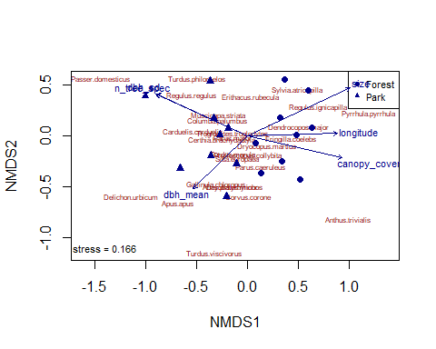

Now the species accumulation curve is shown.

SAC_park <- specaccum(subset(dat[,4:31], dat$category == "park"))

## Warning in cor(x > 0): the standard deviation is zero

SAC_fore <- specaccum(subset(dat[,4:31], dat$category == "forest"))

## Warning in cor(x > 0): the standard deviation is zero

plot(SAC_park, xlab = "Plots", ylab = "Species richness", main="Species accumulation curve")  
  
plot(SAC_fore, xlab = "Plots", ylab = "Species richness", main="Species accumulation curve", col="green", add = T)  
legend("bottomright", legend = c("Park","Forest"), col = c("black","green"), lwd=1, bty = "n")

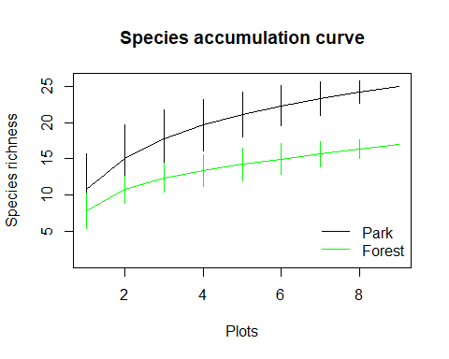

Analysis of bird’s diversity and the variables measured from these two types of ecosystems.

# parks <- read.csv("data/parks.csv", sep=";")  
# forest <- read.csv("data/forest.csv", sep=";")  
alpha <- specnumber(dat[,4:31]) # or use the binary site-species matrix  
gamma <- ncol(dat[,colSums(dat[,4:31])>0])  
  
##Lande’s index (beta) diversity  
gamma - mean(alpha)

## [1] 40.72222

##Whittaker’s index  
  
#gamma/mean(alpha)  
  
  
#For parks  
  
alphap <- specnumber(parks[,4:31])  
  
gammap <- ncol(parks[,colSums(parks[,4:31]) > 0])  
  
##Lande’s index   
gammap - mean(alphap)

## [1] 28.22222

##Whittaker’s index  
  
#gammap/mean(alphap)  
  
#For forest  
alphaf <- specnumber(forest[,4:31])  
  
gammaf <- ncol(parks[,colSums(parks[,4:31]) > 0])  
  
##Lande’s index   
gammaf - mean(alphaf)

## [1] 31.22222

##Whittaker’s index  
  
#gammaf/mean(alphaf)

The number of shared and unique species for a given for the two plots combine and separated.

beta_virt <- betadiver(dat[,4:31], method = NA)  
# a  
beta_virt$a

## 1 2 3 4 5 6 7 8 9 10 11 12 13 14 15 16 17  
## 2 7   
## 3 7 9   
## 4 4 5 4   
## 5 6 6 6 5   
## 6 5 5 7 4 5   
## 7 4 5 5 3 3 2   
## 8 5 6 7 4 4 6 4   
## 9 5 6 6 3 4 4 4 6   
## 10 4 5 5 4 5 5 2 5 4   
## 11 7 8 8 6 7 6 5 7 6 7   
## 12 5 6 7 4 6 6 3 6 5 6 7   
## 13 4 6 7 3 4 4 3 5 5 4 5 5   
## 14 5 7 7 4 4 5 4 7 6 5 7 5 6   
## 15 5 5 6 3 4 4 2 4 4 4 5 5 5 5   
## 16 7 6 8 4 6 7 3 5 4 4 6 6 4 4 4   
## 17 9 8 9 5 6 7 5 7 7 6 9 6 5 7 6 8   
## 18 7 7 8 6 5 7 4 7 6 5 7 6 5 6 6 8 11

beta_virt$b

## 1 2 3 4 5 6 7 8 9 10 11 12 13 14 15 16 17  
## 2 5   
## 3 7 5   
## 4 3 2 3   
## 5 1 1 1 2   
## 6 4 4 2 5 4   
## 7 2 1 1 3 3 4   
## 8 4 3 2 5 5 3 5   
## 9 2 1 1 4 3 3 3 1   
## 10 3 2 2 3 2 2 5 2 3   
## 11 3 2 2 4 3 4 5 3 4 3   
## 12 3 2 1 4 2 2 5 2 3 2 1   
## 13 3 1 0 4 3 3 4 2 2 3 2 2   
## 14 3 1 1 4 4 3 4 1 2 3 1 3 2   
## 15 4 4 3 6 5 5 7 5 5 5 4 4 4 4   
## 16 2 3 1 5 3 2 6 4 5 5 3 3 5 5 5   
## 17 4 5 4 8 7 6 8 6 6 7 4 7 8 6 7 5   
## 18 7 7 6 8 9 7 10 7 8 9 7 8 9 8 8 6 3

beta_virt$c

## 1 2 3 4 5 6 7 8 9 10 11 12 13 14 15 16 17  
## 2 4   
## 3 4 3   
## 4 7 7 10   
## 5 5 6 8 2   
## 6 6 7 7 3 2   
## 7 7 7 9 4 4 7   
## 8 6 6 7 3 3 3 2   
## 9 6 6 8 4 3 5 2 3   
## 10 7 7 9 3 2 4 4 4 3   
## 11 4 4 6 1 0 3 1 2 1 0   
## 12 6 6 7 3 1 3 3 3 2 1 3   
## 13 7 6 7 4 3 5 3 4 2 3 5 3   
## 14 6 5 7 3 3 4 2 2 1 2 3 3 1   
## 15 6 7 8 4 3 5 4 5 3 3 5 3 2 3   
## 16 4 6 6 3 1 2 3 4 3 3 4 2 3 4 5   
## 17 2 4 5 2 1 2 1 2 0 1 1 2 2 1 3 1   
## 18 4 5 6 1 2 2 2 2 1 2 3 2 2 2 3 1 2

plot(betadiver(dat[,4:31], method=NA), pch = 16, cex = 2,)  
legend("topleft", legend = "Virtual matrix", bty = "n")

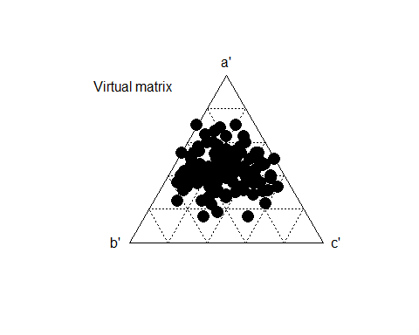

beta_virtp <- betadiver(parks, method = NA)  
# a  
beta_virtp$a

## 1 2 3 4 5 6 7 8  
## 2 23   
## 3 23 25   
## 4 20 22 23   
## 5 21 23 23 22   
## 6 21 21 22 21 21   
## 7 23 22 24 20 20 20   
## 8 25 24 25 21 23 22 24   
## 9 23 23 24 21 22 22 24 27

beta_virtp$b

## 1 2 3 4 5 6 7 8  
## 2 5   
## 3 7 5   
## 4 3 1 0   
## 5 3 1 1 2   
## 6 4 4 3 4 4   
## 7 2 3 1 5 5 5   
## 8 4 5 4 8 6 7 5   
## 9 7 7 6 9 8 8 6 3

beta_virtp$c

## 1 2 3 4 5 6 7 8  
## 2 4   
## 3 4 3   
## 4 7 6 7   
## 5 6 5 7 1   
## 6 6 7 8 2 3   
## 7 4 6 6 3 4 5   
## 8 2 4 5 2 1 3 1   
## 9 4 5 6 2 2 3 1 2

plot(betadiver(parks, method=NA), pch = 16, cex = 2,)  
legend("topleft", legend = "Virtual matrix", bty = "n")

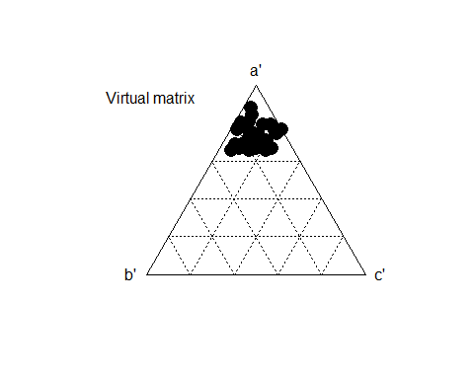

#vennd iagram <- as alternative to show the overlap of shared species

We can see how nice heterogeneity is present between the two ecosystems

Now the similarity between plots by Sorensen, Simpson and Jaccard

#Sorensen similarity  
sorparks <- betadiver(parks[,4:31], method = "sor")  
sorensen <- as.matrix(sorparks)[,]  
plot(sorensen)

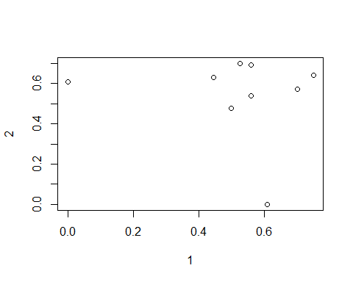

#Simpson similarity  
simpark<- betadiver(parks[,4:31], method = "sim")  
simpsonpark <- as.matrix(simpark)[,]  
plot(simpsonpark)

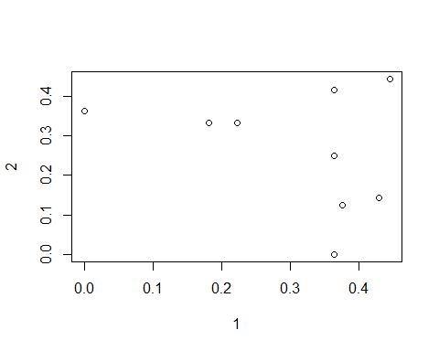

# Jaccard similarity  
jparks <- betadiver(parks[,4:31], method = "j")  
plot(as.matrix(jparks)[,])

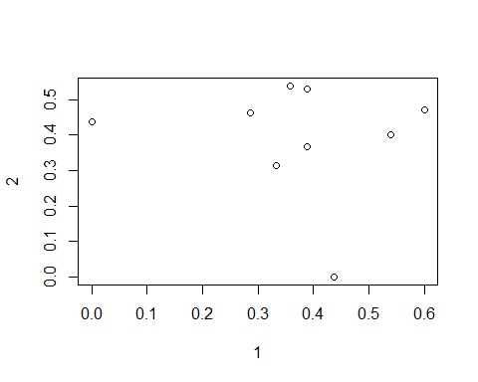

#Sorensen similarity  
sorforest <- betadiver(forest[,4:31], method = "sor")  
sorensenforest <- as.matrix(sorforest)[,]  
plot(sorensen)



#Simpson similarity  
simf <- betadiver(forest[,4:31], method = "sim")  
simpson <- as.matrix(simf)[,]  
plot(simpson)

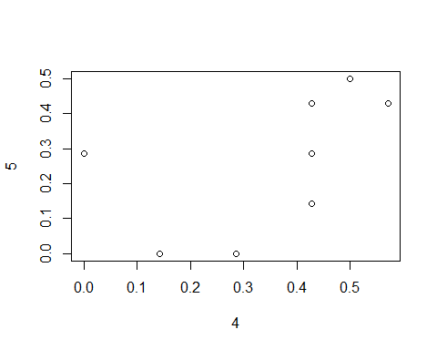

# Jaccard similarity  
  
jforest <- betadiver(forest[,4:31], method = "j")  
as.matrix(jforest)[,]

## 4 5 6 7 8 9 10  
## 4 0.0000000 0.5555556 0.3333333 0.3000000 0.3333333 0.2727273 0.4000000  
## 5 0.5555556 0.0000000 0.4545455 0.3000000 0.3333333 0.4000000 0.5555556  
## 6 0.3333333 0.4545455 0.0000000 0.1538462 0.5000000 0.3333333 0.4545455  
## 7 0.3000000 0.3000000 0.1538462 0.0000000 0.3636364 0.4444444 0.1818182  
## 8 0.3333333 0.3333333 0.5000000 0.3636364 0.0000000 0.6000000 0.4545455  
## 9 0.2727273 0.4000000 0.3333333 0.4444444 0.6000000 0.0000000 0.4000000  
## 10 0.4000000 0.5555556 0.4545455 0.1818182 0.4545455 0.4000000 0.0000000  
## 11 0.5454545 0.7000000 0.4615385 0.4545455 0.5833333 0.5454545 0.7000000  
## 12 0.3636364 0.6666667 0.5454545 0.2727273 0.5454545 0.5000000 0.6666667  
## 11 12  
## 4 0.5454545 0.3636364  
## 5 0.7000000 0.6666667  
## 6 0.4615385 0.5454545  
## 7 0.4545455 0.2727273  
## 8 0.5833333 0.5454545  
## 9 0.5454545 0.5000000  
## 10 0.7000000 0.6666667  
## 11 0.0000000 0.6363636  
## 12 0.6363636 0.0000000

plot(as.matrix(jforest)[,])

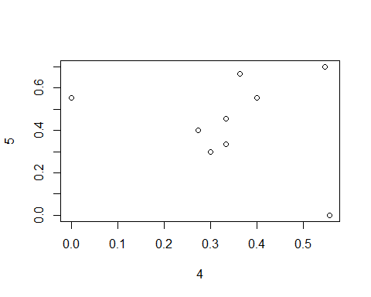

#calculate mean of these similarities indices and compare between sites

RANK abundance curve <- takes abundant species per site and plot it against relative species abundance rank

# Klosterpark  
plot1_1 <- data.frame(sp = colnames(dat[,4:31]), ab = as.numeric(dat[1,4:31]))  
plot1_2 <- data.frame(sp = colnames(dat[,4:31]), ab = as.numeric(dat[2,4:31]))  
plot1_3 <- data.frame(sp = colnames(dat[,4:31]), ab = as.numeric(dat[3,4:31]))  
  
plot1_12 <- merge(plot1_1, plot1_2, by = "sp")  
plot1 <- merge(plot1_12, plot1_3, by = "sp")  
plot1$abun <- plot1$ab.x + plot1$ab.y + plot1$ab  
plot1 <- plot1[which(plot1$abun!=0),]  
dim(plot1)

## [1] 20 5

plot1$relabun <- plot1$abun * 100 / sum(plot1$abun)  
plot1$rank <- rank(-plot1$relabun, ties.method = "random")  
plot1 <- plot1[order(plot1$rank),]  
  
# City Forest  
plot2_1 <- data.frame(sp = colnames(dat[,4:31]), ab = as.numeric(dat[4,4:31]))  
plot2_2 <- data.frame(sp = colnames(dat[,4:31]), ab = as.numeric(dat[5,4:31]))  
plot2_3 <- data.frame(sp = colnames(dat[,4:31]), ab = as.numeric(dat[6,4:31]))  
  
plot2_12 <- merge(plot2_1, plot2_2, by = "sp")  
plot2 <- merge(plot2_12, plot2_3, by = "sp")  
plot2$abun <- plot2$ab.x + plot2$ab.y + plot2$ab  
plot2 <- plot2[which(plot2$abun!=0),]  
dim(plot2)

## [1] 12 5

plot2$relabun <- plot2$abun * 100 / sum(plot2$abun)  
plot2$rank <- rank(-plot2$abun, ties.method = "random")  
plot2 <- plot2[order(plot2$rank),]  
  
# Forest Weende  
plot3_1 <- data.frame(sp = colnames(dat[,4:31]), ab = as.numeric(dat[7,4:31]))  
plot3_2 <- data.frame(sp = colnames(dat[,4:31]), ab = as.numeric(dat[8,4:31]))  
plot3_3 <- data.frame(sp = colnames(dat[,4:31]), ab = as.numeric(dat[9,4:31]))  
  
plot3_12 <- merge(plot3_1, plot3_2, by = "sp")  
plot3 <- merge(plot3_12, plot3_3, by = "sp")  
plot3$abun <- plot3$ab.x + plot3$ab.y + plot3$ab  
plot3 <- plot3[which(plot3$abun!=0),]  
dim(plot3)

## [1] 12 5

plot3$relabun <- plot3$abun * 100 / sum(plot3$abun)  
plot3$rank <- rank(-plot3$abun, ties.method = "random")  
plot3 <- plot3[order(plot3$rank),]  
  
# Forest Billingshäuser Schlucht  
plot4_1 <- data.frame(sp = colnames(dat[,4:31]), ab = as.numeric(dat[10,4:31]))  
plot4_2 <- data.frame(sp = colnames(dat[,4:31]), ab = as.numeric(dat[11,4:31]))  
plot4_3 <- data.frame(sp = colnames(dat[,4:31]), ab = as.numeric(dat[12,4:31]))  
  
plot4_12 <- merge(plot4_1, plot4_2, by = "sp")  
plot4 <- merge(plot4_12, plot4_3, by = "sp")  
plot4$abun <- plot4$ab.x + plot4$ab.y + plot4$ab  
plot4 <- plot4[which(plot4$abun!=0),]  
dim(plot4)

## [1] 11 5

plot4$relabun <- plot4$abun * 100 / sum(plot4$abun)  
plot4$rank <- rank(-plot4$abun, ties.method = "random")  
plot4 <- plot4[order(plot4$rank),]  
  
# Cheltenham Park  
plot5_1 <- data.frame(sp = colnames(dat[,4:31]), ab = as.numeric(dat[13,4:31]))  
plot5_2 <- data.frame(sp = colnames(dat[,4:31]), ab = as.numeric(dat[14,4:31]))  
plot5_3 <- data.frame(sp = colnames(dat[,4:31]), ab = as.numeric(dat[15,4:31]))  
  
plot5_12 <- merge(plot5_1, plot5_2, by = "sp")  
plot5 <- merge(plot5_12, plot5_3, by = "sp")  
plot5$abun <- plot5$ab.x + plot5$ab.y + plot5$ab  
plot5 <- plot5[which(plot5$abun!=0),]  
dim(plot5)

## [1] 13 5

plot5$relabun <- plot5$abun * 100 / sum(plot5$abun)  
plot5$rank <- rank(-plot5$abun, ties.method = "random")  
plot5 <- plot5[order(plot5$rank),]  
  
# City Cemetery  
plot6_1 <- data.frame(sp = colnames(dat[,4:31]), ab = as.numeric(dat[16,4:31]))  
plot6_2 <- data.frame(sp = colnames(dat[,4:31]), ab = as.numeric(dat[17,4:31]))  
plot6_3 <- data.frame(sp = colnames(dat[,4:31]), ab = as.numeric(dat[18,4:31]))  
  
plot6_12 <- merge(plot6_1, plot6_2, by = "sp")  
plot6 <- merge(plot6_12, plot6_3, by = "sp")  
plot6$abun <- plot6$ab.x + plot6$ab.y + plot6$ab  
plot6 <- plot6[which(plot6$abun!=0),]  
dim(plot6)

## [1] 16 5

plot6$relabun <- plot6$abun * 100 / sum(plot6$abun)  
plot6$rank <- rank(-plot6$abun, ties.method = "random")  
plot6 <- plot6[order(plot6$rank),]  
  
# Plotting  
plot(plot1$rank, plot1$relabun, type = "l",  
 col = "blue3", pch = 16, lwd = 2,  
 ylim = c(0, 35),  
 xlab = "Rank", ylab = "Relative species abundance [%]")  
points(plot2$rank, plot2$relabun, type = "l",  
 col = "red2", pch = 16, lwd = 2)  
points(plot3$rank, plot3$relabun, type = "l",  
 col = "coral1", pch = 16, lwd = 2)  
points(plot4$rank, plot4$relabun, type = "l",  
 col = "pink", pch = 16, lwd = 2)  
points(plot5$rank, plot5$relabun, type = "l",  
 col = "deepskyblue", pch = 16, lwd = 2)  
points(plot6$rank, plot6$relabun, type = "l",  
 col = "deepskyblue3", pch = 16, lwd = 2)  
legend("topright",legend = c("Klosterpark Weende", "Cheltenham Park", "City Cemetery", "City Forest", "Forest Weende", "Forest Schlucht"), col = c("blue3", "deepskyblue", "deepskyblue3", "red2", "coral1", "pink"), cex = 0.7, pch = 16)

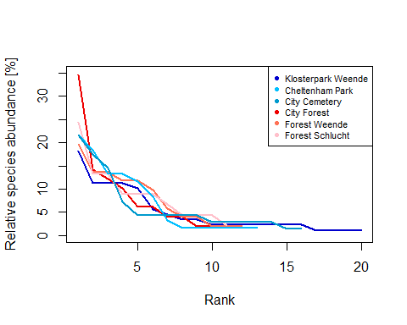

#library(wesanderson)  
#library("RColorBrewer")  
  
#par(mfrow = c(1, 1))  
#plot1_1 <- data.frame(sp = colnames(dat[,4:31]), ab = as.numeric(dat[1,4:31]))  
  
#plot1_1 <- plot1_1[which(plot1_1$ab!=0),]  
#dim(plot1_1)  
  
# Add rank of species in the first community  
#plot1_1$rank <- rank(-plot1_1$ab, ties.method = "random")  
# Ordering data before plotting  
#plot1_1 <- plot1_1[order(plot1_1$rank), ]  
# Plot  
#plot(plot1_1$rank, plot1_1$ab, type = "b",  
# col = "coral", pch = 16, lwd = 1,  
# main = "RAD",  
# xlab = "Rank", ylab = "Abundances")  
  
  
  
#plot1_2 <- data.frame(sp = colnames(dat[,4:31]), ab = as.numeric(dat[2,4:31]))  
#plot1_2 <- plot1_2[which(plot1_2$ab!=0),]  
#dim(plot1_2)  
  
#plot1_2$rank <- rank(-plot1_2$ab, ties.method = "random")  
  
#plot1_2 <- plot1_2[order(plot1_2$rank), ]  
#points(plot1_2$rank, plot1_2$ab, type = "both", col = "coral2", pch = 16)  
  
#plot1_3 <- data.frame(sp = colnames(dat[,4:31]), ab = as.numeric(dat[3,4:31]))  
  
#plot1_3 <- plot1_3[which(plot1_3$ab!=0),]  
#dim(plot1_3)  
#plot1_3$rank <- rank(-plot1_3$ab, ties.method = "random")  
#plot1_3 <- plot1_3[order(plot1_3$rank), ]  
#points(plot1_3$rank, plot1_3$ab, type = "b",  
# col = "coral3", pch = 16, lwd = 1)  
  
  
#plot2_1 <- data.frame(sp = colnames(dat[,4:31]),  
# ab = as.numeric(dat[4,4:31]))  
#plot2_1 <- plot2_1[which(plot2_1$ab!=0),]  
#dim(plot2_1)  
#$rank <- rank(-plot2_1$ab, ties.method = "random")  
#plot2_1 <- plot2_1[order(plot2_1$rank), ]  
#points(plot2_1$rank, plot2_1$ab, type = "b",  
# col = "aquamarine", pch = 16, lwd = 1)  
  
  
  
#plot2_2 <- data.frame(sp = colnames(dat[,4:31]),  
# ab = as.numeric(dat[5,4:31]))  
#plot2_2 <- plot2_2[which(plot2_2$ab!=0),]  
#dim(plot2_2)  
#plot2_2$rank <- rank(-plot2_2$ab, ties.method = "random")  
#plot2_2 <- plot2_2[order(plot2_2$rank), ]  
#points(plot2_2$rank, plot2_2$ab, type = "b",  
# col = "aquamarine3", pch = 16, lwd = 1)  
  
#plot2_3 <- data.frame(sp = colnames(dat[,4:31]),  
# ab = as.numeric(dat[6,4:31]))  
#plot2_3 <- plot2_3[which(plot2_3$ab!=0),]  
#dim(plot2_3)  
#plot2_3$rank <- rank(-plot2_3$ab, ties.method = "random")  
#plot2_3 <- plot2_3[order(plot2_3$rank), ]  
#points(plot2_3$rank, plot2_3$ab, type = "b",  
# col = "aquamarine4", pch = 16, lwd = 1)  
  
#plot3_1 <- data.frame(sp = colnames(dat[,4:31]),  
# ab = as.numeric(dat[7,4:31]))  
#plot3_1 <- plot3_1[which(plot3_1$ab!=0),]  
#dim(plot3_1)  
#plot3_1$rank <- rank(-plot3_1$ab, ties.method = "random")  
#plot3_1 <- plot3_1[order(plot3_1$rank), ]  
#points(plot3_1$rank, plot3_1$ab, type = "b",  
# col = "antiquewhite", pch = 16, lwd = 1)  
  
#plot3_2 <- data.frame(sp = colnames(dat[,4:31]),  
# ab = as.numeric(dat[8,4:31]))  
#plot3_2 <- plot3_2[which(plot3_1$ab!=0),]  
#(plot3_2)  
#plot3_2$rank <- rank(-plot3_2$ab, ties.method = "random")  
#plot3_2 <- plot3_2[order(plot3_2$rank), ]  
#points(plot3_2$rank, plot3_2$ab, type = "b",  
# col = "antiquewhite3", pch = 16, lwd = 1)  
  
  
#plot3_3 <- data.frame(sp = colnames(dat[,4:31]),  
# ab = as.numeric(dat[9,4:31]))  
#plot3_3 <- plot3_3[which(plot3_1$ab!=0),]  
#dim(plot3_3)  
#plot3_3$rank <- rank(-plot3_3$ab, ties.method = "random")  
#plot3_3 <- plot3_3[order(plot3_3$rank), ]  
#points(plot3_3$rank, plot3_3$ab, type = "b",  
# col = "antiquewhite4", pch = 16, lwd = 1)  
  
  
#plot4_1 <- data.frame(sp = colnames(dat[,4:31]),  
# ab = as.numeric(dat[10,4:31]))  
#plot4_1 <- plot4_1[which(plot4_1$ab!=0),]  
#dim(plot4_1)  
#plot4_1$rank <- rank(-plot4_1$ab, ties.method = "random")  
#plot4_1 <- plot4_1[order(plot4_1$rank), ]  
#points(plot4_1$rank, plot4_1$ab, type = "b",  
# col = "brown1", pch = 16, lwd = 1)  
  
#plot4_2 <- data.frame(sp = colnames(dat[,4:31]),  
# ab = as.numeric(dat[11,4:31]))  
#plot4_2 <- plot4_2[which(plot4_2$ab!=0),]  
#dim(plot4_2)  
#plot4_2$rank <- rank(-plot4_2$ab, ties.method = "random")  
#plot4_2 <- plot4_2[order(plot4_1$rank), ]  
#points(plot4_2$rank, plot4_2$ab, type = "b",  
# col = "brown4", pch = 16, lwd = 1)  
  
#plot4_3 <- data.frame(sp = colnames(dat[,4:31]),  
# ab = as.numeric(dat[12,4:31]))  
#plot4_3 <- plot4_3[which(plot4_3$ab!=0),]  
#dim(plot4_3)  
#plot4_3$rank <- rank(-plot4_3$ab, ties.method = "random")  
#plot4_3 <- plot4_3[order(plot4_3$rank), ]  
#points(plot4_3$rank, plot4_3$ab, type = "b",  
# col = "brown2", pch = 16, lwd = 1)  
  
  
#plot5_1 <- data.frame(sp = colnames(dat[,4:31]),  
# ab = as.numeric(dat[13,4:31]))  
#plot5_1 <- plot5_1[which(plot5_1$ab!=0),]  
#dim(plot5_1)  
#plot5_1$rank <- rank(-plot5_1$ab, ties.method = "random")  
#plot5_1 <- plot5_1[order(plot5_1$rank), ]  
#points(plot5_1$rank, plot5_1$ab, type = "b",  
# col = "chartreuse", pch = 16, lwd = 1)  
  
  
#plot5_2 <- data.frame(sp = colnames(dat[,4:31]),  
# ab = as.numeric(dat[14,4:31]))  
#plot5_2 <- plot5_2[which(plot5_2$ab!=0),]  
#dim(plot5_2)  
#plot5_2$rank <- rank(-plot5_2$ab, ties.method = "random")  
#plot5_2 <- plot5_2[order(plot5_2$rank), ]  
#points(plot5_2$rank, plot5_2$ab, type = "b",  
# col = "chartreuse3", pch = 16, lwd = 1)  
  
#plot5_3 <- data.frame(sp = colnames(dat[,4:31]),  
# ab = as.numeric(dat[15,4:31]))  
#plot5_3 <- plot5_3[which(plot5_3$ab!=0),]  
#dim(plot5_3)  
#plot5_3$rank <- rank(-plot5_3$ab, ties.method = "random")  
#plot5_3 <- plot5_3[order(plot5_3$rank), ]  
#points(plot5_3$rank, plot5_3$ab, type = "b",  
# col = "chartreuse4", pch = 16, lwd = 1)  
  
  
#plot6_1 <- data.frame(sp = colnames(dat[,4:31]),  
# ab = as.numeric(dat[16,4:31]))  
#plot6_1 <- plot6_1[which(plot6_1$ab!=0),]  
#dim(plot6_1)  
#plot6_1$rank <- rank(-plot6_1$ab, ties.method = "random")  
#plot6_1 <- plot6_1[order(plot6_1$rank), ]  
#points(plot6_1$rank, plot6_1$ab, type = "b",  
# col = "cadetblue", pch = 16, lwd = 1)  
  
  
#plot6_2 <- data.frame(sp = colnames(dat[,4:31]),  
# ab = as.numeric(dat[17,4:31]))  
#plot6_2 <- plot6_2[which(plot6_2$ab!=0),]  
#dim(plot6_2)  
#plot6_2$rank <- rank(-plot6_2$ab, ties.method = "random")  
#plot6_2 <- plot6_2[order(plot6_2$rank), ]  
#points(plot6_2$rank, plot6_2$ab, type = "b",  
# col = "cadetblue3", pch = 16, lwd = 1)  
  
  
#plot6_3 <- data.frame(sp = colnames(dat[,4:31]),  
# ab = as.numeric(dat[18,4:31]))  
#plot6_3 <- plot6_3[which(plot6_3$ab!=0),]  
#dim(plot6_3)  
#plot6_3$rank <- rank(-plot6_3$ab, ties.method = "random")  
#plot6_3 <- plot6_3[order(plot6_3$rank), ]  
#points(plot6_3$rank, plot6_3$ab, type = "b",  
# col = "cadetblue4", pch = 16, lwd = 1)  
  
  
#legend( "topright",legend=c("1_1 (11 species)", "1_2 (12 species)", "1_3 (14 species)", "2_1 (7 species)", "2_2 (7 species)", "2_3 (9 species)", "3_1 (6 species)", "3_2 (6 species)", "3_3 (6 species)", "4_1 (7 species)", "4_2 (10 species)", "4_3 (8 species)", "5_1 (7 species)", "5_2 (8 species)", "5_3 (9 species)", "6_1 (9 species)", "6_2 (13 species)", "6_3 (14 species)"), col= c("coral", "coral2", "coral3", "aquamarine", "aquamarine3", "aquamarine4","antiquewhite", "antiquewhite3","antiquewhite4","brown1", "brown4,brown2", "chartreuse","chartreuse3", "chartreuse4", "cadetblue", "cadetblue3", "cadetblue4"), cex = 0.7)  
  
#datplot <- bind_rows(plot1_1,plot1_2,plot1_3)  
  
  
#plot6_2$plot <- "plot6_2"  
  
#plot1 <- cbind(plot1_1[,1:3], plot1_2[,1:3], plot1_3[,1:3])  
  
  
#ggplot()+  
# geom_line(aes(rank, ab, colour="plot1_1"), data=plot1_1)+  
#geom_line(aes(rank, ab, colour="plot1_2"), data=plot1_2)+  
#geom_line(aes(rank, ab, colour="plot1_3"), data=plot1_3)+  
#geom_line(aes(rank, ab, colour="plot2_1"), data=plot2_1)+  
#geom_line(aes(rank, ab, colour="plot2_2"), data=plot2_2)+  
#geom_line(aes(rank, ab, colour="plot2_3"), data=plot2_3)+  
#geom_line(aes(rank, ab, colour="plot3_1"), data=plot3_1)+  
#geom_line(aes(rank, ab, colour="plot3_2"), data=plot3_2)+  
#geom_line(aes(rank, ab, colour="plot3_3"), data=plot3_3)+  
#geom_line(aes(rank, ab, colour="plot4_1"), data=plot4_1)+  
#geom_line(aes(rank, ab, colour="plot4_2"), data=plot4_2)+  
#geom_line(aes(rank, ab, colour="plot4_3"), data=plot4_3)+  
#geom_line(aes(rank, ab, colour="plot5_1"), data=plot5_1)+  
#geom_line(aes(rank, ab, colour="plot5_2"), data=plot5_2)+  
#geom_line(aes(rank, ab, colour="plot5_3"), data=plot5_3)+  
#geom_line(aes(rank, ab, colour="plot6_1"), data=plot6_1)+  
#geom_line(aes(rank, ab, colour="plot6_2"), data=plot6_2)+  
#geom_line(aes(rank, ab, colour="plot6_3"), data=plot6_3)+  
# labs(y = "Abundance", x = "Rank", color = "")  
  
#rank abundance curve per site  
#datsite<-aggregate(data=dat[,1:31],.~site, sum)

datp_NMDS <- metaMDS(jparks, k = 2)

## Run 0 stress 0.1891579   
## Run 1 stress 0.21503   
## Run 2 stress 0.218472   
## Run 3 stress 0.1888744   
## ... New best solution  
## ... Procrustes: rmse 0.1254807 max resid 0.2656085   
## Run 4 stress 0.2089544   
## Run 5 stress 0.2233708   
## Run 6 stress 0.2288515   
## Run 7 stress 0.2267795   
## Run 8 stress 0.1958146   
## Run 9 stress 0.3209238   
## Run 10 stress 0.2089544   
## Run 11 stress 0.1888744   
## ... Procrustes: rmse 1.996929e-06 max resid 3.212939e-06   
## ... Similar to previous best  
## Run 12 stress 0.2114897   
## Run 13 stress 0.2084861   
## Run 14 stress 0.3017338   
## Run 15 stress 0.2114901   
## Run 16 stress 0.1958146   
## Run 17 stress 0.214247   
## Run 18 stress 0.1881943   
## ... New best solution  
## ... Procrustes: rmse 0.1599653 max resid 0.3621774   
## Run 19 stress 0.218472   
## Run 20 stress 0.2401441   
## *** No convergence -- monoMDS stopping criteria:  
## 14: stress ratio > sratmax  
## 6: scale factor of the gradient < sfgrmin

datf_NMDS <- metaMDS(jforest, k=2)

## Run 0 stress 0.174371   
## Run 1 stress 0.1632269   
## ... New best solution  
## ... Procrustes: rmse 0.2226489 max resid 0.4438746   
## Run 2 stress 0.1912414   
## Run 3 stress 0.1708869   
## Run 4 stress 0.2100509   
## Run 5 stress 0.1853256   
## Run 6 stress 0.1912737   
## Run 7 stress 0.1634615   
## ... Procrustes: rmse 0.1459894 max resid 0.2686024   
## Run 8 stress 0.1951734   
## Run 9 stress 0.1587959   
## ... New best solution  
## ... Procrustes: rmse 0.204202 max resid 0.3675787   
## Run 10 stress 0.1738179   
## Run 11 stress 0.1670135   
## Run 12 stress 0.1506224   
## ... New best solution  
## ... Procrustes: rmse 0.2826464 max resid 0.4771622   
## Run 13 stress 0.1759368   
## Run 14 stress 0.1936784   
## Run 15 stress 0.1938985   
## Run 16 stress 0.2262795   
## Run 17 stress 0.1794955   
## Run 18 stress 0.1738524   
## Run 19 stress 0.1627734   
## Run 20 stress 0.2006613   
## *** No convergence -- monoMDS stopping criteria:  
## 18: stress ratio > sratmax  
## 2: scale factor of the gradient < sfgrmin

par(mfrow = c(1, 2))  
stressplot(datp_NMDS, main = "Park")  
stressplot(datf_NMDS, main = "Forest")

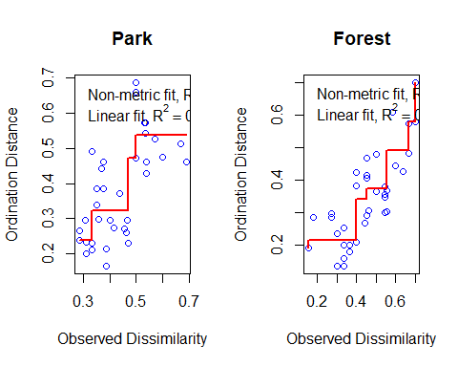

par(mfrow = c(1, 2))  
plot(datp_NMDS, display = "sites", type = "t", main = "Goodness of fit")  
points(datp_NMDS, display = "sites", cex = goodness(datp_NMDS)*200)   
title(main = "Goodness of fit")  
  
plot(datf_NMDS, display = "sites", type = "t", main = "Goodness of fit")  
points(datf_NMDS, display = "sites", cex = goodness(datf_NMDS)*200)   
title(main = "Goodness of fit")

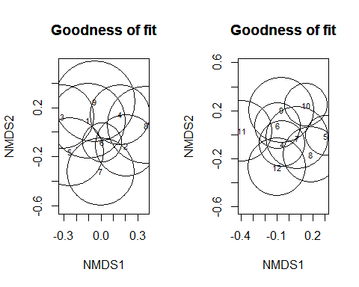

datpclust <- hclust(jparks, method = "complete")  
plot(datpclust, xlab = "", cex = 0.7, ann = FALSE)  
abline(h = 0.78, lwd = 2, col = "black", lty = 2)  
  
datfclust <- hclust(jforest, method = "complete")  
plot(datfclust, xlab = "", cex = 0.7, ann = FALSE)  
abline(h = 0.78, lwd = 2, col = "black", lty = 2)

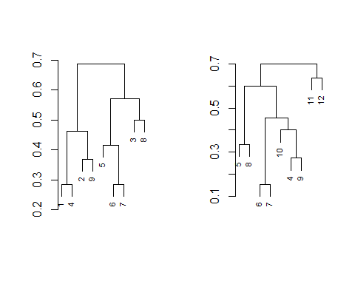

datpclust_3 <- cutree(datpclust, k = 3)  
  
plot(datp_NMDS, display = "sites", type = "n", main = "Park")  
ordihull(datp_NMDS, groups = datpclust_3,  
 draw = "polygon", col = c("#fc8d59", "#ffffbf", "#91bfdb"),  
 label = FALSE)  
points(datp_NMDS, display = "sites", pch = 21, col = "black",  
 bg = c("#fc8d59", "#ffffbf", "#91bfdb")[datpclust_3])  
legend(x = 0.4, y = -0.2, legend = c(paste0("Cl. ", seq(1:3))),  
 col = c("#fc8d59", "#ffffbf", "#91bfdb"), pch = 16)  
  
datfclust_3 <- cutree(datfclust, k = 3)  
  
plot(datf_NMDS, display = "sites", type = "n", main = "Forest")  
ordihull(datf_NMDS, groups = datfclust_3,  
 draw = "polygon", col = c("#fc8d59", "#ffffbf", "#91bfdb"),  
 label = FALSE)  
points(datf_NMDS, display = "sites", pch = 21, col = "black",  
 bg = c("#fc8d59", "#ffffbf", "#91bfdb")[datfclust_3])  
legend(x = 0.4, y = -0.2, legend = c(paste0("Cl. ", seq(1:3))),  
 col = c("#fc8d59", "#ffffbf", "#91bfdb"), pch = 16)

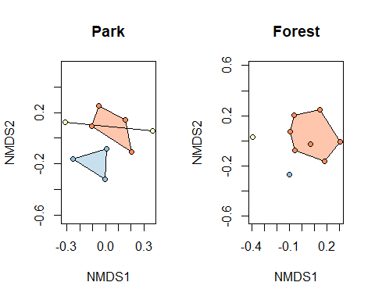

Shannon diversity index

H <- diversity(dat[,4:31], index = "shannon")  
plot(H~dat$site, xlab="Sampling plots", xaxt="n", ylab = "Shannon index")  
axis(1, at=1:6, labels=c("KL","CI","WE","SC","CH","CE"))

