|  |
| --- |
| Kenya  **REPUBLIC OF KENYA**  **MINISTRY OF WATER, SANITATION AND IRRIGATION**  **KENYA WATER SECURITY AND CLIMATE RESILIENCE PROJECT**  **Project No.: P117635 Credit No. IDA 5268 KE** |
| **REVISED DRAFT REPORT**   |  |  | | --- | --- | | |  | | --- | | **REVISED RESETTLEMENT ACTION PLAN NO. 4 (RAP 4) FOR** **TERTIARY CANALS IN LOWER NZOIA IRRIGATION PROJECT WITH LAND OWNERS IN BLOCK 1 TO 4 ALLOWING ACCESS ON THEIR LAND** | | |

**JANUARY 2023**

# EXECUTIVE SUMMARY

The Government of Kenya (GOK) received credit financing from World Bank (WB) and Kreditanstalt für Wiederaufbau (KfW) to implement activities under the Kenya Water Security and Climate Resilience Project (KWSCRP). The objectives of the project are to (a) increase access to irrigation water for project beneficiaries and (b) enhance the institutional framework and strengthen capacity for water security and climate resilience in certain areas of the territory of the Recipient. Four Resettlement Action Plans (RAPs) for phase one of Lower Nzoia Irrigation Development Project [1](LNIDP) which are; RAP 1, 2, 3 and 4 have been prepared and are being implemented.

Land required for the construction of the KWSCRP/ LNIP Tertiary Canals was to be compulsorily acquired and therefore RAP 4 was prepared, approved and disclosed in May 2021 to guide land acquisition and overall resettlement program. However, after detailed consultations that began just before the K1 WB Implementation Support Mission of October 2022, it was agreed that through revisions of the approach and design, the land required to lay the tertiary canals would be significantly reduced. This was to be achieved by redesigning the tertiary canal infrastructure and remove the roads that were originally to be constructed next to the canals. The construction of the tertiary canals and the associated roads using the original design could have necessitated acquisition of 83Acres of land in blocks 1 to 14; a process that had already began with publication of intention to acquire land Kenya Gazette Notice. According to the RAP 4 report, acquisition of land for the construction of tertiary canals and accompanying roads could have resulted to relocation and resettlement of total of 1,253 Project Affected Households (PAHs) with a total of 6,265 Project Affected Persons (PAPs) who are settled and deriving some livelihoods from these areas. Homesteads belonging to 39 PAHs could have been affected and physically relocated.

The reduced scope of land needed to lay the canals under the revised design would ensure that no households and families are physically displaced from their homes as was the case in the original tertiary canal design. The revised design also reduced the needed land for tertiary canals to 30 Acres from the initial 83 Acres thus avoiding adverse impact on 53 acres of land. The land owners were informed that with the revised designs which excludes the roads, there will be no physical displacement and relocation of homesteads and households. In response to this new outlook, with minimal impact, and the semi-private nature of these tertiary canals, it was agreed that land would not be compulsorily acquired, and instead consent will be sought from farmers to access their lands to make these investments, without any transfer of land.

As part of the inter-agency consultations during October 2022, it was acknowledged that National Irrigation Authority general practice in Kenya is in fact not to acquire and own land for the construction of the Tertiary Canals, and that it has mechanisms and experiences in obtaining such informed consent from land owners to lay canals on private land. It was thus considered viable to request the landowners along the tertiary canal alignment who are also direct beneficiaries/ farmers of the project to allow the parabolic tertiary canals to be laid on their land. The parabolic tertiary canals are small productive assets with overall minimal impact with major benefits accruing to the same beneficiary farmers within reasonably short time.

This RAP 4 revision describes the approach going forward for the LNIP Tertiary canal investments, including its guiding principles: minor impact (small percent of any holding and no physical relocation), flexibility in design layout based on consultation and consent and option to withhold consent, prior informed consent and verification of individual claimants to land, compensation for damages during construction, and a functional grievance mechanism.

All costs associated with this revised RAP, as highlighted in the table below, include the provision for contingencies and RAP administration costs to ensure full and speedy implementation of this revised RAP 4. All the costs will be met by the Government of Kenya with the budget allocated to KWSCRP.

Summary of Revised RAP Budget for Blocks 1 to 4

|  |  |  |
| --- | --- | --- |
| **#** | **Block No** | **Verified RAP Budget (Ksh)** |
| 1 | Block 1 | 357,272.00 |
| 2 | Block 2 | 531,724.00 |
| 3 | Block 3 | 715,769.00 |
| 4 | Block 4 | 1,272,481.00 |
|  | **Sub-Total 1** | **2,877,246.00** |
| 6 | Provision for Contingencies | 575,449.12 |
|  | **Sub-Total 2** | **3,452,694.72** |
| 8 | RAP Administration Cost | 345,269.00 |
|  | **Total** | **3,797,964.00** |

After this revised RAP 4 is approved by World Bank, it will replace the original RAP 4 and there will be no land acquisition and all the land parcels which have been gazetted for acquisition by the Government of Kenya will be deleted through publication of the deletion Kenya Gazette Notice. The process of land acquisition is already paused and NLC has been formally notified of the intent to cancel land acquisition. This will void all the subsequent aspects of the land acquisition and resettlement associated with the LNIP tertiary canals in blocks 1 to 14 and should any future land acquisition needs arise in future, this RAP will be revised and updated further to address these changes.

# TABLE OF CONTENTS

**EXECUTIVE SUMMARY i**

**TABLE OF CONTENTS iii**

**LIST OF TABLES iv**

**LIST OF FIGURES iv**

**ANNEXES iv**

**LIST OF ACRONYMS v**

**1 INTRODUCTION 1**

**2 DESCRIPTION OF TERTIARY CANALS UNDER KWSCRP 1 2**

2.1 Measures Taken to Avoid and/or Minimise Project Impacts 3

**3 METHODOLOGY OF GAINING ACCESS PRIVATE LAND TO LAY CANALS 6**

3.1 Process of verification and payments of losses of the affected assets 6

3.2 Valuation methodology for affected developments 7

**4 LEGAL AND POLICY FRAMEWORK 8**

**5 PUBLIC ENGAGEMENT AND DISCLOSURE 11**

**6 SOCIO-ECONOMIC PROFILE OF PAPS AS PER EARLIER DESIGN 15**

6.1 General background 15

6.2 Age distribution 15

6.3 Gender Distribution of Household Heads among the PAPs 16

6.4 Educational Level 17

6.5 Land Ownership 17

6.6 Occupation 19

6.7 Household Incomes 19

6.8 Health and nutrition 20

**7 PROJECT IMPACTS AND MITIGATION MEASURES 21**

7.1 RAP 4 Project Components and impacts 21

7.2 Impacts of laying the Tertiary Canal on the freely accessed private land 21

**8 GRIEVANCE REDRESS MECHANISM 22**

8.1 Overview of Grievance Redress Mechanism 22

8.2 Subject Matter of Grievances / Expected Grievances 22

8.3 Existing LNIP Grievance Mechanism 22

8.3.1 Level One: Locational Committees 22

8.3.2 Level Two: project level grievance 23

8.3.3 Level three: Legal system 24

8.3.4 Grievance flow 25

**9 INSTITUTIONAL FRAMEWORK FOR RAP IMPLEMENTATION 28**

9.1 RAP Disclosure 28

9.2 RAP Implementation 28

**10 RAP IMPLEMENTATION SCHEDULE 29**

**11 MONITORING AND EVALUATION 30**

11.1 Internal monitoring 30

11.2 External Monitoring and Reporting 30

**12 RAP BUDGET 31**

**REFERENCES 33**

**ANNEXES 34**

# LIST OF TABLES

Table 1: Dimensions of Tertiary Canals in Block 1 2

Table 2: Dimensions of Tertiary Canals in Block 2 2

Table 3: Dimensions of Tertiary Canals in Block 3 2

Table 4: Dimensions of Tertiary Canals in Block 4 3

Table 5: Summary of Dimensions Tertiary Canal Components & After redesigning 3

Table 6: Summary of relevant resettlement legal statutes applicable 8

Table 7: Comparative Analysis of World Bank OP 4.12 and Kenyan legislations 9

Table 8: Summary of Sensitization Meetings held in Block 1- 4 on Design Changes 11

Table 9: Current status of the PAPs signing of the consent forms 12

Table 10: Summary of the Issues raised during the land owners’ sensitization meetings 12

Table 11: Summary of Dimensions Tertiary Canal Components & After redesigning 21

Table 12: Number of Parcels and PAPs in Blocks 1 to 4 21

Table 13: RAP Preparation and Implementation schedule 29

Table 14: RAP Monitoring Indicators 30

Table 15:Cost breakdown of affected developments by Tertiary Canal in Blocks 1 to 4 31

Table 16: Summary of Revised RAP Budget for Blocks 1 to 4 32

# LIST OF FIGURES

Figure 1: The sketch below shows a section of the parabolic canal before change of design 4

Figure 2: The sketch below shows a section of the parabolic canal after change of design 4

Figure 3: Demonstration of typical precast & laid parabolic Tertiary Canal structure 4

Figure 4: Layout of LNIP irrigation blocks 5

Figure 5: Age Distribution of Household Heads 16

Figure 6: Gender Distribution of Household Heads 16

Figure 7: Educational Level 17

Figure 8: Land Ownership Documents 18

Figure 9: PAPs with Land Ownership Documents 18

Figure 10: Occupation of the PAPs 19

Figure 11: Monthly Income 20

Figure 12: Grievance tiers 24

Figure 13: Grievance flow diagram 27

# ANNEXES

Annex 1: Minutes of meetings held on reviewed Tertiary canal designs

Annex 2: Signed attendance registrars

Annex 3: Revised Consent Form

Annex 4: Presentation on the Final Tertiary Canal Alignments Report

# LIST OF ACRONYMS

ACK Anglican Church of Kenya

ADR Alternative dispute resolution

AIDS Acquired Immuno-deficiency Syndrome

APDK Association of People with Disabilities of Kenya

DCC Deputy County Commissioner

FGD Focused Group Discussions

GPS Geographical Positioning System

GRM Grievance Redress Mechanism

HH Household Head

HIV Human Immuno Virus

ID Identity card

ISC Implementation Support Consultants

IWUA Irrigation Water Users Association

KCSE Kenya Certificate of Secondary Education

KNBS Kenya National Bureau of Statistics

KRA Kenya Revenue Authority

KWSCRP Kenya Water Security and Climate Resilience Project

LNIP Lower Nzoia Irrigation Project

LRCC Locational Resettlement and Compensation Committees

LRP Livelihood Restoration Programmes

M&E Monitoring and Evaluation

MOF Ministry of Finance

NGOs Non-governmental organizations

NIA National Irrigation Authority

NLC National Land Commission

O & M Operation and Maintenance

OP Operational Policy

PAPs Project Affected Persons

PASW Predictive Analytics Software

PWDs Persons with Disability

PIU Project Implementation Unit

PMU Project Monitoring Unit

RAP Resettlement Action Plan

RPF Request for Proposal

SPSS Statistical Packages for Social Sciences

SCSDO Sub County Social Development Officers

TOR Terms of Reference

USD United States Dollar

UTM Universal Transverse Mercator

1. **INTRODUCTION**

Land required for the construction of the Tertiary Canals under KWSCRP was to be compulsorily acquired and therefore RAP 4 was prepared, approved and disclosed in May 2021 to guide land acquisition and overall resettlement program. However, after detailed consultations that began just before the KWSCRP WB Implementation Support Mission of October 2022, it was agreed that through revisions of the approach and design, the land required to lay the tertiary canals would be significantly reduced. This was to be achieved by redesigning the tertiary canal infrastructure and remove the roads that were originally to be constructed next to the canals. The construction of the tertiary canals and the associated roads using the original design could have necessitated acquisition of 83Acres of land in blocks 1 to 14; a process that had already began with publication of intention to acquire land Kenya Gazette Notice. According to the RAP 4 report, acquisition of land for the construction of tertiary canals and accompanying roads could have resulted to relocation and resettlement of total of 1,253 Project Affected Households (PAHs) with a total of 6,265 Project Affected Persons (PAPs) who are settled and deriving some livelihoods from these areas. Homesteads belonging to 39 PAHs could have been affected and physically relocated.

The reduced scope of land needed to lay the canals under the revised design would ensure that no households and families are physically displaced from their homes as was the case in the original tertiary canal design. The revised design also reduced the needed land for tertiary canals to 30 Acres from the initial 83 Acres thus avoiding adverse impact on 53 acres of land. The land owners were informed that with the revised designs which excludes the roads, there will be no physical displacement and relocation of homesteads and households. In response to this new outlook, with minimal impact, and the semi-private nature of these tertiary canals, it was agreed that land would not be compulsorily acquired, and instead consent will be sought from farmers to access their lands to make these investments, without any transfer of land.

As part of the inter-agency consultations in October 2022, it was acknowledged that National Irrigation Authority general practice in Kenya is in fact not to acquire and own land for the construction of the Tertiary Canals, and that it has mechanisms and experiences in obtaining such informed consent from land owners to lay canals on private land. It was thus considered viable to request the land owners who are also direct beneficiaries/ farmers of the project to allow the parabolic tertiary canals to be laid on their land. The parabolic tertiary canals are small productive assets with overall minimal impact with major benefits accruing to the same beneficiary farmers within reasonably short time. This RAP 4 revision describes the approach going forward for the Tertiary canal infrastructure, including its guiding principles: minor impact (small percent of any holding and no physical relocation), flexibility in design layout based on consultation and option to withhold consent, prior informed consent and verification of individual claimants to land, compensation for damages during construction, and a functional grievance mechanism.

1. **DESCRIPTION OF TERTIARY CANALS UNDER KWSCRP 1**

The dimensions of the width required for laying the permanent structures and the working areas in block 1 to 4 varies from one tertiary canal to another as shown on the tables below. The Government of Kenya intends to adopt the same approach for the tertiary canals in the subsequent blocks and the related impacts will be reassessed as and when the finance is available with NIA to construct the remaining tertiary canals.

Table 1: Dimensions of Tertiary Canals in Block 1

| **Tertiary Name** | **Length (m)** | **Width for parabolic construction (permanent structure laid)** | **Additional width required for working corridor*(m) (temporary access)[2]** |
| --- | --- | --- | --- |
| TC 1.1 | 2 | 1.62 | 4.38 |
| TC 1.2 | 77 | 1.62 | 4.38 |
| TC 1.3 | 120 | 1.95 | 4.05 |
| TC 1.4 | 317 | 1.62 | 4.38 |

Table 2: Dimensions of Tertiary Canals in Block 2

|  |  |  |  |
| --- | --- | --- | --- |
| **Tertiary name** | **Length (m)** | **Width for parabolic construction (permanent structure laid)** | **Additional width required for working corridor*(m) (temporary access)** |
| TC 2.1 | 82 | 1.62 | 4.38 |
| TC 2.2 | 76 | 1.77 | 4.23 |
| TC 2.3 | 183 | 1.62 | 4.38 |
| TC 2.4 | 287 | 1.77 | 4.23 |
| TC 2.5 | 435 | 1.95 | 4.05 |
| TC 2.6 | 391 | 1.77 | 4.23 |

Table 3: Dimensions of Tertiary Canals in Block 3

|  |  |  |  |
| --- | --- | --- | --- |
| **Tertiary name** | **Length(m)** | **Width for parabolic construction (permanent structure laid)** | **Additional width required for working corridor*(m) (temporary access)** |
| TC 3.1 | 555 | 1.95 | 4.05 |
| TC 3.2 | 770 | 1.77 | 4.23 |
| TC 3.3 | 1078 | 2.20 | 3.80 |

Table 4: Dimensions of Tertiary Canals in Block 4

|  |  |  |  |
| --- | --- | --- | --- |
| **Tertiary name** | **Length(m)** | **Width for parabolic construction (permanent structure laid)** | **Additional width required for working corridor*(m) (temporary access)** |
| TC 4.1 | 6 | 1.62 | 4.38 |
| TC 4.2 | 5 | 1.62 | 4.38 |
| TC 4.3 | 231 | 1.77 | 4.23 |
| TC 4.4 | 155 | 1.62 | 4.38 |
| TC 4.5 | 3502 | 2.37 | 3.63 |
| TC 4.6 | 289 | 1.95 | 4.05 |

* 1. **Measures Taken to Avoid and/or Minimise Project Impacts**

The tertiary canals were realigned to avoid homesteads to reduce the impacts on settlements. Secondly, the canals have been designed along existing access roads to avoid acquiring land for access roads. The revised design also reduced the needed land for tertiary canals to 30 Acres from the initial 83 Acres thus avoiding adverse impact on 53 acres of land as explained in the table and figures below. This was achieved by reducing the width of the tertiary canal infrastructure and remove the roads that were originally to be constructed next to the canals.

Table 5: Summary of Dimensions Tertiary Canal Components & After redesigning

|  |  |  |  |
| --- | --- | --- | --- |
| **#** | **Description of the Dimensions** | **Canals without Roads (Revision of RAP 4)** | **Canals with Roads (Original RAP 4)** |
| 1. | Total length of the Tertiary canals | 45Km | 45Km |
| 2. | Width of the Tertiary Canals Block 1 | 1.62m – 1.95m | 1.62m – 1.95m |
| 3. | Width of the Tertiary Canals Blocks 2 to 14 | 1.62m – 3.13m | 6.52m |
| 4. | Affected land size | 30Acres | 83Acres |

Figure 1: The sketch below shows a section of the parabolic canal before change of design

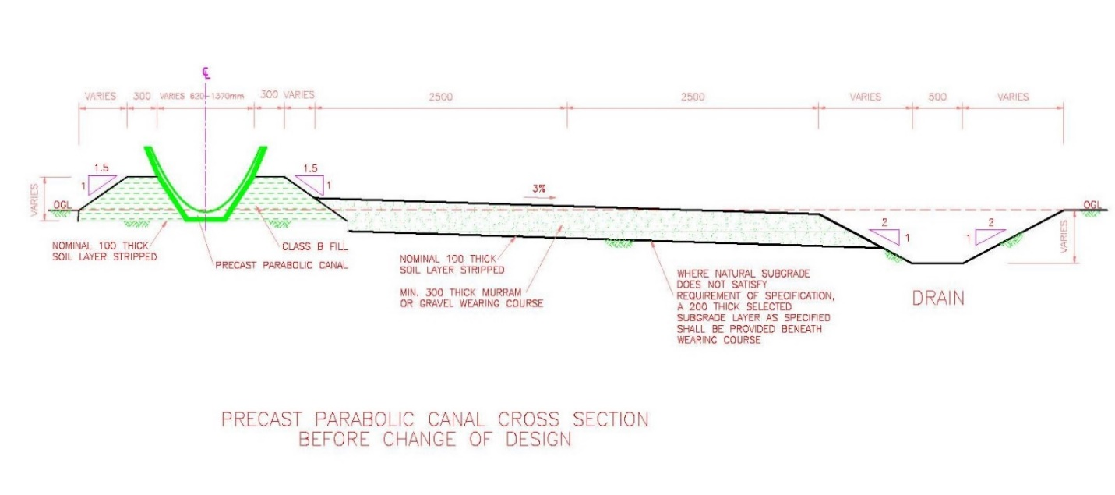

Figure 2: The sketch below shows a section of the parabolic canal after change of design

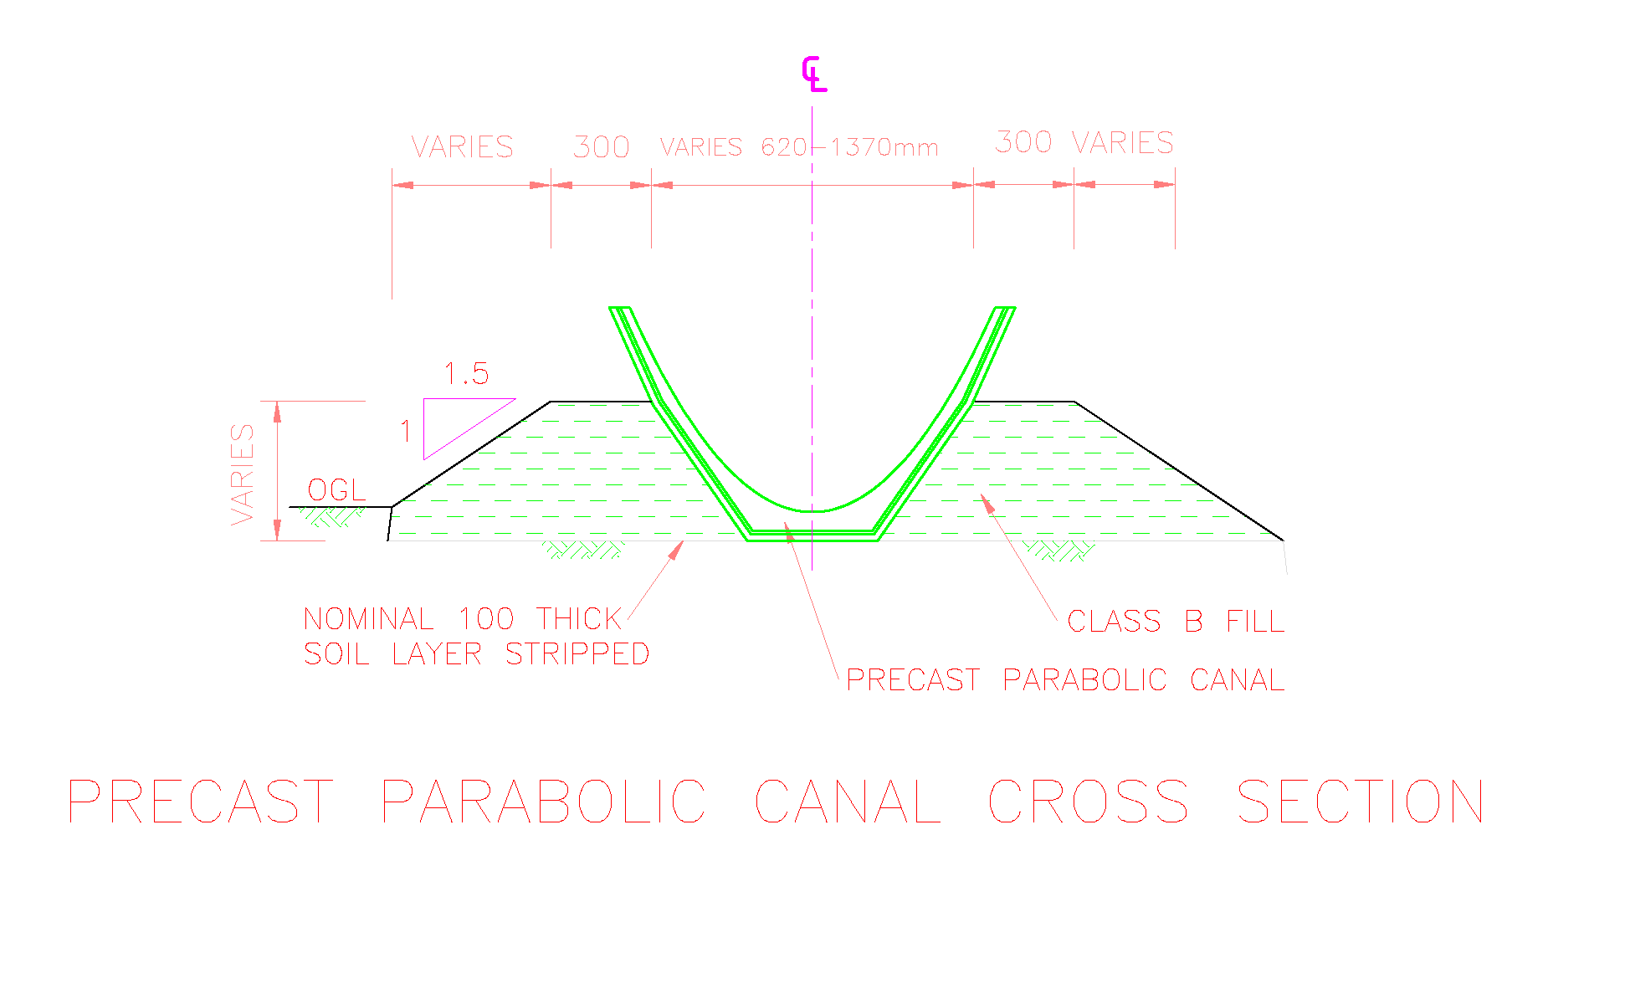

Figure 3: Demonstration of typical precast & laid parabolic Tertiary Canal structure

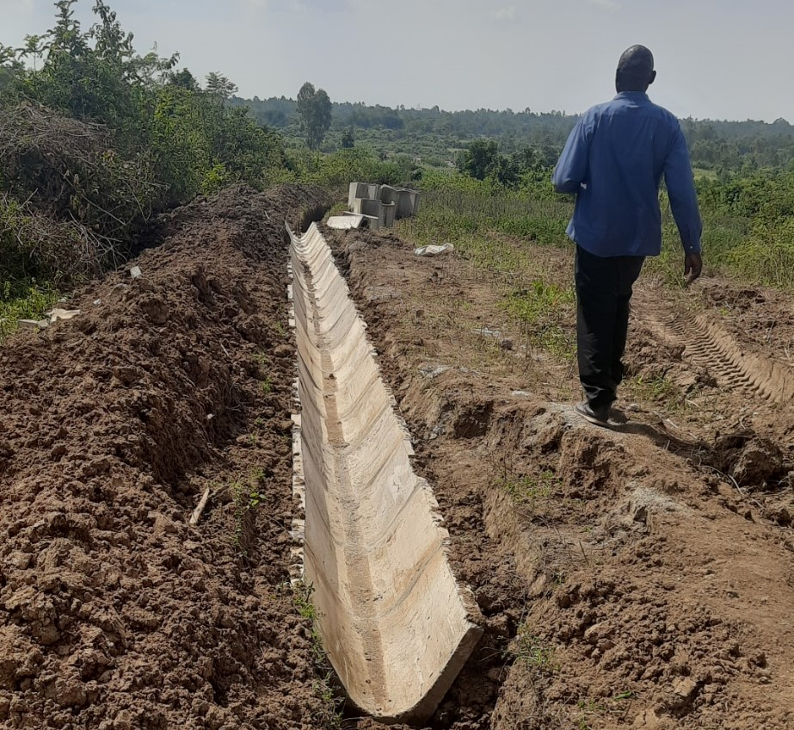

Figure 4: Layout of LNIP irrigation blocks

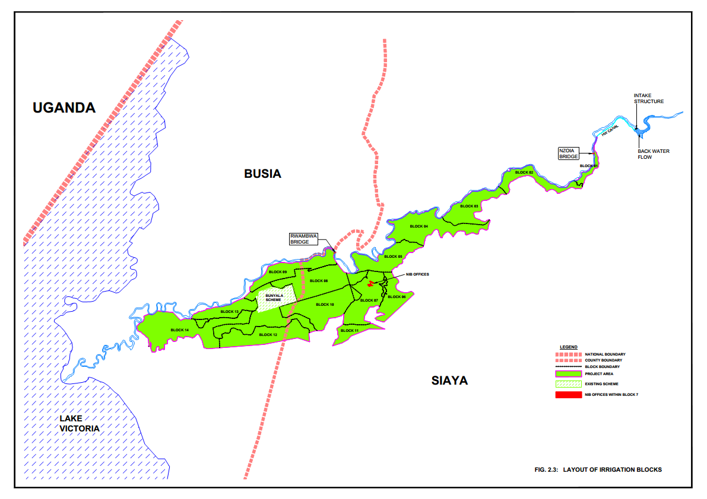

1. **METHODOLOGY OF GAINING ACCESS PRIVATE LAND TO LAY CANALS** 
   1. **Process of verification and payments of losses of the affected assets**

Following the revised design, the ground locations where the tertiary canals are to be laid has been determined by the ISC team led by the surveyor in previous project activities that involved engagements with the landowners and beneficiary farmers who are also members of the IWUAs. The tertiary canals redesign and related field surveys activities were caried out in early October 2022. The new designs were used to sensitize the farmers and stakeholders. Thereafter broad PAP mobilization /consultations were done from mid-October 2022 and were subsequently followed by individualized PAP consultations that were part of identification, verification of losses, seeking consent and signing of consent forms that took place from mid-October 2022 to end of December 2022. Hence, all the owners of the land where the tertiary canals will be laid are aware of the government intention to lay the canals on their land. After an advance notice to the land owners and upon mobilizing all the interested parties of the developments on the affected sections of each parcel of land, the project team began the verification of each tertiary canal on the ground and documenting the full description of the developments that are affected on its width including on the temporary working areas.

The field verification of the affected assets which typically comprise of crops, trees and fences within the Tertiary Canal width areas and the working area will be conducted jointly by NIA, PMU, chairman block and area chief. The description and values of the verified assets will be listed in the consent forms that will then be individually signed by the PAPs. The legal ownership of land has already been confirmed from the official land searches that had been obtained from the Siaya Land Registry during the previously intended land acquisition process. The owner of developments on land is deemed to be the undisputed known owner of the affected assets on land during the field verification process. Ownership of the developments on land could be by having planted or erected the affected fence or structure or could be by inheritance from parents or other relatives. Affected development is any planted or erected improvements on the 6m width of the land to be affected during the laying of the Tertiary Canal and it includes the area required for laying the permanent Tertiary Canal structures and the contractor working areas as outlined in Tables 1 to 4.

In cases where the owner of developments on land is not the registered legal owner of land, this scenario will be documented on the Consent Form. Both the land owner and the development owner will sign the form stating that the due payments for damages/affected assets will be made to the owner of developments on land (even though she or he does not legally own the land on which the affected assets are erected or planted). After signing the consent forms, the owners of affected developments will be paid the amounts of money as agreed and indicated on individual consent forms to help them reinstate and restore their affected developments. Where the landowner does not own any affected development on the land (affected development is claimed/ owned by another separate PAP) or the affected section of land is empty/ bear land (with no erected nor planted development), the PAP will sign a consent form giving assess to the land without any monetary value being paid to him.

Where the ownership of any affected development is disputed and cannot be resolved during the field verification exercise or a PAP is dissatisfied by any aspect in the asset verification and payments of the affected assets, the grievances will be expeditiously referred to the project level GRM for hearing and resolution.

* 1. **Valuation methodology for affected developments**

The valuation methodology of the affected crops adopted local rates from the State Department of Agriculture at the time of valuation in 2021 with no significant inflation considered during the last one year and taking into account acreage of each particular crop with an emphasis to ensure full replacement cost.

For affected trees, the valuation adopted the local KFS (Kenya Forestry Services) rates, considering the age factor for trees. All the rates adopted reflects the market rates of 2021 with no significant inflation considered over the last one year. The crops within the project area are categorized into two major categories:

* Annual crops - crops that complete their growing season within one year.
* Perennial crops - crops that go through their entire life cycle, in two or more years. Perennial crops are harvested multiple times before their death.

1. **LEGAL AND POLICY FRAMEWORK**

This section describes the legal operating environment for acquisition of land as was anticipated in the overall the implementation of the LNIP. The chapter highlights major issues related to land legislation in Kenya and WB policies with regards to involuntary resettlement that are necessitated by compulsory land acquisition (which is not being done for the Tertiary Canals). It provides a brief overview of the Kenya land policy, and the Kenya’s constitutional provisions related to land use, planning, acquisition, management and tenure, and more specifically the legislations related to land expropriation or acquisition, land valuation and land replacement.

Due to the new approach where the land owners freely give consent for the government to access and lay Tertiary Canals on their land, the parcels which had been published in a previous intention to acquire Kenya Gazette Notice will be deleted. After this RAP report is approved, a deletion Kenya Gazettee Notice will be published notifying the landowners and the general public that the government would no longer be acquiring any land for the construction of Tertiary Canals. Although there is no voluntary land donation as the land owners give free access to their land for the laying of the Tertiary Canal and allowing project to construct semi-private assets, same mitigation measures have been put in place: it has been confirmed that any investment represents only minor impact (small percent of any holding and no physical relocation); there is flexibility in design layout based on consultation and consent; there is the option to withhold consent, all land and property owners are consulted and provided information for prior informed consent and verification of individual claimants to land; compensation is paid for damages during construction and for affected developments (e.g. fences, hedges), and the existing functional grievance redress mechanism applies to this scope of work.

Table 6: Summary of relevant resettlement legal statutes applicable

| **Legal Framework** | **Functional Relationship Land Acquisition** |
| --- | --- |
| Constitution of Kenya 2010 | Constitution of Kenya 2010 recognizes individuals’ right to acquire and own property provided they are citizens of the country in article 40. However, Article 66 of the same Constitution provides for the State to regulate the manner in which these rights may be curtailed for the benefit of the general public. Article 47 of the Constitution provides for administrative action to override the individual rights but the victim has to be given written reason for the action taken that undermines the right. |
| Environment and Land Court Act, 2011 | Article 162 of the constitution provides for the creation of specialized courts to handle all matters on land and the environment. Such a court will have the status and powers of a High Court in every respect. Article 159 on the principles of judicial authority, indicates that courts will endeavour to encourage application of alternative dispute resolution mechanisms, including traditional ones, so long as they are consistent with the constitution. Section 20, of the Environment and Land Court Act, 2011 empowers the Environment and Land Court, on its own motion, or on application of the parties to a dispute, to direct the application of alternative dispute resolution (ADR), including traditional dispute resolution mechanisms. |
| The Land Act 2012 | It is the substantive law governing land in Kenya and provides legal regime over administration of public and private lands. It also provides for the acquisition of land for public benefit. The government has the powers under this Act to acquire land for projects, which are intended to benefit the general public. The projects requiring resettlement are under the provision of this Act. |

In this regard, a deletion Kenya Gazettee Notice will be published notifying the landowners and the general public that the government would no longer be acquiring any land for the construction of Tertiary Canals.

Table 7: Comparative Analysis of World Bank OP 4.12 and Kenyan legislations

| **World Bank OP 4.12** | **Kenyan Legislation** | **Comparison** | **Agreed approach to Address Gap** |
| --- | --- | --- | --- |
| World Bank OP4.12 has overall policy objectives, requiring that:  Involuntary resettlement should be avoided wherever possible, or minimized, exploring all alternatives.  Resettlement programs should be sustainable, include meaningful consultation with affected parties, and provide benefits to the affected parties.  Displaced persons should be assisted in improving livelihoods etc., or at least restoring them to previous levels. | According to Kenyan Legislation, involuntary resettlement may occur as a result of projects implemented in public interest.  The Land Act, 2012 Act outlines procedures for sensitizing the affected population to the project and for consultation on implications and grievance procedures.  The Land Act 2012 guarantees the right to fair and just compensation in case of relocation. | The Land Act does not stipulate that resettlement should be avoided wherever possible; on the contrary, as long as a project is for public interest, involuntary resettlement is considered to be inevitable.  Same as the World Bank  Just and fair compensation as outlined in the Land Act 2012 is not clear and can only be determined by NLC, which can be subjective. It does not talk about improving livelihood or restoring them to pre-project status. | With the revised designs that have reduced footprint, there will be no physical nor economic displacement. World Bank OP 4.12 provisions on involuntary resettlement occasioned by compulsory land acquisition will therefore not apply. Should Land Acquisition needs arise in future, the RAP will be revised and updated accordingly  Principles of OP 4.12 apply and the approach is designed according to para 2(a) “Involuntary resettlement should be avoided where feasible, or minimized, exploring all viable alternative project designs”.  The landowners will give free access to the land through signing of consent forms which include payment for damages to developments by the Ministry of Water teams as the private land is accessed and tertiary canals laid on the land. The parcels of land which the government had intended to acquire by the publication of intention to acquire land Gazette Notice will be deleted through a deletion Kenya Gazette Notice and the land will henceforth remain registered property of the current land owners.  There will be no loss of livelihoods by the laying of the tertiary canals on the limited space but instead the availability of irrigation water will greatly improve the overall livelihoods and income levels of the farming communities in the project areas. While the approach is not involuntary resettlement nor voluntary land donation, principles for voluntary land donation are applied. |

1. **PUBLIC ENGAGEMENT AND DISCLOSURE**

With the change in the design and overall approach, owners of land that had been earmarked for acquisition for construction of the tertiary canals in blocks 1 to 4 were engaged by PMU and NIA PIU Staff in October 2022 with the view of informing them of the new approach and to request them to give access to their land for the Tertiary Canals to be laid.

Table 8: Summary of Sensitization Meetings held in Block 1- 4 on Design Changes

|  |  |  |  |  |  |  |
| --- | --- | --- | --- | --- | --- | --- |
| **Block** | **Date** | **Venue** | **Gender** | |  | **Total** |
| **Male** | **Female** | **Vulnerable Women (Widows)** |
| 1 | 18/10/2022 | Sango Market | 12 | 5 | 1 | 18 |
| 2 | 19/10/2022 | Rabar Market | 17 | 3 | 4 | 24 |
| 3 | 21/10/2022 | Nyabera Baraza Site | 28 | 4 | 7 | 39 |
| 4 | 24/10/2022 | Nduru Market | 17 | 2 | 16 | 35 |
| **Total** | | | **74** | **14** | **28** | **116** |

Although 116 PAPs attended the initial sensitization meetings held in October 2022, a total of 180 PAPs (entire PAP population affected by Tertiary Canals in blocks 1 to 4) were consulted at individual PAP level during the field asset verification and consent signing process between October and December 2022. Consultation with PAPs and other stakeholders has been a continuous process that started during RAP preparation and will continue into RAP Implementation. With the continuing consultations and sensitization on the new RAP approach in the 4 blocks, 153 PAPs have signed consent forms that allows the laying of the canals on their land. However, one (1) landowner on currently design Tertiary Canal 1.3 route declined to allow free access to his land and demanded to be paid the anticipated compensation. He was reminded that there will be no compulsory land acquisition for Tertiary Canals and a deletion Kenya Gazette Notice will be published.

The benefits that would accrue to the land owners who allowed connection of their land to irrigation water through the Tertiary canals was presented and was well received. The benefits that accrued to the farmers include having access to irrigation water within a reasonably shorter time as compared to the lengthy NLC process that strictly follows the Land Act. Access to irrigation water would increase their annual crop production as they will be freed from solely depending on rainfed agriculture. The revised design also reduced the needed land for tertiary canals to 30 Acres from the initial 83 Acres thus avoiding adverse impact on 53 acres of land. The 53 acres is valuable productive land which the farmers will utilize for irrigated agriculture when they get the water through the reduced scope of the tertiary canals. The first lot of farmers could also receive the irrigation water and start utilizing the water as soon as the connections are completed and before the end of the project financing period which ends on 31 December 2022. Negative impacts associated with this process include the temporary social disruptions due to the presence of construction teams on private land and loss of productive land where the tertiary canals will be laid permanently.

However, he was assured that as and when he accepts to give free access for the laying of the canal on his land in future, all he will need to do is sign the consent form for laying the parabolic canal. If this land owner does not give free consent for access within reasonable time, the project will approach and consult other neighboring land owners and when they agree to give free access, the canal Tertiary Canal 1.3 will be redesigned to avoid the dissenting farmer’s land. Any further consultations, realignment of the Tertiary Canal 1.3 and seeking consent from other willing and consenting land owners will take approximately 4 weeks and it is expected that this will have been completed by mid-February 2023. Table below shows the current status of the PAPs allowing accesses and signing of the consent forms hence allowing the laying of Tertiary Canals.

Table 9: Current status of the PAPs signing of the consent forms

|  |  |  |  |  |  |
| --- | --- | --- | --- | --- | --- |
| **Block No** | **No. of Parcels** | **No. of PAPs** | **No. of PAPs who have given Consent** | **Consent Forms Signed** | **Consent Forms yet to be Signed** |
| Block 1 | 7 | 7 | 6[3] | 6 | 0 |
| Block 2 | 15 | 15 | 15 | 15 | 0 |
| Block 3 | 32 | 32 | 32 | 32 | 0 |
| Block 4 | 106 | 126[4] | 126 | 100 | 26 |
| **Total** | **168** | **180** | **179** | **153** | **26** |

The land owners were also informed that with the revised designs which excludes the roads, there will be no physical displacement and relocation of homesteads and households. The land owners will legally retain the ownership of the land where the tertiary canals will be laid and there will be no form of written or implied land transfer from the farmers to the Government. The PAPs are identified through a ground verification process described in section 3.1 of this report. The ownership of land has already been confirmed from the official land searches that had been obtained from the Siaya Land Registry during the previously intended land acquisition process that began after the RAP 4 was prepared. They were informed that all the land parcels which the Ministry of Water, Sanitation and Irrigation (MoWSI) had submitted to NLC and Kenya Gazette Notices for intention to acquire published will be nullified through the publication of a deletion Kenya Gazette Schedule to demonstrate that MoWSI has no intention of acquiring land for the tertiary canals in any of the blocks. The summary of the issues that arose during the consultation meetings are presented in Table 10 below.

Table 10: Summary of the Issues raised during the land owners’ sensitization meetings

| # | **Issue Raised by Asset owners** | **Response on Way Forward** |
| --- | --- | --- |
| 1 | **What happened to the compensation?**  The farmers wanted to know what happened to the previously agreed-upon compensation and why it wasn’t being done as was done for other canals. | The farmers were informed that due to the project coming to an end in December 2022, it was carefully observed that the ongoing compulsory land acquisition for the Tertiary canals that was being undertaken by the National Land Commission (NLC) would impede any project progress due to the duration it was taking and as had been similarly witnessed in other LNIP components. To overcome these impendent, tertiary canals were redesigned to remove the access roads and their land take requirements and, in essence, reduce the land needed for the tertiary canal’s infrastructure. The land corridor was reduced from 6m to approximately 2m. This reduced land size could be contributed by the farmers to allow the timely construction tertiary canals and the provide irrigation water to the farmers within reasonable time and before the expiry of the credit financing period. |
| 2 | **What of the damages incurred during construction?**  The farmers noted that the tertiary canals ran through some property and wanted to know whether also this property damage would not be compensated. | The farmers were assured that due to the reduced corridor, a canal's path would be redesigned to ensure minimal damage was incurred by the farmers. However, in cases where the damage cannot be avoided, the National Irrigation Authority (NIA) will cater for the damages through a compensatory payment. To enable this, an assessment and evaluation of the any affected assets will be undertaken by project teams lead by NIA so as to know and pay the assets owner the replacement value of the damaged assets. In addition, it was made clear that this payment wasn't for land acquisition but for the damages the farmers might incur while the contractors laid the tertiary canals on private land. The corridor being considered in this compensatory payment will be 2m plus the working space required to lay the canals with a maximum width of 6m to accommodate the temporary working areas. |
| 3 | **Will there be a written agreement?**  The farmers wanted to know how they would be assured of payment for the damages incurred and from whom to expect the payment. In addition, what is the expected timeline for these activities to be done? | After the assessment and evaluation, the farmers were assured that an agreement would be made between the asset owners and the project. The agreement could be by signing of consent forms between affected asset owners and NIA. NIA will be in charge of paying for any damages incurred while laying the tertiary canals. The timeline given depended on the signing of the consent by the asset owners. The consent agreement will include the following: The details of the affected assets and their value and when the payment will be made, and through what means. The land owners could also consent to not hindering water flow after tertiary canal construction. The consent form will also have details of the owners of the land parcel on which the canals are laid. |
| 4 | **What happens to the land gazetted for acquisition?**  The farmers wanted to know how they'll be assured that their land was still theirs despite already being gazetted for acquisition. | The farmers were assured that MoWSI will instruct NLC to publish a Kenya Gazette Notice to delete all the parcels that had been published with intention to acquire land for the Tertiary Canals. The deletion Gazette Notice will be the indication that there is no intention to acquire any land for the construction of the Tertiary Canals. Once the gazette has been published, the farmers/ land owners will be provided with a copy. |

1. **SOCIO-ECONOMIC PROFILE OF PAPS AS PER EARLIER DESIGN**

Using the former Tertiary Canal design, the socio-economic survey was conducted for all then 1,253 project affected households during the 100% census in 2021 during the RAP 4 preparation phase. The socioeconomics set up and characteristics of the PAPs does not change with the change in the design and hence the following section reflect the socio-economic baseline of PAPs in Blocks 1 to 4.

The socio-economic baseline presented in this section includes data on project household demographics, education, livelihoods, health and nutrition and basic services and community facilities. The data forms the basis of a better understanding of the structure and make-up of affected households, their livelihoods practices adopted to secure household food needs and income; as well as providing a baseline for evaluating the success of livelihood restoration support.

* 1. **General background**

Siaya County which has a land surface area of 2,530km² and water surface area is 1,005 km2. With a total population estimated to be 885,762 persons (KNBS 2012 Population projections) comprising of 419,227 males and 466,535 females. Administratively, there is a County Commissioners in charge of Siaya County and similarly there are 2 Deputy County Commissioners in charge of Ugenya and Ugunja Sub Counties assisted by Assistant County Commissioners and followed by chief and assistant chiefs at location and Sub-locations levels respectively. Every village is led by an elder appointed by the Chief or Assistant Chief to assist in matters that are important in public administration, such as maintaining public order, implementation of government policies, dispute resolution and providing overall leadership to the communities in the area of jurisdiction. Most recently under the Nyumba Kumi initiative, a peace committees and Huduma Committees have been set up and each of these are led by a Chairman who also reports directly to the Assistant Chief on peace and development matters respectively. The Chief, Assistant Chiefs and those working under him/her act as the bridge between the government and the people. Chiefs are generally respected by the community members. This hierarchy of leadership forms part of the Institutional Framework for the RAP implementation. This administration plays a significant role in dispute resolution, issuance of letters of confirming property ownership and therefore they chair the grievance committees at Location and Sub-Location level.

* 1. **Age distribution**

From the survey the age distribution of the respondents is as follow: 8.7 % (0-5yrs), 32.1 % (5-18yrs), 32.2 % (19-35yrs), 16.7 % (36-49yrs), 8.2 % (49-65yrs) 2.2% (65 yrs and above. The majority of PAPs are aged 65years and below. However, it important to note that no aged PAP considered to be vulnerable shall be relocated.

Figure 5: Age Distribution of Household Heads

*Source: Household interview*

* 1. **Gender Distribution of Household Heads among the PAPs**

It was noted that affected households include female household heads which make up 48% of PAHs. These include widows who form the lager group in this category of female household heads while the others are separated or single women. In the RAP widows fall under the category of vulnerable groups so that they are not disinherited during compensation. During discussions with opinion leaders and FGDs in the project area the fate of widows in the payment process featured prominently. This is because widows often lose land to the late husband’s extended family who claim land and other assets. Additionally, illiterate widows and vulnerable assets owners will be supported go through assets verification, consent signing and payment procedures. Each PAP/ eligible development owner will sign the consent form and be paid for what is undisputedly his or hers even if they do not legally own the land on which the affected developments are erected or planted.

Figure 6: Gender Distribution of Household Heads

*Source: Household interview*

* 1. **Educational Level**

Majority (49%) of the respondents have attained primary education. Only 12 % of the respondents are illiterate. Education is essential in empowering people to take advantage of opportunities. During the community introductory meetings what came out clearly is that they have capacity to interrogate information given and even how it affects and serves the people and this can be attributed to the fact that they are educated. It is assumed that the educated can effectively articulate their issues and understand information passed on to them, they can participate in socio economic development initiatives and they can be trained as trainers on new farming technologies and agribusiness. But the RAP implementation committee will need to support 12% illiterate PAPs who may require special attention in order to make sure that their interests are well articulated during compensation.

Figure 7: Educational Level

*Source: Household Data*

* 1. **Land Ownership**

The land tenure system in the community is freehold. The Communities in the project region are primarily patrilineal and therefore the men own land and inheritance of any form of property is clearly defined along male lines of descendants. The man is the households’ head and owns the land. From a cultural stand point a woman does not own land and may not inherit land even when the husband is deceased. Only 37 % of the PAPs own the land while 63% do not own the land. Further, only 29% of the PAPs have land ownership documents while 71 % do not have. However, as part of land survey work done in this area, the ownership of land has already been confirmed from the official land searches that had been obtained from the Siaya Land Registry during the previously intended land acquisition process. The owner of developments on land is deemed to be the undisputed known owner during the field verification process. Ownership of the developments could be by having planted or erected the affected development(s) or could be by inheritance from parents or other relatives. Affected development on land is any planted or erected improvements on the 6m width of the land to be affected during the laying of the tertiary canal and it includes the area required for laying the permanent Tertiary Canal structures and the contractor working areas as outlined in Tables 1 to 4.

There will be no change in land ownership occasioned by the Tertiary canal design changes. The landowners will give free access to the land through signing of consent forms which include payment for damages to developments by the GoK (with the budget allocated to KWSCRP) as the private land is accessed and tertiary canals laid on the land. The parcels of land which the government had intended to acquire by the publication of intention to acquire land Gazette Notice will be deleted through a deletion Kenya Gazette Notice and the land will henceforth remain registered property of the current land owners.

Figure 8: Land Ownership Documents

Figure 9: PAPs with Land Ownership Documents

* 1. **Occupation**

The main sources of income for most 88.9 % of the respondents are subsistence farming. However, these are subsistence farmers’ using rudimentary methods of farming only to face various challenges in crop production even as they rely on low and unreliable rainfall, and as inferred in the FGDS, certified seeds, fertilizer and farm inputs are hardly used. From key informant interviews rainfall is inadequate at below 500 mm/year and also unreliable especially for maize farming in project areas. Only 2.5 % of the PAPs are in formal employment. Other income sources include livestock farming (7%) and business (5.8%).

Figure 10: Occupation of the PAPs

* 1. **Household Incomes**

The survey shows that majority (88%) of the respondents have income of less than Kshs. 15,000 per month. This is drawn mainly from crop farming. Poverty level is taken as that of Siaya County, which is around 48% (County Integrated Development Plan 2013 - 2017) and higher than the national average of 34 per cent, hence considered as high. The causes of poverty in these areas are diverse and include poor soil fertility leading to low farm yields, low income among households to afford farm inputs, over-reliance on traditional methods of farming and lack of alternative sources of income. Income sources include livestock, fishing, formal and informal employment, business, remittances, pensions, etc. There exists food insecurity at the household level as farmers are unable to produce enough under rain-fed conditions due to the unpredictable weather patterns and from the interviews most household expenses are high on food as the harvest is not adequate to meet household food security needs. Successful irrigated farming will increase food production. There will be no loss of livelihoods by the laying of the tertiary canals on the limited space but instead the availability of irrigation water will greatly improve the overall livelihoods and income levels of the farming communities in the project areas

Figure 11: Monthly Income

* 1. **Health and nutrition**

There exists a health facility in each of the Sub-Locations and within reasonable proximity (< 5 Km). Most common disease is malaria (93%) followed by other water borne diseases (31%) which include Diarrhea, Typhoid, Cholera and Amoeba calling for measures to ensure water treatment combined with sanitation improvements. Cases of Covid-19 infections were also reported in the County with some patient being admitted in Siaya County referral Hospital, while some were put in isolation under home-based care. The actual number of Covid -19 patients in the County was not established in this study. HIV/AIDS is at 20% and is a major challenge as it is appreciably higher than the national prevalence of 6.2% (rate in Siaya County is 17.8%). There exists poor nutrition in the area and there is an outreach program by the Community Health Volunteers/Health Committees in collaboration with AMREF which provides food/nutrition supplements to affected children. According to the latest KDHS Report (2008-09), 34% of children below 5 years of age in Western region, including Siaya are food insecure due to poverty and inadequate food particularly for children.

1. **PROJECT IMPACTS AND MITIGATION MEASURES**
   1. **RAP 4 Project Components and impacts**

This revised RAP 4 includes the Tertiary canals which will be laid on privately owned land after the land owners give free access to the land

* 1. **Impacts of laying the Tertiary Canal on the freely accessed private land**

Although there will be no land acquisition and no physical displacement of households due to the construction of the parabolic tertiary canals and all residential structures will be avoided, there will be loss of trees, fences, crops which will be within the width for parabolic canal construction (permanent structure) and additional width required for the working corridor which is temporary access). The width of the corridor required for laying the permanent structures and the working areas in block 1 to 4 varies from one tertiary canal to another as shown on the tables below. If there be future tertiary canals design changes that would necessitate land acquisition, the related impacts will be reassessed, this RAP revised and updated further to document and address these changes and related impacts.

Table 11: Summary of Dimensions Tertiary Canal Components & After redesigning

|  |  |  |  |
| --- | --- | --- | --- |
| **#** | **Description of the Dimensions** | **Canals without Roads (Revision of RAP 4)** | **Canals with Roads (Original RAP 4)** |
| 1. | Total length of the Tertiary canals | 45Km | 45Km |
| 2. | Width of the Tertiary Canals Block 1 | 1.62m – 1.95m | 1.62m – 1.95m |
| 3. | Width of the Tertiary Canals Blocks 2 to 14 | 1.62m – 3.13m | 6.52m |
| 4. | Affected land size | 30Acres | 83Acres |

Table 12: Number of Parcels and PAPs in Blocks 1 to 4

|  |  |  |
| --- | --- | --- |
| **Block No** | **No. of Parcels** | **No. of PAPs** |
| Block 1 | 7 | 7 |
| Block 2 | 15 | 15 |
| Block 3 | 32 | 32 |
| Block 4 | 114 | 126 |
| **Total** | **168** | **180** |

1. **GRIEVANCE REDRESS MECHANISM**
   1. **Overview of Grievance Redress Mechanism**

Currently, there is an established and functional three-level grievance redress mechanism for KWSCRP/ LNIP under the implementation process of RAPs 1, 2, 3 and 4. The established GRM will also support the revised RAP 4 process. The existing GRM was agreed upon by the relevant parties and has been fully operationalized.

A well-defined Grievance Redress Mechanism (GRM) that provides the PAPs and the community members with avenues of lodging complaints and concerns and receiving quick/timely response is critical. Grievance mechanisms are important to the RAP process as they allow for RAP implementers to identify disputes in good time and allow for them to be resolved in a transparent and accountable manner. Lack of perceived transparency may lead to feelings of mistrust and misinformed judgements on both sides. A well established and validated grievance mechanism can also promote good relations between the project proponent and the affected community thus reducing the risk of hostilities and delays on the construction program, both before and after the contractor takes possession of the sites.

Grievance redress mechanism is a core component of managing operational risk. Grievance redress mechanisms have proven to be an effective tool for early identification, assessment, and resolution of complaints which may arise during project implementation.

There is a strong belief that lack of a proper grievance redress mechanism has occasioned the stalling of many development projects around the world due to misunderstandings and disputes over various issues. This has made the business case for a functional GRM even stronger as the costs of ignoring such disputes or responding too late have proven to be too high for organizations to recover from. An effective grievance mechanism has the ability to identify minor incidents affecting PAPs before they escalate into unmanageable conflicts.

* 1. **Subject Matter of Grievances / Expected Grievances**

Grievances that may arise from the asset verification process, payments of any affected development and contractors’ actual access to and use of the private land will be handled within the project level GRM. The consent form will have the contact numbers of each block chairman, NIA Irrigation Scheme Manager, PMU and ISC sociologists based in the KWSCRP/LNIP which the aggrieved PAPs can use to raise any grievances alongside other existing channels of lodging grievances.

* 1. **Existing LNIP Grievance Mechanism**
     1. **Level One: Locational Committees**

The project affects several locations and NIA and the RAP implementation Consultant are working together with the local administration through the chief to ensure that local level grievance handling structures are easily accessible to PAPs from the affected villages.

The Consultant has a community liaison officer (Grievance focal point) who works closely with the local administrators to ensure that grievances are received and addressed appropriately and on time. The focal point is the chief who is the chairperson of the committee.

A Local Grievance Committee constituted of the following members exists at the local level:

1. Location Chief –chairman
2. Village Elder from the village where the aggrieved PAP comes from;
3. Four PAP representatives consisting of a man, a woman and a youth (18 to 30 years) and an elder who are elected by PAPs in each location.
4. Community liaison Officer (Grievance Focal point) from NIA/ Resettlement Implementation Consultant (RIC) who will be the secretary

**Procedures of Grievances at Level One**

This committee will sit at the office of the chief once a week to address any reported grievance. The following procedure is proposed:

1. A PAP registers a grievance and within one working day, the committee members are alerted of the case;
2. The affected person is immediately informed of the next date of the scheduled hearing. Depending on the case load, a maximum of 7 working days should be given between the date that a case is recorded and the date when the hearing is held;
3. The committee meets once every seven calendar days to deal with emerging cases. At these meetings, hearings with the affected persons and related witnesses will be held;
4. The committee will communicate its judgement to the affected persons within 3 working days;
5. If no resolution is made or the PAP is not satisfied with the judgement, the case is moved to the next level by the committee. This will be done within 5 working days of the hearing;
6. If the PAP is not satisfied with the judgement, he or she will be allowed to move the case to the next level.
   * 1. **Level Two: project level grievance**

Cases not resolved at the locational level committee are forwarded to the project level committee within 5 working days where technical experts will have an opportunity to address the grievances.

A project Level Committee Constituted of the following members is in place:

1. A specifically delegated representative from NIA
2. Project Manager/ Engineer (Consultant)
3. Project Sociologist (Consultant)- Secretary
4. A specifically delegated representative of the County Government e.g. the Chief Officer Roads
5. Deputy County Commissioner (DCC)- Chair
6. Members: three PAP representatives consisting of a man, a woman and a youth.
7. KWSCRP hired Resettlement Implementation Consultant (RIC)

**Procedures of Grievance at Level Two**

1. A grievance is forwarded from the Local Level Committee and logged at DCC or the site residence engineer’s Office.
2. Within five working days, a notice is sent out to all the interested parties informing them of the date of the hearing;
3. A hearing will then be held within 7 days of the grievance being raised;
4. The ruling of the hearing should be communicated within 5 working days;
5. The ruling of the project level committee is final
   * 1. **Level three: Legal system**

The PAPs are at liberty to seek assistance from any other relevant government agency such as the office of the ombudsman or any other legal system if they are not satisfied by the judgement of the project level committee.

Figure 12: Grievance tiers



* + 1. **Grievance flow**

**Step 1: Reporting and Receiving Grievances**

A communication campaign will ensure that PAPs and other stakeholders know where and how to submit grievances. The LNIDP related grievances should be received from different channels including:

**Email**[5]: The official email address for receiving the grievances and feedback from PAPs and stakeholders are; [manyonge@irrigation.go.ke](mailto:manyonge@irrigation.go.ke) and [gsakwa@kwscrp.org](mailto:gsakwa@kwscrp.org).

**Verbal/ Personal visit**: Grievances can be recorded from personal visits to project office at *the resident engineer’s office site or the chief’s office.*

**Project staff**: Grievances can also be filed through project staff including focal persons or individual members of GRC.

Written grievances can be submitted at the suggestion box which shall be located within strategic places within the compound of the chief’s office. Anonymous complaints will be accepted and investigated accordingly.

**Step: 2 Recording and processing of grievances**

All submitted complaints and grievances will be entered into a database and GRM log book which will be updated regularly. Each complaint and grievance should be ranked, analyzed and monitored according to type, accessibility and degree of priority. A database will be established to track complaints and their resolution. At *NIA/ Consultant office*, all complaints will be documented and archived both physically (hard copies) and soft (computer/electronic database including all scanned documents received or related to the case along the process). Grievance redress log is provided in appendix: iv.

**Step 3: Reviewing and Investigating Grievances**

All grievances will need to undergo some degree of review and investigation, depending on the type of grievance and clarity of circumstances.

**Step 4: Developing resolution options and preparing a response**

Once the grievance is well understood, resolution options can be developed taking into consideration stakeholders’ preferences, project policy, past experience, current issues, and potential outcomes.

**Step 5: Feedback mechanism**

One of the most important steps of the LNIDP –GRM is to provide clear feedback of outcome to the complainants. The GRM focal points at the *project level*, are responsible to give feedback to the complainants via email, message or call. The complainants must know that their complaints were recorded by the Committee and that they are investigating the issue. In case of anonymous complain/grievance, acknowledgement will not be possible. The means through which the complainant has been acknowledged shall also be recorded in the database. In this regard, the complainants shall receive acknowledgement feedback within 5 working days after the issue is reported.

**Means of acknowledgment and communicating the grievance redress outcome**

**Email/ messaging**: Either an automatic or manual reply will be sent to the complainants confirming the receipt of their complaints and getting back to them after analyzing it. The complainant, who has sent his /her grievance through email, will receive the final feedback through email.

**Grievance feedback form**: An offline either printed or soft Grievance feedback form will be used. The form is provided in appendix v.

**Phone Call:** The complainant, who has shared his/her grievance through mobile, will also receive feedback through a call by relevant Focal Point.

**Grievance redress timeframe**

After the grievance/complain is resolved, the Committees must provide feedback to the complainant within 30 days from the date the grievance is reported. The Committees must also record the satisfaction of the complainant on the solutions provided in the feedback form. The solutions must also be recorded in the database for reporting to the appropriate authorities.

**Step 6: Monitoring, Reporting and Evaluating a Grievance Mechanism**

Monitoring and reporting can be a useful tool for measuring the effectiveness of the grievance redress mechanism and the efficient use of resources, and for determining broad trends and recurring problems so that they can be resolved proactively before they become points of contention. Monitoring and reporting also create a base level of information that can be used to report back to communities. To ensure smooth operation of GRM, NIA/Consultant will conduct frequent supervisions and monitoring missions on grievances handling system to ensure the GRM is functioning and included in regular reporting mechanism. The status of grievances submitted and grievance redress will be reported by focal persons through quarterly reports.

Figure 13: Grievance flow diagram

Recording and Processing of grievances

and acknowledging

Reporting and Receiving Grievances

Review and investigate

Feedback mechanism

Monitor and Evaluate

Develop Resolution Options and Respond to the Grievances

1. **INSTITUTIONAL FRAMEWORK FOR RAP IMPLEMENTATION**
   1. **RAP Disclosure**

Upon approval and to pave way for its implementation, the revised RAP 4 will be disclosed in English while the executive summary (non-technical) will be translated into Kiswahili language.

Disclosure will be in electronic form on the website of the following institutions namely:

1. KWSCRP
2. NIA
3. Ministry of Water and Sanitation and Irrigation
4. World Bank external affairs

Hard copies will be made available in the same Offices with additional copies availed at the following sites:

1. KWSCRP Nairobi Office
2. NIA office in Bunyala scheme and HQ
3. Office of contractor
4. All locational offices affected by the project
5. All Ward offices affected by the project
   1. **RAP Implementation**

NIA PIU will be responsible of managing the process of verification of affected assets and payment of the disturbance allowances. The records related to the verification and payments of disturbance allowances will be filed by NIA and PMU. After the verification of types and number of affected assets, determination of their values is completed and included on the consent form, PAPs will sign the forms. NIA will then authorize the ISC to prepare the payment schedule based on data and information on the consent forms.

The ISC will instructs the Contractor to make payments to the PAPs as the total amounts presented on the signed consent forms. NIA and ISC will verify that the Contractor has made payments to the PAPs by working directly with the Contractor when the payments are being made. Payment documents such as vouchers and acknowledgment receipt of cheques by the PAPs will be prepared and signed by the PAP in duplicate; one copy will be for the contractor to use in making his claims and another copy will be for NIA & PMU for record keeping and referencing. When the cheques are being presented to the PAPs by the Contractor, photos will be taken in addition to getting copies of all payment documents for filing. Both NIA and PMU will receive and file all payment records such as copy of the cheques to farmer, and copy of the sign off document that the PAP indeed received all the entitled payments as indicated on the consent forms

1. **RAP IMPLEMENTATION SCHEDULE**

The revised RAP 4 implementation period and timelines will be at least 9 months which is the anticipated project period (after the expected project extension period).

Table 13: RAP Preparation and Implementation schedule

|  |  |  |  |  |  |  |  |  |  |
| --- | --- | --- | --- | --- | --- | --- | --- | --- | --- |
|  | **Months** | | | | | | | | |
|  | **Oct 22** | **Nov 22** | **Dec 22** | **Jan 23** | **Feb 23** | **Mar 23** | **Apr 23** | **May 23** | **Jun 23** |
| **Activities** |  |  |  |  |  |  |  |  |  |
| PAP Sensitization of revised Design |  |  |  |  |  |  |  |  |  |
| PAP Continuous Consultation |  |  |  |  |  |  |  |  |  |
| RAP Preparation |  |  |  |  |  |  |  |  |  |
| RAP Review and Approval |  |  |  |  |  |  |  |  |  |
| Publication of the deletion Kenya Gazette |  |  |  |  |  |  |  |  |  |
| Existing and Functional GRM |  |  |  |  |  |  |  |  |  |
| Asset Verification and Signing of Consent Forms |  |  |  |  |  |  |  |  |  |
| Payment of disturbance Allowance and clearing the access |  |  |  |  |  |  |  |  |  |
| Contractor laying of Canals on private land |  |  |  |  |  |  |  |  |  |

1. **MONITORING AND EVALUATION**
   1. **Internal monitoring**

Monitoring will be carried out on a continuous basis by the NIA PIU who will collect and record the information on verification of affected assets, signing consent forms, making of payments to the PAPs and on PAPs giving access to the contractors to lay Tertiary canals and submit the monitoring reports, on timely basis, to the KWSCRP/PMU.

* 1. **External Monitoring and Reporting**

The project will recruit a RAP Audit Consultant (firm of experts) who will conduct external monitoring as part of its core function. The RAP Audit consultant will undertake Compliance and Completion Audit. The purpose of the compliance/completion audit is to determine whether the Project has met its RAP commitments and can be released from further responsibility. Hence, the independent compliance and completion audit will focus on the assessment of compliance with the commitments of this RAP, the relevant Kenyan legislation and the World Bank Policies.

Table 14: RAP Monitoring Indicators

| **Item** | **Indicator** |
| --- | --- |
| Trees, crops and fences | Number of PAPs paid for trees, crops and fences. |
| Time taken to verify affected assets and pay the PAPs |
| Consultations | Number of meetings held with various stakeholders especially the PAPs |
| Information dissemination to PAPs and stakeholders |
| Grievance | Number of grievances reported  Number of grievances resolved  Time taken to resolve grievances  Effectiveness GRM |

1. **RAP BUDGET**

The total budget for restoration of affected developments in Blocks 1 to 4 is estimated to be **Kshs. 3,797,964**. The RAP budget amount was derived from the field verification of affected developments per canal and recorded in the Consent Form. The Consent forms are either fully signed or waiting signing to enable the payments to be processed and paid to all the eligible PAPs.

Table 15:Cost breakdown of affected developments by Tertiary Canal in Blocks 1 to 4

| **Block Name** | **Tertiary Name** | **Length(m)** | **No. of Parcels Affected** | **No. of PAPs** | **Consent Signing Status** | **Estimated Amount (Kshs)** |
| --- | --- | --- | --- | --- | --- | --- |
| Block 1 | TC 1.1 | 2 | 1 | 1 | Consent Form Signed | 6,000 |
| TC 1.2 | 77 | 2 | 2 | Consent Form Signed | 71,772 |
| TC 1.3 | 120 | 1 | 1 | Consent Form Signed | 18,000 |
| TC 1.4 | 317 | 3 | 3 | 2 Consent Form Signed,1 Consent form not signed | 261,500 |
| **Total for Block 1** | | **516** | **7** | **7** |  | **357,272** |
| Block 2 | TC 2.1 | 82 | 1 | 1 | Consent Form Signed | 12,500 |
| TC 2.2 | 76 | 1 | 1 | Consent Form Signed | 21,500 |
| TC 2.3 | 183 | 4 | 4 | Consent Form Signed | 175,200 |
| TC 2.4 | 287 | 3 | 3 | Consent Form Signed | 39,544 |
| TC 2.5 | 435 | 4 | 4 | Consent Form Signed | 178,740 |
| TC 2.6 | 391 | 2 | 2 | Consent Form Signed | 104,240 |
| **Total for Block 2** | | **1,454** | **15** | **15** |  | **531,724** |
| Block 3 | TC 3.1 | 555 | 2 | 2 | Consent Form Signed | 113,000 |
| TC 3.2 | 770 | 21 | 21 | Consent Form Signed | 264,940 |
| TC 3.3 | 1,078 | 9 | 9 | Consent Form Signed | 337,829 |
| **Total for Block 3** | | **2,403** | **32** | **32** |  | **715,769** |
| Block 4 | TC 4.1 | 6 | 1 | 1 | Consent Form Signed | 4,084 |
| TC 4.2 | 5 | 1 | 1 | Consent Form Signed | 7,500 |
| TC 4.3 | 231 | 2 | 2 | Consent Form Signed | 15,000 |
| TC 4.4 | 155 | 2 | 2 | Consent Form Signed | 31,470 |
| TC 4.5 | 3,502 | 106 | 118 | 92 consent forms Signed, 26 Consent forms not Signed | 1,195,577 |
| TC 4.6 | 289 | 2 | 2 | Consent Form Signed | 18,850 |
| **Total for Block 4** | | **4,188** | **114** | **126** |  | **1,272,481** |
| **Grand Total** | | **8,561** | **168** | **180** |  | **2,877,246** |

All costs associated with this revised RAP as highlighted in the table 16 below, they include the provision for contingences and RAP administration costs to ensure full and speedy implementation of this revised RAP 4 for the currently planned scope of work. All the costs will be met by GoK with the budget allocated to KWSCRP.

Table 16: Summary of Revised RAP Budget for Blocks 1 to 4

|  |  |  |
| --- | --- | --- |
| **#** | **Block No** | **Verified RAP Budget (Ksh)** |
| 1 | Block 1 | 357,272.00 |
| 2 | Block 2 | 531,724.00 |
| 3 | Block 3 | 715,769.00 |
| 4 | Block 4 | 1,272,481.00 |
|  | **Sub-Total 1** | **2,877,246.00** |
| 6 | Provision for Contingencies | 575,449.12 |
|  | **Sub-Total 2** | **3,452,694.72** |
| 8 | RAP Administration Cost | 345,269.00 |
|  | **Total** | **3,797,964.00** |

# REFERENCES

2019 Kenya Population and Housing census Volume 1 A Population Distribution by Administrative Units; August 2020; by KNBS

Busia County Integrated Development Plan (2018 – 2022)

Constitution of Kenya, 2010

IFC (2002), Handbook for Preparing a RAP, International Finance Corporation, 2121 Pennsylvania Avenue, NW, Washing, DC 20433 USA.

RAP Report 2

RAP Report 3

RAP Reports 1

Republic of Kenya, Ministry of Lands, Sessional Paper No.3 of 2009 on National Land Policy, August 2009.

Republic of Kenya, The Land ACT, 2012

Republic of Kenya, The Land and Environmental Court Act 2011.

Republic of Kenya, The Land Registration Act 2012

Siaya County Agricultural Sector Development Strategy: 2013 – 2022 by Siaya County Government

Siaya County Integrated Development Plan (2018 – 2022)

Well – Being In Kenya a Socio- Economic Profile: 2020; by KNBS

World Bank (2004), Involuntary Resettlement Policy 4.12 (Revised April 2004).

# ANNEXES

Annex 1: Minutes of meetings held on reviewed Tertiary canal designs

Annex 2: Signed attendance registrars

Annex 3: Revised Consent Form

Annex 4: Presentation on the Final Tertiary Canal Alignments Report

1. “Lower Nzoia Irrigation Scheme Phase 1” is an infrastructure investment under KWSCRP subcomponent 1.1, and also commonly referred to as LNIP
2. Temporary Access means giving access for the tertiary canal contractor to enter, work and complete all works on privately owned land for up to a maximum of 5 days
3. One (1) land owner Tertiary Canal 1.3 has not given consent
4. The number of PAPs for TC4.5 is 118 as opposed to 106 (No. of Parcels in the TC) as some parcels have more than 1 PAP signing. The land owner would sign against their developments and the lessee would do sign against their developments.
5. Communities and individuals who believe that they are adversely affected by a World Bank (WB) supported project may submit complaints to this project-level grievance redress mechanism or the WB’s Grievance Redress Service (GRS). Project affected communities and individuals may submit their complaint to the WB’s independent Inspection Panel which determines whether harm occurred, or could occur, as a result of WB non-compliance with its policies and procedures. Complaints may be submitted at any time after concerns have been brought directly to the World Bank's attention, and Bank Management has been given an opportunity to respond. For information on how to submit complaints to the World Bank’s corporate GRS, please visit http://www.worldbank.org/en/projects-operations/products-and-services/grievance-redress-service. For information on how to submit complaints to the World Bank Inspection Panel, please visit www.inspectionpanel.org.