**Project Report**

**1. INTRODUCTION**

**1.1 Overview**

A project that demonstrates the use of Android Jetpack Compose to build a UI for a snack squad app. Snack Squad is a sample project built using the Android Compose UI toolkit. It demonstrates how to create a simple e-commerce app for snacks using the Compose libraries. The user can see a list of snacks, and by tapping on a snack, and by tapping on the "Add to Cart" button, the snack will be added to the cart. The user can also see the list of items in the cart and can proceed to checkout to make the purchase.

**1.2 Purpose**

The main objective of the Project on Online Food Ordering System is to manage the details of Food Item, Category, Customer, Order, Confirm Order. It manages all the information about Food Item, Payment, Confirm Order, Food Item.

**2. Problem Definition & Design Thinking**

**2.1 Empathy Map**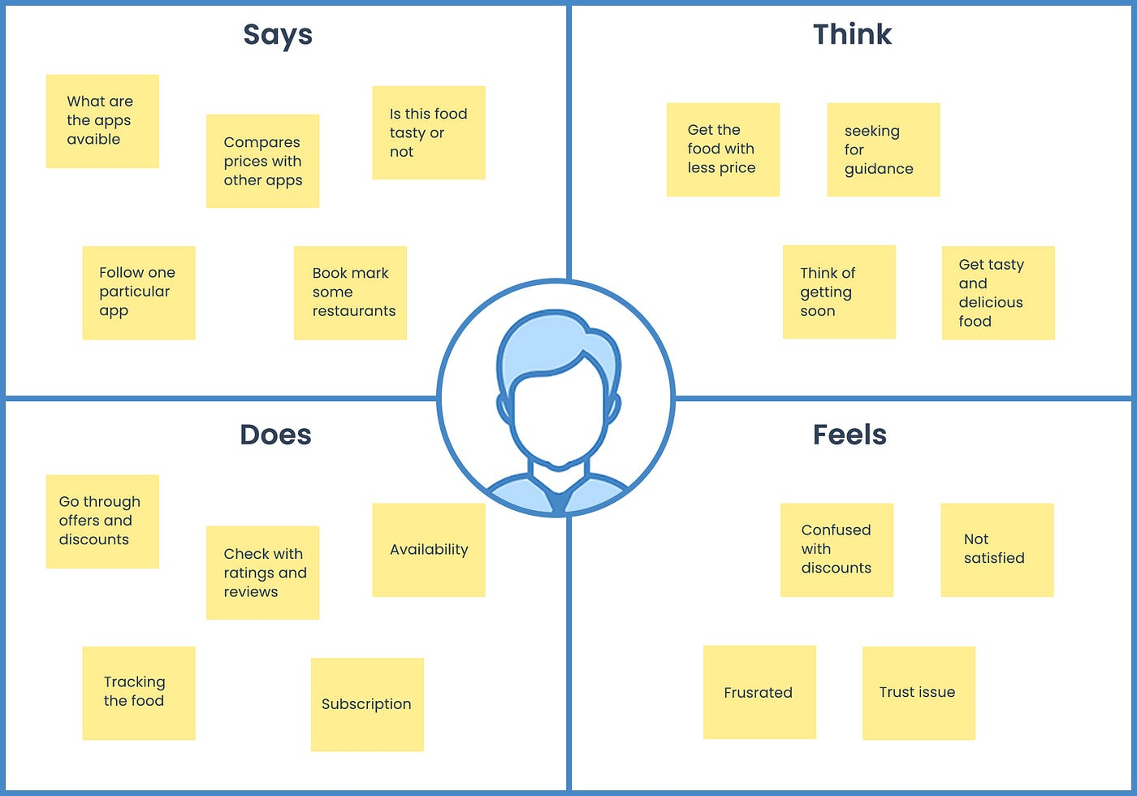

**2.2 Ideation & Brainstorming Map**

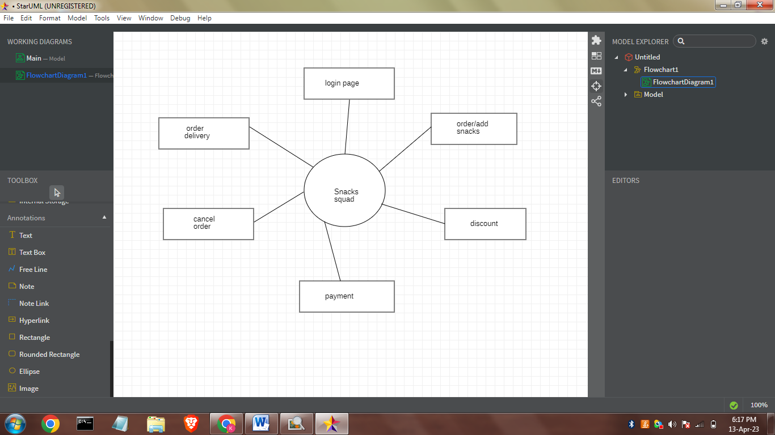**3.Result:** 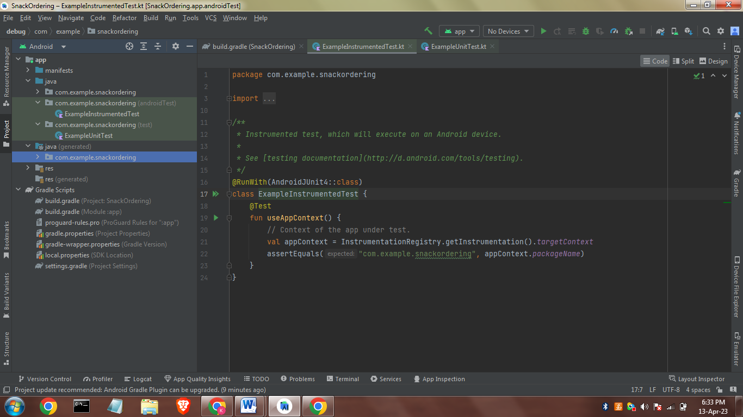

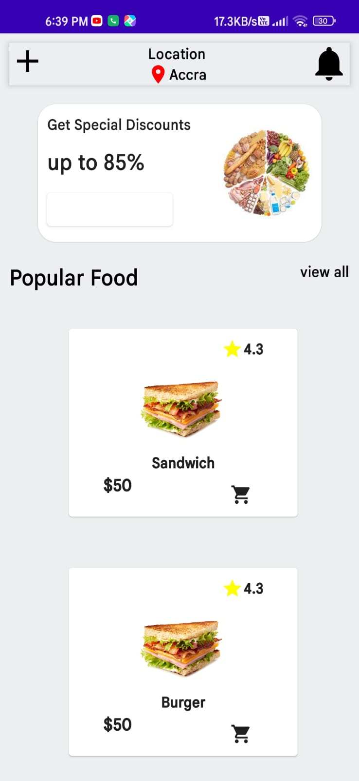

# 4. TRAILHEAD PROFILE PUBLIC URL

**Team Lead – KATHIRESAN**

<https://developers.google.com/profile/u/112782510968778847817>

**GOKUL -** <https://developers.google.com/profile/u/115169442818018648783>

**MAGESH -**

<https://developers.google.com/profile/u/114378214637865696570?authuser=5>

**SUDHARSAN –**

<https://developers.google.com/profile/u/100522275404621648763>

**5.** **ADVANTAGES & DISADVANTAGE**

# The advantage of this application is, it takes our order of snacks of our choice and offers and deliver the snacks at our door step.

# 6. APPLICATIONS

This application is used to order snacks from anywhere from home/office.

**7. CONCLUSION**

# The registered user can able to add the snacks in the cart,order/cancels the orders ,check for offers ,combos and order for the snacks.

**8. FUTURE SCOPE**

Artificial technology can be embedded to identify the frequent users,frequent ordered snacks and based on this snacks recommendations feature can be added.