Week 10:
ROLL NO.:240801151
Name: Kathiravan v
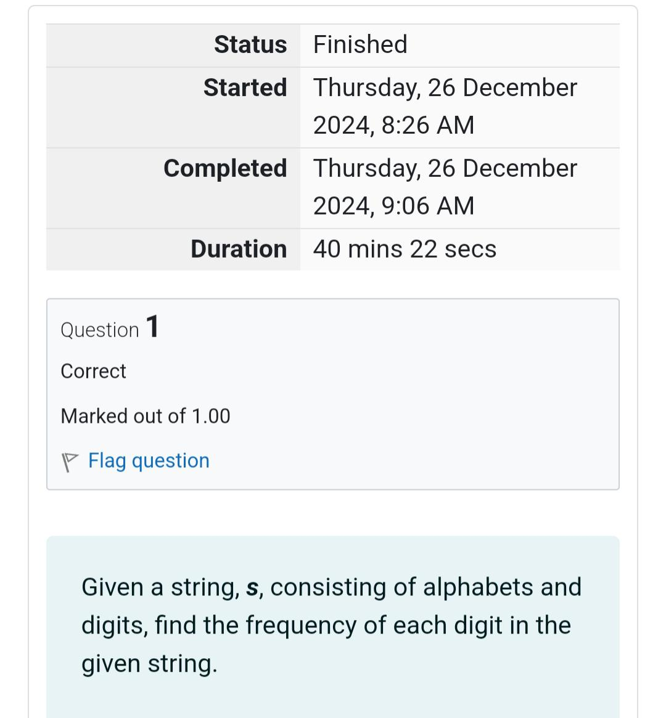
Q1) Given a string, s, consisting of alphabets and digits, find the frequency of each digit in the
given string.
Input Format
The first line contains a string, num which is the given number.
Constraints
1 ≤ len(num) ≤ 1000
All the elements of num are made of English alphabets and digits.
Output Format
Print ten space-separated integers in a single line denoting the frequency of each digit
from 0 to 9.
Sample Input 0
a11472o5t6
Sample Output 0
0 2 1 0 1 1 1 1 0 0
Explanation 0
In the given string:
• 1 occurs two times.
• 2, 4, 5, 6 and 7 occur one time each.
• The remaining digits 0, 3, 8 and 9 don't occur at all.
Hint:
• Declare an array, freq of size 10 and initialize it with zeros, which will be used to count
the frequencies of each of the digit occurring.
• Given a string, s, iterate through each of the character in the string. Check if the current
character is a number or not.
• If the current character is a number, increase the frequency of that position in the freq
array by 1.
• Once done with the iteration over the string, s, in a new line print all the 10 frequencies
starting from 0 to 9, separated by spaces.
Code:
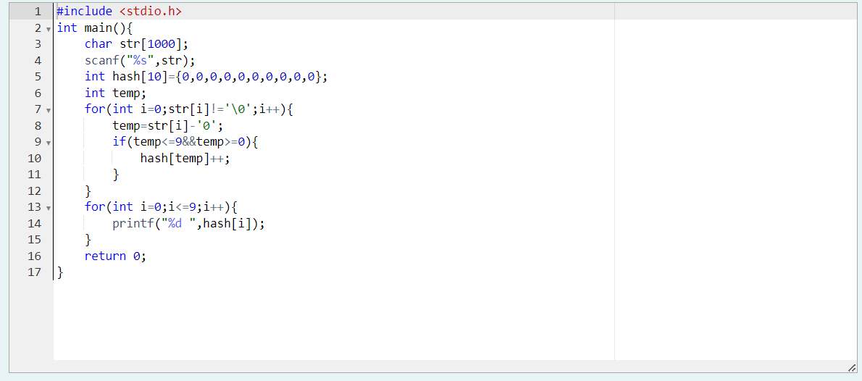
OUTPUT:
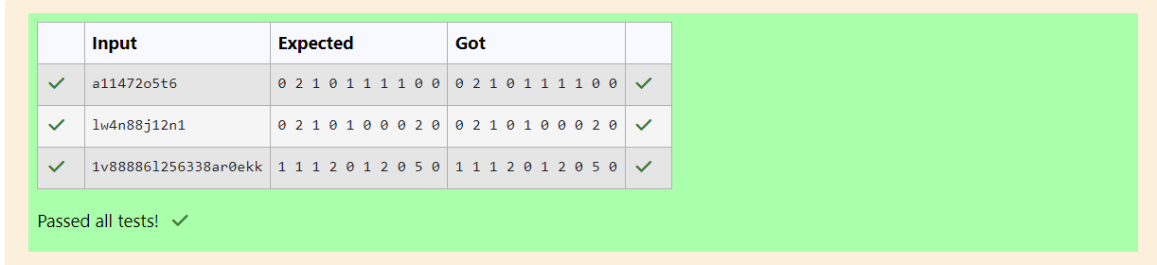

Q2)
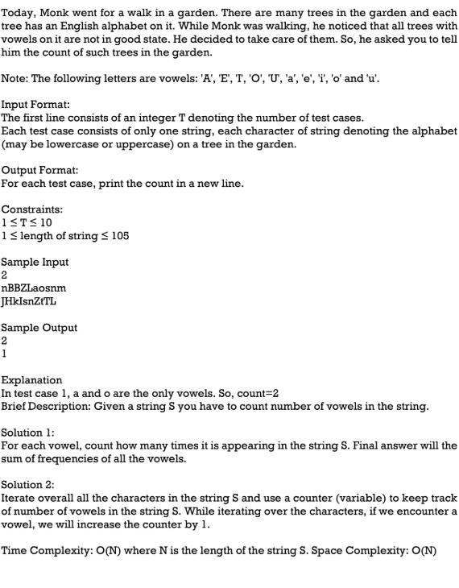
Code:
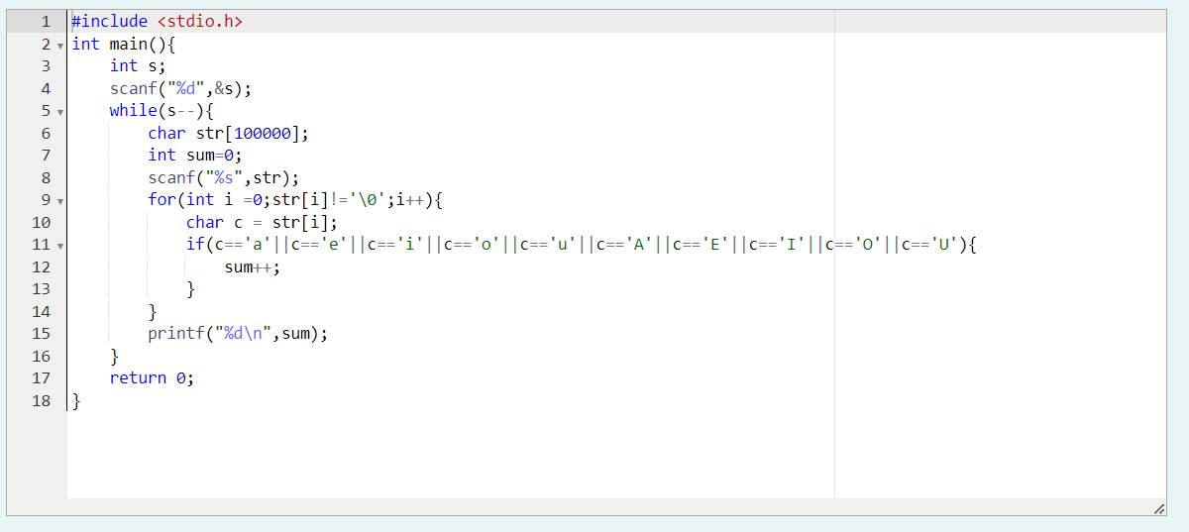
OUTPUT:
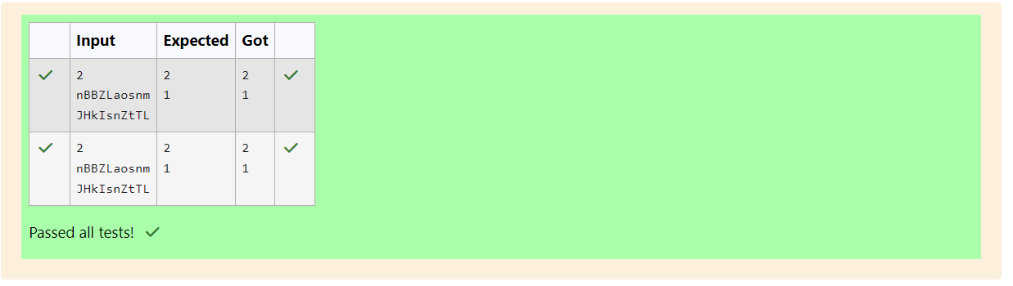

Q3) Given a sentence, s, print each word of the sentence in a new line.
Input Format
The first and only line contains a sentence, s.
Constraints
1 ≤ len(s) ≤ 1000
Output Format
Print each word of the sentence in a new line.

Sample Input
This is C
Sample Output
This
is
C
Explanation
In the given string, there are three words ["This", "is", "C"]. We have to print each of these
words in a new line.
Hint
Here, once you have taken the sentence as input, we need to iterate through the input, and
keep printing each character one after the other unless you encounter a space. When a
space is encountered, you know that a token is complete and space indicates the start of
the next token after this. So, whenever there is a space, you need to move to a new line,
so that you can start printing the next token.

Code:
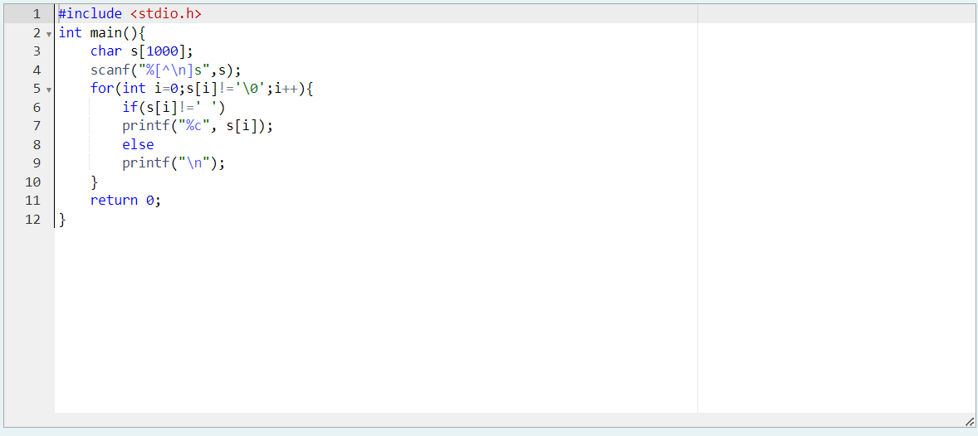

OUTPUT:
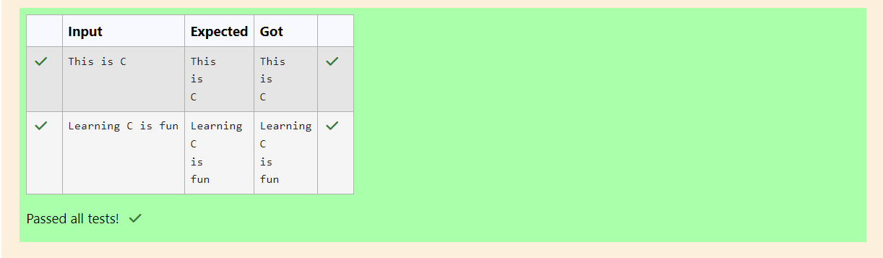

Q4) 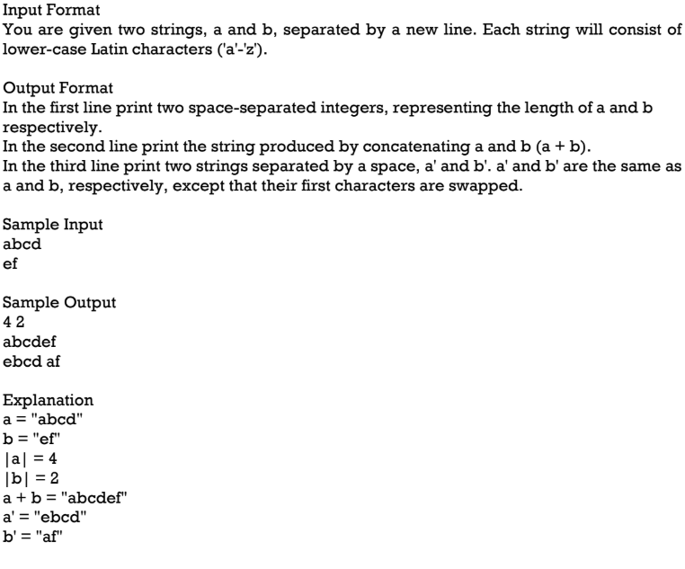

Code:
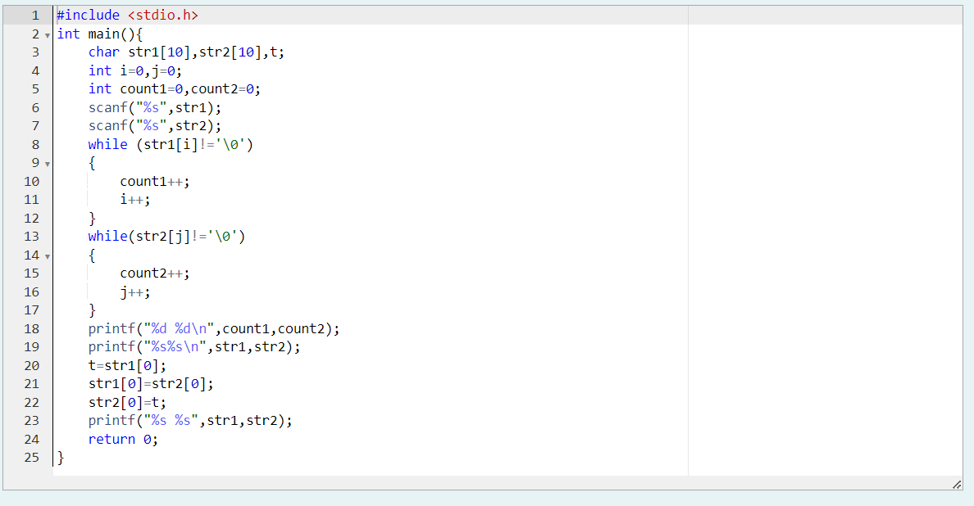

OUTPUT:
