Week 4 – 1:
--Coding-C-Language Features-Optional.
ROLL NO.:240801151
Name: Kathiravan v
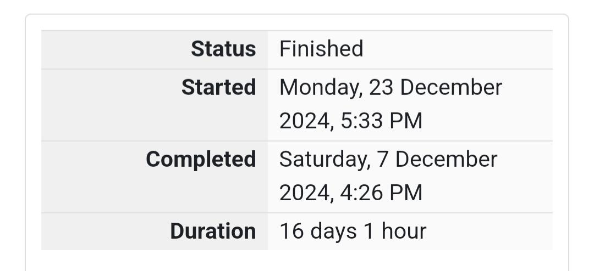
Q1) Alice and Bob are playing a game called "Stone Game". Stone game is a two-player game.
Let N be the total number of stones. In each turn, a player can remove either one stone or
four stones. The player who picks the last stone, wins. They follow the "Ladies First" norm.
Hence Alice is always the one to make the first move. Your task is to find out whether Alice
can win, if both play the game optimally.
Input Format
First line starts with T, which is the number of test cases. Each test case will contain N
number of stones.
Output Format
Print "Yes" in the case Alice wins, else print "No".
Constraints 1<=T<=1000 1<=N<=10000
Sample Input
3
1
6
7
Sample Output
Yes
Yes
No

Code:
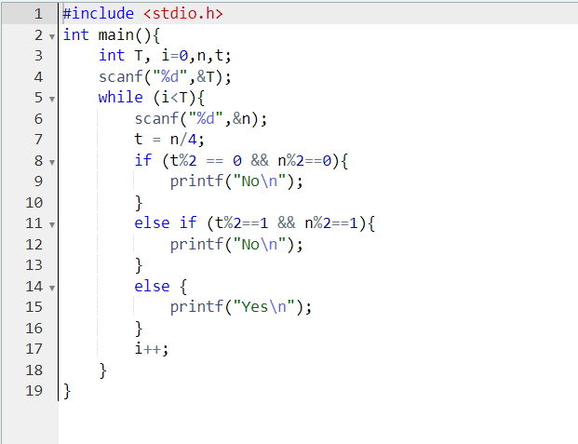

OUTPUT:
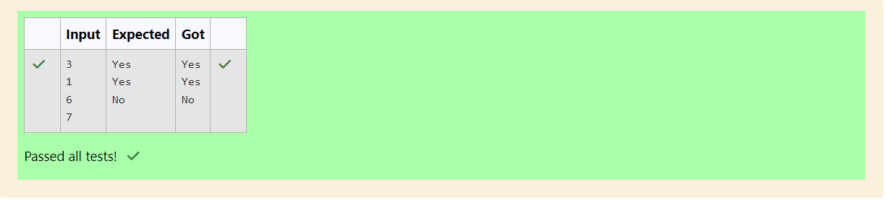

Q2) You are designing a poster which prints out numbers with a unique style applied to each
of them. The styling is based on the number of closed paths or holes present in a given
number.
The number of holes that each of the digits from 0 to 9 have are equal to the number of
closed paths in the digit. Their values are:
1, 2, 3, 5, 7 = 0 holes.
0, 4, 6, 9 = 1 hole.
8 = 2 holes.
Given a number, you must determine the sum of the number of holes for all of its digits.
For example, the number 819 has 3 holes.
Complete the program, it must return an integer denoting the total number of holes in
num.
Constraints
1 ≤ num ≤ 109
Input Format For Custom Testing
There is one line of text containing a single integer num, the value to process.
Sample Input
630
Sample Output
2

Code:
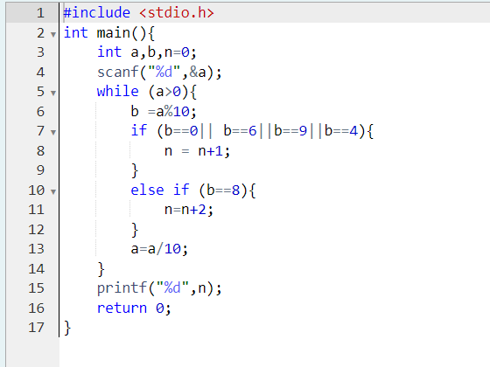

OUTPUT:
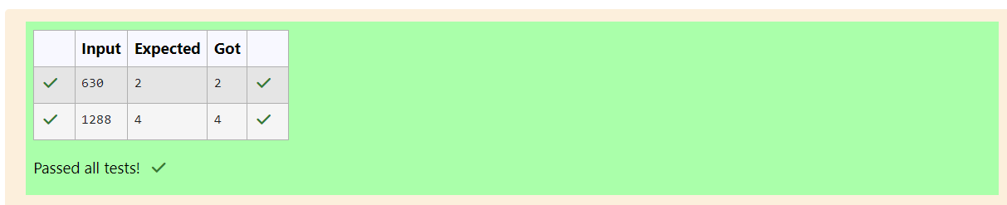

Q3) The problem solvers have found a new Island for coding and named it as Philaland. These
smart people were given a task to make a purchase of items at the Island easier by
distributing various coins with different values. Manish has come up with a solution that if
we make coins category starting from $1 till the maximum price of the item present on
Island, then we can purchase any item easily. He added the following example to prove
his point.
Let’s suppose the maximum price of an item is 5$ then we can make coins of {$1, $2, $3,
$4, $5}to purchase any item ranging from $1 till $5.
Now Manisha, being a keen observer suggested that we could actually minimize the
number of coins required and gave following distribution {$1, $2, $3}. According to him
any item can be purchased one time ranging from $1 to $5. Everyone was impressed with
both of them. Your task is to help Manisha come up with a minimum number of
denominations for any arbitrary max price in Philaland.
Input Format
Contains an integer N denoting the maximum price of the item present on Philaland.
Output Format
Print a single line denoting the minimum number of denominations of coins required.
Constraints
1<=T<=100 1<=N<=5000
Sample Input 1:
10
Sample Output 1:
4

Code:
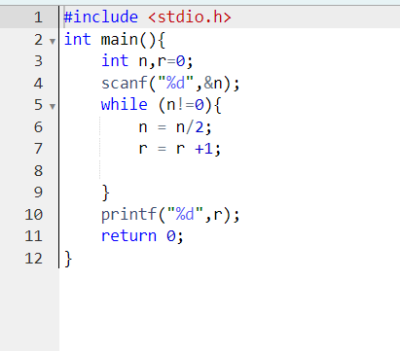

OUTPUT:
