Week 5 – 1:
ROLL NO.:240801151
Name: Kathiravan v
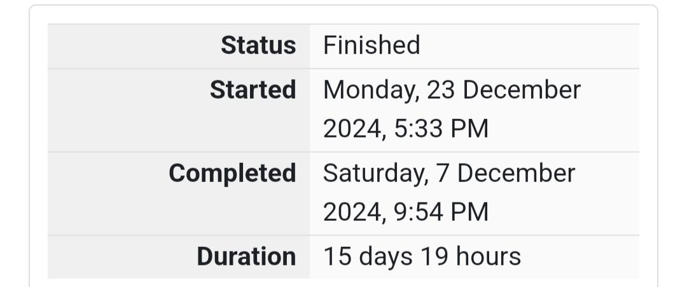
Q1) Write a program that prints a simple chessboard.
Input format:
The first line contains the number of inputs T.
The lines after that contain a different value for size of the chessboard
Output format:
Print a chessboard of dimensions size * size.
Print W for white spaces and B for black spaces.
Sample Input:
2
3
5
Sample Output:
WBW
BWB
WBW
WBWBW
BWBWB
WBWBW
BWBWB
WBWBW

Code:
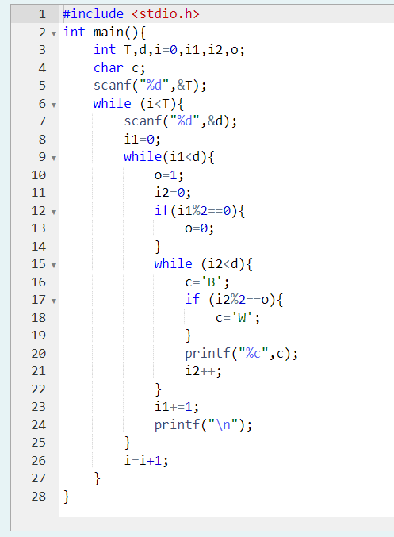

OUTPUT:
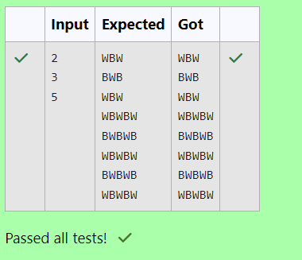
Q2) Let’s print a chessboard!
Write a program that takes input:
The first line contains T, the number of test cases
Each test case contains an integer N and also the starting character of the chessboard
Output Format
Print the chessboard as per the given examples
Sample Input:
2
2 W
3 B
Sample Output:
WB
BW
BWB
WBW
BWB
Code:
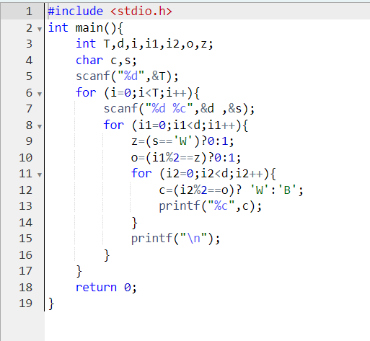

OUTPUT:
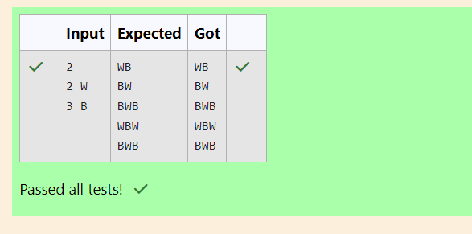

Q3) Decode the logic and print the Pattern that corresponds to given input.
If N= 3 then pattern will be:
10203010011012
**4050809
****607
If N= 4, then pattern will be:
1020304017018019020
**50607014015016
****809012013
******10011
Constraints: 2 <= N <= 100
Input Format
First line contains T, the number of test cases, each test case contains a single integer N
Output Format
First line print Case #i where i is the test case number, In the subsequent line, print the
pattern
Sample Input
3
3
4
5
Sample Output
Case #1
10203010011012
**4050809
****607
Case #2
1020304017018019020
**50607014015016
****809012013
******10011
Case #3
102030405026027028029030
**6070809022023024025
****10011012019020021
******13014017018
********15016

Code:
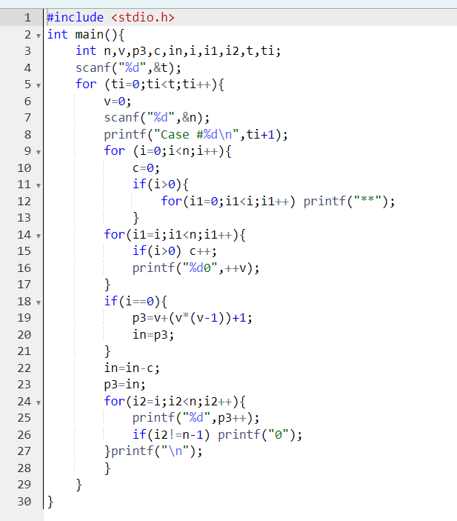

OUTPUT:
