Week 5 – 2:
ROLL NO.:240801151
Name: kathiravan.v
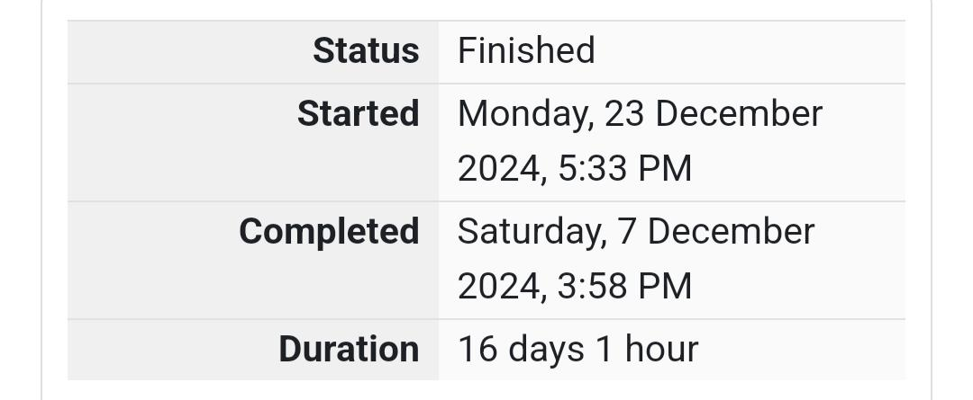
Q1) The k-digit number N is an Armstrong number if and only if the k-th power of each digit
sums to N.
Given a positive integer N, return true if and only if it is an Armstrong number.
Note: 1 <= N <= 10^8
Hint: 153 is a 3-digit number, and 153 = 1^3 + 5^3 + 3^3.
Sample Input:
153
Sample Output:
true
Sample Input:
123
Sample Output:
false
Sample Input:
1634
Sample Output:
True

Code:
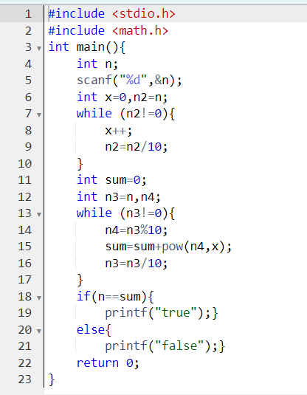

OUTPUT:
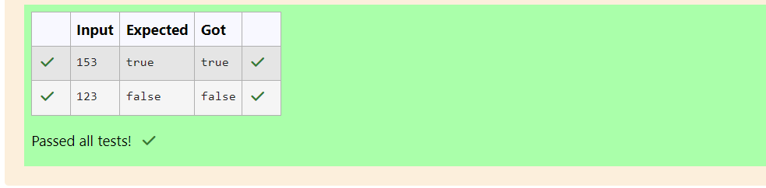

Q2) Take a number, reverse it and add it to the original number until the obtained number is
a palindrome.
Constraints
1<=num<=99999999
Sample Input 1
32
Sample Output 1
55
Sample Input 2
789
Sample Output 2
66066
Code:
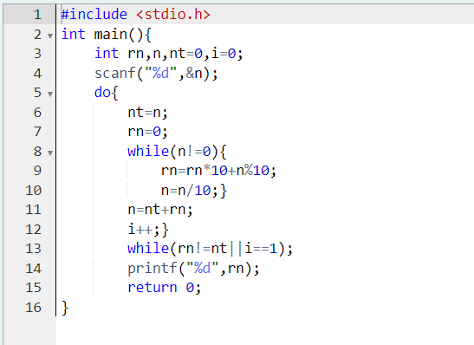
OUTPUT:
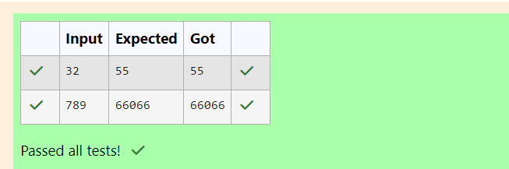
Q3) A number is considered lucky if it contains either 3 or 4 or 3 and 4 both in it. Write a
program to print the nth lucky number. Example, 1st lucky number is 3, and 2nd lucky
number is 4 and 3rd lucky number is 33 and 4th lucky number is 34 and so on. Note that
13, 40 etc., are not lucky as they have other numbers in it.
The program should accept a number 'n' as input and display the nth lucky number as
output.
Sample Input 1:
3
Sample Output 1:
33
Code:
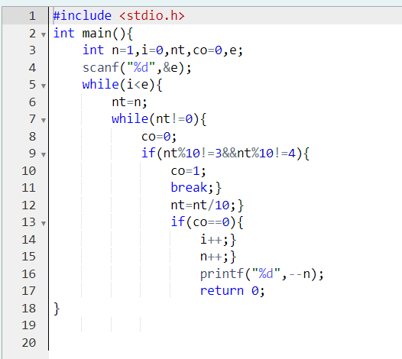
OUTPUT:
