Basic Linux Commands – Session-1, Assignment-2

1.pwd
Command to find the absolute path corresponding to the present working directory from the root directory
e.g. pwd
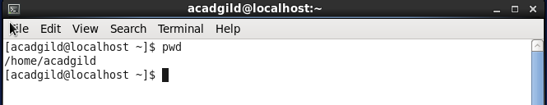

2.vi
The default editor that comes with the Unix/Linux operating system is called vi. The vi editor is a full screen editor and has two modes of operation:
- Command mode commands which cause action to be taken on the file, and
- Insert mode in which entered text is inserted into the file.
To use vi on a file, type in vi filename. If the file named filename exists, then the first page of the file will be displayed; if the file does not exist, then an empty file and screen are created into which you may enter text.
e.g. vi sample.txt
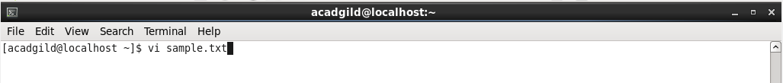

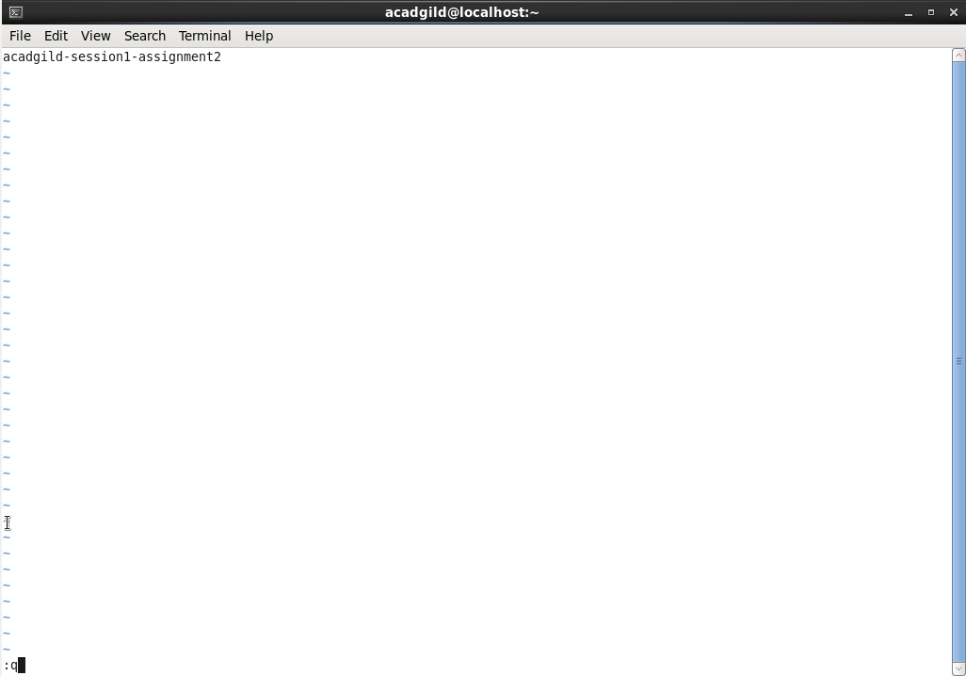
3. touch
The touch command is used to update the access date and / or modification date of a file or directory. In its default usage, it is the equivalent of creating or opening a file and saving it without any change to the file contents.
-a, change the access time only
-c, if the file does not exist, do not create it
-d, update the access and modification times
-m, change the modification time only
-r, use the access and modification times of file
-t, creates a file using a specified time
e.g. touch sample.txt
- Update the access time, if the file exists, else create an empty file
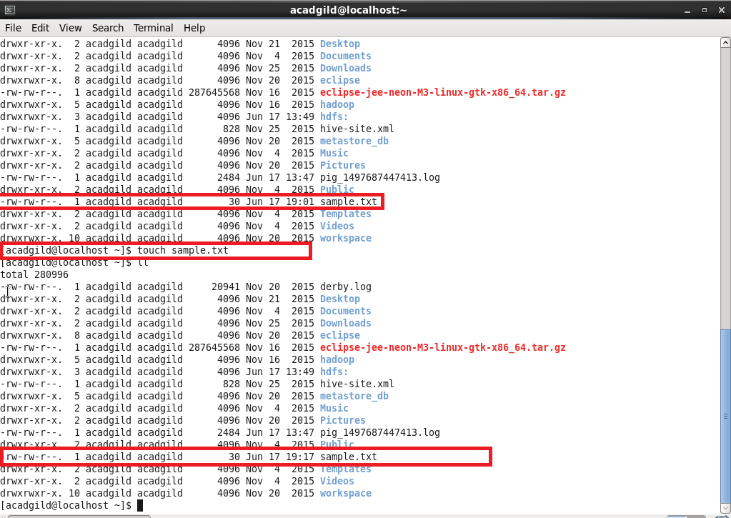
4.mkdir
This command is used to create a new directory in the file system.
e.g. mkdir testdir
mkdir –m <permission seq> <directory-name>
permission-sequence - The first digit represents the owner, the second represents the group and the third represents other users. The number 7 represents all three types of permission (i.e., read, write and execute), 6 stands for read and write only, 5 stands for read and execute, 4 is read only, 3 is write and execute, 2 is write only, 1 is execute only and 0 is no permissions.
e.g. mkdir 777 assignment1

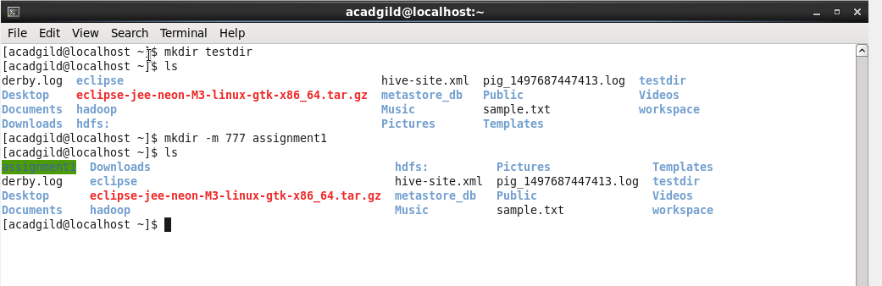
5.rm
The rm (i.e., remove) command is used to delete files and directories
e.g. rm sample.txt

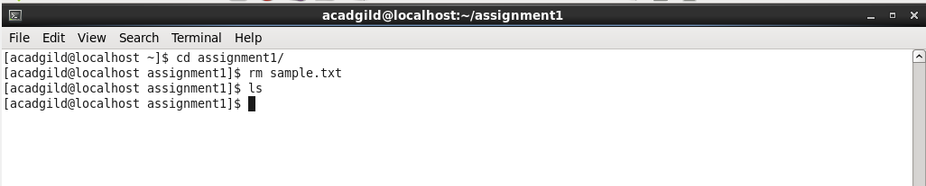

e.g. rm –rf assignment1

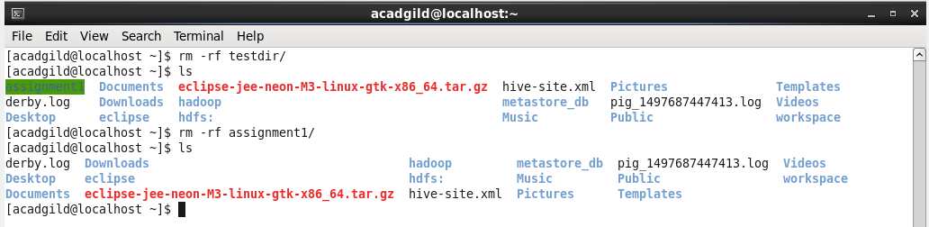
6. ls
This command is to list the contents in a directory
e.g. ls
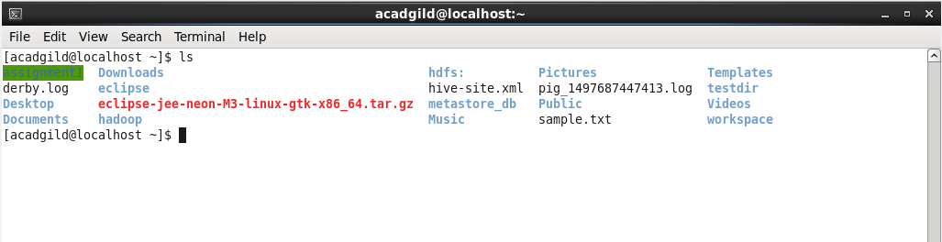
7. echo
The echo command is used to writes its arguments to standard output.
e.g. echo Assignment1 (print the string “Assignment1” to the standard output)
echo $PATH ( To print the system path to standard output)
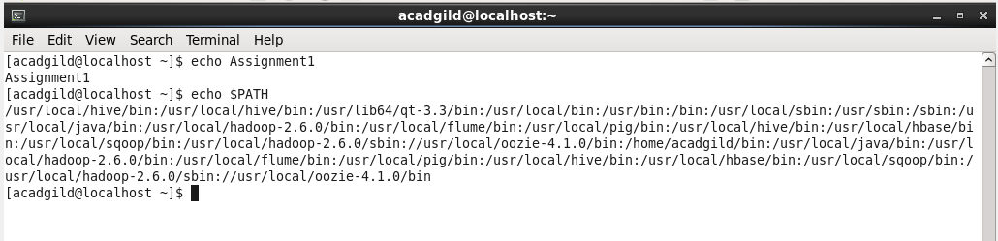
8. cat
The cat (short for “concatenate“) command allows users to create single or multiple files, view contain of file, concatenate files and redirect output in terminal or files.
e.g. cat sample.txt
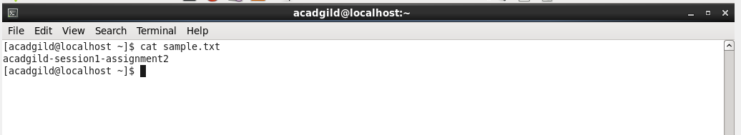
e.g. cat sample.txt sample1.txt (concatenate the contents of sample.txt and sample1.txt and display it in standard output)
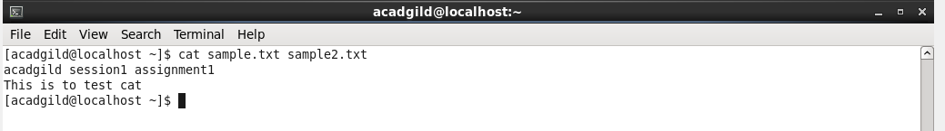

9. who
The who command prints information about all users who are currently logged in.
e.g. who
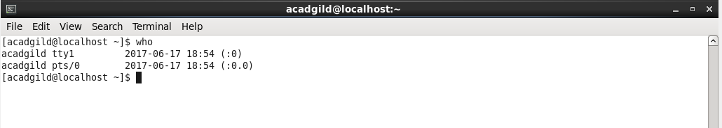
10.cd
The cd command is used to change the working directory. This command can be used to move around within the hierarchy of file system.
e.g. cd assignment1
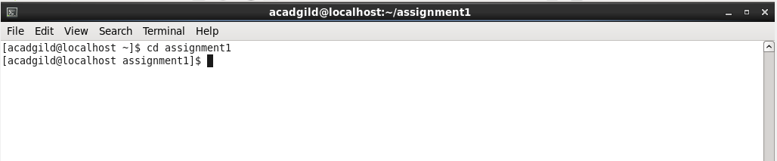
e.g. cd .. ( change from current directory to the immediate parent directory)
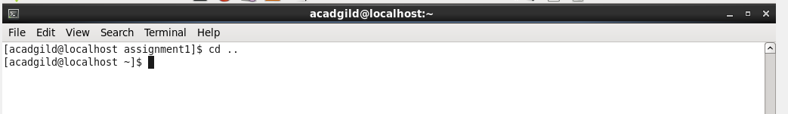
11.date
Date command is used to print the date and time. By default the date command displays the date in the time zone that the Linux operating system is configured.
e.g. date
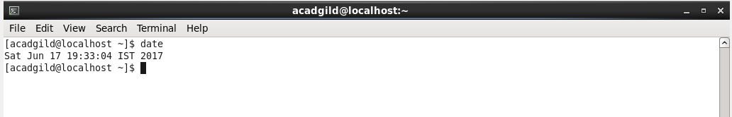

12.cal
Command to display a conveniently-formatted calendar from the command line.
e.g. cal
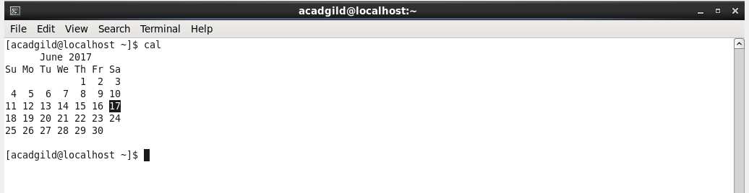
13.mv
mv (short for move) is a Unix command that moves one or more files or directories from one place to another. If both filenames are on the same filesystem, this results in a simple file rename; otherwise the file content is copied to the new location and the old file is removed.
e.g. mv sample.txt ./assigment1
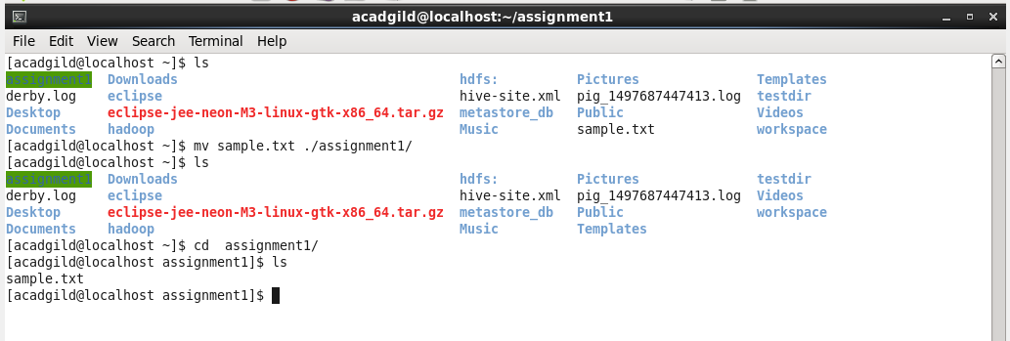
14.cp
The cp command is used to make copies of files and directories.
e.g. cp sample.txt ./assignment1/sample.txt
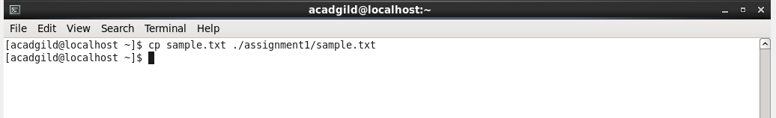

15.which
The which command is used to find the location of a program.
e.g. which hadoop
