Big Data – Session2-Assignment1

Task 1
Check whether /user/acadgild directory exists or not in the HDFS.
If it doesn't exist, then create this.
Create a directory /user/acadgild/hadoop.

Solution
Attempt to check whether the directory exists or not using command
hadoop fs –ls –user/acadgild/hadoop
If the directory does not exists, then use the following command to create one in hdfs file system
hadoop fs –mkdir /user/acadgild/hadoop

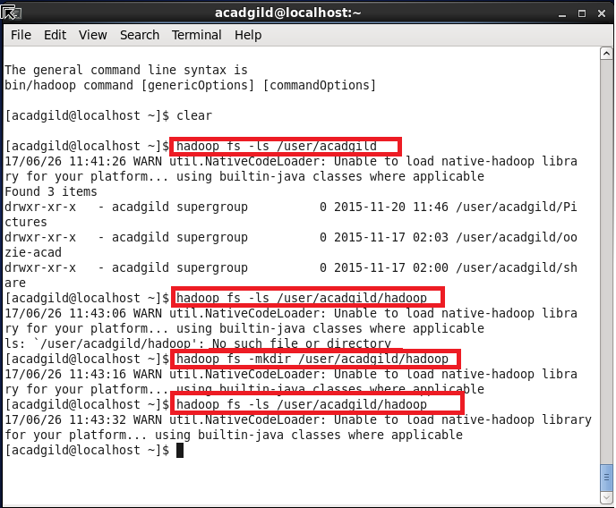
Task 2:
Create a file in HDFS under directory /user/acadgild/hadoop, with name word-count.txt.
Whatever we type on screen should get appended to the file.
Try to type (on screen) few lines from any online article or textbook.

Solution
Create a file using the following command
hadoop fs –touchz /user/acadgild/hadoop/word-count.txt

Since, there is no other mean to redirect the stdin content to a file for append in hdfs, I just pipelined the echo command output to hadoop fs –AppendToFile command
echo “some text” | hadoop fs –AppendToFile - /user/acadgild/hadoop/word-count.txt
hadoop fs –cat /user/acadgild/hadoop/word-count.txt
