BigData-Session2-Assignment2

Task:3
Create a file max-temp.txt in local FS.
Put some 10-15 records of date and temperature example:
dd-mm-yyyy,temperature
Example:
10-01-1990,10
10-02-1991,20
Move this file to HDFS at /user/acadgild/hadoop.
Solution

Create a file name max-temp.txt in local file system using vi editor
vi max-temp.txt
put the editor in insertion mode using <esc>+i to insert records and save the file <esc>+”:wq”

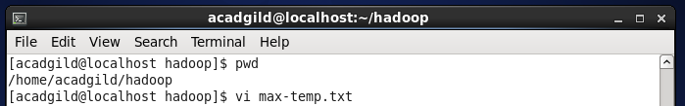
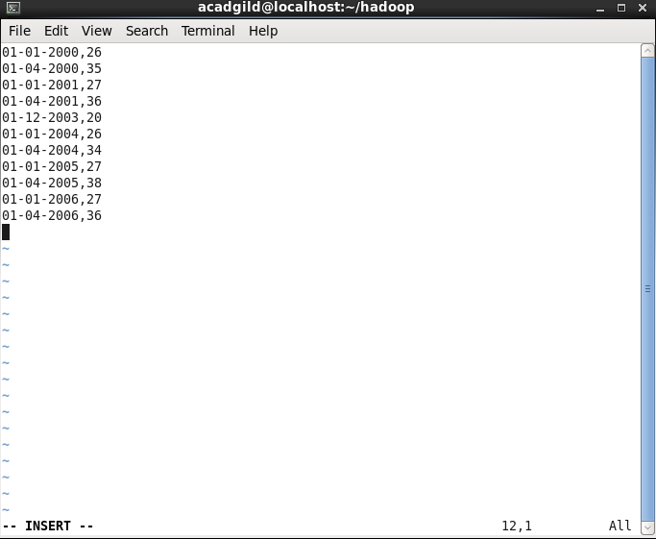
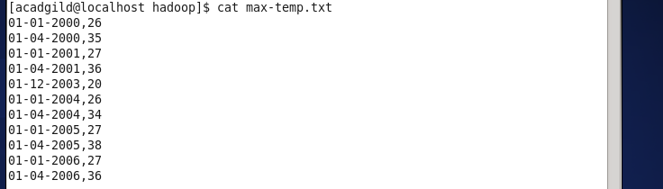

Move the file from local file system to hadoop folder in hdfs using the command
hadoop fs – moveFromLocal /home/acadgild/hadoop/max-temp.txt /user/acadgild/hadoop
This command will copy of max-temp.txt in local file system to destination hdfs folder and delete the copy of max-temp.txt from the local file system.

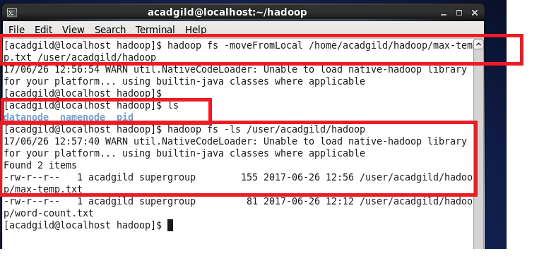

Tasks:4
Change the permission of the file /user/acadgild/hadoop/max-temp.txt, such that
only the owner and the group members have full control over the file.
Others do not have any control over it.

Solution
Use the following command to change the file permission
hadoop fs –chmod 770 /user/acadgild/max-temp.txt

chmod Permission Modes

7 7 7

user group world

r+w+x r+w+x r+w+x

4+2+1 4+2+1 4+2+1 = 777

