The Chat Application consists of a Server and a Client module. This Application apart from sending regular text data can also generate sounds when certain keywords are entered. This application uses Windows Sockets for implementing the TCP/IP protocol.

Phases of development in this project are

- Design
- Implementation
- Testing

Design

Server:

The server has to listen for incoming requests from any client connected in the network. After getting a valid request the server has to accept the request and establish a communication line with the client. The processes involved in the communication are

      - Getting keyboard input and storing them in buffers
      - Transferring the buffer data to the client by using the communication socket.
      - Getting incoming bytes from the client
      - Displaying text data from the received bytes.
      - Scan for certain keywords from the received bytes
      - Generate sounds when certain keywords are found.

Receiving of the incoming bytes from the Client and sending of the bytes to the Client has to be carried out in two separate threads such that the user can freely type or read the messages without waiting.

Apart from maintaining the communication the Server has to monitor the state of the Client and must close the communication line if the Client is closed.

Client:

The Client is the one which sends the request to the server. For this the client should know the IP no of the Server machine. After establishing the communication line the functions of the client are same as that of the Server. It has to receive keyboard input and send them to the Server. Also the incoming text has to be displayed in a Window and sounds have to generated. Both sending and receiving of data has to be carried out in two separate threads as in the case of the Server. The Client need not monitor the state of the Server.

Implementation:

The application was created by using MFC(Microsoft Visual C++) under Microsoft Visual C++ 6. The Sockets are implemented by using the MFC class CAsyncSocket and Sounds are generated by using the WINMM.LIB library file.

Originally two test programs, one for the Server and the other for the Client were created.

Server:

This is a Dialog Box based program using the MFC class CDialog. The Dialog Box contains the following Controls.

      - A Text Control for displaying the Client status message
      - A List Box for displaying the incoming messages from the Client
      - A Text Control for typing the text which is to be sent to the Client.
      - A Send Button for the user to transmit typed data to Client.
      - A Close Button for closing the Server.

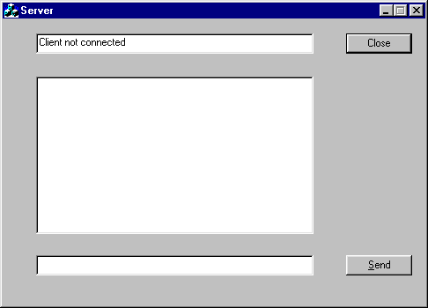

From Inside the Dialog Box a Socket is created and made to listen for any incoming Client Request. In case of any Client Request the Socket notifies the Dialog Box. After establishing the connection a new Socket is created for data communication. These Socket functions are implemented by the Create(), Listen() and Accept() methods of the CAsyncSocket class

Data typed in the corresponding Text Box is read and sent to the Client when the user clicks the Send Button. For transmission of Data the method Send() of CAsyncSocket class is used.

Reading of incoming messages from the Client is performed in a separate thread. For receiving the incoming data the Receive() method of the CAsyncSocket class is used. The received text data is displayed in the List Box.

A new class CstringTokenizer is used for splitting the incoming text. The split text is scanned for certain keywords and when found the appropriate sounds are played from WAV files by using the WIN32 function PlaySound(..). For this a collection of WAV files are packed with the application.

The following are the WAV files along with the associated keywords for playing them.

:BC - baby_cry.wav
:CL - clap.wav
:BL - boy_laugh.wav
:EL - evil_laugh.wav
:GL- girl_laugh.wav
:KL- kid_laugh.wav
:MG- man_giggle.wav
:MH- man_hilarious_laugh.wav
:ML - man_laugh.wav
:WC- women_crying.wav
:WH- women_hilarious_laugh.wav

Client:

The Client is also a MFC Dialog Box program containing the following Controls.

      - A Text Control for the user to type the Server name
      - A Connect Button for establishing a connection with the Server
      - A List Box displaying incoming messages from the Server
      - A Text Control for typing the text which is to be sent to the Server
      - A Send Button
      - A Close Button for closing the Client.

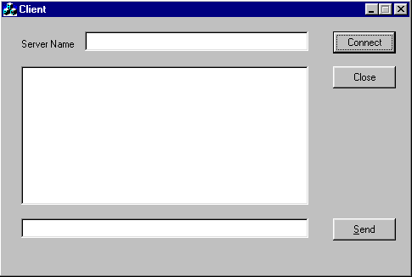

Working of the Client is similar to that of the Server but it does not use any listening Socket. The Connect() method of the CAsyncSocket is used to establish a connection to the Server.

Testing:

The testing involves Black Box Testing of the Application and Unit Testing of the methods.

Server:

The following Server methods are subjected to Unit testing.

CDialog Class methods

      - OnSAccept()
      - OnSClose()
      - OnSend()
      - OnSReceive()

CAsyncSocket methods

      - OnAccept()
      - OnClose()
      - OnConnect()
      - OnReceive()

Client:

The following Client methods are subjected to Unit Testing.

      - OnConnect
      - OnSend
      - OnCReceive

The test results are satisfactory for both the Black Box testing and Unit Testing.

Upgradation:

After testing the prototype models. Both the Server and Client functions were combined into a single Dialog Based program. With this design, connecting between two running copies of the same program is made possible and the users don’t need two separate programs(Server and Client) for chatting. Also the upgraded version is compiled under Release mode with the MFC libraries statically linked. With this type of linking, the program runs under any WINDOWS system without support of any external DLL’s.

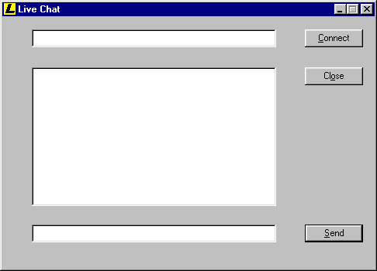

Advantages:

      - The user friendly interface enables effortless use
      - The Sockets implementing TCP/IP protocols makes this application suitable for any kind of network including the internet.
      - The modular design of the Server and the Client enables scalability and provides scope for future improvement.
      - Both the Server and the Client programs occupy less Disk memory.

Future Plans:

      - Using a centralized server or file for listing the IP addresses of different user’s.

Whenever a user starts the program his internet IP address along with his ID will be entered into a common file stored in a web host. This can be done by using a FTP connection. When another user starts his program, the details of available friends can be found from this common file and listed in the program window.

      - Inclusion of graphics and animation features.

Along with sound features animating images, bitmaps, icons too can be displayed in the program window. To implement this feature a Web browser control instead of a List box will be used as the program’s main window. This will make the application more attractive.

