**PROGRAM:**

**calculator.js**

exports.add = function (a,b) {

return (parseInt(a)+parseInt(b));

};

exports.sub = function (a,b) {

return a-b;

};

exports.mul = function (a,b) {

return a*b;

};

exports.div = function (a,b) {

return a/b;

};

**ex7.js**

var calculator = require('./calculator');

//import require from 'requirejs';

var http=require("http");

var url=require("url");

var querystring=require("querystring");

function onRequest(req,res){

var path=url.parse(req.url).pathname;

console.log('Request for '+path+'received');

var query=url.parse(req.url).query;

console.log(query);

var a=querystring.parse(query)["a"];

var b=querystring.parse(query)["b"];

var sign=querystring.parse(query)["sign"];

res.write("<style>");

res.write("div{background-color: black;color: white;}h2{font-size: larger;font-family: 'Times New Roman', Times, serif;font-style: italic;font-weight: bold;}h1{font-size: larger;font-family: 'Times New Roman', Times, serif;font-style: italic;font-weight: bold;}");

res.write("</style>");

res.write("<center><div><h2>CALCULATOR</h2></div></center>");

res.write("<h1>First Number="+a);

res.write("<h1>Second Number="+b);

if (sign=='+'){

res.write("<h1>Addition:"+calculator.add(a,b))

}

else if(sign=='-')

{

res.write("<h1>Subtraction:"+calculator.sub(a,b))

}

else if(sign=='*')

{

res.write("<h1>Multiplication:"+calculator.mul(a,b))

}

else if(sign=='/')

{

res.write("<h1>Division:"+calculator.div(a,b))

}

res.end();

};

http.createServer(onRequest).listen(8080);

console.log('server has started');

**ex-7.html**

<html>

<head>

<title> GET METHOD</title>

<style>

.div{

background-color: black;

color: white;

align-items: center;

}

body{

background-image: url("https://as1.ftcdn.net/v2/jpg/02/85/88/92/1000_F_285889235_4OdZaoyEhH7D1ZBAGrBNsOJrHUHLtM9o.jpg");

background-repeat: no-repeat;

background-size: cover;

background-position: right;

background-attachment: fixed;

float: right;

padding-top: 10%;

padding-right: 8%;

}

.dic1{

font-size: larger;

font-family: 'Times New Roman', Times, serif;

font-style: italic;

font-weight: bold;

color:black;

}

.table,th,td

{

border: 2px solid black;

border-collapse: collapse;

padding-top: 10px;

padding-bottom: 20px;

padding-left: 30px;

padding-right: 40px;

}

.submit{

color: white;

background-color: black; }

</style>

</head>

<body>

<form action="http://localhost:8080" method="get">

<center><div class="div"><h1>CALCULATOR</h1></div></center>

<div class="dic1">

Enter 1st Number:<input type="number" name="a"><br><br>

Enter 2nd Number:<input type="number" name="b"><br><br>

Enter Operation :<select type="text" name="sign" value="">

<option value="+">+</option>

<option value="-">-</option>

<option value="*">*</option>

<option value="/">/</option></select><br><br>

<center><input type="submit" name="login" value="=" class="submit">

</center>

</div>

</form>

</body>

</html>

**OUTPUT:**

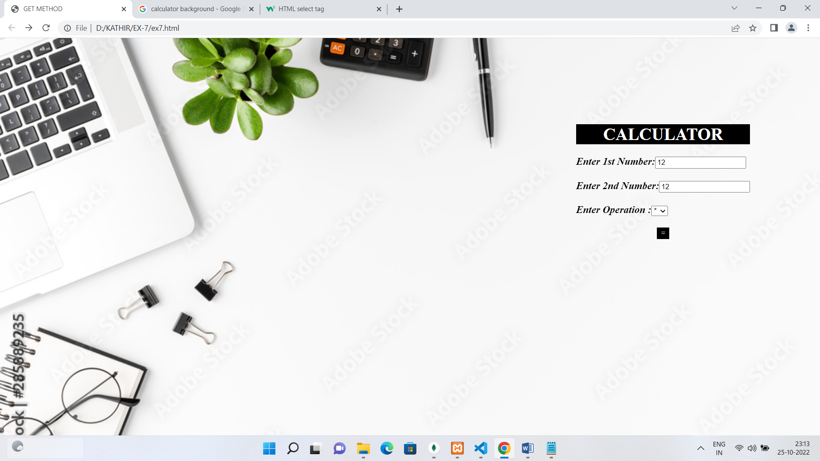

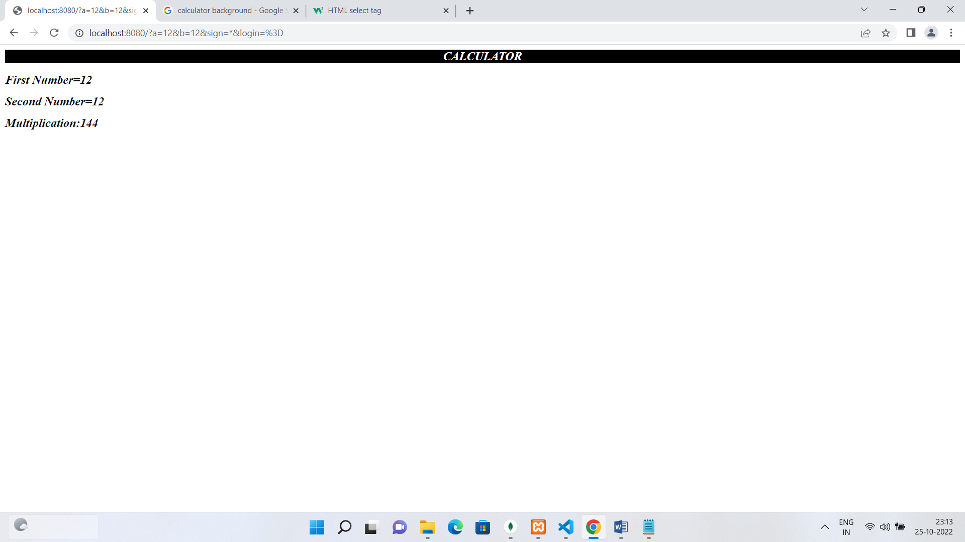

|  |  |  |
| --- | --- | --- |
| **COE** | **20** |  |
| **Record** | **15** |  |
| **Viva** | **15** |  |
| **Total** | **50** |  |

**RESULT:**