AI Time-Audit: Before and After Productivity Study
CAPSTONE 42 | Project report starter
Research question: How much time can AI save across common student or office tasks?
DATA STATUS: ILLUSTRATIVE DEMO DATA — not real experimental observations.

1. Objectives
Measure task completion time with and without AI assistance, compare output quality, and identify situations where AI assistance increases risk or rework.

2. Tasks and method
- Summarising lecture notes
- Drafting a formal email
- Planning a weekly schedule
- Comparing research sources
- Creating spreadsheet formulas
- Creating a presentation outline
Use equivalent task briefs, include prompting and verification in AI time, and apply the same quality rubric to both outputs. Where possible, have a reviewer score anonymised outputs.

3. Illustrative results
Task | Manual (min) | AI (min) | Saved (min) | Quality M / AI
Summarising lecture notes | 25 | 8 | 17 | 4 / 4
Drafting a formal email | 20 | 7 | 13 | 4 / 4
Planning a weekly schedule | 18 | 6 | 12 | 3 / 4
Comparing research sources | 40 | 18 | 22 | 4 / 3
Creating spreadsheet formulas | 30 | 12 | 18 | 4 / 4
Creating a presentation outline | 45 | 20 | 25 | 4 / 4
Illustrative total: 178 manual minutes vs 71 AI-assisted minutes, a difference of 107 minutes (60.1%). Mean quality: 3.83/5 manual and 3.83/5 AI-assisted.
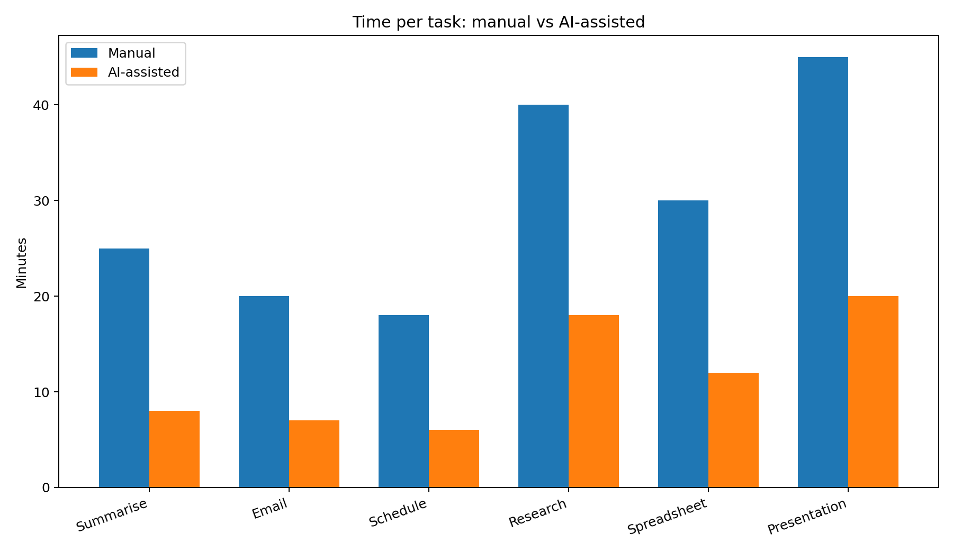
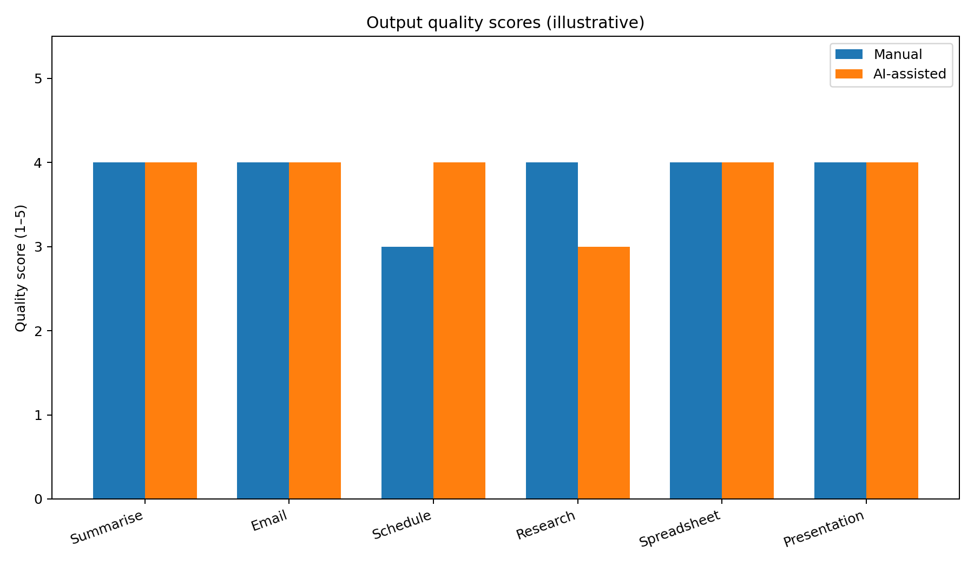

4. When AI may make work worse
- Unsupported claims or fabricated references
- Missing context or nuance in summaries
- Incorrect formulas or untested edge cases
- Generic drafts that require extensive editing
- Privacy risks from sensitive input

5. Limitations
These values are illustrative. A real study should repeat tasks, control task difficulty, record rework, use consistent rubrics, and independently verify AI-generated factual claims.

6. Conclusion
This starter pack demonstrates a way to measure time savings alongside output quality. Do not claim the illustrative figures as findings. Replace them with measured data and revise the interpretation before submission.

